1.Prerequisites

1.Install XAMPP web server

2.Editor like Sublime Text(VS code recommended)

3.Any web browser with latest version

2. Languages and Technologies used

1.HTML5,CSS

2.JavaScript(to create dynamically updating content)

3.XAMPP(A web server by Apache Friends)

4.Php

5.MySQL

3. Steps to run the project in your machine

1.Download and install XAMPP in your machine

2.Extract all the files and move it to the ‘htdocs’ folder of your XAMPP directory(Location: C:\xampp\htdocs)

3.Start the Apache and Mysql in your XAMPP control panel

4.Open your web browser and type ‘localhost/phpmyadmin’

5.In phpmyadmin page,create a new database from the left panel and name it as ‘resumebuilder’ and Tablename as ‘register’

6.Import the file ‘resumebuilder.sql’ inside your newly created database and click ok.

7.Open a new tab and type ‘localhost/foldername’in the url of your browser

8.Hurry!That’s it!

4. Software Used

1. XAMPP was installed on the Windows 10 and files were built inside C:\xampp\htdocs

2.Vscode was used as a text editor.

3. Google Chrome Version 94.0.4606.61 was used to run the project(localhost/resumebuilder was used as the url)

5.Starting Apache And MySQL in XAMPP:

The XAMPP Control Panel allows you to manually start and stop Apache or MySQL manually, click the ‘Start’ button under ‘Actions’.

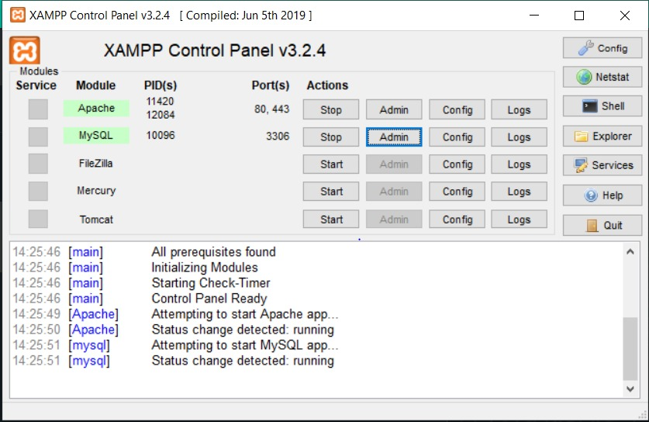

GETTING INTO THE PROJECT:

Resume builder using php and mysql.This system has a ‘Home’ page from where the user can get started by clicking on the button ‘LETS GET STARTED’ he can even see the services and About us by using navbar . Fig1.1 shows the ‘Home’ page of our project.

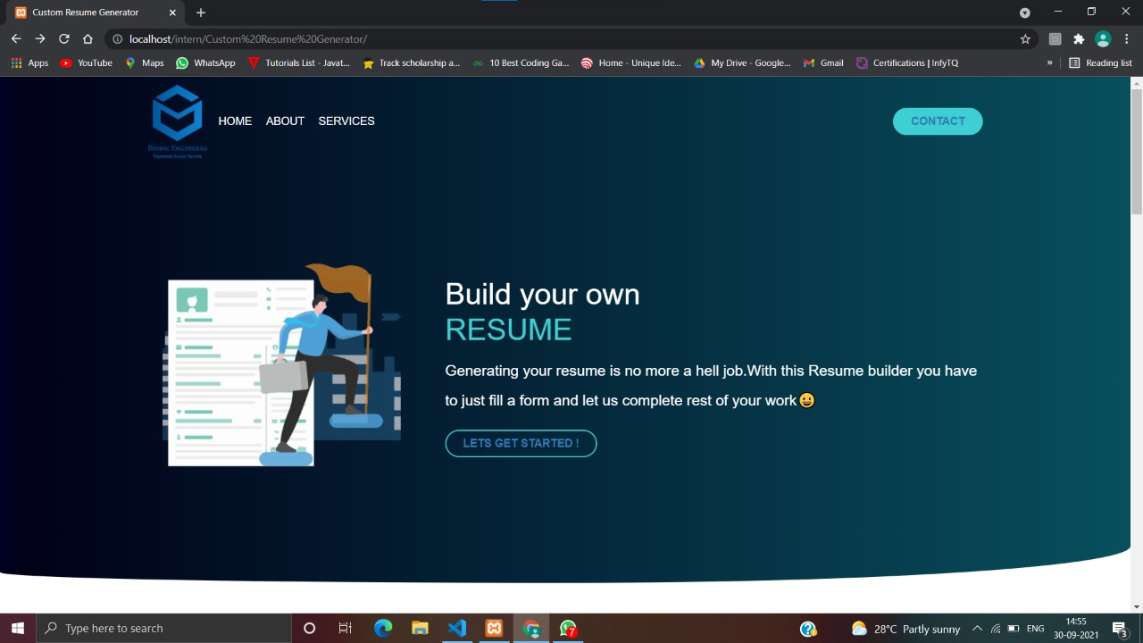

Fig 1.1:HOME PAGE

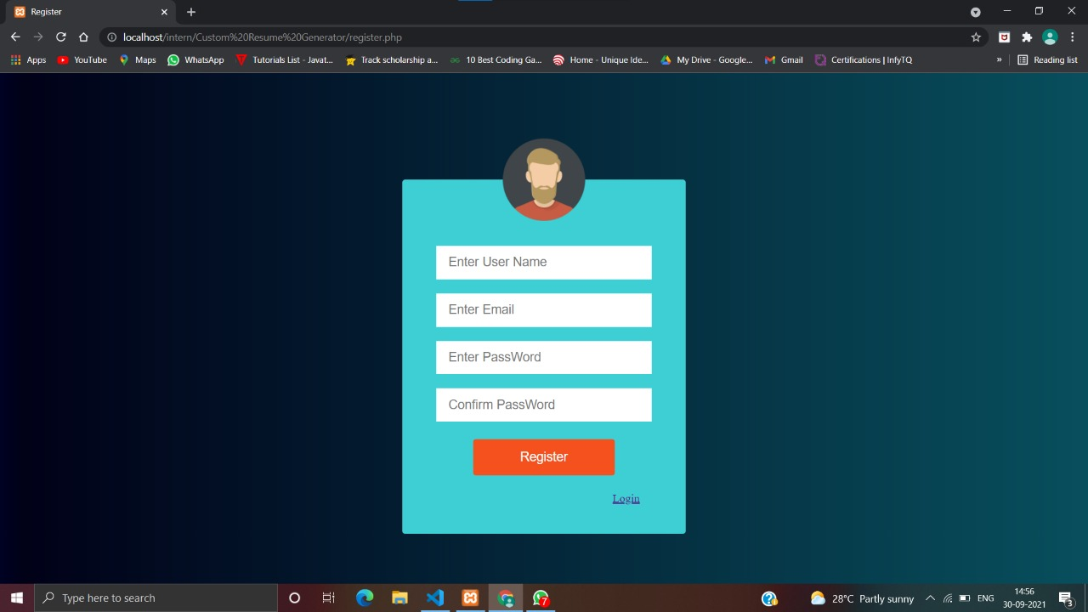

Fig 1.2:Register Page

‘Register Page’ page (Fig 1.2) allows user to register,then he/she will be redirected to Login Page(Fig 1.3)

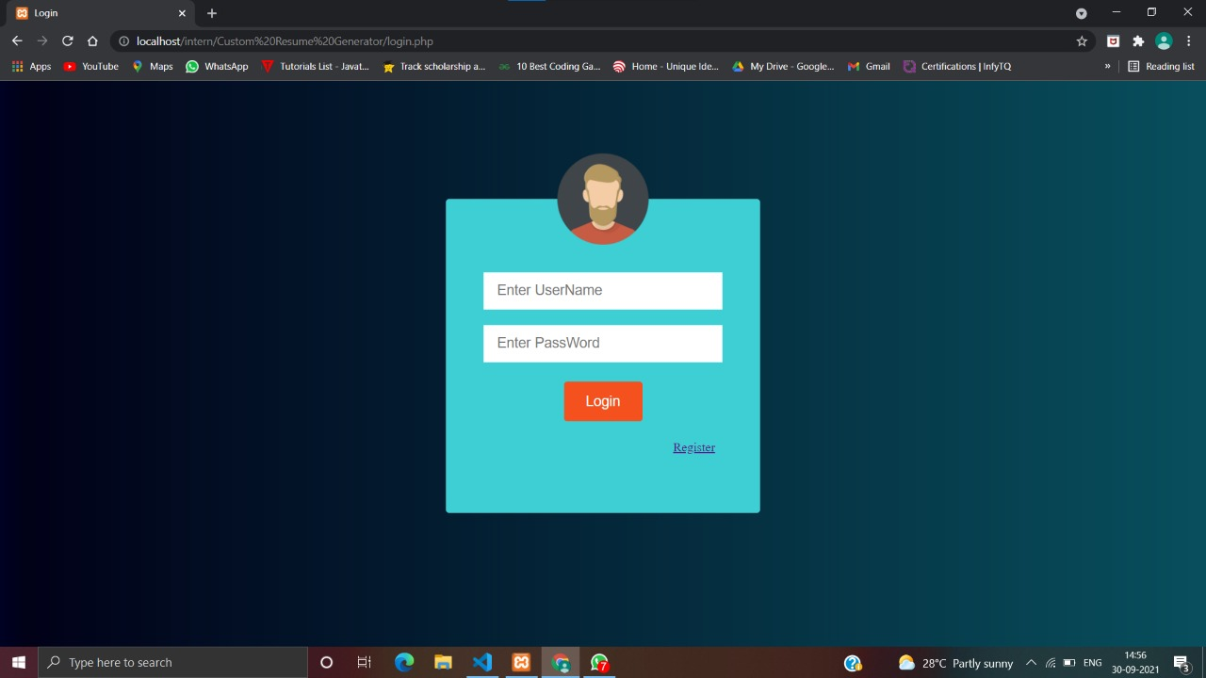

Fig 1.3:Login Page

Login page will allow the user to login after registering or if he is new user he can register using the given link

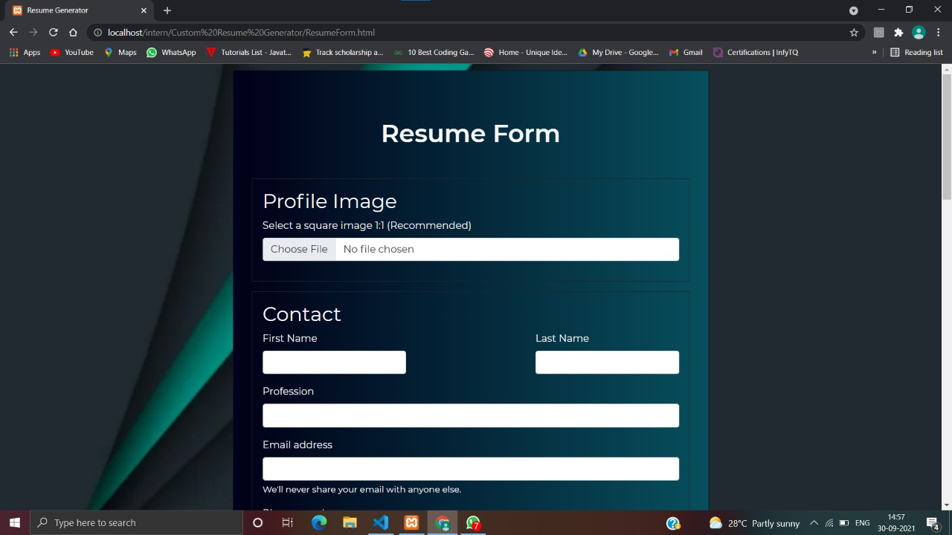

Fig 1.4:Profile page

‘Resume Form’page (Fig 1.4) allows users to enter our personal details like image,first and last name,profession etc…

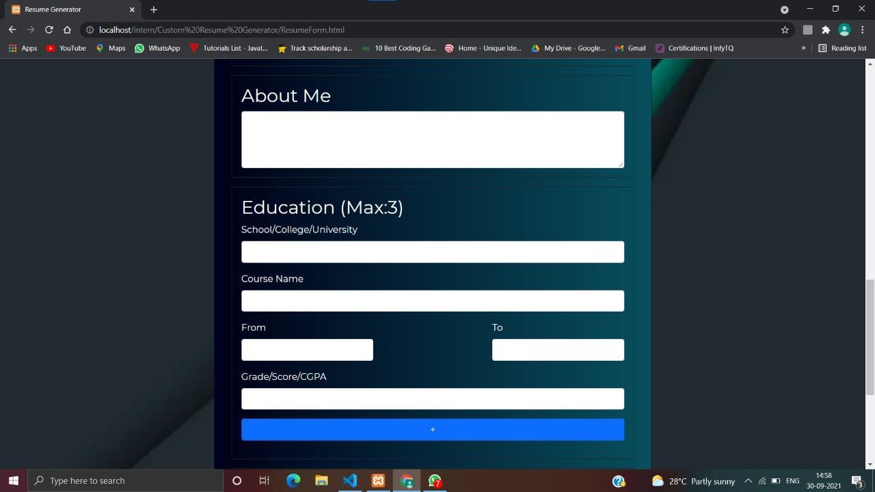

Fig 1.5:Education

When the user scroll down after entering his/her personal details there comes another page where user can enter his education details like course,grade etc….

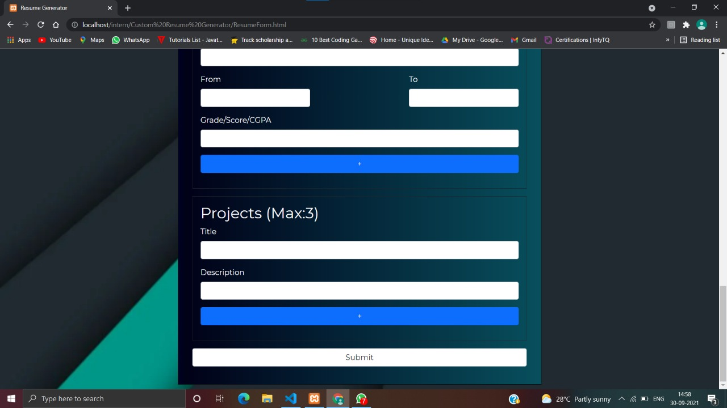

Fig 1.6:Projects

Fig 1.6 shows the page of projects where user can enter his/her project details where he/she can enter max 3 projects

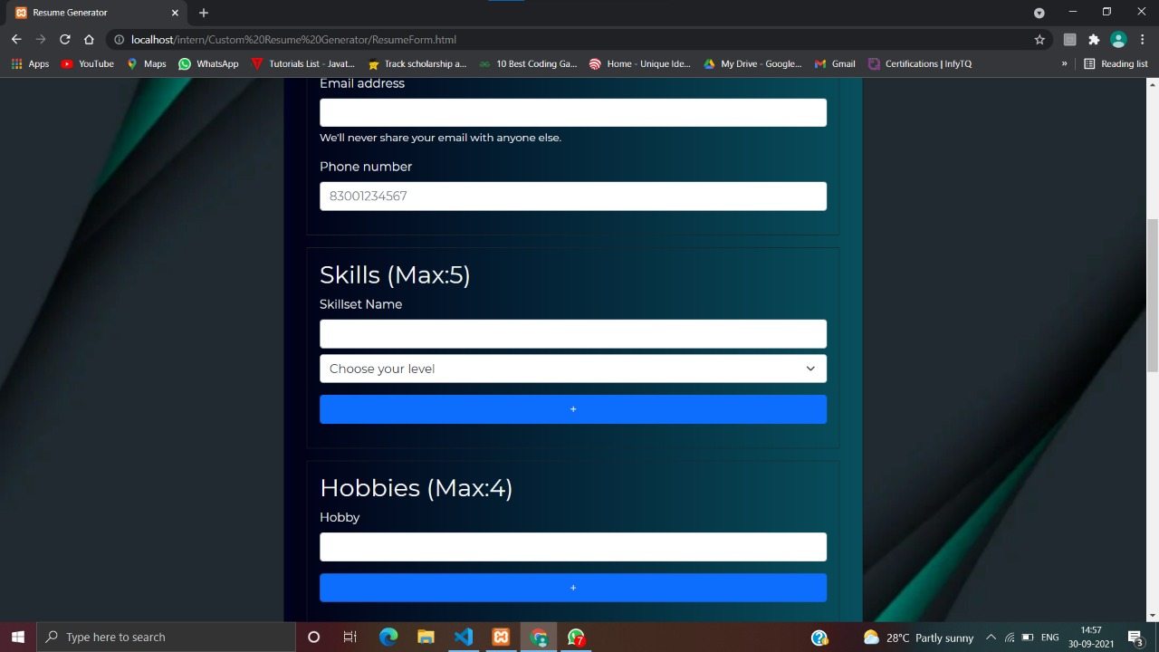

Fig 1.7:Skills & Hobbies

Here , in fig 1.7 page the user will be able to enter his/her skills(max:5) and hobbies(max:4)

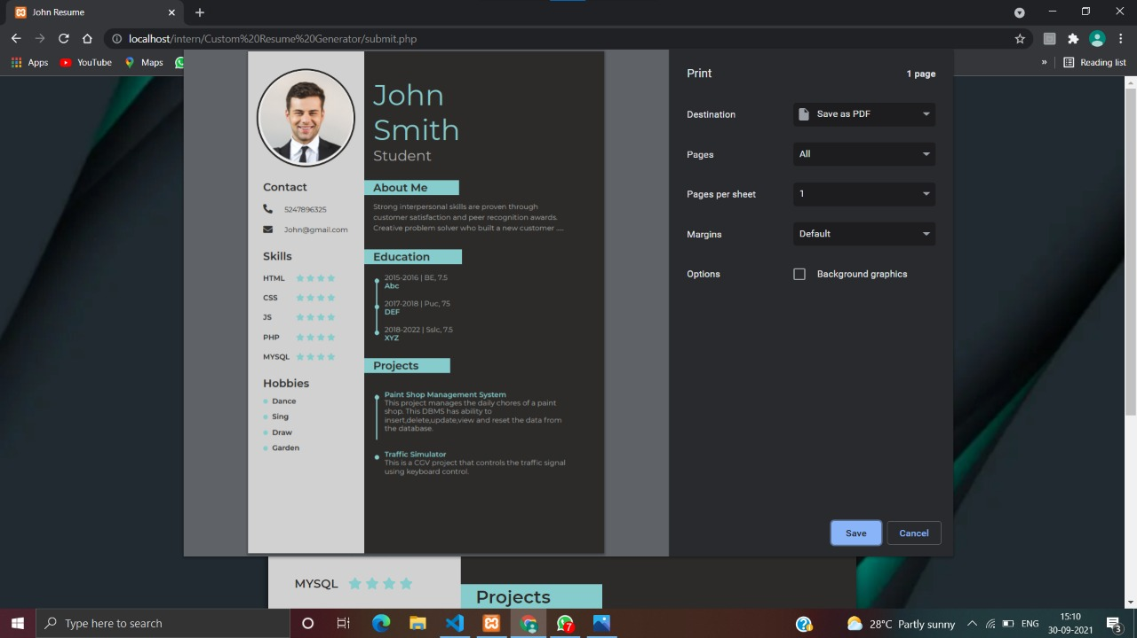

Fig 1.8:Print Window

‘Print Window’ in this the user will be able print his resume