BEYOND THE MAP

Al-Sammarraie Nooruldeen Sameer Fawzi
Dincă Alexandra-Maria
Lițescu David-Adrian
Neagu Andrei
Bucharest Academy of Economic Studies Cibernetics, Statistics and Economic Informatics Economic Informatics

In our project, we analysed the correlation between theft-related crimes and various socio-economic factors, such as population tertiary education levels, income, and population size. Our goal was to determine how these factors influenced the prevalence of theft crimes across different regions.
We collected data on crime rates related to theft, including burglary, larceny, and auto theft, and examined the educational attainment of the population, average income levels, and overall population sizes in those areas. Using statistical analysis methods, we looked for patterns and correlations to identify whether higher education, income levels, or population size were linked to increased or decreased theft rates.
Our findings reveal that the relationship between socio-economic factors and theft is more complex than it may first appear. In some regions with high education and income levels, theft rates remain elevated. This suggests that factors such as urban density, the concentration of wealth, and potentially the attractiveness of high-value targets may contribute to higher crime rates, despite favourable economic conditions. In other words, while education and income can deter crime, in densely populated or affluent areas, these benefits might be offset by increased opportunities for theft.
Overall, our project highlighted the importance of socio-economic factors in shaping crime patterns, offering valuable insights into how education and income levels can influence criminal activity. These findings could contribute to more effective crime prevention policies and social programs aimed at addressing the root causes of theft-related crimes.

Key words: Education, Income, Unemployment, Robberies, Burglaries, Migration

Chapters:
- Data Analysis
- Spatial Global and Local Analysis - Univariate
- Spatial Global and Local Analysis - Bivariate
- Conclusions

1. Data Analysis
We decided to start analysing how our variables are spatially represented using quantile maps for each variable. 5 quantiles were chosen as they provide more granularity than quartiles, and it helps us spot any spatial patterns and trends, detect possible outliers and highlight the relationships between the data and the demographic features.
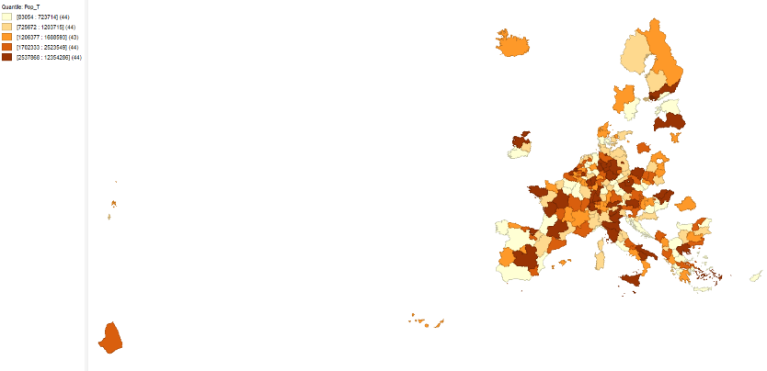
Fig. 1 – Quantile Total Population
Total population: This variable shows the total number of people within a given region. As seen in the picture, the regions which have a higher concentration of people are the metropolitan areas and the capitals of each country.

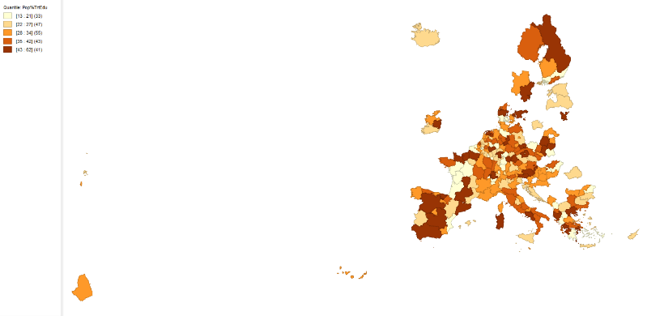
Fig. 2 – Quantile Population % that attained tertiary education
The following variable deals with the percentage of people who have completed a tertiary level of education (university, college and other equivalents). We notice that the higher values may appear either in cities or in places where the number of people is not high. As such, it’s important to assess all of the variables that will be mentioned while accounting for the number of people in a given region

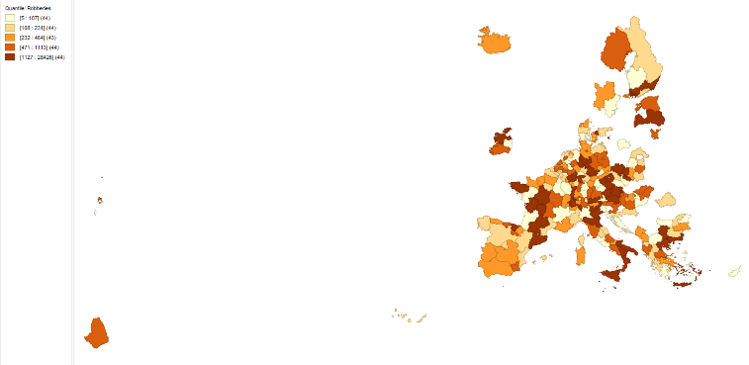
Fig. 3 – Quantile Number of Robberies

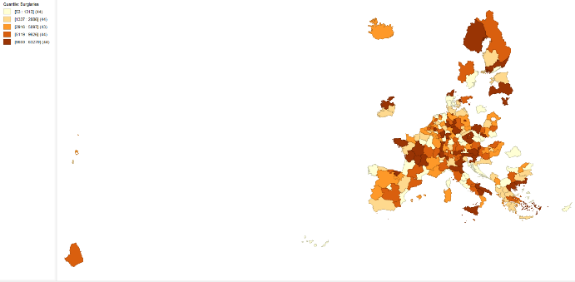
Fig. 4 – Quantile Number of Burglaries
We have decided to analyse two common offenses—robberies and burglaries—that might be influenced by regional education and income levels. In these quantile maps, overlapping hotspots indicate that both types of crimes tend to occur in similar areas. Wealthier areas possess more valuable targets and often have dense urban centres that naturally facilitate more crime opportunities. This suggests that while education plays a role, economic factors such as wealth concentration and population density are also significant drivers behind the incidence of these crimes.

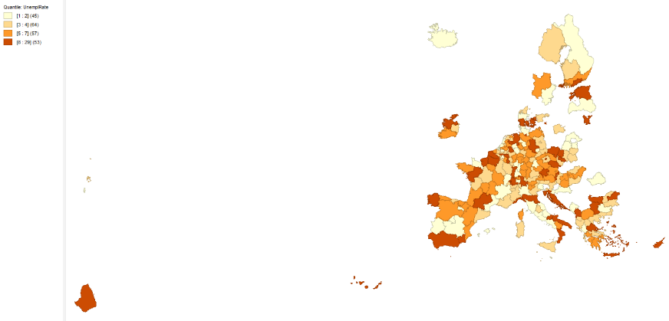
Fig. 5 – Quantile Unemployment Rate

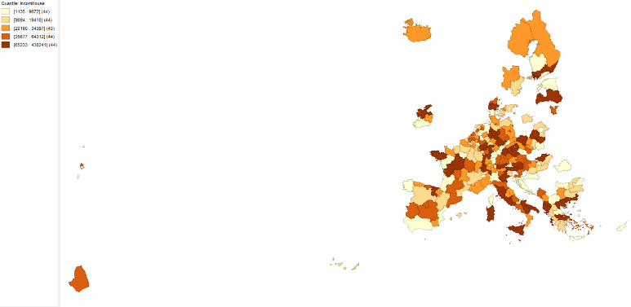
Fig. 6 – Quantile Income per Household
The unemployment rate is one of the measures used to understand both the economic situation and the quality of life that a citizen in a region experiences. As stated above, having issues finding a job may lead people to turn to a life of crime. Additionally, people prefer working higher income jobs, and those may be harder to find in an area with more individuals, and such some people may end up searching for jobs for a longer period of time.
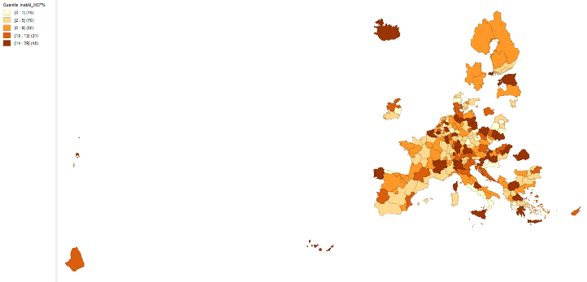
Fig. 7 - Quantile Inability to Afford a Meal with Meat, Chicken, Fish (or Vegetarian Equivalent)
This map illustrates the share of the population in each NUTS2 region that struggles to afford a meal containing meat, fish, or a vegetarian equivalent. Generally, we see clusters of an elevated inability to afford these meals in regions that face lower incomes, higher unemployment, or greater cost-of-living pressures. Overall, the map highlights pronounced socio-economic disparities across Europe, revealing how varying economic conditions and living standards can affect the basic nutritional opportunities available to different populations.

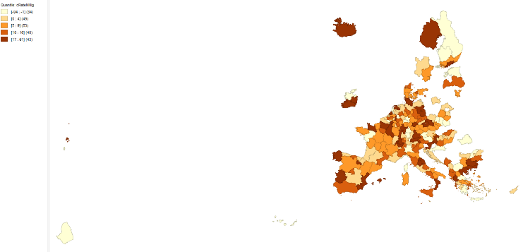
Fig. 8 – Quantile Crude Rate of Net Migration
For our dataset, the crude net migration rate offers insights into regional attractiveness and economic dynamics. Regions with a positive rate likely draw new residents thanks to better job prospects, higher living standards, or more dynamic economic conditions. In contrast, areas with a negative rate may be experiencing economic stagnation or quality-of-life issues that prompt residents to leave.

2. Spatial Global and Local Analysis – Univariate
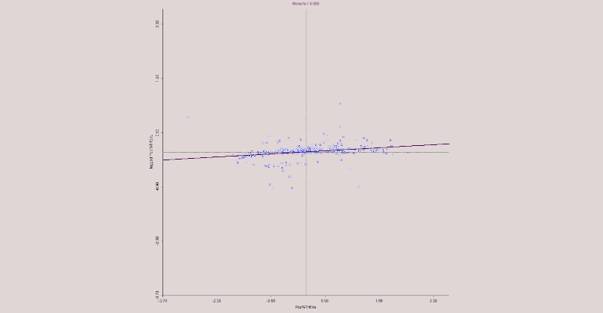
Fig. 9 - Moran’s I for Population % that attained Tertiary Education

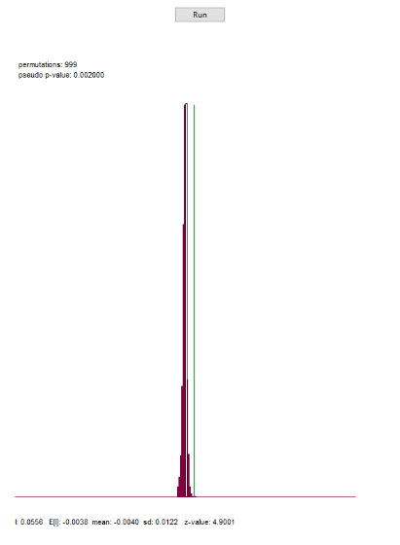
Fig. 10 – Permutation Test (999 perms.) for Population % that attained Tertiary Education
We have a significant (p-value = 0.002 < 0.05) low positive spatial autocorrelation (Moran’s I = 0.056), which shows similarities between the regions of the EU. If a region has a high percentage of population that attained tertiary education, then its neighbouring regions will also have a high percentage of population that attained tertiary education and vice versa.

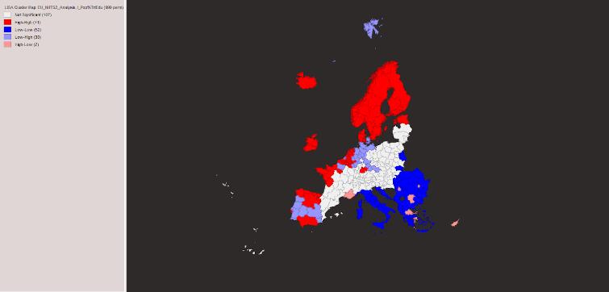
Fig. 11 – LISA Cluster Map Population % that attained Tertiary Education
We identify that most of the regions fall into the High-High category . This means that if a region has a high percentage of population that attained tertiary education, its neighbouring regions also have a high percentage of population that attained tertiary education, suggesting spatial spillover. In other words, areas with a high percentage of the population that attained tertiary education tend to cluster together.
The next group of regions is Low-Low. This pattern suggests the presence of spatial spillover as well, where certain regions are characterized by a low percentage of population that attained tertiary education and their neighbours also have a low percentage of population that attained tertiary education. This means that areas with a low percentage of the population that attained tertiary education tend to cluster together.
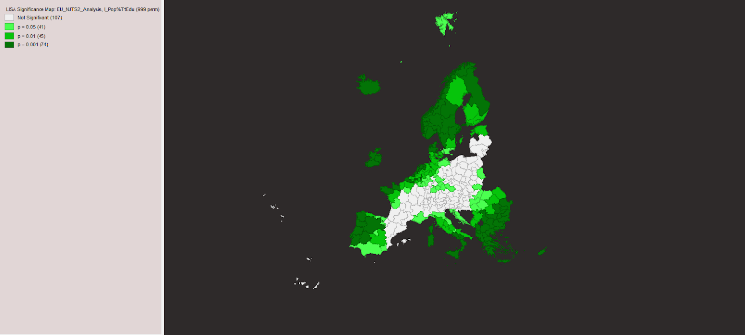
Fig. 12 – Significance Map Population % that attained Tertiary Education
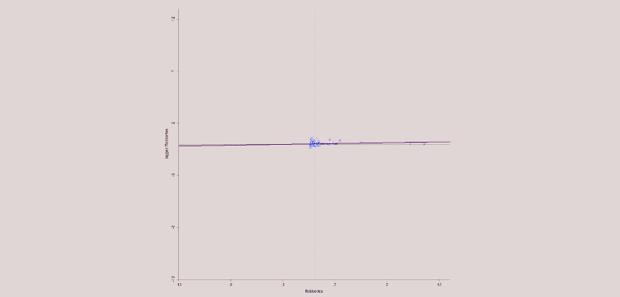
Fig. 13 - Moran’s I for Number of Robberies

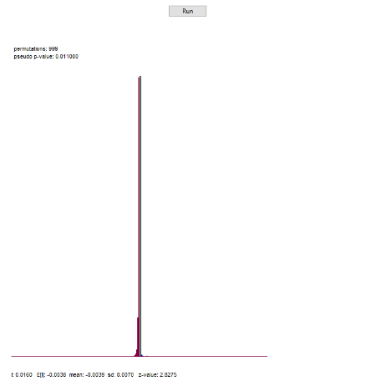
Fig. 14 – Permutation Test (999 perms.) for Number of Robberies
We have a significant (p-value = 0.011 < 0.05) low positive spatial autocorrelation (Moran’s I = 0.016), which shows similarities between the regions of the EU. If a region has a high number of robberies then its neighbouring regions will also have a high number of robberies and vice versa.

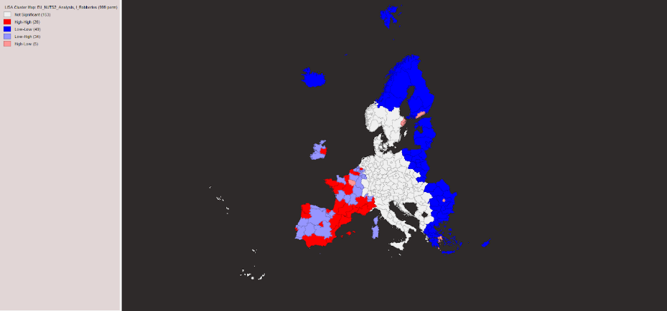
Fig. 15 – LISA Cluster Map for Number of Robberies
From local spatial autocorrelation, we identify that most of the regions fall into the Low-Low category (49 regions). This means that if a region has a low number of robberies, its neighbouring regions also tend to have a low number of robberies, suggesting the presence of spatial spillover. In other words, areas with a low number of robberies tend to cluster together.
The next group of regions is Low-High (34 regions). This pattern suggests the presence of spatial disparities, where certain regions are characterized by a low number of robberies and their neighbours have a high number of robberies.
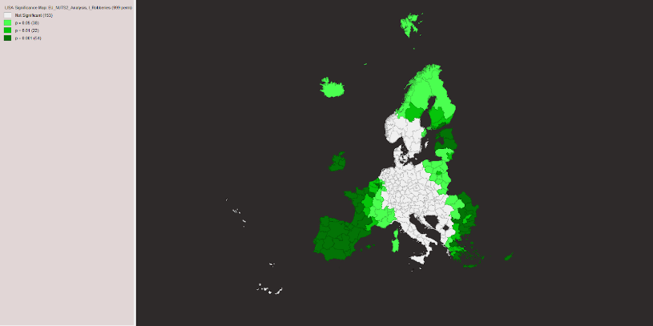
Fig. 16 – Significance Map for Number of Robberies

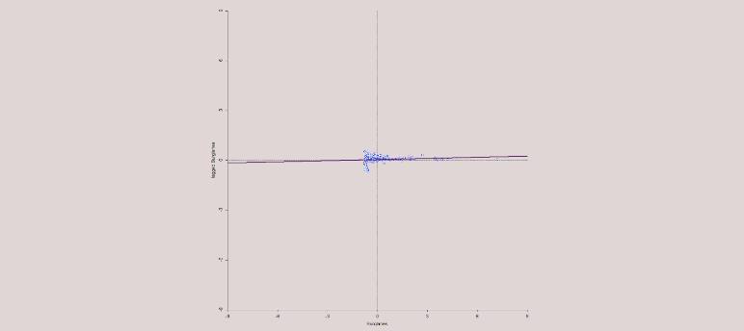
Fig. 17 – Moran’s I for Number of Burglaries
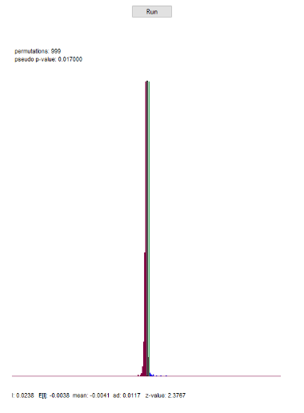
Fig. 18 – Permutation Test (999 perms.) for Number of Burglaries
We have a significant (p-value = 0.017 < 0.05) low positive spatial autocorrelation (Moran’s I = 0.024), which shows similarities between the regions of the EU. If a region has a high number of burglaries then its neighbouring regions will also have a high number of burglaries and vice versa.
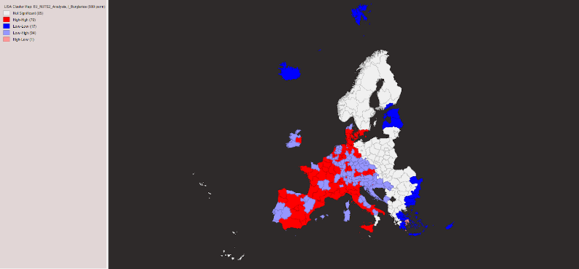
Fig. 19 – LISA Cluster Map for Number of Burglaries
From local spatial autocorrelation, we identify that most of the regions fall into the Low-High category. This means that if a region has a low number of burglaries, its neighbouring regions tend to have a high number of burglaries, suggesting spatial disparities.
The next group of regions is High-High. This pattern suggests the presence of spatial spillover, where certain regions are characterized by a high number of burglaries and their neighbours also have a high number of burglaries. In other words, areas with a high number of burglaries tend to cluster together.

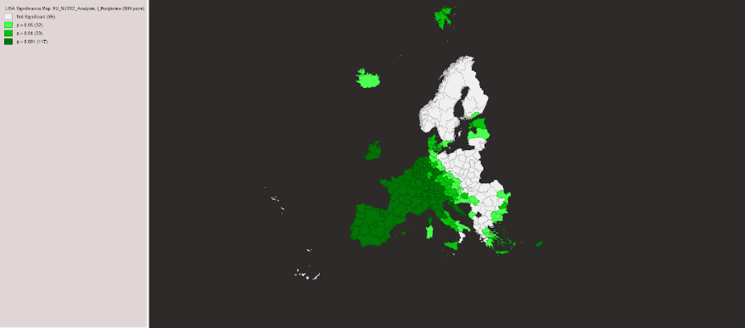
Fig. 20 – Significance Map for Number of Burglaries

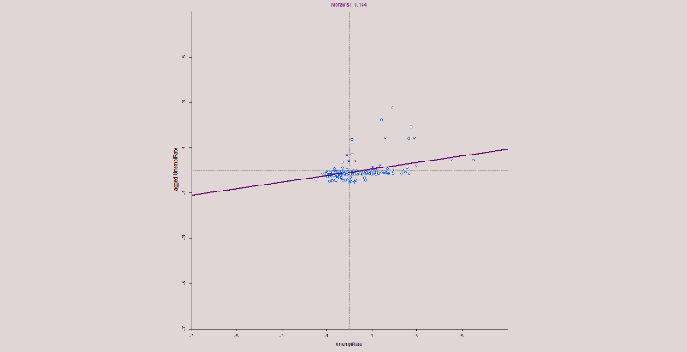
Fig. 21 – Moran’s I for Unemployment Rate
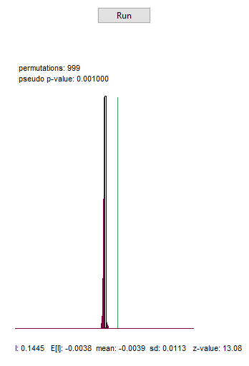
Fig. 22 – Permutation Test (999 perms.) for Unemployment Rate
We have a significant (p-value = 0.001 < 0.05) low positive spatial autocorrelation (Moran’s I = 0.144), which shows similarities between the regions of the EU. If a region has a high unemployment rate then its neighbouring regions will also have a high unemployment rate and vice versa.
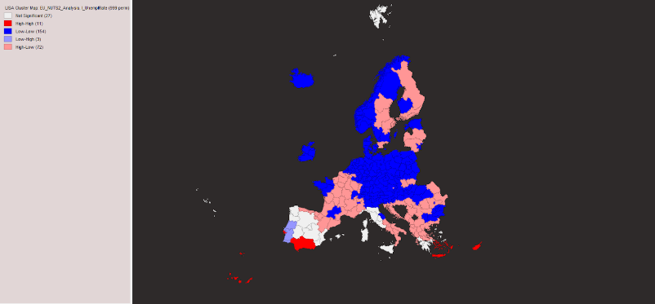
Fig. 23 – LISA Cluster Map for Unemployment Rate
From local spatial autocorrelation, we identify that most of the regions fall into the Low-Low category (154 regions). This means that if a region has a low rate of unemployment, its neighbouring regions tend to also have a low rate of unemployment, suggesting the presence of spatial spillover. In other words, areas with low unemployment rates tend to cluster together.
The next group of regions is High-Low (72 regions). This pattern suggests the presence of spatial disparities, where certain regions are characterized by a high unemployment rate and their neighbours have a low unemployment rate.
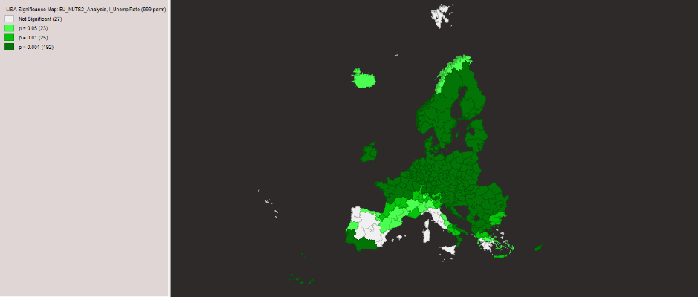
Fig. 24 – Significance Map for Unemployment Rate

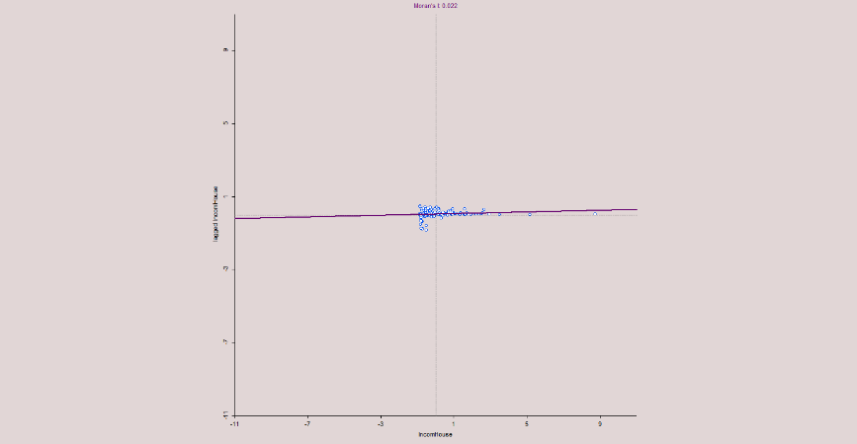
Fig. 25 – Moran’s I for Income per Household
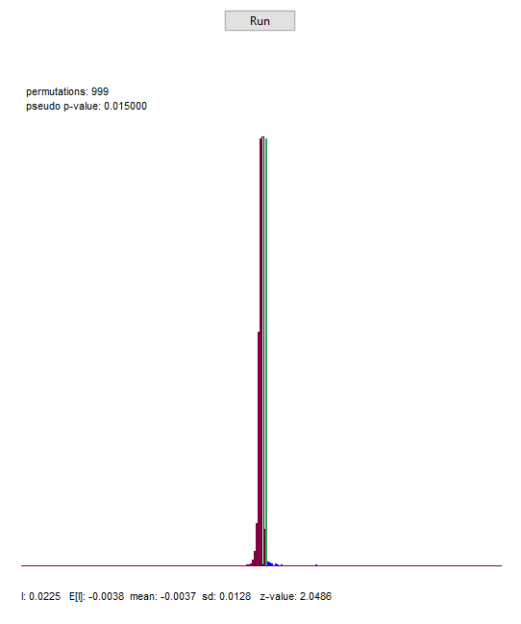
Fig. 26 – Permutation Test (999 perms.) for Income per Household
We have a significant (p-value = 0.015 < 0.05) low positive spatial autocorrelation (Moran’s I = 0.022), which shows similarities between the regions of the EU. If a region has a high income of households then its neighbouring regions will also have a high income of households and vice versa.
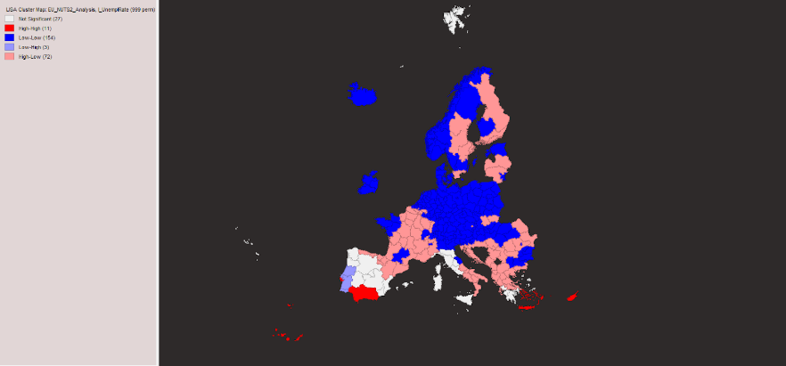
Fig. 27 – LISA Cluster Map for Income per Household
From local spatial autocorrelation, we identify that most of the regions fall into the Low-Low category (154 regions). This means that if a region has a low rate of unemployment, its neighbouring regions tend to also have a low rate of unemployment, suggesting the presence of spatial spillover. In other words, areas with low unemployment rates tend to cluster together.
The next group of regions is High-Low (72 regions). This pattern suggests the presence of spatial disparities, where certain regions are characterized by a high unemployment rate and their neighbours have a low unemployment rate.
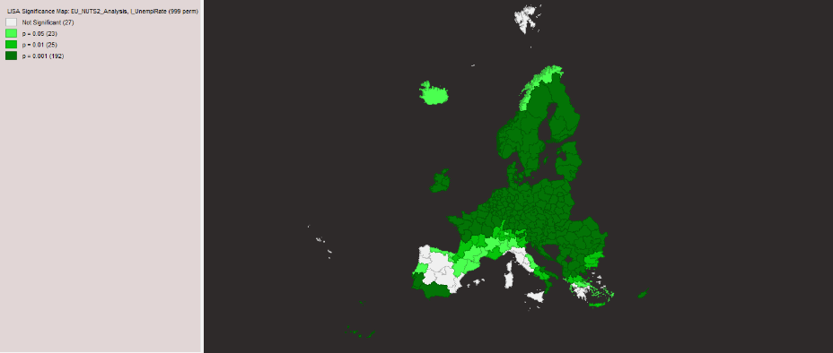
Fig. 28 – Significance Map for Income per Household
3. Spatial Global and Local Analysis – Bivariate
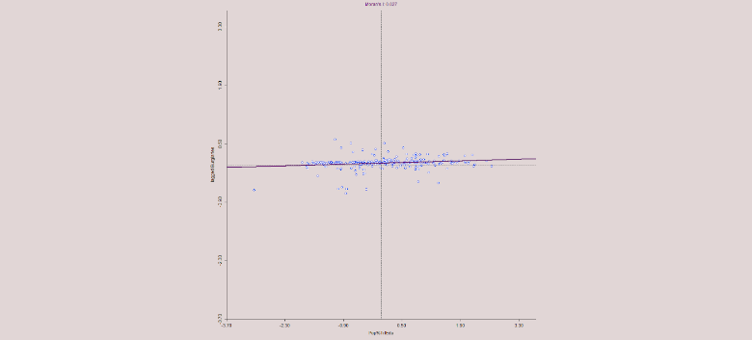
Fig. 29 – Moran’s I for Population % that attained Tertiary Education and Number of Burglaries
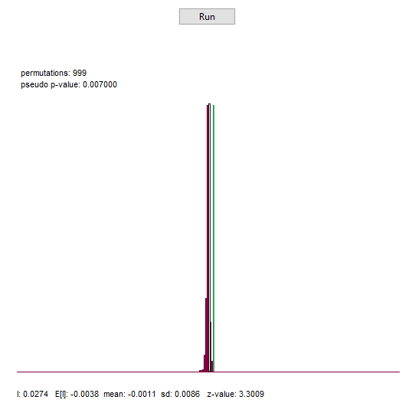
Fig. 30 – Permutation Test for Population % that attained Tertiary Education and Number of Burglaries
We have a significant (p-value = 0.007 < 0.05) low positive spatial autocorrelation (Moran’s I = 0.027) between the percentage of the population that attained tertiary education and the number of burglaries. If a region has a high percentage of the population that attained tertiary education then its neighbouring regions will have a high number of burglaries and vice versa.
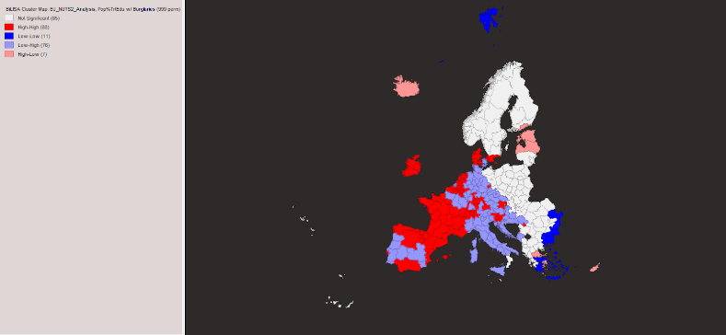
Fig. 31 – LISA Cluster Map for Population % that attained Tertiary Education and Number of Burglaries
From local spatial autocorrelation, we identify that most of the regions fall into the High-High category (88 regions). This means that if a region has a high percentage of the population that completed tertiary education, its neighbouring regions tend to have a high number of burglaries. This pattern could reflect the presence of spatial spillover. This clustering may reflect broader urban and economic dynamics rather than a direct link between education and crime.
The next group of regions is Low-High (76 regions). This pattern suggests the presence of spatial disparities, where certain regions are characterized by a low percentage of the population that completed tertiary education and their neighbours have a high number of burglaries.
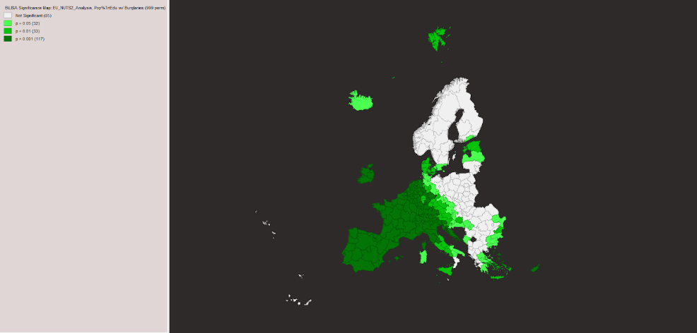
Fig. 32 – Significance Map for Population % that attained Tertiary Education and Number of Burglaries

Analogous, for Population % that attained Tertiary Education and Number of Robberies.

Table 1
In this spreadsheet, we have the data that we collected and did an analysis on how the education level, the employment status and the income of people in a region can affect the crimes that occur in that region, focusing on theft-related crimes.
The column variables are the following:
CNTR_CODE – Country Code; NUTS2_ID - ID of the NUTS2 region; NUTS2_Name – Name of the NUTS2 Region; Pop_T – Total Population of Each Region; Pop%TrtEdu – Percentage Rate of Population that Attained Tertiary Education; Robberies – Number of Robberies; Burglaries - Number of Burglaries; UnemplRate – Unemployment Rate; IncomeHouse – Income per Household; InabMealMCF% - Inability to Afford a Meal with Meat, Chicken, Fish (or Vegetarian Equivalent); cRateNMig – Crude Rate of Net Migration

Bibliography (All data was collected from the year 2022):
Total population on 1 January by NUTS2 region: https://doi.org/10.2908/DEMO_R_D2JAN
Population by educational attainment level & NUTS 2 region (%): https://doi.org/10.2908/EDAT_LFSE_04
Police-recorded offences by NUTS 2 region (robberies & burglaries): https://doi.org/10.2908/CRIM_GEN_REG
Unemployment rate by NUTS2 region: https://doi.org/10.2908/TGS00010
Income of households by NUTS 2 region (balance): https://doi.org/10.2908/NAMA_10R_2HHINC
Inability to afford a meal with meat, chicken, fish (or vegetarian equivalent) every second day by NUTS region: https://doi.org/10.2908/ILC_MDES03_R
Crude Rate of Net Migration: https://doi.org/10.2908/TGS00099

