Bucharest University of Economic Studies
Faculty of Cybernetics, Statistics and Economic Informatics
Internship Project
Website Design and Front-End Development in WordPress Including Logo Creation
Academic coordinator: Ilie-Nemedi Iulian
Student: Al Sammarraie Nooruldeen Sameer Fawzi

Table of Contents
- Introduction
- 1. General Presentation of the Organization
- 2. Technologies Used During the Internship
- 3. Project Activities and Timeline
- 4. Website Design and Front-End Development in WordPress
- 5. Challenges and Solutions
- 6. Final Testing and Deployment
- Conclusions
- Bibliography
- List of Figures

Introduction
During my internship at the Informality Data Research Lab (IDRL), part of INCSMPS, I was responsible for the complete design and front-end development of the lab’s official website (https://informality.ro), integrating my own visual concepts into WordPress and crafting a custom logo to reinforce the brand identity. My role spanned wireframing and prototyping, setting up site infrastructure, delivering a cohesive brand look and feel, customizing the CMS, and coding the responsive user interface. I used Figma to develop all design assets from the logo to page mockups and then brought these assets to life within WordPress. By the end of the project, the site was successfully launched in a team-wide conference, showcasing a seamless blend of creative design and technical execution.
This internship allowed me to apply theoretical knowledge in a real-world project, gain practical experience with CMS tools, and understand the process of launching a functional and optimized website from start to finish.

1. General Presentation of the Organization
The Informality Data Research Lab (IDRL) is a research initiative under the National Scientific Research Institute for Labour and Social Protection (INCSMPS). Established in 2024, the lab focuses on analyzing informal employment and vulnerable labor groups to support evidence-based policymaking. IDRL collaborates with academic institutions, public authorities, and NGOs, and maintains a commitment to transparency and public engagement through its online presence. To support transparency and public engagement, IDRL launched an official website that presents its mission, research areas, ongoing projects, and events. The platform plays a key role in ensuring access to information, increasing institutional visibility, and promoting dialogue around labour market informality.

2. Technologies Used During the Internship
- Figma: For wireframing, prototyping, and creating high-fidelity designs including the site layout, logo, and certificate templates.
- WordPress: As the content management system to implement all designs, configure themes, and manage site content.
- HTML5 & CSS3: For custom front-end styling and responsive layout adjustments beyond the theme defaults.
- JavaScript (vanilla): To enhance interactive elements and ensure dynamic behavior on the client side.
- Browser Developer Tools: To debug layout issues, test responsiveness, and refine performance.
- Git: For version control of custom code snippets and style sheets.

3. Project Activities and Timeline
- Wireframing and Prototyping: Developing interactive mockups in Figma to align on layout and user flow.
- Setting Up Site Infrastructure: Installing WordPress on staging; configuring theme and initial plugins.
- Creating the Brand Identity: Designing the logo, selecting typography, and defining a color scheme.
- Content Management System Customization: Tailoring menus, page templates, and custom fields.
- User Experience (UX) & User Interface (UI): Applying design system components for consistency and accessibility.
- Front-End Development: Translating Figma designs into HTML, CSS, and JS within WordPress theme files.
- Regular Updates and Maintenance: Iterating on design tweaks, content updates, and plugin patches.

4. Website Design and Front-End Development in WordPress
- Logo and identity
- Home Page: Featured a hero banner, key research highlights, and quick links.
- About Us: Showcased the lab’s mission, team biographies, and timeline.
- Research Areas: Interactive cards outlining each focus topic.
- Projects & Publications: Custom templates for project case studies and publication lists.
- Events & Workshops: Calendar integration and responsive event cards.
- Contact Page: Embedded form and Google Maps section.
- Certifications for lab members

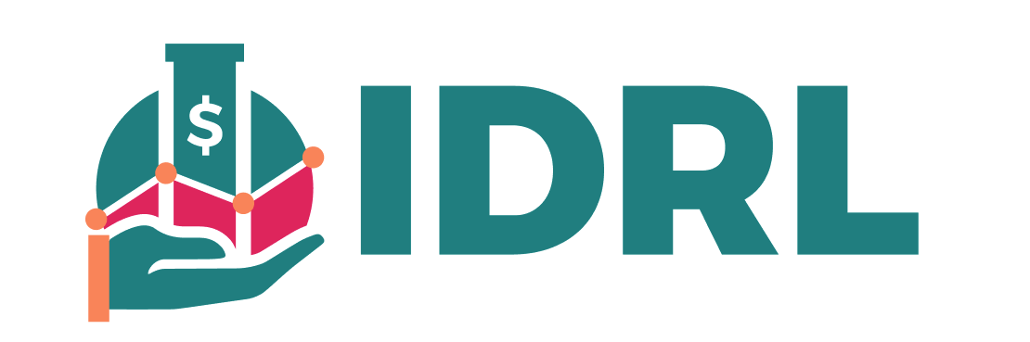
Figure 1

Figure 2

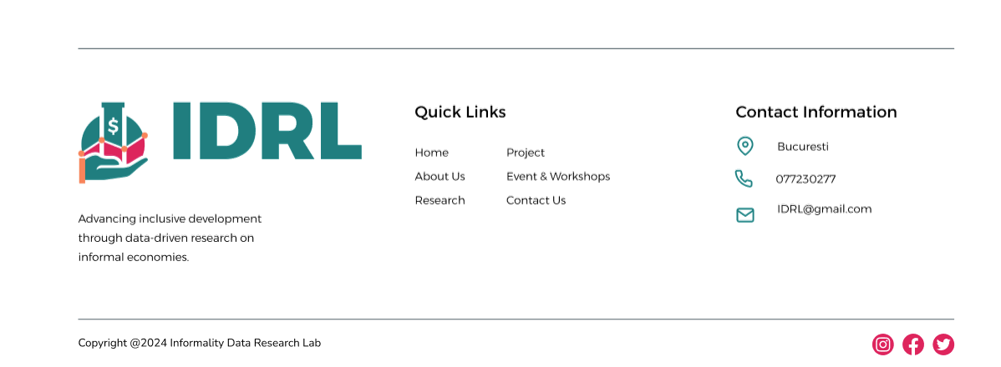
Figure 3

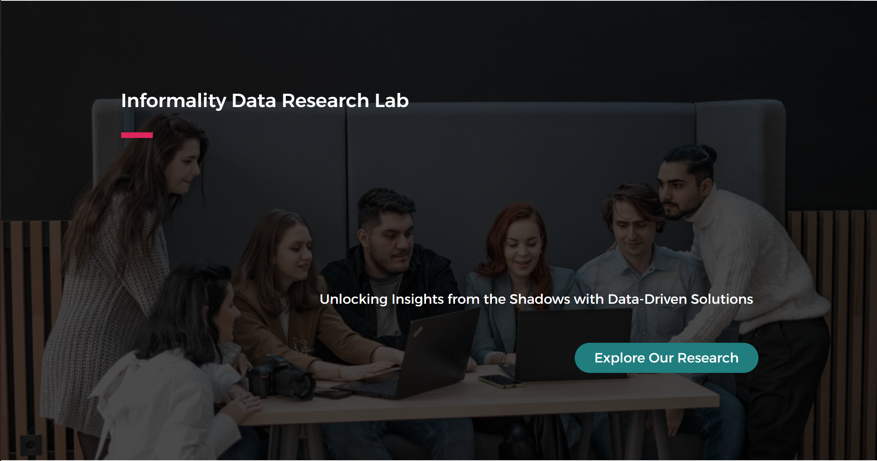
Figure 4

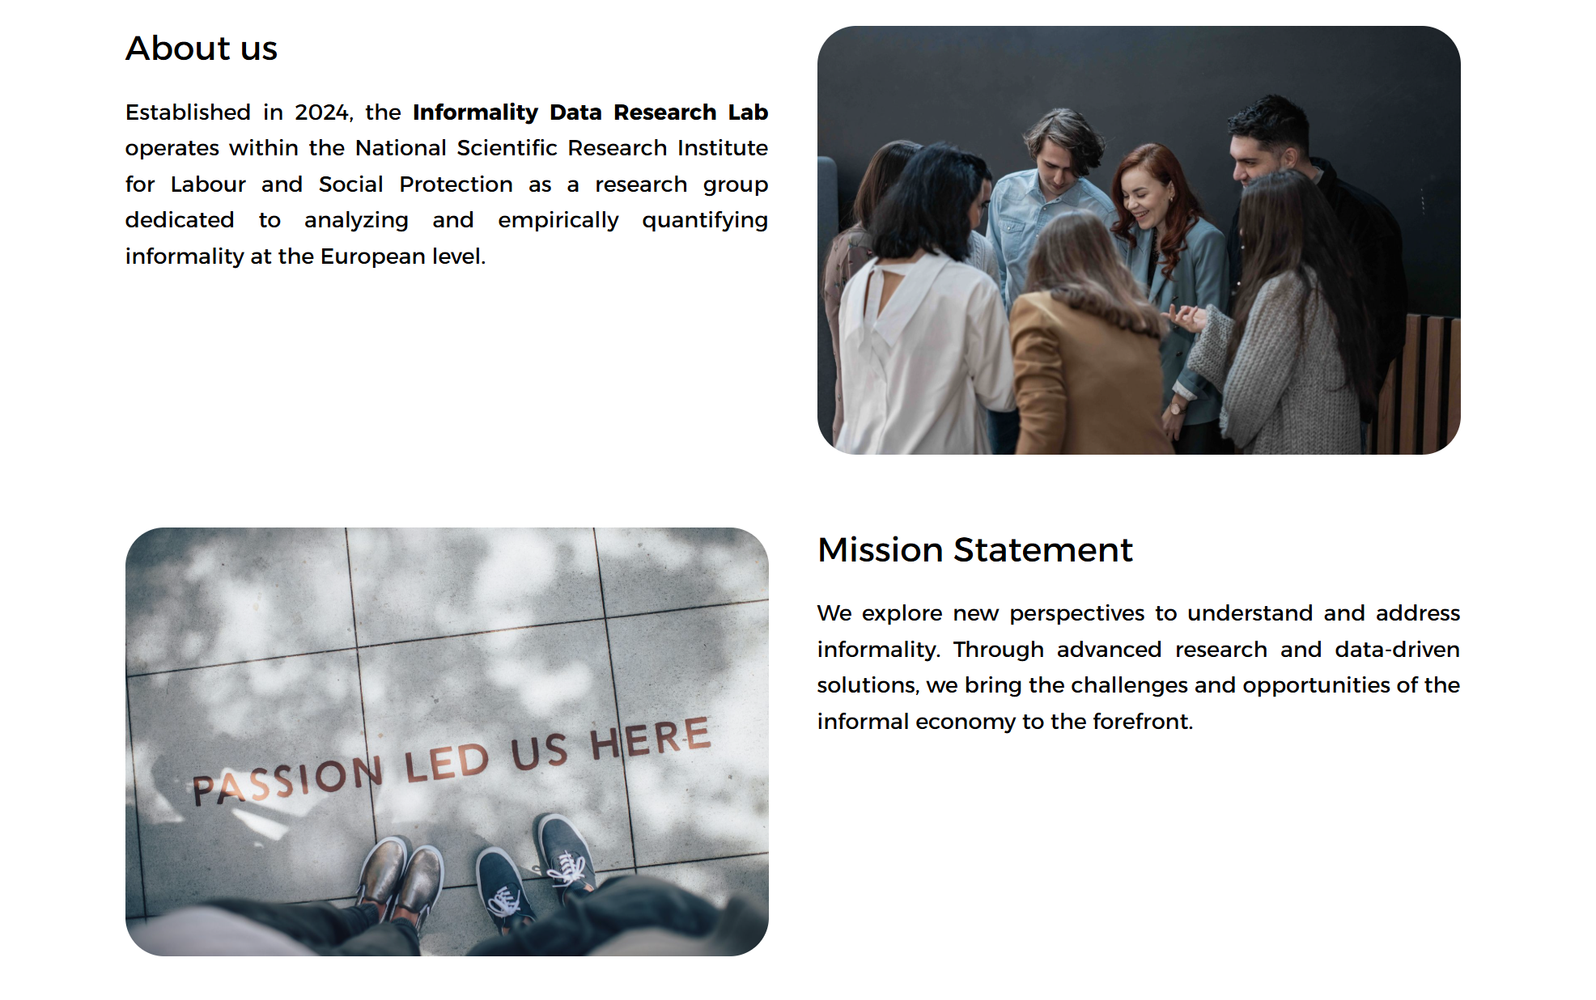
Figure 5

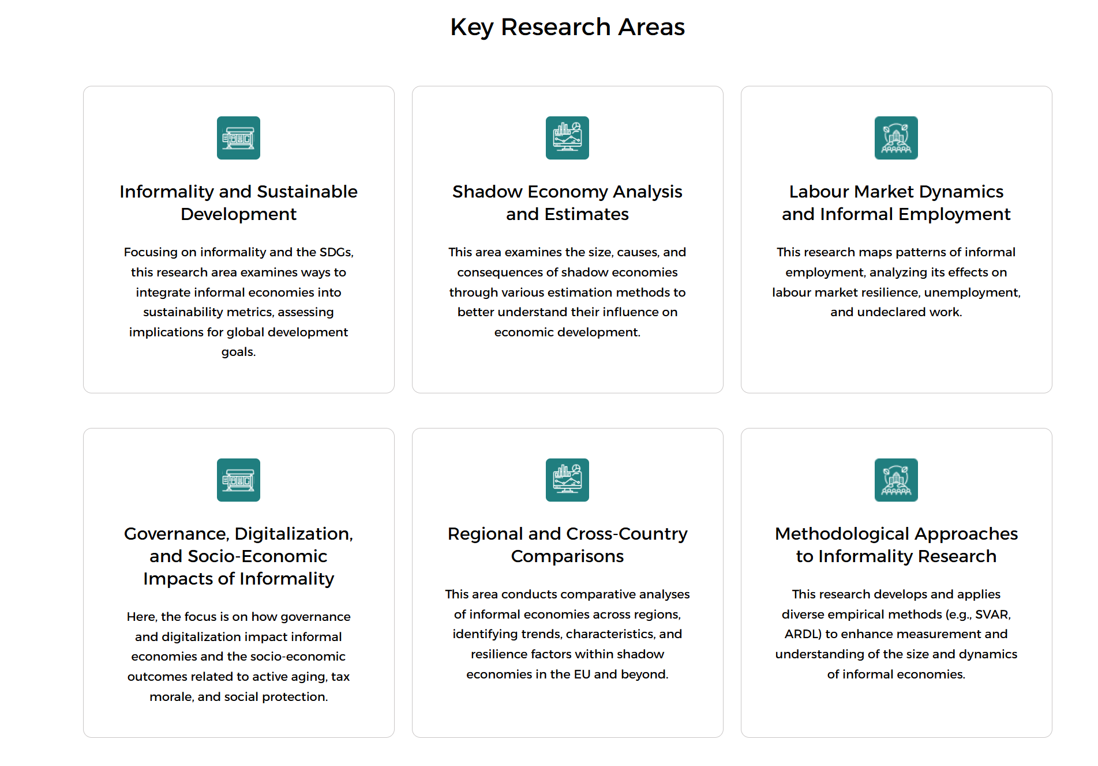
Figure 6
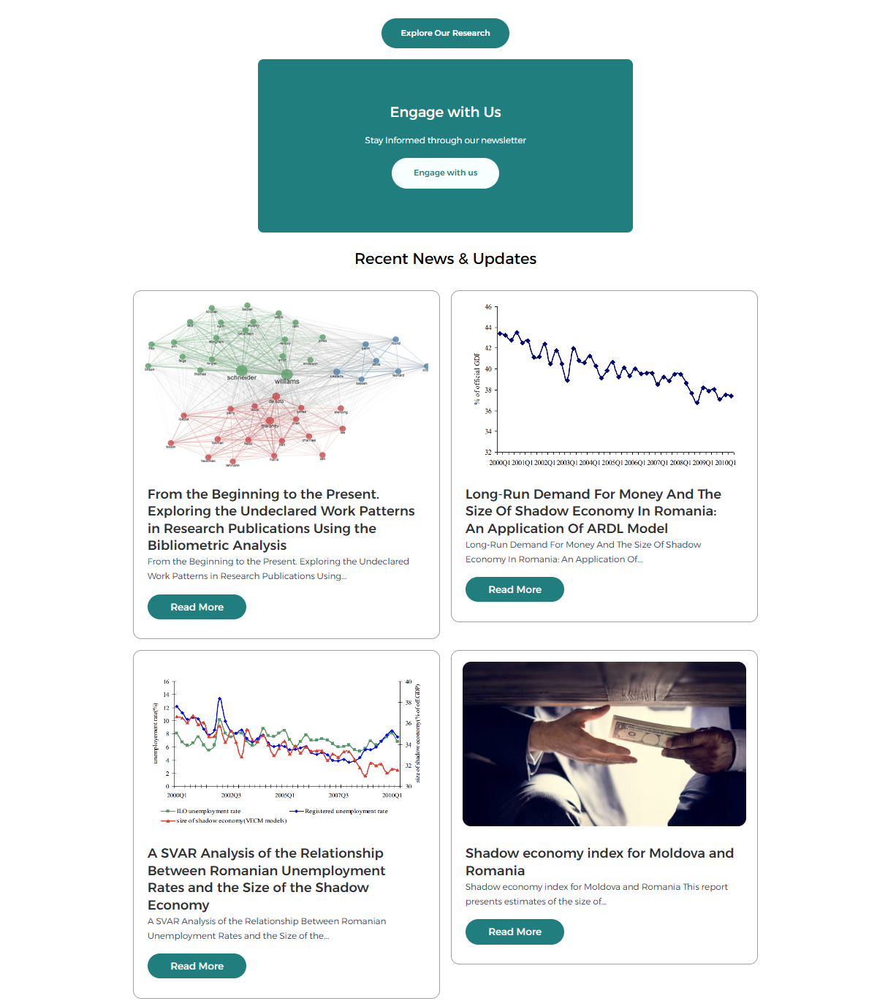
Figure 7
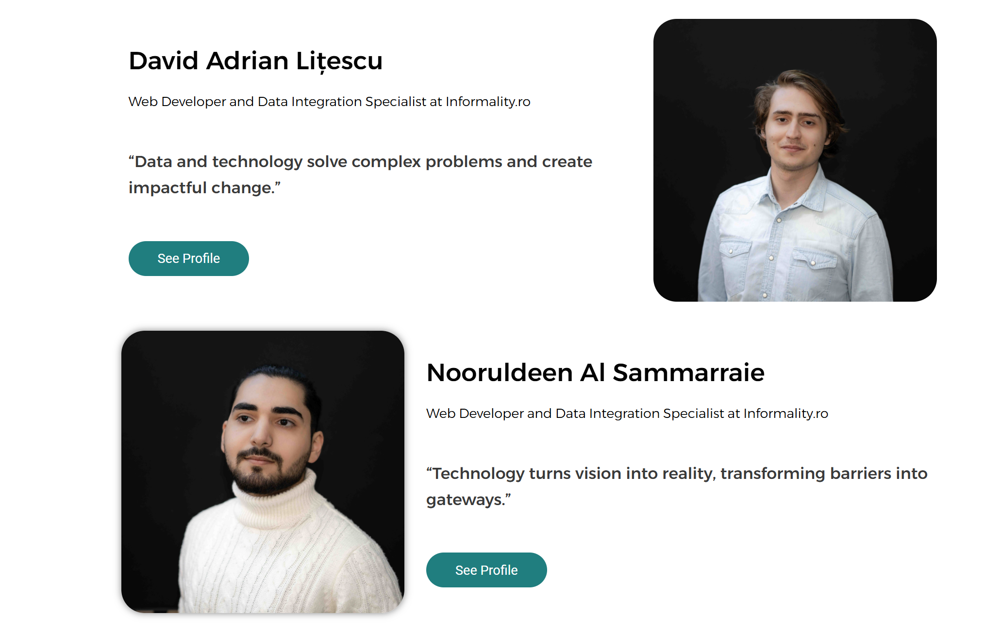
Figure 8

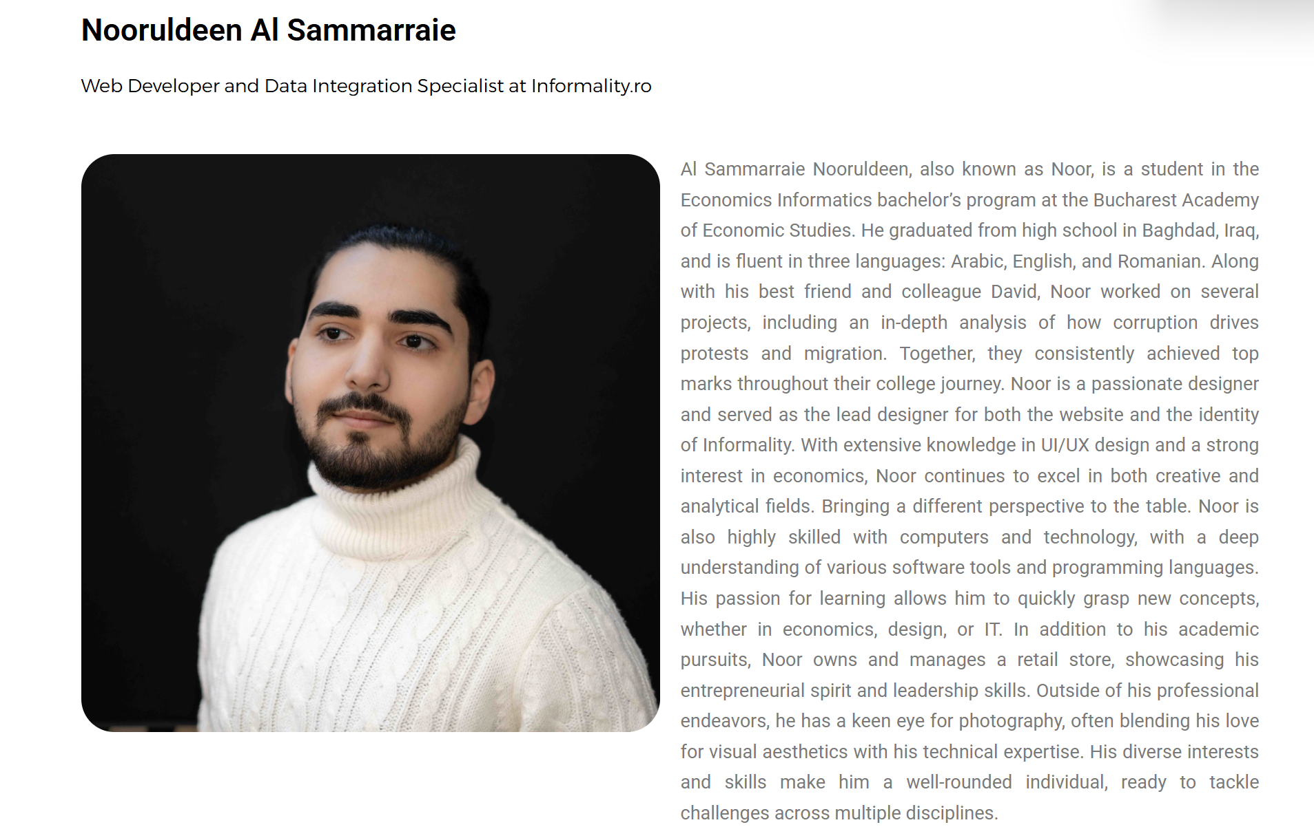
Figure 9

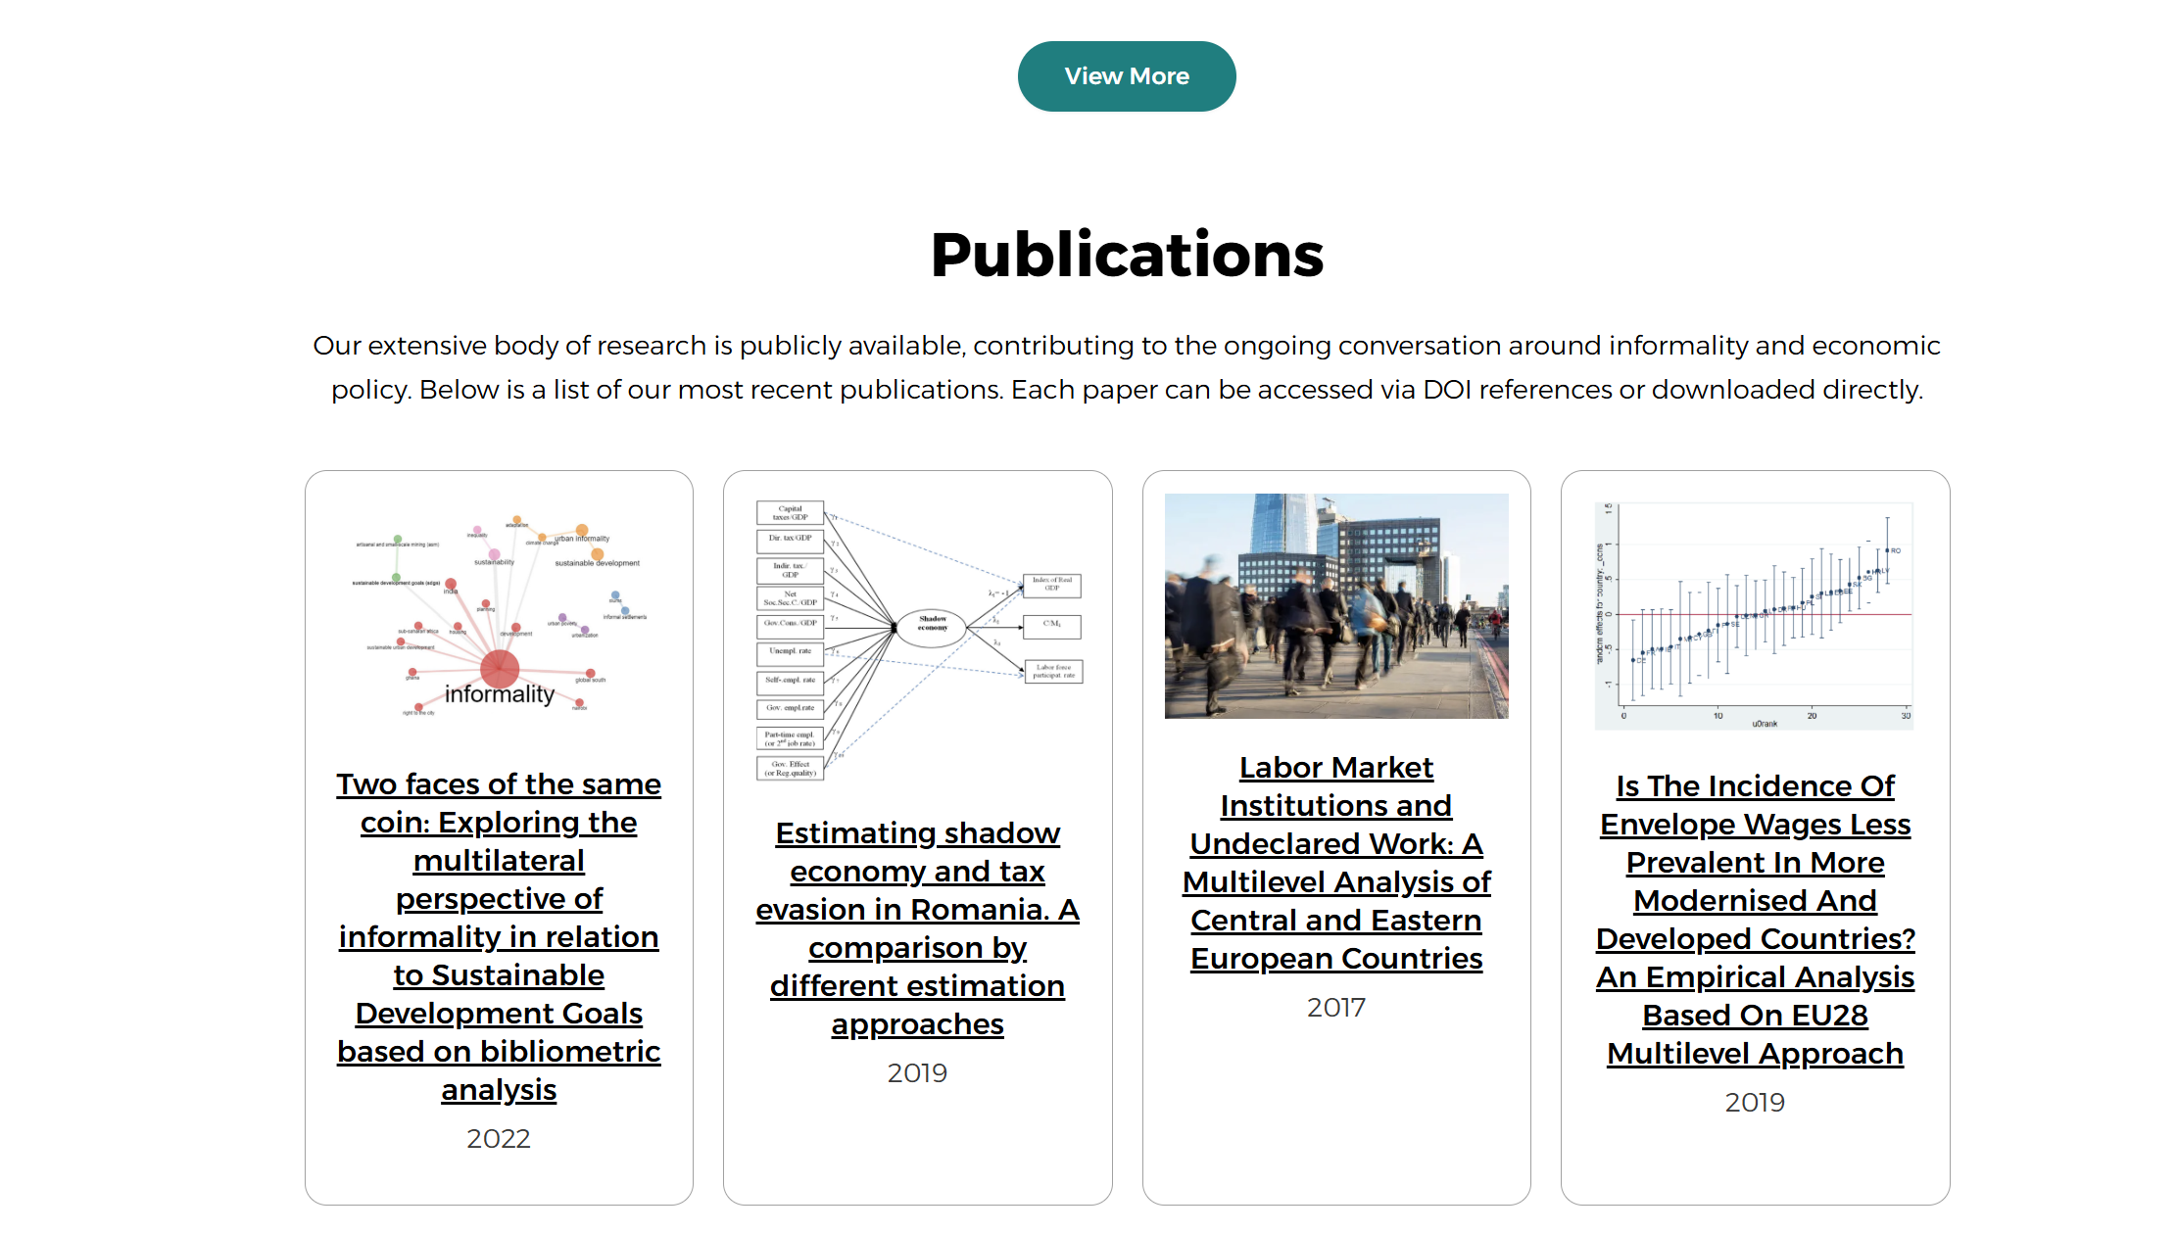
Figure 10

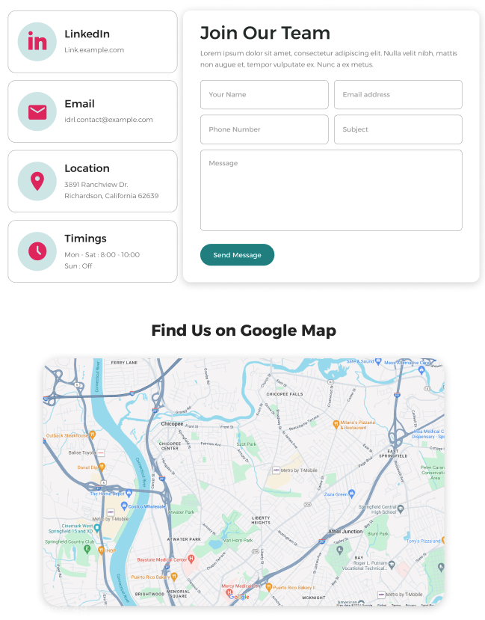
Figure 11

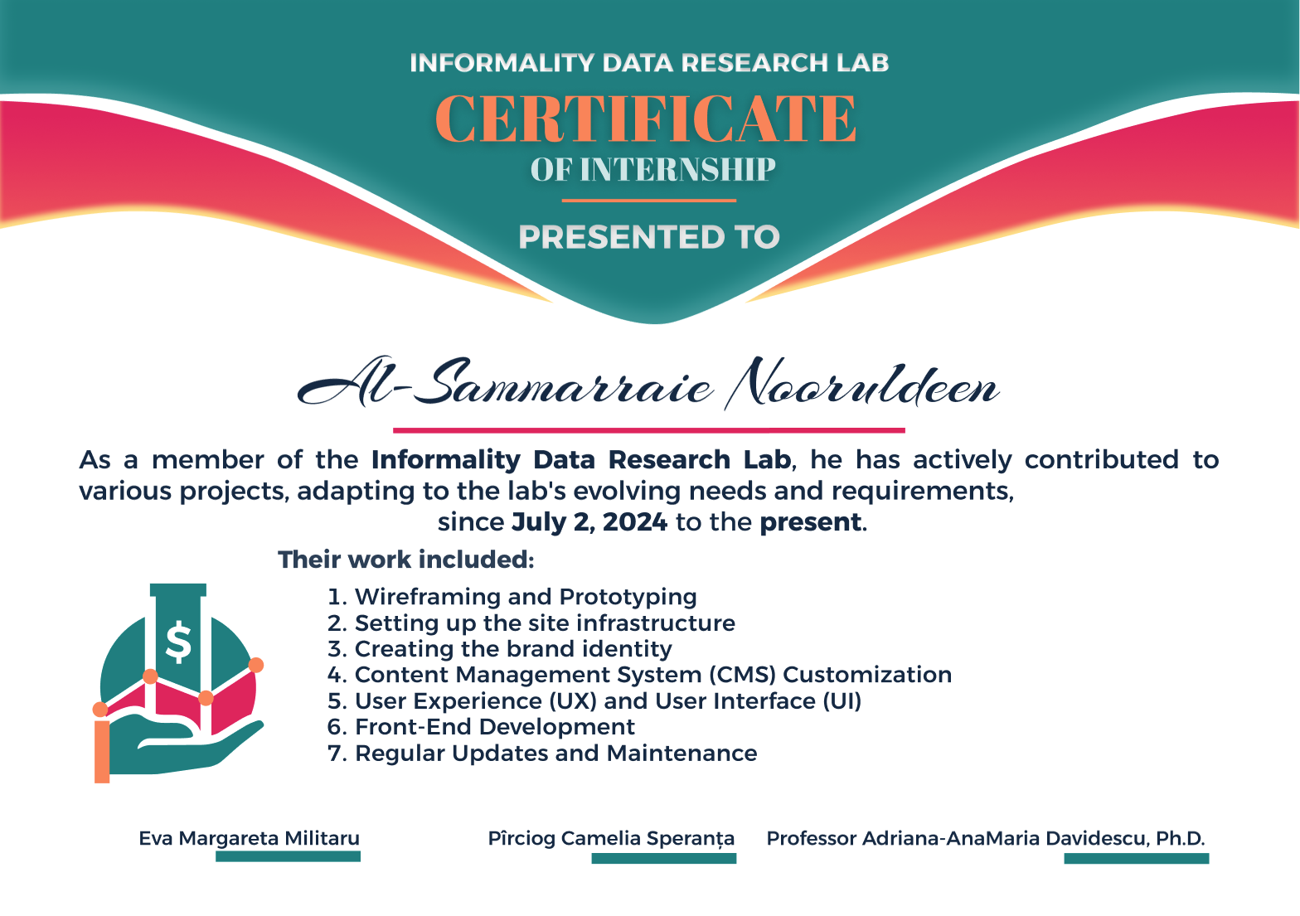
Figure 12

5. Challenges and Solutions
- Creative Alignment: Iterating on visual concepts to match stakeholder feedback addressed by scheduling daily design reviews in Figma.
- Tool Integration: Synchronizing Figma exports with WordPress theming overcame by establishing a clear naming convention for assets and local testing.
- Responsive Edge Cases: Ensuring the UI held up on small screens solved through targeted CSS media queries and live device testing.

6. Final Testing and Deployment
- Cross-browser and device compatibility tests.
- Accessibility audit against WCAG 2.1 AA standards.
- Performance checks using Google Lighthouse.
- Backup scheduling setup on the production server.
- Migrated the site from staging to the live domain and held a conference demonstration.

Conclusions
This internship deepened my expertise at the intersection of design and development. Leading the visual concept from wireframe to live code taught me how to maintain design fidelity throughout the production pipeline. I strengthened my skills in Figma for rapid prototyping, refined my WordPress theming workflow, and learned to anticipate and solve real-world responsiveness and performance issues. Collaborating with researchers and developers also reinforced the importance of clear communication and iterative feedback. Overall, I emerged with a robust process for translating creative vision into an accessible, high-quality web experience.

Bibliography
- Figma Documentation and Help Center: https://www.figma.com/resources/
- WordPress Developer Resources: https://developer.wordpress.org/
- W3C Web Accessibility Guidelines (WCAG 2.1): https://www.w3.org/WAI/standards-guidelines/wcag/
- Google Lighthouse Performance Documentation: https://developers.google.com/web/tools/lighthouse
- Josh Clark, Designing Interfaces: Patterns for Effective Interaction Design, O’Reilly, 2014

List of Figures
- Figure 1: Logo Design
- Figure 2: Header
- Figure 3: Footer
- Figure 4: Homepage: Head
- Figure 5: Homepage: about us
- Figure 6: Homepage: key research areas
- Figure 7: Homepage: ending
- Figure 8: About us: people section
- Figure 9: A profile of a person from about us
- Figure 10: Research: Publications section
- Figure 11: About us
- Figure 12: A certification example

