Immigration Database Project – Semester 2
Student: Al Sammarraie Nooruldeen Sameer Fawzi
Group: 1074

Table of Contents
Introduction
Conceptual Schema
2.1. Semester 1 Schema
2.2. Semester 2 Schema
Implementation and problems
Conclusion

Introduction
This project involves the design and implementation of an Oracle database for an immigration management system. In Semester 1, the focus was on developing the conceptual schema, defining the primary entities (such as immigrants and visa applications) and their relationships. Semester 2 builds on this foundation by refining the schema (adding new tables and columns) and implementing advanced database functionality using PL/SQL. The PL/SQL components include stored procedures, functions, packages, triggers for business rules and auditing, as well as various programming constructs (loops, conditional logic, cursors, collections, and exception handling). The goal is to demonstrate a robust solution that manages immigration data and ensures data integrity, auditability, and maintainability. The following report presents the final schema design (both original and enhanced versions) and 30 PL/SQL code blocks with problem statements, fulfilling the project requirements for complexity and scope.

Conceptual Schema

Semester 1 Schema
In Semester 1, the database schema was designed to capture core information about immigrants and their visa applications. The primary entities and relationships were identified as follows:
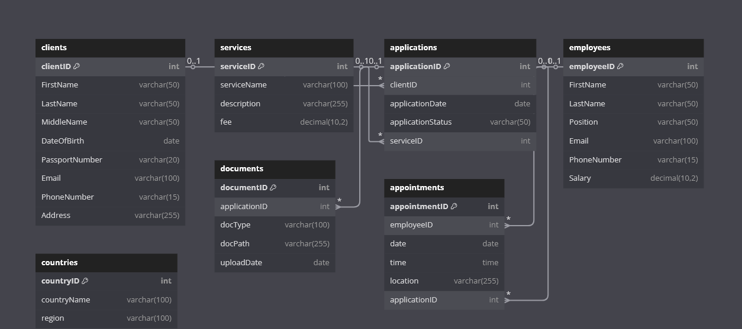

Semester 2 Schema
In Semester 2, the schema was enhanced to improve data normalization and to support new requirements (such as auditing changes):
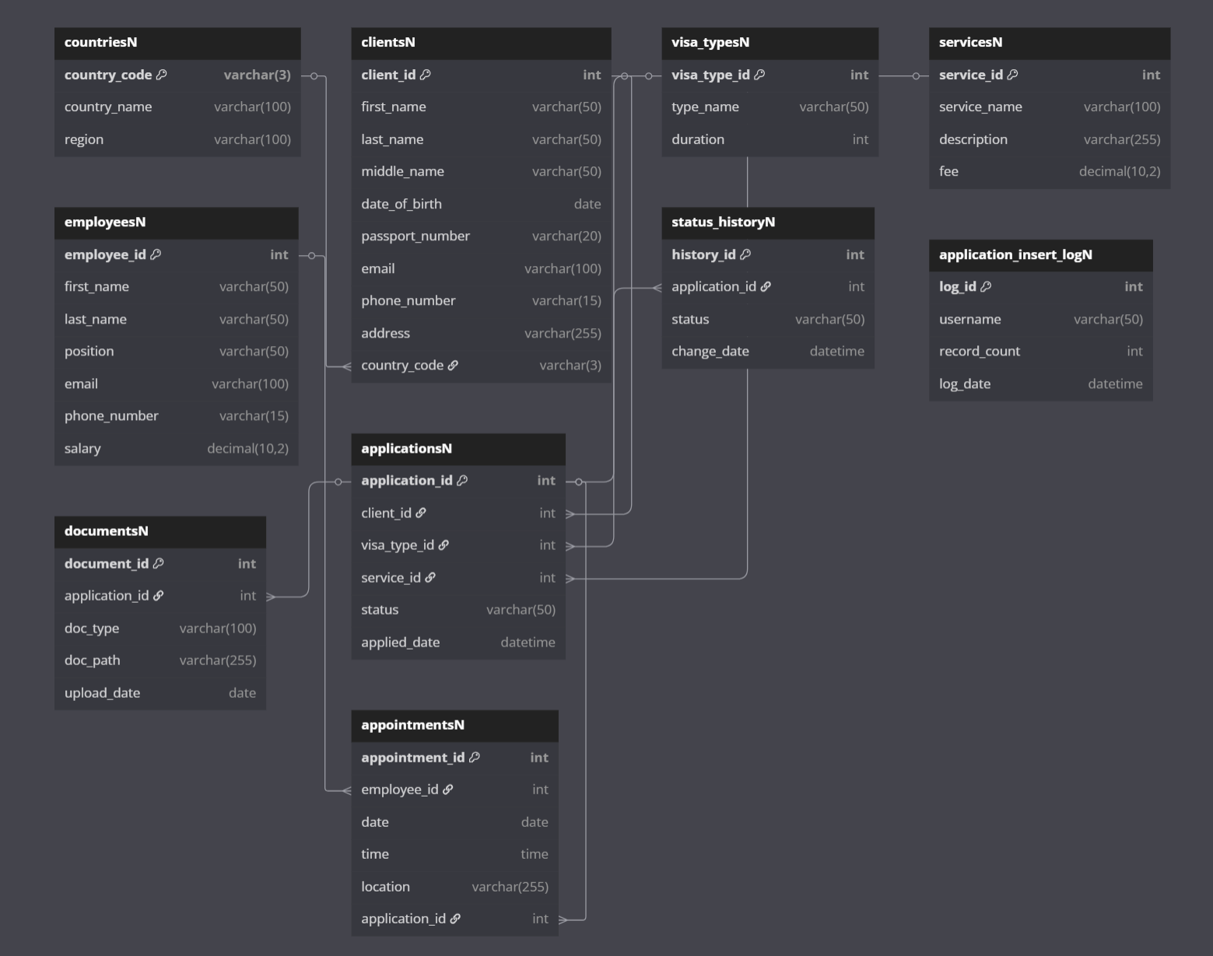

3. Implementations and problems
1. Problem: Create the VISA_TYPES table
CREATE TABLE VISA_TYPES (
VISA_TYPE_ID NUMBER PRIMARY KEY,
TYPE_NAME VARCHAR2(50) NOT NULL,
DURATION_MONTHS NUMBER(3)
);
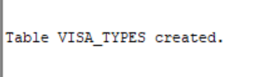
2. Drop & recreate a backup of applicationsN
Problem:
Write a PL/SQL block that drops a table called applicationsN_Backup if it exists (suppressing “table does not exist”) and then creates it as a copy of applicationsN.
BEGIN
BEGIN
EXECUTE IMMEDIATE 'DROP TABLE applicationsN_Backup CASCADE CONSTRAINTS';
EXCEPTION
WHEN OTHERS THEN
IF SQLCODE != -942 THEN -- ORA-00942: table or view does not exist
RAISE;
END IF;
END;

EXECUTE IMMEDIATE 'CREATE TABLE applicationsN_Backup AS SELECT * FROM applicationsN';
END;
/

SELECT * FROM applicationsN_Backup WHERE ROWNUM <= 5;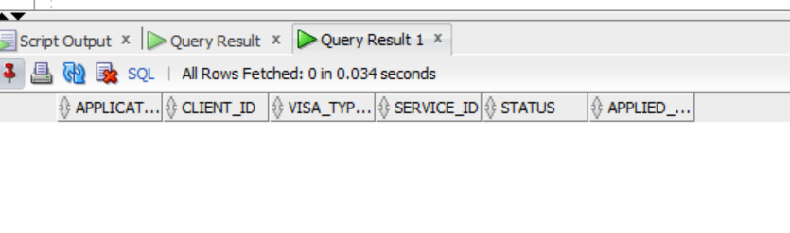
3. Count rows in applicationsN_Backup via dynamic SQL
Problem:
Write a PL/SQL block that uses EXECUTE IMMEDIATE to count the number of rows in applicationsN_Backup and prints the result.`
count rows in applicationsN_Backup.
DECLARE
v_count NUMBER;
BEGIN
EXECUTE IMMEDIATE 'SELECT COUNT(*) FROM applicationsN_Backup'
INTO v_count;
DBMS_OUTPUT.PUT_LINE('applicationsN_Backup has ' || v_count || ' row(s).');
END;
/
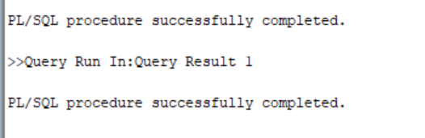
4. Display total fees paid by a given client
Problem:
Using an implicit cursor (SELECT INTO), compute the total sum of fee (from servicesN) for all applications submitted by client_id = 1001. Print that total.

DECLARE
v_total_fee NUMBER;
BEGIN
SELECT NVL(SUM(s.fee), 0)
INTO v_total_fee
FROM applicationsN a
JOIN servicesN s ON a.service_id = s.service_id
WHERE a.client_id = 1001;

DBMS_OUTPUT.PUT_LINE('Total fees for client 1001: ' || v_total_fee);
END;
/
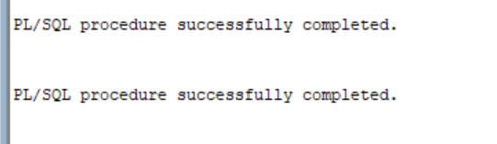
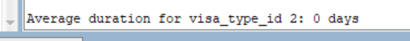
5. Display average visa duration for a given visa type
Problem:
Using AVG, compute the average duration (from visa_typesN) for visa_type_id = 2 and round it to 2 decimal places. Print the result.

DECLARE
v_avg_duration NUMBER;
BEGIN
SELECT ROUND(NVL(AVG(duration), 0), 2)
INTO v_avg_duration
FROM visa_typesN
WHERE visa_type_id = 2;

DBMS_OUTPUT.PUT_LINE('Average duration for visa_type_id 2: ' || v_avg_duration || ' days');
END;
/
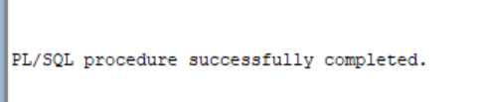
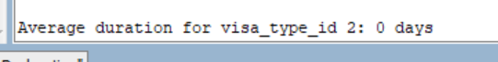
6. Conditional message based on number of clients from a given country
Problem:
Count how many clients in clientsN have country_code = 'USA'.
If 0, print “No clients from USA.”
If 1 or 2, print “Few clients from USA.”
Otherwise, print “Many clients from USA.”

DECLARE
v_count_clients NUMBER;
BEGIN
SELECT COUNT(*)
INTO v_count_clients
FROM clientsN
WHERE country_code = 'USA';

IF v_count_clients = 0 THEN
DBMS_OUTPUT.PUT_LINE('No clients from USA.');
ELSIF v_count_clients <= 2 THEN
DBMS_OUTPUT.PUT_LINE('Few clients from USA.');
ELSE
DBMS_OUTPUT.PUT_LINE('Many clients from USA.');
END IF;
END;
/
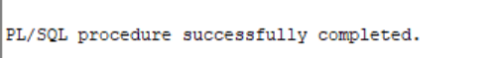

7. Use a CASE expression to label visa durations
Problem:
Suppose you pass in a variable v_dur (visa duration in days).
Using a CASE expression, label it:
- < 30 → "Short‐term"
- 30 .. 180 → "Medium‐term"
- > 180 → "Long‐term"
Print the label for v_dur := 45.

DECLARE
v_dur NUMBER := 45; -- example duration in days
v_label VARCHAR2(20);
BEGIN
SELECT CASE
WHEN v_dur < 30 THEN 'Short-term'
WHEN v_dur BETWEEN 30 AND 180 THEN 'Medium-term'
ELSE 'Long-term'
END
INTO v_label
FROM dual;

DBMS_OUTPUT.PUT_LINE('Visa duration ' || v_dur || ' days → ' || v_label);
END;
/
DECLARE
v_dur NUMBER := 45; -- example duration in days
v_label VARCHAR2(20);
BEGIN
SELECT CASE
WHEN v_dur < 30 THEN 'Short-term'
WHEN v_dur BETWEEN 30 AND 180 THEN 'Medium-term'
ELSE 'Long-term'
END
INTO v_label
FROM dual;

DBMS_OUTPUT.PUT_LINE('Visa duration ' || v_dur || ' days → ' || v_label);
END;
/
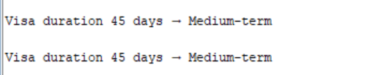
8. Loop through the most recent 3 status history entries for an application
Problem:
For application_id = 2001, retrieve the 3 most recent statuses from status_historyN (ordered by change_date DESC) and print each. If fewer than three exist, print “No status at position X” for that index.

DECLARE
v_status VARCHAR2(50);
BEGIN
FOR i IN 1..3 LOOP
BEGIN
SELECT status
INTO v_status
FROM (
SELECT status,
ROW_NUMBER() OVER (ORDER BY change_date DESC) AS rn
FROM status_historyN
WHERE application_id = 2001
)
WHERE rn = i;

DBMS_OUTPUT.PUT_LINE('Status ' || i || ': ' || v_status);
EXCEPTION
WHEN NO_DATA_FOUND THEN
DBMS_OUTPUT.PUT_LINE('No status at position ' || i);
EXIT;
END;
END LOOP;
END;
/
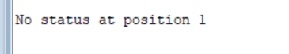
9. Generate a unique 6‐digit document_id using a WHILE loop
Problem:
Use a WHILE loop starting from v_doc_id := 100000 up to 100010.
On each iteration, check if there exists a row in documentsN with that document_id.
If none exists, print “First unused document_id: <id>” and exit.
If an error occurs, catch it and print “Error checking id <id>”.

DECLARE
v_doc_id NUMBER := 100000;
v_cnt NUMBER;
BEGIN
WHILE v_doc_id <= 100010 LOOP
BEGIN
SELECT COUNT(*)
INTO v_cnt
FROM documentsN
WHERE document_id = v_doc_id;

IF v_cnt = 0 THEN
DBMS_OUTPUT.PUT_LINE('First unused document_id: ' || v_doc_id);
EXIT;
END IF;
EXCEPTION
WHEN OTHERS THEN
DBMS_OUTPUT.PUT_LINE('Error checking document_id ' || v_doc_id);
END;

v_doc_id := v_doc_id + 1;
END LOOP;
END;
/
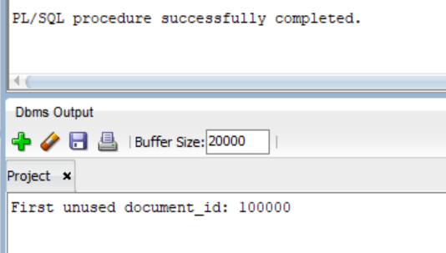
10. Loop through documentsN and stop at first PDF
Problem:
Use an explicit LOOP … EXIT with a cursor over documentsN ordered by upload_date.
Fetch (document_id, doc_type) and exit the loop as soon as doc_type = 'PDF', printing “Found PDF document: <id>”. If none found, exit naturally.

DECLARE
CURSOR c_docs IS
SELECT document_id, doc_type
FROM documentsN
ORDER BY upload_date;

v_id documentsN.document_id%TYPE;
v_type documentsN.doc_type%TYPE;
BEGIN
OPEN c_docs;
LOOP
FETCH c_docs INTO v_id, v_type;
EXIT WHEN c_docs%NOTFOUND;

IF UPPER(v_type) = 'PDF' THEN
DBMS_OUTPUT.PUT_LINE('Found PDF document with ID: ' || v_id);
EXIT;
END IF;
END LOOP;
CLOSE c_docs;
END;
/
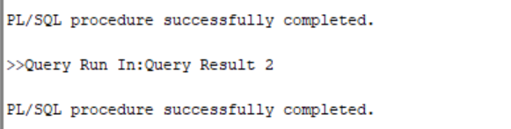
11. Use an associative array (INDEX BY) to map each client’s ID to their number of applications, then print “Client <ID>: <count>” only for those with at least three application.
SET SERVEROUTPUT ON;
DECLARE
TYPE t_app_cnt IS TABLE OF NUMBER INDEX BY PLS_INTEGER;
v_cnts t_app_cnt;
v_count NUMBER;
l_idx PLS_INTEGER;
BEGIN
FOR rec IN (SELECT DISTINCT client_id FROM applicationsN) LOOP
SELECT COUNT(*)
INTO v_count
FROM applicationsN
WHERE client_id = rec.client_id;
v_cnts(rec.client_id) := v_count;
END LOOP;

l_idx := v_cnts.FIRST;
WHILE l_idx IS NOT NULL LOOP
IF v_cnts(l_idx) >= 3 THEN
DBMS_OUTPUT.PUT_LINE(
'Client ' || l_idx || ': ' || v_cnts(l_idx) || ' application(s)'
);
END IF;
l_idx := v_cnts.NEXT(l_idx);
END LOOP;
END;
/
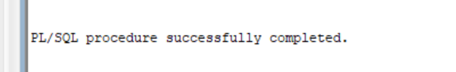
12. Problem:
Collect the two most recent service IDs that client 1001 has used (using a single SELECT … BULK COLLECT), store them in a nested table, and then, for each ID, query servicesN to display its service_name and fee.
(Covers: C – Nested table + looping; A – Implicit SQL with SELECT … BULK COLLECT and SELECT … INTO; G – Output display)
SET SERVEROUTPUT ON;
DECLARE
TYPE t_num_nt IS TABLE OF NUMBER;
v_nt t_num_nt;
v_name servicesN.service_name%TYPE;
v_fee servicesN.fee%TYPE;
BEGIN
SELECT service_id
BULK COLLECT INTO v_nt
FROM (
SELECT service_id
FROM applicationsN
WHERE client_id = 1001
ORDER BY applied_date DESC
)
WHERE ROWNUM <= 2;

DBMS_OUTPUT.PUT_LINE('Client 1001''s most recent services:');
FOR i IN 1 .. v_nt.COUNT LOOP
SELECT service_name, fee
INTO v_name, v_fee
FROM servicesN
WHERE service_id = v_nt(i);

DBMS_OUTPUT.PUT_LINE(
v_nt(i) || ' – ' || v_name || ' (Fee: ' || v_fee || ')'
);
END LOOP;
END;
/
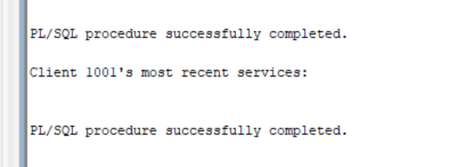
13. Problem:
Fetch the three highest service fees that client 1001 has incurred
SET SERVEROUTPUT ON;
DECLARE
TYPE t_top_fees IS VARRAY(3) OF NUMBER;
v_top t_top_fees := t_top_fees();
CURSOR c_fee IS
SELECT fee
FROM (
SELECT s.fee, ROW_NUMBER() OVER (ORDER BY s.fee DESC) AS rn
FROM applicationsN a
JOIN servicesN s ON a.service_id = s.service_id
WHERE a.client_id = 1001
)
WHERE rn <= 3;
BEGIN
FOR rec IN c_fee LOOP
v_top.EXTEND;
v_top(v_top.COUNT) := rec.fee;
END LOOP;

DBMS_OUTPUT.PUT_LINE('Top 3 fees for client 1001:');
FOR i IN 1 .. v_top.COUNT LOOP
DBMS_OUTPUT.PUT_LINE(' ' || i || ': $' || v_top(i));
END LOOP;
END;
/
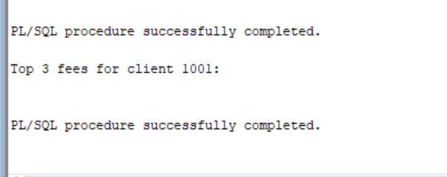
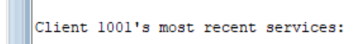
14. Write a PL/SQL block that deliberately causes and handles these implicit exceptions:
SET SERVEROUTPUT ON;
DECLARE
v_tmp VARCHAR2(5);
v_res NUMBER;
v_str VARCHAR2(8) := 'ABCDEFGH';
BEGIN
BEGIN
SELECT email
INTO v_tmp
FROM clientsN
WHERE client_id = -1;
EXCEPTION
WHEN NO_DATA_FOUND THEN
DBMS_OUTPUT.PUT_LINE('Caught NO_DATA_FOUND');
END;

BEGIN
v_res := 10 / 0;
EXCEPTION
WHEN ZERO_DIVIDE THEN
DBMS_OUTPUT.PUT_LINE('Caught ZERO_DIVIDE');
END;

BEGIN
v_tmp := v_str; -- v_str length = 8, too big for v_tmp
EXCEPTION
WHEN VALUE_ERROR THEN
DBMS_OUTPUT.PUT_LINE('Caught VALUE_ERROR');
END;
END;
/
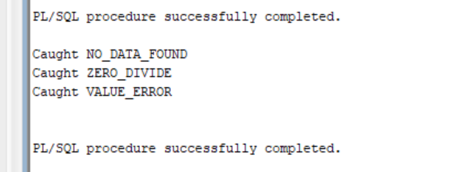
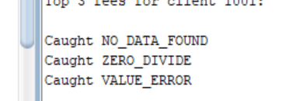
15. Problem:
Prompt for fee if fee < 0 then RAISE it if fee > 10000 then RAISE ex_fee_high; otherwise print “Fee OK: <fee>”. Handle both exceptions and WHEN OTHERS.
SET SERVEROUTPUT ON;
DECLARE
v_fee NUMBER := &fee;
ex_fee_low EXCEPTION;
ex_fee_high EXCEPTION;
BEGIN
IF v_fee < 0 THEN
RAISE ex_fee_low;
ELSIF v_fee > 10000 THEN
RAISE ex_fee_high;
ELSE
DBMS_OUTPUT.PUT_LINE('Fee OK: ' || v_fee);
END IF;
EXCEPTION
WHEN ex_fee_low THEN
DBMS_OUTPUT.PUT_LINE('Explicit: Fee too low (' || v_fee || ')');
WHEN ex_fee_high THEN
DBMS_OUTPUT.PUT_LINE('Explicit: Fee too high (' || v_fee || ')');
WHEN OTHERS THEN
DBMS_OUTPUT.PUT_LINE('Unexpected error: ' || SQLERRM);
END;
/
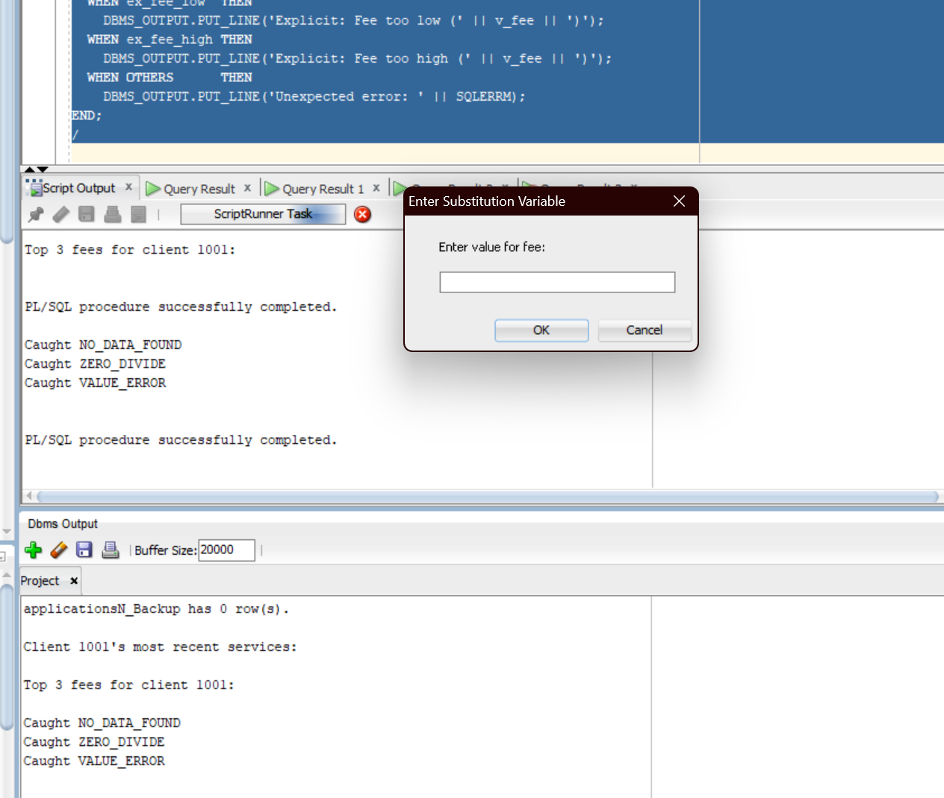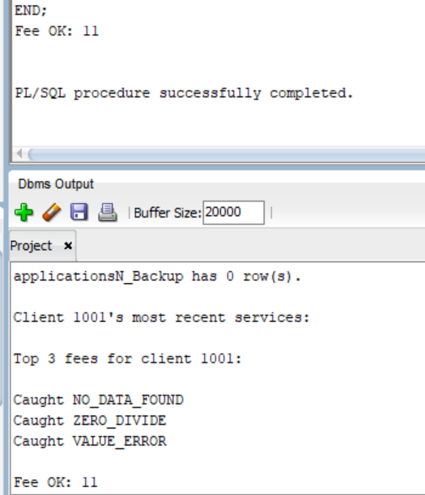
16. Problem:
Count how many documents exist for application 2001 and print the result.
SET SERVEROUTPUT ON;
DECLARE
v_doc_count NUMBER;
BEGIN
SELECT COUNT(*)
INTO v_doc_count
FROM documentsN
WHERE application_id = 2001;
DBMS_OUTPUT.PUT_LINE('Total documents for application 2001: ' || v_doc_count);
END;
/
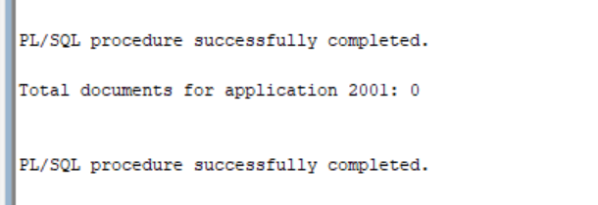
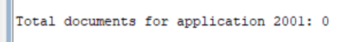
17. Problem:
Declare an explicit cursor retrieving each employee_id and count of appointments, then loop to print
SET SERVEROUTPUT ON;
DECLARE
CURSOR c_appt_count IS
SELECT employee_id, COUNT(*) AS appt_cnt
FROM appointmentsN
GROUP BY employee_id;
BEGIN
FOR rec IN c_appt_count LOOP
DBMS_OUTPUT.PUT_LINE(
'Employee ' || rec.employee_id || ': ' || rec.appt_cnt || ' appointment(s)'
);
END LOOP;
END;
/

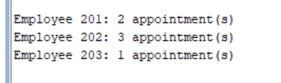

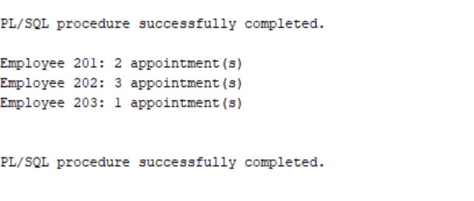
17. Problem:
Create a cursor c_status(p_aid IN NUMBER) that selects history_id, status, change_date from status_historyN for the given p_aid; prompt for &aid and loop to print
SET SERVEROUTPUT ON;
DECLARE
CURSOR c_status(p_aid IN NUMBER) IS
SELECT history_id, status, change_date
FROM status_historyN
WHERE application_id = p_aid
ORDER BY change_date;
v_aid NUMBER := &aid;
BEGIN
FOR rec IN c_status(v_aid) LOOP
DBMS_OUTPUT.PUT_LINE(
'History ' || rec.history_id
|| ' at ' || TO_CHAR(rec.change_date, 'DD-MON-YYYY HH24:MI:SS')
|| ': ' || rec.status
);
END LOOP;
END;
/
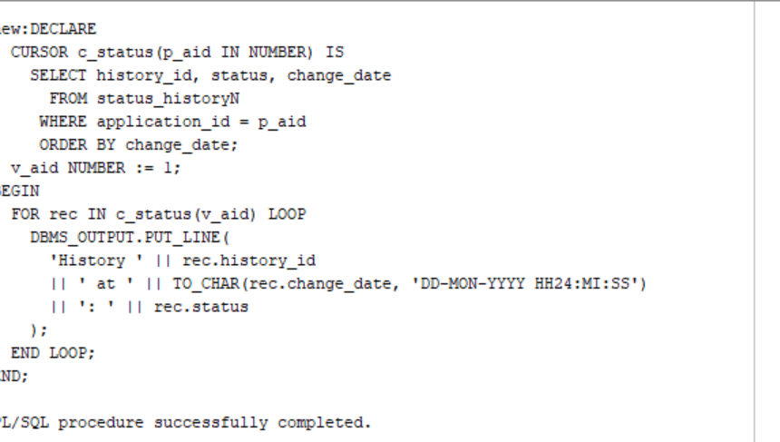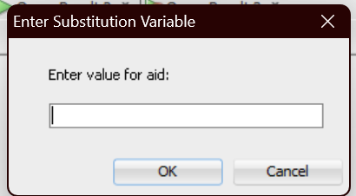

-- 19. Update all services whose service_name starts with 'Std ' to instead start with 'Standard '.
-- Display servicesN before the update.
SELECT * FROM servicesN;
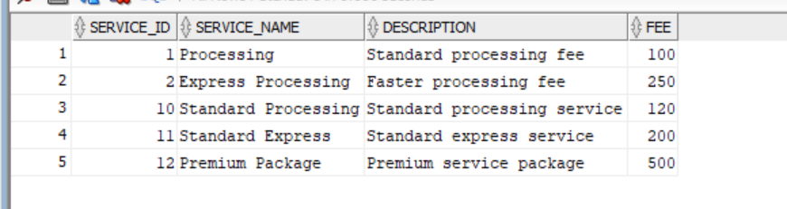
ET SERVEROUTPUT ON;
DECLARE
CURSOR c_update IS
SELECT service_id, service_name
FROM servicesN
WHERE service_name LIKE 'Std %'
FOR UPDATE OF service_name;
BEGIN
FOR rec IN c_update LOOP
UPDATE servicesN
SET service_name = REPLACE(rec.service_name, 'Std ', 'Standard ')
WHERE CURRENT OF c_update;
DBMS_OUTPUT.PUT_LINE(
'Updated service ' || rec.service_id
|| ' title to: ' || REPLACE(rec.service_name, 'Std ', 'Standard ')
);
END LOOP;
END;
/

Display servicesN after the update.
SELECT * FROM servicesN;
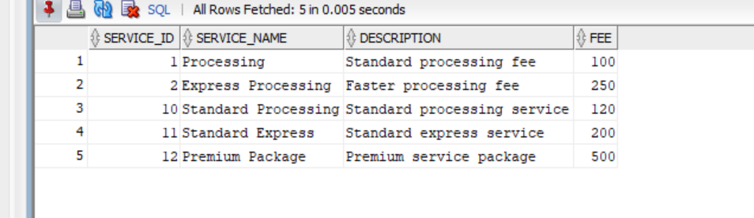
-- 20. Create a procedure show_documents(p_client_id IN NUMBER) that prints all documents for a given client.
-- Display documentsN before running the procedure:
SELECT * FROM documentsN;
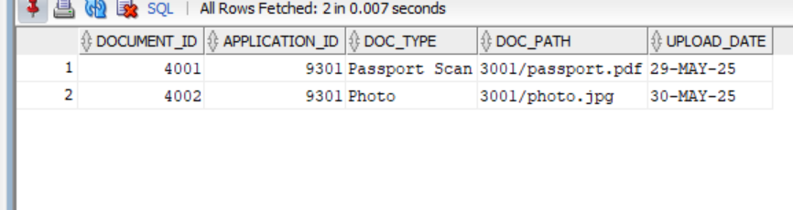
SET SERVEROUTPUT ON;
CREATE OR REPLACE PROCEDURE show_documents(p_client_id IN NUMBER) IS
CURSOR c_docs IS
SELECT d.document_id, d.doc_type, d.doc_path, d.upload_date
FROM documentsN d
JOIN applicationsN a ON d.application_id = a.application_id
WHERE a.client_id = p_client_id
ORDER BY d.upload_date;
BEGIN
FOR rec IN c_docs LOOP
DBMS_OUTPUT.PUT_LINE(
'Document ' || rec.document_id
|| ' | Type: ' || rec.doc_type
|| ' | Path: ' || rec.doc_path
|| ' | Uploaded: ' || TO_CHAR(rec.upload_date, 'DD-MON-YYYY')
);
END LOOP;
END;
/

BEGIN
show_documents(3001);
END;
/
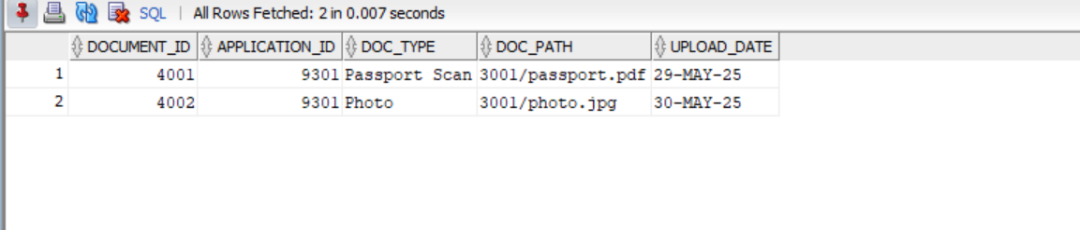
Problem:
Create a function get_total_fees(p_client_id IN NUMBER) RETURN NUMBER that returns the total sum of fee from servicesN for all applications of p_client_id.
SET SERVEROUTPUT ON;

CREATE OR REPLACE FUNCTION get_total_fees(p_client_id IN NUMBER) RETURN NUMBER IS
v_total NUMBER;
BEGIN
SELECT NVL(SUM(s.fee), 0)
INTO v_total
FROM applicationsN a
JOIN servicesN s ON a.service_id = s.service_id
WHERE a.client_id = p_client_id;

RETURN v_total;
END;
/

DECLARE
v_result NUMBER;
BEGIN
v_result := get_total_fees(1001);
DBMS_OUTPUT.PUT_LINE('Total fees for client 1001: $' || v_result);
END;
/
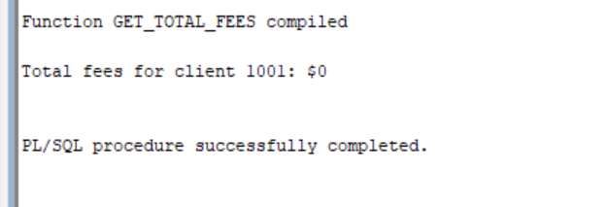
-- 22. Create a procedure add_application(p_client_id IN NUMBER, p_visa_type_id IN NUMBER, p_service_id IN NUMBER)
-- that checks if an application exists for that client, visa, and service. If not, insert it and print “Application created.”
-- If it exists, print “Application already exists.”
CREATE SEQUENCE seq_applicationsN START WITH 10000 INCREMENT BY 1;
/

CREATE OR REPLACE PROCEDURE add_application(
p_client_id IN NUMBER,
p_visa_type_id IN NUMBER,
p_service_id IN NUMBER
) IS
v_exists NUMBER;
v_new_id NUMBER;
BEGIN
SELECT COUNT(*)
INTO v_exists
FROM applicationsN
WHERE client_id = p_client_id
AND visa_type_id = p_visa_type_id
AND service_id = p_service_id;

IF v_exists = 0 THEN
v_new_id := seq_applicationsN.NEXTVAL;
INSERT INTO applicationsN (
application_id, client_id, visa_type_id, service_id, status, applied_date
) VALUES (
v_new_id, p_client_id, p_visa_type_id, p_service_id, 'NEW', SYSDATE
);
DBMS_OUTPUT.PUT_LINE('Application created: ' || v_new_id);
ELSE
DBMS_OUTPUT.PUT_LINE('Application already exists.');
END IF;
EXCEPTION
WHEN OTHERS THEN
DBMS_OUTPUT.PUT_LINE('Error: ' || SQLERRM);
END;
/

-- Run the procedure:
BEGIN
add_application(1001, 1, 1);
END;
/
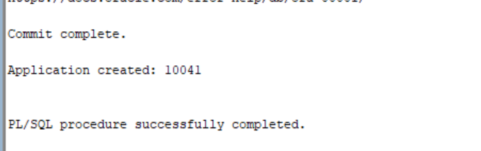
23. Problem:
Create a procedure show_client_status(p_client_id IN NUMBER) that lists all status history entries for a given client’s applications (showing application_id, status, change_date). If none exist, print “No status history for client <ID>.”
SET SERVEROUTPUT ON;

CREATE OR REPLACE PROCEDURE show_client_status(p_client_id IN NUMBER) IS
CURSOR c_status IS
SELECT h.application_id,
h.status,
h.change_date
FROM status_historyN h
JOIN applicationsN a ON h.application_id = a.application_id
WHERE a.client_id = p_client_id
ORDER BY h.change_date;
v_found BOOLEAN := FALSE;
BEGIN
FOR rec IN c_status LOOP
v_found := TRUE;
DBMS_OUTPUT.PUT_LINE(
'Application ' || rec.application_id
|| ' | Status: ' || rec.status
|| ' | Changed: ' || TO_CHAR(rec.change_date, 'DD-MON-YYYY HH24:MI:SS')
);
END LOOP;
IF NOT v_found THEN
DBMS_OUTPUT.PUT_LINE('No status history for client ' || p_client_id);
END IF;
END;
/
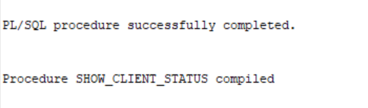
BEGIN
show_client_status(1001);
END;
/ 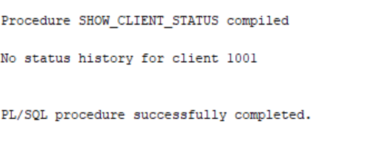
24. Problem:
Create a function client_count_by_country(p_cc IN VARCHAR2) RETURN NUMBER that returns the number of clients whose country_code matches p_cc (case-insensitive).
SET SERVEROUTPUT ON;

CREATE OR REPLACE FUNCTION client_count_by_country(p_cc IN VARCHAR2)
RETURN NUMBER IS
v_count NUMBER;
BEGIN
SELECT COUNT(*)
INTO v_count
FROM clientsN
WHERE LOWER(country_code) = LOWER(p_cc);
RETURN v_count;
END;
/

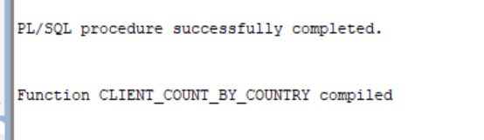
DECLARE
v_result NUMBER;
BEGIN
v_result := client_count_by_country('USA');
DBMS_OUTPUT.PUT_LINE('Number of clients in USA: ' || v_result);
END;
/
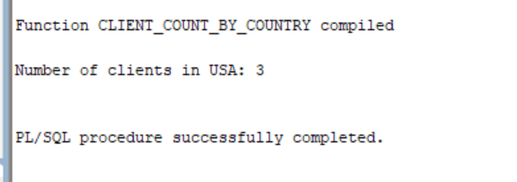
25. Create package client_utils_pkg with:
-- • PROCEDURE show_client_applications(p_client_id) lists application_id, status, applied_date for that client.
-- • FUNCTION application_count(p_client_id) RETURN NUMBER counts applications for that client.
CREATE OR REPLACE PACKAGE client_utils_pkg AS
PROCEDURE show_client_applications(p_client_id IN NUMBER);
FUNCTION application_count(p_client_id IN NUMBER) RETURN NUMBER;
END client_utils_pkg;
/

CREATE OR REPLACE PACKAGE BODY client_utils_pkg AS

PROCEDURE show_client_applications(p_client_id IN NUMBER) IS
BEGIN
FOR rec IN (
SELECT application_id, status, applied_date
FROM applicationsN
WHERE client_id = p_client_id
ORDER BY applied_date
) LOOP
DBMS_OUTPUT.PUT_LINE(
'Application ' || rec.application_id
|| ' | Status: ' || rec.status
|| ' | Applied: ' || TO_CHAR(rec.applied_date, 'DD-MON-YYYY')
);
END LOOP;
END show_client_applications;

FUNCTION application_count(p_client_id IN NUMBER) RETURN NUMBER IS
v_cnt NUMBER;
BEGIN
SELECT COUNT(*) INTO v_cnt
FROM applicationsN
WHERE client_id = p_client_id;
RETURN v_cnt;
END application_count;

END client_utils_pkg;
/

SET SERVEROUTPUT ON;
DECLARE
v_total NUMBER;
BEGIN
v_total := client_utils_pkg.application_count(1001);
DBMS_OUTPUT.PUT_LINE('Client 1001 has ' || v_total || ' application(s).');
client_utils_pkg.show_client_applications(1001);
END;
/
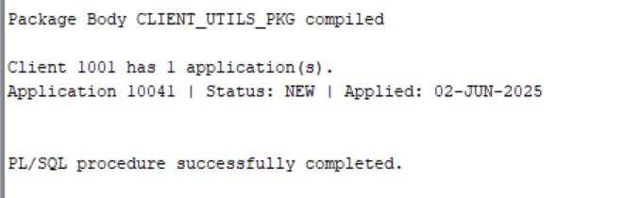
-- Package specification
CREATE OR REPLACE PACKAGE client_utils_pkg AS
PROCEDURE show_client_applications(p_client_id IN NUMBER);
FUNCTION application_count(p_client_id IN NUMBER) RETURN NUMBER;
END client_utils_pkg;
/

-- Package body
CREATE OR REPLACE PACKAGE BODY client_utils_pkg AS

PROCEDURE show_client_applications(p_client_id IN NUMBER) IS
BEGIN
FOR rec IN (
SELECT application_id, status, applied_date
FROM applicationsN
WHERE client_id = p_client_id
ORDER BY applied_date
) LOOP
DBMS_OUTPUT.PUT_LINE(
rec.application_id || ' – ' || rec.status || ' | ' || TO_CHAR(rec.applied_date, 'DD-MON-YYYY')
);
END LOOP;
END show_client_applications;

FUNCTION application_count(p_client_id IN NUMBER) RETURN NUMBER IS
v_count NUMBER;
BEGIN
SELECT COUNT(*)
INTO v_count
FROM applicationsN
WHERE client_id = p_client_id;
RETURN v_count;
END application_count;

END client_utils_pkg;
/ 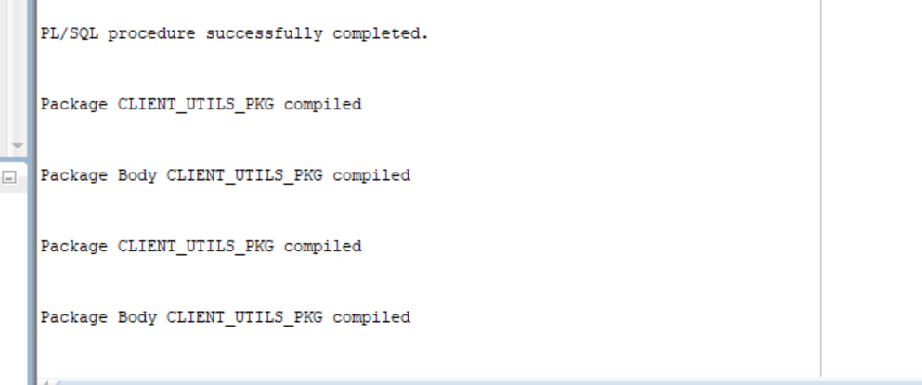
SET SERVEROUTPUT ON;
DECLARE
v_total NUMBER;
BEGIN
v_total := client_utils_pkg.application_count(1001);
DBMS_OUTPUT.PUT_LINE('Client 1001 has the following ' || v_total || ' applications:');
client_utils_pkg.show_client_applications(1001);
END;
/

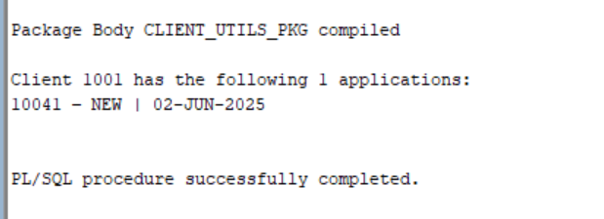
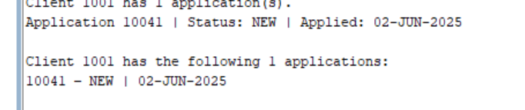
26. Problem:
Create a trigger that fires before INSERT or UPDATE on appointmentsN and ensures the new appointment_date is not earlier than the corresponding application’s applied_date. If :NEW.appointment_date < (SELECT applied_date FROM applicationsN W
HERE application_id = :NEW.application_id), then set
CREATE OR REPLACE TRIGGER trg_appointments_date_fix
BEFORE INSERT OR UPDATE ON appointmentsN
FOR EACH ROW
DECLARE
v_applied_date applicationsN.applied_date%TYPE;
BEGIN
SELECT applied_date
INTO v_applied_date
FROM applicationsN
WHERE application_id = :NEW.application_id;

IF :NEW.appointment_date < v_applied_date THEN
:NEW.appointment_date := v_applied_date;
END IF;
END trg_appointments_date_fix;
/ 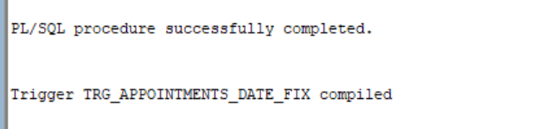
-- 27. Create a trigger that fires before INSERT on documentsN. Regardless of whether doc_path includes the corresponding application_id, prepend it so that the final doc_path reads '<application_id>/<original_path>'.

CREATE OR REPLACE TRIGGER trg_documents_path_fix
BEFORE INSERT ON documentsN
FOR EACH ROW
DECLARE
v_app_id documentsN.application_id%TYPE := :NEW.application_id;
BEGIN
IF INSTR(:NEW.doc_path, v_app_id || '/') = 0 THEN
:NEW.doc_path := v_app_id || '/' || :NEW.doc_path;
END IF;
END trg_documents_path_fix;
/
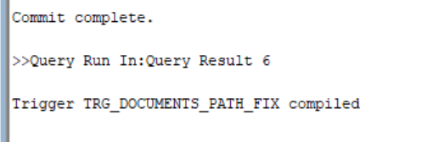
-- Insert a document without application_id in the path (trigger will prepend)
INSERT INTO documentsN (
document_id, application_id, doc_type, doc_path, upload_date
) VALUES (
8001, 9101, 'Test Document', 'testdoc.pdf', SYSDATE
);

COMMIT;

-- Verify that doc_path was corrected
SELECT document_id, application_id, doc_path
FROM documentsN
WHERE document_id = 8001; 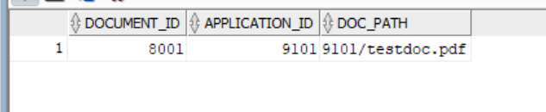
-- 28. Create a log table Document_Count_Log and sequence Document_Count_Log_seq.
CREATE TABLE Document_Count_Log (
log_id NUMBER PRIMARY KEY,
log_date DATE NOT NULL,
total_documents NUMBER NOT NULL
);

CREATE SEQUENCE Document_Count_Log_seq START WITH 1 INCREMENT BY 1;
COMMIT;

-- Statement‐level trigger that fires after INSERT or DELETE on documentsN
CREATE OR REPLACE TRIGGER trg_doc_count_log
AFTER INSERT OR DELETE ON documentsN
DECLARE
v_total NUMBER;
BEGIN
SELECT COUNT(*)
INTO v_total
FROM documentsN;

INSERT INTO Document_Count_Log (
log_id, log_date, total_documents
) VALUES (
Document_Count_Log_seq.NEXTVAL, SYSDATE, v_total
);
END;
/
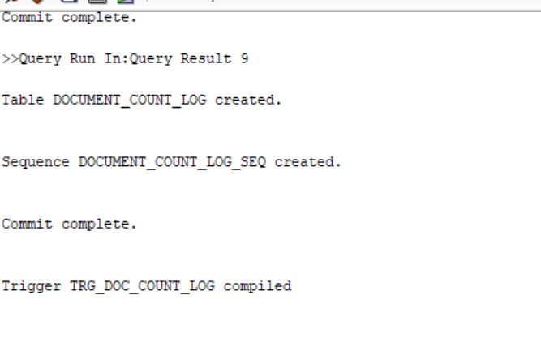
-- Create log table and sequence for documents
CREATE TABLE Document_Count_Log (
log_id NUMBER PRIMARY KEY,
log_date DATE NOT NULL,
total_documents NUMBER NOT NULL
);

CREATE SEQUENCE Document_Count_Log_seq START WITH 1 INCREMENT BY 1;
COMMIT;

-- Statement‐level trigger after insert or delete on documentsN
CREATE OR REPLACE TRIGGER trg_doc_count_log
AFTER INSERT OR DELETE ON documentsN
DECLARE
v_total NUMBER;
BEGIN
SELECT COUNT(*) INTO v_total FROM documentsN;
INSERT INTO Document_Count_Log (
log_id, log_date, total_documents
) VALUES (
Document_Count_Log_seq.NEXTVAL, SYSDATE, v_total
);
END trg_doc_count_log;
/
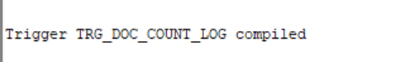
-- Insert a row into documentsN and display the logs.
INSERT INTO documentsN (document_id, application_id, doc_type, doc_path, upload_date)
VALUES (6001, 9301, 'User Manual', '9301/manual.pdf', SYSDATE);

SELECT * FROM Document_Count_Log ORDER BY log_id DESC;
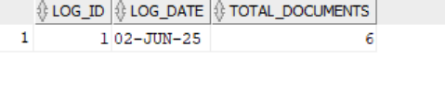
29. Create log table and sequence for status_historyN
CREATE TABLE StatusHistory_Count_Log (
log_id NUMBER PRIMARY KEY,
log_date DATE NOT NULL,
total_history NUMBER NOT NULL
);

CREATE SEQUENCE StatusHistory_Count_Log_seq START WITH 1 INCREMENT BY 1;
COMMIT;

-- Statement‐level trigger after INSERT or DELETE on status_historyN
CREATE OR REPLACE TRIGGER trg_statushistory_count_log
AFTER INSERT OR DELETE ON status_historyN
DECLARE
v_total NUMBER;
BEGIN
SELECT COUNT(*) INTO v_total FROM status_historyN;
INSERT INTO StatusHistory_Count_Log (
log_id, log_date, total_history
) VALUES (
StatusHistory_Count_Log_seq.NEXTVAL, SYSDATE, v_total
);
END trg_statushistory_count_log;
/
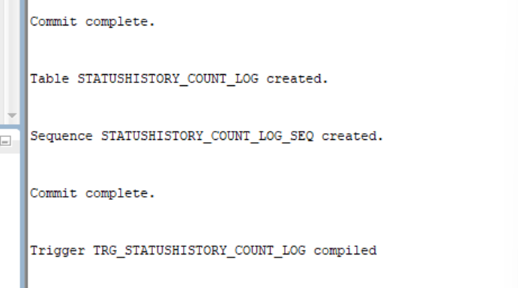
INSERT INTO status_historyN (
history_id, application_id, status, change_date
) VALUES (
3001, 9101, 'REVIEWED', SYSDATE
);
COMMIT;

SELECT * FROM StatusHistory_Count_Log ORDER BY log_id DESC;
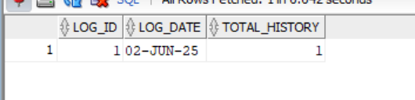
-- Delete the previously added row from status_historyN and display the logs again.
DELETE FROM status_historyN WHERE history_id = 3001;
SELECT * FROM StatusHistory_Count_Log ORDER BY log_id DESC; 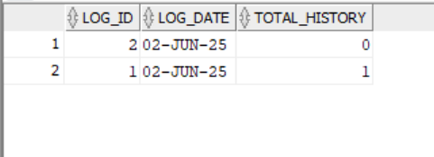
30.Problem:
Create a procedure reassign_appointments(p_old_emp IN NUMBER, p_new_emp IN NUMBER) that updates appointmentsN, setting employee_id = p_new_emp wherever employee_id = p_old_emp.
After the update, print
SET SERVEROUTPUT ON;
CREATE OR REPLACE PROCEDURE reassign_appointments(
p_old_emp IN NUMBER,
p_new_emp IN NUMBER
) IS
v_count NUMBER;
BEGIN
IF p_old_emp = p_new_emp THEN
DBMS_OUTPUT.PUT_LINE('Source and target are the same');
RETURN;
END IF;

UPDATE appointmentsN
SET employee_id = p_new_emp
WHERE employee_id = p_old_emp;

v_count := SQL%ROWCOUNT;
DBMS_OUTPUT.PUT_LINE(
'Reassigned ' || v_count || ' appointment(s) from '
|| p_old_emp || ' to ' || p_new_emp
);
END;
/

-- Example call:
BEGIN
reassign_appointments(101, 102);
END;
/ 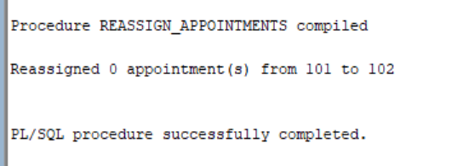
Problem:
Loop through the most recent 3 status entries of application 9001 and display them.
(Covers: B – Numeric FOR loop; D – Implicit exception NO_DATA_FOUND; A – Use of ROW_NUMBER())
SET SERVEROUTPUT ON;
DECLARE
v_status VARCHAR2(50);
BEGIN
FOR i IN 1..3 LOOP
BEGIN
SELECT status
INTO v_status
FROM (
SELECT status, ROW_NUMBER() OVER (ORDER BY change_date DESC) AS rn
FROM status_historyN
WHERE application_id = 9001
)
WHERE rn = i;
DBMS_OUTPUT.PUT_LINE('Status ' || i || ': ' || v_status);
EXCEPTION
WHEN NO_DATA_FOUND THEN
DBMS_OUTPUT.PUT_LINE('No more status found at position ' || i);
EXIT;
END;
END LOOP;
END;
/
