Database Project by Al Sammarraie Nooruldeen Group 1074

Managing Immigration Papers:

1. Project Description
The purpose of this project is to design and implement a database system to manage immigration-related documents and processes efficiently. The database will track clients, their applications, required documents, services, and appointments with employees. The system aims to streamline the management of immigration papers, ensuring accurate record-keeping, and providing insights into the economic aspects such as service fees and employee salaries.
This project aligns with economic themes by incorporating cost management, fee tracking, and resource allocation. It will help immigration firms manage client data, reduce processing times, and improve the overall experience.

2. Database Schema
Table 1 Clients table and it contains: ClientID (which is the primary key), FirstName, LastName, DateOfBirth, PassportNumber, Email, PhoneNumber, Address
Table 2 applications table and it contains: applicationID (which is the primary key), clientID (which is a foreign key FK), applicationDate, status, serviceID(FK)
Table 3 services table and it contains: serviceID (PK), serviceName, description, fee
Table 4 employees table and it contains: employeeID (PK), firstName, lastName, position, email, phoneNumber, salary
Table 5: which is the countries table and it contains: countryID (pk), countryName, region
Table 6: which is the documents table and it contains: documentID (PK), applicationID (FK), docType, docPath, uploadDate
Table 7 which is the appointments table and it contains: appointmentID (PK), employeeID (FK), date, time, location, applicationID (FK)
The schema consists of seven tables with the following relationships:
- Clients: Tracks client information.
- Applications: Tracks immigration applications linked to clients and services.
- Services: Lists services offered by the organization.
- Employees: Tracks employees handling the cases.
- Countries: Contains country-related data.
- Documents: Tracks documents associated with applications.
- Appointments: Tracks appointments between employees and clients for specific applications.
Schema Relationships:
- A client can submit multiple applications.
- An application is linked to one service.
- An application may require multiple documents.
- An employee can manage multiple appointments.
- Appointments are tied to specific applications.

3. Constructing the Database

DDL Statements (Examples):

Creating Tables
CREATE TABLE Clients (
clientID INT PRIMARY KEY,
FirstName VARCHAR(50),
LastName VARCHAR(50),
DateOfBirth DATE,
PassportNumber VARCHAR(20),
Email VARCHAR(100),
PhoneNumber VARCHAR(15),
Address VARCHAR(255)
);
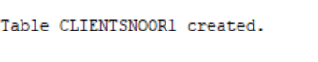

Creating Tables
CREATE TABLE Employeesnoor1 (
employeeID INT PRIMARY KEY,
FirstName VARCHAR(50),
LastName VARCHAR(50),
Position VARCHAR(50),
Email VARCHAR(100),
PhoneNumber VARCHAR(15),
Salary DECIMAL(10, 2)
);
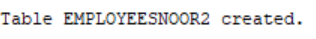

Altering Tables
ALTER TABLE Clients ADD (MiddleName VARCHAR(50));
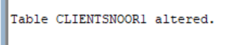

Dropping Tables
DROP TABLE Countries;

Adding a Unique Constraint
ALTER TABLE Clients ADD CONSTRAINT unique_email UNIQUE (Email);
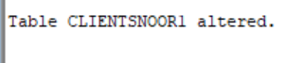
Adding a Check Constraint
ALTER TABLE Employees ADD CONSTRAINT check_salary CHECK (Salary > 0);

Renaming a Column
ALTER TABLE Applications RENAME COLUMN status TO applicationStatus;


4. DML Statements

Example 1:

ALTER SESSION SET NLS_DATE_FORMAT = 'YYYY-MM-DD';
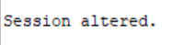
I had to do the command above to change the date format because it annoyed me.
INSERT INTO Clients (clientID, FirstName, LastName, DateOfBirth, PassportNumber, Email, PhoneNumber, Address)
VALUES (1, 'John', 'Doe', '1990-01-01', 'P12345678', 'john.doe@example.com', '+1234567890', '123 Main St');
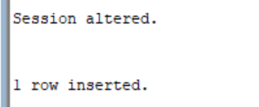

Example 2:
UPDATE Clients
SET Email = 'john.updated@example.com'
WHERE clientID = 1;


Example 3:
DELETE FROM Employees WHERE employeeID = 10;


Example 4:
MERGE INTO Services s
USING (SELECT 2 AS serviceID, 'Visa Renewal' AS serviceName, 'Renewal of visa services' AS description, 200.00 AS fee FROM dual) src
ON (s.serviceID = src.serviceID)
WHEN MATCHED THEN
UPDATE SET fee = src.fee
WHEN NOT MATCHED THEN
INSERT (serviceID, serviceName, description, fee) VALUES (src.serviceID, src.serviceName, src.description, src.fee);
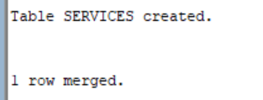

Example 5:
INSERT INTO Clients (clientID, FirstName, LastName, DateOfBirth, PassportNumber, Email, PhoneNumber, Address)
VALUES (1, 'John', 'Doe', TO_DATE('1990-01-01', 'YYYY-MM-DD'), 'P12345678', 'john.doe@example.com', '+1234567890', '123 Main St');


Example 6:
UPDATE Employees
SET Salary = Salary + 5000
WHERE Position = 'Manager';
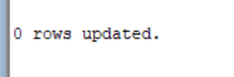

Example 7:
INSERT INTO Employees (employeeID, FirstName, LastName, Position, Email, PhoneNumber, Salary)
VALUES (1, 'Alice', 'Smith', 'Manager', 'alice.smith@example.com', '+1234567891', 70000);


Example 8:
INSERT INTO Services (serviceID, serviceName, description, fee)
VALUES (1, 'Visa Application', 'Processing visa applications', 150.00); 

Example 9:
UPDATE Clients
SET Email = 'john.updated@example.com'
WHERE clientID = 1;


Example 10:
MERGE INTO Clients c
USING (SELECT 2 AS clientID, 'Jane' AS FirstName, 'Doe' AS LastName, TO_DATE('1995-02-15', 'YYYY-MM-DD') AS DateOfBirth, 'P98765432' AS PassportNumber, 'jane.doe@example.com' AS Email, '+1234567892' AS PhoneNumber, '456 Elm St' AS Address FROM dual) src
ON (c.clientID = src.clientID)
WHEN MATCHED THEN
UPDATE SET Email = src.Email
WHEN NOT MATCHED THEN
INSERT (clientID, FirstName, LastName, DateOfBirth, PassportNumber, Email, PhoneNumber, Address) VALUES (src.clientID, src.FirstName, src.LastName, src.DateOfBirth, src.PassportNumber, src.Email, src.PhoneNumber, src.Address);


5. Select Statements

Select clients who applied for services costing more than $100:
SELECT c.FirstName, c.LastName, s.serviceName, s.fee
FROM Clients c
JOIN Applications a ON c.clientID = a.clientID
JOIN Services s ON a.serviceID = s.serviceID
WHERE s.fee > 100;
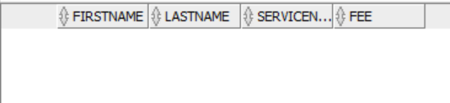

Retrieve all applications within a date range:
SELECT *
FROM Applications
WHERE applicationDate BETWEEN '2025-01-01' AND '2025-01-31';
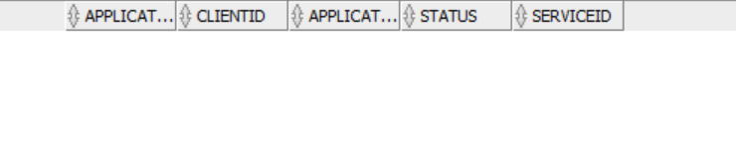

Count the number of pending applications:
SELECT COUNT(*) AS PendingApplications
FROM Applications
WHERE status = 'Pending';
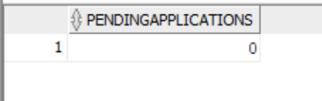

Retrieve employee details handling appointments on a specific date:
SELECT e.FirstName, e.LastName, a.date, a.time
FROM Employees e
JOIN Appointments a ON e.employeeID = a.employeeID
WHERE a.date = '2025-01-20';

Use NVL to replace null phone numbers with 'N/A':
SELECT FirstName, LastName, NVL(PhoneNumber, 'N/A') AS Phone
FROM Clients;
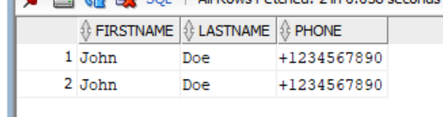

Display employees sorted by salary in descending order:
SELECT FirstName, LastName, Salary
FROM Employees
ORDER BY Salary DESC;
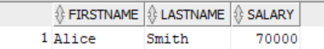

List clients whose email contains "gmail":
SELECT FirstName, LastName, Email
FROM Clients
WHERE Email LIKE '%gmail.com';
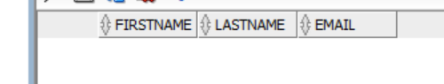
Find clients born before 1990:
SELECT FirstName, LastName, DateOfBirth FROM Clients WHERE DateOfBirth < TO_DATE('1990-01-01', 'YYYY-MM-DD');
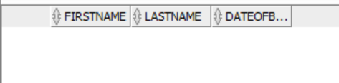
Display employees earning above the average salary:
SELECT FirstName, LastName, Salary FROM Employees WHERE Salary > (SELECT AVG(Salary) FROM Employees);
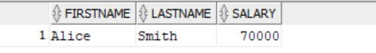

Display all clients without a passport number:
SELECT FirstName, LastName FROM Clients WHERE PassportNumber IS NULL;


Find clients whose names start with 'A' or 'B':
SELECT FirstName, LastName FROM Clients WHERE FirstName LIKE 'A%' OR FirstName LIKE 'B%';
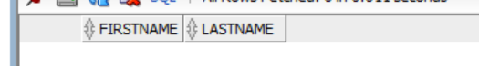

List services that have never been applied for:
SELECT serviceName FROM Services s LEFT JOIN Applications a ON s.serviceID = a.serviceID WHERE a.serviceID IS NULL;


Find the most common document type:
SELECT docType, COUNT(*) AS Total FROM Documents GROUP BY docType ORDER BY Total DESC FETCH FIRST 1 ROWS ONLY;
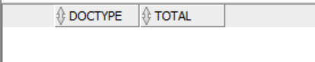

Retrieve the most recently uploaded document:
SELECT *
FROM Documents
ORDER BY uploadDate DESC
FETCH FIRST 1 ROWS ONLY;
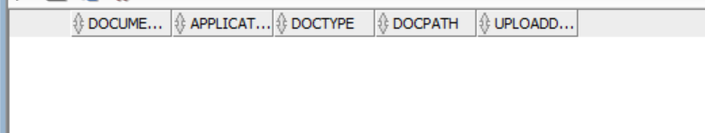

List services with fees not in a specific range:
SELECT serviceName, fee FROM Services WHERE fee NOT BETWEEN 50 AND 200;


Retrieve the first 5 highest-paid employees:
SELECT FirstName, LastName, Salary FROM Employees ORDER BY Salary DESC FETCH FIRST 5 ROWS ONLY;
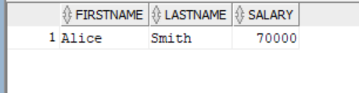

Retrieve clients who haven't applied for any service:
SELECT c.FirstName, c.LastName FROM Clients c LEFT JOIN Applications a ON c.clientID = a.clientID WHERE a.applicationID IS NULL;
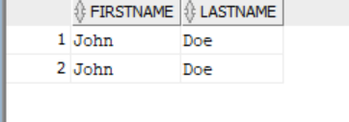

Find all clients whose last name contains 'son':
SELECT FirstName, LastName FROM Clients WHERE LastName LIKE '%son%'; 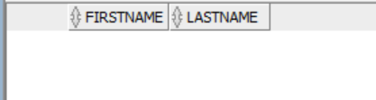

Retrieve the most recent application submitted:
SELECT *
FROM Applications
WHERE applicationDate = (SELECT MAX(applicationDate) FROM Applications);
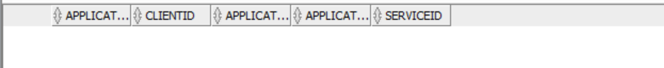

Use INTERSECT to find clients with both 'Pending' and 'Approved' applications:
SELECT clientID
FROM Applications
WHERE applicationStatus = 'Pending'
INTERSECT
SELECT clientID
FROM Applications
WHERE applicationStatus = 'Approved';
