**COMSATS UNIVERSITY ISLAMABAD**



**CSC211-Data Structures & Algorithms BDS 3A**

**Department of Computer Science**

**Final Lab Semester Group Project**

**Railway Management System**

* **Submitted By:**

**Mohib Ullah Azhar FA22-BDS-021**

**Noor E Eman Malik FA22-BDS-034**

**Mohammad Sofyan Abdullah FA22-BDS-047**

* **Submitted To:**

**Ma’am Nusrat Shaheen**

* **Date of Submission:**

**18th December 2023**

**RAILWAY MANAGEMENT SYSTEM**

**FEATURES:**

The following project is a train management system that controls the maximum aspects of railway (train) management. This management system comprises of:

* Linked List
* Graphs
* Binary Search Tree(BST)
* Stack
* Array List
* Loops/Switch
* Console-based GUI
* Vectors
* File Handling
* Error Handling

**Credentials:**

1. **Admin:**

* Password

1. **TRAIN:**

* Insert a Train
* View All Trains
* Search Specific Train
* Update Train Data
* Delete a Train

1. **TICKETS:**

* View All Tickets
* Search Specific Ticket
* View Recent Tickets and updation

1. **FILE HANDLING:**

* Back-Up Data

1. **User:**

* User authentication and passwords

1. **TRAIN & TICKETS:**

* View All Trains
* Book a Train
* View the **Minimum Distance** from one Station to another along with the **Trains on that Route**
* View the **Minimum Cost** from one Station to another along with the **Trains** on that Route
* Cancel Bookings
* View minimum cost Train
* View Maximum cost Train
* Inorder costs of train
* Logout

**Working:**

(NOTE: Can not enter strings with spaces due to the limitations of file handling)

**Admin Operations :**

**Overview:**

This management system provides various functionalities for the administrator to manage Trains and Tickets.

**Login:**

The admin must provide a password to access the Admin Menu. The admin password is set to **"admin123."**

**Admin Menu:**

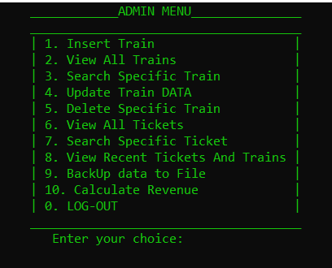

1. **Train Insertion:**

The admin can insert a new train along with its details and routes.This process is implemented using a linked list, and the inserted data is saved in the "**trains.txt"** file.

1. **View Trains:**

The admin has the privilege to view all available trains, including their details.

1. **Search Specific Train:**

The admin can search for a specific train based on its source and destination routes.

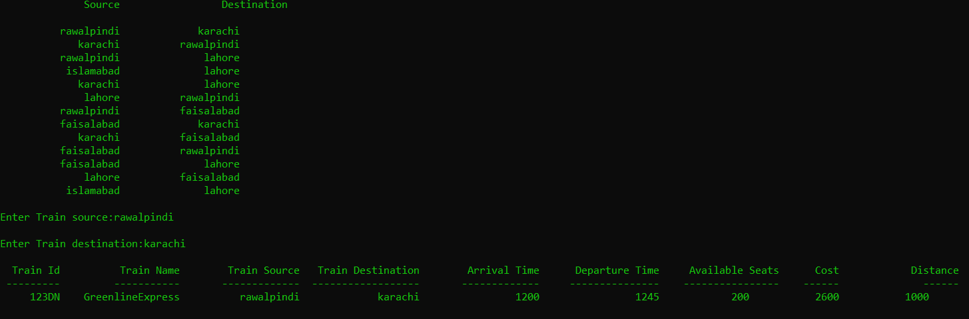

1. **Update Train Data:**

The admin has the authority to search and update the details of a train.The train node is searched using its unique train ID.

1. **Train Deletion:**

The admin has the authority to delete a train, including all its details.

Deleting a train will result in the loss of ticket details booked for that specific train.

1. **View All tickets Booked:**

In the admin module, the ticket details are displayed in a structured format, including information such as ticket number, train number, train name, booker name, number of seats, booked cost, source, destination, arrival time, and departure time. This display provides a comprehensive overview of booked tickets, facilitating efficient management and tracking of passenger reservations.

1. **VIEW RECENT TRAINS AND TICKETS:**

Whenever a train is inserted or a ticket is booked, then two stacks are maintained, the one stack contains the train ids and the other stack contains the ticket number. The admin can view the most recently inserted train and booked ticket.

**10. Calculate Revenue:**

This function allows user to calculate the revenue of the tickets booked at any stage.

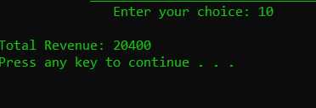

**User Operations:**

The user() function presents a menu for users, offering options to sign up, log in, or exit the program. Users can choose to register for a new account, log in to an existing one, or exit the Train Management System.

1. **Sign Up:**

Invokes the signup function to allow users to create a new account. And then stores user credentials in a separate file named “**user.txt”** for later use.

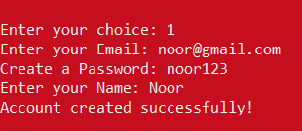

1. **Login:**

Invokes the login function for users to log in with existing credentials, providing authentication.

1. **Exit:**

Exits the program. And returns to the main Menu.

**User Menu() Function:**

The User Menu() function displays a user-specific menu after successful login. Users can perform various operations related to train management, ensuring authenticated access.

1. **View Trains:**

Displays all available trains along with their details so that user can select the train he wants to travel in.

1. **Book Ticket:**

Initiated through the bookTicketMenu function, the ticket booking process involves users providing source and destination details, selecting an available train by its unique ID, and confirming the booking. Users enter their name and specify the number of seats, receiving a detailed confirmation summary. Upon confirmation, the system generates a unique ticket number and saves the booked ticket information, including Train Number, Train Name, Booker Name, Number of Seats, Booked Cost, Source, Destination, Arrival Time, and Departure Time. Users are then prompted to return to the main menu for further interactions within the Train Management System.

1. A screenshot of a computer

   Description automatically generated**View Minimum Distance and Cost:**The "View Minimum Distance and Cost" feature utilizes **Dijkstra's algorithm and Prims algorithm** to compute optimal routes in a graph-based system. By taking a source city and graph structure as input, the function calculates and displays minimum distances and costs to all other cities. The output includes comprehensive details such as minimum routes, available trains on each route, and associated information like train IDs, names, timings, available seats, costs, and distances. This functionality enhances user decision-making by providing insights into efficient travel routes and associated expenses. Overall, it optimizes the user experience within the Train Management System.
2. **View Booking Video:**

Displays a video link related to the booking process for user ease. 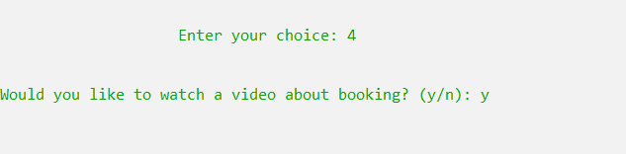

1. **Feedback:**

* **Feedback Menu:**

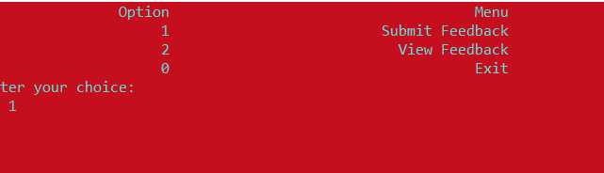

* **Submit Feedback:**

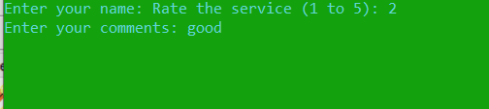

* **View Feedback:**

1. 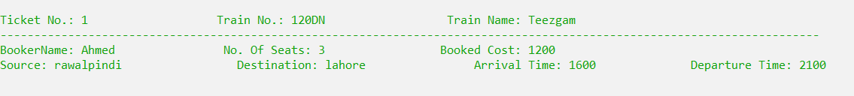**To View Booked Tickets:**

User can see its own booked ticket.

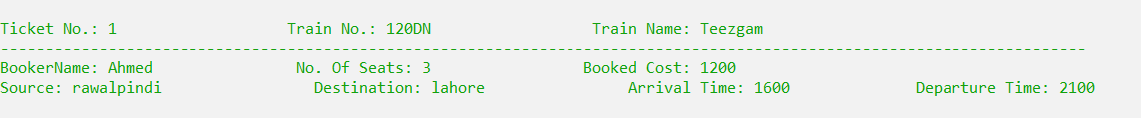

1. **Search a Train by its cost:**

By using CostTree we can search for the specific cost.

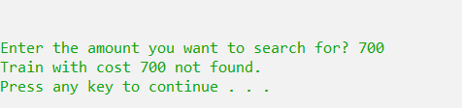

1. **Minimum Cost Train:**

Searches the minimum cost train for the user on a specific route. 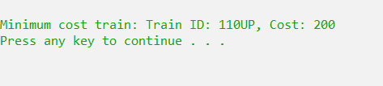

1. **Maxmimum Cost Train:**

Searches the maximum cost train for the user using Trees.

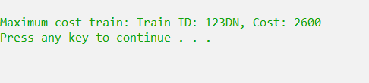

1. **To see train prices in an ascending order:**

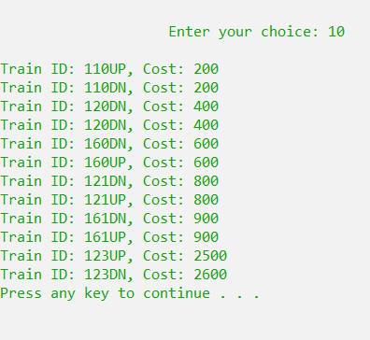

1. **To cancel a ticket:**

User can cancel his ticket by entering the ticket number .

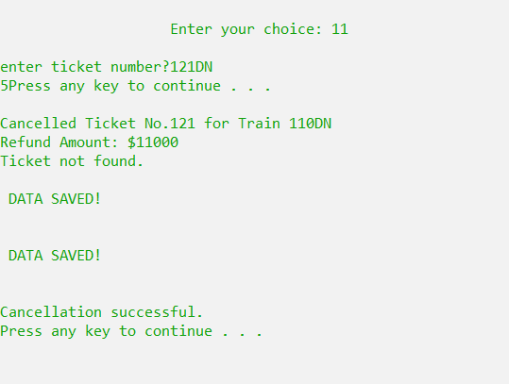

1. **Main Menu:**

Returns to the main menu.

