**INTERPRETER vs COMPILER**

|  |  |
| --- | --- |
| **INTERPRETER** | **COMPILER** |
| Translates program one statement at a time | Scans the entire program and translates it as a whole into machine code. |
| Interpreters usually take less amount of time to analyze the source code. However, the overall execution time is comparatively slower than compilers. | Compilers usually take a large amount of time to analyze the source code. However, the overall execution time is comparatively faster than interpreters. |
| The interpreter does not generate any intermediate code forms. | The compiler gives intermediate code forms or object code |
| The execution of the program takes place after every line is evaluated and hence the error is raised line by line if any. | The execution of the program happens only after the entire program is compiled. |
| Machine code is not stored anywhere. | Stores machine code in the disk storage. |
| Displays the errors from line to line. The program runs till the error is found and proceeds further on resolving. | All the errors are shown at the end of the compilation and the program cannot be run until the error is resolved |

**Data types in Python**

1. Numeric
2. String
3. List
4. Tuple
5. Dictionary

**Note:** type() function is used to determine the type of data type.

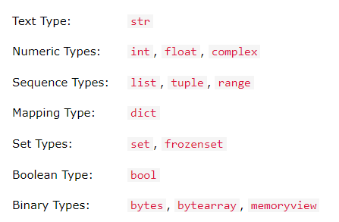

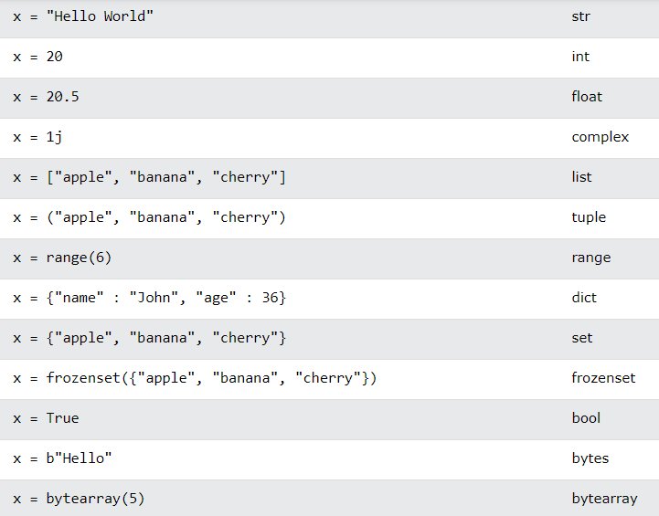



**Numeric**

Int, float and complex number

**String**

 A string is a collection of one or more characters put in a single quote, double-quote or triple quote. In python there is no character data type, a character is a string of length one. It is represented by str class

**List**

List are just like the arrays, declared in other languages which is a ordered collection of data. It is very flexible as the items in a list do not need to be of the same type and they are mutable.

Lists in Python can be created by just placing the sequence inside the square brackets[]

**Tuple**

The only difference between tuple and list is that tuples are immutable i.e. tuples cannot be modified after it is created. It is represented by tuple class.

Tuples are usually faster than lists.

**Dictionary**

Dictionary in Python is an unordered collection of data values, dictionary holds key:value pair

Each key-value pair in a Dictionary is separated by a colon :, whereas each key is separated by a ‘comma’

Dictionary can be created by placing a sequence of elements within curly {} braces, separated by ‘comma’

 Values in a dictionary can be of any datatype and can be duplicated, whereas keys can’t be repeated and must be immutable

Dictionary keys are case sensitive, same name but different cases of Key will be treated distinctly

**Print function**

The print() function prints the specified message to the screen, or other standard output device.

The message can be a string, or any other object, the object will be converted into a string before written to the screen.

