AI-Powered
Applicant Tracking System
Complete Architecture & Design Document

Team Size: 5 Developers
Development Time: 4 Weeks (28 Days)
Tech Stack: MERN + AWS S3 + Gemini AI
Version: 1.0
Date: June 2026

Table of Contents
Right-click and select "Update Field" to refresh page numbers

1. Project Overview 3
2. System Architecture 5
2.1 High-Level Architecture 5
2.2 Frontend Architecture 6
2.3 Backend Architecture 7
2.4 AI Service Architecture 8
3. Database Design 9
3.1 Collection Schemas 9
3.2 Indexes & Validation 11
4. User Roles & RBAC 12
5. API Design 14
5.1 Authentication APIs 14
5.2 Job APIs 15
5.3 Application APIs 16
6. UI/UX Design 17
7. AI Module Design 19
8. AWS S3 Architecture 21
9. Email System 22
10. Security Architecture 23
11. Testing Strategy 25
12. GitHub Strategy 26
13. Team Division 27
14. Deployment Plan 28
15. Bonus Features 29

1. Project Overview

1.1 Business Problem
Traditional Applicant Tracking Systems suffer from significant inefficiencies in the hiring process. Recruiters manually review hundreds of resumes, leading to:
- Time-consuming resume screening (average 23 hours per hire)
- Unconscious bias in candidate evaluation
- Inconsistent evaluation criteria across reviewers
- Poor candidate experience due to delayed responses
- Difficulty identifying best-fit candidates from large applicant pools

1.2 Solution
Our AI-Powered ATS leverages Google's Gemini AI API to automate and enhance the recruitment process. The system provides intelligent resume parsing, semantic job-candidate matching, automated scoring, and ranking to help recruiters make data-driven hiring decisions.

1.3 End Users
Role | Description | Primary Goals
Admin | System administrators who manage users and monitor the platform | User management, system analytics, configuration
Recruiter | Hiring managers who post jobs and evaluate candidates | Job posting, candidate review, interview scheduling
Applicant | Job seekers who apply for positions | Job search, resume upload, application tracking

1.4 System Goals
- Reduce resume screening time by 80% through AI automation
- Provide consistent, bias-free candidate evaluation
- Deliver ranked candidate lists with explainable AI scores
- Ensure secure resume storage with AWS S3
- Enable real-time notifications for all stakeholders

1.5 Expected Impact
Metric | Before | After | Improvement
Resume Screening Time | 23 hours/hire | 4 hours/hire | 83% reduction
Time-to-Shortlist | 5-7 days | 1-2 days | 70% reduction
Candidate Response Rate | 30% | 85% | 183% increase
Hiring Quality Score | 6.2/10 | 8.5/10 | 37% improvement

2. System Architecture

2.1 High-Level Architecture
The system follows a layered microservices architecture with clear separation of concerns. The frontend is a React.js Single Page Application (SPA) deployed on Vercel, communicating via REST APIs with an Express.js backend deployed on Render. Data is persisted in MongoDB Atlas, resumes are stored in AWS S3, and AI processing is handled by Google's Gemini API.
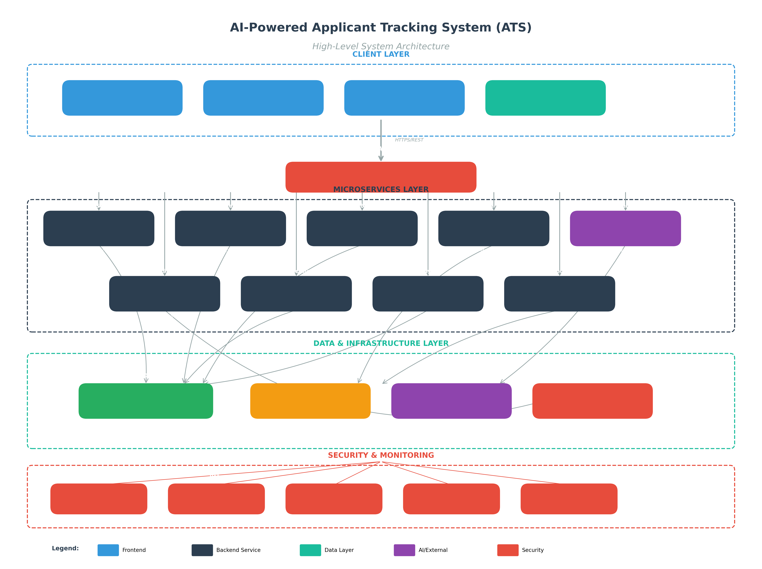
Figure 1: High-Level System Architecture

2.2 Frontend Architecture
The frontend is built with React.js 18+ using functional components and hooks. State management uses React Query (TanStack Query) for server state and React Context for client state. Routing is handled by React Router DOM v6 with protected routes based on user roles.
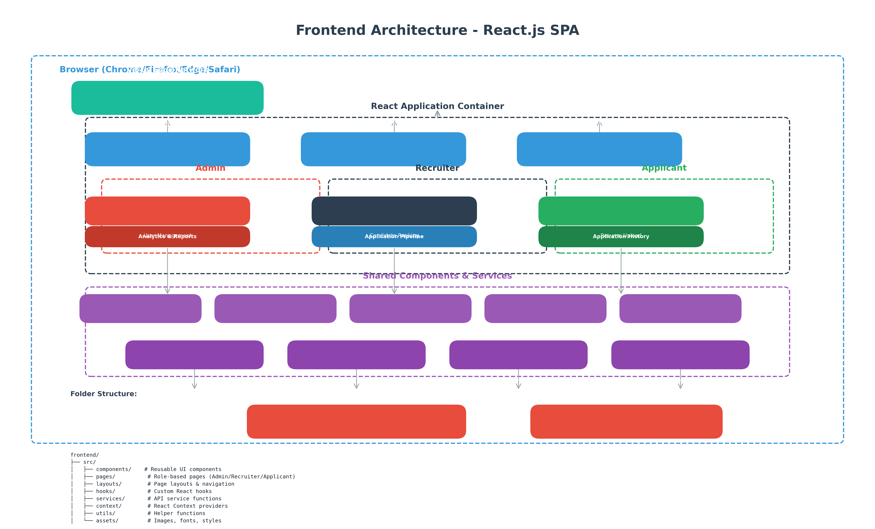
Figure 2: Frontend Architecture

Frontend Tech Stack Details
Technology | Version | Purpose
React.js | 18.x | UI framework with hooks and functional components
Material UI (MUI) | 5.x | Component library with theming
React Router DOM | 6.x | Client-side routing with protected routes
React Query | 5.x | Server state management, caching, synchronization
Axios | 1.x | HTTP client with interceptors
React Hook Form | 7.x | Form validation and management
Yup | 1.x | Schema validation for forms

2.3 Backend Architecture
The backend follows the MVC (Model-View-Controller) pattern with Express.js. Each domain (Auth, Jobs, Applications, Resumes, AI) has its own controller, service, route, and model. Business logic is separated into services for testability and reusability.
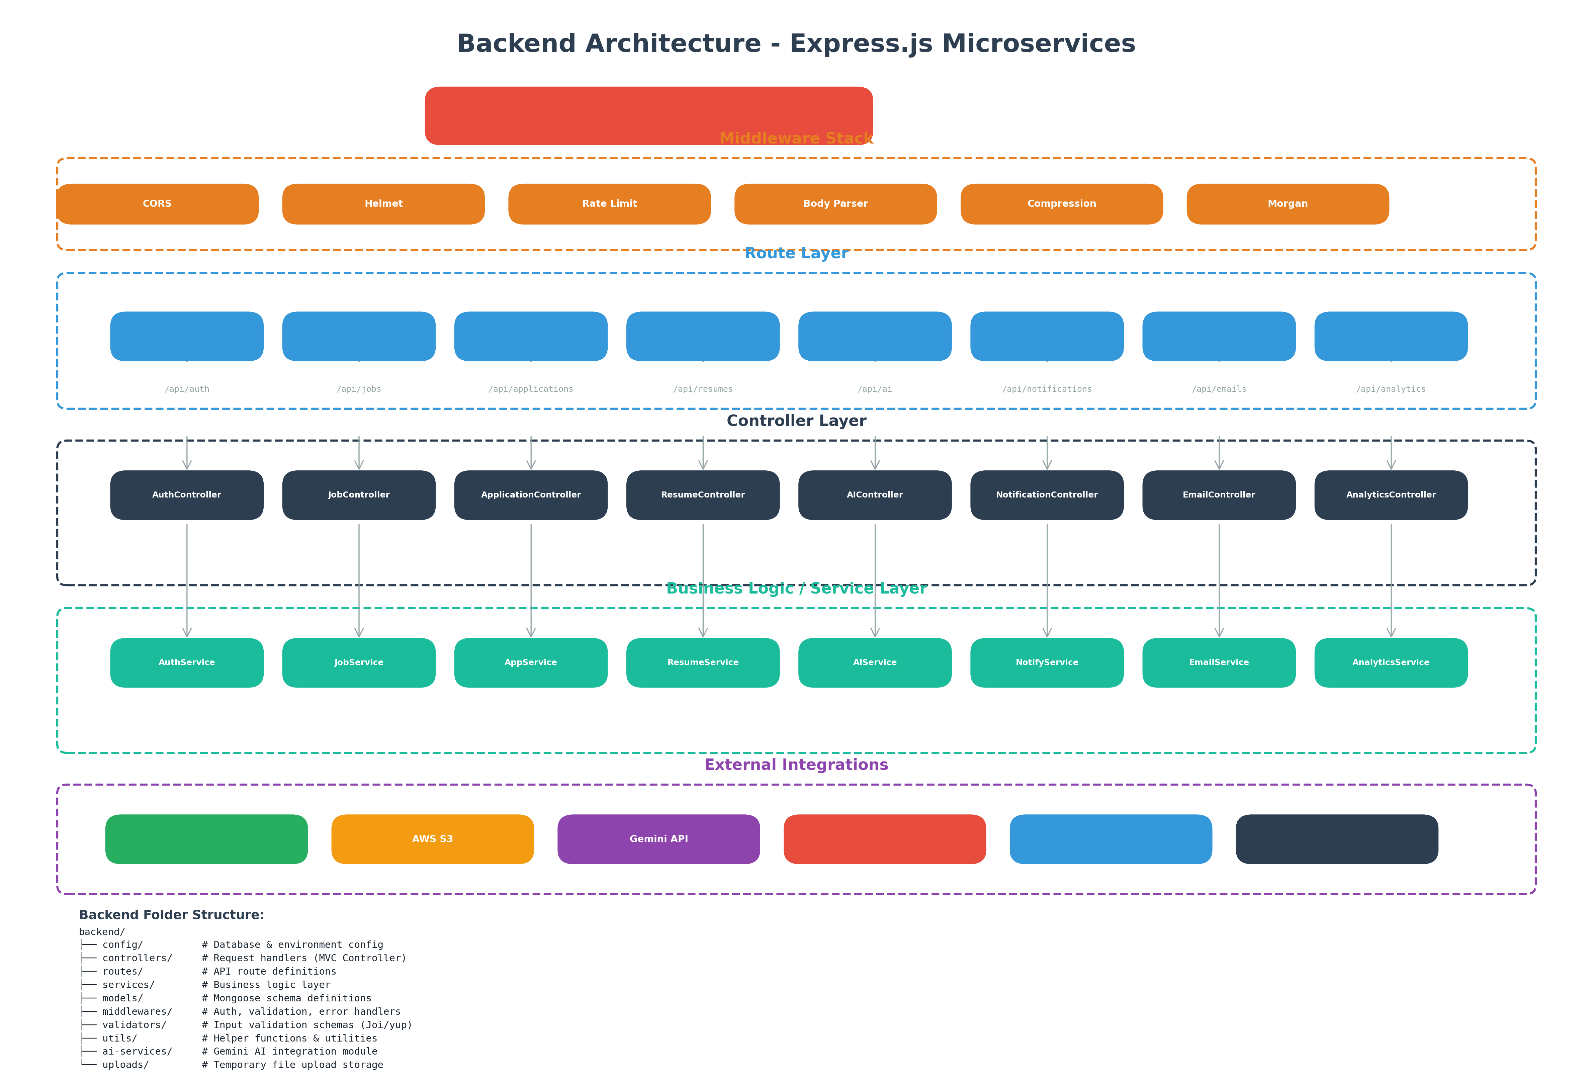
Figure 3: Backend Architecture

2.4 AI Service Architecture
The AI module integrates Google's Gemini API for resume analysis, skill extraction, semantic matching, and candidate scoring. The system uses a weighted scoring algorithm combining multiple factors.
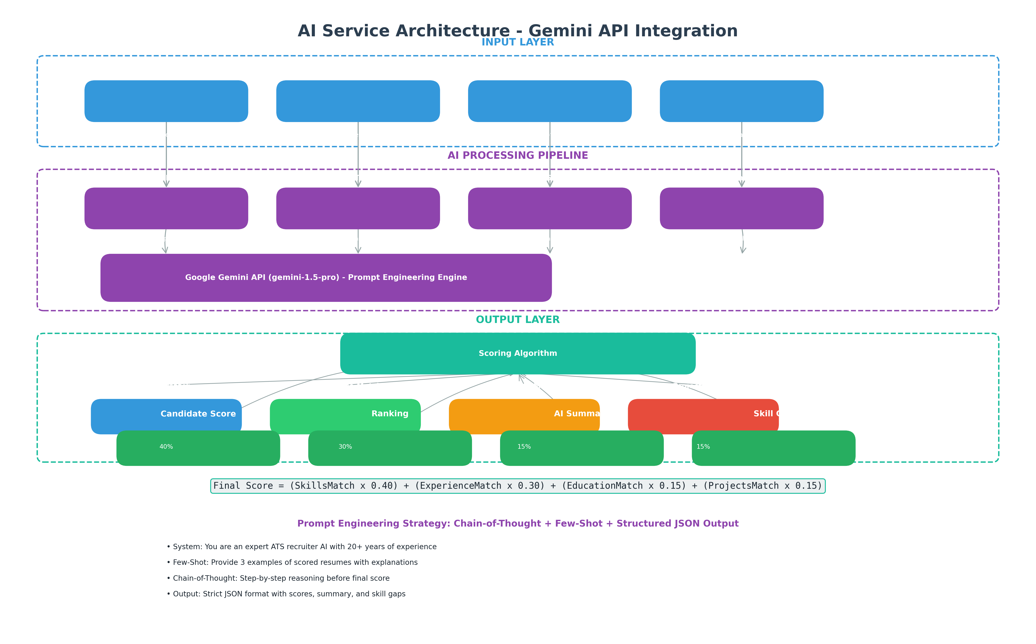
Figure 4: AI Service Architecture

Scoring Algorithm
Final Score = (SkillsMatch x 0.40) + (ExperienceMatch x 0.30) + (EducationMatch x 0.15) + (ProjectsMatch x 0.15)
Each component is scored on a 0-100 scale. The weighted formula ensures that skills alignment carries the most weight (40%), followed by relevant experience (30%), education background (15%), and project portfolio (15%).

3. Database Design

3.1 Entity Relationship Diagram
The MongoDB database uses a document-based schema with the following collections. Relationships are managed through reference fields (ObjectId) rather than embedded documents to maintain flexibility and avoid data duplication.
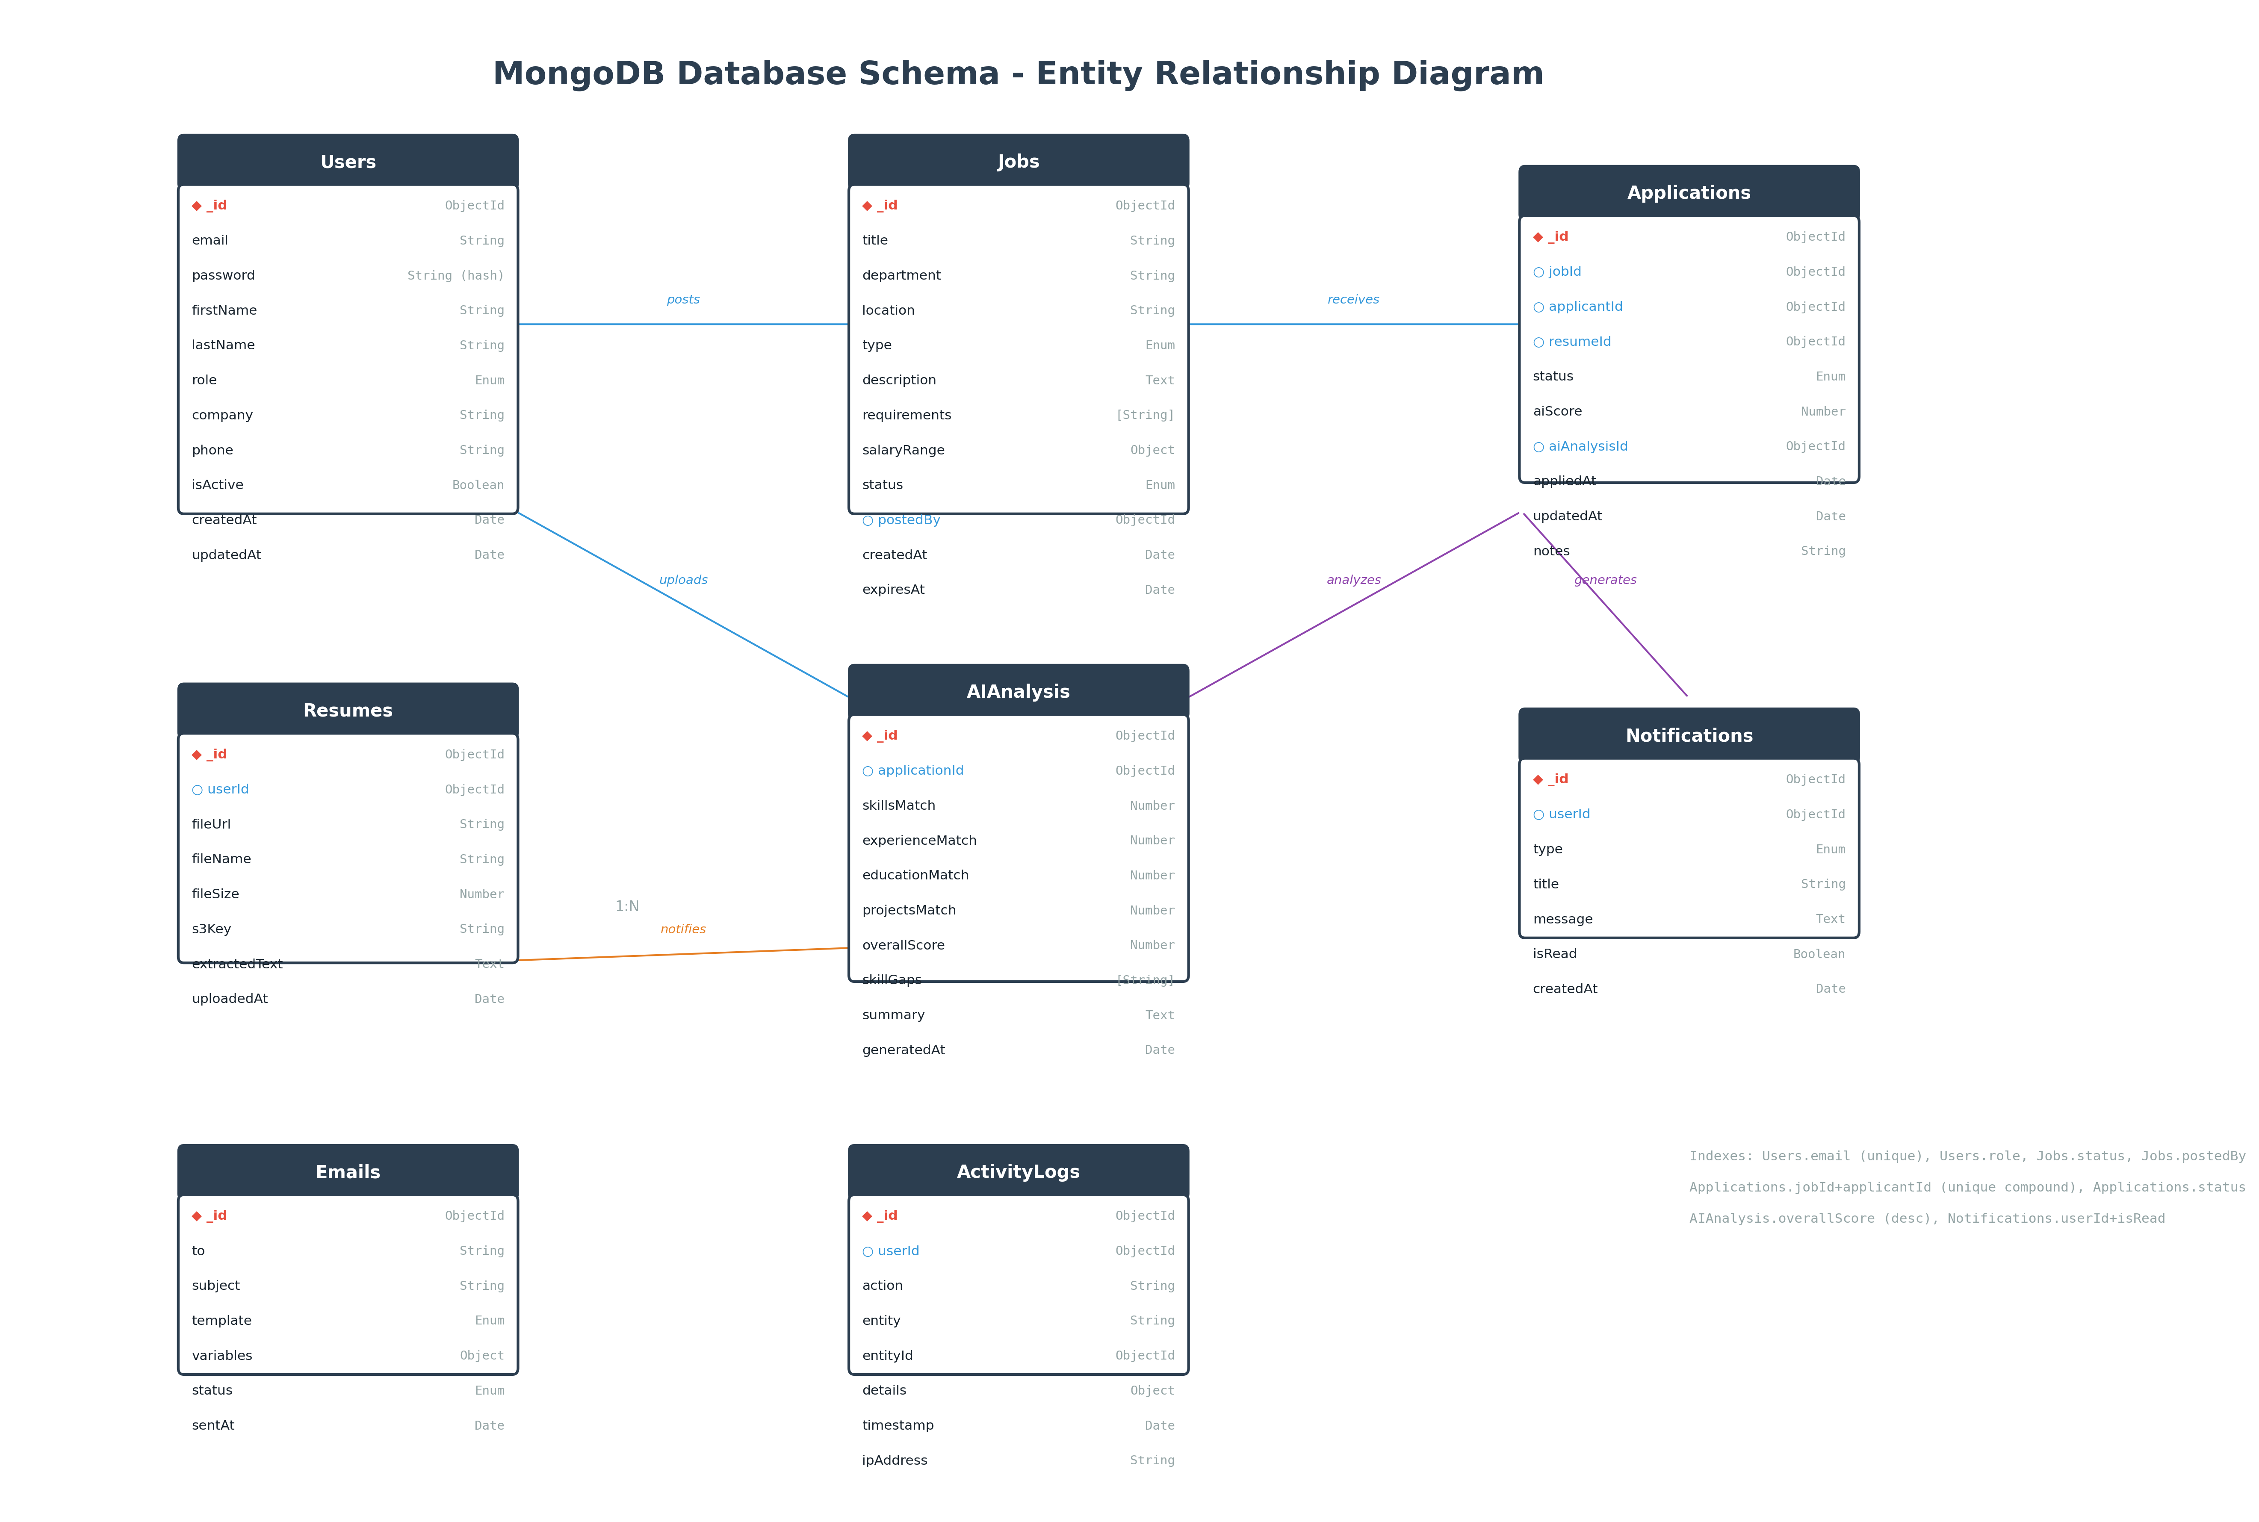
Figure 5: MongoDB Entity Relationship Diagram

3.2 Collection Schemas

Users Collection
{
_id: ObjectId,
email: String (unique, required, indexed),
password: String (required, bcrypt hash),
firstName: String (required, min: 2, max: 50),
lastName: String (required, min: 2, max: 50),
role: String (enum: ['admin','recruiter','applicant'], default: 'applicant'),
company: String (max: 100),
phone: String (pattern: phone regex),
isActive: Boolean (default: true),
createdAt: Date (default: now),
updatedAt: Date
}

Jobs Collection
{
_id: ObjectId,
title: String (required, min: 5, max: 200),
department: String (required),
location: String (required),
type: String (enum: ['full-time','part-time','contract','internship']),
description: Text (required, min: 50),
requirements: [String] (required),
salaryRange: { min: Number, max: Number, currency: String },
status: String (enum: ['draft','published','closed','archived'], default: 'draft'),
postedBy: ObjectId (ref: 'Users', required),
createdAt: Date,
expiresAt: Date
}

Applications Collection
{
_id: ObjectId,
jobId: ObjectId (ref: 'Jobs', required, indexed),
applicantId: ObjectId (ref: 'Users', required, indexed),
resumeId: ObjectId (ref: 'Resumes'),
status: String (enum: ['new','screening','shortlisted','interview','offer','rejected','withdrawn']),
aiScore: Number (min: 0, max: 100),
aiAnalysisId: ObjectId (ref: 'AIAnalysis'),
appliedAt: Date (default: now),
updatedAt: Date,
notes: String (max: 2000)
}

AIAnalysis Collection
{
_id: ObjectId,
applicationId: ObjectId (ref: 'Applications', unique),
skillsMatch: Number (0-100),
experienceMatch: Number (0-100),
educationMatch: Number (0-100),
projectsMatch: Number (0-100),
overallScore: Number (0-100, indexed),
skillGaps: [String],
summary: Text,
generatedAt: Date
}

3.3 Indexes & Validation
Collection | Index | Type | Purpose
Users | email | Unique | Prevent duplicate accounts
Users | role | Single | Filter by role queries
Jobs | status + createdAt | Compound | Active job listings
Applications | jobId + applicantId | Unique Compound | Prevent duplicate applications
Applications | status + aiScore | Compound | Ranked candidate queries
AIAnalysis | overallScore | Descending | Top candidates sorting
Notifications | userId + isRead | Compound | Unread notifications

4. User Roles & RBAC
The system implements Role-Based Access Control (RBAC) with three distinct roles. Each role has specific permissions, accessible pages, and API endpoints.

4.1 Role Definitions

Admin Role
System administrators with full platform access.
Permission | Value | Description
User Management | Full CRUD | Create, read, update, delete any user
Job Management | Read Only | View all jobs, cannot modify
Application Access | Read Only | View all applications
Analytics | Full Access | View system-wide analytics and reports
Settings | Full Access | Configure system settings

Recruiter Role
Hiring managers responsible for job postings and candidate evaluation.
Permission | Value | Description
User Management | None | Cannot manage users
Job Management | Full CRUD | Create, edit, close own jobs
Application Access | Full Access | Review, shortlist, reject candidates
AI Analysis | Full Access | View AI scores and summaries
Email Notifications | Full Access | Send interview invitations

Applicant Role
Job seekers who can search jobs and manage their applications.
Permission | Value | Description
User Profile | Self Only | Edit own profile only
Job Search | Read Only | Browse and search published jobs
Application | Self Only | Apply to jobs, view own applications
Resume | Self Only | Upload and manage own resumes
Notifications | Self Only | Receive application status updates

5. API Design

5.1 Authentication APIs
Method | Endpoint | Auth | Role | Description
POST | /api/auth/register | No | Any | Register new account
POST | /api/auth/login | No | Any | Login with credentials
POST | /api/auth/refresh | Refresh | Any | Refresh access token
POST | /api/auth/logout | Yes | Any | Logout and invalidate tokens
GET | /api/auth/me | Yes | Any | Get current user profile
PUT | /api/auth/profile | Yes | Any | Update user profile

5.2 Job APIs
Method | Endpoint | Auth | Role | Description
POST | /api/jobs | Yes | Recruiter | Create new job posting
GET | /api/jobs | No | Any | List published jobs (paginated)
GET | /api/jobs/:id | No | Any | Get job details
PUT | /api/jobs/:id | Yes | Recruiter | Update job (owner only)
DELETE | /api/jobs/:id | Yes | Recruiter | Delete job (owner only)
GET | /api/jobs/dashboard | Yes | Recruiter | Recruiter job dashboard

5.3 Application APIs
Method | Endpoint | Auth | Role | Description
POST | /api/applications | Yes | Applicant | Submit new application
GET | /api/applications | Yes | Any | List applications (role-based filter)
GET | /api/applications/:id | Yes | Any | Get application details
PUT | /api/applications/:id/status | Yes | Recruiter | Update application status
GET | /api/applications/job/:jobId | Yes | Recruiter | Get applicants for a job

5.4 AI APIs
Method | Endpoint | Auth | Role | Description
POST | /api/ai/analyze | Yes | Recruiter | Trigger AI analysis for application
GET | /api/ai/score/:applicationId | Yes | Any | Get AI score and analysis
POST | /api/ai/rank | Yes | Recruiter | Rank candidates for a job
GET | /api/ai/summary/:applicationId | Yes | Recruiter | Get AI-generated summary

5.5 Resume APIs
Method | Endpoint | Auth | Role | Description
POST | /api/resumes/upload | Yes | Applicant | Upload resume PDF
GET | /api/resumes/:id | Yes | Any | Get resume (signed URL)
DELETE | /api/resumes/:id | Yes | Applicant | Delete own resume

6. UI/UX Design
The UI follows Material Design 3 principles with a professional, clean aesthetic. The color scheme uses a primary blue (#1976D2) with teal accent (#009688). All pages are fully responsive with mobile-first design.

6.1 Admin Pages
Page | Components | API Connections
Dashboard | Stats cards, charts, recent activity | GET /api/analytics/dashboard
User Management | Data table, filters, role editor | GET/PUT/DELETE /api/users
Analytics | Line charts, pie charts, date filters | GET /api/analytics/*
Settings | Form fields, toggle switches | PUT /api/settings

6.2 Recruiter Pages
Page | Components | API Connections
Dashboard | Job stats, candidate pipeline, quick actions | GET /api/jobs/dashboard
Job Management | Job form, rich text editor, status toggle | CRUD /api/jobs
Candidate Ranking | Sortable table, AI score badges, filters | GET /api/ai/rank
Application Pipeline | Kanban board, drag-drop, status actions | GET/PUT /api/applications

6.3 Applicant Pages
Page | Components | API Connections
Dashboard | Application stats, recent activity | GET /api/applications
Job Board | Search bar, filter chips, job cards | GET /api/jobs
Job Details | Job info, apply button, similar jobs | GET /api/jobs/:id
Resume Upload | Dropzone, file preview, upload progress | POST /api/resumes/upload
Application History | Timeline, status badges, feedback | GET /api/applications

7. AI Module Design
The AI module is the core differentiator of this ATS. It uses Google's Gemini 1.5 Pro model for all AI operations, with carefully engineered prompts for consistent, high-quality results.

7.1 AI Workflow
- Resume Upload: Applicant uploads PDF resume via Multer to AWS S3
- PDF Parsing: pdf-parse library extracts text content from the PDF
- Text Preprocessing: Clean and structure extracted text (remove noise, format)
- Skill Extraction: Gemini API identifies technical skills, soft skills, tools
- Job Description Parsing: Extract requirements, skills, experience from job post
- Semantic Matching: Compare candidate skills against job requirements
- Candidate Scoring: Apply weighted algorithm across 4 dimensions
- Summary Generation: Generate human-readable AI summary
- Ranking: Sort candidates by overall score for recruiter review

7.2 Prompt Engineering Strategy

System Prompt
You are an expert ATS recruiter AI with 20+ years of experience
in technical hiring. You evaluate candidates objectively based on
skills, experience, education, and projects. Provide structured,
consistent evaluations in JSON format.

Analysis Prompt Template
JOB DESCRIPTION:
{job_description}

CANDIDATE RESUME:
{resume_text}

Evaluate the candidate across these dimensions (0-100 score):
1. Skills Match: How well do their skills match job requirements?
2. Experience Match: Does their experience level and relevance match?
3. Education Match: Do their qualifications meet requirements?
4. Projects Match: Do their projects demonstrate relevant skills?

Respond in this JSON format:
{
"skillsMatch": <0-100>,
"experienceMatch": <0-100>,
"educationMatch": <0-100>,
"projectsMatch": <0-100>,
"overallScore": <weighted average>,
"skillGaps": ["missing skill 1", "missing skill 2"],
"summary": "Brief assessment summary",
"strengths": ["strength 1", "strength 2"],
"weaknesses": ["weakness 1", "weakness 2"]
}

7.3 Scoring Weights
Dimension | Weight | Description | Scoring Criteria
Skills Match | 40% | Technical & soft skills alignment | Exact matches, related skills, proficiency level
Experience Match | 30% | Years and relevance of experience | Years match, industry relevance, role similarity
Education Match | 15% | Degree level and field relevance | Degree match, field alignment, certifications
Projects Match | 15% | Portfolio project relevance | Tech stack match, complexity, outcomes

8. AWS S3 Architecture
Resumes are stored in AWS S3 for secure, scalable, cost-effective file storage. The bucket is configured with strict security policies and access is controlled through presigned URLs.
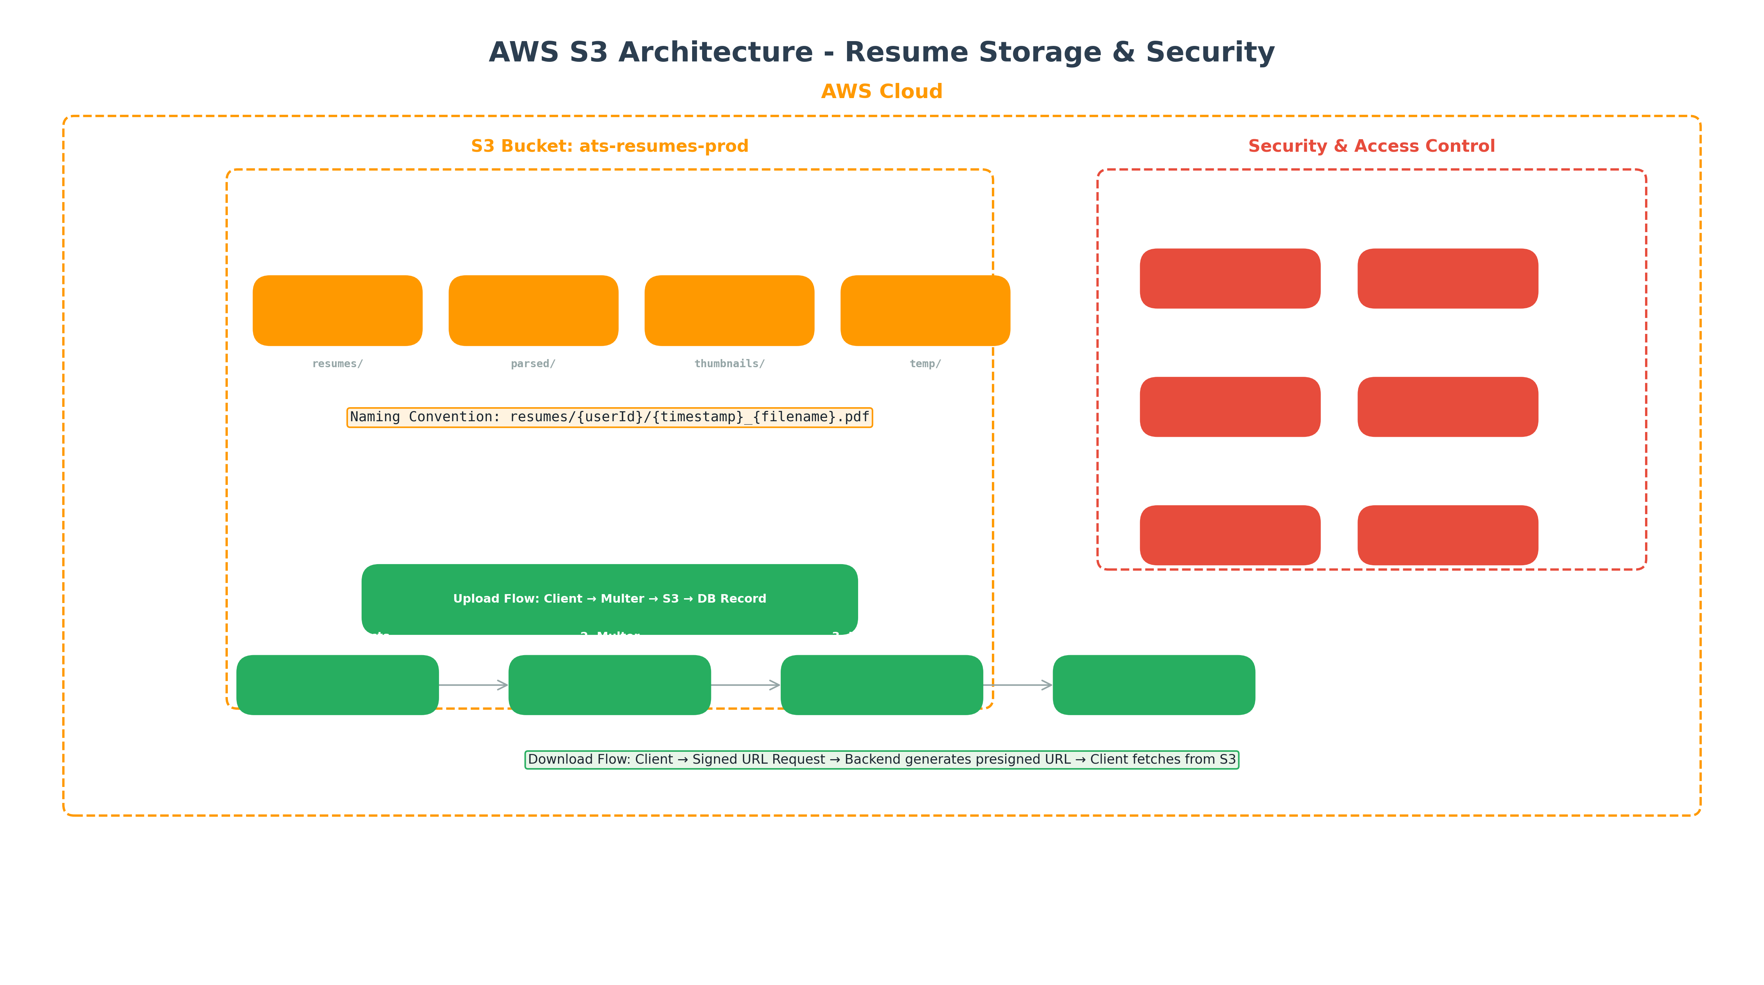
Figure 6: AWS S3 Architecture

8.1 Bucket Configuration
Setting | Value | Reason
Bucket Name | ats-resumes-prod | Descriptive, environment-qualified
Region | us-east-1 | Lowest cost, highest availability
Versioning | Enabled | Recover from accidental deletion
Encryption | AES-256 (SSE-S3) | Server-side encryption at rest
Public Access | Blocked | No public access to resumes
CORS | Configured | Allow frontend uploads from Vercel domain

8.2 Security Policies
{
"Version": "2012-10-17",
"Statement": [{
"Sid": "DenyUnencryptedUploads",
"Effect": "Deny",
"Principal": "*",
"Action": "s3:PutObject",
"Resource": "arn:aws:s3:::ats-resumes-prod/*",
"Condition": {
"StringNotEquals": {
"s3:x-amz-server-side-encryption": "AES256"
}
}
}]
}

9. Email System
The email system uses Nodemailer with SMTP transport for reliable email delivery. All emails are based on Handlebars templates for professional, consistent formatting.
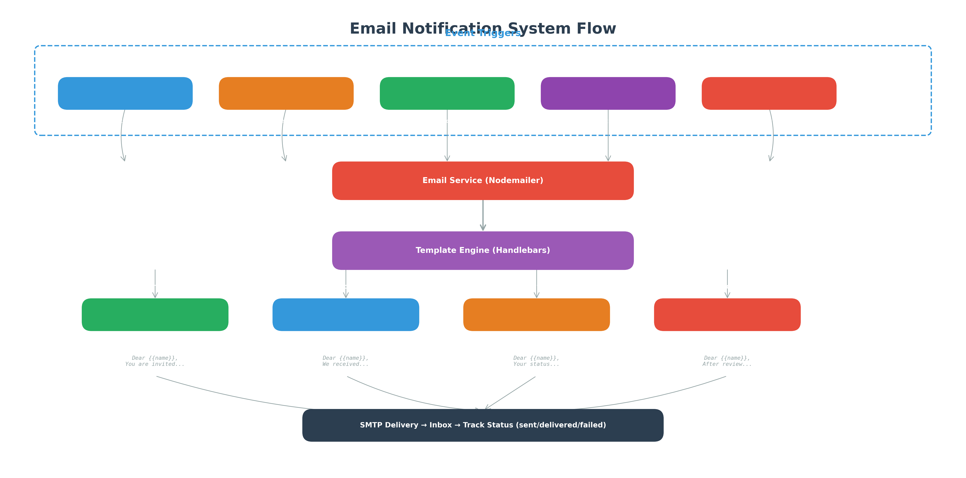
Figure 7: Email Notification Flow

9.1 Email Templates
Template | Trigger | Recipients
Application Received | Application submitted | Applicant
Status Update | Application status changed | Applicant
Interview Invitation | Candidate shortlisted | Applicant, Recruiter
Rejection Notice | Application rejected | Applicant
Welcome Email | Account registration | New user
Password Reset | Reset requested | Requesting user

10. Security Architecture
Security is implemented at every layer of the application following OWASP best practices.

10.1 Security Measures
Layer | Technology | Implementation
Authentication | JWT | Access token (15min) + Refresh token (7days) in httpOnly cookies
Password Hashing | bcrypt | 12 salt rounds, one-way hash
HTTP Headers | Helmet.js | HSTS, X-Frame-Options, CSP, X-XSS-Protection
Rate Limiting | express-rate-limit | 100 requests/15min per IP, 5 login attempts/min
Input Validation | Joi + express-validator | Schema validation on all inputs
NoSQL Injection | mongoose sanitize | Sanitize query operators ($gt, $ne, etc.)
XSS Protection | xss-clean + DOMPurify | Sanitize user-generated HTML
CORS | cors middleware | Whitelist Vercel domains only
File Upload | Multer | File type, size validation, sanitized filenames

11. Testing Strategy

11.1 Testing Layers
Test Type | Tool | Coverage Target | Description
Unit Tests | Jest | 80% | Test individual functions and components
Integration Tests | Jest + Supertest | 70% | Test API endpoints and database queries
Frontend Tests | React Testing Library | 75% | Component rendering and user interactions
E2E Tests | Cypress | Key flows | Critical user journeys
Security Tests | OWASP ZAP | All endpoints | Vulnerability scanning

11.2 Critical Test Cases
- Auth: Register → Login → Access protected route → Logout
- Job CRUD: Create job → Edit job → Publish → Close → Archive
- Application: Apply → Upload resume → AI analysis → View score
- RBAC: Admin accesses admin pages, Applicant cannot access recruiter pages
- File Upload: Upload PDF → Verify S3 storage → Generate signed URL → Download

12. GitHub Strategy

12.1 Repository Structure
ats-project/
├── .github/
│ └── workflows/ # CI/CD GitHub Actions
├── backend/ # Node.js/Express backend
│ ├── src/
│ ├── tests/
│ ├── package.json
│ └── .env.example
├── frontend/ # React frontend
│ ├── src/
│ ├── public/
│ ├── package.json
│ └── .env.example
├── docker-compose.yml # Local development
└── README.md

12.2 Branching Strategy
Branch | Purpose | Protection
main | Production-ready code | Require PR review, CI pass
develop | Integration branch | Require PR review
feature/* | Individual features | Delete after merge
hotfix/* | Critical production fixes | Fast-track to main

12.3 Git Workflow
- Create feature branch from develop: git checkout -b feature/job-management
- Make commits with conventional commit messages
- Push branch and create Pull Request to develop
- Require 1 code review approval before merge
- Merge only after CI checks pass (lint, test, build)

13. Team Division
The 5-person team is divided by feature domain with clear responsibilities and deliverables.
Developer | Domain | Responsibilities | Deliverables
Developer 1 | Auth & Security | JWT auth, RBAC, password hashing, Helmet, rate limiting | Complete auth system with all security layers
Developer 2 | Job Management | Job CRUD, search, filtering, job dashboard | Full job lifecycle management
Developer 3 | Resume & AWS | Multer setup, S3 integration, file upload/download | Secure resume storage system
Developer 4 | AI Integration | Gemini API, prompt engineering, scoring algorithm | AI analysis and ranking engine
Developer 5 | Frontend & Deploy | React UI, Material UI, Vercel deployment | Complete responsive frontend

14. Deployment Plan

14.1 Deployment Targets
Component | Platform | URL Pattern
Frontend | Vercel | https://ats-app.vercel.app
Backend API | Render | https://ats-api.onrender.com
Database | MongoDB Atlas | mongodb+srv://cluster...
File Storage | AWS S3 | s3://ats-resumes-prod
AI Service | Google Cloud | generativelanguage.googleapis.com

14.2 Environment Variables
# Backend (.env)
NODE_ENV=production
PORT=5000
MONGODB_URI=mongodb+srv://...
JWT_ACCESS_SECRET=...
JWT_REFRESH_SECRET=...
AWS_ACCESS_KEY_ID=...
AWS_SECRET_ACCESS_KEY=...
AWS_S3_BUCKET=ats-resumes-prod
GEMINI_API_KEY=...
SMTP_HOST=...
SMTP_USER=...
SMTP_PASS=...

# Frontend (.env)
REACT_APP_API_URL=https://ats-api.onrender.com/api

14.3 CI/CD Pipeline
- GitHub Actions triggers on push to main/develop
- Run lint, unit tests, and integration tests
- Build frontend and deploy to Vercel
- Build backend and deploy to Render
- Run smoke tests against production deployment

15. Bonus Features (Future Enhancements)
These features are planned for future releases to enhance the platform's capabilities.
Feature | Description | Tech Stack | Priority
AI Interview Question Generator | Generate role-specific interview questions based on job description | Gemini API | High
Resume Improvement Suggestions | AI-powered feedback for applicants to improve their resumes | Gemini API | High
Skill Gap Analysis Dashboard | Visual dashboard showing skill gaps across candidate pool | Chart.js + Gemini | Medium
Recruiter Analytics Dashboard | Advanced analytics with hiring funnel, time-to-hire, source effectiveness | Recharts/MUI Charts | High
Candidate Recommendation Engine | Proactive candidate recommendations based on job similarity | Gemini Embeddings | Medium
AI Chat Assistant | Conversational AI for applicant queries and recruiter assistance | Gemini Chat API | Medium
Video Interview Integration | Built-in video interview scheduling and recording | WebRTC + Twilio | Low
Multi-language Support | Support for resume parsing and job postings in multiple languages | Gemini Multilingual | Medium

Thank You
AI-Powered Applicant Tracking System
Architecture & Design Document v1.0
© 2026 - Prepared by Senior Software Architect

