**MILESTONE 1**



**Spring 2025**

**CSE-403L Database Management System Lab**

Submitted by: **Ayesha Fayyaz (2123)**

**Noor ul huda (2117)**

**Uswa Asad (2131)**

**Aleshba Aaina (2202)**

Semester: **6th**

Section: **B**

“On my honor, as student of University of Engineering and Technology, I have neither given nor received unauthorized assistance on this academic work.”

Submitted to:

**Engr. Sumayyea Salahuddin**

(May 25, 2025)

Department of Computer Systems Engineering

University of Engineering and Technology, Peshawar

**Mental Health Counseling Portal**

**ENTITY DESCRIPTIONS**

|  |  |
| --- | --- |
| **Entity** | **Description** |
| **User** | Represents a registered individual who uses the platform to book appointments and receive therapy.  *Example: Sarah logs in and books a session with Dr. Ahmed for July 10 at 3 PM.* |
| **Register** | Captures initial registration info (name, phone, password, email) and links to the user via UID.  *Example: Sarah registers using name, phone, email and password.* |
| **Doctor** | Licensed therapists who provide counseling. Identified by DID.  *Example: Dr. Ahmed is avaliable.* |
| **Admin** | Platform managers who approve appointments, manage doctors, and supervise system activity.  *Example: Admin approves Zainab payment.Admin added Ayesha as a New Doctor. Admin Deleted Dr.Bilal* |
| **Appointment** | A scheduled session between a user and doctor. Includes mode (Online/In-person), time, and status.  *Example: Appointment #105 for July 15, 2025, at 11:00 AM.* |
| **Session** | A parent table representing the therapy session linked to an appointment. Includes session type (Online or Physical). |
| **Online_Session** | Subtype of session for online meetings. Stores email and Google Meet link.  *Example: Google Meet session at 2 PM.* |
| **InPerson_Session** | Subtype of session for clinic-based therapy. Stores clinic address.  *Example: In-person session at Lahore clinic at 3 PM.* |
| **Medical_Records** | Doctor's notes per appointment. Includes issue, prescribed medicine, and optional notes.  *Example: Session with Dr. Ahmed diagnosing anxiety and suggesting CBT.* |
| **Payment** | Tracks payments made for appointments. Includes payment type, amount, transaction ID, proof, and status.  *Example: Rs. 1500 paid via Easypaisa for Appointment #105.* |
| **Credit** | Subtype of payment for credit card payments. References payment.PID. |
| **Cash** | Subtype of payment for physical in-person payments. |
| **MobileFinance** | Subtype of payment for mobile wallet payments (JazzCash). |
| **OnlinePayment** | Subtype of payment for other online methods (e.g., Easypaisa). |

**BUSINESS RULES**

**1. User Registration and Login**

* Registration is stored in register, then linked to user by UID.
* Passwords are stored securely in the user table.
* Only authenticated users can:
  + Book appointments
  + Make payments
  + View medical records

**2. Doctor Management**

* Stored in doctor table with DID.
* Multiple users can book a single doctor.

**3. Appointment Scheduling**

* Stored in appointment with:
  + UID → user
  + DID → doctor
  + AID → admin
  + time, day, mode, status, online_email, rescheduled_at
* A doctor cannot have two appointments at the same day and time (unique constraint).

**4. Session Management**

* One session is created per appointment in the session table.
* Session type is stored as:
  + Online → in online_session (with meet link and email)
  + Physical → in inperson_session (with clinic address)
* Only one session type is allowed per appointment.

**5. Medical Records**

* Each appointment can have one medical_records entry.
* Includes:
  + issue → patient's condition
  + medicine → prescribed treatment
  + notes → additional doctor comments

**6. Payment Processing**

* One payment per appointment (linked via Anum).
* Stored in payment table with:
  + PID, UID, Anum, type, txn_id, proof, status
* Payment subtypes:
  + cash, credit, onlinepayment, mobilefinance
* Each uses PID as both primary key and foreign key to payment.

**7. Admin Management**

* Stored in admin table with AID.
* One admin can approve multiple users payment , see all appointment with particular doctor , delete doctor and add doctors.

**8. Data Integrity**

* All foreign keys (UID, DID, AID, Anum, SID, PID) must reference existing primary keys.
* Sessions and payments cannot exist without a valid appointment.
* Session types (online/in-person) are mutually exclusive per appointment.

**9. Security**

* Login required for all operations.
* Admin-only access for payment approval, and full system control.
* File uploads for proof of payment are stored securely.

**10. Relationship Constraints Summary**

|  |  |  |
| --- | --- | --- |
| **Relationship** | **Type** | **Description** |
| User → Appointment | 1:M | A user can book many appointments |
| Doctor → Appointment | 1:M | A doctor can attend many appointments |
| Admin → Appointment | 1:M | An admin can manage many appointments |
| Appointment → Session | 1:1 | Each appointment has one session |
| Session → Online/InPerson | 1:1 specialization | Each session is either online or physical |
| Appointment → Medical_Records | 1:1 | Each appointment has one medical record |
| Appointment → Payment | 1:1 | Each appointment has one payment |
| User → Payment | 1:M | A user can make multiple payments |
| Payment → (Credit, Cash, etc.) | 1:1 specialization | Each payment belongs to exactly one subtype |

**ENHANCED ENTITY RELATION DIAGRAM**

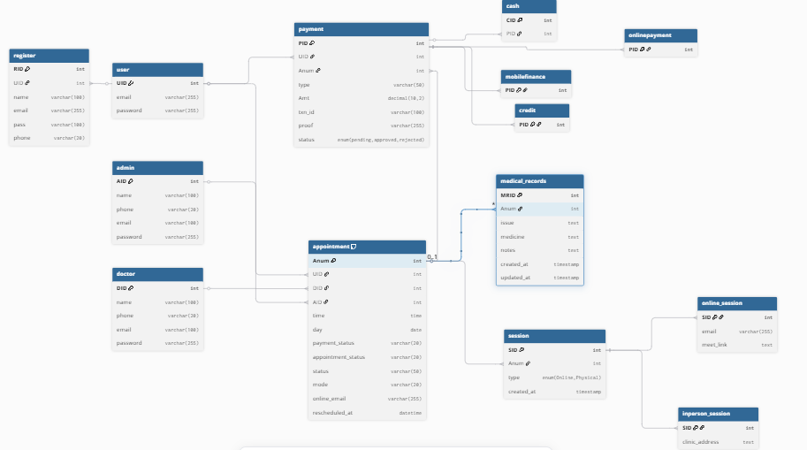

**Refrences**

[1] R. Elmasri and S. B. Navathe, *Fundamentals of Database Systems*, 7th ed. Boston, MA, USA: Pearson, 2015.

[2] R. S. Pressman and B. R. Maxim, *Software Engineering: A Practitioner’s Approach*, 8th ed. New York, NY, USA: McGraw-Hill, 2014.

[3] D. M. Hilty, D. C. Ferrer, M. B. Parish, B. Johnston, E. J. Callahan, and P. M. Yellowlees, “The effectiveness of tele-mental health: A 2013 review,” *Telemedicine and e-Health*, vol. 19, no. 6, pp. 444–454, Jun. 2013.

[4] W. Stallings, *Cryptography and Network Security: Principles and Practice*, 7th ed. Boston, MA, USA: Pearson, 2017.

[5] OpenAI, *ChatGPT* (May 2025). [Online]. Available: https://chat.openai.com/

[6] Microsoft, *Bing AI (Copilot)*. [Online]. Available: https://www.bing.com/chat