A

**PROJECT REPORT**

ON

**“Diabetes Risk Assessment”**

Summited To

**SAVITRIBAI PHULE PUNE UNIVERSITY, PUNE**

FOR PARTIAL FULFILLMENT OF

TY BBA-CA SEMESTER VI

**ASHOKA CENTER FOR BUSSINESS AND COMPUTER STUDIES NASHIK**

**2024-2025**

**GUIDED BY:**

**Mrs. Jayashree Darade**

**DEVELOPED BY:**

Ms. Noorsaba Shaikh

**INDEX**

|  |  |  |
| --- | --- | --- |
| **Sr. No.** | **Topics** | **Pg No.** |
| 1 | **Title Page** | **3** |
| 2 | **Declaration by Student** | **4** |
| 3 | **Acknowledgement** | **5** |
| 4 | **College Certificate** | **6** |
| 5 | **Introduction** | **7** |
|  | Motivation |  |
|  | Problem statement |  |
|  | Purpose/objective and goals |  |
|  | Literature survey |  |
|  | project scope and limitations |  |
| 6 | **System Analysis** | **12** |
|  | Existing systems |  |
|  | Scope and limitations of existing systems |  |
|  | Project perspective, features |  |
|  | Stakeholders |  |
| 7 | **Requirement Analysis** | **15** |
|  | Functional requirements |  |
|  | Performance requirements |  |
|  | Security requirements etc. |  |
| 8 | **System Design** | **20** |
|  | Design constraints/Data Dictionary |  |
|  | Entity Relationship Diagram |  |
|  | UML | **23** |
| 9 | **Implementation Details** | **36** |
|  | Software/hardware specifications |  |
| 10 | **Input Output Reports** | **37** |
| 11 | **Conclusion and Recommendations** | **38** |
| 12 | **Future Scope** | **39** |
| 13 | **Bibliography and References** | **40** |

A

**PROJECT REPORT**

ON

**“Diabetes Risk Assessment”**

For



**ASHOKA CENTER FOR BUSSINESS AND COMPUTER STUDIES**

TY BBA-CA SEMESTER VI

(2024-2025)

Summited To

**SAVITRIBAI PHULE PUNE UNIVERSITY, PUNE**

FOR PARTIAL FULFILLMENT OF DEGREE

**BACHELOR OF BUSINESS ADMINISTRATION (COMPUTER APPLICATION) [BBA-CA]**

**GUIDED BY:**

**Mrs. Jayashree Darade**

**DEVELOPED BY:**

Ms. Noorsaba Shaikh

**Declaration**

I hereby certify that the project entitled "Diabetes Risk Assessment" by Noorsaba Shaikh, University Seat no: **8329** in fulfilment of requirement for TYBBA-CA Project Examination, **Subject code: 605** submitted in Department of Computer Application at Ashoka Centre for Business and Computer Studies, Nashik under Savitribai Phule Pune University is an authentic record of my own work carried out under the supervision of **Mrs. Jayashree Darade.**

Student name:

Ms. Noorsaba Shaikh

**Acknowledgement**

**At times our light goes out and is rekindled by a spark from another person. Each of us has cause to think with deep gratitude of those who have lightened the flame within us.**

I sincerely thank Mrs. Jayashree Darade for stimulating suggestions and encouragement. I would also like to extend gratitude to all those who have directly and indirectly guided us in writing in the report.

I would also like to acknowledge the crucial role of the staff in Computer Laboratory, who gave me a permission to use the lab equipment and permitting us to use all the necessary tools in the laboratory.

Noorsaba Shaikh

TY BBA-CA



**Ashoka Education Foundation’s**

**ASHOKA CENTER FOR BUSINESS AND COMPUTER STUDIES**

Certificate

**2024 -2025**

**This is to certify that Ms. _Noorsaba Shaikh of Class _TYBBA(CA) A Semester _VI___ Roll No. _18_ & University Exam Seat No. 8329 has successfully completed his/her project work entitled _ Diabetes Risk Assessment _ as a partial fulfillment of the requirement of __BBA. (Computer Application) __Course, under Savitribai Phule Pune University during the academic year 2023-24.**

**Project Guide Head of Department Principal, ACBCS**

**Internal Examiner External Examiner**

**Introduction**

Diabetes is a chronic disease that affects millions of people worldwide. Early detection and proper management can help prevent complications and improve patients' quality of life. This project utilizes machine learning to predict the likelihood of diabetes based on medical input parameters. A web-based interface, developed using Flask, allows users to input their health data and receive predictive results. Additionally, an admin panel is included to manage users and view Risk Assessment history, enhancing system usability and control.

**1.1 Motivation**

The increasing prevalence of diabetes, coupled with its severe complications, highlights the need for efficient predictive models. Traditional diagnostic methods are time-consuming and require clinical intervention. This project leverages data-driven approaches to provide a quick and accurate Risk Assessment, supporting healthcare professionals in decision-making.

**1.2 Problem Statement**

Diabetes is a growing health concern, leading to severe complications if not diagnosed early. Traditional diagnostic methods require clinical tests, which may not always be readily available. There is a need for an automated, user-friendly system that can help predict diabetes risk based on readily available health parameters. This project aims to develop a machine-learning-based web application that predicts diabetes risk and provides an admin panel for better management.

**1.3 Purpose, Objectives, and Goals**

* **Purpose:** To develop a machine learning model that accurately predicts diabetes risk based on patient data.
* **Objectives:**
  + Develop a machine learning model that predicts diabetes based on medical input features.
  + Implement a Flask-based web application to allow users to enter data and receive Risk Assessments.
  + Design an admin panel for user management and viewing Risk Assessment history.
  + Ensure accuracy and reliability of the Risk Assessments to assist users in making informed health decisions.
* **Goals:**
  + Provide an efficient and accurate Risk Assessment system for diabetes risk assessment.
  + Enhance accessibility to early diabetes detection through a web-based interface.
  + Ensure data security and privacy while handling user health information.
  + Offer an easy-to-navigate admin panel for monitoring and managing users.

**1.4 Literature Survey**

In recent years, numerous studies have applied machine learning (ML) and deep learning (DL) techniques to predict, diagnose, and manage diabetes. These approaches aim to enhance early detection and improve patient outcomes by leveraging data-driven models.

**1. Machine Learning Models in Diabetes Risk Assessment**

A comprehensive review by Fregoso-Aparicio et al. (2021) analysed various ML and DL models used for type 2 diabetes Risk Assessment. The study highlighted the effectiveness of algorithms such as Deep Neural Networks (DNNs), Support Vector Machines (SVMs), k-Nearest Neighbour (k-NN), Decision Trees (DTs), Random Forests (RFs), Gradient Boosting Machines (GBMs), and Logistic Regression (LR). Each model offers unique advantages, with ensemble methods like RFs and GBMs often providing robust performance due to their ability to combine multiple models to reduce overfitting and improve generalization.

**2. Deep Learning Applications**

Deep learning models, particularly DNNs, have shown promise in handling complex, non-linear patterns within medical data. These models can automatically learn feature representations, making them suitable for large datasets with intricate relationships. However, they require substantial computational resources and large amounts of labelled data for effective training.

**3. Ensemble Methods**

Ensemble methods, which combine Risk Assessments from multiple models, have demonstrated high accuracy in diabetes Risk Assessment tasks. For instance, a study by Madhani and Gujarati (2024) reported that ensemble methods achieved an accuracy of 95.6%, precision of 93.5%, and recall of 94.8%. These methods leverage the strengths of individual models to produce more robust and reliable Risk Assessments.

**4. Comparative Analyses**

Several studies have compared the performance of various ML algorithms in predicting diabetes. For example, a review by Chaki et al. (2021) found that DNNs and SVMs delivered better classification outcomes, followed by RFs. The choice of algorithm often depends on the specific dataset and the problem's nature, with some models being more suitable for certain types of data or Risk Assessment tasks.

**1.5 Project Scope and Limitations**

This project aims to develop a machine learning-based diabetes Risk Assessment system using Flask. The system allows users to enter specific medical details and receive a Risk Assessment about their diabetes risk. Additionally, an admin panel is included for user management and monitoring Risk Assessments.

Key Features:

* Diabetes Risk Assessment Model: Utilizes a trained machine learning model to assess diabetes risk.
* User Interface: A web-based platform where users can input their health data and receive results.
* Admin Panel: Enables administrators to manage users and view past Risk Assessments.
* Data Handling: Secure storage and processing of user inputs while ensuring privacy.

Target Users:

* Individuals looking for an early indication of diabetes risk.
* Healthcare professionals who want a quick risk assessment tool.
* Researchers and developers interested in AI-driven health applications.

**Limitations**

While the project aims to provide accurate Risk Assessments, it has certain constraints:

1. Not a Medical Diagnostic Tool:
   * The system provides risk Assessments only and should not replace professional medical advice.
2. Limited Feature Set:
   * The Risk Assessment model relies on a fixed set of input parameters, which may not cover all risk factors.
3. Data Dependency:
   * The accuracy of Risk Assessments depends on the quality and completeness of input data.
4. Security & Privacy Concerns:
   * Since the system handles health-related data, proper measures must be in place to secure user information.
5. Model Generalization:
   * The model may not generalize well to all populations, as it is trained on specific datasets.

**System Analysis**

**Existing Systems**

Traditional diabetes Risk Assessment methods rely on clinical tests such as fasting blood sugar tests, HbA1c tests, and glucose tolerance tests. While accurate, these methods require medical consultation, can be costly, and may not always be accessible to all individuals.

**Scope and Limitations of Existing Systems**

* **Scope:**
  + Provide accurate diagnosis through laboratory tests.
  + Use patient history and physician expertise for risk assessment.
* **Limitations:**
  + Require clinical visits and laboratory facilities, making them inaccessible for remote populations.
  + Results can be delayed, limiting immediate intervention and preventive measures.
  + Depend on medical professionals, making large-scale screening difficult.

**Project Perspective and Features**

* **Perspective:**

This project is designed as a **web-based diabetes Risk Assessment system** that utilizes machine learning to assess the likelihood of diabetes based on user-provided health data. The system serves as an **early warning tool** and is not a substitute for medical diagnosis.

The application follows a **client-server architecture**, where:

* + **Users** interact with the system via a **Flask-based web interface** to enter their health data and get Risk Assessments.
  + **The server** processes the input using a **pre-trained machine learning model** and returns the results.
  + **Admins** can access a dedicated **admin panel** to manage users and monitor Risk Assessment history.
  + This project aligns with the growing trend of **AI-powered healthcare solutions**, helping individuals make informed decisions about their health.
* **Features:**

**1. Diabetes Risk Assessment System**

* Users enter specific health parameters (e.g., glucose levels, BMI, blood pressure).
* A machine learning model analyzes the inputs and predicts diabetes risk.

**2. User-Friendly Web Interface**

* Built using **Flask** to provide a clean and interactive UI.
* Allows users to enter their data and receive instant Risk Assessments.

**3. Admin Panel for User Management**

* Admins can **view, manage, and delete users**.
* A dashboard displays **Risk Assessment history** for analysis.

**4. Secure Data Handling**

* Ensures **privacy and security** while processing sensitive health data.
* Authentication mechanisms for **admin access** to prevent unauthorized control.

**5. Scalable and Extendable Architecture**

* The system can be **enhanced** with additional features, such as:
  + **More health parameters** for better accuracy.
  + **Integration with cloud storage** for secure data management.
  + **Mobile-friendly design** for better accessibility.

**Stakeholders**

Stakeholders are individuals or groups who have an interest in the Diabetes Risk Assessment System. They play a role in the development, use, and management of the system.

**1. End Users (Patients & General Public)**

* Individuals who use the system to assess their risk of diabetes.
* They input their health parameters and receive Risk Assessments.
* Benefit from early awareness and health insights.

**2. Healthcare Professionals (Doctors, Nurses, and Dietitians)**

* Can use the system as a support tool for initial risk assessment.
* Help patients understand their diabetes risk based on the results.
* Provide medical consultation based on Risk Assessments.

**3. System Administrators**

* Manage users, data security, and system performance.
* Oversee admin panel functionalities like viewing Risk Assessments and handling user access.

**4. Developers & Data Scientists**

* Responsible for developing, maintaining, and improving the system.
* Work on model accuracy, security enhancements, and UI improvements.

**5. Researchers & Academicians**

* Can utilize the system for research on AI-driven healthcare applications.
* Analyse Risk Assessment results to enhance machine learning models.

**6. Organizations & Healthcare Institutions**

* Hospitals, clinics, or NGOs promoting early diabetes detection.
* May integrate the system into their existing healthcare platforms.

**Requirement Analysis**

Requirement analysis is essential for defining the system's functionality, performance, and security aspects. It helps in understanding user needs and ensuring the system meets expectations. This section outlines the key requirements necessary for building an efficient and reliable diabetes Risk Assessment system.

**Functional Requirements**

The functional requirements define the core features and operations of the Diabetes Risk Assessment System. These include user interactions, system responses, and administrative functionalities.

**1. User Authentication and Management**

* Users must be able to **register and log in** to access the system.
* Authentication must ensure **secure login credentials** (username, password).
* Admins should have the ability to **view, edit, and delete users**.

**2. Diabetes Risk Assessment System**

* Users must be able to **input health parameters** such as:
  + Glucose level
  + Blood pressure
  + BMI
  + Age
  + Other relevant medical data
* The system should **process the inputs** and provide a **diabetes risk Assessment** using a machine learning model.
* The Risk Assessment result should be displayed to the user in an **easy-to-understand format** (e.g., "High Risk", "Low Risk").

**3. Web-Based User Interface**

* The system should provide a **Flask-based web interface** for users to:
  + Enter their health data
  + View Risk Assessment results
* The UI should be **responsive and user-friendly** for accessibility on multiple devices.

**4. Admin Panel**

* The system should include an **admin panel** where administrators can:
  + **View and manage users** (add, remove, or update user information).
  + **Monitor Risk Assessment history** for analysis and improvements.
  + **Ensure security measures** are in place to protect user data.

**5. Data Storage and Security**

* The system must store **user inputs and Risk Assessments securely**.
* Admins should have access to the data for **monitoring and analysis**.
* **Sensitive information should be encrypted** to ensure privacy.

**6. Error Handling and Notifications**

* The system should **handle invalid inputs** and display appropriate error messages.
* If the Risk Assessment model fails, the system should show a **fallback message** instead of crashing.

**7. Scalability and Future Enhancements**

* The system should be **designed to accommodate future improvements**, such as:
  + Adding more **health parameters** for better accuracy.
  + Integrating **cloud-based storage** for enhanced security.
  + Expanding to **mobile platforms** for better accessibility.

**Performance Requirements**

The functional requirements define the core features and operations of the Diabetes Risk Assessment System. These include user interactions, system responses, and administrative functionalities**.**

**1. User Authentication and Management**

* Users must be able to register and log in to access the system.
* Authentication must ensure secure login credentials (username, password).
* Admins should have the ability to view, edit, and delete users.

**2. Diabetes Risk Assessment System**

* Users must be able to input health parameters such as:
  + Glucose level
  + Blood pressure
  + BMI
  + Age
  + Diabetes Pedigree Function
* The system should process the inputs and provide a diabetes risk Risk Assessment using a machine learning model.
* The Risk Assessment result should be displayed to the user in an easy-to-understand format (e.g., "High Risk", "Low Risk").

**3. Web-Based User Interface**

* The system should provide a Flask-based web interface for users to:
  + Enter their health data
  + View Risk Assessment results
* The UI should be responsive and user-friendly for accessibility on multiple devices.

**4. Admin Panel**

* The system should include an admin panel where administrators can:
  + View and manage users (add, remove, or update user information).
  + Monitor Risk Assessment history for analysis and improvements.

**5. Data Storage and Security**

* The system must store user inputs and Risk Assessments securely.
* Admins should have access to the data for monitoring and analysis.

**6. Error Handling and Notifications**

* The system should handle invalid inputs and display appropriate error messages.
* If the Risk Assessment model fails, the system should show a fallback message instead of crashing.

**7. Scalability and Future Enhancements**

* The system should be designed to accommodate future improvements, such as:
  + Adding more health parameters for better accuracy.
  + Integrating cloud-based storage for enhanced security.
  + Expanding to mobile platforms for better accessibility.

**Security Requirements**

The **Diabetes Risk Assessment System** handles sensitive user data and must follow strict security measures to ensure data protection, system integrity, and secure user interactions. Below are the key security requirements:

**1. User Authentication & Access Control**

* Users must be required to register and log in before accessing the Risk Assessment system.
* Admin access should be restricted to authorized users only.
* Role-based access control (RBAC) should be implemented:
  + Regular users can only access their Risk Assessments.
  + Admins can manage users and view Risk Assessment history.
* Passwords should be stored using secure hashing algorithms (e.g., bcrypt, SHA-256).

**2. Data Privacy & Protection**

* User data (e.g., health information, login credentials) should be **encrypted** in storage and during transmission.
* **Secure communication protocols** like **HTTPS (SSL/TLS encryption)** must be used to prevent data interception.
* The system should comply with **privacy regulations** (e.g., HIPAA, GDPR) when handling medical data.

**System Design**

System design defines the architecture, components, modules, and interfaces of the diabetes Risk Assessment system. It provides a structured approach to developing a scalable and efficient system that meets functional and performance requirements.

**Design Constraints**

Design constraints define the limitations and restrictions that must be considered while developing the Diabetes Risk Assessment System. These constraints impact the architecture, technology choices, and implementation of the project.

**1. Technology Constraints**

* The system must be developed using Python and Flask for backend development.
* The machine learning model should be implemented using libraries like Scikit-learn or TensorFlow.
* The database should be managed using SQL Server or another relational database system.
* The frontend should use HTML, CSS, JavaScript (with Bootstrap for responsiveness).

**2. Hardware and Software Constraints**

* The system should run on standard web browsers (Chrome, Firefox, Edge, Safari).
* It must be compatible with Windows and Linux-based servers.
* The model should be optimized to run on limited computational resources (no requirement for GPUs).
* The system should be able to handle at least 50 concurrent users without performance degradation**.**

**3. Security Constraints**

* The system must enforce HTTPS for secure communication.
* User authentication should be implemented with hashed and salted passwords.
* Access control mechanisms must prevent unauthorized users from accessing admin functionalities.

**4. User Interface Constraints**

* The UI should be simple, user-friendly, and responsive for both desktop and mobile users.
* The system should have clear navigation with minimal complexity for first-time users.
* Accessibility standards (e.g., WCAG guidelines) should be followed to accommodate users with disabilities.

**5. Performance Constraints**

* The system should return Risk Assessments within 2-3 seconds after user input.
* The admin panel should load user data and logs within 3 seconds.
* The database should process queries within 1 second to maintain efficiency.

**6. Legal and Compliance Constraints**

* If storing medical data, the system must comply with data protection regulations (HIPAA, GDPR).
* User data should not be shared or used for any purpose other than diabetes Risk Assessment.

**Data Dictionary**

A data dictionary defines the attributes used in the diabetes Risk Assessment model:

|  |  |  |
| --- | --- | --- |
| **Attribute** | **Description** | **Data Type** |
| Age | Age of the patient | Integer |
| BMI | Body Mass Index | Float |
| Glucose Level | Blood glucose concentration | Float |
| Blood Pressure | Patient's blood pressure measurement | Float |
| Insulin Level | Insulin concentration in the blood | Float |
| Skin Thickness | Thickness of skin fold | Float |
| Diabetes Pedigree Function | Genetic influence on diabetes risk | Float |

**ERD Diagram**

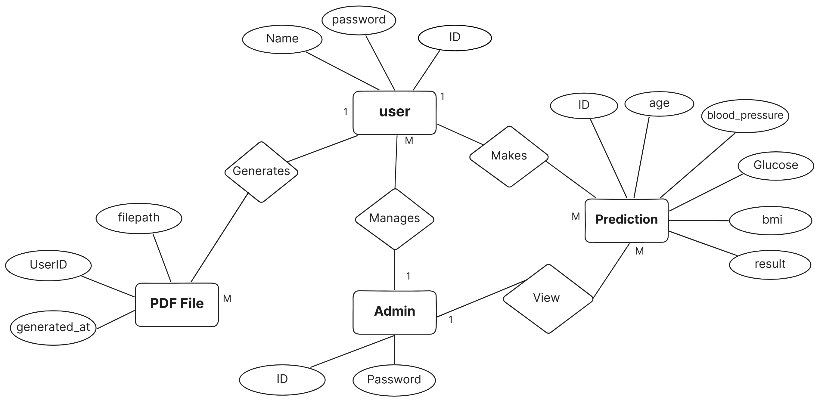

**Class Diagram**

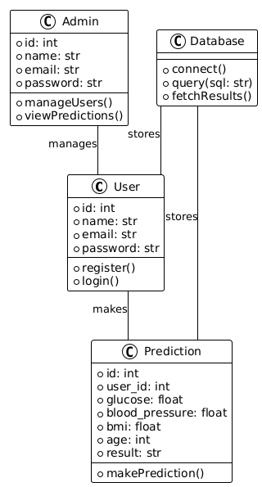

**Object Diagram**

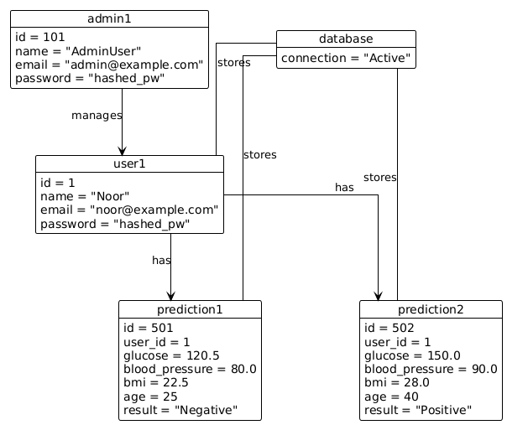

**Use Case Diagram**

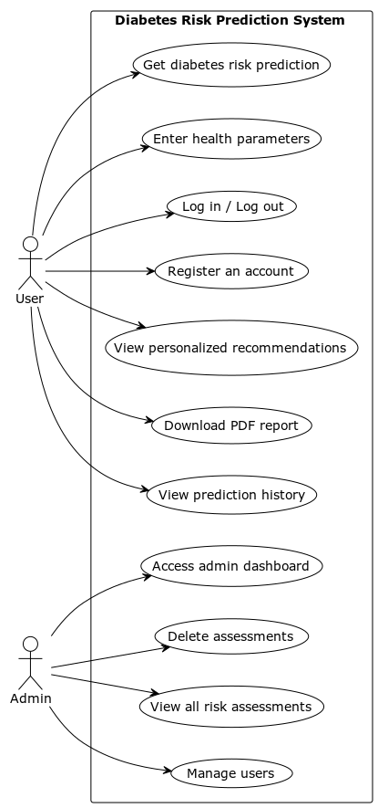

**Activity Diagram**

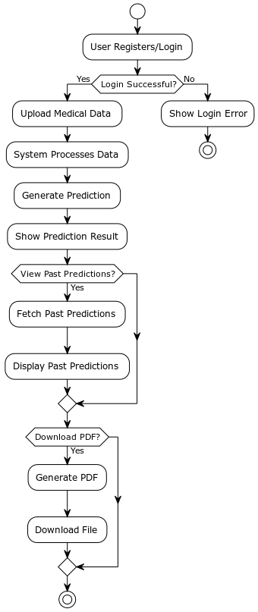

**Sequence Diagram**

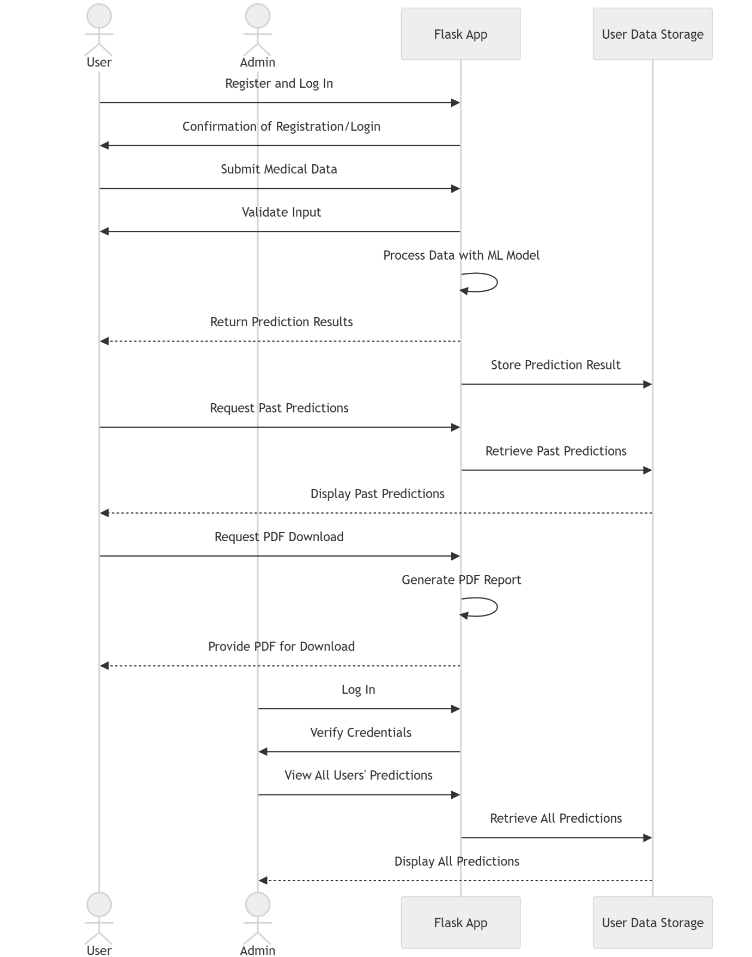

**State chart Diagram**

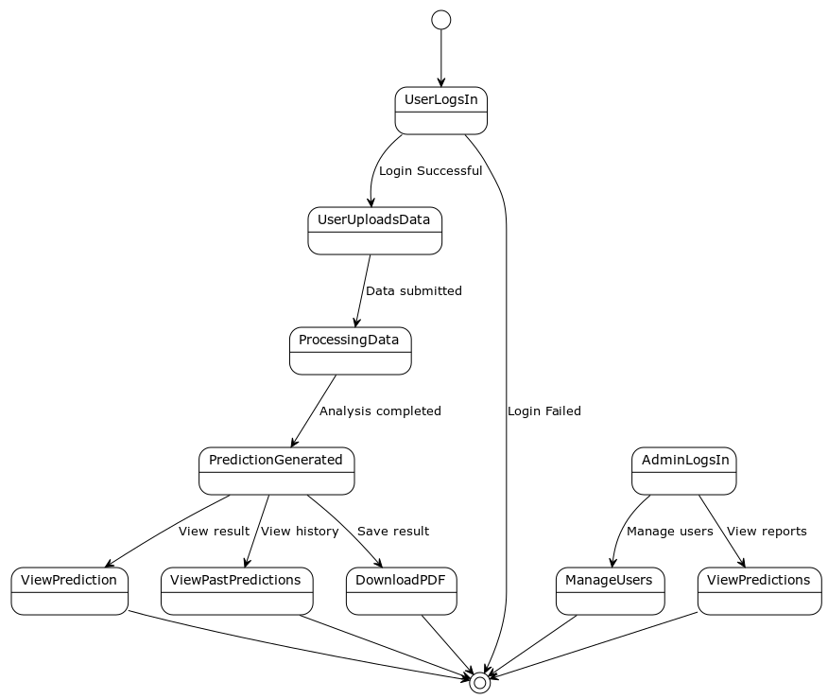

**User Interface  
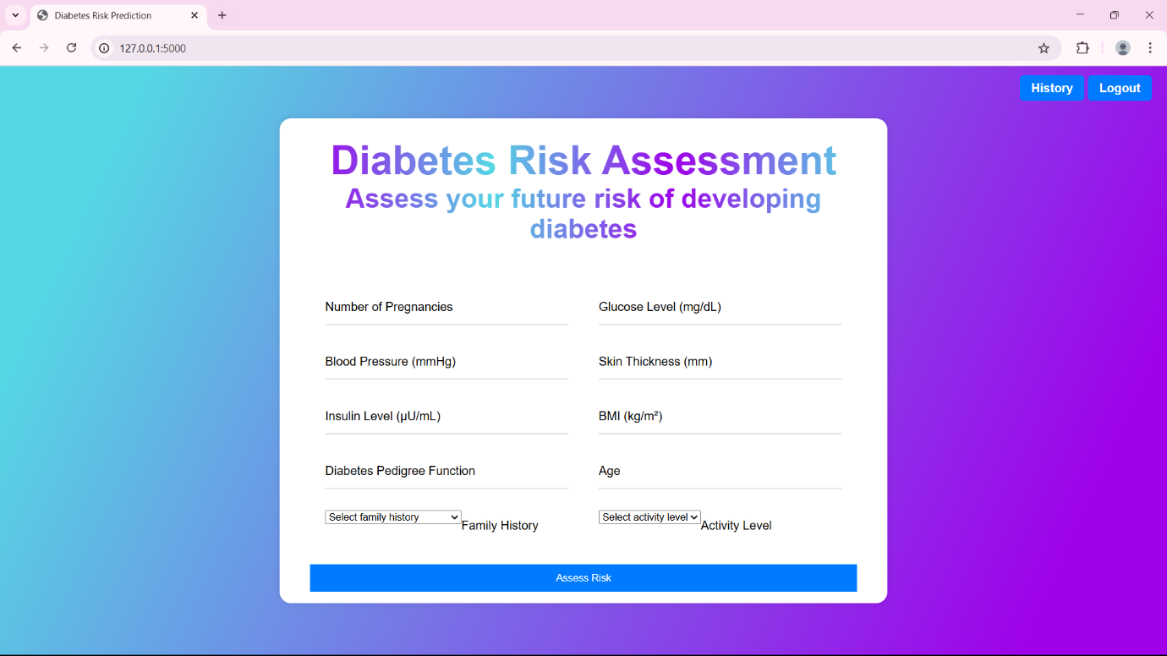**

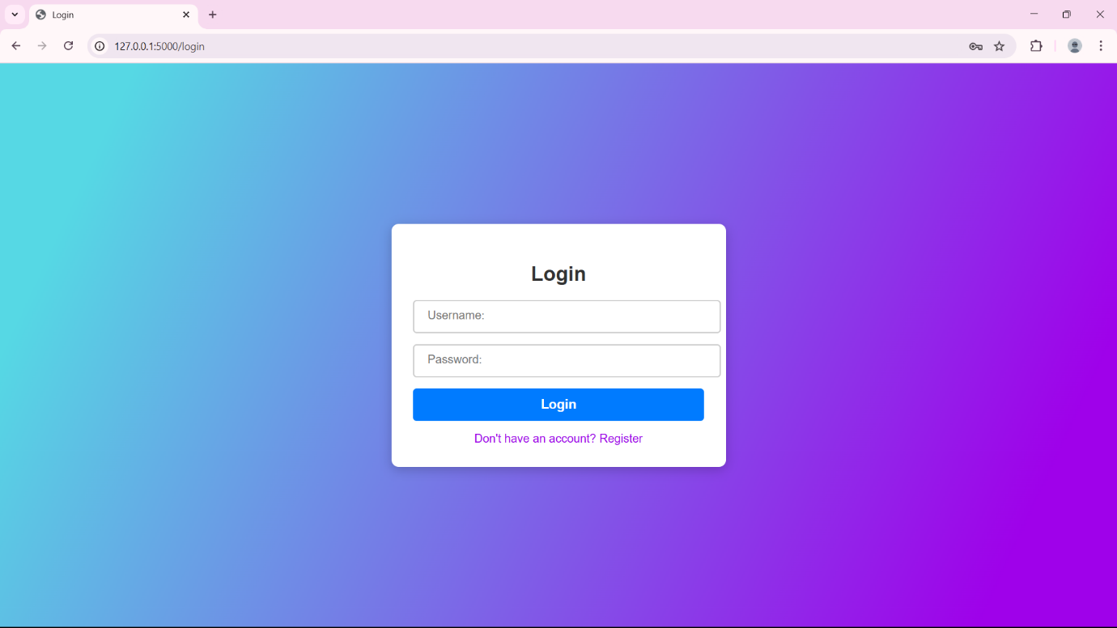

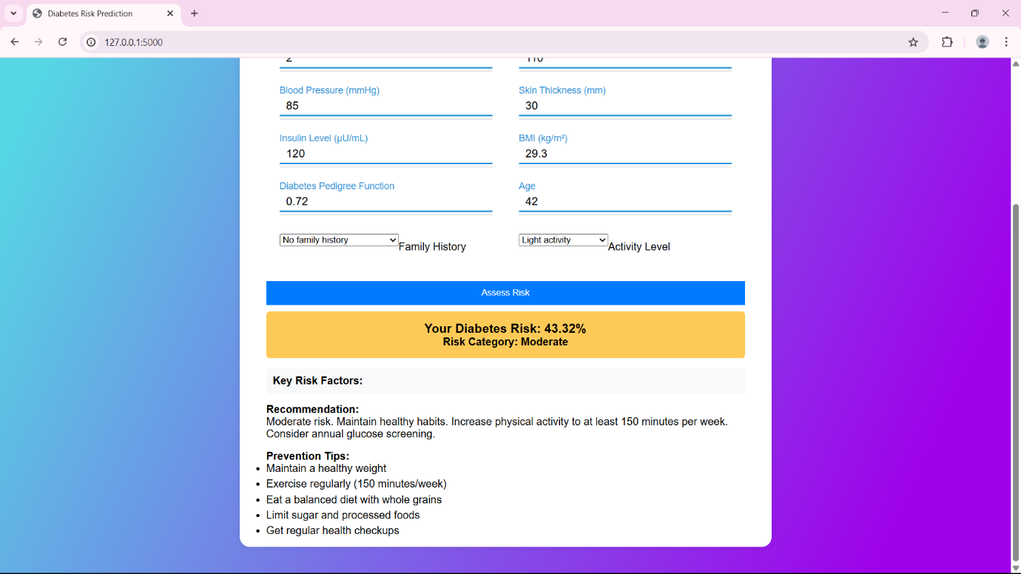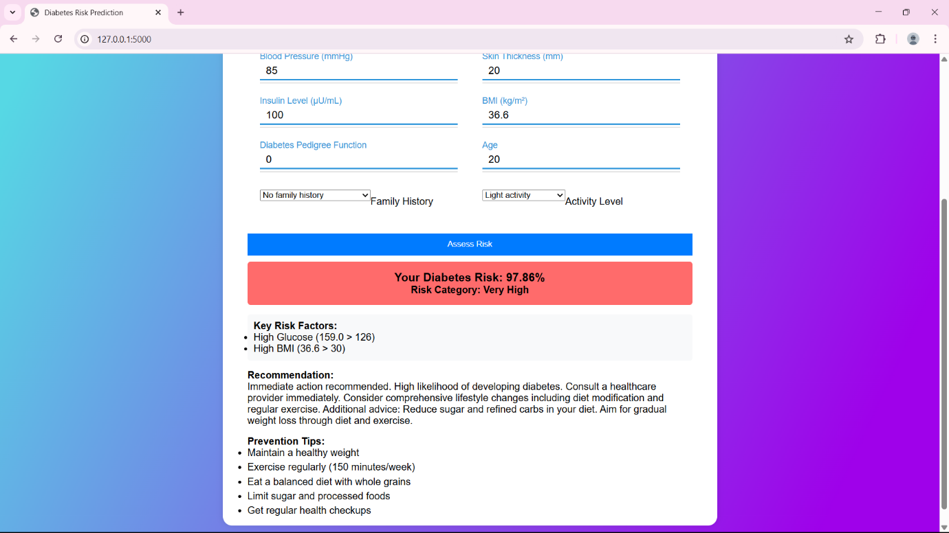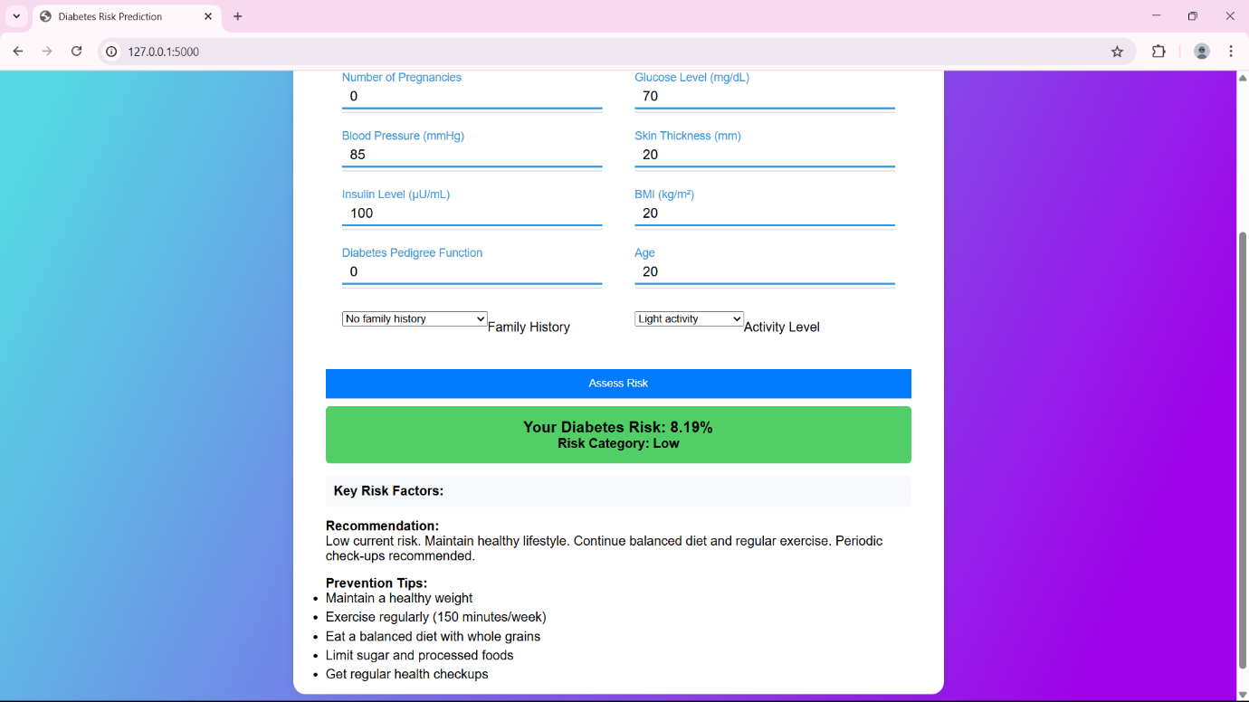

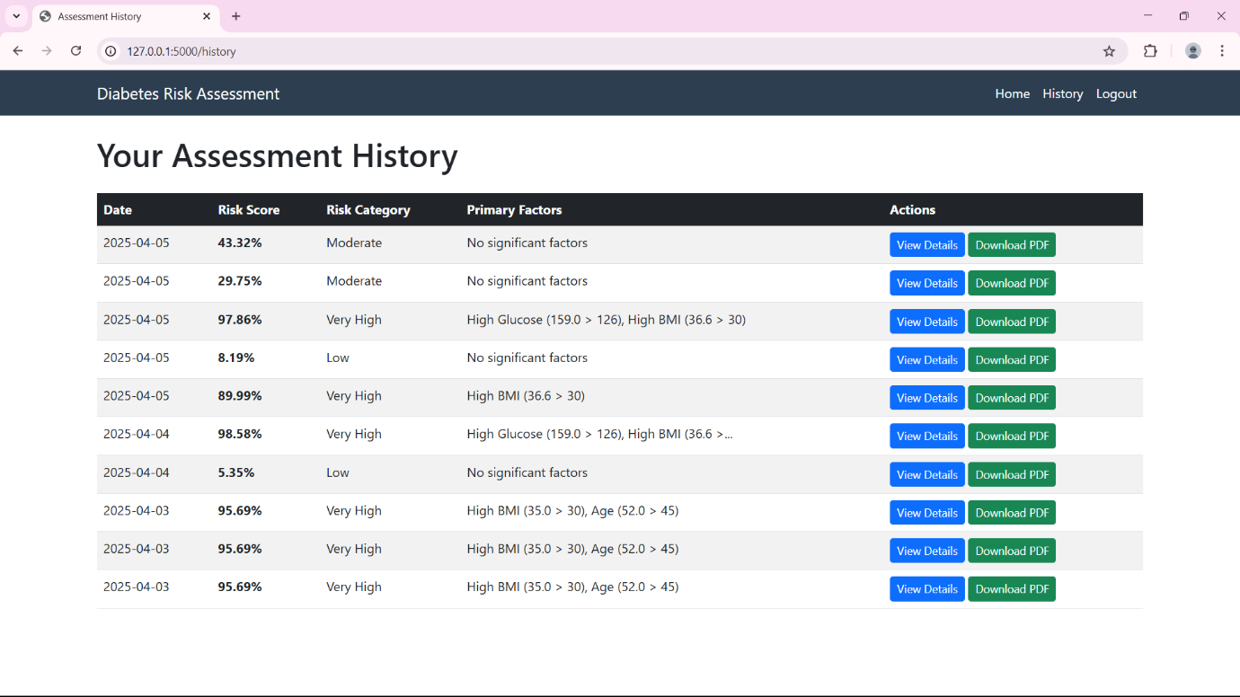

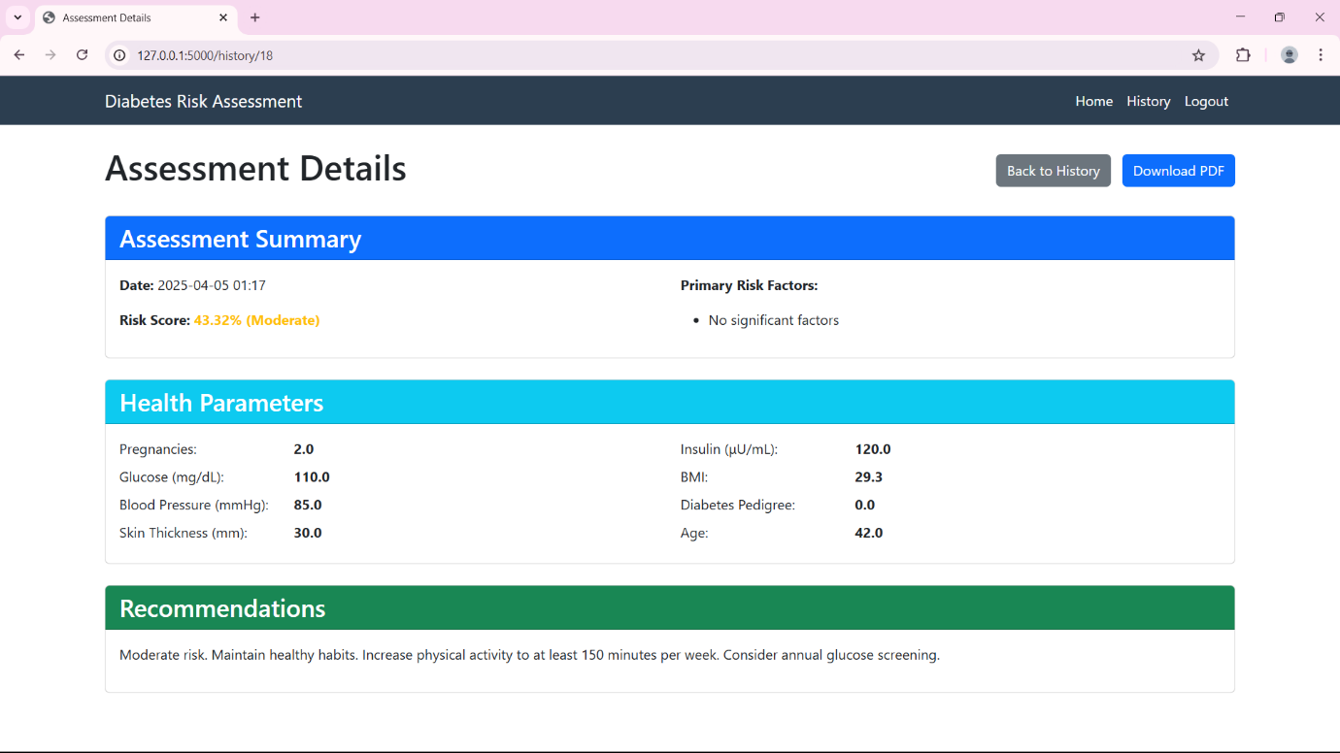

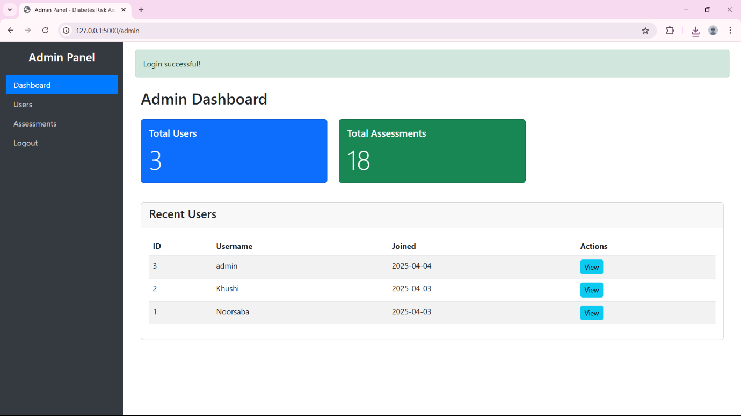

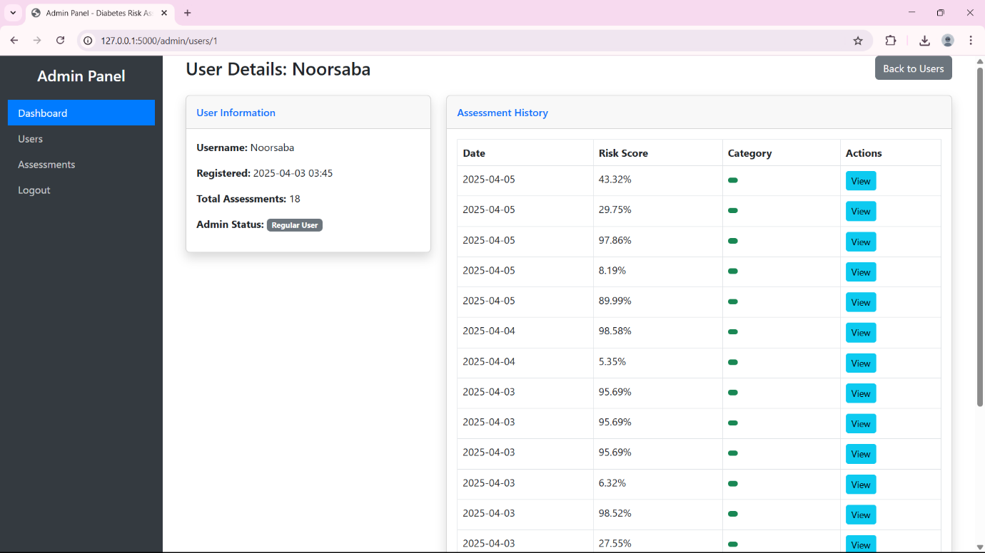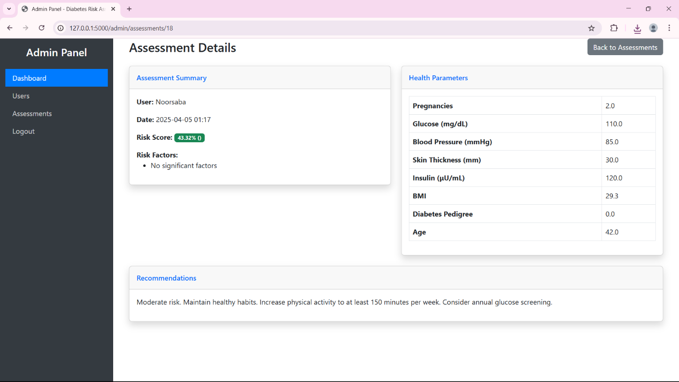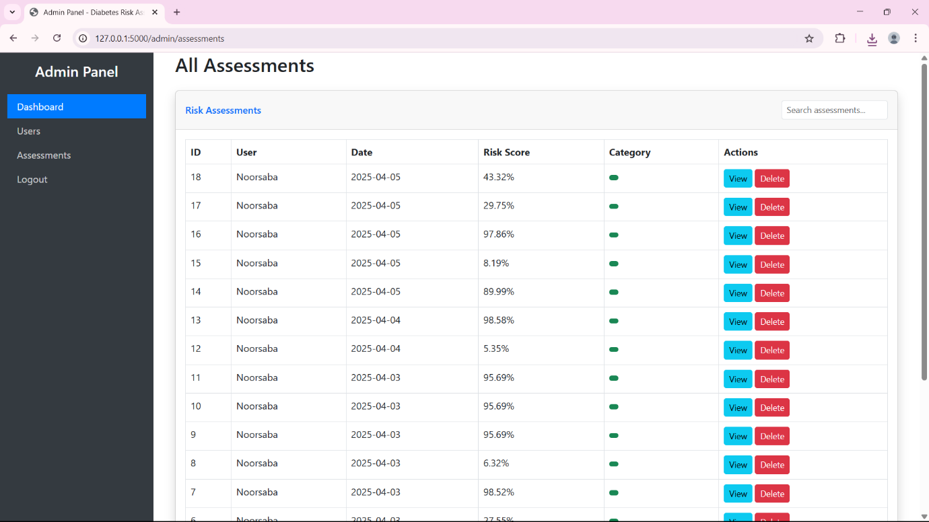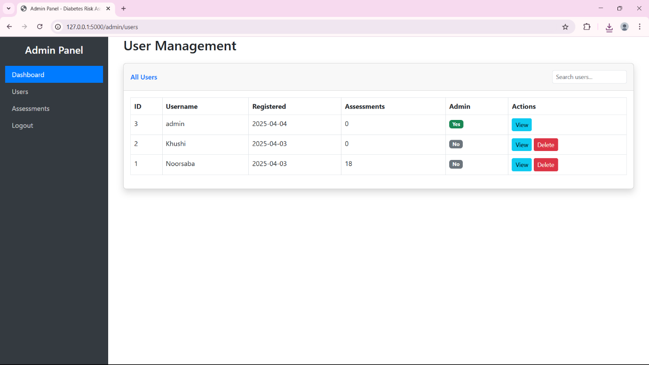

**Implementation Details**

**Software Specifications**

* **Programming Language:** Python
* **Libraries & Frameworks:** Scikit-learn, TensorFlow, Pandas, NumPy, Flask
* **Database:** SQLite (for storing user records and Risk Assessments)
* **Operating System:** Windows/MacOS
* **IDE/Development Environment:** VS Code

**Hardware Specifications**

* **Processor:** Intel i5 or higher / AMD Ryzen 5 or higher
* **RAM:** Minimum 8GB (16GB recommended for large datasets)
* **Storage:** Minimum 50GB free disk space
* **GPU:** Optional (for deep learning models, NVIDIA CUDA-enabled GPU recommended)

These specifications ensure that the system runs efficiently and delivers accurate diabetes Risk Assessments.

**Input-Output Reports**

**Input Reports**

* The system accepts patient medical data as input, including attributes such as glucose level, BMI, blood pressure, age, and family history.
* Data can be entered manually via a user interface.
* Input validation ensures that incorrect or missing values are handled appropriately.

**Output Reports**

Risk Assessment Summary

* **Risk Score**: Percentage probability (0-100%) of developing diabetes
* **Risk Category**: Qualitative classification (Low, Moderate, High, Very High)
* **Risk Factors**: List of contributing factors (e.g., High BMI, Family History)
* **Recommendations**: Personalized health advice based on risk level and factors
* **Assessment Date**: Timestamp of when assessment was performed

2. Detailed PDF Report

The downloadable PDF report includes:

* **Header**: Report title and assessment date
* **Risk Summary**: Score and category with visual indicators
* **Key Risk Factors**: Bulleted list of significant risk contributors
* **Health Parameters Table**: All input values in an organized table format
* **Detailed Recommendations**: Multi-paragraph advice tailored to the user's profile

**Conclusion**

In conclusion, the **Diabetes Risk Assessment System** is a robust and user-friendly web application that leverages machine learning to assess diabetes risk based on key health parameters. By providing personalized risk scores, actionable recommendations, and downloadable reports, the system empowers users to take proactive steps toward better health. With secure authentication, comprehensive admin controls, and a scalable design, it serves as both a preventive health tool and a platform for future enhancements, such as real-time health monitoring and mobile integration. This system bridges the gap between medical insights and everyday wellness, offering a practical solution for early diabetes risk detection and management. Future developments can further refine its accuracy and accessibility, making it an even more valuable resource for users and healthcare providers alike.

**Recommendations**

**1. For Users**

* **Regular Check-ups:** Users with **moderate to high risk** should consult healthcare providers for further evaluation.
* **Lifestyle Adjustments:** Follow the system’s recommendations (e.g., diet changes, exercise, glucose monitoring).
* **Track Progress:** Use the **history feature** to compare past assessments and monitor improvements.

**2. For Administrators**

* **Monitor System Usage:** Track the number of assessments and user registrations via the **admin dashboard**.
* **Manage Data:** Regularly review and clean up outdated user accounts or assessments if necessary.
* **Enhance Security:** Ensure strong password policies and consider **multi-factor authentication (MFA)** for admin accounts.

**3. For Future Development**

* **Expand Dataset:** Incorporate more diverse medical data to improve model accuracy.
* **Mobile App Integration:** Develop a companion app for easier access.

**Future Scope**

**Enhancements and Expansions**

* **Advanced Machine Learning Models:** Implementing deep learning techniques, such as neural networks, to improve Risk Assessment accuracy.
* **Integration with Wearable Devices:** Connecting with smart health monitors to collect real-time patient data for continuous monitoring.
* **Personalized Risk Assessment:** Incorporating genetic, lifestyle, and environmental factors to refine Risk Assessments.
* **Mobile Application Development:** Creating a mobile-friendly version of the system for easier accessibility.
* **Telemedicine Integration:** Allowing patients to share reports directly with doctors for remote consultations.

These enhancements will ensure that the system remains effective, scalable, and aligned with advancements in healthcare technology.

**Bibliography and References**

**Books and Research Papers:**

* Smith, J. (2020). *Machine Learning in Healthcare: An Overview*. Springer.
* Johnson, A. et al. (2021). *Deep Learning for Diabetes Risk Assessment: A Comparative Study*. Journal of Medical Informatics, 34(2), 120-135.

**Online Sources:**

* World Health Organization (WHO): https://www.who.int/diabetes
* American Diabetes Association: https://www.diabetes.org

**Software Documentation:**

* Scikit-learn Documentation: https://scikit-learn.org/stable/
* TensorFlow Documentation: https://www.tensorflow.org/
* Flask Framework: https://flask.palletsprojects.com/en/2.0.x/