
National Textile University
Department of Computer Science
Subject:
Mobile application and development
Submitted To:
Sir Rehan Sarwar
Submitted By:
Noor ul Ain
Registration No:
23-NTU-CS-1221
Lab no:
3
Semester:
6th

Task 1: Objective: Master the Card widget's visual properties and child arrangement. Create three Card widgets with varying color properties and elevation values. Requirement: Each card must contain a Row or Column of multiple Icon widgets with different sizes and colors.
Code:
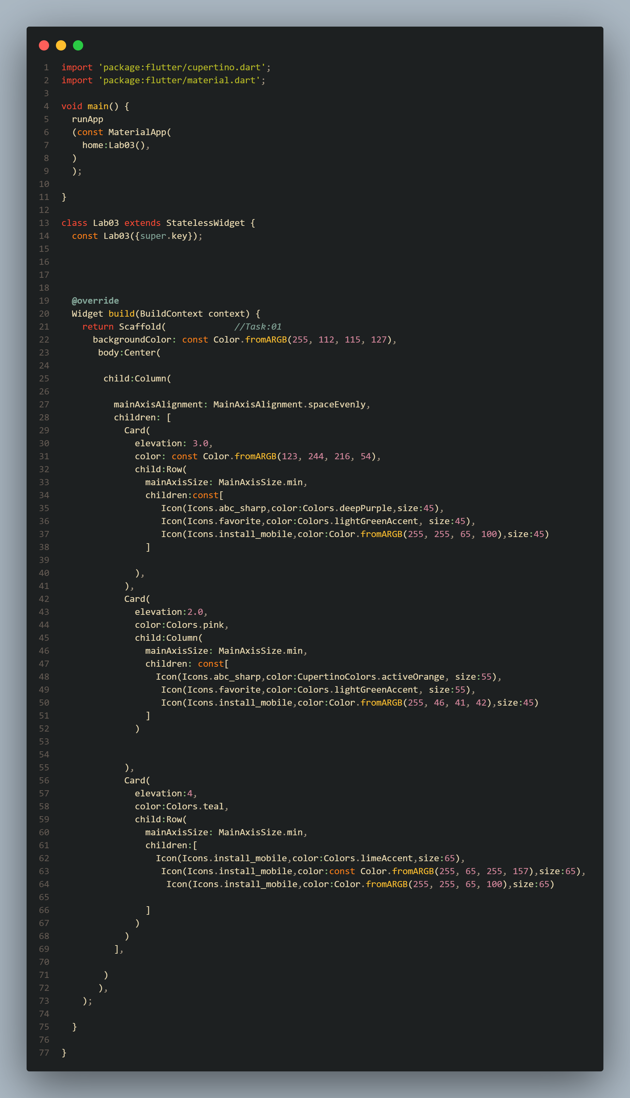
Output:
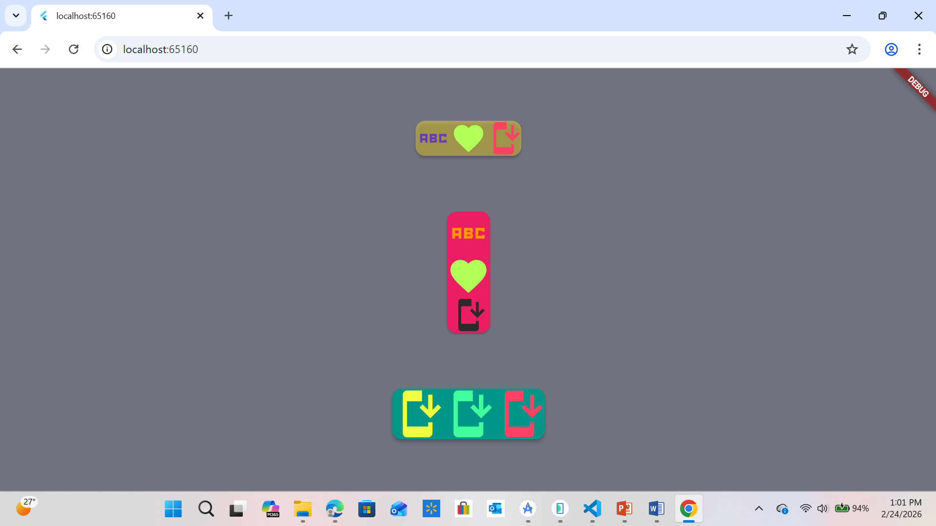

Task 2:
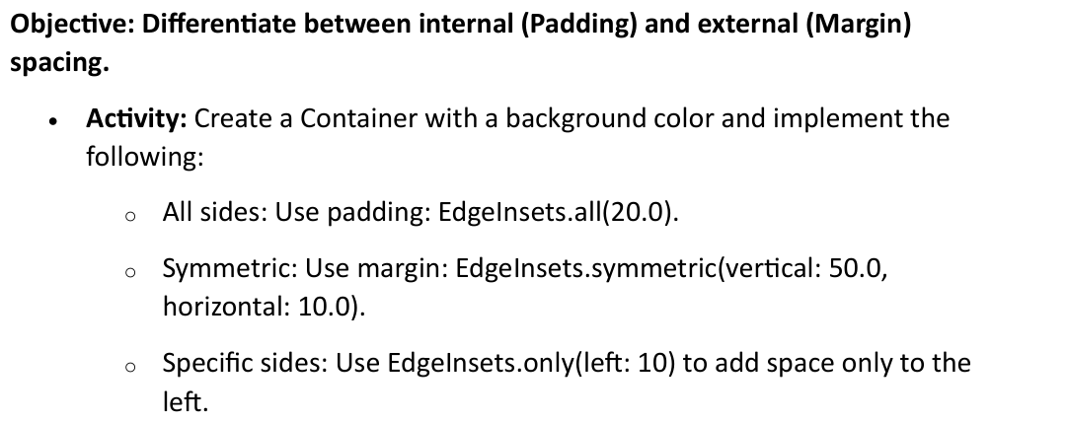

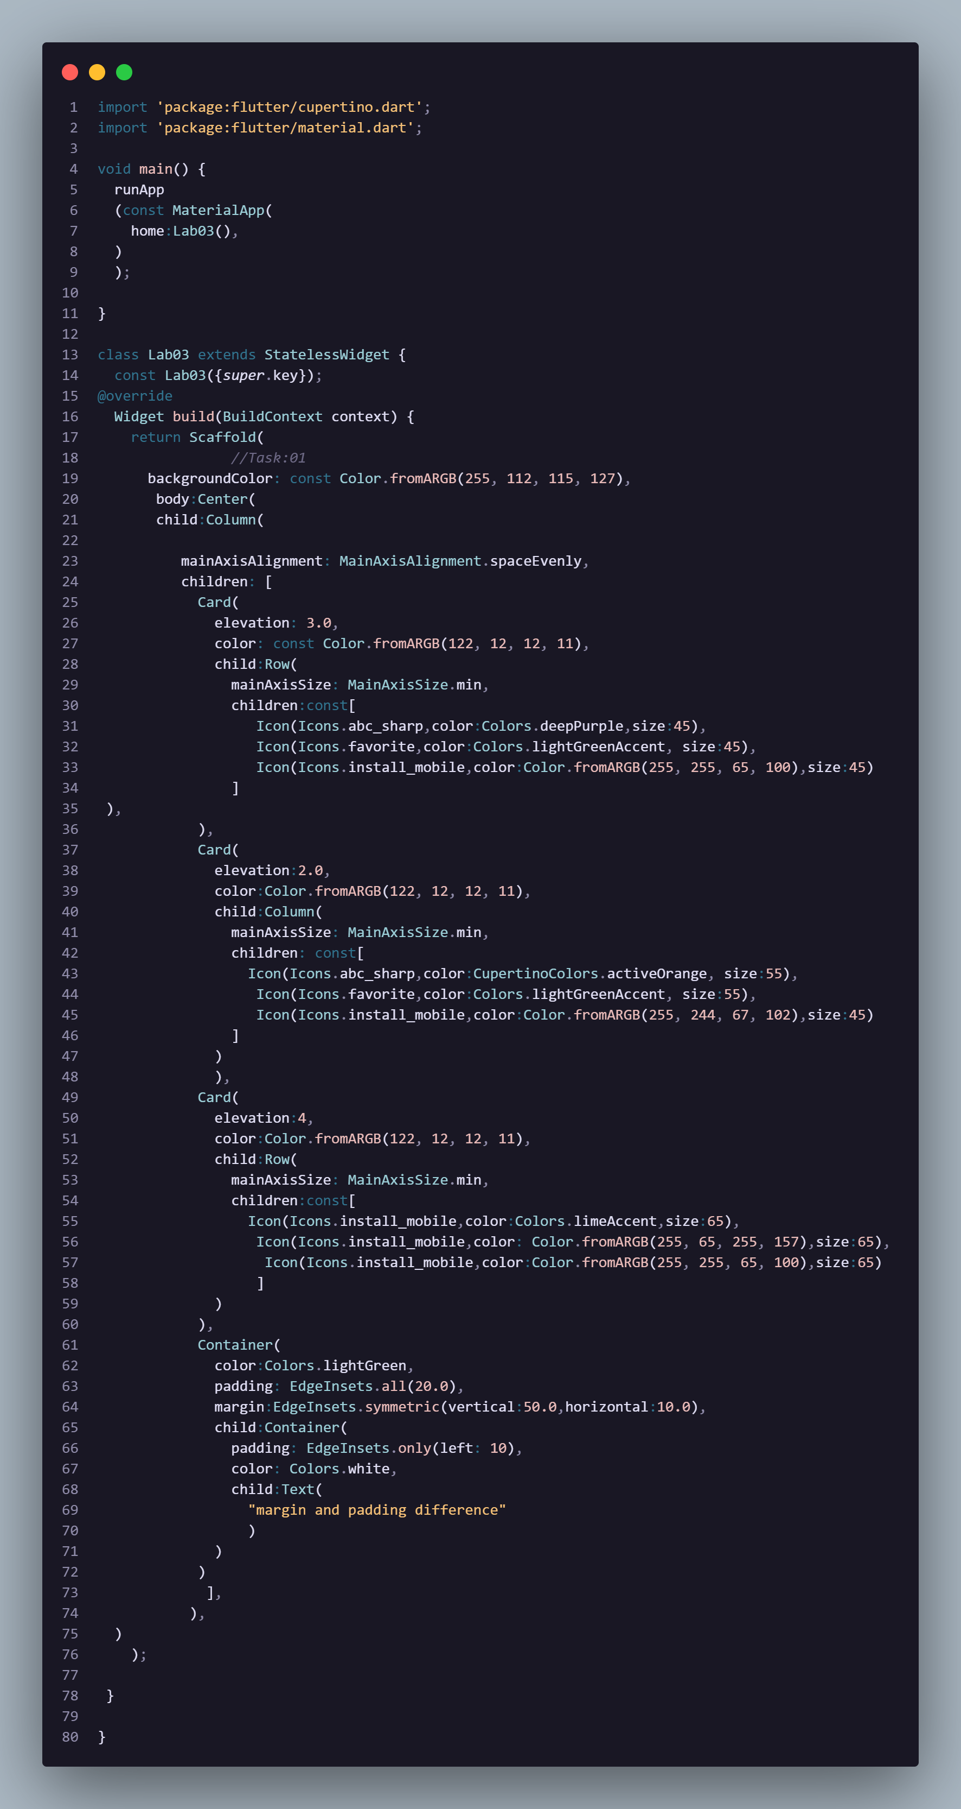
Output:
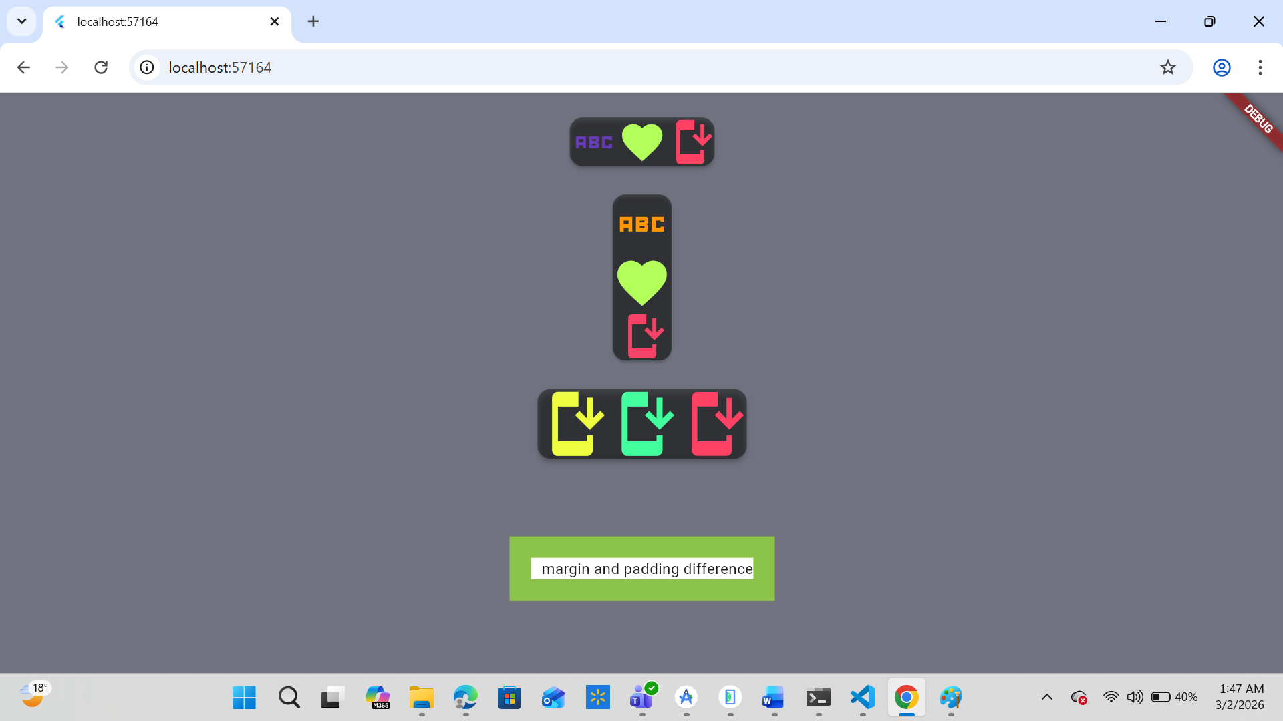

Task 3:
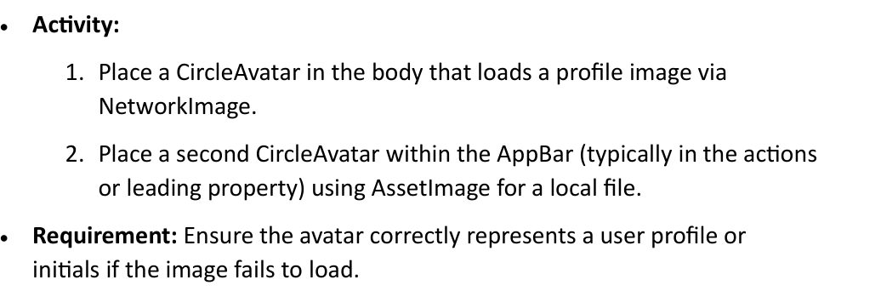
Code:
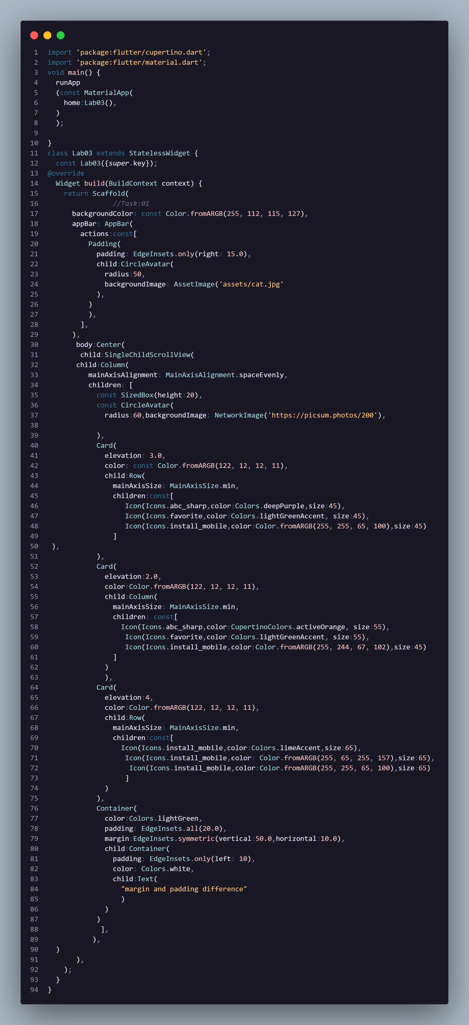

Output:
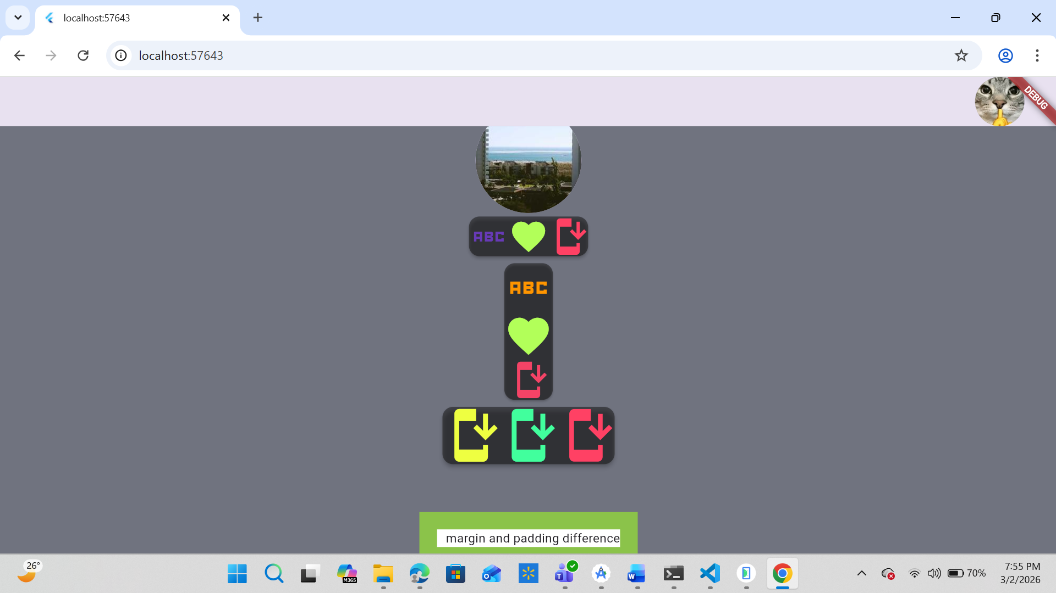
Task 4:
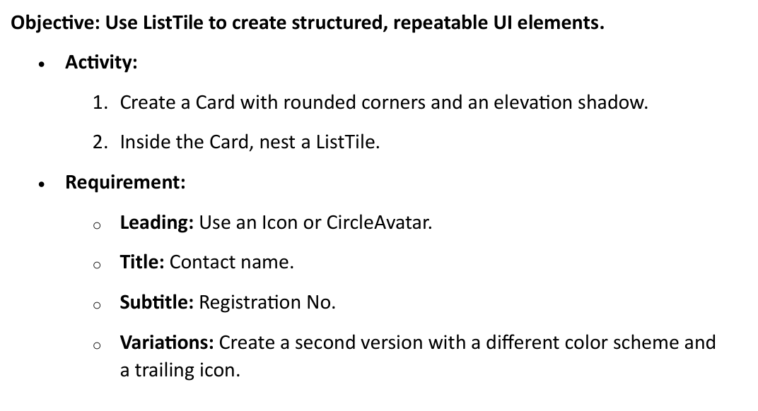
Code:
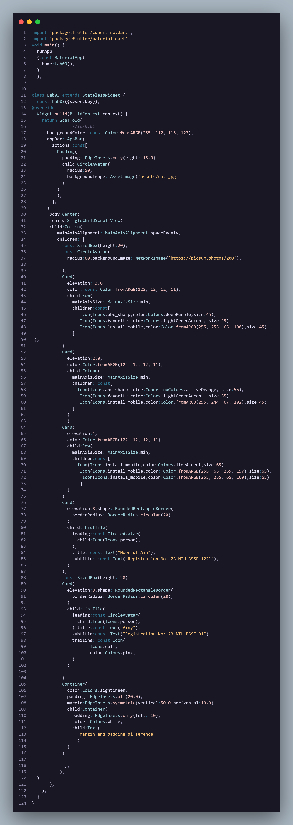
Output:
