(Generative AI)

Generative AI Perspective on Implement Client Script & UI Policy (Incident) — ServiceNow

1. Overview
The Implement Client Script & UI Policy (Incident) project uses fixed, rule-based logic — UI Policies and Client Scripts — to enforce mandatory fields, auto-set values, and block invalid saves on the Incident form. This logic is written once by a developer and always behaves the same way for a given input.
Generative AI works differently. Instead of following a fixed script, it uses large language models to understand free text (like a Short Description or Work Notes) and generate new content on demand — summaries, draft replies, suggested resolutions, or even suggested field values. This document looks at how Generative AI could realistically support the same Incident form used in this project.

2. Objective of This Section
The objective is to identify practical points in this project's workflow where Generative AI (such as ServiceNow's Now Assist) could reduce manual typing and speed up agent work, without replacing the data-integrity rules already enforced by the UI Policy and Client Scripts.

3. Rule-Based Automation vs. Generative AI
- Rule-based (this project): fixed logic such as "If Impact is High, make Assigned To mandatory" — the same input always produces the same result.
- Generative AI: reads the free-text fields on the form (Short Description, Description, Work Notes) and generates new text or suggestions — the output can vary and improves as the underlying model learns from more data.
Both approaches can sit on the same Incident form. The screenshot below shows the onSubmit Client Script that currently enforces the Assigned To rule — this is the deterministic side that Generative AI would work alongside, not replace.
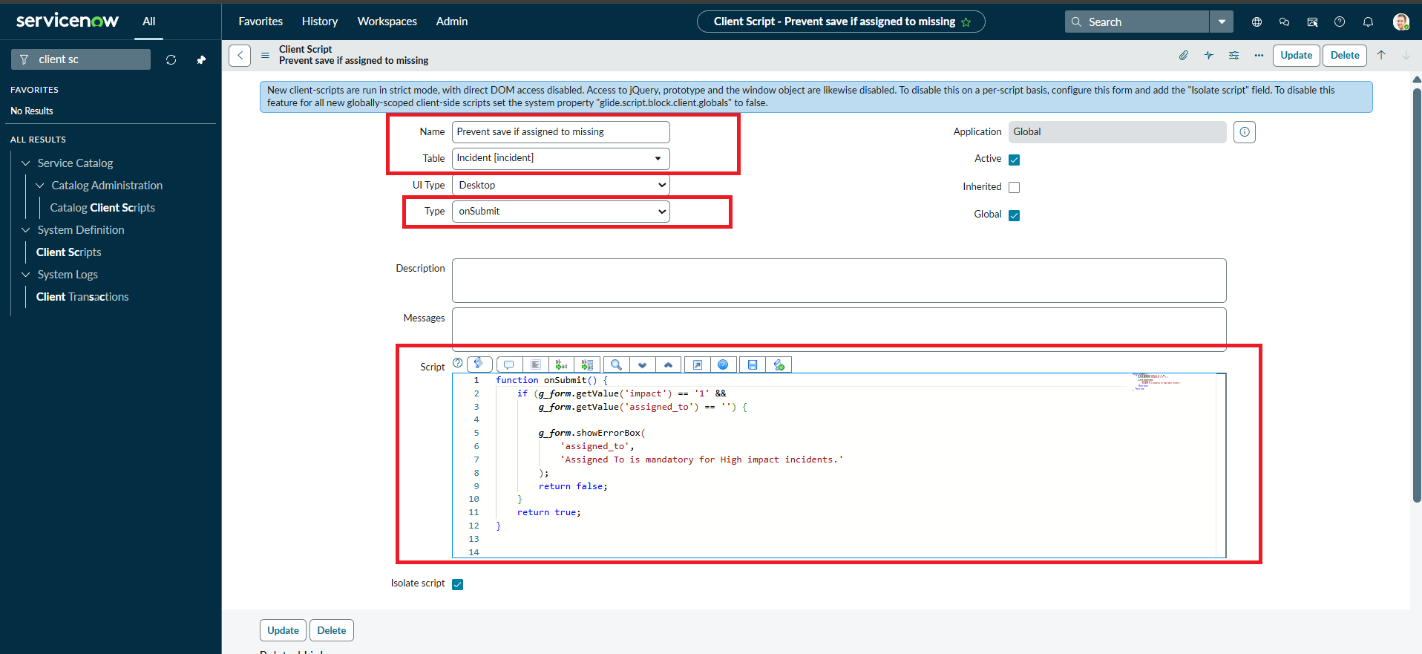
onSubmit Client Script enforcing Assigned To — the rule-based logic that stays in place even if Generative AI is added

4. Where Generative AI Could Help on This Form

Drafting the Short Description and Description
In the tests for this project, the Short Description was typed manually (e.g. "testing UI policy"). A generative model could instead take a few keywords or a voice note from the caller and draft a clear, well-formatted Short Description and Description automatically, before the UI Policy conditions are even evaluated.
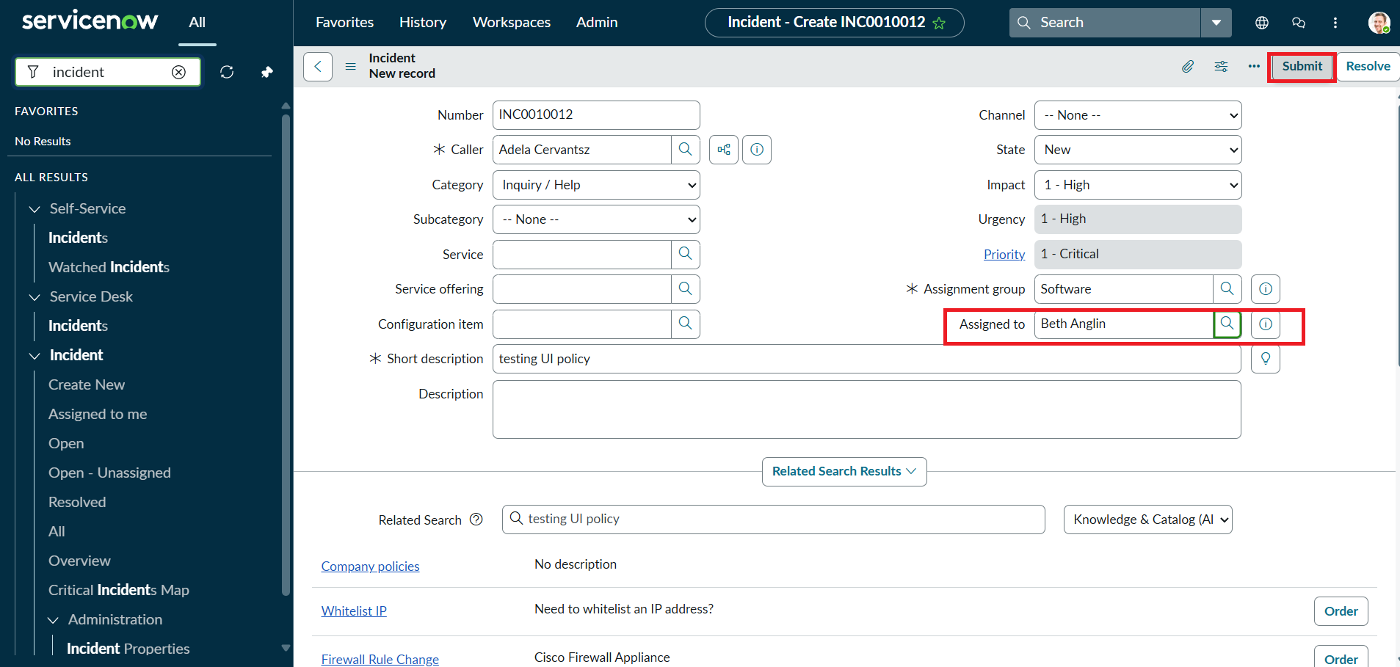
Incident form where Short Description and Description are currently typed manually — a natural place for Generative AI drafting assistance

Summarizing Long Incidents
For a High impact Incident with a lot of Work Notes and updates, Generative AI can produce a short summary of what has happened so far, saving the next agent from reading the entire history before continuing the fix.

Suggesting a Resolution Note
Once an Incident is resolved, Generative AI can draft a resolution note based on the Work Notes and the actions already taken, which the agent can quickly review and edit instead of writing it from scratch.

Explaining Validation Errors in Plain Language
When the onSubmit script blocks a save — as seen in the mandatory-field test for this project — Generative AI could turn the technical error into a short, friendly explanation for less experienced agents, without changing the underlying validation logic.
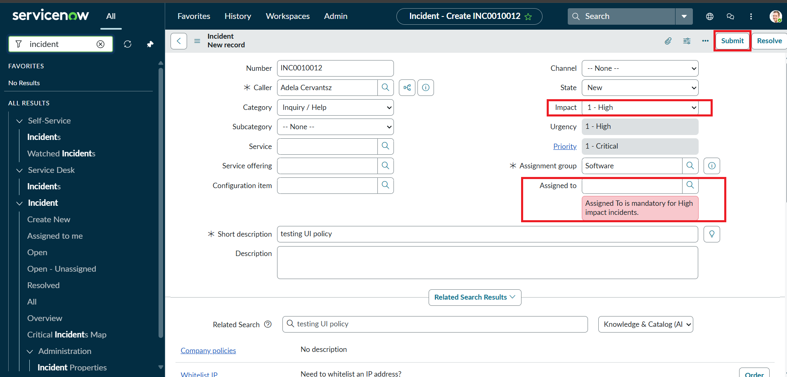
Validation error from the onSubmit script — Generative AI could rephrase this message in a more conversational way for the agent

5. How Generative AI Complements This Project's Logic
- UI Policies and Client Scripts guarantee that mandatory fields are always enforced and invalid records are always blocked — this must remain deterministic.
- Generative AI adds a text-generation layer on top — drafting, summarizing, and explaining — without altering whether a record is allowed to save.
- If a future version of the onChange script needed smarter Urgency suggestions based on free-text description instead of a single Impact value, a generative/predictive model could supply the suggested value, while the UI Policy still enforces it as mandatory or read-only.

6. Considerations Before Adding Generative AI
Generated text should always be reviewed by the agent before saving, since a language model can occasionally produce inaccurate or incomplete text. The deterministic rules in this project (mandatory fields, read-only fields, save validation) should remain the final safeguard, with Generative AI treated as a drafting assistant rather than the source of truth for data integrity.

7. Conclusion
This project's UI Policy and Client Scripts already ensure that Incident data is complete and consistent. Generative AI does not need to change any of that logic — it can sit alongside it, helping agents draft descriptions, summarize long Incidents, suggest resolution notes, and explain validation errors in plain language, while the existing rules continue to guarantee that every High impact Incident still has a valid Assigned To, Assignment Group, and Urgency before it is saved.

