MACHINE LEARNING
A clear and brief introduction
1. What is Machine Learning?
Machine Learning (ML) is a branch of artificial intelligence that enables computers to learn patterns from data and use those patterns to make predictions or decisions. Instead of giving a computer every rule manually, we provide examples and allow an algorithm to learn useful relationships.
2. Why is Machine Learning Important?
Modern organizations generate large amounts of data. Machine Learning helps turn that data into useful information by identifying patterns, making predictions, and supporting automation. It is used in everyday digital services as well as in scientific and business applications.
- Automates tasks that involve repeated analysis of data.
- Finds patterns that may be difficult to identify manually.
- Supports prediction, classification, recommendation, and anomaly detection.
- Can improve results when it is trained and evaluated with suitable data.
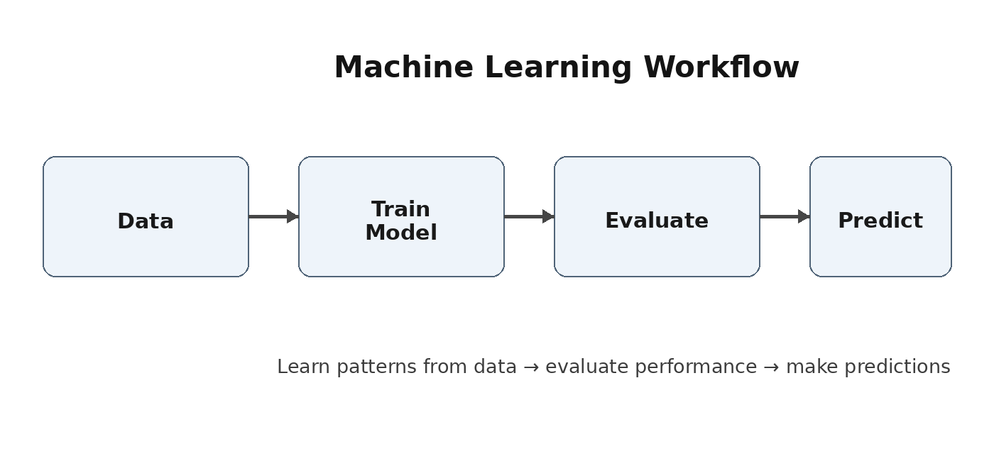
Figure 1. A simple Machine Learning workflow
3. Basic Terms
Data | Examples used to teach or evaluate the model.
Feature | An input variable used by the model.
Model | A learned mathematical representation of patterns in data.
Prediction | The output produced for new input data.

4. How Machine Learning Works
A typical ML project follows a sequence of steps. The quality of the final result depends on the quality of the data, the choice of model, and the way performance is tested.
Step 1 - Collect Data
Relevant examples are gathered from databases, sensors, applications, documents, or other sources. The data should represent the problem the model will face in practice.
Step 2 - Prepare the Data
Data may contain missing values, duplicate records, incorrect entries, or inconsistent formats. Preparation can include cleaning, transformation, and selecting useful features.
Step 3 - Train the Model
An algorithm uses training data to learn relationships between inputs and outputs, or to discover patterns when labels are not available.
Step 4 - Evaluate the Model
The model is tested on data that was not used for training. Evaluation helps determine whether the model generalizes well to new examples.
Step 5 - Use the Model
After testing, the model can be used to make predictions or support decisions on new data. In real systems, performance should continue to be monitored.
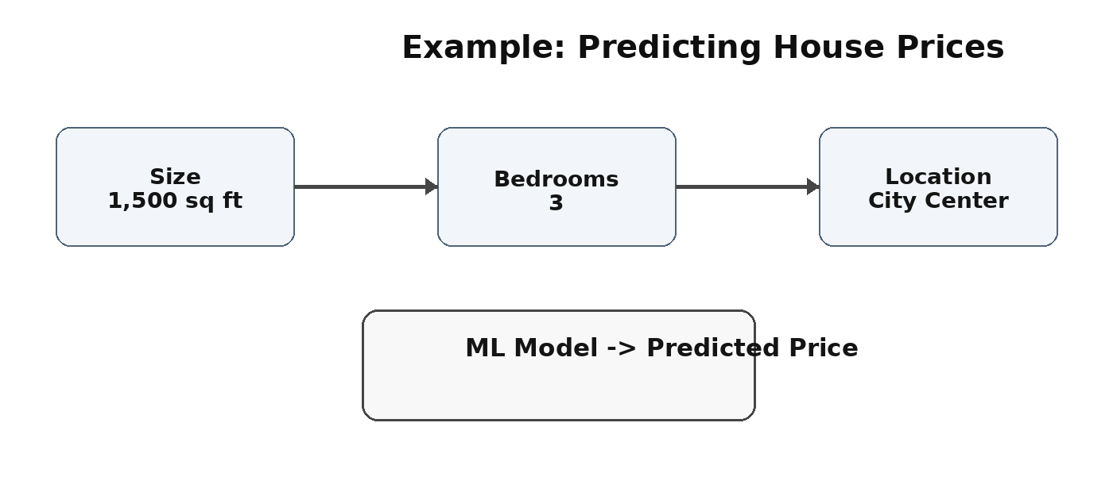
Figure 2. Example of a model using input features to predict an output
Simple Example
Suppose an organization wants to estimate a house price. The model may learn from historical records containing size, number of bedrooms, location, and known selling prices. After training, it can estimate the price of a new house from its input features.

5. Main Types of Machine Learning
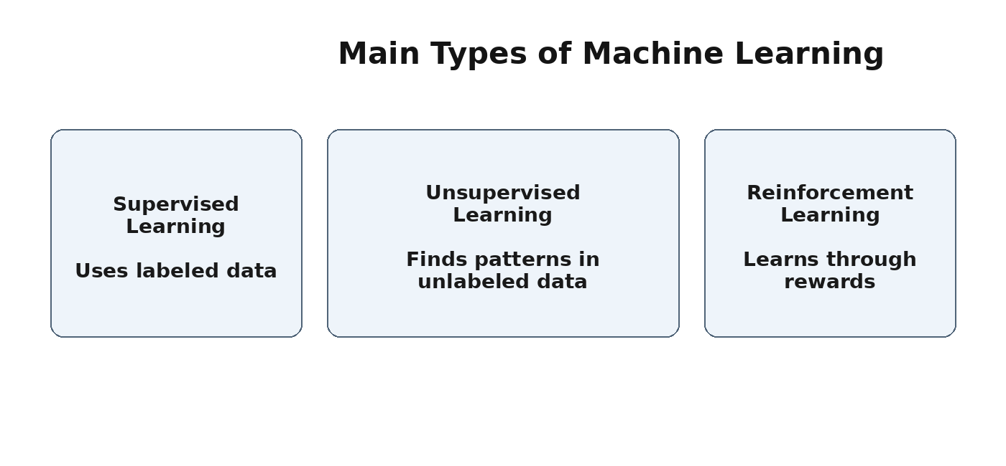
Figure 3. Three common types of Machine Learning
Supervised Learning
Supervised learning uses labeled examples, meaning the expected answer is known during training. The model learns to map inputs to known outputs.
- Classification: predicts categories, such as spam or not spam.
- Regression: predicts numerical values, such as sales or temperature.
Unsupervised Learning
Unsupervised learning works with unlabeled data. The goal is to discover useful structure, groups, or relationships within the data.
- Clustering can group similar customers, documents, or products.
- Pattern discovery can reveal relationships that were not explicitly defined.
Reinforcement Learning
Reinforcement learning trains an agent to choose actions based on feedback from an environment. Useful actions receive rewards, while poor actions may receive penalties.
6. Model Training and Testing
A common practice is to separate available data into training and testing portions. The training portion is used to learn the model, while the testing portion is used to check performance on unseen examples.

7. Applications of Machine Learning
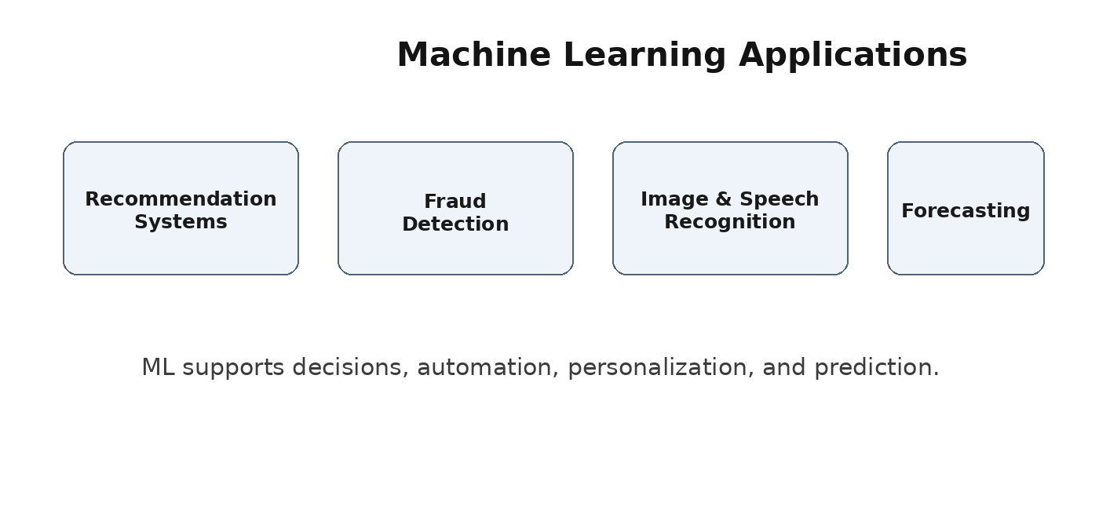
Figure 4. Examples of real-world Machine Learning applications
- Recommendation Systems: suggest products, videos, music, or other content based on patterns in data.
- Fraud and Anomaly Detection: identify unusual behavior or transactions that may require investigation.
- Image and Speech Recognition: classify images, recognize spoken words, and support natural-language systems.
- Forecasting: estimate future values such as demand, sales, or other measurable outcomes.
8. Benefits
- Faster analysis of large datasets.
- Automation of repetitive prediction and classification tasks.
- Ability to discover complex patterns in data.
- Support for personalized and data-driven services.
9. Challenges
- Poor-quality or biased data can lead to unreliable results.
- Overly complex models may be difficult to explain.
- Models need testing, monitoring, and suitable updates after deployment.
- Privacy, security, and responsible data use should be considered.
10. Conclusion
Machine Learning allows computers to learn from data and apply learned patterns to new situations. Its main strengths are prediction, pattern discovery, and automation. Successful ML systems require suitable data, an appropriate model, careful evaluation, and responsible use.

