Power BI

Reporting on Implement Client Script & UI Policy (Incident) — ServiceNow

1. Overview
This project enforced data integrity on the Incident table using UI Policies and Client Scripts — making fields like Assignment Group mandatory, Urgency read-only, and blocking saves when required data was missing. Power BI does not replace this enforcement; instead, it sits downstream of it, turning the now-clean, consistent Incident data into dashboards and reports that management can actually use.
This document looks at how the data produced by this project could be pulled into Power BI, and what kinds of reports and dashboards would be valuable given the specific rules that were configured (Impact, Urgency, Assignment Group, Assigned To, State).

2. Why Clean Data Matters for Power BI
Power BI reports are only as reliable as the data behind them — a classic "garbage in, garbage out" problem. Before this project, an Incident could be saved with a blank Assignment Group or an inconsistent Urgency value, which would silently skew any Power BI report built on top of it (e.g., wrong workload counts per team). Because the onSubmit script blocks incomplete High impact Incidents, and the UI Policy keeps Urgency aligned with Impact, the underlying dataset Power BI would connect to is already validated at the source.
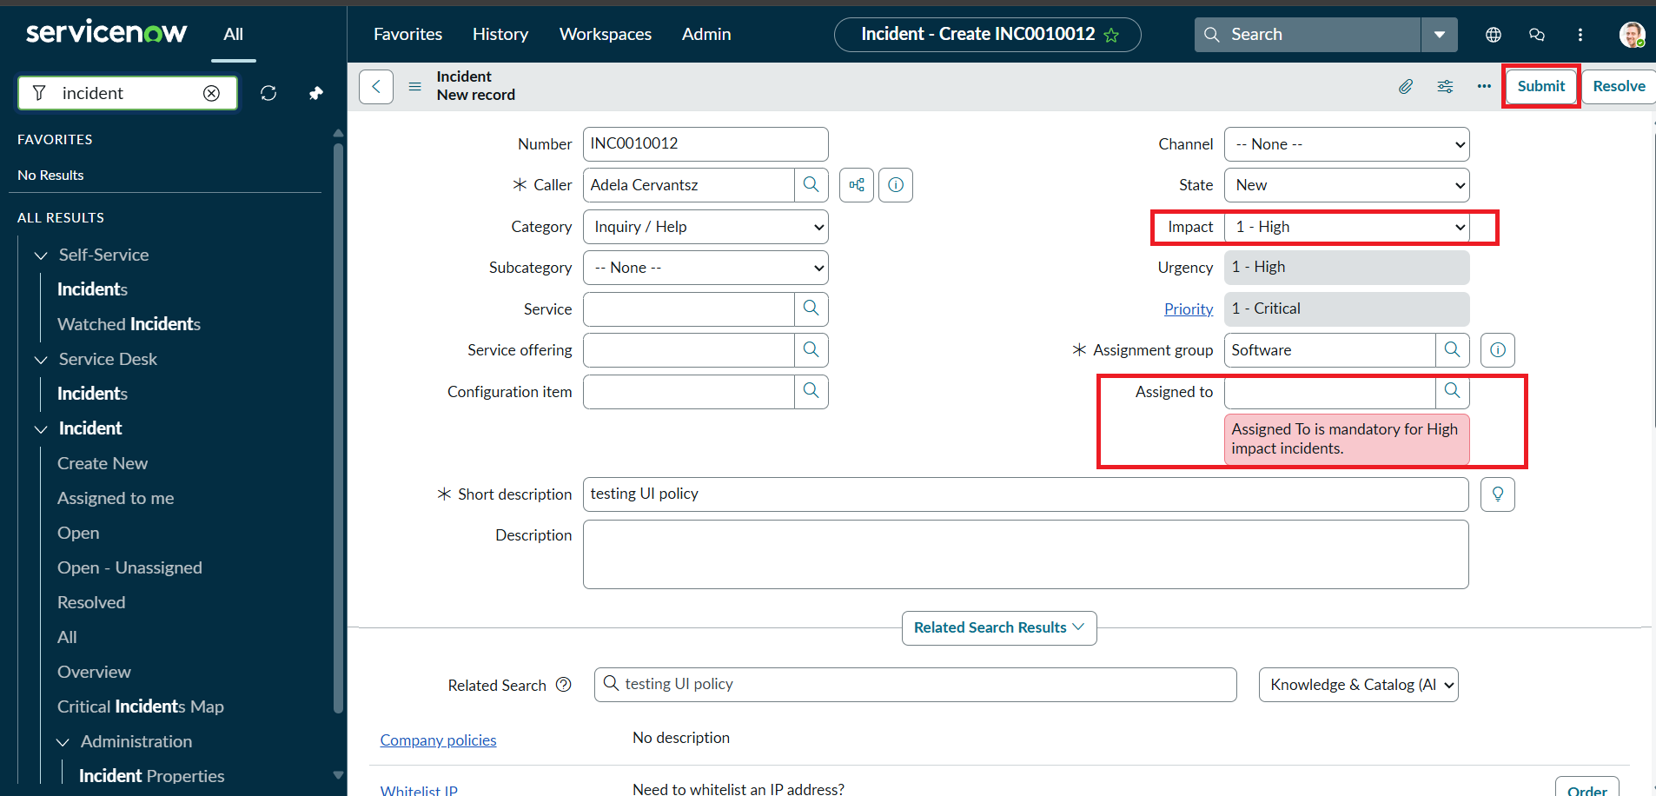
The onSubmit validation shown here guarantees Assigned To is never blank for a High impact Incident — exactly the kind of gap that would otherwise break a Power BI workload report

3. Connecting Power BI to This Data
- ServiceNow Incident data can be pulled into Power BI using the ServiceNow connector (Get Data → More → Online Services → ServiceNow) or via the ServiceNow REST/Table API and Power Query.
- Power Query (the same engine used to import the data) can apply extra cleansing steps — trimming text, standardizing Impact/Urgency labels — on top of what the UI Policy and Client Scripts already enforce at entry.
- A scheduled refresh keeps the Power BI dataset in sync with new and updated Incidents, so dashboards reflect the latest data enforced by this project's rules.

4. Suggested Dashboards & Reports

Impact vs. Urgency Compliance
Since the onChange script auto-sets Urgency to High whenever Impact is High, a simple Power BI matrix of Impact × Urgency should show almost all High-Impact Incidents also marked High Urgency. Any exceptions (created before the rule existed, or via API) stand out immediately as a data-quality signal.
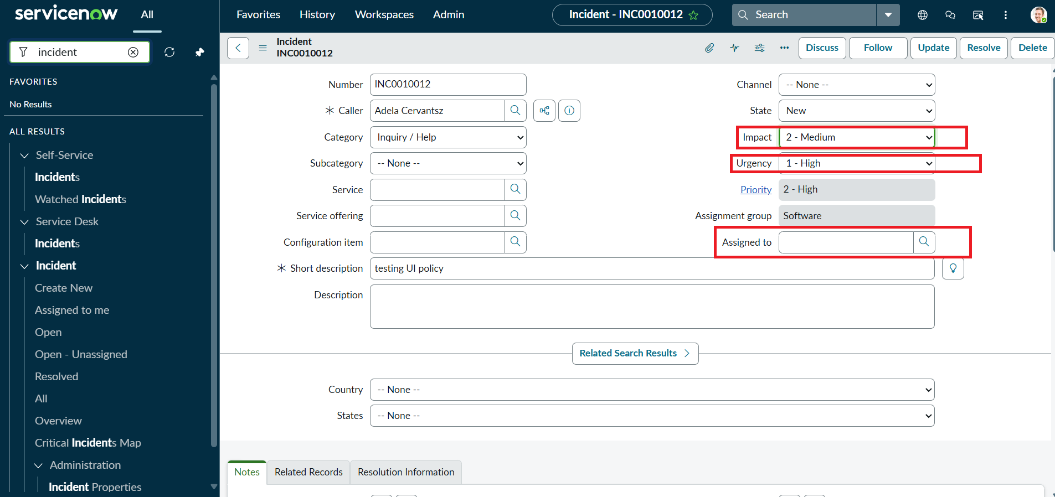
Impact/Urgency/Assigned To values on this Incident are exactly the fields a Power BI compliance matrix would report on

Assignment Group Workload
Because Assignment Group is mandatory for every High impact Incident, a Power BI bar chart of open Incidents by Assignment Group will always have complete, attributable data — no "blank" or "unassigned" category skewing the workload view.

Mandatory-Field Compliance Rate
A KPI card showing the percentage of High impact Incidents that have Assigned To populated would, in theory, always read 100% going forward — since the onSubmit script no longer allows a High impact Incident to be saved without it. This card is a good way to demonstrate the business value of the UI Policy/Client Script work to stakeholders who think in dashboards, not scripts.

State Change Audit
Since the onCellEdit script forces State changes to go through the form rather than the list, State transitions in the underlying audit/history table are cleaner and easier to trend in a Power BI line chart (e.g., Incidents by State over time) without stray, unexplained list-edit changes muddying the trend.

5. Example Report Layout
- Page 1 — Executive Summary: total open Incidents, % High impact, mandatory-field compliance KPI card.
- Page 2 — Workload: Incidents by Assignment Group, by Assigned To, filterable by Impact/Urgency.
- Page 3 — Data Quality: Impact vs. Urgency matrix, count of any legacy records missing required fields, State-change trend.

6. Conclusion
The UI Policy and Client Scripts built in this project don't just improve the Incident form experience — they directly improve the quality of any Power BI report built on top of the same data. Mandatory fields, auto-set values, and blocked invalid saves mean fewer blanks, fewer inconsistencies, and dashboards that management can trust without extra clean-up steps in Power Query.

