Salesforce

Salesforce Equivalent of Implement Client Script & UI Policy (Incident) — ServiceNow

1. Overview
This project was built on ServiceNow, using UI Policies and Client Scripts on the Incident table to make fields mandatory, auto-populate values, control field behavior, and block invalid saves. Salesforce is a different CRM/platform, but it offers its own declarative and programmatic tools that achieve the same kind of data-integrity goals on a record like a Case (Salesforce's equivalent of an Incident).
This document maps each ServiceNow component used in this project to its closest Salesforce equivalent, so the same business requirement — consistent, validated Incident/Case data — could be reproduced on the Salesforce platform.

2. Component-by-Component Mapping

UI Policy → Validation Rules / Dynamic Forms & Page Layouts
The "High Impact Control" UI Policy in this project made Assignment Group mandatory and Urgency read-only when Impact was High. In Salesforce, this is done with a Validation Rule (e.g., blocking save if Priority = 'High' AND Owner is blank) combined with Dynamic Forms / Page Layout field properties to conditionally show fields as read-only based on record values.
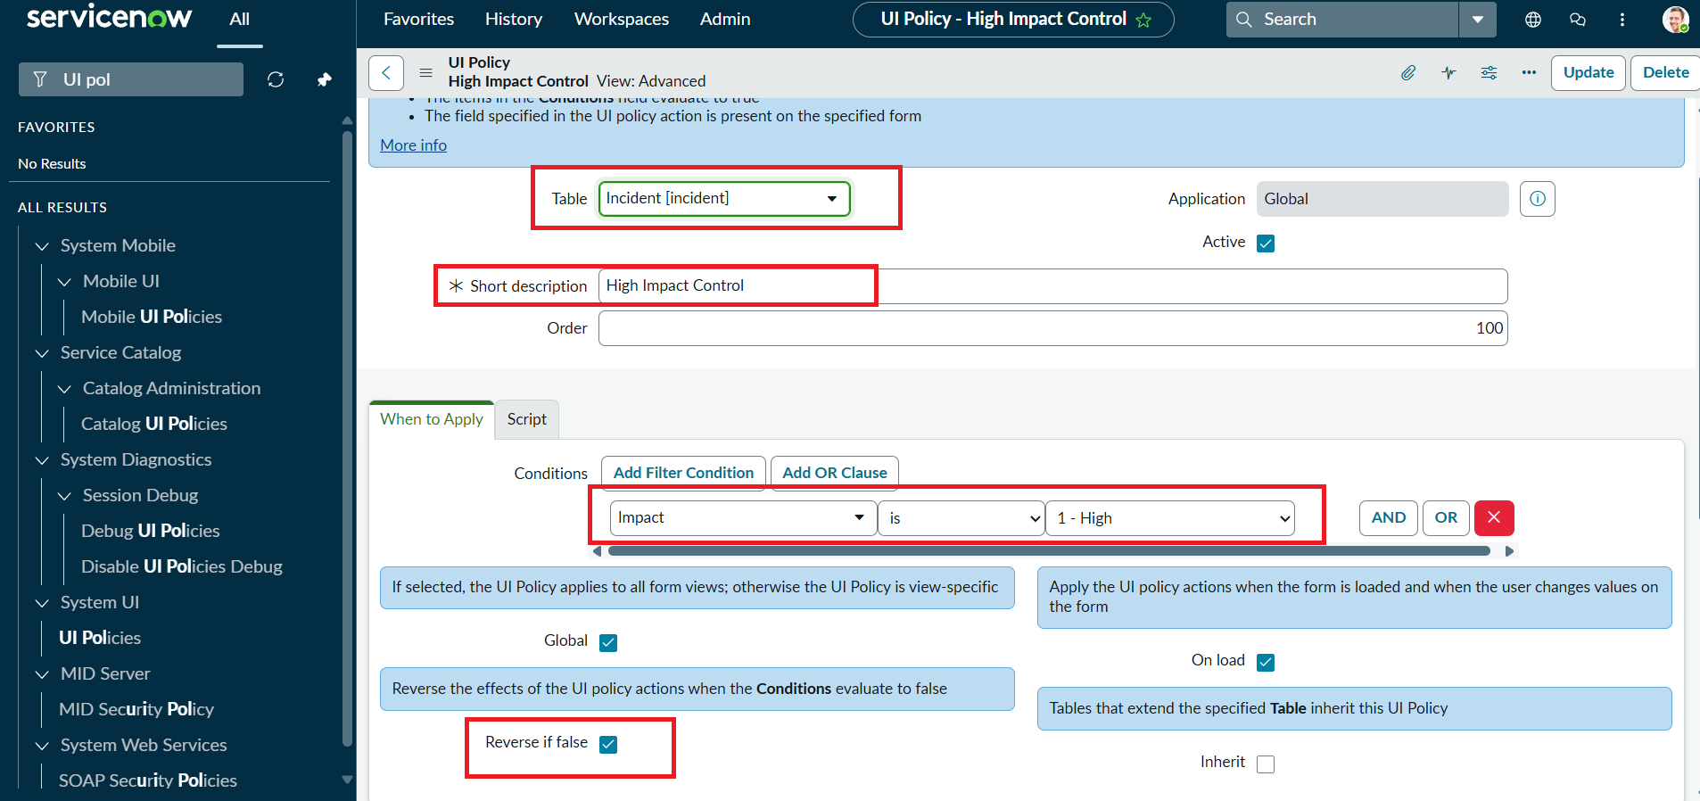
ServiceNow UI Policy condition (Impact is 1 - High) — in Salesforce this becomes a Validation Rule formula plus a Dynamic Forms visibility condition

UI Policy Actions → Field-Level Security & Conditional Visibility
The two UI Policy Actions in this project (Assignment Group → Mandatory, Urgency → Read-only) map to Salesforce's Dynamic Forms component visibility rules, which can mark a field as read-only or required directly on the Lightning Record Page based on other field values — without any code.

onChange Client Script → Flow (Record-Triggered, Screen Flow) or Apex
The onChange script that auto-sets Urgency to High when Impact becomes High is a classic use case for a Salesforce Flow: a record-triggered Flow (or a screen Flow launched from a Quick Action) can update a field automatically the moment another field changes, the same way g_form.setValue() does in ServiceNow.
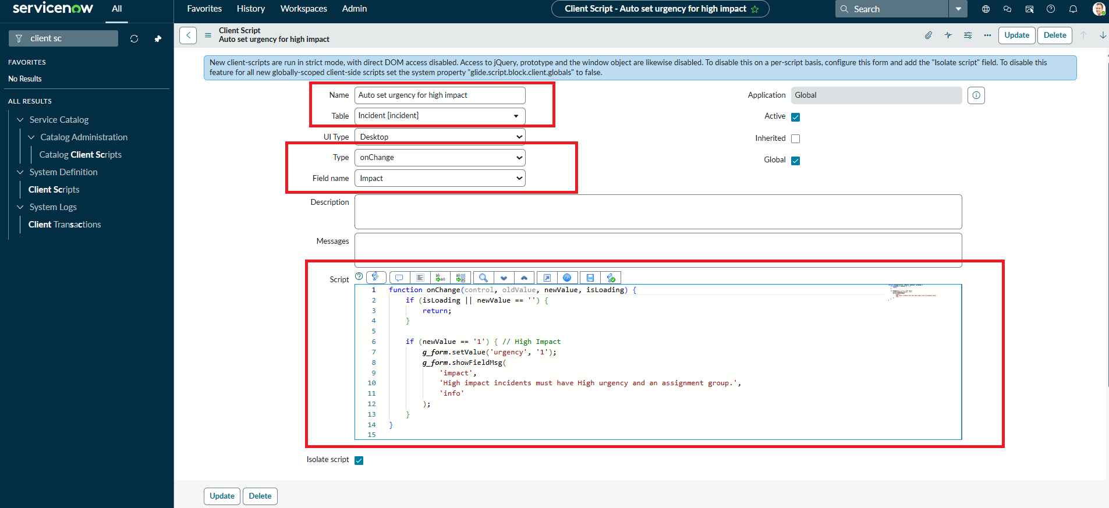
ServiceNow onChange Client Script auto-setting Urgency — in Salesforce this logic is typically built as a record-triggered Flow with an Update Records action

onSubmit Client Script → Validation Rule
The onSubmit script that blocks the save when Impact is High and Assigned To is empty is functionally identical to a Salesforce Validation Rule: AND(Priority = 'High', ISBLANK(OwnerId)) with an error message shown on the Owner field, preventing the Case from saving until it is corrected.
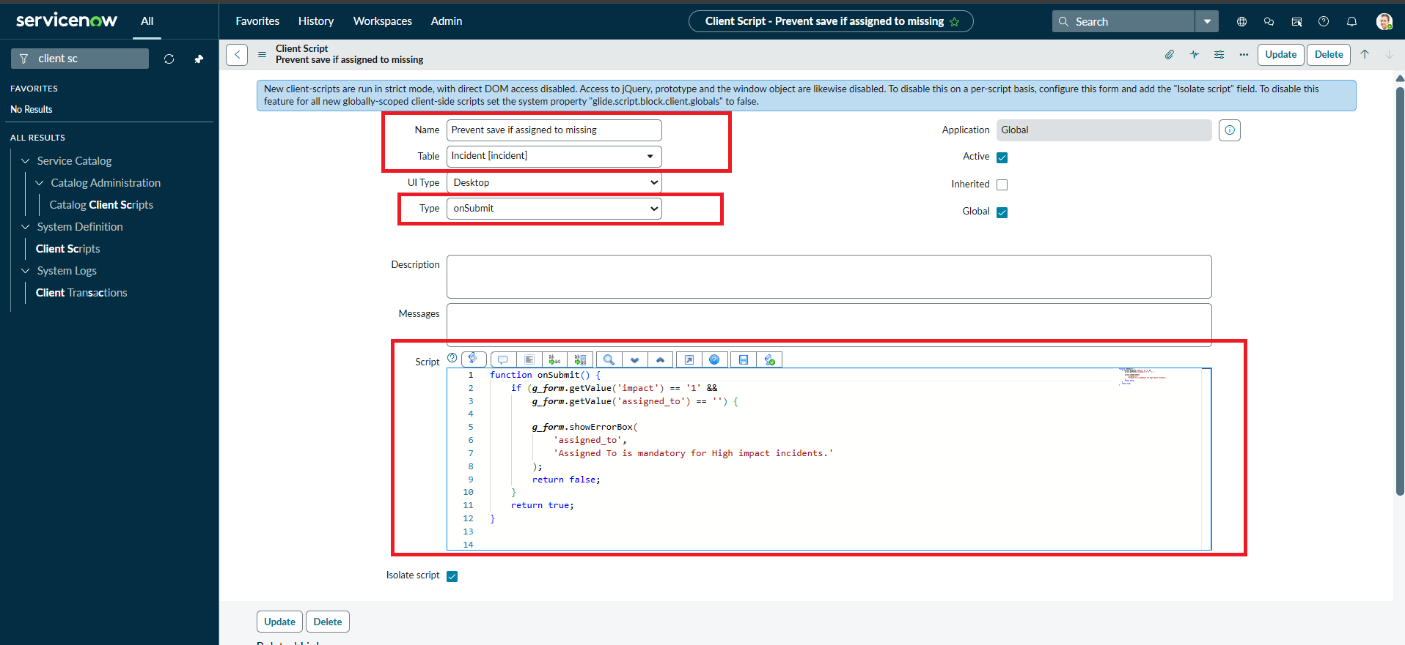
ServiceNow onSubmit Client Script requiring Assigned To — in Salesforce, a Validation Rule performs the equivalent save-time check

onCellEdit Client Script → Inline Edit Restrictions / Field-Level Security
The onCellEdit script that blocks direct State changes from the Incident list view has a close Salesforce equivalent in disabling inline editing for a field on list views, or using Field-Level Security / a Validation Rule that specifically rejects list-view-only inline edits, forcing the user to open the record.

3. Behavior Comparison Table
- Mandatory field on condition — ServiceNow: UI Policy Action (Mandatory: true) → Salesforce: Validation Rule + Required checkbox / Dynamic Forms
- Read-only field on condition — ServiceNow: UI Policy Action (Read only: true) → Salesforce: Dynamic Forms visibility rule or Field-Level Security
- Auto-set a field value — ServiceNow: onChange Client Script (g_form.setValue) → Salesforce: Record-Triggered Flow (Update Records)
- Block save on invalid data — ServiceNow: onSubmit Client Script (g_form.showErrorBox) → Salesforce: Validation Rule (error message)
- Restrict list/inline edits — ServiceNow: onCellEdit Client Script (callback(false)) → Salesforce: Disable inline editing / Field-Level Security

4. Testing Parity
The same five test activities carried out in this project (mandatory enforcement, successful save, reverse condition, list edit blocking, form-based update) would be verified in Salesforce the same way: create/edit a Case with Priority = High and Owner blank to confirm the Validation Rule blocks save; fill Owner and save to confirm success; change Priority back to Medium/Low to confirm the Validation Rule no longer applies; and attempt an inline list edit versus a normal record edit to compare behavior.
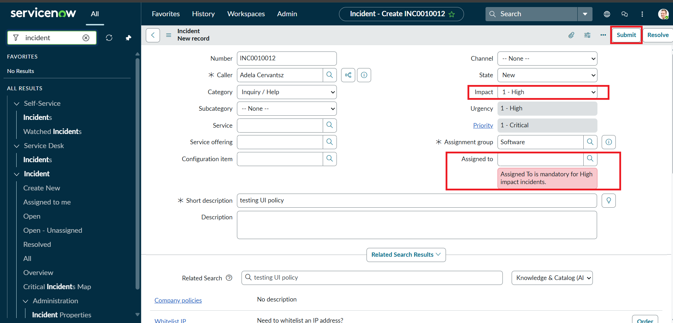
ServiceNow validation blocking save for a missing Assigned To — the same scenario a Salesforce Validation Rule error message would cover for a Case Owner

5. Key Differences to Note
- ServiceNow Client Scripts run purely on the client (browser) for onChange/onSubmit/onCellEdit; Salesforce Flow and Validation Rules run on the server, so there is no separate "client-side only" layer — logic is more centralized.
- ServiceNow UI Policies are reversible by design ("Reverse if false"); in Salesforce, achieving the same automatic reversal typically needs the Flow or Validation Rule to be re-evaluated on every save/change, which happens naturally since Validation Rules always re-check current values.
- ServiceNow's onCellEdit script directly intercepts list-view inline edits with custom script; Salesforce more commonly disables inline editing for a field/object rather than writing custom logic for it.

6. Conclusion
Although this project was implemented on ServiceNow using UI Policies and Client Scripts, the same business requirement — enforcing mandatory fields, auto-populating values, and blocking incomplete Incident/Case data — is fully achievable on Salesforce using Validation Rules, Dynamic Forms, and record-triggered Flows. The two platforms use different tools and terminology, but the underlying goal of reliable, validated record data before submission stays the same.

