Subphase I) Performance Testing

Implement Client Script & UI Policy (Incident) — ServiceNow

1. Purpose
After the UI Policy and Client Scripts were configured on the Incident table, this subphase validates that the configured rules behave correctly under real usage. Each test checks a specific piece of functionality — mandatory enforcement, successful save, condition reversal, and protection against unauthorized list edits — to confirm the solution performs as designed before it is considered complete.

2. Scope of Testing
- Mandatory field enforcement when Impact is set to High
- Successful save once all required conditions are met
- Reverse if false behaviour when Impact is changed away from High
- Blocking of direct State edits from the Incident list view
- Allowing State updates from the Incident form itself

3. Test Activities & Results

Activity 1 — Mandatory Field Enforcement
A new Incident was created with Impact set to High and the Assigned To field left empty. On Submit, the record was correctly blocked from saving, and an inline error "Assigned To is mandatory for High impact incidents." was displayed — confirming the onSubmit Client Script works as configured.
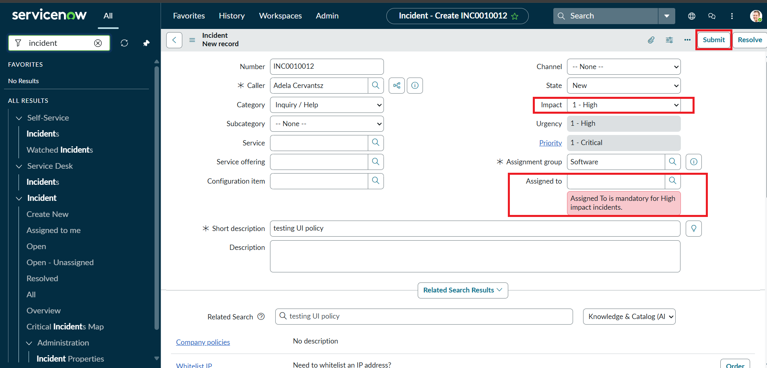
Save blocked with validation error when Assigned To is missing for a High impact Incident

Activity 2 — Successful Save
The Assigned To field was then filled in and the Incident was submitted again. This time the record saved successfully with no errors. Urgency remained read-only per the UI Policy Action, confirming the mandatory, read-only, and auto-set behaviors all worked together correctly.
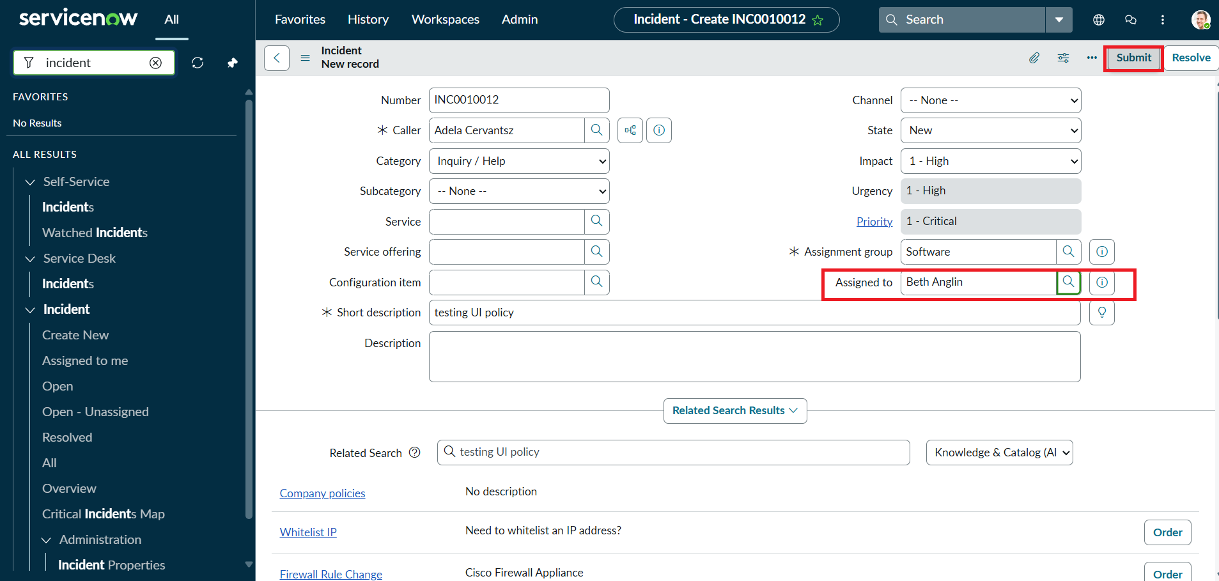
Incident saved successfully once Assigned To was completed

Activity 3 — Reverse Condition Test
An existing High impact Incident was updated by changing Impact from High to Medium. As expected with "Reverse if false" enabled, Assigned To was no longer mandatory and Urgency became editable again, and the record saved without errors — confirming the UI Policy correctly reverses its actions when the condition is no longer true.
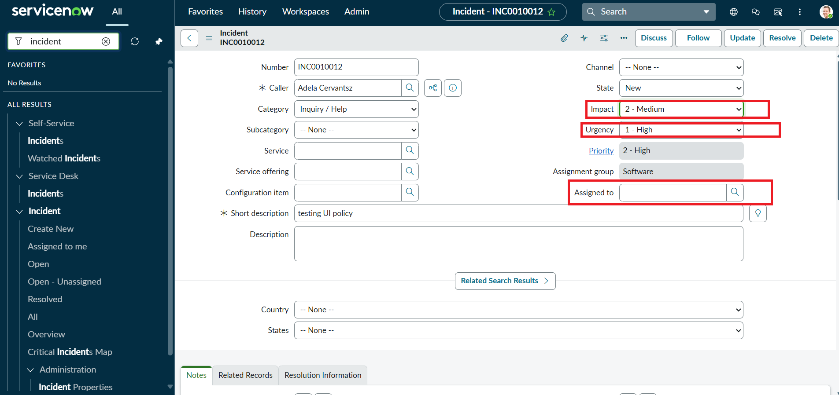
Impact changed to Medium — Urgency editable and Assigned To no longer mandatory

Activity 4 — List Edit Blocking
From the Incident list view, an attempt was made to edit the State field directly (double-click / inline edit). The onCellEdit Client Script intercepted the action, displayed the alert "State cannot be changed from the list. Please open the Incident.", and the change was cancelled — confirming unauthorized list-level edits are blocked.
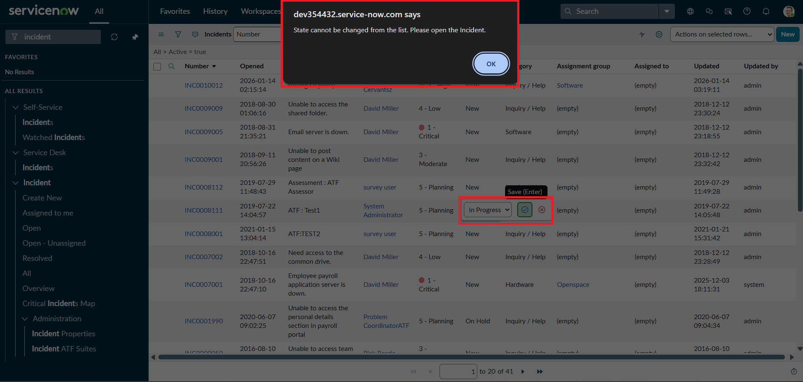
Inline list edit on State blocked with a warning alert

Activity 5 — Form-Based Update
To confirm the block was specific to list editing, the same State field was then updated directly on the Incident form and saved using Update. The change was accepted and saved successfully, verifying that legitimate form-based updates are not affected by the onCellEdit restriction.

4. Outcome
All five test activities passed as expected. The UI Policy and Client Scripts together enforce mandatory data, control field editability, auto-populate values, and protect the State field from unauthorized list edits — while allowing normal form-based updates to proceed. This confirms the Incident form meets the intended business rules and is ready for use.

