TABLEAU
A brief introduction to data visualization and business intelligence
1. Introduction
Tableau is a data visualization and business intelligence platform used to connect to data, analyze information, and present insights through interactive charts and dashboards. It helps users understand large amounts of data in a simple visual form.
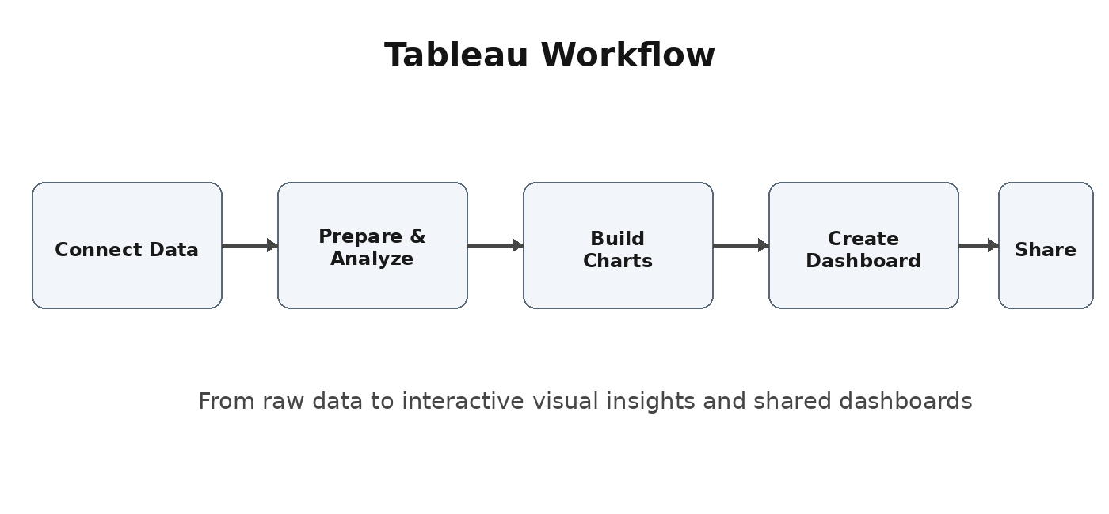
2. Why Tableau is Used
- Turns raw data into clear visual reports and dashboards.
- Helps users identify trends, comparisons, patterns, and unusual results.
- Supports interactive filtering so users can explore data quickly.
- Makes it easier to communicate data-driven findings to others.
3. Basic Tableau Concepts
- Data Source: The file, database, or other location from which Tableau gets data.
- Worksheet: A place where a single visualization is created.
- Dashboard: A collection of multiple views combined on one screen.
- Story: A sequence of visual views used to explain insights step by step.

TABLEAU - WORKING WITH DATA
4. Tableau Workflow
A typical Tableau process starts by connecting to data, exploring fields, creating visualizations, combining them into dashboards, and then sharing the results with users.
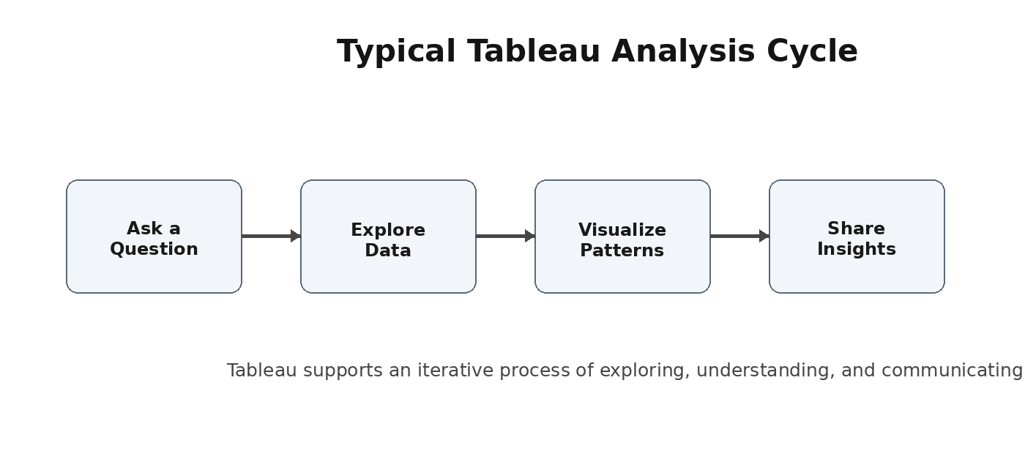
5. Connecting and Preparing Data
- Tableau can work with structured data such as spreadsheets and database tables.
- Users select fields such as dimensions and measures to build views.
- Data can be filtered, grouped, sorted, and combined to support analysis.
- Good data preparation improves the accuracy and usefulness of the final dashboard.
6. Dimensions and Measures
Dimensions are generally descriptive fields used to categorize information, such as Region, Product, or Department. Measures are numeric values that can be analyzed, such as Sales, Quantity, or Profit.

TABLEAU - VISUALIZATION
7. Common Visualizations
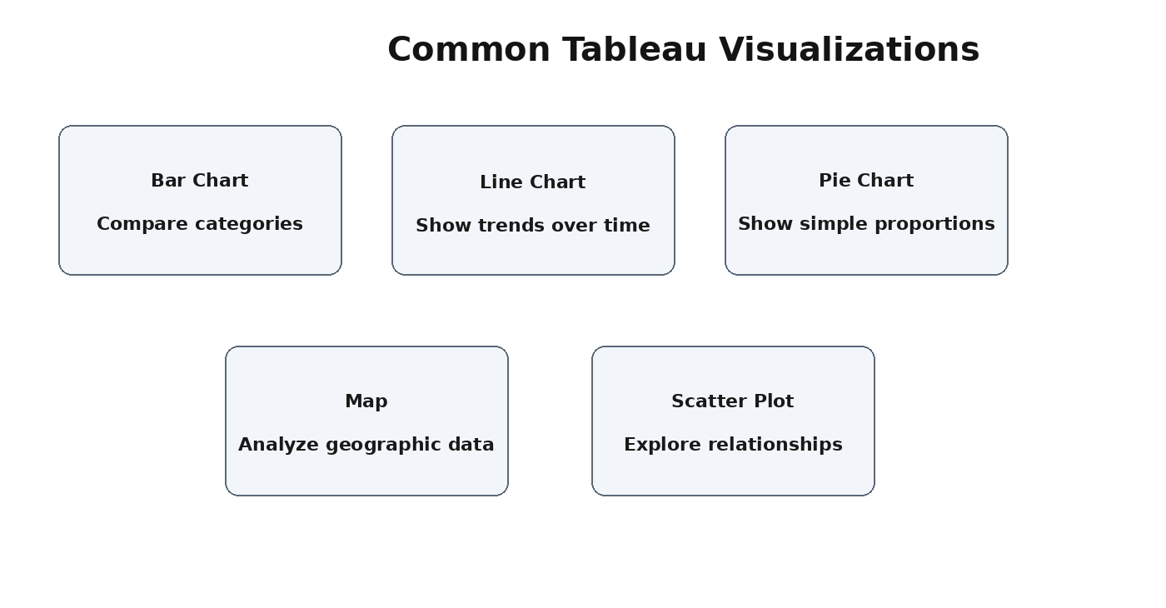
- Bar charts are useful for comparing values across categories.
- Line charts are useful for showing changes and trends over time.
- Maps help display location-based patterns and geographic differences.
- Scatter plots help explore relationships between two numeric measures.
8. Interactive Dashboards
A Tableau dashboard brings multiple visualizations together so users can view related information in one place. Filters, highlights, and interactive selections allow users to focus on the part of the data that matters to them.

TABLEAU - APPLICATIONS AND BENEFITS
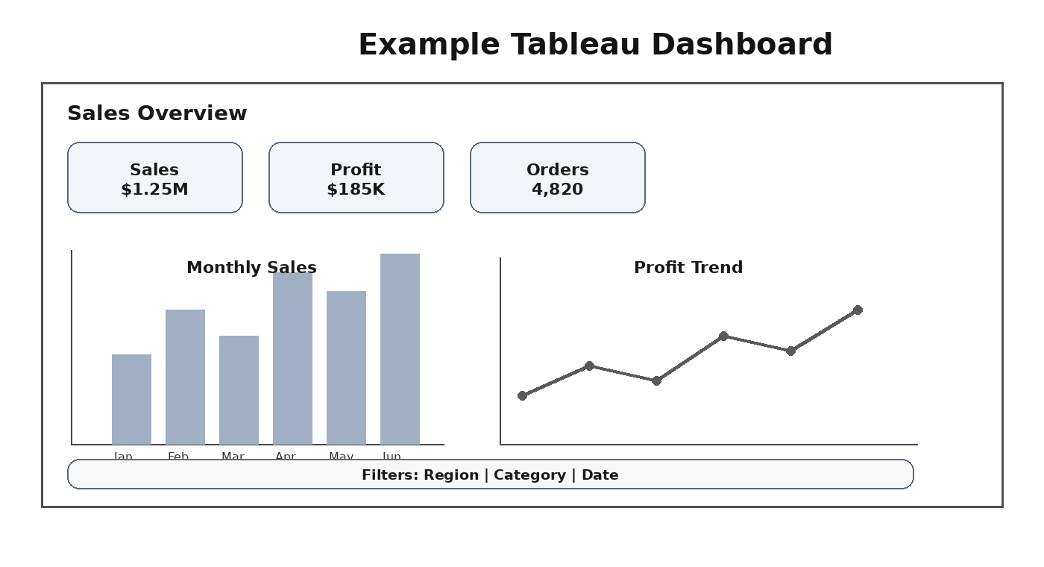
9. Example Use Cases
- Sales analysis: Compare revenue, profit, products, and regions.
- Business reporting: Present key performance indicators in dashboards.
- Customer analysis: Study customer segments, behavior, and trends.
- Operations: Monitor performance, volume, and service-related measures.
10. Benefits of Tableau
- Visual and easy to understand: Data is presented through charts and dashboards.
- Interactive analysis: Filters and selections help users explore information.
- Faster insight discovery: Visual patterns can be easier to identify than raw tables.
11. Best Practices
- Choose a visualization that matches the question being asked.
- Keep dashboards simple and avoid unnecessary visual elements.
- Use clear titles, labels, and filters so the audience understands the view.
12. Conclusion
Tableau provides a practical way to explore data and communicate insights through interactive visualizations. By connecting data, building meaningful charts, and organizing them into dashboards, users can turn complex information into understandable reports and support better data-driven discussions.

