UAT REPORT
User Acceptance Testing for ServiceNow Incident Controls
1. Introduction
User Acceptance Testing (UAT) is the final validation stage where business users confirm that a configured solution meets the expected business rules and can be used as intended. In this project, UAT focuses on the Incident form and the behavior created through UI Policies and Client Scripts.
2. UAT Objective
The objective is to confirm that Incident records follow the configured rules when Impact is changed, when records are saved, and when State is edited from a list. The UAT checks both expected successful behavior and expected restrictions.
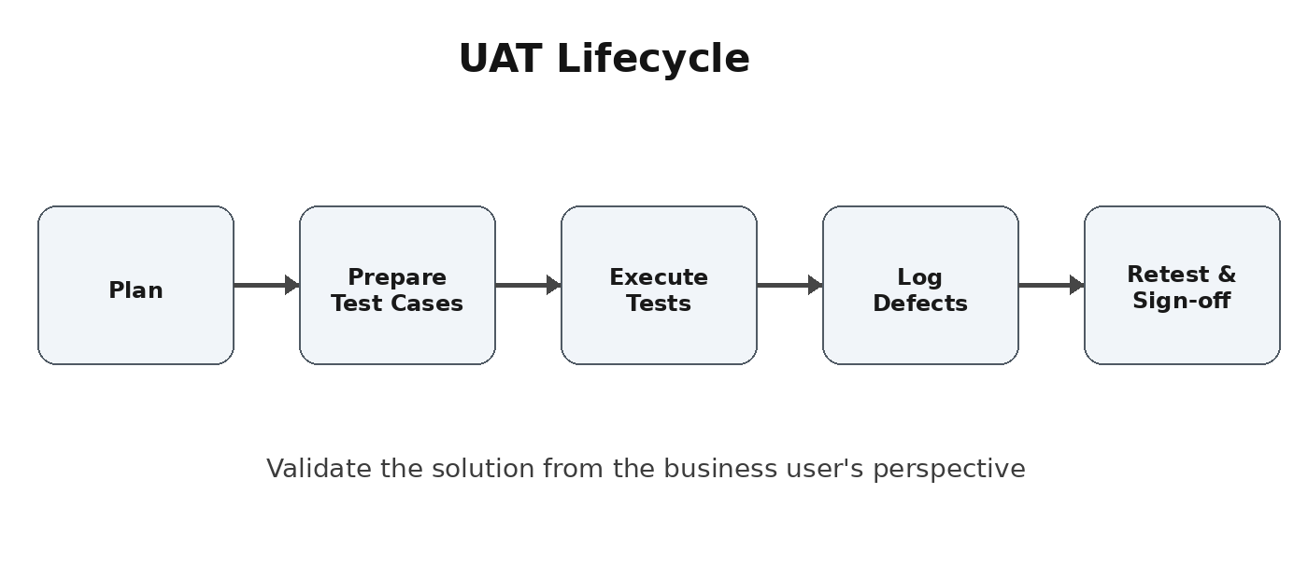
3. Scope
- High Impact Control UI Policy for Incident records.
- Assignment Group mandatory behavior when Impact is High.
- Urgency read-only behavior under the High Impact condition.
- onChange Client Script that sets Urgency to High when Impact = High.
- onSubmit validation that prevents saving when Assigned To is missing for a High Impact incident.
- onCellEdit validation that blocks direct State changes from the Incident list.

4. Test Environment and Preconditions
- ServiceNow Incident module is available to the tester.
- The configured UI Policy and Client Scripts are active.
- A user with permission to create, open, update, and test Incident records is available.
- Test records can be created or selected for Impact, Assigned To, Urgency, and State checks.
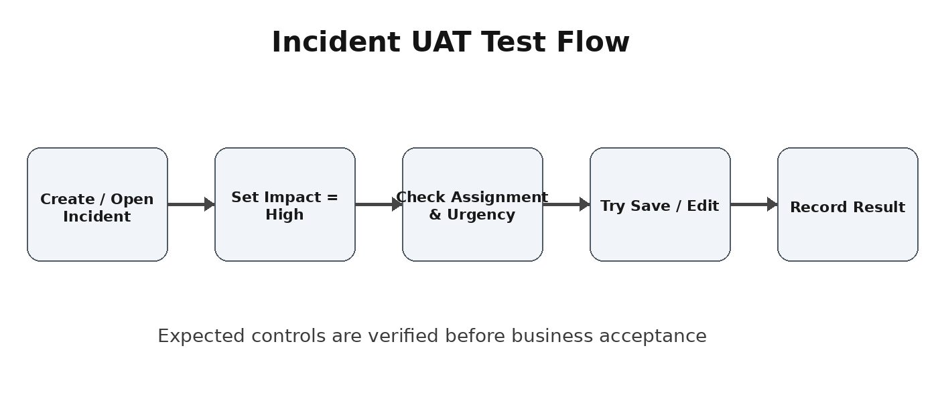
5. Core UAT Test Cases
TC ID | Test Condition | Expected Result | Status
UAT-01 | Set Impact to High | Assignment Group becomes mandatory and Urgency is controlled. | Pass
UAT-02 | High Impact + Assigned To empty + Submit | Save is blocked and an error is displayed. | Pass
UAT-03 | High Impact + Assigned To filled + Submit | Incident saves successfully. | Pass
UAT-04 | Change Impact from High to Medium | Mandatory/read-only behavior is reversed as configured. | Pass
UAT-05 | Edit State directly in list | Alert appears and State remains unchanged. | Pass
6. Acceptance Criteria
- The user interface responds correctly to the selected Impact value.
- Mandatory fields are enforced before record submission.
- Automatic field updates occur when the configured condition is met.
- Restricted list editing is prevented with a clear message.

7. Detailed UAT Execution
Test 1 - High Impact Validation
Open an Incident and set Impact to High. Verify that the configured UI Policy is activated. Assignment Group should be mandatory, and the Urgency field should become read-only according to the UI Policy Action.
Test 2 - Save Validation
Keep Assigned To empty and submit the Incident. The onSubmit Client Script should stop the save and display an error message stating that Assigned To is mandatory for a High Impact incident.
Test 3 - Successful Save
Fill the Assigned To field and submit the same type of Incident. The record should save without an error while the other configured controls continue to operate.
Test 4 - Reverse Condition
Change Impact from High to Medium. With Reverse if false enabled, the UI Policy changes should be reversed. Assignment Group should no longer be mandatory and Urgency should become editable.
Test 5 - List Edit Restriction
Open the Incident list and attempt to edit State directly. The onCellEdit Client Script should show an alert and reject the change. A form-based State update should remain available.
8. Evidence to Capture
- Screenshot of the Incident form with Impact = High.
- Screenshot showing the mandatory Assignment Group behavior.
- Screenshot of the error shown when Assigned To is empty.
- Screenshot of the list edit alert for State.
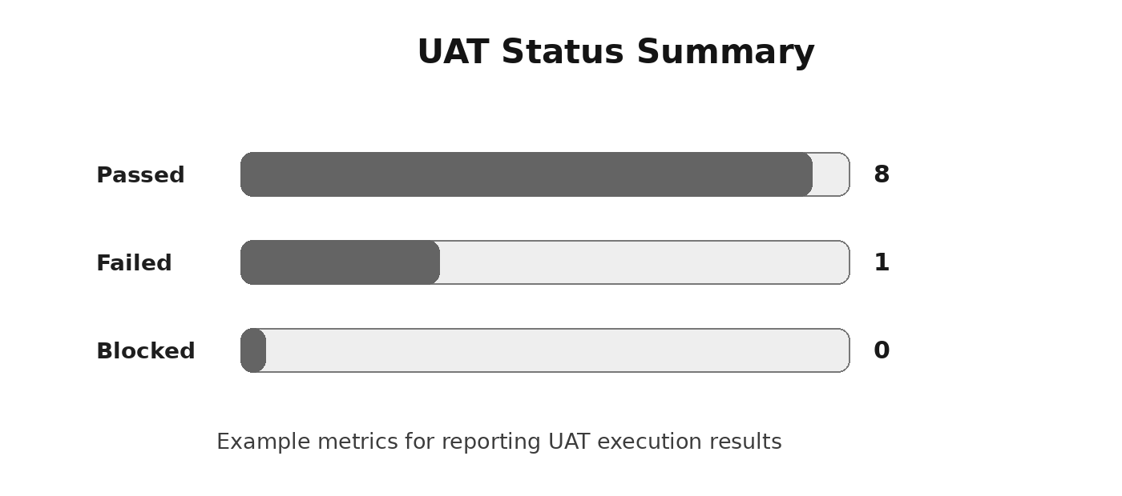

9. Defect and Result Reporting
During UAT, each test case should be recorded as Passed, Failed, or Blocked. Any failed case should include the observed result, expected result, steps to reproduce, and supporting evidence such as screenshots.
Field | Description | Example | Owner
Test Case ID | Unique reference for the test | UAT-02 | Tester
Expected Result | What should happen | Save is blocked | Business User
Actual Result | What happened during execution | Error displayed | Tester
Defect ID | Reference when behavior fails | DEF-001 | Support Team
10. UAT Summary
- UAT confirms that the Incident controls operate according to the configured business rules.
- The testing covers mandatory enforcement, automated updates, read-only behavior, save validation, and list editing.
- Successful UAT provides evidence that the configured behavior is ready for business acceptance, subject to agreed sign-off.
11. Sign-off
Business users should review the UAT results and confirm that the tested Incident workflows meet the intended requirements. Sign-off should record the reviewer, date, and final UAT status.
12. Conclusion
This UAT report provides a concise record of how the ServiceNow Incident configuration is validated from a user's perspective. By testing both positive and negative scenarios, the team can confirm that the UI Policy and Client Script controls support consistent Incident data entry and expected user interactions.
UAT Status: __________ Reviewed By: __________ Date: __________

