Image water marking

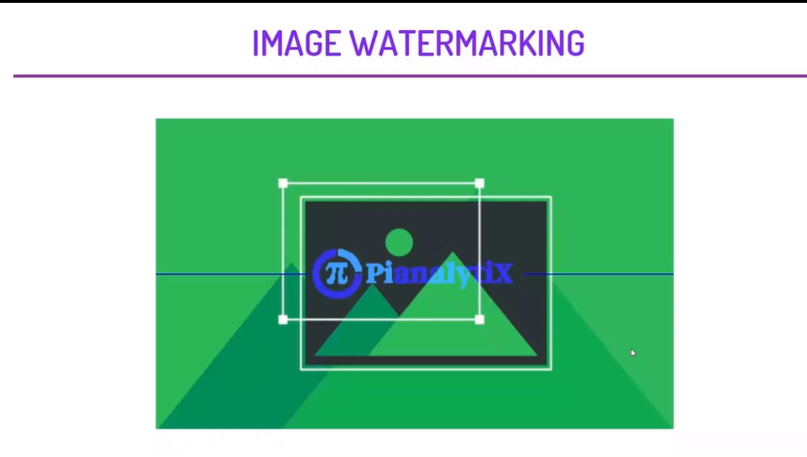

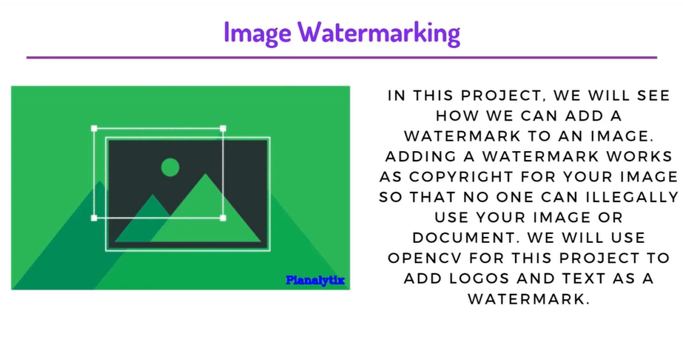

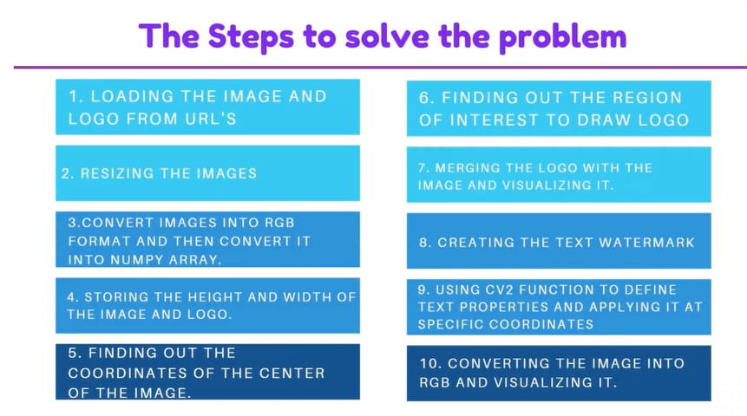

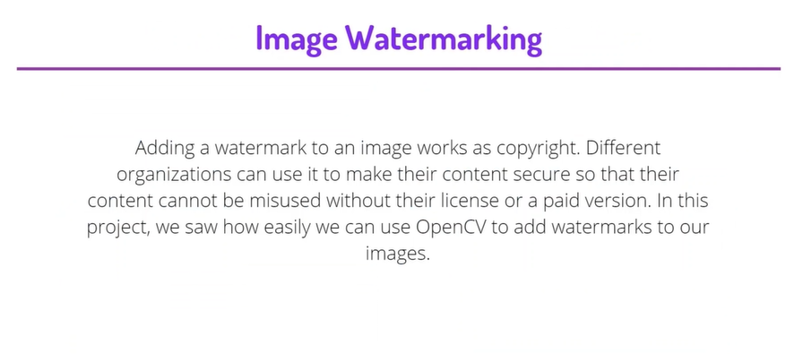

1st import the libraries:

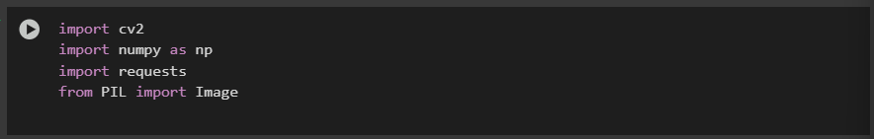

Import the images:

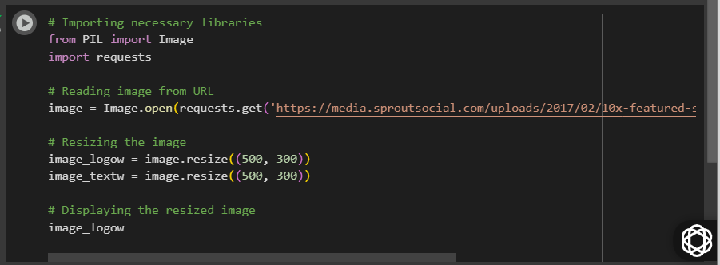

Add the logo for from url

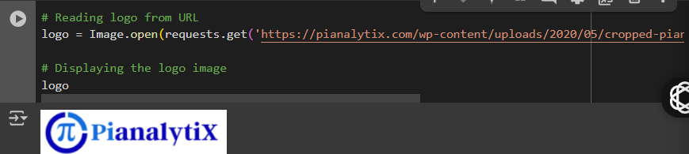

In order to use these images, we will first convert them into rbg format and store it as a numpy array. Similarly, we will also extract the shape

i.e. it's height and width.

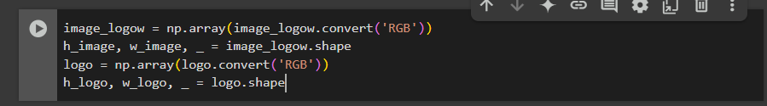

We will place our watermark in the center of the image so for that we need to calculate the center of the image. Here, we will find out the

center coordinates of the image using height and width of the image.

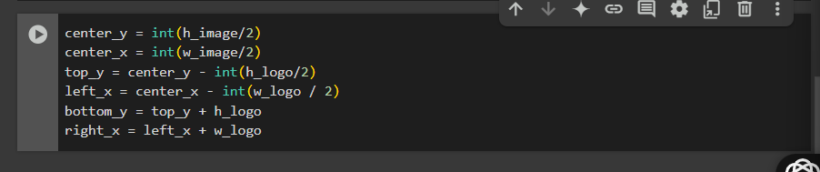

A Region of Interest defined as the area we need to place our watermark on. Here, we will find out ROI using the coordinates we found above.

Next we will use OpenCV to merge our logo on ROI. Similarly we will also add a line or a pattern on our image.

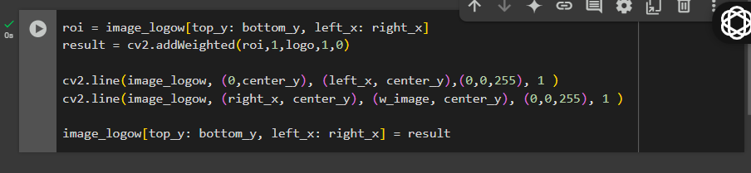

Visualization :

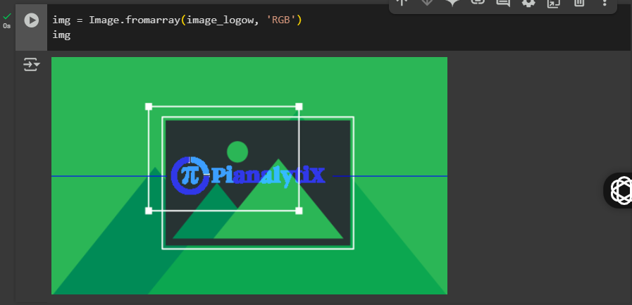

Next we shall see how we can use a text as a watermark. We will convert our image into RGB and save it as a numpy array. To put a text as a

watermark we will be using putText() function of OpenCV. Here we can use different features like size of the text, thickness of the text, font

family, etc.

