

***NOrmalization***

*Blood Bank ManagementSystem Project*



*November 15, 2020*

*Miss ANam Qureshi*

*HADIQA KHAN 19K-0121*

*NOOR US SAHAR 19K-0224*

*SHARJEEL KHAN 19K-1287*

Blood

|  |  |  |  |  |  |  |  |  |
| --- | --- | --- | --- | --- | --- | --- | --- | --- |
| Donation_id | Blood_group | Blood_sign | Density | Hemoglobin | Ph_value | Iron | Wbc | Rbc |

|  |  |  |  |  |  |  |  |  |  |  |
| --- | --- | --- | --- | --- | --- | --- | --- | --- | --- | --- |
| First Name | Last  Name | Donor_id | Gender | Age | Contact | Blood_group | Blood_sign | Email | Password | Date |

Donor_Registration

Donation

|  |  |  |  |  |  |  |  |  |
| --- | --- | --- | --- | --- | --- | --- | --- | --- |
| Donation_id | Donor_id | Blood_center | Date_of_donation | Last_donated | Availability | Location_id | Branch | Weight |

Acceptor

|  |  |  |  |  |  |  |
| --- | --- | --- | --- | --- | --- | --- |
| Acc_id | FirstName | LastName | Contact | Near_address | Blood_group | Blood_sign |

Stock

|  |  |  |
| --- | --- | --- |
| Blood_group | Blood_sign | Quantity |

Record

|  |  |  |
| --- | --- | --- |
| Blood_group | Blood_sign | Quantity |

Location

|  |  |  |  |  |  |  |  |
| --- | --- | --- | --- | --- | --- | --- | --- |
| Loc_id | B_name | Hosp/BloodC | Address | Contact | Email | Contact_person | Area |

Disease

|  |  |  |  |  |  |  |
| --- | --- | --- | --- | --- | --- | --- |
| Donation_id | BP | Anemia | Diabetes | Chainsmoker | HIV | Allergies |

# DDL/ RELATIONAL DATA MODEL

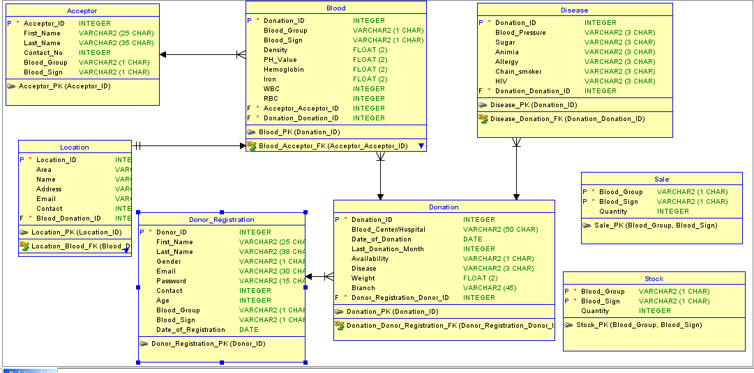

https://www.youtube.com/watch?v=hzAglgAT89k