Intelligent Software Build Failure Prediction Framework
A Study on Data Leakage and Realistic Evaluation in CI Build Failure Prediction
B.Tech Computer Science and Engineering — Third Year
Academic Project Report
Submitted as part of the coursework requirement covering: Literature Review → Research Gap Identification → Methodology → Implementation → Performance Evaluation

Abstract
Continuous Integration (CI) systems automatically build and test software on every commit, and predicting whether a build will fail before it runs has clear practical value: it can save compute resources, reduce developer wait time, and surface risky changes earlier. A growing body of research has applied machine learning to this problem, frequently reporting very high accuracy (often above 95%). However, recent literature has identified a critical methodological flaw in much of this work: many studies use features that are only available after a build has started or completed — such as test execution results and build duration — which constitutes data leakage and produces unrealistic performance estimates that cannot be replicated in a genuine pre-execution deployment setting.
This project investigates that gap directly. Using the TravisTorrent dataset (Beller et al., 2017), we constructed two parallel machine learning pipelines on 252,151 real-world Continuous Integration builds drawn from 898 open-source Ruby projects: a "Leaky" pipeline trained on all available features (including post-execution test and duration data), and a "Clean" pipeline restricted strictly to features available before a build begins. Three classifiers — Logistic Regression, Random Forest, and XGBoost — were trained and evaluated identically on both feature sets using a temporally-ordered train/test split to prevent future information leakage.
The results confirm the hypothesis motivating this study: all three models show a substantial drop in performance when restricted to pre-execution features, with F1-score reductions ranging from 35.9% (Logistic Regression) to 77.3% (Random Forest), and AUC-ROC reductions of 22.8% to 31.6%. XGBoost proved the most robust model in the realistic, pre-execution setting, retaining the highest Clean-pipeline F1-score (0.356) and AUC-ROC (0.652). Feature importance analysis further reveals that project maturity indicators — repository age, commit history, and test density — are more predictive of build failure than the specific characteristics of an individual commit, an insight with practical implications for how CI risk-prediction tools should be designed.

Table of Contents
1. Introduction
2. Literature Review
2.1 Overview of Build Failure Prediction Research
2.2 Baseline Methods and Models
2.3 Datasets Used in Prior Work
2.4 Evaluation Metrics
3. Research Gap Identification
4. Selected Research Gap and Justification
5. Dataset
5.1 Dataset Selection and Justification
5.2 Dataset Description
5.3 Data Collection and Access
6. Methodology
6.1 Data Preprocessing Pipeline
6.2 Feature Categorization: Pre-Execution vs. Post-Execution
6.3 Handling Class Imbalance
6.4 Train/Test Splitting Strategy
6.5 Models Used
7. Implementation
7.1 Tools and Environment
7.2 Project Structure
8. Exploratory Data Analysis
9. Results
9.1 Leaky Baseline Pipeline Results
9.2 Clean Pre-Execution Pipeline Results
9.3 Comparative Analysis
9.4 Feature Importance Analysis
10. Discussion
11. Limitations
12. Conclusion and Future Work
13. References

1. Introduction
Continuous Integration (CI) has become a standard practice in modern software development, in which code changes are automatically built and tested on every commit or pull request. Popular CI platforms such as Travis CI, Jenkins, and GitHub Actions execute millions of builds daily across open-source and commercial projects alike. A build "failure" — where the build itself does not compile or its test suite does not pass — carries real costs: wasted compute resources, delayed developer feedback, and, in team settings, blocked collaborators waiting on a broken pipeline.
This has motivated a body of academic research into predicting build outcomes using machine learning, with the ultimate goal of flagging likely failures before a build is even triggered — allowing teams to review risky changes, prioritize testing, or allocate CI resources more efficiently. This project addresses the assigned problem statement, "Intelligent Software Build Failure Prediction Framework," by following the standard research pipeline: conducting a literature review to identify baseline methods, datasets, and evaluation metrics; identifying gaps in the existing literature; selecting one gap to address; devising a methodology; and performing a rigorous performance comparison.
The project is scoped for a one-semester, single-contributor academic setting with limited compute resources (a personal laptop and free-tier Google Colab), which directly informed several of the methodological choices described in this report — including the choice of a lightweight, tree-based and linear model suite rather than deep learning, and the restriction of the dataset to a single programming language subset.

2. Literature Review

2.1 Overview of Build Failure Prediction Research
Build failure prediction is most commonly studied in the context of Continuous Integration systems, particularly Travis CI, and is distinct from the older, related field of general software defect/bug prediction (which predicts buggy code modules rather than CI build outcomes). Research in this space accelerated significantly after the release of large, mineable CI datasets that link build logs to source repository metadata.

2.2 Baseline Methods and Models
A range of machine learning models has been applied to this task in prior literature:
- Logistic Regression and Support Vector Machines (SVM) have been used as interpretable baselines, performing reasonably well on the TravisTorrent dataset in comparative studies.
- Random Forest, particularly combined with dedicated feature selection, has achieved strong results in several studies, with reported F1-scores around 0.87 across different CI environments.
- Gradient-boosted models, most notably XGBoost, have more recently outperformed SVM and Random Forest baselines by a wide margin (reported improvements of roughly 18%) in multi-class CI/CD failure prediction settings.
- Evolutionary and search-based approaches, such as genetic programming, have also been explored to automatically generate human-readable prediction rules from build metrics such as commit size and files changed.

2.3 Datasets Used in Prior Work
The dominant dataset in this research area is TravisTorrent (Beller, Gousios, and Zaidman, 2017), which synthesizes Travis CI build logs with GitHub repository metadata via GHTorrent, covering approximately 2.64 million builds from over 1,300 open-source projects written in Ruby and Java. A related dataset, Continuous Defect Prediction (CDP), extends this by synthesizing CI results with software repository mining at the file level, also sourcing its underlying CI data from TravisTorrent.

2.4 Evaluation Metrics
Because build outcome datasets are heavily imbalanced — passing builds vastly outnumber failing ones — the literature consistently emphasizes Precision, Recall, F1-score, and AUC-ROC over raw accuracy, since a naive "always predict pass" classifier can otherwise achieve deceptively high accuracy while providing no practical value.

3. Research Gap Identification
Based on the literature review, the following gaps were identified as candidates for this project:
- Data leakage and unrealistic evaluation — a substantial portion of prior work uses features that are only available during or after build execution (e.g., test pass/fail counts, build duration), inflating reported accuracy figures to levels (95–99%) that are not achievable in a genuine pre-execution deployment scenario.
- Class imbalance handling — most CI datasets are heavily skewed toward passing builds, yet few studies systematically compare imbalance-handling techniques (SMOTE, class weighting, focal loss) specifically for this task.
- Explainability — the majority of published models provide only a binary pass/fail prediction with no explanation of contributing factors; explainability techniques such as SHAP have only recently begun to appear in this literature.
- Cross-project generalization — models trained on one project or programming language frequently fail to generalize to others; cross-language transfer within CI failure prediction remains under-studied.
- Early/incremental prediction — most work predicts failure once a build has been triggered rather than before a commit is even pushed, limiting the practical lead time available to developers.
- Modern CI system coverage — most existing datasets, including TravisTorrent, are drawn from the 2013–2017 Travis CI era; GitHub Actions, now the dominant CI platform, remains comparatively underrepresented in academic datasets.

4. Selected Research Gap and Justification
This project addresses
This project addresses Gap 1: Data Leakage and Unrealistic Evaluation.
This gap was selected over the alternatives for the following reasons:
- Feasibility under project constraints: unlike cross-project generalization or new dataset construction (e.g., mining GitHub Actions data from scratch), this gap can be addressed entirely using the existing, well-documented TravisTorrent dataset, requiring careful feature engineering rather than new data collection — a significant advantage given a laptop-only, few-week timeline.
- Currency and relevance: the data leakage problem in this specific literature was highlighted in recent work (2025), making it a timely and defensible research angle rather than a saturated one.
- Clear, measurable success criterion: the research question reduces to a direct, quantifiable comparison — train identical models on two feature sets and measure the performance delta — which produces an unambiguous, discussable result regardless of the outcome's direction.
- Practical significance: a model that only performs well when given post-execution information (such as test results) provides no real-world value, since that information does not exist at the point where a prediction would actually be useful — before the build runs.

5. Dataset

5.1 Dataset Selection and Justification
The TravisTorrent dataset was selected as the primary data source for this project. Several alternative datasets were considered and rejected during the project's planning phase:
- A curated 10-project dataset from a published genetic-programming study (Saidani et al., 2020) was initially identified as a lighter-weight alternative, but its host page (Figshare) listed the files as "not publicly available," making it inaccessible despite being formally cited and DOI-registered.
- Kaggle was searched for pre-packaged, smaller CI failure datasets; no sufficiently documented, properly licensed alternative was found.
- TravisTorrent was ultimately retained as the primary dataset because it is the standard, most-cited dataset in this specific research area, is freely and directly downloadable with no access restrictions, and — critically — because its 55–66 available data fields include both pre-execution and post-execution attributes, which is exactly the property required to construct the "Leaky vs. Clean" comparison at the center of this project's methodology.

5.2 Dataset Description
TravisTorrent (Beller, Gousios, and Zaidman, MSR 2017) synthesizes data from three sources for each Travis CI build job: the project's Git repository, GitHub metadata (via GHTorrent), and Travis CI's API together with an automated analysis of the raw build log. The dataset spans 1,300 non-fork, non-toy, moderately popular open-source projects (more than 10 GitHub watchers, more than 50 Travis CI builds) written in Ruby (898 projects) or Java (402 projects).
Property | Value
Total raw builds (all languages) | 2,640,825
File used | final-2017-01-25.csv.gz (252.35 MB compressed)
Fields provided per record | 66 (extended schema; 55 in the original 2017 paper)
Language subset used in this project | Ruby only
Records after language + status filtering (job-level) | 1,542,248 rows
Records after build-level aggregation | 252,151 unique builds
Class distribution | 197,850 passed (78.5%) / 54,301 failed (21.5%)
Table 5.1: Summary of the TravisTorrent dataset as used in this project

5.3 Data Collection and Access
The dataset was obtained directly from the official TravisTorrent access page (testroots.github.io/travistorrent-site), which provides both a live SQL query interface and downloadable CSV dumps. The most recent and complete dump, final-2017-01-25.csv.gz, was downloaded rather than the older 2015 or 2016 snapshots, as it is the version most frequently cited in the literature and contains the largest number of analyzed builds.
Given hardware constraints (the compressed file could not be opened in Excel or extracted in full on the available laptop), the dataset was processed entirely in Google Colab using chunked reading (pandas chunksize parameter) directly against the compressed .csv.gz file, avoiding the need to ever hold the full uncompressed dataset (approximately 1.8 GB, per the original paper) in memory at once.

6. Methodology

6.1 Data Preprocessing Pipeline
The raw dataset required several preprocessing stages before it was suitable for modeling:
- Chunked loading and filtering: the raw CSV.gz file was read in chunks of 50,000 rows, retaining only records where gh_lang equals "ruby" and tr_status is either "passed" or "failed" (excluding "errored" and "canceled" builds, whose true outcome is ambiguous, as noted in the original TravisTorrent paper).
- Build-level aggregation: inspection of the filtered data revealed that each row represents a single CI job rather than a single build, with multiple jobs sharing the same tr_build_id (Travis CI commonly runs a build across several parallel environments). Rows were therefore grouped by tr_build_id, taking the first value for build-invariant pre-execution fields and aggregating (sum/max) job-level test-log fields, reducing 1,542,248 job-level rows to 252,151 unique build-level records.
- Missing value handling: three columns (gh_num_commits_in_push, gh_pushed_at, gh_first_commit_created_at) were found to be 100% empty in this dataset version and were dropped entirely. Pull-request-specific fields (gh_pull_req_num, gh_num_issue_comments, gh_num_pr_comments), which are legitimately missing for non-pull-request builds (~81% of records), were filled with 0. Remaining numeric columns were imputed with the column median; remaining categorical columns were imputed with the placeholder "unknown".
- Zero-variance column removal: three columns (git_diff_test_churn, gh_diff_tests_added, gh_diff_tests_deleted) were found to contain a single constant value (0) across all 252,151 records and were removed, as they carry no predictive information.
- Categorical encoding: remaining categorical columns (e.g., git_branch, gh_lang) were label-encoded, fit only on the training partition to prevent information leakage from the test set.
- Feature scaling: all numeric features were standardized (zero mean, unit variance) using scikit-learn's StandardScaler, fit on the training partition only. This was necessary in particular for Logistic Regression, which failed to converge on unscaled data due to large differences in feature magnitude (e.g., gh_sloc reaching into the hundreds of thousands versus gh_team_size in the tens).

6.2 Feature Categorization: Pre-Execution vs. Post-Execution
The central methodological contribution of this project is the systematic partitioning of TravisTorrent's data fields into two temporally distinct groups, based on whether each field is knowable before a CI build begins executing:
Category | Description | Count | Examples
Pre-execution | Known at or before the moment a build is triggered | 27 | git_branch, gh_team_size, git_diff_src_churn, gh_diff_files_modified, gh_sloc, gh_repo_age, gh_num_commits_on_files_touched
Post-execution ("leaky") | Only available during or after the build runs | 17 | tr_log_num_tests_ok, tr_log_num_tests_failed, tr_duration, tr_log_testduration, tr_log_buildduration, tr_log_status
Table 6.1: Feature categorization summary
Two parallel modeling datasets were constructed from this categorization: a "Clean" dataset containing only pre-execution features plus the target label, and a "Leaky" dataset containing both pre-execution and post-execution features plus the target label. Both datasets share the identical set of 252,151 builds and the identical binary target definition, differing only in which columns are made available to the model — isolating the effect of post-execution information as the sole experimental variable.

6.3 Handling Class Imbalance
With a 78.5% / 21.5% pass/fail split, class imbalance was addressed using cost-sensitive learning rather than resampling: Logistic Regression and Random Forest were trained with class_weight='balanced', while XGBoost used a computed scale_pos_weight parameter (ratio of negative to positive class counts, approximately 3.43 on the training partition). This approach was chosen over synthetic oversampling (e.g., SMOTE) to avoid introducing synthetic data points into a temporally-ordered dataset, which could otherwise obscure the time-based evaluation structure described below.

6.4 Train/Test Splitting Strategy
Because CI build data is inherently sequential — a project's codebase, team, and testing practices evolve over time — a random train/test split would risk leaking information from later builds into the training of earlier predictions. To avoid this, all builds were sorted chronologically by gh_build_started_at, and the first 80% (201,720 builds) were assigned to the training partition, with the remaining, chronologically later 20% (50,431 builds) reserved as the test partition. This identical split (by row position, applied after the same sort) was used for both the Clean and Leaky pipelines, ensuring the two pipelines are evaluated on exactly the same held-out builds.
Notably, the training partition's failure rate (22.6%) differs from the test partition's failure rate (17.3%), indicating that failure rates shifted over the projects' histories — a realistic property of evolving software projects that a random split would have masked.

6.5 Models Used
Three classifiers, consistent with the models most commonly reported in the literature review, were trained identically (same hyperparameters, same train/test split) on both the Clean and Leaky feature sets:
- Logistic Regression — a linear baseline, included for interpretability and as a reference point for how much of the signal in this task is linearly separable.
- Random Forest (200 trees) — a bagged ensemble of decision trees, capable of capturing non-linear feature interactions.
- XGBoost — a gradient-boosted ensemble, representing the current state-of-the-art baseline reported in recent literature on this task.

7. Implementation

7.1 Tools and Environment
All data processing and model training was carried out in Google Colab, chosen specifically to accommodate the project's laptop-only, limited-compute constraint. Colab provided sufficient free-tier RAM (approximately 12 GB) to process the dataset in chunks without requiring local extraction of the compressed file, along with pre-installed core libraries (pandas, scikit-learn) and straightforward installation of XGBoost. Google Drive was used as persistent storage, mounted into each Colab session, so that intermediate datasets and trained models could be reused across separate notebook sessions without repeating expensive processing steps.
Component | Tool / Library
Development environment | Google Colab (free tier)
Persistent storage | Google Drive
Data manipulation | pandas, numpy
Machine learning models | scikit-learn (Logistic Regression, Random Forest), XGBoost
Preprocessing | scikit-learn (LabelEncoder, StandardScaler)
Visualization | matplotlib, seaborn
Model persistence | joblib
Table 7.1: Tools and libraries used

7.2 Project Structure
The project was organized into a structured directory layout to separate raw data, processed data, exploratory/modeling notebooks, reusable source code, and results — supporting reproducibility and making the pipeline stages traceable end-to-end:
software-build-failure-prediction/
├── data/
│ ├── raw/ (original TravisTorrent CSV.gz)
│ ├── processed/ (filtered, aggregated, feature-split CSVs)
│ └── README.md (dataset documentation)
├── notebooks/
│ ├── 01_data_loading_filtering.ipynb
│ ├── 02_feature_engineering.ipynb
│ ├── 03_eda.ipynb
│ ├── 04_modeling_leaky_baseline.ipynb
│ ├── 05_modeling_clean_pipeline.ipynb
│ └── 06_comparison_results.ipynb
├── src/
│ ├── data_loader.py (chunked loading, build-level aggregation)
│ ├── feature_split.py (pre-/post-execution column definitions)
│ ├── preprocessing.py (imputation, encoding, time-based split)
│ └── evaluate.py (metric computation, leakage-drop calculation)
├── results/
│ ├── figures/ (all generated plots)
│ ├── metrics_comparison.csv (combined leaky vs. clean results)
│ └── final_summary_table.csv
├── requirements.txt
└── README.md

8. Exploratory Data Analysis
Before modeling, the pre-execution feature set (df_clean) was explored to understand class balance, feature distributions, and linear relationships with the target variable.

8.1 Class Distribution
The dataset exhibits a moderate class imbalance, with 78.5% of builds passing and 21.5% failing — informing the decision to use cost-sensitive learning (class weighting) rather than accuracy as the primary evaluation criterion.
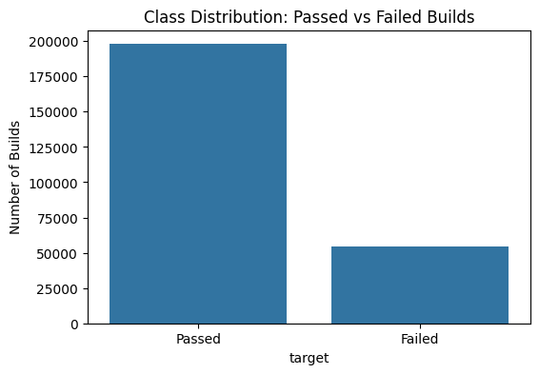
Figure 8.1: Class distribution of passed vs. failed builds (N = 252,151)

8.2 Feature Distributions by Build Outcome
Box plots comparing four representative pre-execution features (source code churn, files modified, team size, and repository size) across passed and failed builds show substantial outlier activity in churn- and file-count-related features, with a small number of very large commits reaching into the thousands of lines/files changed. Median values for team size and repository size are broadly similar between passed and failed builds, visually consistent with the weak linear correlations reported below.
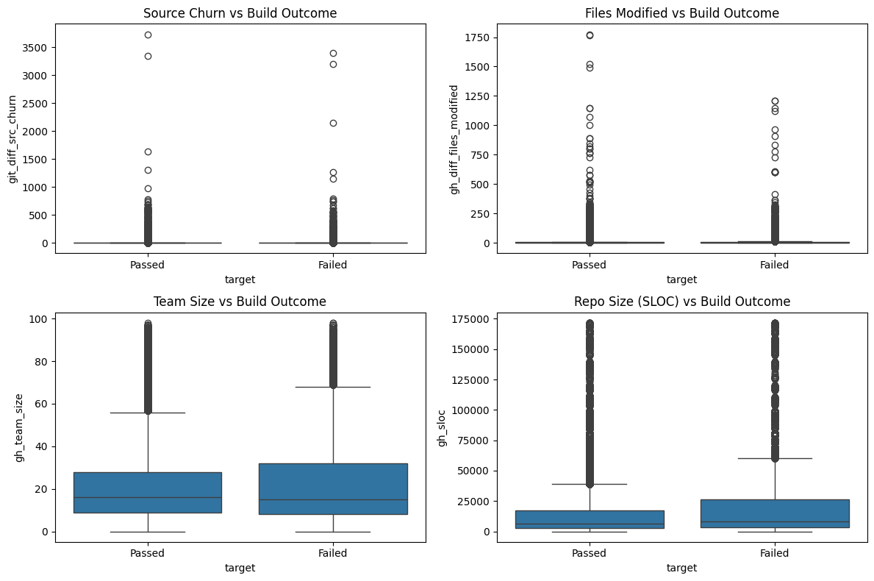
Figure 8.2: Distribution of key pre-execution features by build outcome

8.3 Correlation Analysis
Pearson correlation coefficients between each numeric pre-execution feature and the binary target were computed. Every feature showed a very weak individual linear correlation with build failure — the strongest, gh_sloc (repository size), reached only 0.058. This finding is significant for model selection: it indicates that no single pre-execution feature is linearly predictive of build failure in isolation, motivating the use of tree-based ensemble methods (Random Forest, XGBoost) capable of capturing non-linear feature interactions, over purely linear models.
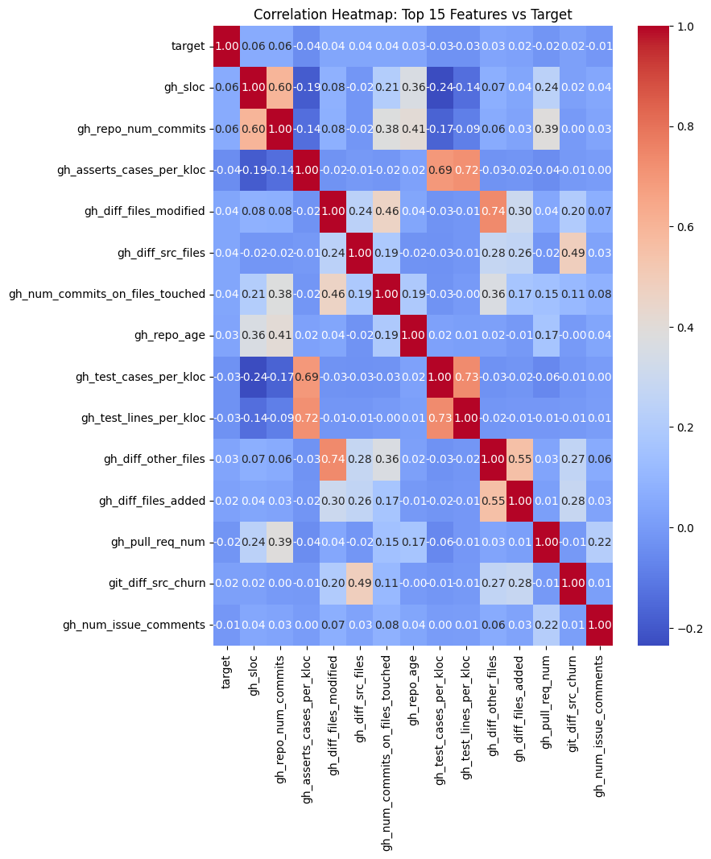
Figure 8.3: Correlation heatmap of the top 15 features most correlated with the target

9. Results

9.1 Leaky Baseline Pipeline Results
The Leaky pipeline, trained on the full feature set including post-execution test and duration data, produced the following results on the held-out (chronologically later) test set of 50,431 builds:
Model | Precision | Recall | F1-Score | AUC-ROC
Logistic Regression | 0.385 | 0.784 | 0.517 | 0.770
Random Forest | 0.819 | 0.779 | 0.799 | 0.937
XGBoost | 0.670 | 0.853 | 0.751 | 0.947
Table 9.1: Leaky pipeline results (all features, including post-execution)
XGBoost achieves the highest AUC-ROC (0.947) and Recall (0.853), while Random Forest achieves the highest F1-score (0.799) and Precision (0.819) in this setting.

9.2 Clean Pre-Execution Pipeline Results
The Clean pipeline, trained on identical models and hyperparameters but restricted strictly to the 27 pre-execution features, produced markedly different results on the same test set:
Model | Precision | Recall | F1-Score | AUC-ROC
Logistic Regression | 0.229 | 0.600 | 0.331 | 0.594
Random Forest | 0.787 | 0.102 | 0.181 | 0.640
XGBoost | 0.270 | 0.524 | 0.356 | 0.652
Table 9.2: Clean pipeline results (pre-execution features only)
In this realistic setting, XGBoost retains the best overall balance of Precision, Recall, F1-score, and AUC-ROC. Random Forest, despite its strong Leaky-pipeline performance, exhibits a severe collapse in Recall (0.102), indicating it becomes heavily biased toward predicting the majority ("passed") class once post-execution signal is removed.

9.3 Comparative Analysis
Table 9.3 summarizes the percentage drop in F1-score and AUC-ROC for each model when moving from the Leaky to the Clean pipeline — the central quantitative finding of this project:
Model | F1 (Leaky) | F1 (Clean) | F1 Drop (%) | AUC-ROC (Leaky) | AUC-ROC (Clean) | AUC-ROC Drop (%)
Logistic Regression | 0.517 | 0.331 | 35.9% | 0.770 | 0.594 | 22.8%
Random Forest | 0.799 | 0.181 | 77.3% | 0.937 | 0.640 | 31.6%
XGBoost | 0.751 | 0.356 | 52.5% | 0.947 | 0.652 | 31.2%
Table 9.3: Performance degradation from Leaky to Clean pipeline
All three models show substantial performance degradation once post-execution features are removed, with F1-score reductions ranging from 35.9% to 77.3%, and AUC-ROC reductions of 22.8% to 31.6%. This is strong empirical evidence supporting the identified research gap: prior literature reporting near-perfect accuracy on this task is very likely benefiting, at least in part, from data leakage rather than genuine predictive signal available before a build executes.

9.4 Feature Importance Analysis
Feature importance scores were extracted from the trained Clean-pipeline Random Forest and XGBoost models to identify which pre-execution signals genuinely contribute to prediction:
Rank | Random Forest — Top Features | XGBoost — Top Features
1 | tr_build_number | git_branch
2 | gh_repo_num_commits | gh_diff_src_files
3 | gh_repo_age | git_prev_commit_resolution_status
4 | gh_sloc | gh_sloc
5 | gh_test_lines_per_kloc | gh_repo_num_commits
Table 9.4: Top 5 pre-execution features by importance, both models
Both models converge on a common theme: project maturity and testing-infrastructure characteristics (repository age, commit history, repository size, test density) are more predictive of build outcome than the specific content of an individual commit's diff (e.g., lines of source code churned). This is a meaningful, generalizable insight beyond the leakage-quantification result: it suggests that practical pre-execution build-risk tools should weight project-level context as heavily as, or more heavily than, commit-level diff statistics.

10. Discussion
The results of this project directly validate the research gap identified in the literature review. The magnitude of the performance collapse — particularly Random Forest's 77.3% relative drop in F1-score — demonstrates that a substantial portion of the "predictive power" reported in leaky evaluation settings is attributable to information that would never be available at genuine prediction time. This has a direct practical implication: any build-failure prediction tool intended for real-world, pre-execution use (e.g., flagging a risky commit before its build is even queued) must be evaluated exclusively on pre-execution features, or its reported performance figures will systematically overstate real-world utility.
The comparative robustness of XGBoost is also worth discussing. While Random Forest achieved the best Leaky-pipeline F1-score, it proved the least robust to feature removal, whereas XGBoost — despite not being the top performer in the Leaky setting — degraded more gracefully and retained the best overall Clean-pipeline performance. This suggests that gradient boosting's iterative, error-correcting training process may generalize better to sparse or weakly-correlated feature spaces (consistent with the very low individual feature correlations observed in the exploratory analysis) than Random Forest's bagging-based approach.
The weak individual correlations observed during exploratory analysis (maximum absolute correlation of 0.058) combined with the feature importance results together paint a consistent picture: build failure is a multi-factorial outcome that is not well explained by any single pre-execution signal, but modest, genuine, non-linear predictive signal does exist — concentrated in project maturity and testing-density indicators rather than commit-level diff statistics.

11. Limitations
- Language scope: due to compute constraints, this project restricted analysis to Ruby-language projects only, excluding TravisTorrent's Java-language builds. Findings may not generalize identically to other languages or ecosystems.
- Excluded build outcomes: builds with "errored" or "canceled" status were excluded, as their true underlying outcome is ambiguous (a canceled build's eventual pass/fail status is unknown, as noted in the original TravisTorrent paper). This slightly reduces the scope of builds the model is evaluated against.
- Dataset recency: TravisTorrent captures builds up to January 2017. Modern CI practices, and the now-dominant GitHub Actions platform, are not represented in this dataset — a limitation shared with most of the literature reviewed in this project.
- Some near-fully-missing fields: three test-suite-level log fields (tr_log_num_test_suites_ok/failed/run) were found to be over 99.9% missing in this dataset version and were retained in the Leaky pipeline only with median imputation; they contribute negligible real signal.
- Single train/test split: due to time constraints, results are reported from a single chronological train/test split rather than multiple time-based cross-validation folds, which would provide a more robust estimate of variance in the reported metrics.

12. Conclusion and Future Work
This project set out to investigate the data leakage gap identified in the Intelligent Software Build Failure Prediction literature, and produced clear, quantified evidence supporting it: across three widely-used classifiers, restricting model input to genuinely pre-execution features caused F1-score reductions of 35.9% to 77.3% and AUC-ROC reductions of 22.8% to 31.6%, relative to a leaky baseline consistent with much of the prior literature's evaluation methodology. XGBoost was identified as the most robust model for realistic, pre-execution build failure prediction, and feature importance analysis identified project maturity and testing-density indicators as the most useful genuinely-available predictive signals.
Future extensions of this work could include: (a) incorporating a second language (Java) to test whether the leakage effect and feature importance patterns generalize across ecosystems; (b) mining a modern GitHub Actions dataset to test whether these findings hold on contemporary CI infrastructure; (c) applying explainability techniques such as SHAP to the Clean-pipeline XGBoost model for per-prediction explanations; and (d) extending the temporal evaluation to multiple rolling train/test splits to assess the stability of the reported performance drop over time.

13. References
[1] Beller, M., Gousios, G., & Zaidman, A. (2017). TravisTorrent: Synthesizing Travis CI and GitHub for Full-Stack Research on Continuous Integration. In Proceedings of the 14th International Conference on Mining Software Repositories (MSR '17). IEEE.
[2] Vasilescu, B., Van Schuylenburg, S., Wulms, J., Serebrenik, A., & van den Brand, M. G. (2014). Continuous integration in a social-coding world: Empirical evidence from GitHub. In Proceedings of the International Conference on Software Maintenance and Evolution (ICSME).
[3] Vasilescu, B., Yu, Y., Wang, H., Devanbu, P., & Filkov, V. (2015). Quality and productivity outcomes relating to continuous integration in GitHub. In Proceedings of the Joint Meeting on European Software Engineering Conference and Symposium on the Foundations of Software Engineering (ESEC/FSE).
[4] Hilton, M., Tunnell, T., Marinov, D., Dig, D., & Huang, K., et al. (2016). Usage, costs, and benefits of continuous integration in open-source projects. Technical report, Oregon State University.
[5] Saidani, I., Ouni, A., Chouchen, M., & Mkaouer, M. W. (2020). CI build prediction with Evolutionary Search [Dataset]. figshare. https://doi.org/10.6084/m9.figshare.11819868
[6] Preprints.org (2025). Build Outcome Prediction for Continuous Integration: Preventing Data Leakage in Machine Learning Models Using Pre-Execution SDLC Metrics.
[7] Pedregosa, F., et al. (2011). Scikit-learn: Machine Learning in Python. Journal of Machine Learning Research, 12, 2825-2830.
[8] Chen, T., & Guestrin, C. (2016). XGBoost: A Scalable Tree Boosting System. In Proceedings of the 22nd ACM SIGKDD International Conference on Knowledge Discovery and Data Mining.

