**Takeaways:-** Read json, Json_tuple, to_json, explode, collect_list, concat_ws

**Problem Statement:**

You are getting transactional data for your ecart business in json format and you have to transform data as per the given instructions

You can run the python script and generate the dummy data

Sample data:-

[

[

{

"transaction_id": "T001",

"customer_id": "C006",

"items": [

{

"item_id": "I010",

"product_name": "Printer",

"quantity": 1,

"price": 1369.88

},

{

"item_id": "I007",

"product_name": "Monitor",

"quantity": 1,

"price": 845.42

}

],

"transaction_time": "2024-07-26T13:16:23Z",

"delivery_info": {

"status": "Shipped",

"delivery_time": "2024-07-31T13:53:23Z",

"address": {

"street": "532 Pine St",

"city": "Star City",

"state": "TX",

"zip": "32658"

}

}

},

{

"transaction_id": "T002",

"customer_id": "C009",

"items": [

{

"item_id": "I003",

"product_name": "Mouse",

"quantity": 3,

"price": 1101.22

}

],

"transaction_time": "2024-07-26T12:06:23Z",

"delivery_info": {

"status": "Pending",

"delivery_time": "2024-07-30T13:53:23Z",

"address": {

"street": "924 Elm St",

"city": "Central City",

"state": "TX",

"zip": "19249"

}

}

},

]

**Step 1**

Read the json file

Output should be in this format

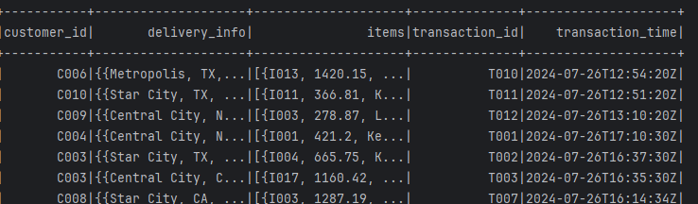

**Step 2**

The delivery_info column contains city, state, street and zipcode.

Fetch those details from the column, alonwith transaction_id and customer_id

Output format

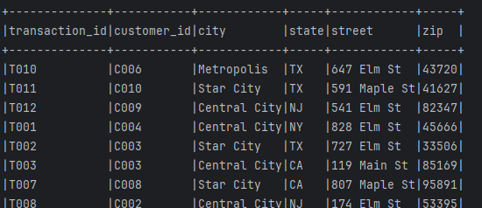

**Step 3**

Filter customer_ids with multiple addresses like in following eg customer_id C009

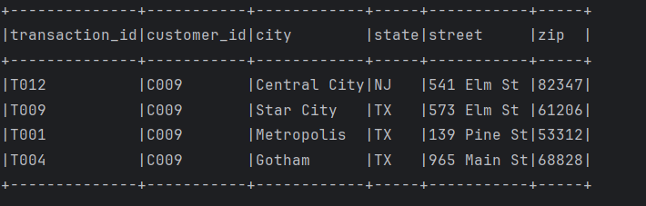

**Step 4**

Create one address column in the format street,city,state,zip

Output format

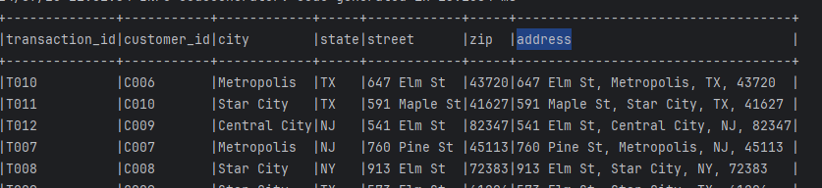

**Step 5**

Create a separate customerAddress Dataframe with all address corresponding to that customer_id

Output format



**Step 6**

Fetch item details corresponding to each transaction ID

Output format

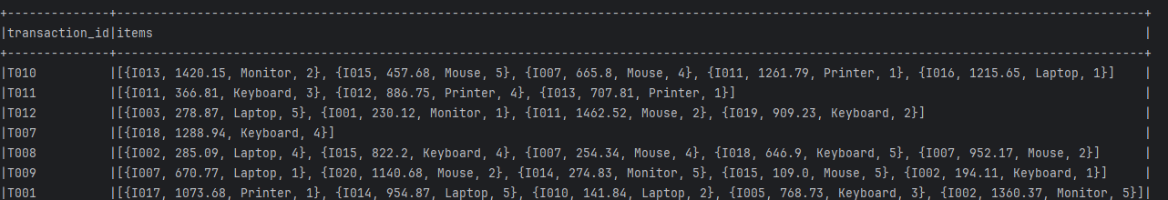

**Step 7**

Denormalize it with just 1 set of item information in one row

Output format

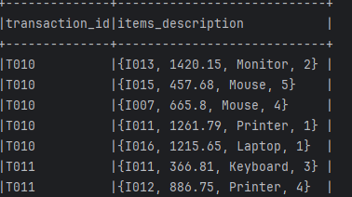

**Step 8**

Split item_Description column as item_id, price, product_name, quantity

Output format

