**NLP and Blender Based Indian Sign Language Animation System**

***A Project Report submitted in partial fulfilment of the***

***requirements for the award of the degree of***

**BACHELOR OF TECHNOLOGY**

***In***

**COMPUTER SCIENCE & ENGINEERING**

***By***

1. Mogalathurthi N S V Devi Parvathi - 21B01A05A7
2. Mathi Sai Divya Sri – 21B01A05A1
3. Neelapala Manasa- 21B01A05B8
4. Kodali Sravani - 21B01A0575
5. Koppada Naga Lakshmi – 22B05A0507

***Under the esteemed guidance of* Mr. P. Sunil**

**(Assistant Professor)**

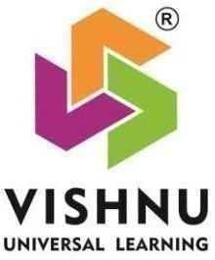

**DEPARTMENT OF COMPUTER SCIENCE & ENGINEERING SHRI**

**VISHNU ENGINEERING COLLEGE FOR WOMEN(A)**

**(Approved by AICTE, accredited by NBA, Affiliated to JNTU Kakinada)**

**BHIMAVARAM – 534 202**

**2024 – 2025**

**SHRI VISHNU ENGINEERING COLLEGE FOR WOMEN(A)**

**(Approved by AICTE, accredited by NBA, Affiliated to JNTU Kakinada)**

**BHIMAVARAM – 534 202**

**DEPARTMENT OF COMPUTER SCIENCE & ENGINEERING**



***CERTIFICATE***

*This is to certify that the project entitled “****NLP and Blender Based Indian Sign Language Animation System”****, is being submitted,* ***M N S V Devi Parvathi, M. Sai Divya Sri, N. Manasa, K. Sravani, K. Naga Lakshmi*** *bearing the* ***Regd. No’s. 21B01A05A7, 21B01A05A1, 21B01A05B8, 21B01A0575, 22B05A0507*** *in partial fulfilment of the requirements for the award of the degree of “****Bachelor of Technology*** *in* ***Computer Science & Engineering****” is a record of Bonafide work carried out by her under my guidance and supervision during the academic year* ***2024–2025*** *and it has been found worthy of acceptance according to the requirements of the university.*

**Internal Guide Head the Department**

**External Examiner**

**ACKNOWLEDGMENT**

The satisfaction that accompanies the successful completion of any task would be incomplete without the mention of the people who made it possible and whose constant encouragement and guidance has been a source of inspiration throughout the course of this seminar. We take this opportunity to express our gratitude to all those who have helped us in this seminar.

We wish to place our deep sense of gratitude to **Sri. K. V. Vishnu Raju**, Chairman of SVES, for his constant support on each and every progressive work of mine.

We wish to express our sincere thanks to **Dr. G. Srinivasa Rao**, Principal of SVECW for being a source of inspiration and constant encouragement.

We wish to express our sincere thanks to **Prof P. Venkata Rama Raju**, Vice-Principal of SVECW for being a source of inspirational and constant encouragement.

We wish to express our sincere thanks to **Dr. P. Srinivasa Raju,** Director Students Affairs & Admin for SVES Group of Institutions for being a source of inspirational and constant encouragement.

We wish to place our deep sense of gratitude to **Dr. P. Kiran Sree**, Head of the Department of Computer Science & Engineering for his valuable pieces of advice in completing this seminar successfully.

We are deeply thankful to our project coordinator **Dr. P. R. Sudha Rani**, Professor for her indispensable guidance and unwavering support throughout our project's completion.

Her expertise and dedication have been invaluable to our success.

We are deeply indebted and sincere thanks to our PRC members

**Dr. A. Seenu, Dr. T. Gayathri**, for their valuable advice in completing this project successfully.

Our deep sense of gratitude and sincere thanks to **Mr. P. Sunil,** Assistant Professor for his unflinching devotion and valuable suggestions throughout my project work.

**Project Associates:**

M N S V Devi Parvathi - 21B01A05A7

Mathi Sai Divya Sri – 21B01A05A1

Neelapala Manasa- 21B01A05B8

Kodali Sravani - 21B01A0575

Koppada Naga Lakshmi – 22B05A0507

**ABSTRACT**

Effective communication remains a fundamental challenge for individuals who use sign language, particularly in interactions with non-signers. This project presents an NLP and Blender-Based Sign Language Animation System, designed to translate spoken and written text into Indian Sign Language (ISL) animations in real time.

Utilizing Natural Language Processing (NLP), the system identifies key words and maps them to corresponding 3D sign animations. When a direct sign is unavailable, it generates letter-by-letter fingerspelling to ensure accurate representation. The animations are developed using Blender, maintaining clarity and correctness in gesture depiction. This system serves as a practical tool for accessibility, education, and assistive communication, fostering improved interaction between sign language users and the wider community. By integrating language processing with 3D animation, this work contributes to more inclusive and effective communication solutions.

**TABLE OF CONTENTS**

**Table of Contents Page No**

INTRODUCTION 01 - 03

1.1 Background and Motivation

1.2 Need for Sign Language Animation

1.3 Objectives of the Project

SYSTEM ANALYSIS 04 - 07

2.1 Existing System and Limitations

2.2 Proposed System

2.3 Feasibility Study

SYSTEM REQUIREMENTS 08 - 12

3.1 Hardware Requirements

3.2 Software Requirements

3.3 Functional and Non-Functional Requirements

SYSTEM DESIGN 13 - 20

4.1 System Architecture

4.2 Data Flow Diagram

4.3 UML Diagrams

IMPLEMENTATION 21 - 32

5.1 Text Processing Using NLP

5.2 Synonym Mapping and Word Recognition

5.3 Animation Generation in Blender

TESTING AND EVALUATION 33 - 37

6.1 Test Cases

6.2 System Performance Analysis

CONCLUSION 38 - 39

REFERENCES 40 – 41

APPENDIX 42 - 52

**List of figures**

**Figure Page No**

4.1 Work flow 15

4.2 Class diagram 17

4.3 Sequence diagram 18

5.1 Project execution process 21

5.2 Web application interface 22

5.3 Sign up page 22

5.4 login page 23

5.5 Home page 23

5.6 Input text 24

5.7 Input text is processed in this format 25

5.8 Animation being played for the corresponding text 25

5.9 Finger spelling 26

5.10 dataset created using blender 27

5.11 Contact page 27

5.12 Importing model into blender 28

5.13 Setting file location 29

5.14 3D model 29

5.15 Animation timeline with keyframes 30

5.16 Animation Rendering 31

6.1 Test cases to check application working 33

6.2 Test case - 01 33

6.3 Test case - 02 34

6.4 Test case - 03 34

6.5 Test case - 04 35

6.6 Test case - 05 35

6.7 Test case - 06 36

6.8 Test case - 07 36

1. **INTRODUCTION**

**1.1 Background and Motivation**

Language is the foundation of human communication, enabling people to exchange ideas, express emotions, and collaborate effectively. For individuals with hearing and speech impairments, sign language serves as an essential mode of communication. However, widespread adoption of sign language is hindered by a lack of awareness, training, and accessibility tools. This gap creates communication barriers, especially in education, employment, and social settings.

Existing methods of sign language interpretation rely heavily on human interpreters, which may not always be available or practical. Some digital solutions exist, but they often lack real-time adaptability and scalability. With recent advancements in Natural Language Processing (NLP), speech recognition, and 3D animation, it is now feasible to develop an automated system that converts text and speech into Indian Sign Language (ISL) animations.

This project, NLP and Blender-Based Sign Language Animation System, is designed to address these challenges by providing a real-time, interactive, and scalable solution for ISL translation. By leveraging NLP for text processing and Blender for 3D animation generation, this system enhances accessibility and promotes inclusivity by enabling individuals to communicate effectively using ISL.

**1.2 Need for Sign Language Animation**

The need for an automated sign language animation system arises from the following challenges and limitations:

* Limited ISL Proficiency: A significant portion of the population, including educators, healthcare professionals, and service providers, lacks familiarity with ISL, making effective communication difficult.
* Dependence on Human Interpreters: Manual sign language interpretation is not always feasible due to availability constraints and associated costs.
* Lack of Real-Time Solutions: Most existing tools focus on static representations of sign language, rather than dynamic, real-time animations that adapt to user input.
* Educational and Accessibility Gaps: The absence of interactive ISL learning tools hinders effective education for both the hearing-impaired and individuals learning sign language.
* Technological Advancements: Recent developments in Natural Language Processing and 3D animation enable the creation of highly accurate, automated ISL translation systems.
* Promoting Inclusivity: Providing an easy-to-use, scalable, and web-based platform ensures that ISL users and non-signers can communicate seamlessly in various domains such as education, workplaces, healthcare, and public services.

**1.3 Objectives of the Project**

The primary objectives of this project are:

* To develop a system that converts spoken and written language into Indian Sign Language animations.
* To utilize Natural Language Processing (NLP) techniques for analyzing, extracting, and interpreting meaningful words from user input.
* To integrate Blender for generating realistic 3D sign language animations, ensuring correct gesture representation.
* To provide a scalable and interactive web-based platform for ISL communication and learning.
* To implement a real-time animation system that supports fingerspelling when predefined ISL signs are unavailable.
* To create a solution that can be extended to assistive technologies, digital accessibility, and educational tools.

By combining linguistic processing and animation technology, this system promotes effective and inclusive communication, ensuring that individuals with hearing impairments can interact effortlessly with the wider community. The implementation of this system represents a significant step toward bridging the accessibility gap and fostering a digitally inclusive society.

**2. SYSTEM ANALYSIS**

**2.1 Existing System and Limitations**

The current methods for sign language translation are largely dependent on human interpreters or pre-recorded sign videos. These approaches, while effective in controlled settings, present several challenges in terms of accessibility, scalability, and real-time adaptability.

**Limitations of the Existing System:**

* Dependence on Human Interpreters: Availability of qualified sign language interpreters is limited, making real-time communication challenging in many situations.
* Lack of Automation: Most existing solutions involve static sign representations, which are not adaptable to different phrases or contexts.
* Limited Digital Tools: Some systems provide text-to-sign translation, but they lack real-time animation and are often restricted to predefined phrases.
* High Cost and Scalability Issues: Manual interpretation services and static video-based solutions are not scalable and can be costly for continuous usage.
* Inaccessibility in Remote Areas: Many regions do not have access to sign language interpreters, making communication difficult for the hearing-impaired community.

**2.2 Proposed System**

To address the challenges of the existing system, the NLP and Blender-Based Sign Language Animation System introduces an automated approach for converting text and speech into real-time Indian Sign Language (ISL) animations. This system aims to provide an accessible, cost-effective, and scalable solution for ISL communication.

**Key Features of the Proposed System:**

Real-Time Text and Speech Processing: The system processes spoken or written language input and translates it into sign language animations instantly.

Natural Language Processing (NLP): NLP techniques are used to extract key words and map them to corresponding ISL gestures.

3D Animation Using Blender: The system utilizes Blender to generate realistic and dynamic sign language animations.

Synonym Mapping for Enhanced Accuracy: The system incorporates a synonym dictionary to improve translation flexibility.

Web-Based Platform for Accessibility: Users can interact with the system through a web interface, making it easily accessible from various devices.

Finger Spelling for Non-Mapped Words: When a word lacks a direct ISL equivalent, the system dynamically generates letter-by-letter animations.

**2.3 Feasibility Study**

To evaluate the practicality and effectiveness of the proposed system, a feasibility study has been conducted considering technical, economic, and operational factors.

**Technical Feasibility:**

Implementation of NLP: The system integrates NLP techniques for analyzing and processing text and speech inputs.

3D Animation Rendering: Blender’s animation capabilities ensure smooth and accurate sign language representation.

Web-Based Deployment: The system is designed for online access, requiring only a standard browser to function.

**Economic Feasibility:**

Cost-Effective Solution: Since the system uses open-source technologies like Blender and Python-based NLP tools, development and deployment costs are minimized.

Scalability: Unlike human interpreters, the system can handle multiple users simultaneously without additional costs.

**Operational Feasibility:**

Ease of Use: The user interface is designed to be intuitive, requiring minimal technical knowledge.

Accessibility: The system benefits individuals with hearing impairments, educators, and anyone learning ISL.

Real-World Applications: The solution can be used in educational institutions, workplaces, public services, and digital accessibility initiatives.

The NLP and Blender-Based Sign Language Animation System overcomes the limitations of existing methods by providing a real-time, automated, and scalable solution for ISL translation. By leveraging NLP for text processing and Blender for 3D animation, the proposed system ensures improved accessibility, inclusivity, and seamless communication for the hearing-impaired community and beyond.

**SYSTEM REQUIREMENTS SPECIFICATION**

**3.1 Hardware Requirements**

The hardware requirements define the minimum and recommended system specifications needed for smooth execution of the project. These specifications ensure that the NLP processing, speech recognition, and 3D animation rendering function without performance bottlenecks.

**Minimum Requirements:**

The minimum specifications are sufficient for basic functionality and testing of the system.

* Processor: Intel Core i3 or AMD equivalent → Capable of handling basic NLP and web-based applications.
* RAM: 4GB → Sufficient for running the web application and small-scale NLP processing.
* Storage: 10GB free space → Required to store necessary animation files and datasets.
* GPU: Integrated Graphics → Supports basic rendering of sign language animations.
* Operating System: Windows 10 / Ubuntu 18.04 or later → Ensures compatibility with the required software.

**Recommended Requirements:**

For optimal performance in real-time animation processing, higher specifications are suggested.

* Processor: Intel Core i5 or higher / AMD Ryzen 5 or higher → Faster text processing and animation rendering.
* RAM: 8GB or more → Handles larger inputs efficiently and supports multitasking.
* Storage: 20GB free space → Required for storing a larger animation dataset.
* GPU: Dedicated GPU (NVIDIA GTX 1050 or higher) → Improves animation playback and real-time rendering in Blender.
* Operating System: Windows 10/11, Ubuntu 20.04 or later → Ensures smooth execution and compatibility with dependencies.

**3.2 Software Requirements**

This section lists the software tools and dependencies necessary to develop, deploy, and execute the system effectively.

* Operating System: Windows, Linux (Ubuntu), or macOS → The project is cross-platform and can be executed on multiple OS environments.
* Programming Language: Python (version 3.8 or later) → Used for NLP processing, speech recognition, and web application development.
* Framework & Libraries: Django (Web Framework) → Handles backend development, user interface, and API integration.
* NLTK (Natural Language Toolkit) → Used for tokenization, lemmatization, and synonym processing.
* WebkitSpeechRecognition API → Used for real-time speech-to-text conversion.
* Animation Software: Blender (version 3.x or later) → Used to create and render 3D animations for sign language gestures.
* Database: SQLite → A lightweight database used to store word mappings, animation files, and synonym data.
* Web Browser: Chrome, Firefox, or Edge → Required for testing and running the web-based interface.

**3.3 Functional Requirements**

Functional requirements define the core capabilities of the system that contribute to real-time text and speech conversion into sign language animations.

1. Text Input Processing

* Accepts text input from users.
* Uses NLP techniques (tokenization, lemmatization, and stopword removal) to process the text.
* Identifies keywords and maps them to corresponding Indian Sign Language (ISL) animations.

2. Speech-to-Text Conversion

* Captures spoken input using WebkitSpeechRecognition API.
* Converts audio input into text in real time.
* Passes the converted text for further processing and animation generation.

3. Sign Language Animation Generation

* The system retrieves appropriate ISL animations from a predefined dataset.
* Uses Blender to render animations dynamically.
* Displays the animation in real time to ensure smooth communication.

4. Synonym Handling

* If a direct ISL animation is unavailable for a given word, the system finds and substitutes a synonym.
* Ensures higher translation accuracy even for words without predefined ISL gestures.

5. Finger Spelling for Unrecognized Words

* If a word does not have a direct sign or a suitable synonym, the system spells out the word letter-by-letter using ISL finger spelling animations.

**3.4 Non-Functional Requirements**

These define the overall performance, usability, and security standards for the system.

1. Performance

* The system must process text input and generate sign language animations within 2-5 seconds.
* Animation playback should be smooth without lag.

1. Scalability

* The system should be capable of handling multiple users simultaneously.
* Should support future expansion, such as adding more animations and gestures.

1. Usability

* The user interface should be intuitive and user-friendly.
* Sign language animations should be clear, precise, and easy to understand.

1. Security

* Protect user data (if authentication is enabled).
* Prevent unauthorized access to animation datasets and NLP processing modules.

1. Maintainability

* The system should follow a modular architecture for easy updates and bug fixes.
* Future enhancements like new sign language animations and expanded NLP features should be easily integrable.

6. Portability

* The application should be cross-platform compatible and run on Windows, Linux, and macOS without significant modifications.

The NLP and Blender-Based Sign Language Animation System is designed to enhance accessibility by providing a real-time ISL translation solution for individuals with hearing impairments. By integrating NLP for text processing, speech recognition for real-time input conversion, and Blender for 3D animations, the system enables seamless communication.

**4.SYSTEM DESIGN**

**4.1 Introduction to System Design**

System design plays a crucial role in defining the architecture, functionality, and workflow of an application. It provides a structured approach to designing different modules, ensuring efficient data flow and seamless interaction between components. The NLP and Blender-Based Sign Language Animation System follows a modular architecture, integrating Natural Language Processing (NLP), WebkitSpeechRecognition, and 3D animation rendering to enable real-time ISL translation.

This design ensures a scalable, efficient, and interactive approach to sign language translation, allowing users to convert text or speech into ISL animations smoothly. By leveraging advanced speech and text processing techniques, the system enhances accessibility for individuals relying on ISL communication.

**4.2 System Architecture**

The system is designed to take text or speech input, process it using NLP techniques, and convert it into Indian Sign Language (ISL) animations. The architecture consists of multiple layers:

1. User Interface (UI): A web-based interface allowing users to input text or speech.
2. Speech Recognition Module: Converts spoken input into text using WebkitSpeechRecognition.
3. Natural Language Processing (NLP) Module: Tokenizes, lemmatizes, and maps words to ISL gestures.
4. Animation Dataset: Stores predefined animations for ISL words and letters.
5. Blender Animation Renderer: Generates and displays ISL animations in real-time.
6. Backend Server: Manages communication between components using Django framework.
7. SQLite Database: Handles user authentication and preferences.

Each component plays a vital role in ensuring smooth data flow and user interaction, making the system highly functional and user-friendly.

**4.3 Workflow of the System**

The system follows a stepwise approach to converting text or speech into ISL animations:

1. User Input:
   * The user enters text manually or speaks into the microphone.
   * The system captures speech using WebkitSpeechRecognition.
2. Preprocessing:
   * Speech input is converted into text.
   * NLP techniques, including tokenization, stopword removal, lemmatization, and synonym mapping, are applied.
3. Animation Mapping:
   * The system searches for predefined ISL animations in the dataset.
   * If a direct ISL equivalent is unavailable, the system generates a finger-spelling animation.
4. Rendering and Display:
   * The Blender engine processes the selected animation.
   * The rendered animation is displayed in the web interface.
5. User Interaction and Feedback:
   * Users can replay animations or modify their input for better accuracy.
   * The system allows future enhancements based on user feedback.

This structured workflow ensures real-time, efficient conversion of speech or text into ISL animations while maintaining accuracy.

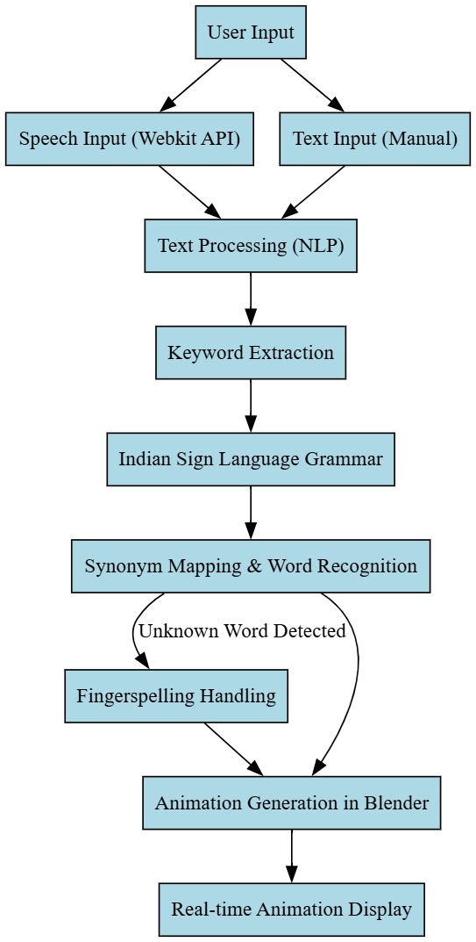

**4.1 Work Flow**

**4.4 UML Diagrams**

Class Diagram

The Class Diagram represents the core structure of the NLP and Blender-Based Sign Language Animation System, detailing key classes and their interactions. It illustrates how different components collaborate to process user input and generate corresponding Indian Sign Language (ISL) animations.

Main Components

1. User Class

* Represents the user interacting with the system by providing input in the form of text or speech.
* If the input is speech, it is processed using speech recognition before further processing.

2. SpeechRecognition Class

* Converts spoken input into text using speech-to-text processing.
* This enables the system to handle both textual and verbal inputs effectively.

3. NLPProcessing Class

* Handles Natural Language Processing (NLP) tasks, including extracting key terms and determining if a direct ISL gesture exists for a given word.
* If no direct gesture is found, it further checks for alternative ways to represent the input.

4. SynonymHandler Class

* If a direct ISL gesture is unavailable, this module searches for a synonym that has a corresponding sign language animation.

5. FingerSpelling Class

* When neither a direct gesture nor a synonym is available, the system defaults to finger spelling, where each letter of the word is represented through ISL.

6. AnimationHandler Class

* Retrieves and renders the appropriate animation based on the processed text.
* Ensures smooth display of ISL gestures for effective communication.

Workflow Overview

1. The user provides input (either speech or text).
2. If speech is detected, it is converted into text before processing.
3. The system analyzes the text to identify a matching ISL gesture.
4. If no direct gesture is available, it looks for a synonym; otherwise, it defaults to finger spelling.
5. The appropriate animation is retrieved and displayed to the user.

This structured class-based approach ensures an efficient and scalable system for translating spoken or written language into ISL animations, bridging communication gaps for the hearing-impaired community.

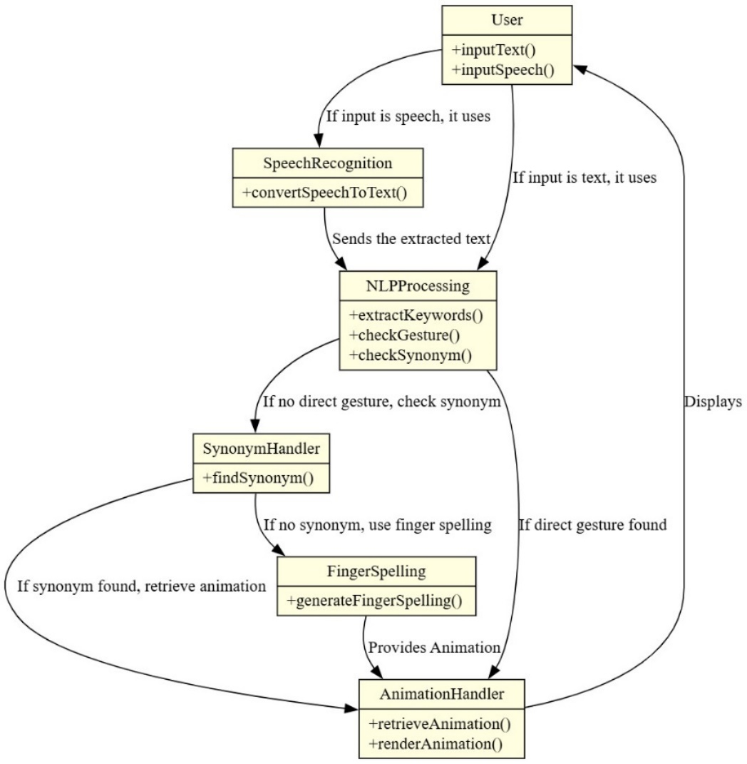

**4.2 Class Diagram**

Sequence Diagram

The Sequence Diagram outlines the step-by-step flow of interaction between system components:

1. The user submits text or speech input.
2. The system processes the input using NLP techniques.
3. The system retrieves the corresponding ISL animation from the dataset.
4. Blender renders and displays the animation.
5. The user views the animated output.

This diagram highlights the logical sequence of operations within the system, ensuring clarity in data processing.

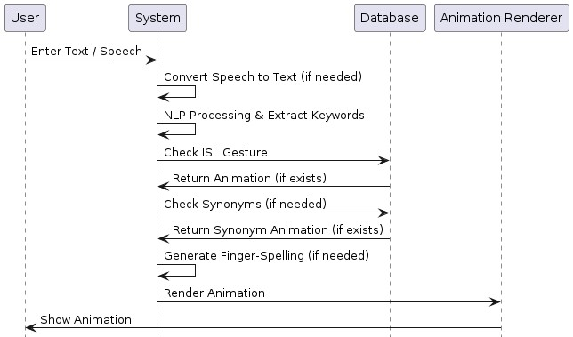

**4.3 Sequence Diagram**

**4.5 System Components**

The system is composed of multiple components working together to provide accurate ISL animations:

* Frontend (Web Interface): Developed using HTML, CSS, and JavaScript, providing an intuitive UI for users.
* Backend (Django Framework): Handles text processing, system logic, and interaction between components.
* Database (SQLite): Stores user-related data, authentication details, and preferences.
* NLP Module (NLTK & Custom Synonym Mapping): Processes user input for semantic analysis and ISL translation.
* Blender 3D Animation Engine: Renders animations for word and letter-based ISL gestures, ensuring smooth visual representation.
* Speech Recognition (WebkitSpeechRecognition): Converts spoken language into text for NLP processing.

Each of these components ensures efficient, accurate, and real-time processing, making the system a practical solution for ISL communication.

**4.6 System Scalability and Future Enhancements**

The current system is designed to function efficiently with the available dataset and system architecture. However, future enhancements could further improve its performance and capabilities. Key areas of improvement include:

1. Expanding the ISL Animation Dataset:
   * Adding more commonly used words and phrases to the existing animation set.
2. Enhancing NLP Accuracy:
   * Improving synonym mapping and contextual understanding for better translations.
3. Integrating AI-based Gesture Prediction:
   * Using AI models to dynamically generate ISL gestures for words without predefined animations.
4. User-Centered Improvements:
   * Implementing user feedback mechanisms to refine translations and animations.
5. Cloud Storage and Real-Time Processing:
   * Enhancing scalability by integrating cloud-based data storage and faster processing capabilities.

These improvements will ensure that the system remains adaptive, scalable, and user-friendly, contributing to broader adoption and effectiveness.

The NLP and Blender-Based Sign Language Animation System is designed to provide real-time, accurate, and scalable sign language translation. By integrating NLP, WebkitSpeechRecognition, and Blender-based animation, this structured approach ensures efficient communication for Indian Sign Language (ISL) users.

With a strong architectural foundation, the system is well-positioned for future growth, making it adaptable for larger ISL datasets, enhanced NLP processing, and real-time user interaction improvements. By continuously improving system design and functionality, this project can significantly contribute to sign language accessibility and digital communication solutions.

**5.SYSTEM IMPLEMENTATION**

The NLP and Blender-Based Sign Language Animation System is developed to bridge the communication gap between individuals who use Indian Sign Language (ISL) and those who rely on spoken or written language. The system enables users to input text or speech, which is then processed through Natural Language Processing (NLP) techniques, mapped to pre-recorded ISL animations, and displayed through a web-based interface using Blender-rendered animations.

The execution of the NLP and Blender-Based Sign Language Animation System begins by setting up the Django development server, which acts as the backend for processing user inputs and rendering animations. The project is implemented as a web-based application, and to run the system, the server must be initialized. This is done by navigating to the project directory in the terminal and executing the command

***python manage.py runserver*.** This command starts the Django development server, enabling users to access the application through a web browser.

Once the server is running, the terminal displays a local server address, typically ***http://127.0.0.1:8000****/,* which serves as the entry point for users to interact with the system. Upon opening this address in a browser, users are directed to the home page, where they can log in or sign up for an account. The authentication system ensures that user credentials are securely managed through an SQLite database.

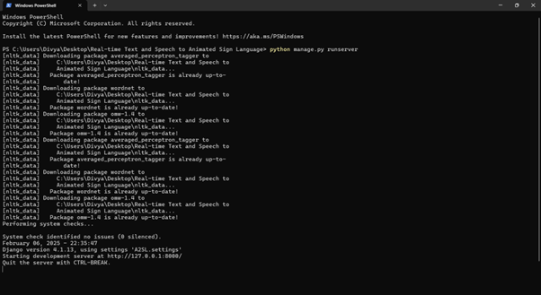

**5.1 Project Execution process**

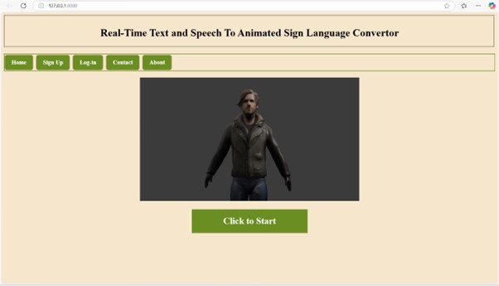The home page serves as the main navigation point, providing users with access to essential system functionalities. It gives an overview of how the platform works and directs users to either log in or sign up for an account.

**5.2 Web Application Interface**

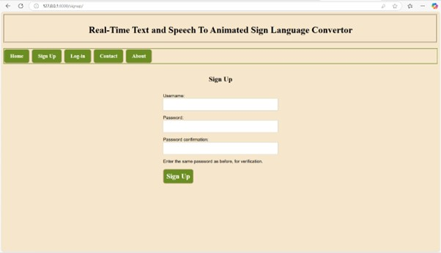For security and personalized interaction, users are required to log in. The login page allows existing users to enter their credentials, while new users must register via the sign-up page, where they provide details such as username, email, and password. These credentials are securely stored in an SQLite database, ensuring authentication and preventing unauthorized access.

**5.3 Sign up page**

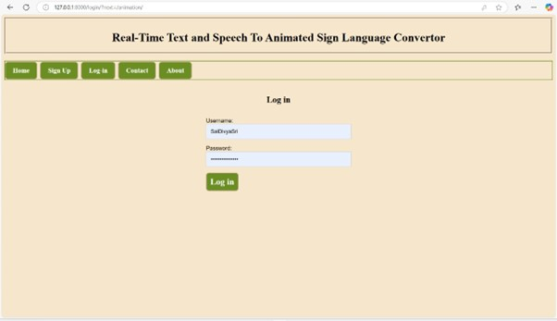

**5.4 Login Page**

Upon successful login, users are directed to the start page, which acts as a transition to the core functionalities of the system. Here, users can choose to input text manually or activate speech recognition for real-time processing.

The input section is designed to be user-friendly, allowing users to enter sentences manually in the text input box or use the microphone to convert speech into text through WebkitSpeechRecognition. This ensures accessibility for those who may not be comfortable with typing. Once the input is received, NLP processing breaks it down into individual words, performing tokenization, lemmatization, and synonym mapping to match words with their corresponding ISL animations

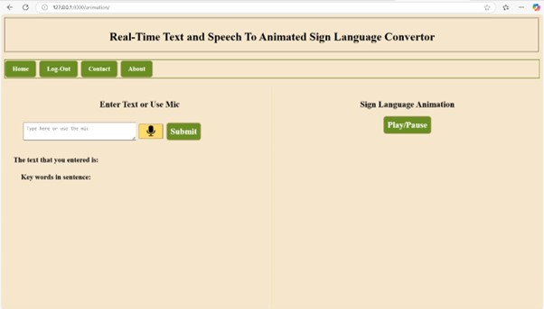

**5.5 Home Page**

If an animation exists for a given word, it is fetched and displayed in real-time. However, if a word does not have a predefined ISL sign, the system dynamically generates letter-by-letter signing using fingerspelling animations. This ensures that even uncommon words can still be represented in ISL.

The animation playback system is powered by Blender, which renders high-quality 3D animations of ISL gestures. These animations are loaded dynamically based on user input and displayed in a smooth sequence to maintain visual clarity. Users can pause, replay, or slow down animations as needed.

The accuracy of the system depends largely on the dataset of animations. The database currently contains 75 animations, including the 26 alphabets, numbers, and frequently used words. The dataset is continuously expanding to cover more ISL gestures and phrases to improve accessibility and effectiveness.

To ensure a seamless experience, the backend of the system is powered by Django, which manages communication between the user interface, NLP processing, and animation rendering. The Pro Exec page provides insights into system execution, performance, and optimization details. Django efficiently handles user requests, processes text input, retrieves animations, and manages authentication.

Users who wish to provide feedback or seek assistance can navigate to the contact page, where they can submit inquiries or suggest improvements. This helps in refining the platform based on real-world user experiences.

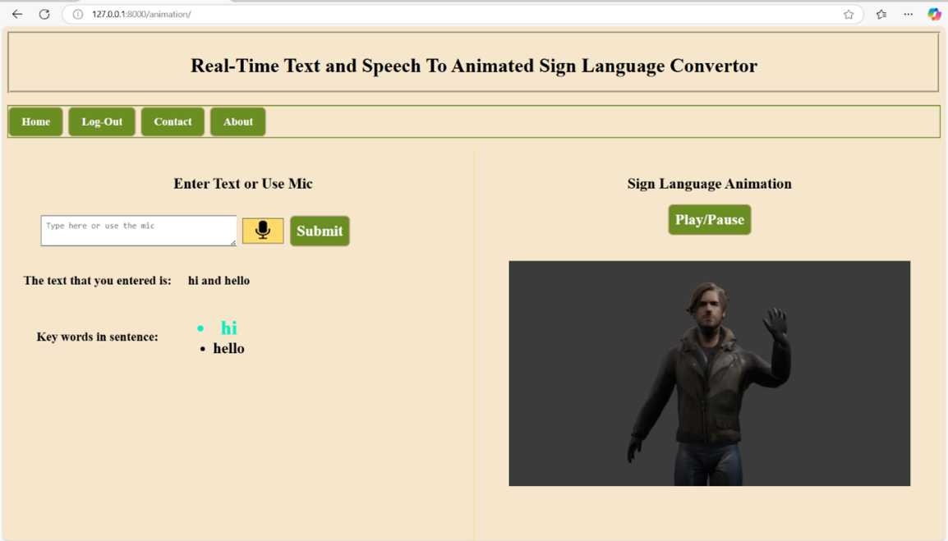

**5.6 Input Text**

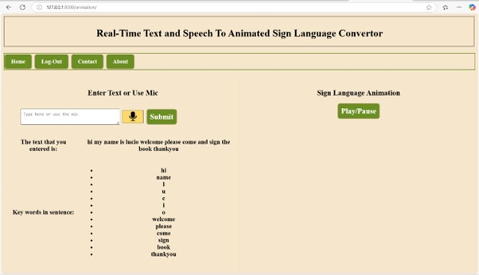

**5.7 Input text is processed in this format**

The system is designed with scalability in mind, allowing future enhancements such as AI-powered gesture recognition, real-time gesture synthesis, and support for additional languages. The integration of NLP, WebkitSpeechRecognition, and Blender-based animations makes this platform a powerful tool for promoting ISL learning and communication accessibility.

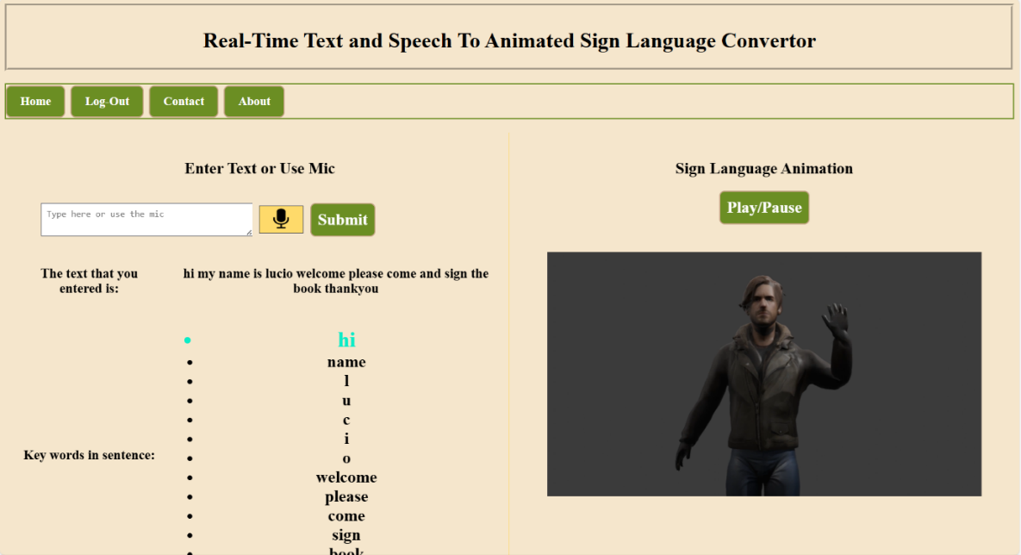

* 1. **Animation being played for the corresponding text**

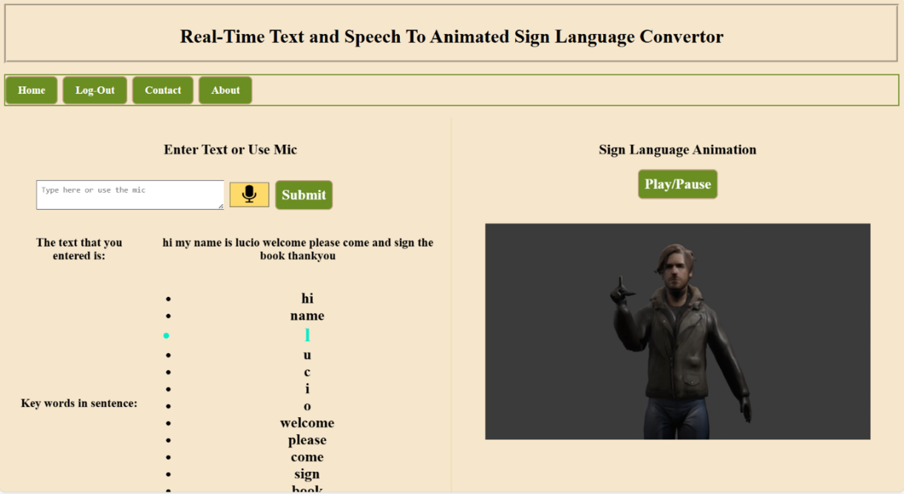

**5.9 Finger spelling for words with no sign in the dataset**

The NLP and Blender-Based Sign Language Animation System ensures that users can receive accurate Indian Sign Language (ISL) animations for both common words and words that do not have a direct ISL sign. The system provides animations by first checking if a word exists in the predefined ISL animation dataset. If the word is found, its corresponding Blender-rendered animation is retrieved and displayed in real time.

For words that do not have a direct ISL animation, the system automatically switches to finger spelling, where each letter of the word is displayed sequentially using predefined alphabet animations. This approach ensures that every word can be represented, even if it is not explicitly stored in the animation dataset.

The process begins when a user enters a word or phrase. The Natural Language Processing (NLP) module analyses the input and attempts to match it with a stored ISL animation. If a match is found, the animation is fetched and played. However, if no predefined sign is available, the word is broken down into individual letters, and the corresponding finger spelling animations are displayed one by one.

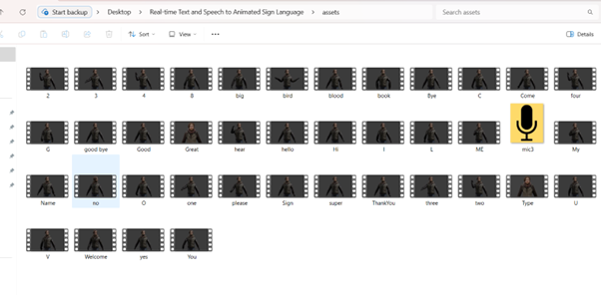

**5.10 Dataset created using Blender**

The contact page serves as a dedicated section where users can seek assistance, provide feedback, or suggest improvements for the NLP and Blender-Based Sign Language Animation System. This page allows users to directly communicate with the development team, ensuring continuous improvements based on real-world usage and feedback.

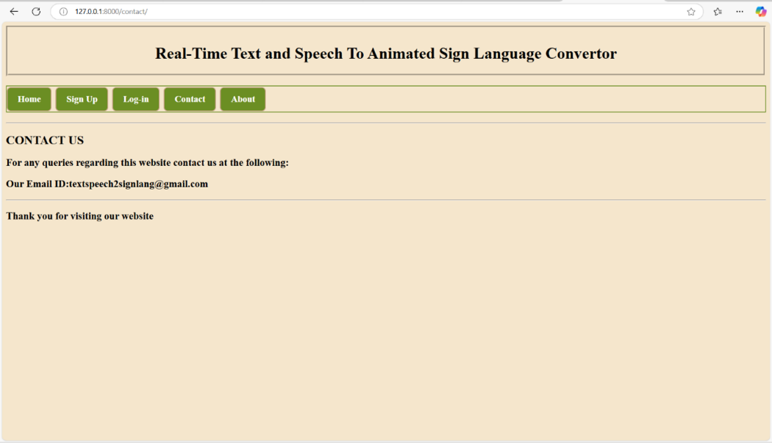

**5.11 Contact Page**

**Animation Creation Process:**

The NLP and Blender-Based Sign Language Animation System uses Blender to create and render Indian Sign Language (ISL) animations. The animation creation process ensures that the hand gestures are accurate, smooth, and visually clear for effective communication. Each animation is designed to replicate real-life ISL gestures, ensuring accessibility for users. The animation workflow follows several structured steps, from importing assets to rendering the final output, which are then stored in the system for real-time playback.

* 1. Importing Assets into Blender

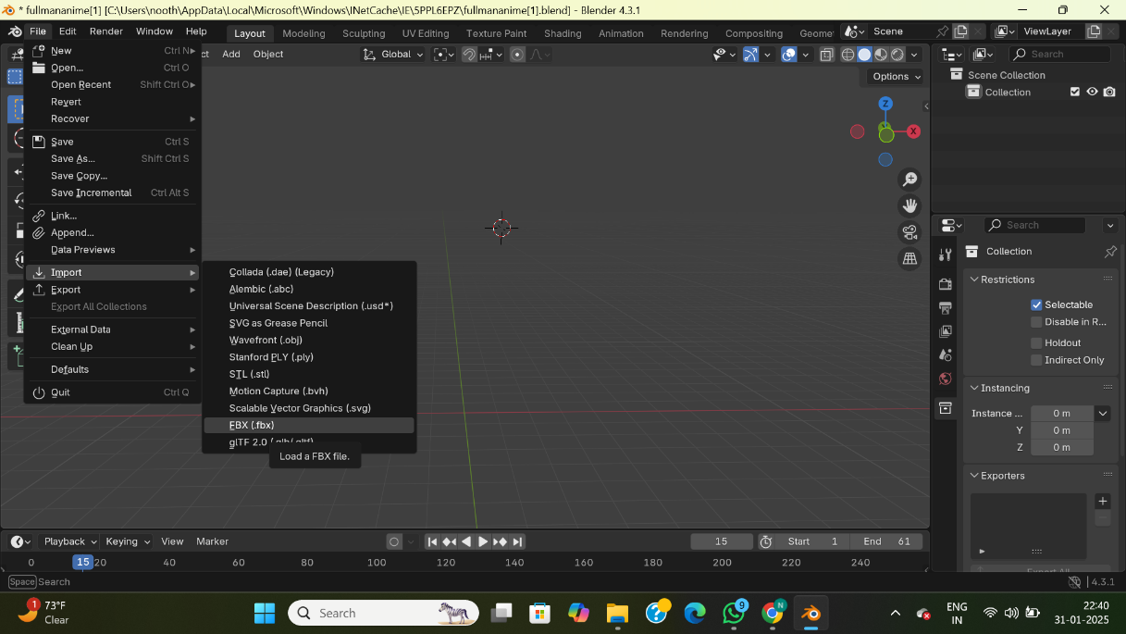The animation process starts with importing the necessary assets into Blender. This includes 3D hand models, skeletal rigging, and texture files. The model used for animations is designed to be highly detailed and flexible, allowing for precise movement of fingers, wrist, and palm. Blender supports various 3D file formats, enabling seamless integration of assets.

**5.12 Importing model into Blender**

* 1. Setting the File Location

To ensure smooth execution and retrieval of animations, a designated file structure is created. The file location is set in Blender, defining directories for animation sequences, textures, and motion data. Proper file organization ensures that animations are stored correctly and can be easily retrieved by the system when needed.

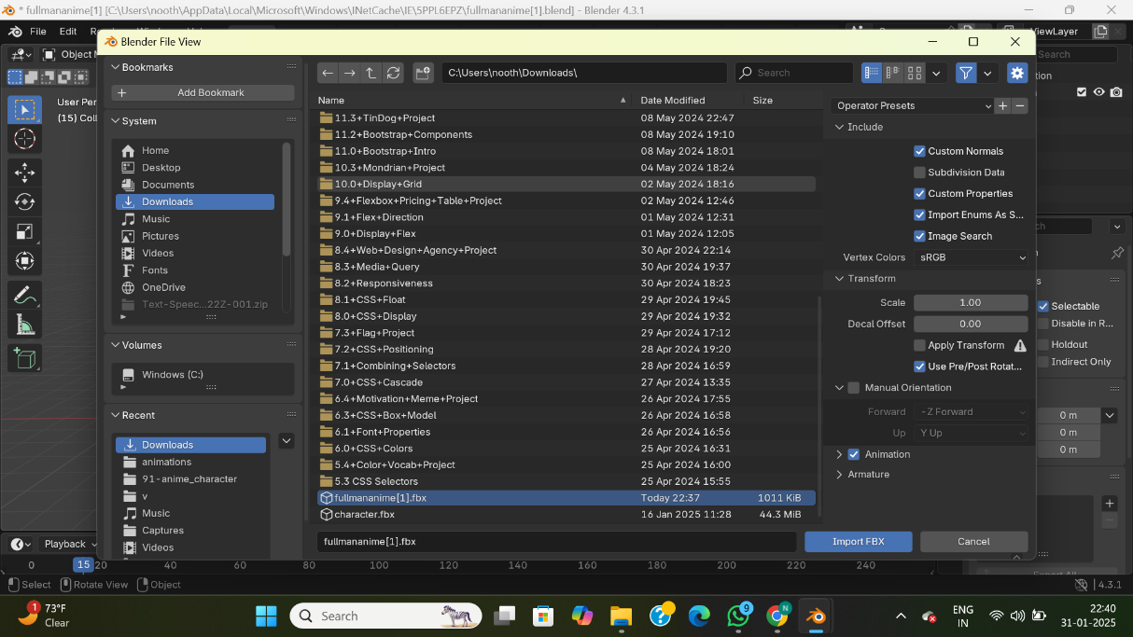

**5.13 Setting the location for the animation to be downloaded**

* 1. Designing and rigging the 3D Hand Model

The 3D model of the hand serves as the core element for ISL animations. The model is carefully structured with realistic finger proportions, wrist movement, and articulation points, ensuring that the gestures are natural and easy to interpret. The rigging process involves adding bones and control points that define how different parts of the hand move. Blender’s inverse kinematics (IK) constraints allow smooth transitions between different signs, making animations more dynamic.

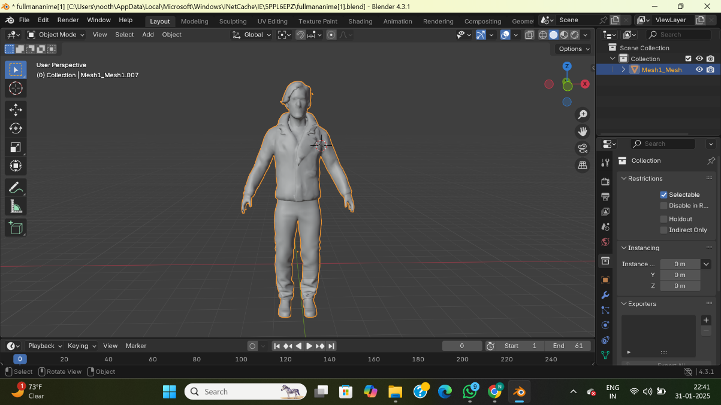

**5.14 3D model created for the creation of Animations**

4. Setting Keyframes for Animation

Once the 3D model is rigged, keyframes are set in Blender’s animation timeline to define the movement of each ISL gesture. Keyframes mark the start, midpoint, and end positions of each sign, ensuring smooth hand movements. By adjusting the interpolation between keyframes, the animation achieves fluid motion, preventing robotic or stiff gestures. Each ISL sign is animated frame by frame to maintain accuracy and clarity.

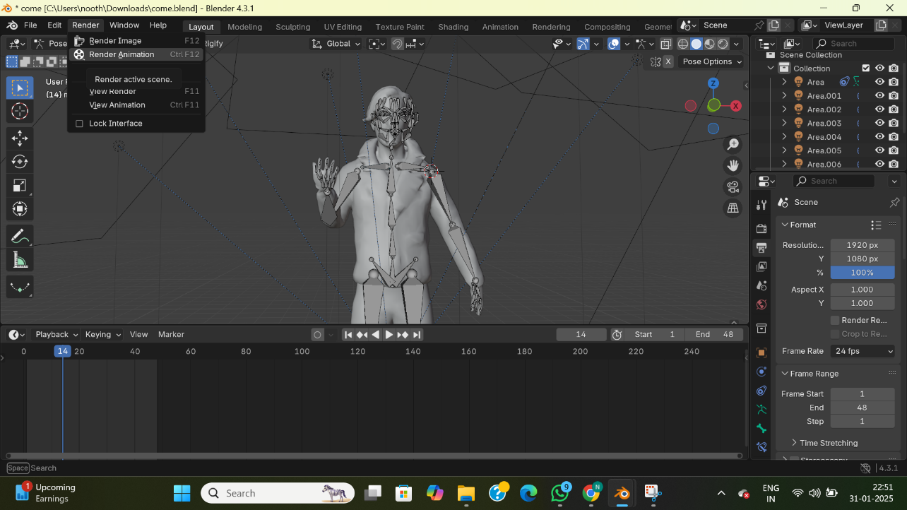

**5.15 The animation timeline with keyframes**

* 1. Rendering the Final Animation Output

After keyframe adjustments, the rendering process converts the animated hand gestures into MP4 files with optimized frame rate and resolution. The system ensures that each animation plays smoothly without lag, enhancing the user experience. The Blender rendering engine processes the animation sequences, applying lighting, shading, and movement smoothing to enhance realism.

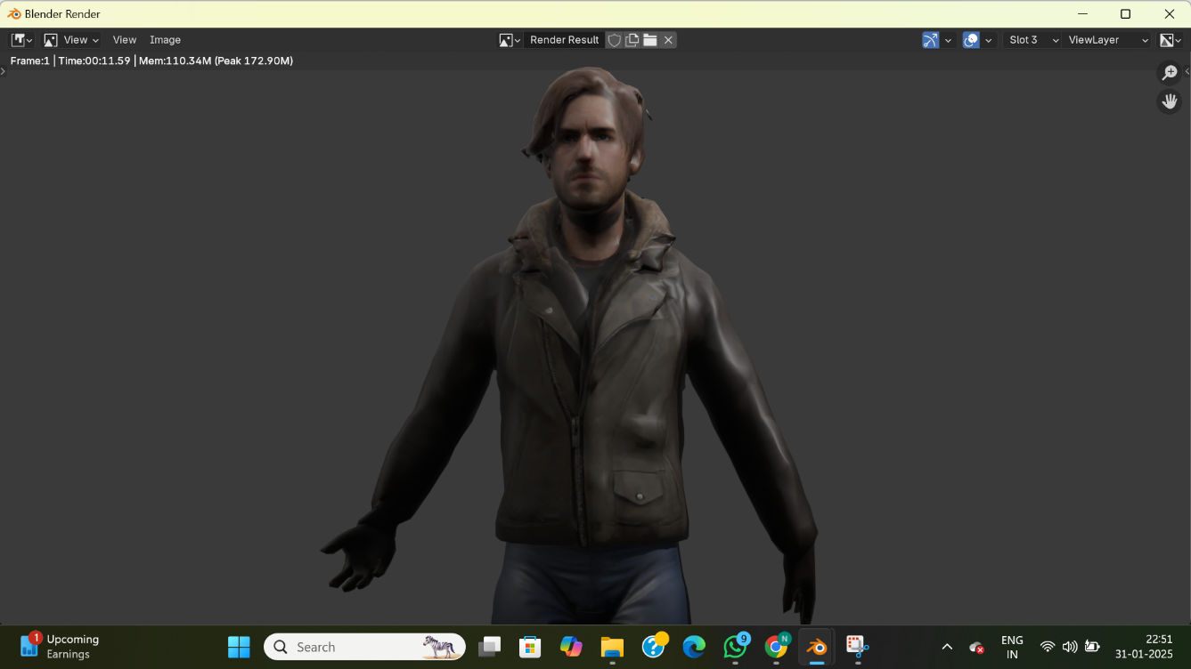

**5.16 Animation Rendering**

Once rendered, the animations are stored in the system dataset, ready for integration. When a user inputs a word, the system searches for the corresponding ISL animation and plays it in real-time. In cases where a word is not available in the dataset, the system generates finger spelling animations dynamically.

The successful implementation of the NLP and Blender-Based Sign Language Animation System ensures seamless conversion of text and speech into Indian Sign Language (ISL) animations using Natural Language Processing (NLP), WebkitSpeechRecognition, and Blender-rendered gestures. By integrating a structured backend (Django), real-time animation retrieval, and dynamic finger spelling, the system provides an interactive and accessible platform for ISL communication. This implementation sets the foundation for future advancements, such as expanding the animation dataset and enhancing NLP accuracy, making it a scalable solution for bridging communication gaps in the digital space.

**6.SYSTEM TESTING**

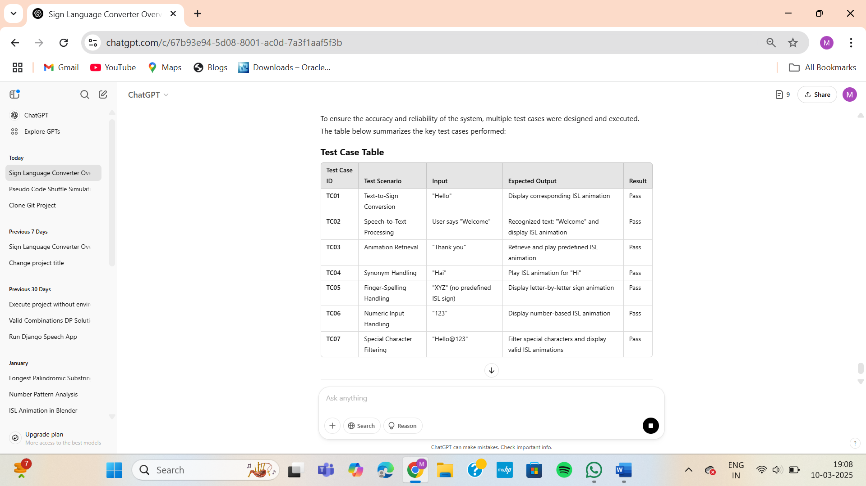To ensure the accuracy and reliability of the system, multiple test cases were designed and executed. The table below summarizes the key test cases performed:

**6.1 Test Cases for testing the application**

The following test cases were conducted to evaluate the system's functionality, accuracy, and reliability in converting text and speech inputs into Indian Sign Language (ISL) animations.

**6.1 Text-to-Sign Conversion**

This test validates whether a given text input is correctly converted into its corresponding ISL animation. For example, when the user enters **"Hello"**, the system successfully retrieves and **displays the ISL sign animation for "Hello."**

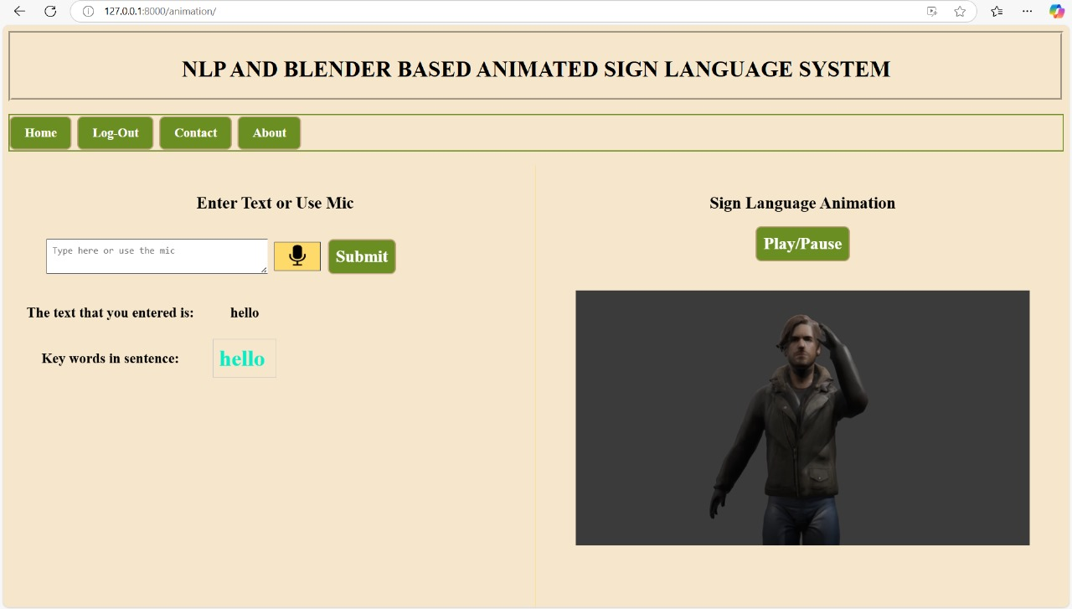

**6.2 Test case - 01**

**6.2 Speech-to-Text Processing**

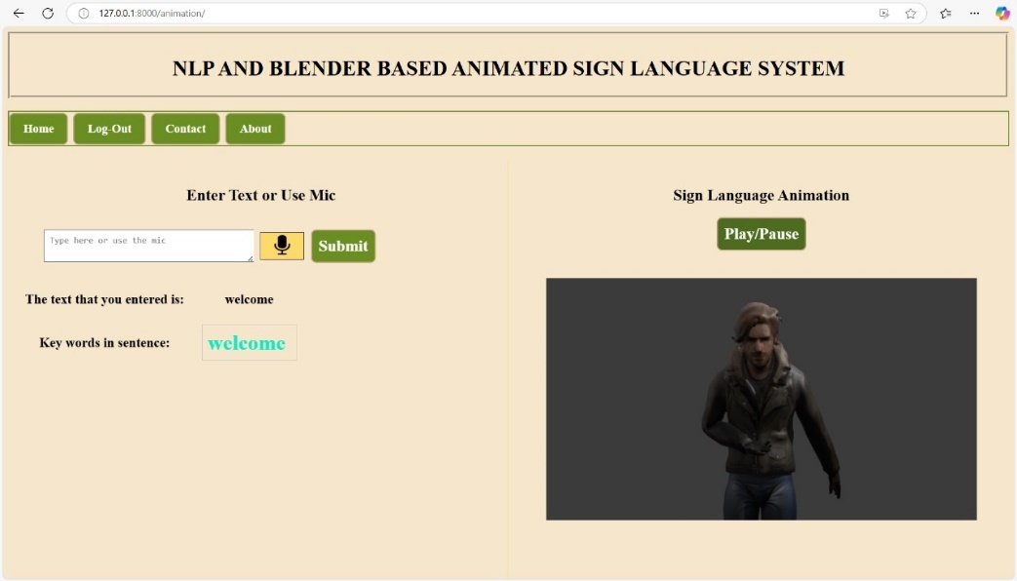This test ensures that spoken words are accurately transcribed and converted into ISL animations. When the user says **"Welcome"**, the system recognizes the speech, converts it into text, and then plays the appropriate ISL animation.

**6.3 Test case - 02**

**6.3 Animation Retrieval**

This test checks whether the system correctly retrieves stored ISL animations for predefined words. For instance, entering **"Thank you"** triggers the correct animation playback.

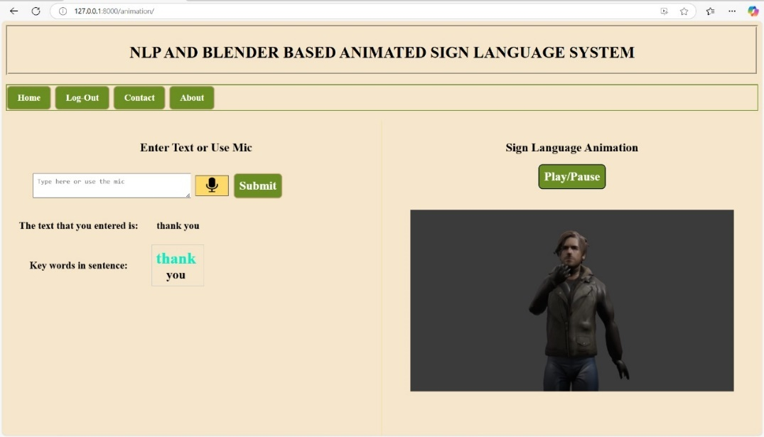

**6.4 Test case - 03**

**6.4 Synonym Handling**

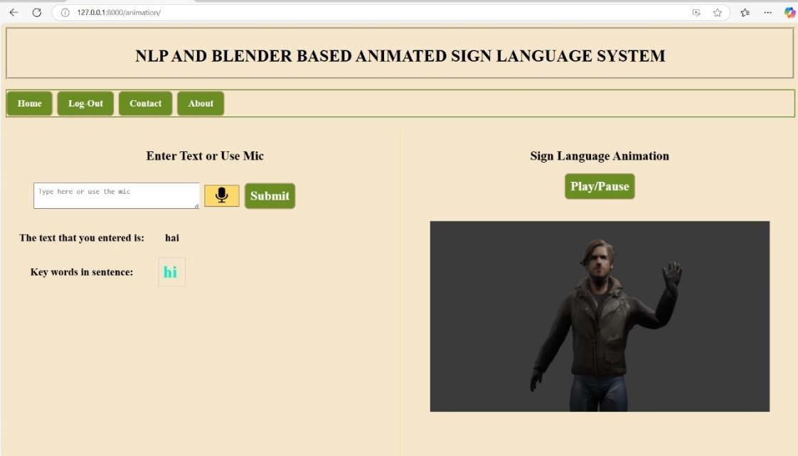The system maps synonyms to their appropriate ISL animations. When a user types **"Hai"**, it is recognized as a synonym for **"Hi"**, and the corresponding ISL animation is played.

**6.5 Test case - 04**

**6.5 Finger-Spelling Handling**

For words that do not have predefined ISL signs, the system performs letter-by-letter animation using finger-spelling. When the user enters **"XYZ"**, the system displays an animation that spells out each letter individually.

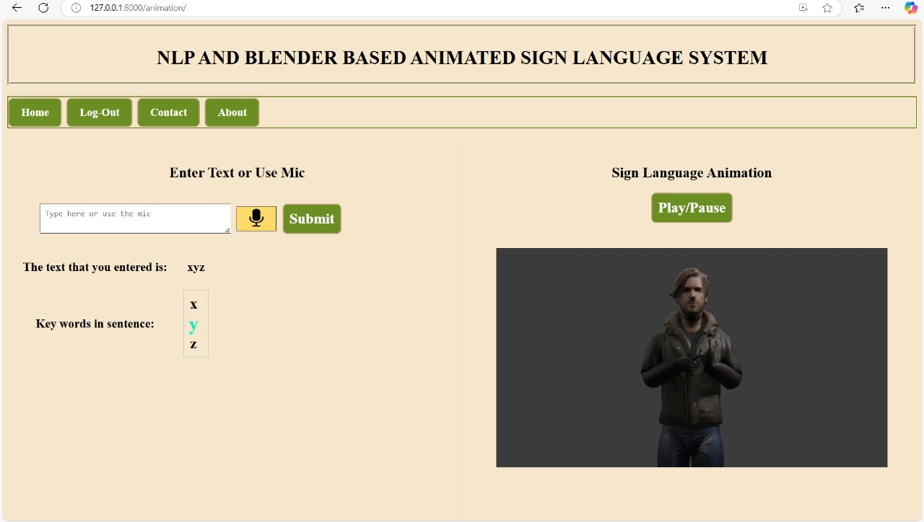

**6.6 Test case - 05**

**6.6 Numeric Input Handling**

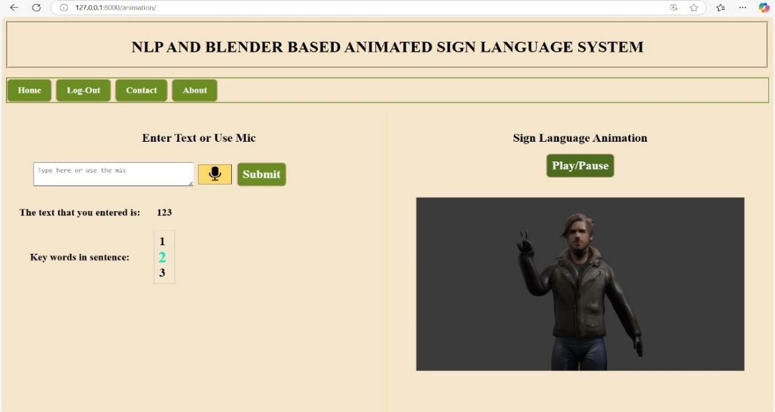The system correctly interprets numbers and maps them to ISL animations. When the user enters **"123"**, the corresponding number signs are displayed.

**6.7 Test case - 06**

**6.7 Special Character Filtering**

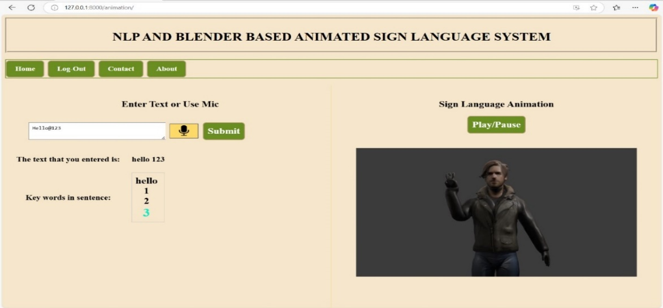This test ensures that special characters are ignored, and only valid ISL animations are displayed. For instance, the input **"Hello@123"** filters out **"@"** and plays animations for **"Hello"** and **"123"** only.

**6.8 Test case – 07**

All test cases passed successfully, demonstrating the system's robustness in handling various inputs. The results confirm that the system effectively converts both text and speech into ISL animations while addressing challenges like synonym recognition, multi-word processing, and special character filtering.

**7.CONCLUSION**

# 

The **NLP and Blender-Based Sign Language Animation System** successfully converts text and speech into **Indian Sign Language (ISL) animations**, making communication more accessible for the hearing-impaired community. By integrating **Natural Language Processing (NLP) with Blender-based 3D animations**, the system provides an efficient and interactive way to interpret spoken and written language into sign language gestures.

The project was tested for various scenarios, including **text-to-sign conversion, speech recognition, synonym handling, and special character filtering**. The results confirmed the system's ability to accurately translate common words and phrases into ISL animations. Even in cases where predefined signs were unavailable, the system efficiently handled **finger-spelling representation**, ensuring that communication remained uninterrupted.

This project lays the foundation for a **practical and scalable ISL translation system**. However, future improvements can focus on **expanding the dataset by adding more animations** to cover a broader vocabulary. A well-structured and extensive dataset will improve the system’s accuracy and fluency, making it more useful for real-world applications. Additionally, refining animation quality and optimizing system performance can further enhance user experience.

With continued development, this system has the potential to become a valuable tool for **education, accessibility, and inclusive communication**, helping bridge the gap between the hearing and hearing-impaired communities.

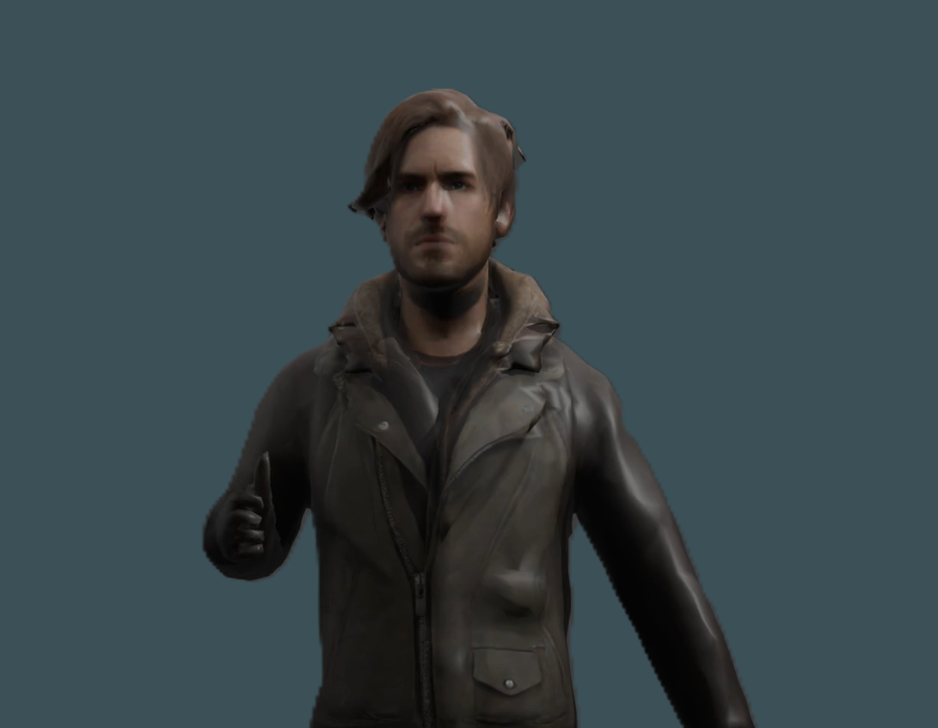

# 

# 8.BIBLIOGRAPHY

* **Research Papers & Articles**
  + "Overview of Sign Language Translation Based on Natural Language Processing" ([ResearchGate](https://www.researchgate.net/publication/388323919_Overview_of_Sign_Language_Translation_Based_on_Natural_Language_Processing))
  + "Including Signed Languages in Natural Language Processing" ([ACL Anthology](https://aclanthology.org/2021.acl-long.570.pdf))
* **Blender Animation Tutorials**
  + "Sign Language Animations in Blender" ([YouTube](https://www.youtube.com/watch?v=VKI4ZOe2cEA))
  + "Blender 3D Easy Hand Tutorial - Basic Rigging and Animating" ([YouTube](https://www.youtube.com/watch?v=KpokgpH1VvE))
* **Datasets & Open Source Projects**
  + "Sign Language Processing" ([Research Sign](https://research.sign.mt/))
  + "3D Animation Framework for Sign Language" ([ResearchGate](https://www.researchgate.net/publication/281434972_3D_Animation_framework_for_sign_language))
* **Software & Libraries**
  + Blender – Open-source 3D creation suite
  + NLTK – Natural Language Toolkit for NLP tasks
  + Web Speech API (WebkitSpeechRecognition) – Browser-based speech-to-text API

**9.APPENDIX**

**Natural Language Processing (NLP)**

Natural Language Processing (NLP) is a fundamental component in the NLP and Blender-Based Sign Language Animation System, responsible for converting text-based inputs into meaningful Indian Sign Language (ISL) animations. NLP techniques ensure that user input, whether provided through text or speech, is accurately processed and mapped to corresponding sign language gestures. This involves a series of language processing steps, such as tokenization, lemmatization, stopword removal, and synonym mapping, all of which work together to refine input data before animation retrieval.

The system first processes user input by removing unnecessary punctuation and special characters, ensuring that only relevant words are considered. Tokenization breaks the input into individual words, which are then analysed to determine their root forms through lemmatization. This helps standardize word variations, making it easier to match words with existing ISL animations. Stopword removal eliminates commonly used words such as "is," "are," and "the," which do not contribute significantly to the sign language gesture. Additionally, the system checks for synonyms in a predefined dictionary to replace words that may not have a direct ISL animation.

For example, if a user inputs "Goodbye, see you later," the system processes the text by removing punctuation, resulting in "Goodbye see you later." The tokenization step then splits it into ["Goodbye," "see," "you," "later"]. Common stopwords like "you" are removed, leaving ["Goodbye," "see," "later"]. If "later" is not available in the animation dataset, the system searches the synonym dictionary and may replace it with a known ISL equivalent. The system then retrieves animations for "Goodbye" and "see," and if "later" has no direct animation, it either maps to a synonym or falls back to finger spelling.

The system integrates NLP with WebkitSpeechRecognition for speech-to-text conversion, ensuring that spoken words can be processed using the same NLP pipeline. When a user speaks into the system, their speech is transcribed into text, which is then analysed, processed, and mapped to ISL animations. The system also utilizes a JSON-based synonym database to enhance word-matching accuracy, reducing the chances of missing animations due to vocabulary variations.

Once the text is fully processed, the system searches for corresponding ISL animations. If an animation is found, it is retrieved and rendered using Blender’s animation engine. If a word lacks an exact animation, the system may use finger spelling, where the letters of the word are individually displayed using ISL gestures. This ensures that the system can handle a wide range of inputs, even when specific words are not present in the dataset.

NLP significantly enhances the system’s ability to understand and process language, making the translation of text and speech into sign language more effective. By leveraging NLP techniques such as synonym mapping, tokenization, and lemmatization, the system can accurately interpret a variety of inputs and provide meaningful sign language translations. Future enhancements could include expanding the synonym database, integrating machine learning models for contextual understanding, and improving animation mapping techniques to cover more complex sentence structures.

**Blender (version 4.3)**

Blender plays a crucial role in the NLP and Blender-Based Sign Language Animation System, serving as the core animation tool for generating and displaying Indian Sign Language (ISL) gestures. It is an open-source 3D modelling and animation software used to create realistic sign language animations that enhance the accessibility and communication experience for users. The system utilizes Blender to animate hand gestures corresponding to ISL, ensuring accurate and fluid motion representation.

The animation process begins with the creation of 3D hand models in Blender, which are rigged using an armature system. Rigging involves adding a skeleton structure to the model, allowing for precise movement of fingers and hand gestures. Each gesture is designed in accordance with ISL standards to ensure accurate representation of words and letters. Keyframing is used to animate transitions between different hand positions, making the gestures smooth and natural.

To generate animations dynamically, the system maps processed text or speech inputs to predefined Blender animations. When a user inputs a word that has a corresponding ISL gesture, the system fetches the animation file from the database and plays it in the web interface. If a word lacks a direct ISL animation, the system falls back to finger spelling, where individual letter animations are displayed sequentially. This ensures that the system can handle a broad vocabulary, even if certain words do not have predefined animations.

The animation files are stored in a structured format, with each word or letter mapped to a specific Blender animation file. These files are rendered in real-time and integrated into the web application, allowing users to see the animated sign language output corresponding to their input. The rendering process ensures high-quality visualization while optimizing performance for smooth playback.

Blender’s rendering capabilities allow for realistic shading, lighting, and movement, enhancing the clarity and effectiveness of ISL animations. The animations are exported as video files or real-time rendered sequences that can be accessed through the Django web application. By leveraging Blender’s powerful animation tools, the system ensures that sign language gestures are not only accurate but also visually engaging.

Future improvements could include expanding the animation dataset, refining motion capture techniques for more lifelike gestures, and integrating artificial intelligence to automate animation generation for new words. By continuing to enhance the Blender-based animation pipeline, the system can provide a more comprehensive and natural sign language translation experience.

**Django Framework:**

Django serves as the backbone of the NLP and Blender-Based Sign Language Animation System, managing the backend logic, handling user interactions, and ensuring seamless communication between different components of the system. It is a high-level Python web framework that facilitates the development of scalable and maintainable applications. Django’s Model-View-Controller (MVC) architecture, robust security features, and built-in database management make it an ideal choice for structuring the project.

In this system, Django is responsible for processing user inputs, managing user authentication, and facilitating data flow between the frontend interface, NLP module, and Blender animation renderer. When a user provides text or speech input, Django handles the request, applies natural language processing techniques to extract key words, and retrieves the corresponding Indian Sign Language (ISL) animations from the dataset.

Django's views and templates are used to render web pages dynamically. The views.py file processes user requests and interacts with the NLP module to analyse input text. The templates directory contains HTML pages that structure the user interface, displaying animations and processed outputs in a user-friendly manner. Django’s URL routing system allows different functionalities, such as home, login, signup, animation processing, and contact pages, to be accessed smoothly.

A key feature of Django in this project is user authentication and session management. The system allows users to sign up, log in, and securely access the animation platform. Django’s built-in authentication mechanisms ensure that user credentials are securely stored and managed.

Django also integrates with SQLite, a lightweight database used in this project primarily for storing user-related data. The database manages user profiles and login credentials, enabling a personalized experience. However, the ISL animations themselves are stored as static files rather than in the database.

Another important aspect of Django’s role is managing API requests and handling errors. It ensures that invalid or unsupported text inputs do not cause disruptions in the animation process. Django logs error, handles exceptions, and provides meaningful feedback to users, improving system reliability.

Overall, Django serves as a powerful bridge between the user interface, text processing, and animation rendering, ensuring efficient workflow execution. Its modular design allows for easy scalability, making it possible to expand the system with additional features such as more animations, advanced NLP capabilities, or real-time user interaction enhancements in the future.

**SQLite3**

SQLite3 is a lightweight, self-contained, and serverless database engine that is widely used for small to medium-scale applications. It is an open-source relational database management system (RDBMS) that stores data in a single file, making it highly portable and easy to use. Unlike other database management systems like MySQL or PostgreSQL, SQLite does not require a separate server to run, making it ideal for applications that need a simple yet efficient way to manage data.

In the NLP and Blender-Based Sign Language Animation System, SQLite3 plays a crucial role in storing and managing user data. Since the project involves user authentication, the database maintains records such as usernames, email addresses, and passwords. The Django framework provides built-in support for SQLite3, allowing seamless interaction between the backend and the database.

One of the key advantages of SQLite3 is its lightweight nature and ease of integration. It is well-suited for applications that do not require high-concurrency database operations. Since SQLite3 stores data in a single .sqlite3 file, it eliminates the complexity of database configuration, making it highly accessible for projects like this one.

The database is primarily used for:

* User authentication (storing login credentials securely).
* Tracking user sessions to allow a smooth experience while using the web application.
* Logging user interactions for potential future enhancements.

Since this project does not involve large-scale data storage for animations (which are stored as files), SQLite3 is a perfect fit due to its simplicity and reliability. The DB Browser for SQLite tool can also be used to inspect the database, modify records, and execute SQL queries visually.

Overall, SQLite3 serves as an efficient and minimalistic database solution that complements the Django backend in ensuring smooth authentication and data storage for users of the NLP and Blender-Based Sign Language Animation System.

**WebkitSpeechRecognition**

Speech recognition plays a significant role in making applications more interactive and accessible. WebkitSpeechRecognition is a built-in browser API that allows real-time speech-to-text conversion without requiring additional external libraries. This technology is particularly useful in applications where voice commands or spoken input need to be processed efficiently.

In the NLP and Blender-Based Sign Language Animation System, WebkitSpeechRecognition is used to convert spoken words into text, allowing users to provide input through speech instead of typing. This feature enhances accessibility, especially for individuals who may find it easier to speak rather than type.

How WebkitSpeechRecognition Works in the Project:

1. The user clicks on the microphone button on the web interface.
2. The WebkitSpeechRecognition API starts recording the speech.
3. Once the user stops speaking, the API converts the speech into text and displays it in the input field.
4. The text is then processed using Natural Language Processing (NLP) to identify keywords and match them with available sign language animations.
5. If an exact match for the word is found in the predefined animation dataset, the corresponding Blender animation is played. Otherwise, finger-spelling is used to represent the word.

Advantages of Using WebkitSpeechRecognition:

* Real-time conversion: Converts speech to text instantly without noticeable delays.
* No external dependencies: It works directly in the browser without requiring third-party installations.
* Cross-platform support: Works on most modern web browsers that support speech recognition.
* Enhances accessibility: Enables users who may have difficulty typing to interact with the system using voice commands.

Since WebkitSpeechRecognition is a browser-dependent API, its availability and performance may vary across different browsers. Currently, it works best on Google Chrome and Chromium-based browsers. However, fallback options like manual text input are provided to ensure usability across different platforms.

By integrating WebkitSpeechRecognition into the system, this project enables a seamless, voice-enabled interaction, making it more intuitive and user-friendly for individuals looking to convert spoken language into Indian Sign Language (ISL) animations.

**Web Development:**

The NLP and Blender-Based Sign Language Animation System is implemented as a web-based application to ensure accessibility across different devices and platforms. The front-end of the system is designed using HTML, CSS, and JavaScript, which together provide a structured, visually appealing, and interactive user experience.

Role of HTML, CSS, and JavaScript in the Project

The web application consists of multiple interfaces where users can input text or speech, view animations, and interact with the system. Each of these technologies plays a crucial role in ensuring smooth functionality and responsiveness.

1. HTML (Hypertext Markup Language)
   * HTML serves as the skeleton of the application, defining the structure and layout of web pages.
   * It is used to create elements like text input areas, buttons, video players, and navigation menus.
   * The application includes multiple HTML pages, such as:
     + Home Page: Introduction to the project.
     + Login & Signup Pages: User authentication.
     + Animation Page: Displays the sign language animations.
     + Contact Page: Provides a form for user feedback.
2. CSS (Cascading Style Sheets)
   * CSS is responsible for the styling and layout of the application, enhancing the user experience with visually appealing designs.
   * It ensures the website is responsive, meaning it adapts to different screen sizes, such as desktops, tablets, and mobile phones.
   * Key design elements include:
     + Color themes that provide a clean and professional look.
     + Animations and transitions to improve visual engagement.
     + Flexbox and Grid layouts for proper alignment of elements.
3. JavaScript
   * JavaScript enables dynamic interactions within the application, allowing users to engage with various features in real time.
   * It is used for:
     + Handling user input events such as clicks, text input, and voice recognition.
     + Controlling speech-to-text conversion using WebkitSpeechRecognition.
     + Managing the real-time playback of animations, ensuring smooth transition between sign gestures.
     + Validating user inputs on login and signup pages.
     + Handling errors, such as displaying messages when an animation for a word is not found.

How Web Technologies Work Together in the Project

* When a user enters text or speech input, JavaScript captures the data and processes it for sign language animation mapping.
* If an animation exists for the word, the system retrieves and plays the corresponding video.
* The front-end elements (HTML & CSS) ensure that the user interface is clear and easy to navigate, while JavaScript dynamically updates the displayed animations.

By integrating HTML, CSS, and JavaScript, this project delivers a seamless, responsive, and accessible user experience, ensuring efficient real-time sign language translation. The web-based approach makes the system lightweight and easy to use without requiring users to install additional software.

This project is a step towards making communication more inclusive and accessible. By integrating **Natural Language Processing, Blender animations, and WebkitSpeechRecognition**, we have built a system that bridges the gap between text, speech, and Indian Sign Language. While the dataset currently includes a limited number of animations, the system demonstrates the potential for **real-time, interactive sign language translation**.

This work is not just about technology but about fostering a world where communication barriers are minimized. The project provides a foundation that can be expanded with **a richer dataset, enhanced NLP techniques, and improved animation capabilities**. As technology advances, solutions like this can contribute significantly to accessibility, education, and interaction for individuals relying on sign language.

With continued improvements, this system can grow into a **more comprehensive and impactful communication tool**. The journey does not end here—rather, it marks the beginning of an evolving effort to create **more inclusive digital interactions**.