實驗報告: DOA Estimation_MUSIC
下世代行動通訊應用導論

學號: b1121123 姓名: 巫煊崴

- 本次實驗程式碼由本人獨立開發，未涉及AI ，模擬結果與講義相同 (得分100完成上傳實驗報告後即算完成實驗)
- 本次實驗程式碼由本人獨立開發，未涉及AI，但截至課堂時間結束，只完成部分結果 (得分90~85視完成比例而定，惟須全程參與表定課堂時間，否則以缺課論)
- 本次實驗程式碼由AI提供範本，並由本人獨立開發部分程式 (得分85~80視獨立開發比例而定，惟須全程參與表定課堂時間，否則以缺課論)
請詳述除AI提供之程式碼外，獨立開發的部分:
數學算式是自己打的，作圖是靠 AI 幫忙

- 本次實驗程式碼完全由AI提供，本人只負責設定實驗所需參數；實驗結果與講義所示圖形完全或部分正確 (得分80~75，惟須全程參與表定課堂時間，否則以缺課論)

- 以上各項得分需先完整作答以下實驗原理。

一、實驗原理:

1. 請解釋Standard MUSIC 之工作原理
利用收到的 N 筆Snapshots數據進行時間平均估算 ：
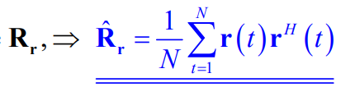
取出最小的 M-K 個特徵向量構成雜訊空間矩陣。
Pseudo Spectra：讓角度在 -90 到 90 之間以極小的步長移動，計算虛擬譜函數 ：
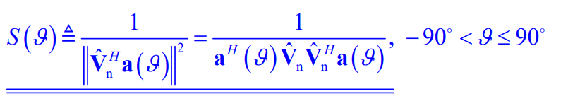
Peak-Searching：找出 S最高、最尖銳的 K 個波峰，波峰對應的角度就是訊號的入射方向。
MUSIC 的精準度極度依賴掃描的細緻度 。如果要非常精準，計算複雜度會因為 Exhaustive Search而增加 。

2. 請解釋Root MUSIC 之工作原理
為了解決標準 MUSIC 計算量太大的問題，Root-MUSIC 將角度搜索轉化為多項式求根，只適用於 ULA 。
令複數變數。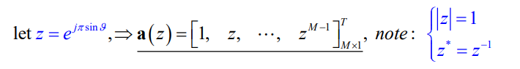
此時，向量變成了多項式形式
將 MUSIC 的分母寫成多項式 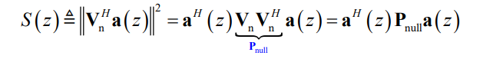這個多項式的階數為 2(M-1) 。
直接解出這個多項式的 2(M-1) 個複數根 z。
在無雜訊的理想情況下，真正代表訊號角度的根會剛好落在複數平面的「單位圓（Unit Circle）」上 。 有雜訊時，則挑選最靠近單位圓的 K 個根 。
透過求得的複數根的Argument，直接反推算出角度 ：
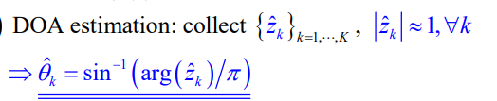

二、實驗結果與分析: 請完成以下作業電腦模擬並附上程式碼及模擬結果 (自行加頁)

clear; clc; close all;

K = 4;
N = 30;
N_trials = 500;
angle_grid = -90:0.1:90;

% (a)
M_a = 10;
SNR_dB_a = 10;
theta_a = [-43, -28, 17, 45];

A_a = exp(1j * pi * (0:M_a-1)' * sin(deg2rad(theta_a)));
S_matrix = (randn(K, N) + 1j * randn(K, N)) / sqrt(2);

sigma2_n_a = 1 / (10^(SNR_dB_a / 10));
noise_a = sqrt(sigma2_n_a / 2) * (randn(M_a, N) + 1j * randn(M_a, N));
X_a = A_a * S_matrix + noise_a;

R_x_a = (X_a * X_a') / N;
[V_a, D_a] = eig(R_x_a);
[~, idx_a] = sort(diag(D_a), 'descend');
V_n_a = V_a(:, idx_a(K+1:end));

A_search_a = exp(1j * pi * (0:M_a-1)' * sin(deg2rad(angle_grid)));
P_music_a = 1 ./ sum(abs(A_search_a' * V_n_a).^2, 2);
P_music_a_dB = 10 * log10(P_music_a);

figure(1);
plot(angle_grid, P_music_a_dB, 'LineWidth', 1.5); grid on;
title('(a) MUSIC Pseudo Spectra (M = 10, SNR = 10 dB) - Vectorized');
xlabel('DOA (\theta)'); ylabel('Pseudo Spectra (dB)'); xlim([-90 90]);
for k = 1:K
line([theta_a(k) theta_a(k)], [min(P_music_a_dB) 0], 'Color', 'r', 'LineStyle', '--');
end

% (b)
M_list = [10, 15, 20];
SNR_dB_list = -6:3:30;
theta_b = [-43, -28, 17, 45];
MSE_results = zeros(length(M_list), length(SNR_dB_list));

search_offset = -5:0.01:5;
search_angles = theta_b' + search_offset;

for m_idx = 1:length(M_list)
M = M_list(m_idx);

A_local_search = zeros(M, K, length(search_offset));
for k = 1:K
for s_idx = 1:length(search_offset)
A_local_search(:, k, s_idx) = exp(1j * pi * (0:M-1)' * sin(deg2rad(search_angles(k, s_idx))));
end
end

for snr_idx = 1:length(SNR_dB_list)
snr_db = SNR_dB_list(snr_idx);
sigma2_n = 1 / (10^(snr_db / 10));
total_sq_error = 0;

for trial = 1:N_trials
A = exp(1j * pi * (0:M-1)' * sin(deg2rad(theta_b)));
S = (randn(K, N) + 1j * randn(K, N)) / sqrt(2);
noise = sqrt(sigma2_n / 2) * (randn(M, N) + 1j * randn(M, N));
X = A * S + noise;

% EVD
R_x = (X * X') / N;
[V, D] = eig(R_x);
[~, idx] = sort(diag(D), 'descend');
V_n = V(:, idx(K+1:end));

est_angles = zeros(1, K);
for k = 1:K
A_k = squeeze(A_local_search(:, k, :));
P_local = 1 ./ sum(abs(A_k' * V_n).^2, 2);
[~, max_idx] = max(P_local);
est_angles(k) = search_angles(k, max_idx);
end

total_sq_error = total_sq_error + sum((theta_b - est_angles).^2);
end
MSE_results(m_idx, snr_idx) = total_sq_error / (4 * N_trials);
end
end

figure(2);
semilogy(SNR_dB_list, MSE_results(1,:), 'x--', 'LineWidth', 1.5); hold on;
semilogy(SNR_dB_list, MSE_results(2,:), 'o-.', 'LineWidth', 1.5);
semilogy(SNR_dB_list, MSE_results(3,:), 's-', 'LineWidth', 1.5);
grid on;
title('(b) MSE vs SNR (Vectorized & Fast)');
xlabel('SNR (dB)'); ylabel('Mean Square Error (MSE)');
legend('M = 10', 'M = 15', 'M = 20', 'Location', 'SouthWest');

% (c)
theta_c = [-43, -28, 17, 19];
SNR_dB_c = 10;
M_c1 = 10; M_c2 = 30;

% M = 10
A_c1 = exp(1j * pi * (0:M_c1-1)' * sin(deg2rad(theta_c)));
S_c1 = (randn(K, N) + 1j * randn(K, N)) / sqrt(2);
noise_c1 = sqrt((1 / (10^(SNR_dB_c / 10))) / 2) * (randn(M_c1, N) + 1j * randn(M_c1, N));
X_c1 = A_c1 * S_c1 + noise_c1;
R_x_c1 = (X_c1 * X_c1') / N; [V_c1, D_c1] = eig(R_x_c1); [~, idx_c1] = sort(diag(D_c1), 'descend');
V_n_c1 = V_c1(:, idx_c1(K+1:end));

A_search_c1 = exp(1j * pi * (0:M_c1-1)' * sin(deg2rad(angle_grid)));
P_music_c1 = 1 ./ sum(abs(A_search_c1' * V_n_c1).^2, 2);
P_music_c1_dB = 10 * log10(P_music_c1);

% M = 30
A_c2 = exp(1j * pi * (0:M_c2-1)' * sin(deg2rad(theta_c)));
noise_c2 = sqrt((1 / (10^(SNR_dB_c / 10))) / 2) * (randn(M_c2, N) + 1j * randn(M_c2, N));
X_c2 = A_c2 * S_c1 + noise_c2;
R_x_c2 = (X_c2 * X_c2') / N; [V_c2, D_c2] = eig(R_x_c2); [~, idx_c2] = sort(diag(D_c2), 'descend');
V_n_c2 = V_c2(:, idx_c2(K+1:end));

A_search_c2 = exp(1j * pi * (0:M_c2-1)' * sin(deg2rad(angle_grid)));
P_music_c2 = 1 ./ sum(abs(A_search_c2' * V_n_c2).^2, 2);
P_music_c2_dB = 10 * log10(P_music_c2);

figure(3);
subplot(2,1,1); plot(angle_grid, P_music_c1_dB, 'b', 'LineWidth', 1.5); grid on;
title('(c) Two Close Rays: M = 10, SNR = 10 dB'); xlabel('DOA (\theta)'); ylabel('Spectra (dB)'); xlim([-90 90]);
subplot(2,1,2); plot(angle_grid, P_music_c2_dB, 'g', 'LineWidth', 1.5); grid on;
title('(c) Two Close Rays: M = 30, SNR = 10 dB'); xlabel('DOA (\theta)'); ylabel('Spectra (dB)'); xlim([-90 90]);

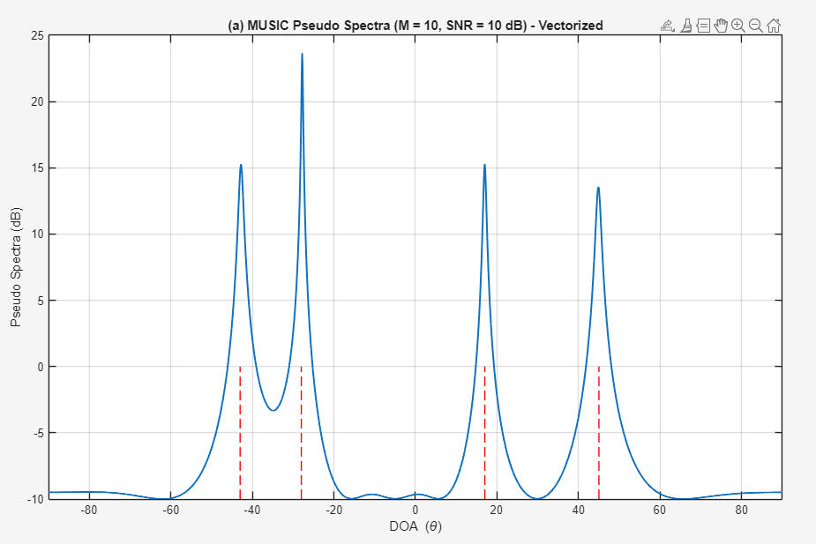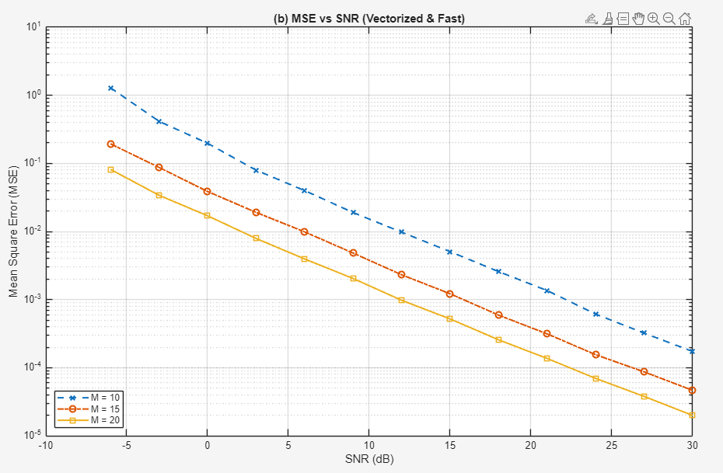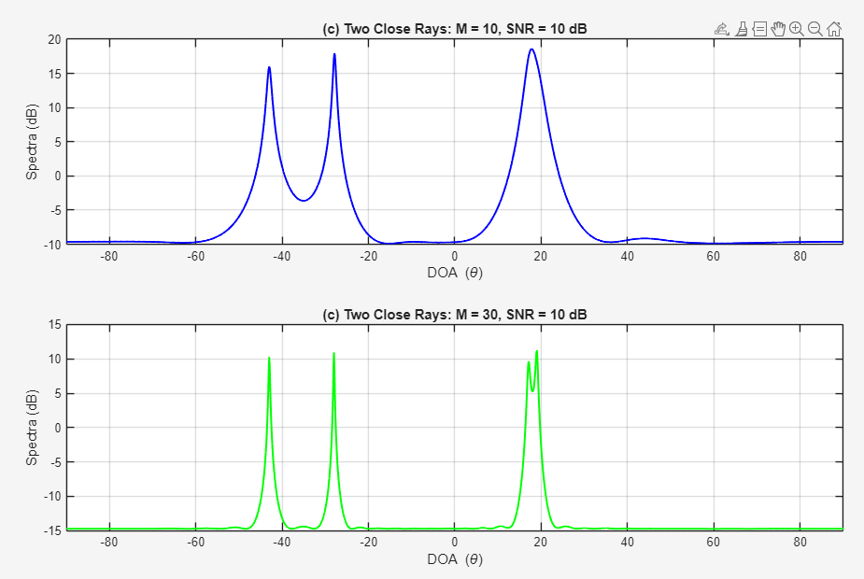

clear; clc; close all;

K = 4;
N = 50;
N_trials = 500;
theta_true = [43, -28, -17, 27];

SNR_dB_list = -3:3:15;

% (a)
M_a = 10;
SNR_dB_a = -3;

A_a = exp(1j * pi * (0:M_a-1)' * sin(deg2rad(theta_true)));
S_a = (randn(K, N) + 1j * randn(K, N)) / sqrt(2);
sigma2_n_a = 1 / (10^(SNR_dB_a / 10));
noise_a = sqrt(sigma2_n_a / 2) * (randn(M_a, N) + 1j * randn(M_a, N));
X_a = A_a * S_a + noise_a;

R_x_a = (X_a * X_a') / N;
[V_a, D_a] = eig(R_x_a);
[~, idx_a] = sort(diag(D_a), 'descend');
V_n_a = V_a(:, idx_a(K+1:end));

P_null = V_n_a * V_n_a';
coef = zeros(2*M_a-1, 1);
for l = -(M_a-1):(M_a-1)
coef(l + M_a) = sum(diag(P_null, l));
end
roots_all = roots(flipud(coef));

figure(1);
r_circle = 0:0.01:2*pi;
plot(cos(r_circle), sin(r_circle), 'r--', 'LineWidth', 1.2); hold on; grid on;
plot(real(roots_all), imag(roots_all), 'ko', 'MarkerSize', 8, 'LineWidth', 1.2);
inside_roots = roots_all(abs(roots_all) < 1);
dist_inside = abs(abs(inside_roots) - 1);
[~, idx_inside] = sort(dist_inside, 'ascend');
signal_roots = inside_roots(idx_inside(1:K));
plot(real(signal_roots), imag(signal_roots), 'bx', 'MarkerSize', 10, 'LineWidth', 1.5);
title('(a) Root-MUSIC Locus of S(z) (M = 10, SNR = -3 dB)');
xlabel('Re(z)'); ylabel('Im(z)');
axis equal; xlim([-2 2]); ylim([-2 2]);

% (b)
M_list = [10, 15, 20];
angle_grid = -90:0.1:90;
MSE_standard = zeros(length(M_list), length(SNR_dB_list));
MSE_root = zeros(length(M_list), length(SNR_dB_list));

for m_idx = 1:length(M_list)
M = M_list(m_idx);
A_search_std = exp(1j * pi * (0:M-1)' * sin(deg2rad(angle_grid)));

for snr_idx = 1:length(SNR_dB_list)
snr_db = SNR_dB_list(snr_idx);
sigma2_n = 1 / (10^(snr_db / 10));

err_std_sum = 0;
err_root_sum = 0;

for trial = 1:N_trials
A = exp(1j * pi * (0:M-1)' * sin(deg2rad(theta_true)));
S = (randn(K, N) + 1j * randn(K, N)) / sqrt(2);
noise = sqrt(sigma2_n / 2) * (randn(M, N) + 1j * randn(M, N));
X = A * S + noise;

R_x = (X * X') / N;
[V, D] = eig(R_x);
[~, idx] = sort(diag(D), 'descend');
V_n = V(:, idx(K+1:end));
P_null_b = V_n * V_n';

P_music = 1 ./ sum(abs(A_search_std' * V_n).^2, 2);

[pks, locs] = findpeaks(P_music);

if length(locs) >= K
[~, sort_pks_idx] = sort(pks, 'descend');
locs = locs(sort_pks_idx(1:K));
else
[~, all_idx] = sort(P_music, 'descend');
locs = zeros(K, 1);
count = 0;
for i = 1:length(all_idx)
if count == 0 || all(abs(all_idx(i) - locs(1:count)) > 30)
count = count + 1;
locs(count) = all_idx(i);
end
if count == K, break; end
end
end
est_angles_std = sort(angle_grid(locs));
coef_b = zeros(2*M-1, 1);
for l = -(M-1):(M-1)
coef_b(l + M) = sum(diag(P_null_b, l));
end
roots_b = roots(flipud(coef_b));

inside_r = roots_b(abs(roots_b) < 1);
[~, sort_r_idx] = sort(abs(abs(inside_r) - 1), 'ascend');
chosen_roots = inside_r(sort_r_idx(1:K));

sin_val = angle(chosen_roots) / pi;
sin_val = max(min(sin_val, 1), -1);
est_angles_root = sort(rad2deg(asin(sin_val)));

est_angles_std = reshape(real(est_angles_std), 1, K);
est_angles_root = reshape(real(est_angles_root), 1, K);

err_std_sum = err_std_sum + sum((sort(theta_true) - est_angles_std).^2);
err_root_sum = err_root_sum + sum((sort(theta_true) - est_angles_root).^2);
end

MSE_standard(m_idx, snr_idx) = err_std_sum / (K * N_trials);
MSE_root(m_idx, snr_idx) = err_root_sum / (K * N_trials);
end
end
toc;

% (b)
figure(2);
markers = {'x', 'o', 's'};
for m_idx = 1:length(M_list)
semilogy(SNR_dB_list, MSE_standard(m_idx, :), ...
['k', markers{m_idx}, '--'], 'LineWidth', 1.5, 'MarkerSize', 8); hold on;
semilogy(SNR_dB_list, MSE_root(m_idx, :), ...
['r', markers{m_idx}, '-'], 'LineWidth', 2, 'MarkerSize', 8);
end
grid on;
xlabel('SNR (dB)'); ylabel('MSE');
xlim([-3 15]); ylim([10^-4 10^0]);

legend('Standard MUSIC: M=10', 'Root-MUSIC: M=10', ...
'Standard MUSIC: M=15', 'Root-MUSIC: M=15', ...
'Standard MUSIC: M=20', 'Root-MUSIC: M=20', ...
'Location', 'NorthEast');
title('(b) MSE Comparison: Standard MUSIC vs Root-MUSIC');
