CONFIDENTAL DOCUMENTATION

Linknet Corporation, Enterprise, Fiber, Media
Network Topology and Infrastructure Architecture
Enterprise infrastructure documentation prepared from actual project source code, deployment references, runtime configuration files, and service integration evidence.
Document Version | 1.0
Prepared By | Media Indo Trend
Date | 08 May 2026
Company / Organization | LinkNet Corporation, Enterprise, Fiber, Media / PT Link Net Tbk
Document Purpose | Audit, security review, deployment review, handover, and internal IT documentation.

Evidence Handling Note
This document intentionally avoids unsupported assumptions. Items not evidenced in the repository are marked as Not Found in Current Configuration or Deployment Detail Not Available.

Table of Contents
Table of Contents 2
1. Executive Summary 4
2. Document Information 4
3. Infrastructure Overview 5
3.1 High-Level Infrastructure Summary 5
3.2 Application Deployment Overview 5
3.3 Environment Overview 6
4. Technology and Infrastructure Stack 6
5. Network Topology Diagram 7
6. Server and Service Communication 9
7. Environment and Configuration 10
7.1 Environment Variables 10
7.2 Deployment and Runtime Configuration 11
7.3 Ports, Domains and TLS 11
8. Security Architecture 12
8.1 Authentication and Access Flow 12
9. Cloud and External Services 13
10. Database and API Inventory 14
10.1 API Communication Surface 14
10.2 Database Schema Summary 14
11. Deployment Architecture 16
11.1 CI/CD and Security Pipeline 17
12. Infrastructure Risks and Recommendations 17
12.1 Hardening Recommendations 19
13. Appendix 19
13.1 Evidence Files Reviewed 19
13.2 Glossary 19
13.3 Explicitly Unavailable Details 20

1. Executive Summary
Infrastructure Assessment Summary
The project is implemented as a multi-application workspace: public Next.js website, Next.js admin CMS, Express.js backend API, PostgreSQL via Prisma, and a standalone S3-oriented filemanager service. Dockerfiles exist for all deployable components. Backend Kubernetes references exist, but full production network, DNS, load balancer, firewall, and database HA details are not fully available in the current configuration.

This document was generated from actual implementation evidence found in source code, Dockerfiles, Kubernetes manifests, CI/CD workflow files, package manifests, Prisma schema, and environment configuration keys. Where deployment infrastructure is not present, the document explicitly marks the gap instead of inventing an architecture.
Scope Area | Finding
Architecture Type | Multi-application / service-separated architecture within one repository: public web, admin frontend, backend API, and filemanager service.
Primary Runtime | Node.js applications using Next.js and Express.js. Backend API exposes /api/v1 and health endpoints.
Persistence | PostgreSQL datasource via Prisma. Database server host/port/HA detail not disclosed in current configuration.
Storage | Local upload path plus AWS S3 and Azure Blob integration paths. Filemanager has concrete AWS S3 bucket/CDN configuration.
Cloud Services | AWS S3, AWS CloudFront, AWS ECR indication, Azure Key Vault CSI template, optional Azure Blob, GA4 Data API and external LinkNet upstream APIs.
Containerization | Dockerfiles found for backend, frontend, web, and filemanager. Backend Kubernetes manifests found. docker-compose not found.
Key Gaps | DNS provider, public IP, production load balancer, firewall/WAF, network policy, S3 IAM policy, database HA/topology, and frontend ingress details are not found.

2. Document Information
Field | Value
Project Name | Revamp LinkNet Corporation, Enterprise, Fiber, Media
Document Title | Network Topology and Infrastructure Architecture
Version | 1.0
Date | 8 May 2026
Prepared By | Media Indo Trend
Company / Organization | LinkNet Corporation, Enterprise, Fiber, Media / PT Link Net Tbk
Classification | Internal IT Documentation
Source Basis | Current source code and configuration under Azure Repository / Azure Devops Service
Review Method | Static analysis of repository files, environment keys, deployment descriptors, middleware, routes, service integrations, package manifests, and Prisma schema.

3. Infrastructure Overview
The implementation separates public website rendering, administrative CMS access, API/business logic, file operations, persistence, and cloud/external integrations. Backend manifests indicate containerized deployment and horizontal scaling capability for the API tier, while frontend and filemanager production orchestration details are not fully present in the repository.

3.1 High-Level Infrastructure Summary
Area | Status | Implementation Evidence
Frontend Server | Found | Next.js public web under web/ and admin CMS under frontend/; Docker standalone mode; ports 3000 and 3001 respectively.
Backend Server | Found | Express.js/TypeScript API under backend/; API prefix /api/v1; health endpoints /health and /ready; Docker exposes port 5000.
Database Server | Partial | PostgreSQL via Prisma DATABASE_URL. Concrete DB host, subnet, HA, backup, and network ACL detail not found.
Reverse Proxy / Load Balancer | Partial | backend/k8s/ingress.yaml uses nginx ingress and TLS annotations. Production edge/LB for frontend/public web not found.
Storage Service | Found | AWS S3 service and Azure Blob optional service found. Filemanager production env references AWS S3 bucket and CloudFront CDN.
Cloud Services | Found | AWS S3/CloudFront/ECR indications, Azure Key Vault CSI template, Azure Blob optional, GA4 Data API.
Container / Orchestration | Partial | Dockerfiles for all components; backend Kubernetes Deployment/Service/HPA/Ingress/KeyVault CSI templates; no docker-compose.
Queue / Broker | Partial | Bull/ioredis dependencies and REDIS_ENABLED feature flag found. Runtime Redis deployment detail not available.

3.2 Application Deployment Overview
- Public Web: Next.js application built with standalone output and intended to call backend API through NEXT_PUBLIC_API_URL or API_INTERNAL_URL.
- Admin CMS: Next.js application built with standalone output, auth-enabled flag, and API base URL configured through environment variables.
- Backend API: Express.js application with middleware chain for security headers, CORS, cookies, CSRF, rate limiting, auth, RBAC, compression, audit logging, and route modules.
- Filemanager: standalone Express service for S3 upload, listing, delete, and signed URL functions; production API key enforcement fails closed when API_KEY is missing.
- Backend Kubernetes: replicas 3, ClusterIP service, HPA min 3 max 10, liveness/readiness probes, securityContext, ConfigMap/Secret references, and nginx ingress TLS template.

3.3 Environment Overview
Environment Indicator | Evidence | Assessment
Development | Local .env files and package scripts found across components. | Development environment exists by convention, but local network topology is not fully documented.
Staging | No explicit staging descriptor found. | Not Found in Current Configuration.
Production | .env.production files, Dockerfiles, CI workflows, backend Kubernetes manifests, and production domains found. | Production intent is evidenced, but edge/network/cloud resource configuration is incomplete.
CI/CD | GitHub Actions build workflow, Trivy scan workflow, and web Azure Pipeline/ECR pipeline files found. | Build/security scanning is evidenced; final deployment promotion workflow is partial.

4. Technology and Infrastructure Stack
Component | Package Name | Version | Dependencies | Key Packages
Backend API | linknet-backend | 1.0.0 | 51 runtime / 27 dev | express@^4.21.3, @prisma/client@^5.7.1, prisma@^5.22.0 (dev), typescript@^5.3.3 (dev), @aws-sdk/client-s3@^3.1001.0, @azure/storage-blob@^12.29.1, @azure/keyvault-secrets@^4.10.0, @google-analytics/data@^5.2.1, bull@^4.16.5, ioredis@^5.3.2
Admin Frontend | free-nextjs-admin-dashboard | 2.2.2 | 45 runtime / 11 dev | next@16.2.4, react@^19.2.0, typescript@^5.9.3 (dev)
Public Web | linknet_web | 0.1.0 | 12 runtime / 12 dev | next@16.2.4, react@19.2.3, typescript@^5.9.3 (dev)
Standalone File Manager | filemanager | 1.0.0 | 10 runtime / 11 dev | express@^4.19.2, typescript@^5.4.5 (dev), @aws-sdk/client-s3@^3.600.0

Infrastructure Category | Implementation Found | Detail
Frontend Server | Next.js | Public web under web/ exposes 3000; admin CMS under frontend/ exposes 3001; both use standalone Docker build pattern.
Backend Server | Node.js / Express.js | backend/src/server.ts initializes Express with security middleware and route modules under /api/v1.
Database | PostgreSQL via Prisma | backend/prisma/schema.prisma datasource provider postgresql and DATABASE_URL environment variable.
Reverse Proxy / LB | Partial | backend/k8s/ingress.yaml references nginx ingress and TLS; production LB/CDN provider for app edge not found.
Cloud Services | AWS and Azure references | AWS S3/CloudFront/ECR, Azure Key Vault CSI template, Azure Blob optional, GA4 Data API.
Storage | Local, S3, Azure Blob | Upload storage service selects local, azure, or s3; filemanager uses AWS S3 directly.
CDN | Partial | CloudFront CDN URL found for filemanager. CDN for primary site/app edge not found.
Queue / Broker | Optional Redis/Bull | Bull/ioredis code paths found; runtime Redis deployment not found.
Container / Orchestration | Docker + partial Kubernetes | Dockerfiles for all apps; backend Kubernetes Deployment/Service/HPA/Ingress; no docker-compose.

5. Network Topology Diagram
Diagram Interpretation
The diagram includes required topology elements where evidence exists. Public load balancer, DNS provider, firewall, WAF, network security group, database subnet, and frontend ingress details are marked as partial or unavailable because they are not defined in the uploaded configuration.

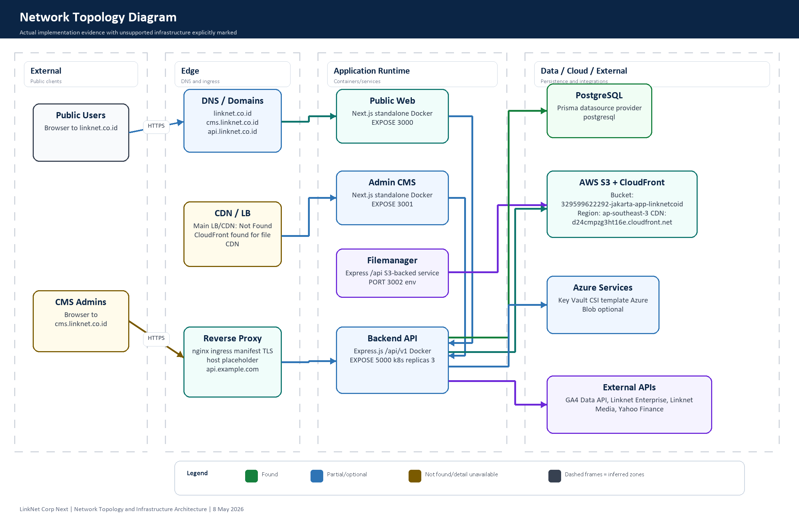
Figure 1. Network Topology Diagram based on current repository evidence
Topology Node | Evidence | Status / Notes
User / Client | Browser access to public site and CMS routes. | External public client boundary.
Internet / Public Access | Domains and HTTPS URLs in environment files. | Public access expected.
DNS / Domain | linknet.co.id, cms.linknet.co.id, api.linknet.co.id values found. | DNS provider and records Not Found in Current Configuration.
CDN / Load Balancer | CloudFront CDN URL found for filemanager; main edge LB not present. | Partial. Primary CDN/LB Deployment Detail Not Available.
Reverse Proxy | backend/k8s/ingress.yaml references nginx ingress and TLS annotations. | Backend only; frontend ingress Not Found in Current Configuration.
Frontend Applications | web/ and frontend/ Next.js Dockerfiles and env config. | Public web and admin CMS separated by app and port.
Backend API | backend/ Express API, Dockerfile and k8s deployment. | API server on port 5000, /api/v1 prefix.
Database Server | Prisma PostgreSQL datasource. | Host/subnet/HA/firewall detail Deployment Detail Not Available.
Storage Service | S3, Azure Blob and local upload implementations. | S3 bucket/CDN concrete in filemanager config; backend bucket env placeholders.
External Integrations | GA4, LinkNet upstream APIs, Yahoo Finance, optional email. | Outbound HTTPS integrations found; production egress controls Not Found.
Internal / Private Network | Kubernetes service/ClusterIP and service-to-database code boundaries. | Inferred from deployment config; concrete VPC/VNet/subnet not found.
Docker / Container Communication | Dockerfiles and backend Kubernetes service manifest. | docker-compose or full container network definition Not Found.

6. Server and Service Communication
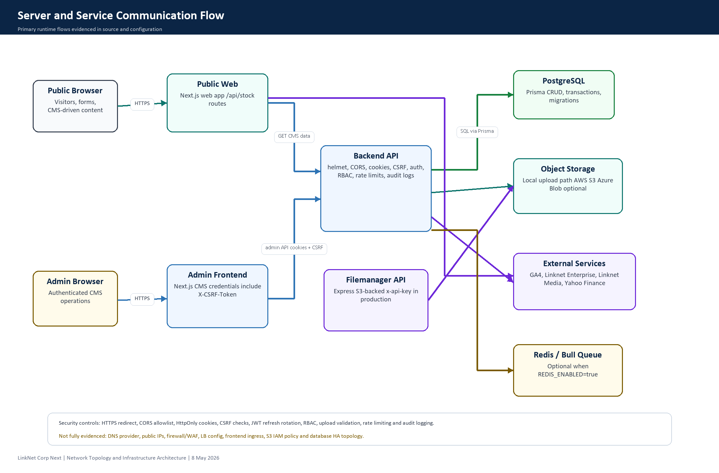
Figure 2. Server and Service Communication Flow
Flow | Implementation Evidence | Communication Notes
Frontend to Backend | frontend service layer and web CMS API clients use NEXT_PUBLIC_API_URL/API_INTERNAL_URL. | HTTPS expected through public domains. Admin sends credentials include, Authorization where available, and X-CSRF-Token for unsafe requests.
Backend to Database | Prisma client uses DATABASE_URL and PostgreSQL datasource. | SQL communication handled by Prisma. DB host, private subnet, SSL mode, and pooler detail not found.
Backend to Storage | storageService selects local/azure/s3; s3Service and azureStorage.service exist. | Uploads may go local disk, S3, or Azure Blob depending on STORAGE_DRIVER and environment variables.
Filemanager to Storage | filemanager/src services use @aws-sdk/client-s3 and CloudFront CDN URL. | S3 object operations under standalone /api service. Production API key required.
Backend to External APIs | Linknet Enterprise controller, Linknet Media controller, GA4 service. | Outbound HTTPS flows. Credential values are not disclosed; allowlist/egress firewall not found.
Web to Yahoo Finance | web/app/api/stock/quote and historical routes use yahoo-finance2. | Public web API route acts as proxy with validation/rate limiting.
Authentication Communication | JWT access/refresh, bcrypt, cookies, CSRF, MFA and RBAC middleware. | Internal auth service only; OAuth provider Not Found in Current Configuration.
Internal Service Communication | Backend Kubernetes Service 80 to container 5000; app-to-filemanager calls not clearly wired. | Service discovery and private DNS detail Deployment Detail Not Available.

7. Environment and Configuration

7.1 Environment Variables
Component | File | Environment Keys Found
Backend | backend/.env.production | API_PREFIX, API_VERSION, AWS_ACCESS_KEY_ID, AWS_REGION, AWS_S3_BUCKET, AWS_S3_ENDPOINT, AWS_S3_PUBLIC_URL, AWS_SECRET_ACCESS_KEY, AZURE_CLIENT_ID, AZURE_CLIENT_SECRET, AZURE_KEY_VAULT_URL, AZURE_STORAGE_ACCOUNT_NAME, AZURE_STORAGE_CONNECTION_STRING, AZURE_STORAGE_CONTAINER, AZURE_STORAGE_CONTAINER_NAME, AZURE_TENANT_ID, BASE_URL, CORS_CREDENTIALS, CORS_ORIGIN, DATABASE_URL, ENABLE_FILE_LOGS, FORCE_HTTPS, ... (38 total keys)
Admin Frontend | frontend/.env.production | NEXT_PUBLIC_API_URL, NEXT_PUBLIC_AUTH_ENABLED, NEXT_PUBLIC_SITE_URL
Admin Frontend Local | frontend/.env.local | NEXT_DISABLE_TYPE_CHECKING, NEXT_PRIVATE_BUILD_WORKER, NEXT_TELEMETRY_DISABLED
Public Web | web/.env.production | NEXT_PUBLIC_API_URL
Public Web Local | web/.env | NEXT_PUBLIC_API_URL
Filemanager | filemanager/.env.production | ALLOWED_ORIGINS, AWS_BUCKET_NAME, AWS_REGION, CDN_URL, MAX_FILE_SIZE_MB, NODE_ENV, PORT
Filemanager Local | filemanager/.env | ALLOWED_ORIGINS, API_KEY, AWS_BUCKET_NAME, AWS_REGION, CDN_URL, MAX_FILE_SIZE_MB, NODE_ENV, PORT

Secret Disclosure Control
The table above lists configuration key names only. Secret values, database URLs, API keys, tokens, passwords, and private keys are intentionally not reproduced in this document.

7.2 Deployment and Runtime Configuration
Configuration Area | Evidence | Assessment
Backend Docker | backend/Dockerfile exposes port 5000 and runs compiled dist/server.js. | Found.
Frontend Docker | frontend/Dockerfile exposes port 3001 using Next standalone server. | Found.
Public Web Docker | web/Dockerfile exposes port 3000 using Next standalone server. | Found.
Filemanager Docker | filemanager/Dockerfile exposes port 3000. | Found, but production env PORT=3002 indicates port mapping must be explicit.
docker-compose | No docker-compose*.yml found. | Not Found in Current Configuration.
Backend Kubernetes Deployment | backend/k8s/deployment.yaml includes Deployment, Service, ConfigMap, Secret template, HPA and probes. | Found for backend only.
Backend Kubernetes Ingress | backend/k8s/ingress.yaml references nginx ingress and TLS secret. | Found with placeholder host api.example.com.
Azure Key Vault CSI | backend/k8s/keyvault-csi.yaml exists. | Template found; actual Key Vault values are placeholders.
CI Build | .github/workflows/ci-build.yml builds backend, frontend, web, filemanager. | Found.
Security Scan | .github/workflows/trivy-scan.yml runs weekly and PR/push Trivy scans. | Found.
Web Pipeline | web/azure-pipelines.yml and web/azure-pipelines-develop.yml. | Partial: Azure App Service/hybrid artifact and AWS ECR push indication.

7.3 Ports, Domains and TLS
Item | Value / Evidence | Notes
Public Web Port | 3000 | Docker EXPOSE 3000 in web/Dockerfile.
Admin CMS Port | 3001 | Docker EXPOSE 3001 in frontend/Dockerfile.
Backend API Port | 5000 | Docker EXPOSE 5000; Kubernetes Service maps port 80 to targetPort 5000.
Filemanager Port | 3000 Docker EXPOSE; PORT=3002 production env | Potential runtime mapping mismatch requiring deployment clarity.
Public Domain | https://linknet.co.id | Found in frontend/public web environment.
CMS Domain | https://cms.linknet.co.id | Found in CORS/site configuration.
API Domain | https://api.linknet.co.id | Found as backend base URL in frontend/web configuration.
Kubernetes Ingress Host | api.example.com placeholder | Deployment Detail Not Available for actual production ingress host.
TLS / HTTPS | Backend HTTPS redirect middleware and ingress TLS annotations found. | Certificate issuer, TLS termination point and frontend TLS config Not Found.

8. Security Architecture
Security Area | Implementation Found | Assessment
HTTPS Implementation | Backend HTTPS redirect and nginx ingress TLS/HSTS annotations. | Partial. Production TLS termination and certificate details not found.
Security Headers | Helmet and custom security headers middleware; Next.js headers found. | Found.
CORS | Production allowed origins include cms.linknet.co.id and linknet.co.id. | Found. Validate all deployed origins before go-live.
Authentication Layer | JWT access/refresh, refresh token hash/rotation, HttpOnly cookies, bcrypt password hashing, optional MFA. | Found.
Authorization | RBAC route permissions with User, Role, Permission models. | Found.
CSRF | CSRF middleware for unsafe cookie-authenticated API calls and frontend token forwarding. | Found.
Rate Limiting | Auth, upload, public form and selected public API rate limiters. | Found.
Upload Security | MIME/extension/size/magic-byte validation; ClamAV path exists but memory upload scan does not enforce ClamAV. | Partial. Add AV enforcement in production upload pipeline.
Secret Management | Environment variables and Azure Key Vault CSI template. | Partial. Actual secret manager binding and rotation policy not found.
Firewall / WAF / Network Policy | No concrete firewall/WAF/NSG/security group/network policy files found. | Not Found in Current Configuration.
S3/IAM Access | SDK integrations and bucket/CDN reference found. | IAM policy, bucket policy and block-public-access settings Not Found.
Public vs Private Access | Code defaults private storage for S3/Azure public access unless explicit opt-in. | Good application-level default; infrastructure policy still needs verification.

8.1 Authentication and Access Flow
- Admin login flow validates credentials, account status, lockout and optional MFA before issuing access and refresh tokens.
- Refresh tokens are stored as hashes and rotated, reducing impact if database token rows are exposed.
- Auth token can be supplied through HttpOnly cookie and selected bearer handling; cookie-authenticated unsafe methods require CSRF token matching.
- RBAC middleware protects CMS, dashboard, analytics, upload and administrative operations according to route-level permissions.
- OAuth or third-party identity provider integration is Not Found in Current Configuration.

9. Cloud and External Services
Service / Provider | Evidence Found | Usage / Integration | Configuration Status
AWS S3 | @aws-sdk/client-s3 in backend/filemanager; filemanager bucket config. | Object upload/list/delete/presigned URL and CDN URL mapping. | Partial. Bucket exists in config; IAM/bucket policy not found.
AWS CloudFront | filemanager .env.production CDN_URL d24cmpzg3ht16e.cloudfront.net. | File delivery CDN for S3-backed assets. | Found for filemanager; primary site CDN not found.
AWS ECR | web/azure-pipelines-develop.yml references ECR registry and repository. | Container image push for public web pipeline. | Partial.
Azure Key Vault | backend services and k8s keyvault-csi.yaml template. | Secret retrieval / Kubernetes CSI secret mount pattern. | Template only; deployment values placeholders.
Azure Blob Storage | @azure/storage-blob and azureStorage.service.ts. | Optional storage backend. | Partial, enabled only when storage driver/env configured.
Google Analytics Data API | @google-analytics/data and GA4 service with GA4_PROPERTY_ID. | Analytics reporting/dashboard data. | Found.
LinkNet Enterprise API | linknetEnterprise.controller.ts. | Coverage/nearest address API through upstream OAuth token endpoint. | Found; credentials via env.
LinkNet Media API | linknetMedia.controller.ts. | Media portal data proxy with token generation. | Found; salt via env.
Yahoo Finance | web stock quote/historical API routes use yahoo-finance2. | Public stock quote and historical data proxy. | Found.
Email Service | email.util.ts logs/mock-style email behavior. | Password reset or notification utility exists. | Provider Deployment Detail Not Available.
OAuth Provider | No OAuth/social login provider implementation identified. | Not used by current auth implementation. | Not Found in Current Configuration.

10. Database and API Inventory

10.1 API Communication Surface
API / Route Group | Purpose | Security Layer
/api/v1/auth/* | Login, refresh, logout, MFA, password reset and account session flow. | Rate limit, bcrypt, JWT, refresh hash, HttpOnly cookies, CSRF-aware flow.
/api/v1/users, /roles, /permissions | User and RBAC administration. | Auth and permission middleware.
/api/v1/pages, /components, /menu, /settings | CMS page builder, public settings and menu data. | Admin auth/RBAC for mutations; public read routes where implemented.
/api/v1/news, /events, /careers, /reports, /announcements | Corporate content modules. | CMS-protected CRUD and public read flows.
/api/v1/form-modules, /contact | Dynamic forms, submissions and contact data. | Validation, upload controls, public rate limiting, CMS auth for administration.
/api/v1/upload, /filemanager, /files | Upload and file metadata operations. | Upload scanner, MIME/extension/size checks, RBAC and storage permissions.
/api/v1/dashboard, /analytics, /activity-logs | Operational dashboard, analytics and audit/activity records. | Authenticated CMS-only routes.
/health, /ready | Health and readiness endpoints. | Basic probes public; detailed diagnostics protected in production.
web/app/api/stock/* | Public website stock quote/historical proxy. | Input validation and per-IP rate limiting.
filemanager /api/* | Standalone S3 filemanager service. | x-api-key fail-closed in production plus helmet/CORS/rate limit.

10.2 Database Schema Summary
Prisma schema inventory found 57 model definitions. The full source-of-truth remains backend/prisma/schema.prisma; the table below summarizes model/table names, primary key indication, relationship evidence, and field counts.
Prisma Model | Table | Primary Key | Relationships / FK Evidence | Fields
User | users | id | Not Found in Current Configuration | 32
RefreshToken | refresh_tokens | id | userId -> User.id | 7
PasswordResetToken | password_reset_tokens | id | Not Found in Current Configuration | 6
PasswordHistory | password_histories | id | userId -> User.id | 5
Role | roles | id | Not Found in Current Configuration | 10
Permission | permissions | id | Not Found in Current Configuration | 8
RolePermission | role_permissions | id | permissionId -> Permission.id; roleId -> Role.id | 6
UserRole | user_roles | id | roleId -> Role.id; userId -> User.id | 6
Setting | settings | id | Not Found in Current Configuration | 12
Menu | menus | id | parentId -> Menu?.id | 24
Page | pages | id | createdById -> User.id; updatedById -> User?.id | 28
PageComponent | page_components | id | pageId -> Page.id | 9
Career | careers | id | Not Found in Current Configuration | 18
Award | awards | id | Not Found in Current Configuration | 22
ManagementCategory | management_categories | id | Not Found in Current Configuration | 12
Management | managements | id | categoryId -> ManagementCategory.id | 21
ContactSubmission | contact_submissions | id | userId -> User?.id | 17
LogActivity | log_activities | id | userId -> User?.id | 14
VisitorLog | visitor_logs | id | Not Found in Current Configuration | 7
UrlRedirect | url_redirects | id | Not Found in Current Configuration | 9
Folder | folders | id | parentId -> Folder?.id | 12
File | files | id | createdById -> User.id; folderId -> Folder?.id | 26
ContactUs | contact_us | id | Not Found in Current Configuration | 16
FormModule | form_modules | id | Not Found in Current Configuration | 26
FormStep | form_steps | id | formModuleId -> FormModule.id | 13
FormField | form_fields | id | formModuleId -> FormModule.id; formStepId -> FormStep?.id; parentFieldId -> FormField?.id | 27
FormFieldOption | form_field_options | id | fieldId -> FormField.id | 12
FormFieldRule | form_field_rules | id | formModuleId -> FormModule.id; sourceFieldId -> FormField?.id; targetFieldId -> FormField?.id | 14
FormResponseConfig | form_response_configs | id | formModuleId -> FormModule.id | 14
FormIntegrationConfig | form_integration_configs | id | formModuleId -> FormModule.id | 13
FormSubmission | form_submissions | id | formModuleId -> FormModule.id | 35
FormSubmissionValue | form_submission_values | id | submissionId -> FormSubmission.id | 10
FormSubmissionGroup | form_submission_groups | id | submissionId -> FormSubmission.id | 10
FormSubmissionGroupValue | form_submission_group_values | id | groupId -> FormSubmissionGroup.id | 10
FormSubmissionFile | form_submission_files | id | fileId -> File?.id; groupId -> FormSubmissionGroup?.id; submissionId -> FormSubmission.id | 19
FormSubmissionDispatchLog | form_submission_dispatch_logs | id | integrationConfigId -> FormIntegrationConfig?.id; submissionId -> FormSubmission.id | 15
CareerContent | career_content | id | Not Found in Current Configuration | 17
ReportType | report_types | id | Not Found in Current Configuration | 13
ReportSection | report_sections | id | type_id -> ReportType.id | 12
news | news | id | category_id -> news_categories.id; created_by_id -> User.id; updated_by_id -> User?.id | 36
news_categories | news_categories | id | Not Found in Current Configuration | 13
news_highlights | news_highlights | id | news_id -> news.id | 8
news_tag_relations | news_tag_relations | id | news_id -> news.id; tag_id -> news_tags.id | 6
news_tags | news_tags | id | Not Found in Current Configuration | 7
news_views | news_views | id | news_id -> news.id | 7
events | events | id | Not Found in Current Configuration | 29
event_news_relations | event_news_relations | id | event_id -> events.id; news_id -> news.id | 8
event_registrations | event_registrations | id | event_id -> events.id | 16
event_registration_participants | event_registration_participants | id | registration_id -> event_registrations.id | 9
reports | reports | id | type_id -> ReportType?.id; section_id -> ReportSection?.id | 27
AnnouncementType | announcement_types | id | Not Found in Current Configuration | 14
AnnouncementSection | announcement_sections | id | type_id -> AnnouncementType.id | 16
announcements | announcements | id | type_id -> AnnouncementType?.id; section_id -> AnnouncementSection?.id | 19
ComponentVisibility | component_visibility | id | Not Found in Current Configuration | 7
LabelGroup | label_groups | id | Not Found in Current Configuration | 8
LabelNode | label_nodes | id | groupId -> LabelGroup.id; parentId -> LabelNode?.id | 17
CookieConsent | cookie_consents | id | Not Found in Current Configuration | 8

11. Deployment Architecture
Architecture Dimension | Assessment | Evidence
Monolith vs Microservice | Service-separated multi-application architecture, not a single monolith. | Separate backend, frontend, web, and filemanager packages with individual Dockerfiles.
Frontend / Backend Separation | Separated. | Admin CMS and public website call backend API via configured base URLs.
Containerization | Present. | Dockerfiles for all four components.
Orchestration | Partial. | Backend Kubernetes manifests only. No complete cluster-level topology or frontend/filemanager manifests.
Shared Hosting / VPS / Cloud | Deployment Detail Not Available. | Wamp path indicates local workspace; production provider not conclusively defined.
Cloud Deployment Indication | Partial AWS and Azure indications. | AWS S3/CloudFront/ECR, Azure Pipeline/App Service artifact, Azure Key Vault/Blob references.
Scalability | Backend horizontal scaling evidenced; full system scalability partially defined. | Backend HPA min 3 max 10; frontend/filemanager autoscaling not found; DB/storage HA not found.
High Availability | Partial. | Backend replicas 3; load balancer, multi-AZ database, cache HA and storage policy not found.
Observability | Partial. | Health endpoints, logs, activity logs and GA4 analytics found. Centralized metrics/APM not found.

11.1 CI/CD and Security Pipeline
Pipeline | Evidence | Notes
GitHub CI Build | .github/workflows/ci-build.yml | Build matrix includes backend, frontend, web and filemanager.
Trivy Security Scan | .github/workflows/trivy-scan.yml | Scans dependency vulnerabilities and secrets on push/PR and weekly schedule.
Azure Pipeline | web/azure-pipelines.yml | Next.js SSR/hybrid artifact for Azure App Service/platform path.
AWS ECR Pipeline | web/azure-pipelines-develop.yml | Build, SAST/Trivy and Docker push to AWS ECR registry in ap-southeast-3.
Deployment Approval / Rollback | Not found. | Release gates, rollback runbooks and promotion controls Not Found in Current Configuration.

12. Infrastructure Risks and Recommendations
Risk Framing
Risks below are infrastructure and deployment risks, not confirmed exploitation findings. Severity reflects potential audit/security impact if the missing deployment controls are not implemented or evidenced.

Risk | Severity | Evidence / Concern | Recommendation
Incomplete edge topology evidence | Medium | DNS provider, production load balancer, public IPs and frontend ingress are not defined in repo. | Document actual DNS records, CDN/LB, ingress, TLS termination, and routing paths in infrastructure-as-code or a controlled runbook.
Firewall/WAF/network policy not evidenced | Medium | No WAF, firewall, NSG/security group or Kubernetes NetworkPolicy definitions found. | Add WAF and network policy evidence; restrict backend/database/storage to required sources only.
Database topology unavailable | Medium | DATABASE_URL exists, but host, SSL mode, subnet, HA, backup and retention are not visible. | Define DB architecture, private access, SSL requirement, backup/restore, HA and monitoring controls.
Secrets and env governance risk | High | Environment files exist in workspace and contain deployment-sensitive keys; values are not reproduced here. | Move production secrets to managed secret store; ensure .env production files are excluded from Git and rotated if ever exposed.
S3 IAM and bucket policy unavailable | Medium | S3 integration and bucket/CDN reference found, but IAM/bucket policy is not present. | Attach least-privilege IAM policy, block public access unless intentionally public through CDN, and log S3 access.
Filemanager port mismatch | Medium | Docker EXPOSE 3000 but .env.production PORT=3002. | Clarify container port mapping and service targetPort; align Dockerfile, runtime env and ingress/service definition.
Backend ingress uses placeholder host | Medium | backend/k8s/ingress.yaml references api.example.com. | Replace placeholder with actual controlled host and TLS secret reference; verify HSTS and TLS policy at edge.
Frontend/filemanager orchestration missing | Medium | Kubernetes manifests exist only for backend. | Add deployment manifests or platform specs for frontend, public web and filemanager, including resource limits, probes, scaling and network rules.
Queue deployment unclear | Low | Bull/ioredis optional paths found, but Redis deployment not defined. | If REDIS_ENABLED=true in production, document Redis topology, authentication, persistence, HA and network restrictions.
Upload malware scanning partial | Medium | MIME/magic validation exists; ClamAV path exists but memory-upload route scanning does not fully enforce AV. | Enforce AV scanning/quarantine for all accepted upload flows before public access or downstream processing.
Single point of failure not fully assessed | Medium | Backend HPA exists, but DB/cache/storage edge HA details are unavailable. | Add HA design for DB, cache, file service, CDN/LB and backup/restore objectives.

12.1 Hardening Recommendations
- Create infrastructure-as-code for edge, DNS, load balancer, TLS certificates, firewall/WAF, Kubernetes ingress and network policies.
- Use a managed secrets platform as the only production secret source and rotate secrets that may have existed in local or historical deployment files.
- Restrict database access to backend runtime identities/subnets and require TLS for database connections where supported.
- Apply least-privilege IAM to S3 and CloudFront, enforce S3 block-public-access, and use CDN/origin access controls for public assets.
- Publish a deployment runbook covering domains, ports, health checks, rollback, backup/restore, scaling thresholds and incident escalation.
- Add monitoring/APM/log aggregation for backend, frontend, filemanager, database, storage and external API failures.
- Standardize all component deployments with health probes, resource requests/limits, autoscaling rules and private service discovery.

13. Appendix

13.1 Evidence Files Reviewed
Area | Files / Paths
Backend Source | backend/src/server.ts, backend/src/routes, backend/src/controllers, backend/src/services, backend/src/middleware
Database | backend/prisma/schema.prisma and migrations
Frontend | frontend/package.json, frontend/Dockerfile, frontend environment files and service/config code
Public Web | web/package.json, web/Dockerfile, web/app API routes, web Azure Pipeline files
Filemanager | filemanager/package.json, filemanager/Dockerfile, filemanager/src and environment files
Containers | backend/Dockerfile, frontend/Dockerfile, web/Dockerfile, filemanager/Dockerfile
Kubernetes | backend/k8s/deployment.yaml, backend/k8s/ingress.yaml, backend/k8s/keyvault-csi.yaml
CI/CD | .github/workflows/ci-build.yml, .github/workflows/trivy-scan.yml, web/azure-pipelines*.yml

13.2 Glossary
Term | Definition
CDN | Content Delivery Network used to cache/distribute static or media assets closer to users.
Ingress | Kubernetes edge routing resource that exposes services through HTTP/HTTPS host/path routing.
RBAC | Role-Based Access Control; application permissions mapped through roles and user assignments.
CSRF | Cross-Site Request Forgery; mitigated here through CSRF token validation for unsafe cookie-authenticated requests.
Prisma | Node.js ORM used by the backend to access PostgreSQL.
HPA | Horizontal Pod Autoscaler; Kubernetes scaling resource found in backend deployment manifest.
S3 | AWS object storage service used by backend/filemanager integration paths.
Key Vault CSI | Kubernetes CSI driver pattern for mounting Azure Key Vault secrets into pods.

13.3 Explicitly Unavailable Details
- Production DNS provider, authoritative zone configuration, public IPs and DNS record TTLs.
- Production CDN/load balancer configuration for main public website and CMS.
- Firewall, WAF, security group, network security group, Kubernetes NetworkPolicy or egress firewall definitions.
- Production database host topology, subnet, SSL enforcement, backup/restore policy and HA setup.
- Actual IAM policies for AWS S3/CloudFront/ECR and workload identity bindings.
- Actual Azure Key Vault instance name, tenant/workload identity binding and secret rotation process.
- Complete deployment manifests for frontend, public web and filemanager runtimes.

