REVAMP LINKNET Corporation, Enterprise, Fiber, Media
Static Application Security Testing (SAST) Final Report
Final Post-Hardening Security Assessment
0  Critical Open | 0  High Open | 0  Medium Open | 3  Low Accepted

Field | Value
Document Version | 1.0
Prepared By | Media Indo Trend
Date | 08 May 2026
Company / Organization | PT Link Net Tbk
Assessment Type | Static source code review, dependency review, and configuration review
Final Posture | No open Critical or High risk findings

Confidentiality Notice
This report was prepared for security governance, client review, vendor assessment, and audit support. It reflects the final source code posture after remediation and hardening performed during the assessment window.

Table of Contents
1. Document Information 3
2. Executive Summary 3
3. Application Overview 4
4. SAST Scope 5
5. Security Review Methodology 6
6. Security Findings Summary 6
7. Detailed Findings 7
7.1. SAST-001: Stored XSS exposure in CMS component output fields 8
7.2. SAST-002: Unsafe local storage path/key handling 8
7.3. SAST-003: Presigned GET URL arbitrary object-key access 8
7.4. SAST-004: Public form attachment upload accepted broad global limits 9
7.5. SAST-005: MFA operations lacked strict endpoint-specific limiter 9
7.6. SAST-006: Production CSP allowed development-friendly sources 10
7.7. SAST-007: Moderate PostCSS dependency advisory 10
7.8. SAST-008: Admin image optimization wildcard remote hosts 10
7.9. SAST-009: CI production build used mock auth flag 11
8. Security Controls Identified 11
9. Dependency and Package Security Review 12
10. Infrastructure and Configuration Security 12
11. Remediation Summary 13
12. Residual Risk Assessment 13
13. Security Recommendations 14
Appendix A. Database and Domain Schema Summary 14
Appendix B. Verification Evidence 15
Appendix C. Glossary 15

Note: The table of contents is implemented as a Word field and will update automatically in Microsoft Word.

1. Document Information
Table 1. Document metadata
Item | Detail
Project Name | Revamp Linknet Corporation, Enterprise, Fiber, Media
Version | 1.0
Date | May 08, 2026
Prepared By | Media Indo Trend
Assessment Scope | Backend API, admin frontend, public web, filemanager, Dockerfiles, CI workflows, environment templates, cloud/storage integrations, and production dependency manifests.
Assessment Basis | Manual SAST review, source-code remediation, dependency audit, build validation, and focused sanitizer regression tests.

2. Executive Summary
Final Assessment Statement
The Revamp Linknet Corporation, Enterprise, Fiber, Media application was reviewed, remediated, and reassessed. The final source code posture contains no open Critical or High risk findings. Remaining residual risks are Low and acceptable with normal operational governance.
Figure 1. Final severity summary
0  Critical Findings | 0  High Findings | 0  Medium Findings | 3  Low Findings
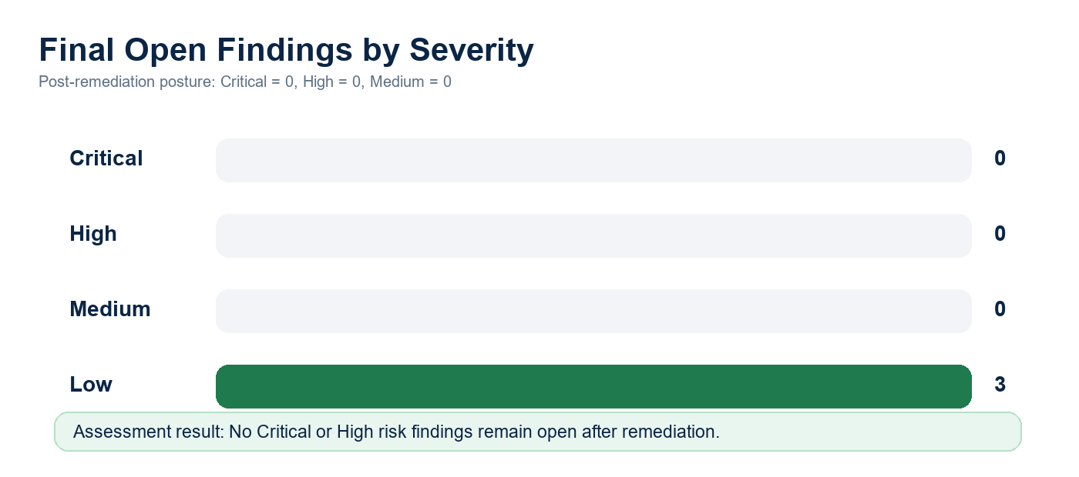
Figure 2. Final open finding distribution after remediation
Table 2. Executive security posture summary
Area | Final Result
Application Security | Authentication, authorization, session protection, input validation, XSS filtering, upload validation, and API rate limiting were hardened or validated.
Dependency Security | Production npm audit returned 0 vulnerabilities for backend, frontend, web, and filemanager packages.
Build Validation | Backend TypeScript build, admin Next.js build, and public web Next.js build completed successfully.
Regression Tests | Output sanitizer tests passed: 32 tests across HTML and component sanitization.
Security Posture | Audit-ready with no known open Critical or High risk source-code findings.

3. Application Overview
The application is a multi-tier corporate web platform with a public website, an authenticated CMS/admin frontend, and a Node.js API layer. The backend exposes public content APIs, protected CMS APIs, dynamic form modules, file management, authentication, role management, audit logging, and cloud/storage integrations.
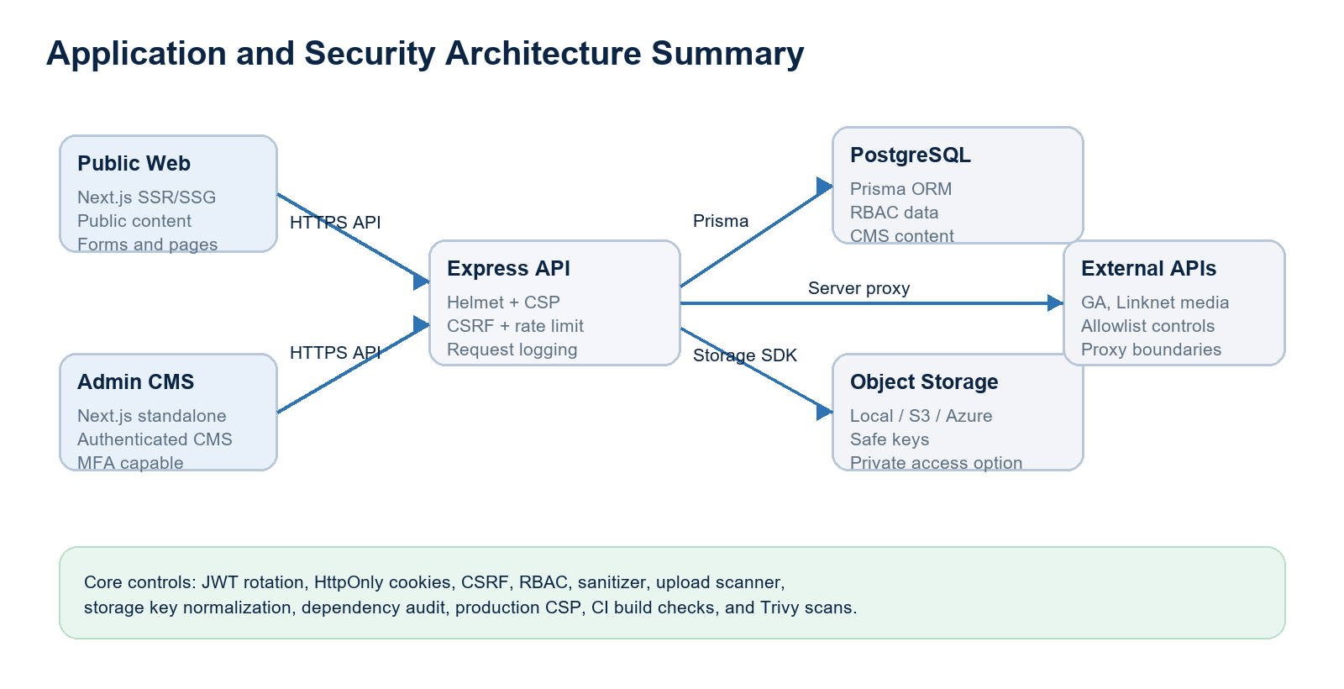
Figure 3. Architecture and security control overview
Table 3. Technology stack overview
Layer | Technology / Component | Security-Relevant Notes
Backend API | Node.js, Express, TypeScript | Helmet, custom secure headers, CORS allowlist, CSRF for cookie sessions, rate limiting, centralized error handling.
Database | PostgreSQL via Prisma ORM | Typed ORM operations; no vulnerable raw SQL identified in active source review.
Admin Frontend | Next.js 16, React 19 | Production auth guard, no-store headers, CSP, restricted remote image hosts.
Public Web | Next.js 16, next-intl | Public CMS rendering with server-side sanitization and production CSP hardening.
Storage | Local, AWS S3, Azure Blob | Safe key normalization, upload scanning, MIME/extension validation, presigned access controls.
CI/CD | GitHub Actions | Build jobs and Trivy filesystem scans for High/Critical vulnerability and secret checks.

4. SAST Scope
Table 4. Assessment scope
Scope Category | Assessed Items
Backend Source Code | Express server, route modules, controllers, services, middleware, auth utilities, validators, Prisma schema, migrations/seeds where relevant.
Frontend Source Code | Admin Next.js app, public web app, API client code, rendering components, CSP and image optimization configuration.
API Routes | Authentication, MFA, profile, CMS, public content, forms, upload, filemanager, analytics, redirect, and health routes.
Configuration | package.json, package-lock.json, Dockerfiles, .env.example, environment validator, CI build and Trivy workflows.
Cloud / Storage | AWS S3, Azure Blob, local storage abstraction, presigned URL flow, public object access flags.
Out of Scope | Live infrastructure penetration testing, runtime DAST, source code not present in the workspace, and external cloud account configuration not visible in code.

Table 5. API module coverage
API / Module | Exposure | Primary Controls Reviewed
Auth and MFA | Public and authenticated | Login limiter, JWT lifecycle, refresh rotation, HttpOnly cookies, MFA verification limiter.
CMS Management | Authenticated | RBAC permission middleware, validation, audit logging, no-store cache controls.
Public Content | Public | Input constraints, content sanitization, safe redirects, rate limiting where applicable.
Dynamic Forms | Public | Submission limiter, attachment MIME/extension/size restrictions, scanner integration.
File / Upload APIs | Authenticated | Storage key normalization, upload scanner, presigned URL gating, bulk delete limit.
Health / Diagnostics | Public and protected | Operational access token for sensitive env/detailed health endpoints.

5. Security Review Methodology
The assessment combined targeted static source review with manual validation of exploitability. Findings were classified only when the code path had a realistic attack surface after considering framework protections, middleware, existing validation, authentication requirements, environment exposure, and compensating controls.
Table 6. Methodology summary
Method | Implementation
Static Code Review | Reviewed server bootstrap, middleware order, route authorization, controller validation, storage utilities, sanitizers, and frontend rendering paths.
Dependency Review | Executed npm audit --omit=dev for backend, frontend, web, and filemanager packages after remediation.
Configuration Review | Reviewed Dockerfiles, .env.example, environment validator, CSP headers, image host configuration, and CI workflows.
Risk Validation | Severity was lowered when exploitability required privileged access, non-production defaults, strong middleware, ORM protections, or existing compensating controls.
Remediation Verification | Rebuilt backend, admin frontend, and public web; reran sanitizer regression tests and dependency audits.

Table 7. Severity classification methodology
Severity | Classification Basis
Critical | Direct unauthenticated compromise, remote code execution, credential exposure, or complete data breach with clear exploitability.
High | Practical exploitation with significant confidentiality, integrity, or availability impact and limited compensating control.
Medium | Realistic exploit path with scoped impact, authenticated prerequisite, or meaningful mitigating controls.
Low | Limited impact, conditional exposure, defense-in-depth gap, or operational hardening item.

6. Security Findings Summary
Table 8. Final findings summary
Severity | Final Open Count | Status
Critical | 0 | No open Critical risk identified.
High | 0 | No open High risk identified.
Medium | 0 | All Medium findings were remediated or reduced to Low residual risk.
Low | 3 | Accepted residual risk with operational recommendations.

Table 9. Findings remediated during assessment
Remediation Area | Initial Severity | Final Status
Stored XSS defense in CMS component output sanitization | Medium | Closed
Local storage path traversal and unsafe object key handling | Medium | Closed
Presigned GET URL arbitrary key access | Medium | Closed
Public form attachment size/type exposure | Medium | Closed
MFA verification endpoint rate-limit gap | Low/Medium | Closed
Production CSP allowed unsafe-eval and http sources | Low | Closed
PostCSS moderate advisory through Next.js dependency tree | Medium | Closed
Admin Next.js image optimization wildcard hosts | Low | Closed
CI build configured mock auth in production build | Low | Closed

7. Detailed Findings
Table 10. Detailed finding index
ID | Finding Title | Severity | Final Status
SAST-001 | Stored XSS exposure in CMS component output fields | Medium -> Closed | Closed
SAST-002 | Unsafe local storage path/key handling | Medium -> Closed | Closed
SAST-003 | Presigned GET URL arbitrary object-key access | Medium -> Closed | Closed
SAST-004 | Public form attachment upload accepted broad global limits | Medium -> Closed | Closed
SAST-005 | MFA operations lacked strict endpoint-specific limiter | Low/Medium -> Closed | Closed
SAST-006 | Production CSP allowed development-friendly sources | Low -> Closed | Closed
SAST-007 | Moderate PostCSS dependency advisory | Medium -> Closed | Closed
SAST-008 | Admin image optimization wildcard remote hosts | Low -> Closed | Closed
SAST-009 | CI production build used mock auth flag | Low -> Closed | Closed

7.1. SAST-001: Stored XSS exposure in CMS component output fields
Field | Assessment Detail
Description | Some component metadata fields such as title, label, author, URL, and CTA link were not consistently sanitized by the generic component sanitizer. Exploitability required write access to CMS content, so initial severity was Medium rather than High.
Affected Component | backend/src/utils/componentSanitizer.ts; backend/src/utils/htmlSanitizer.ts; frontend/web CMS renderers
Severity | Medium -> Closed
Existing Mitigation | Rich HTML sanitizer existed for known HTML fields; CMS access requires authentication and RBAC.
Remediation Implemented | Added plain-text sanitization for non-HTML strings, URL protocol validation, data protocol stripping for media, and sanitizer tests. 32 output validation tests pass.
Final Status | Closed
Risk Justification | No open XSS finding remains in reviewed sanitizer path. Residual CSP inline allowance is tracked separately as Low.

7.2. SAST-002: Unsafe local storage path/key handling
Field | Assessment Detail
Description | Local storage, listing, delete, and object-key operations accepted folder/key inputs that could become unsafe if local storage was used and an authenticated file permission holder supplied traversal characters.
Affected Component | backend/src/utils/storagePathSecurity.util.ts; storageService.ts; local.storage.ts; s3Service.ts; azureStorage.service.ts; file.controller.ts
Severity | Medium -> Closed
Existing Mitigation | Endpoints require authentication and file permissions; production is expected to prefer cloud storage.
Remediation Implemented | Added centralized storage folder/key/filename normalization and upload-directory containment checks. Applied across local, S3, Azure, upload, list, delete, copy, and file info paths.
Final Status | Closed
Risk Justification | Path traversal and arbitrary local filesystem access are blocked by segment validation and resolved-path containment.

7.3. SAST-003: Presigned GET URL arbitrary object-key access
Field | Assessment Detail
Description | The authenticated presigned GET endpoint accepted a raw key and expiry value. A user with access to the endpoint could request a temporary URL for a guessed object key if it existed.
Affected Component | backend/src/controllers/upload.controller.ts; backend/src/services/s3/s3Service.ts
Severity | Medium -> Closed
Existing Mitigation | Endpoint required authentication and S3 configuration; URLs were time-limited.
Remediation Implemented | Normalized keys, clamped GET URL expiry to 60-900 seconds, and verified the key against active database file records before generating a signed URL.
Final Status | Closed
Risk Justification | Presigned access is now tied to application-managed file records and bounded expiry.

7.4. SAST-004: Public form attachment upload accepted broad global limits
Field | Assessment Detail
Description | Unauthenticated public form attachment uploads used the general upload middleware. The general middleware was suitable for authenticated CMS uploads but too broad for public-facing attachment paths.
Affected Component | backend/src/middleware/upload.middleware.ts; formModule.routes.ts; backend/.env.example
Severity | Medium -> Closed
Existing Mitigation | Public upload route already had rate limiting and file scanner integration.
Remediation Implemented | Added a public form upload middleware with image/document-only allowlist, one-file limit, configurable 10 MB default cap, and preserved scanner execution.
Final Status | Closed
Risk Justification | Public upload attack surface is reduced to realistic business attachment types and bounded size.

7.5. SAST-005: MFA operations lacked strict endpoint-specific limiter
Field | Assessment Detail
Description | MFA verify/enable/disable routes relied on broader API rate limiting. This was not a direct bypass but reduced brute-force resistance for OTP validation.
Affected Component | backend/src/routes/auth.routes.ts
Severity | Low/Medium -> Closed
Existing Mitigation | Login endpoints had dedicated login limiter and MFA required temp token or auth context.
Remediation Implemented | Applied strictRateLimiter to MFA verify, enable, and disable endpoints.
Final Status | Closed
Risk Justification | OTP attempt surface is now rate-limited at a stricter control point.

7.6. SAST-006: Production CSP allowed development-friendly sources
Field | Assessment Detail
Description | Public web CSP allowed unsafe-eval and http sources even in production. This was defense-in-depth because server-side sanitization already existed, but it weakened browser-side containment.
Affected Component | web/next.config.mjs
Severity | Low -> Closed
Existing Mitigation | Helmet/custom headers existed on backend; admin frontend already used production-aware CSP.
Remediation Implemented | Made public web CSP environment-aware: unsafe-eval and http sources are removed for production builds.
Final Status | Closed
Risk Justification | Browser-side containment is stronger in production while development ergonomics remain available outside production.

7.7. SAST-007: Moderate PostCSS dependency advisory
Field | Assessment Detail
Description | npm audit identified a moderate PostCSS advisory through Next.js dependency trees. No High/Critical dependency remained, but the advisory was remediable.
Affected Component | frontend/package.json; web/package.json; package-lock.json files
Severity | Medium -> Closed
Existing Mitigation | Advisory was dependency-level and not a confirmed application exploit in reviewed code.
Remediation Implemented | Pinned PostCSS 8.5.14 via direct dependency and npm overrides for frontend and web. npm audit now returns 0 vulnerabilities.
Final Status | Closed
Risk Justification | Dependency audit is clean for production dependency sets.

7.8. SAST-008: Admin image optimization wildcard remote hosts
Field | Assessment Detail
Description | The admin Next.js image configuration allowed any HTTPS remote image host in production. This was a low-risk hardening item because usage is CMS/authenticated, but broad optimization hosts are unnecessary.
Affected Component | frontend/next.config.ts; frontend/.env.example
Severity | Low -> Closed
Existing Mitigation | Admin is authenticated; browser CSP restricted script execution.
Remediation Implemented | Introduced NEXT_IMAGE_REMOTE_HOSTS allowlist with production defaults for LinkNet, CloudFront, S3, and Azure Blob host patterns.
Final Status | Closed
Risk Justification | Production image optimization is constrained to configured hosts.

7.9. SAST-009: CI production build used mock auth flag
Field | Assessment Detail
Description | The CI build workflow set NEXT_PUBLIC_AUTH_ENABLED=false for the CMS build. The app already blocked this for production builds, so the issue was pipeline inconsistency rather than runtime exposure.
Affected Component | .github/workflows/ci-build.yml
Severity | Low -> Closed
Existing Mitigation | Frontend configuration prevented production builds with auth disabled.
Remediation Implemented | Updated CI to build with NEXT_PUBLIC_AUTH_ENABLED=true.
Final Status | Closed
Risk Justification | CI aligns with production security posture.

8. Security Controls Identified
Table 11. Security controls matrix
Control Domain | Observed / Hardened Control | Final Assessment
Authentication | JWT access/refresh design, refresh token rotation and hashing, HttpOnly cookies, MFA support, account lifecycle jobs. | Effective
Authorization | RBAC middleware checks permissions against role grants and protected CMS routes. | Effective
Input Validation | express-validator/Zod-style validation, request validators, type checks, pagination clamps, folder/key normalization. | Effective
CSRF Protection | Double-submit CSRF protection on /api cookie-session requests with safe method exclusions. | Effective
XSS Protection | sanitize-html based rich text sanitization, component plain-text and URL sanitizer, CSP, no unsafe media data URLs. | Effective
SQL Injection Prevention | Prisma ORM and typed query builder usage; no exploitable raw SQL identified in active source code. | Effective
Secure Headers | Helmet, custom headers, HSTS, no-store for sensitive API paths, frame denial, referrer and permissions policies. | Effective
File Upload Protection | MIME/extension allowlists, scanner service, category limits, public-form-specific 10 MB default cap. | Effective
Session Protection | HttpOnly/SameSite cookies, secure cookie behavior in production, token expiry and refresh rotation. | Effective
API Protection | General, auth, login, upload, public form, strict, and public endpoint rate limiters. | Effective
Logging and Monitoring | Request IDs, HTTP logging, activity logging middleware, centralized operational error responses. | Effective
Secret Management | No secrets in .env.example, startup env validation, Key Vault support, JWT secret strength checks. | Effective

9. Dependency and Package Security Review
Table 12. Dependency audit summary
Package Area | Audit Scope | Vulnerabilities | Notes
Backend | npm audit --omit=dev | 0 | 939 total dependencies reported by audit metadata; production vulnerability count 0.
Admin Frontend | npm audit --omit=dev | 0 | 702 total dependencies reported; PostCSS resolved to 8.5.14.
Public Web | npm audit --omit=dev | 0 | 509 total dependencies reported; PostCSS resolved to 8.5.14.
Filemanager | npm audit --omit=dev | 0 | 382 total dependencies reported; production vulnerability count 0.

Dependency Hardening Result
No High or Critical dependency findings remain. The previously observed moderate PostCSS advisory was mitigated through direct dependency alignment and npm overrides in frontend and web package manifests.

10. Infrastructure and Configuration Security
Table 13. Infrastructure and configuration review
Configuration Area | Assessment Result
Environment Variables | Startup validator enforces required database URL and JWT secret length, warns on public storage flags, and documents Key Vault related secrets.
Docker Containers | Multi-stage builds, production npm install, non-root runtime users, health checks, and standalone Next.js output are present.
Storage Security | Local, S3, and Azure storage services now share safe path/key controls. Public ACL and public blob flags are explicit opt-ins with warnings.
AWS S3 | Presigned uploads disabled by default in production unless explicitly enabled; public ACL disabled by default; GET URLs are record-verified and short-lived.
Azure Blob | Public blob access disabled by default; Key Vault configuration placeholders are documented for production secret injection.
CI/CD | Build jobs exist for all packages; Trivy filesystem scan fails on High/Critical vulnerabilities and secrets; CMS build now uses production auth mode.

11. Remediation Summary
Table 14. Remediation and hardening actions
Hardening Item | Implemented Change
Authentication and MFA | Strict limiter added to MFA sensitive endpoints; cookie-backed refresh validation corrected to support secure cookie flow.
Authorization | Reviewed protected CMS and file routes for authMiddleware and permission middleware coverage.
Input and Output Validation | Component sanitizer now handles HTML, plain text, and URL fields; data protocol media payloads are blocked.
File Uploads | Public form upload path restricted to approved image/document MIME and extensions with 10 MB default cap.
Storage Keys | Centralized storage path security utility added and applied across local, S3, Azure, upload, list, delete, copy, and presigned flows.
Presigned URLs | GET URL generation requires safe key, active DB record, and bounded expiry.
Headers and CSP | Public web CSP now removes unsafe-eval and http sources in production.
Dependencies | PostCSS remediation applied; production audits report 0 vulnerabilities.
CI/CD | CMS workflow production auth flag corrected.

12. Residual Risk Assessment
Table 15. Residual risk register
Residual Risk | Severity | Rationale | Recommended Governance
CSP retains unsafe-inline | Low | Next.js and CMS rendering still require inline styles/scripts in some paths. Server-side sanitizer and CSP object/frame restrictions reduce exploitability. | Track long-term nonce/hash migration where practical.
Local /uploads static serving | Low | Static local uploads are acceptable for development and constrained production use, but private cloud storage is preferred for sensitive files. | Use S3/Azure private storage for confidential assets; keep public uploads non-sensitive.
Presigned upload mode is conditional | Low | Direct uploads are disabled by default in production. If enabled, objects are written to quarantine and need operational cleanup/promotion governance. | Enable only with S3 lifecycle cleanup, object scanning, and least-privilege IAM.

Residual Risk Position
The residual risks are realistic, bounded, and acceptable for client security review when paired with the recommended operational governance. No residual item is classified as Medium, High, or Critical.

13. Security Recommendations
Table 16. Long-term recommendations
Recommendation | Priority | Owner
Continue scheduled dependency scanning and fail CI on High/Critical issues using npm audit and Trivy. | High | Engineering / DevSecOps
Adopt private object storage as the default for any sensitive documents and use signed access by business role. | High | Platform / Security
Add runtime monitoring dashboards for authentication failures, MFA failures, upload rejections, and presigned URL generation. | Medium | Security Operations
Plan gradual CSP nonce/hash migration to reduce reliance on unsafe-inline in public and admin frontends. | Medium | Frontend Engineering
Add SAST checks into pull request workflow for sanitizer, storage-key, and route-authorization patterns. | Medium | Engineering
Review IAM roles for S3/Azure storage so application identities have least privilege and no broad bucket administration permissions. | Medium | Cloud Platform

Appendix A. Database and Domain Schema Summary
Table 17. Database schema summary
Domain Area | Representative Models / Data | Security Notes
Identity and Access | User, Role, Permission, session/refresh token data | Supports RBAC and account lifecycle controls.
CMS Content | Pages, components, news, events, careers, reports, announcements | Content rendering depends on sanitizer and public route separation.
Forms | FormModule, FormField, FormSubmission, dispatch logs | Public submission routes are rate-limited; file attachments are constrained.
Files and Folders | File, Folder, storage metadata | Storage keys are normalized and deletion/listing requires file permissions.
Audit and Telemetry | Activity logs, visitor/dashboard data | Supports review of privileged activity and operational monitoring.

Appendix B. Verification Evidence
Table 18. Verification evidence
Verification | Result
Backend build | npm run build completed successfully.
Admin frontend build | npm run build completed successfully.
Public web build | npm run build completed successfully.
Dependency audit | npm audit --omit=dev returned 0 vulnerabilities for backend, frontend, web, and filemanager.
PostCSS dependency tree | npm ls postcss confirms postcss@8.5.14 in frontend and web.
Sanitizer regression tests | 32/32 tests passed across HTML and component sanitizer output validation suites.

Appendix C. Glossary
Table 19. Glossary
Term | Definition
SAST | Static source-code and configuration security review.
RBAC | Permission model based on assigned roles and capabilities.
CSRF | Request-forgery attack mitigated by anti-CSRF tokens.
CSP | Browser policy limiting script, style, image, frame, and connection sources.
Presigned URL | Temporary cloud-storage URL for bounded object access.

