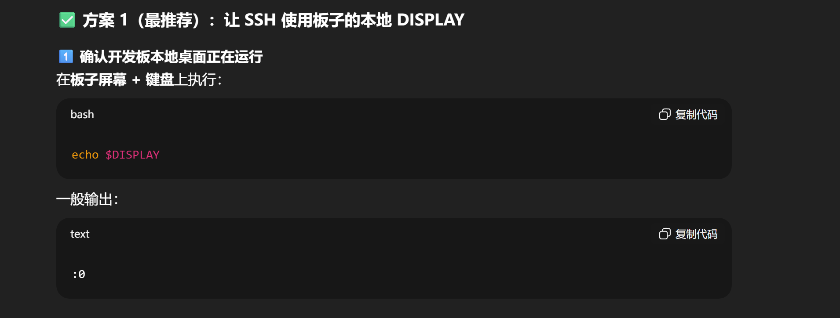
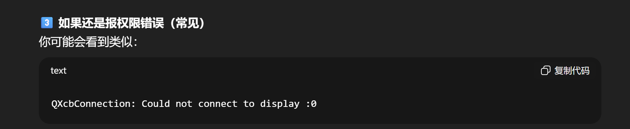
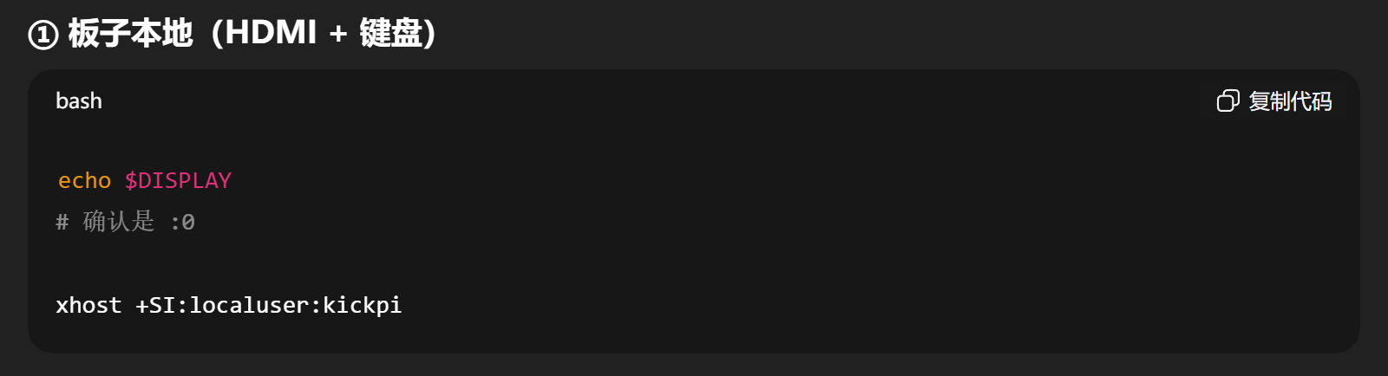
echo $DISPLAY
# 确认是 :0
SSH: export DISPLAY=:0
Local display: xhost +SI:localuser:kickpi

