<https://www.freesound.org/people/broumbroum/sounds/50561/>

select.mp3

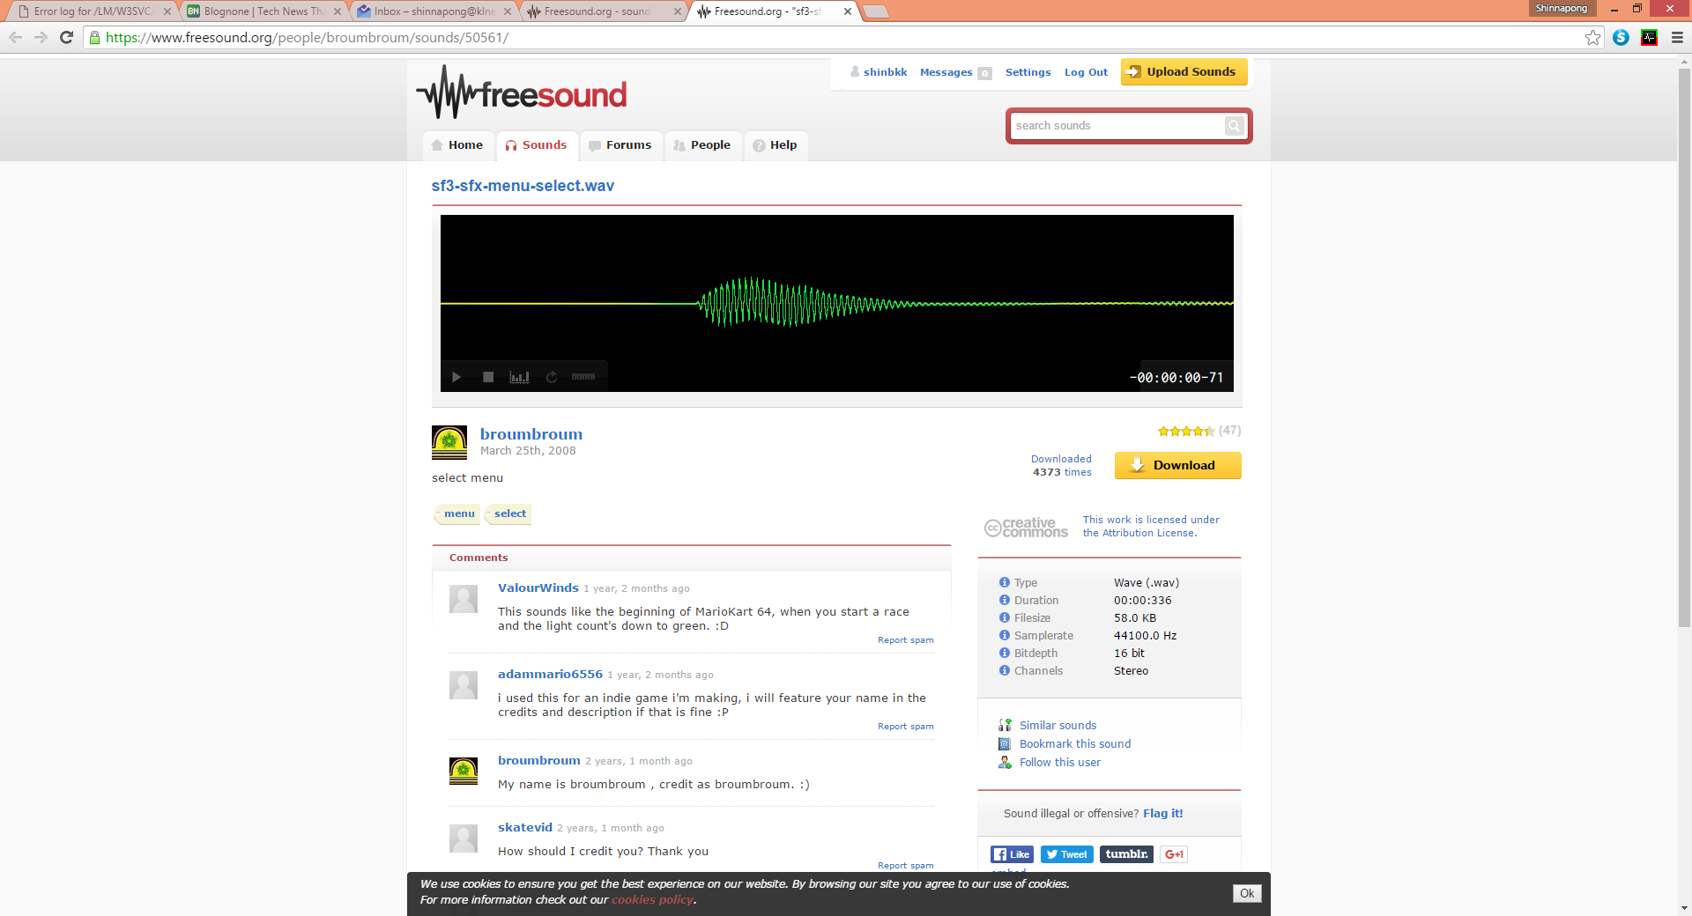

<https://www.freesound.org/people/CGEffex/sounds/101137/>

play.mp3

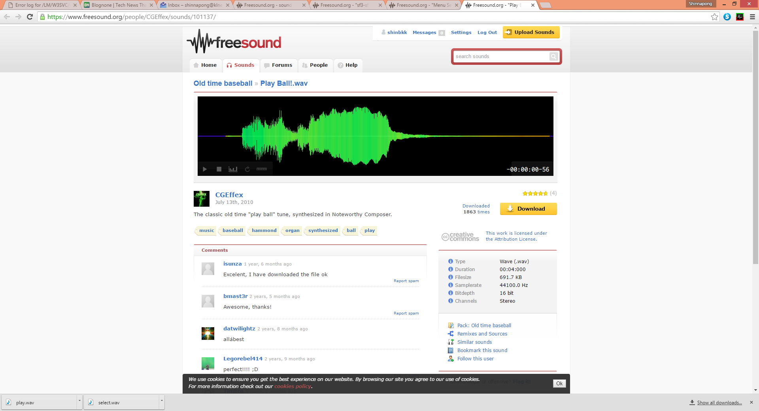

<https://www.freesound.org/people/Deatlev/sounds/257425/>

nextstep.mp3

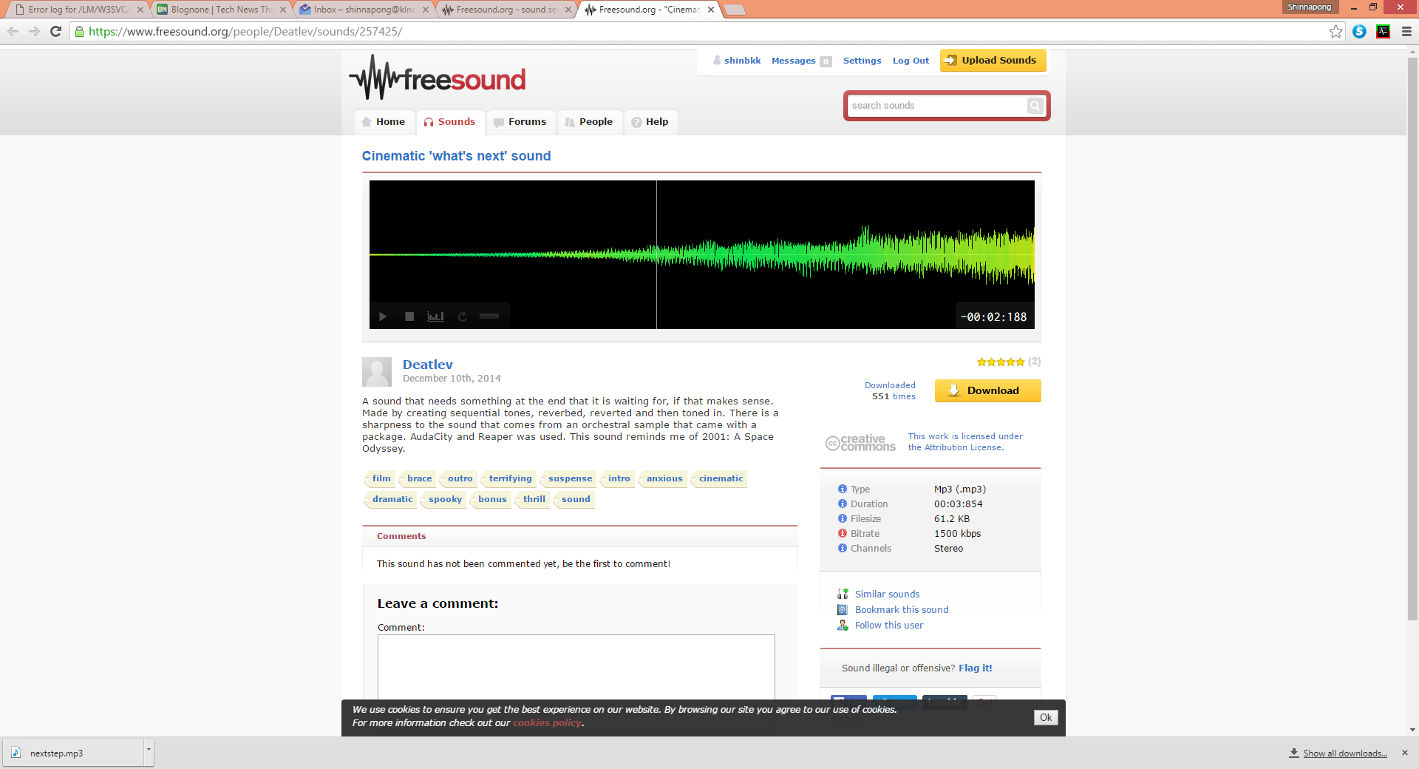

<https://www.freesound.org/people/broumbroum/sounds/50557/>

back.wav

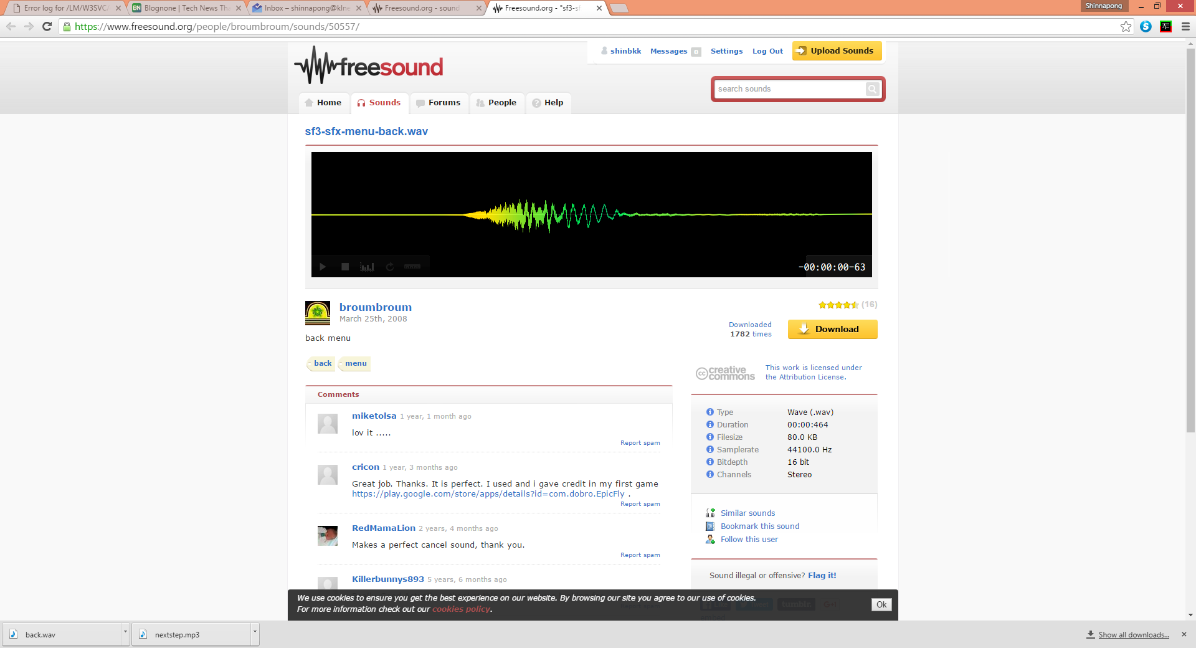

<https://www.freesound.org/people/broumbroum/sounds/50565/>

next.mp3

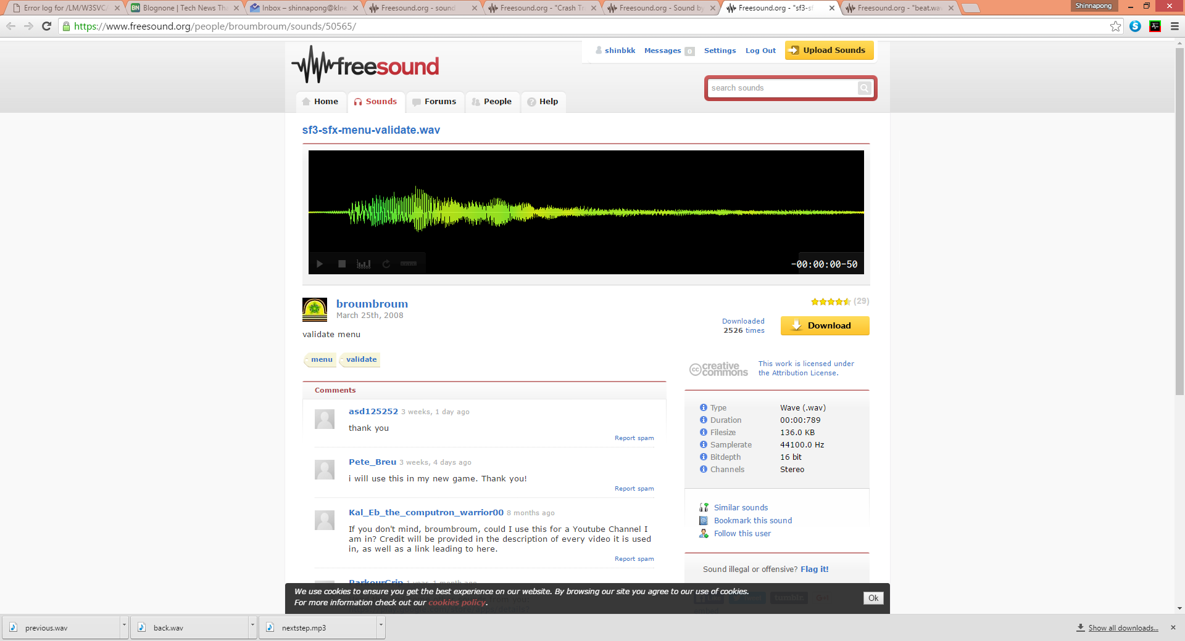

BGMusic Loop

<https://www.freesound.org/people/ShadyDave/sounds/277325/>

bgmusic01

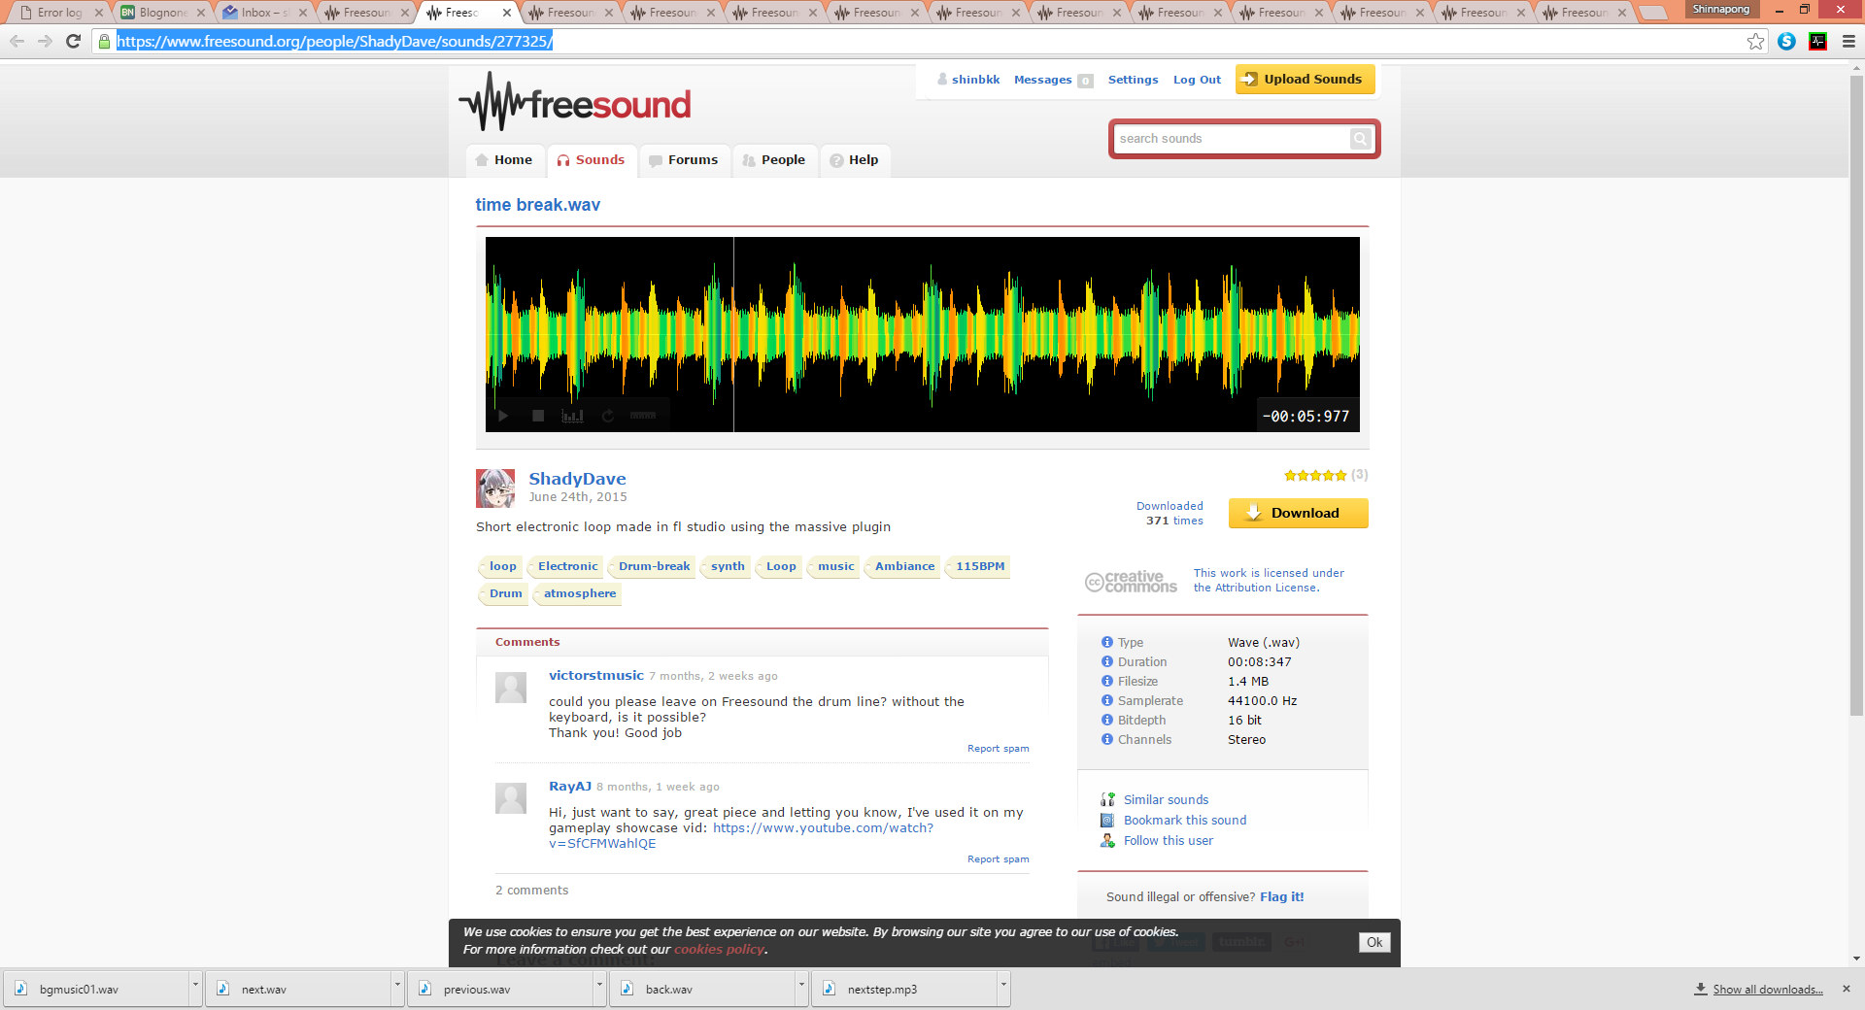

https://www.freesound.org/people/ShadyDave/sounds/320732/

Bgmusic02

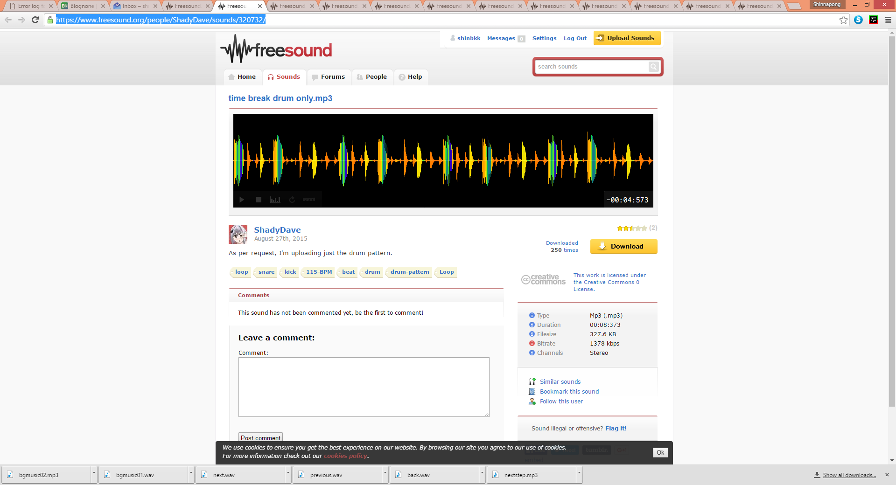

<https://www.freesound.org/people/ShadyDave/sounds/277375/>

bgmusic03

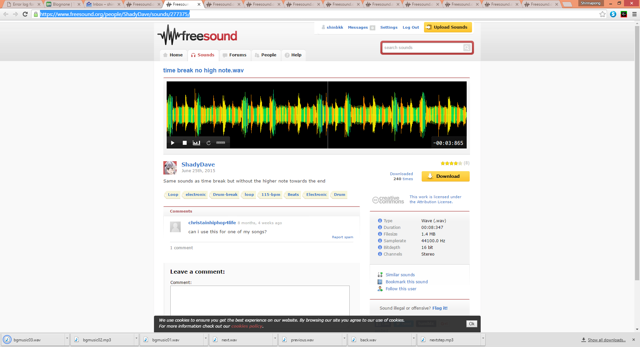

<https://www.freesound.org/people/keinzweiter/sounds/175376/>

bgmusic04

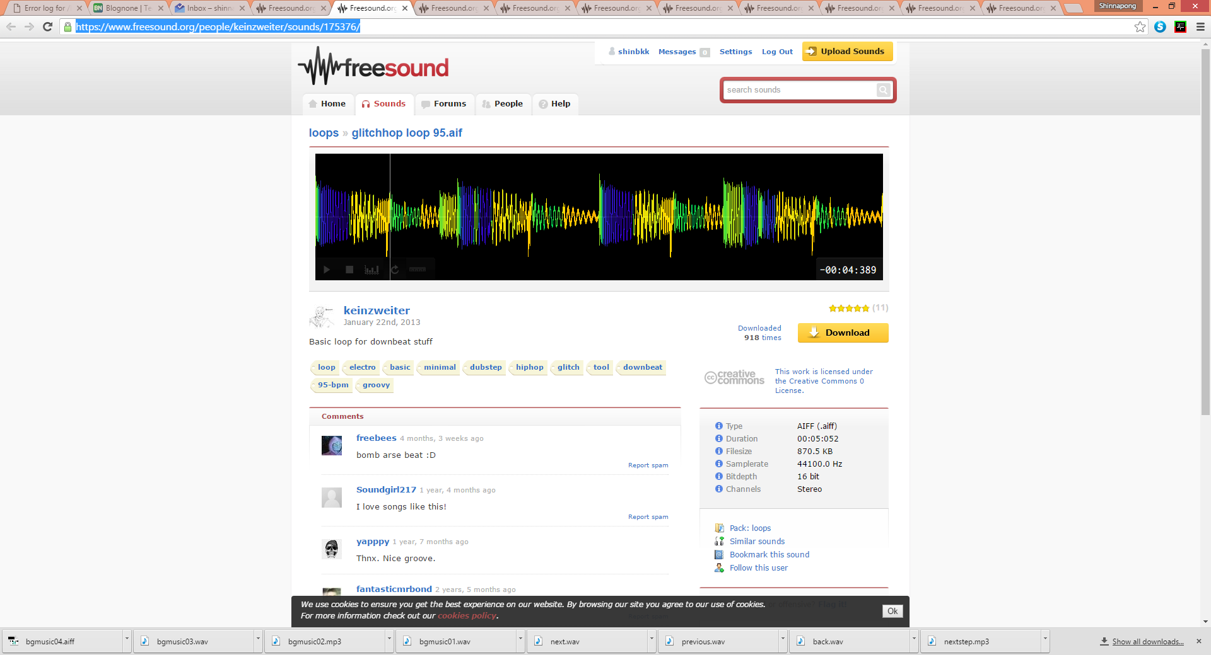

<https://www.freesound.org/people/Jaturo/sounds/171374/>

bgmusic05

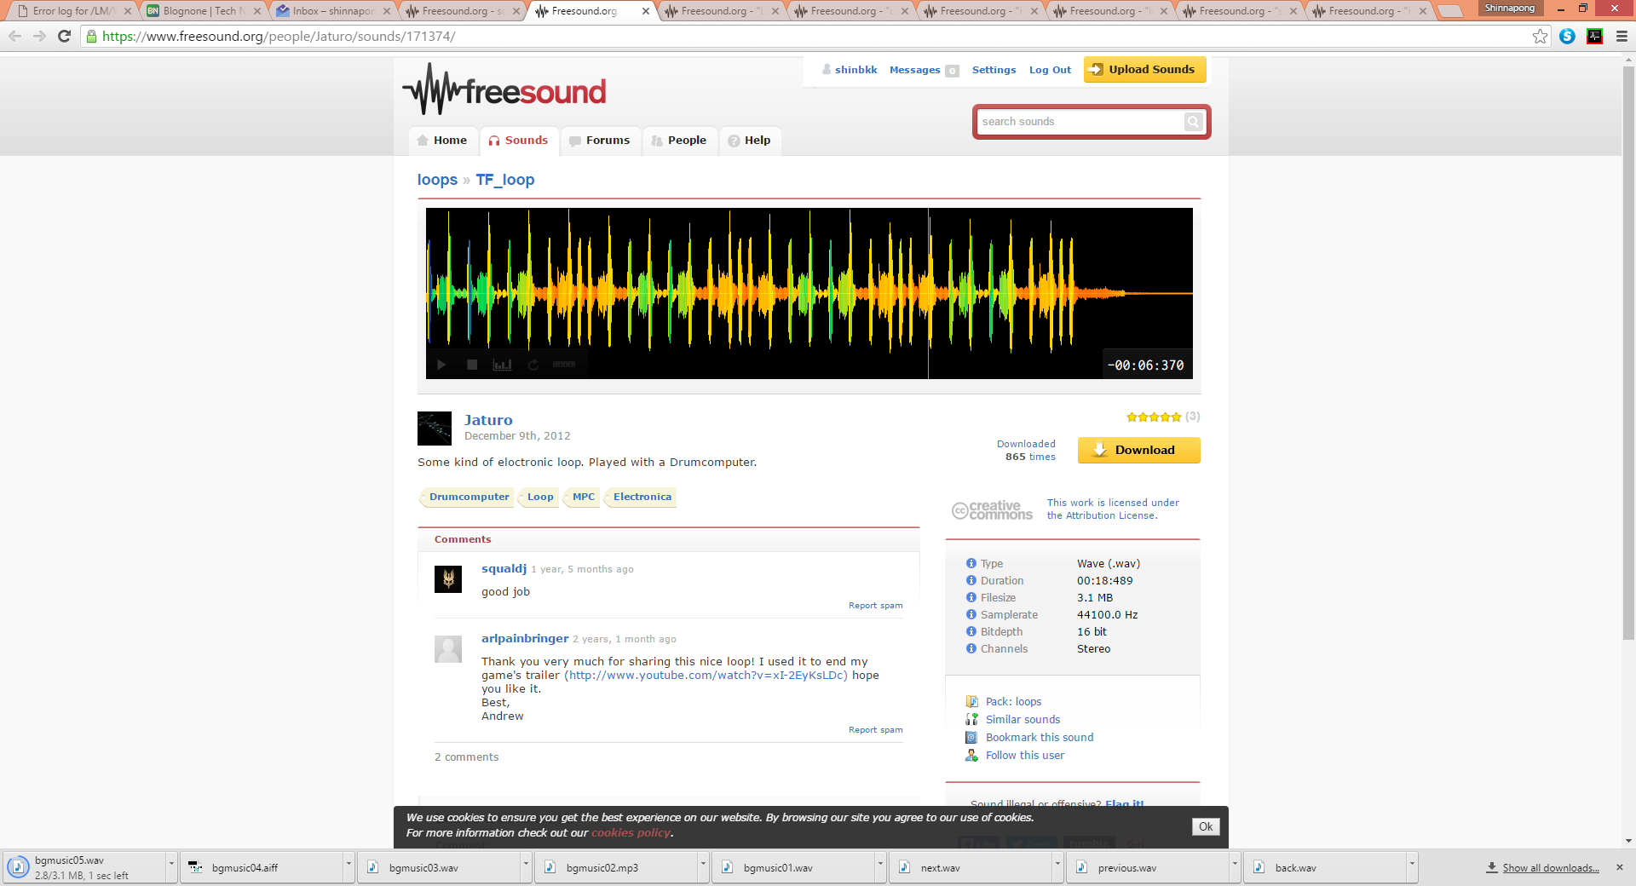

<https://www.freesound.org/people/Goup_1/sounds/195633/>

bgmusic06

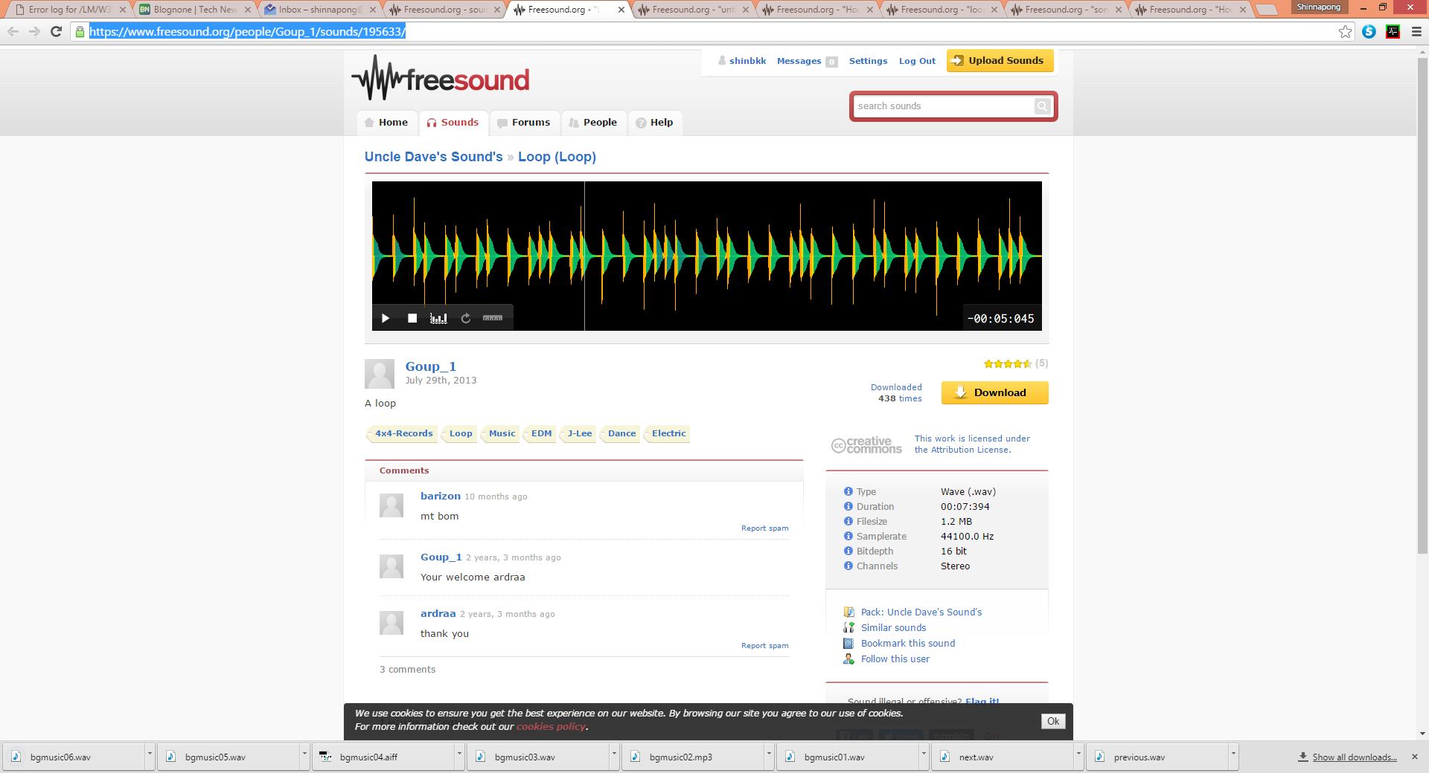

<https://www.freesound.org/people/dayvonjersen/sounds/152479/>

bgmusic07

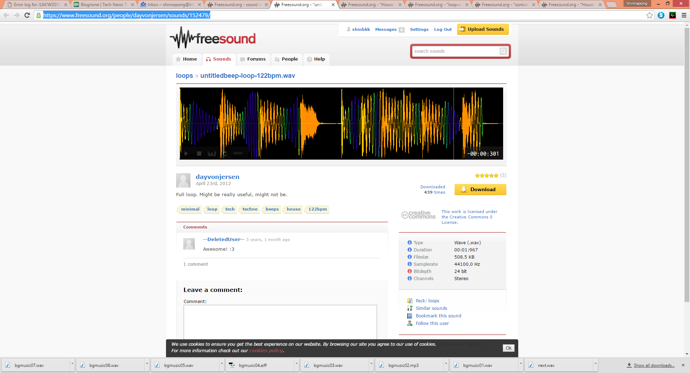

<https://www.freesound.org/people/kwahmah_02/sounds/264110/>

bgmucis08

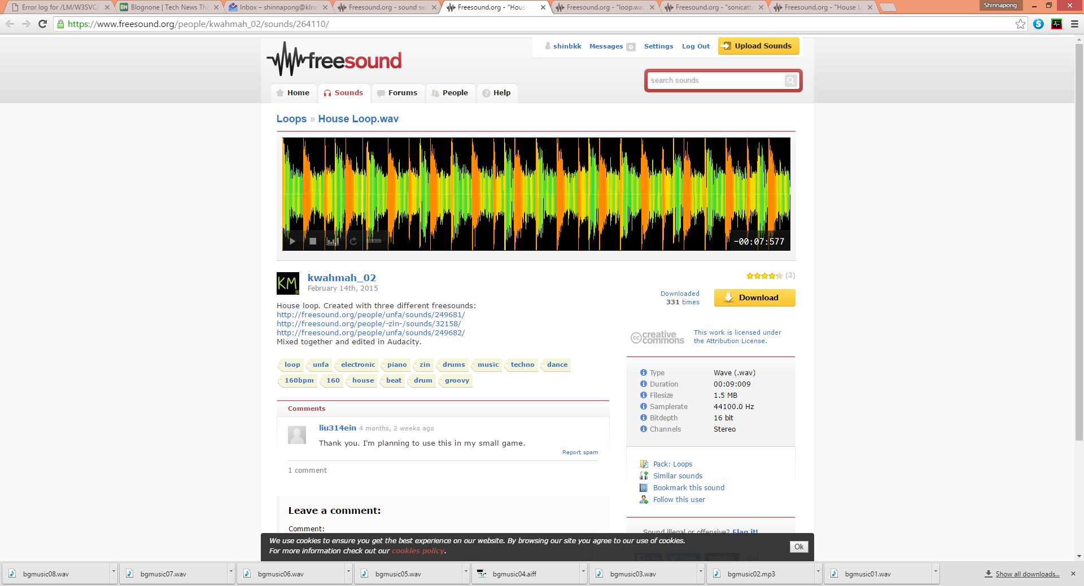

<https://www.freesound.org/people/Xythe/sounds/100870/>

bgmusic09

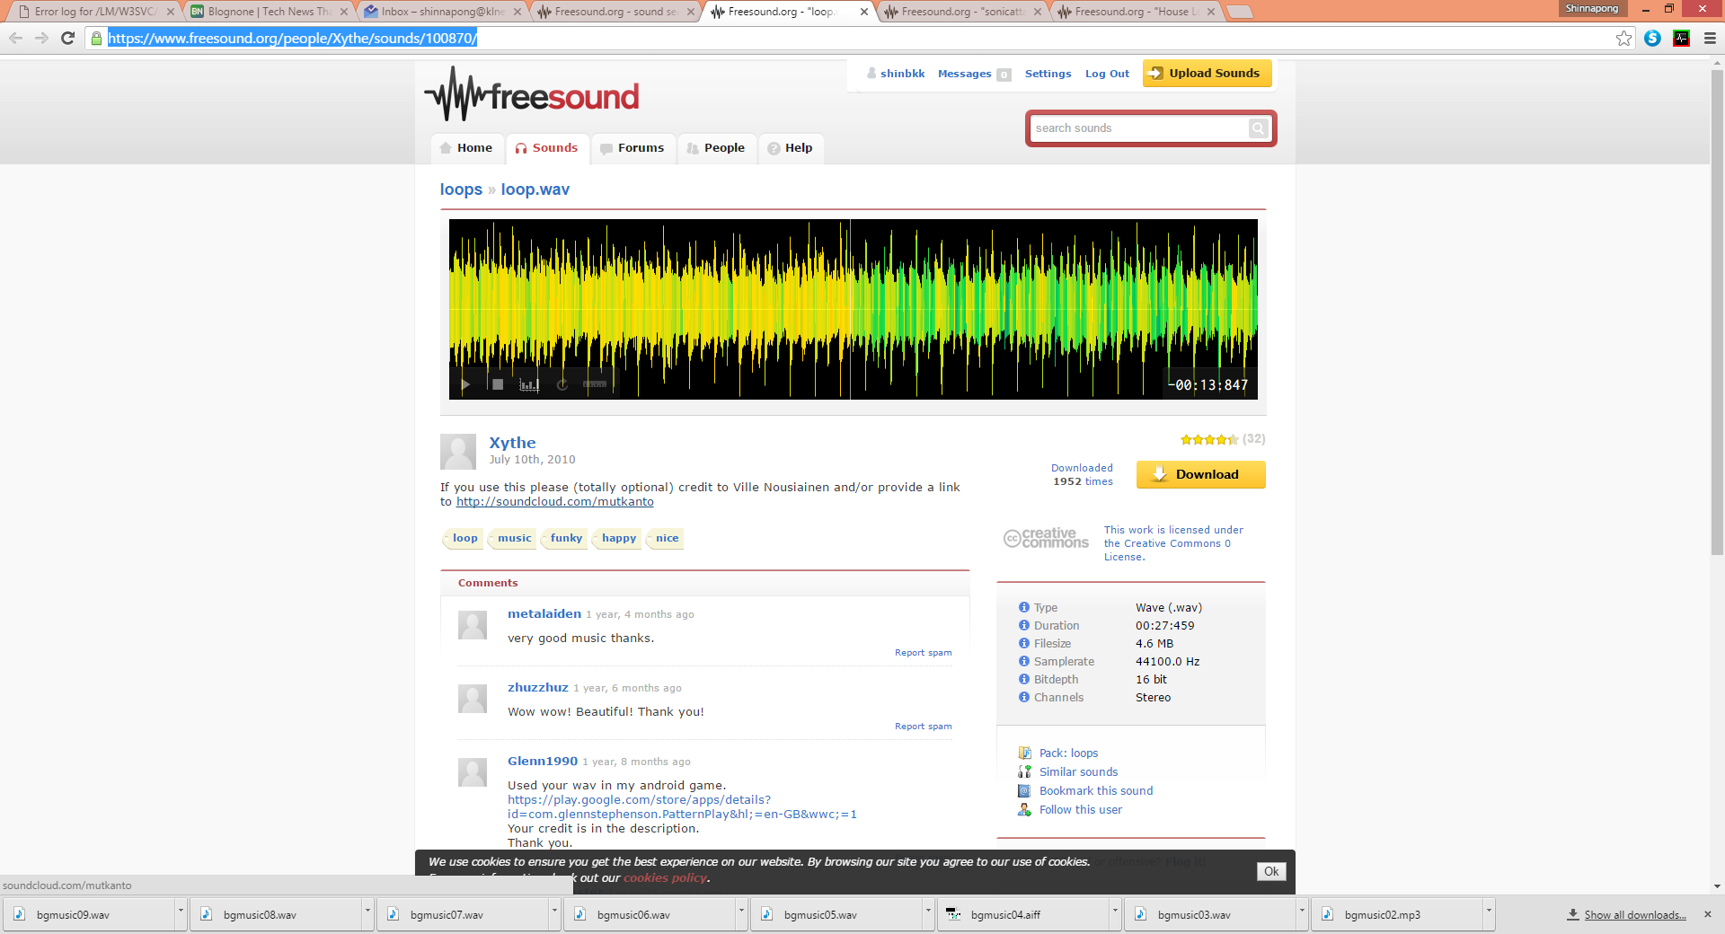

<https://www.freesound.org/people/sirplus/sounds/65230/>

bgmusic10

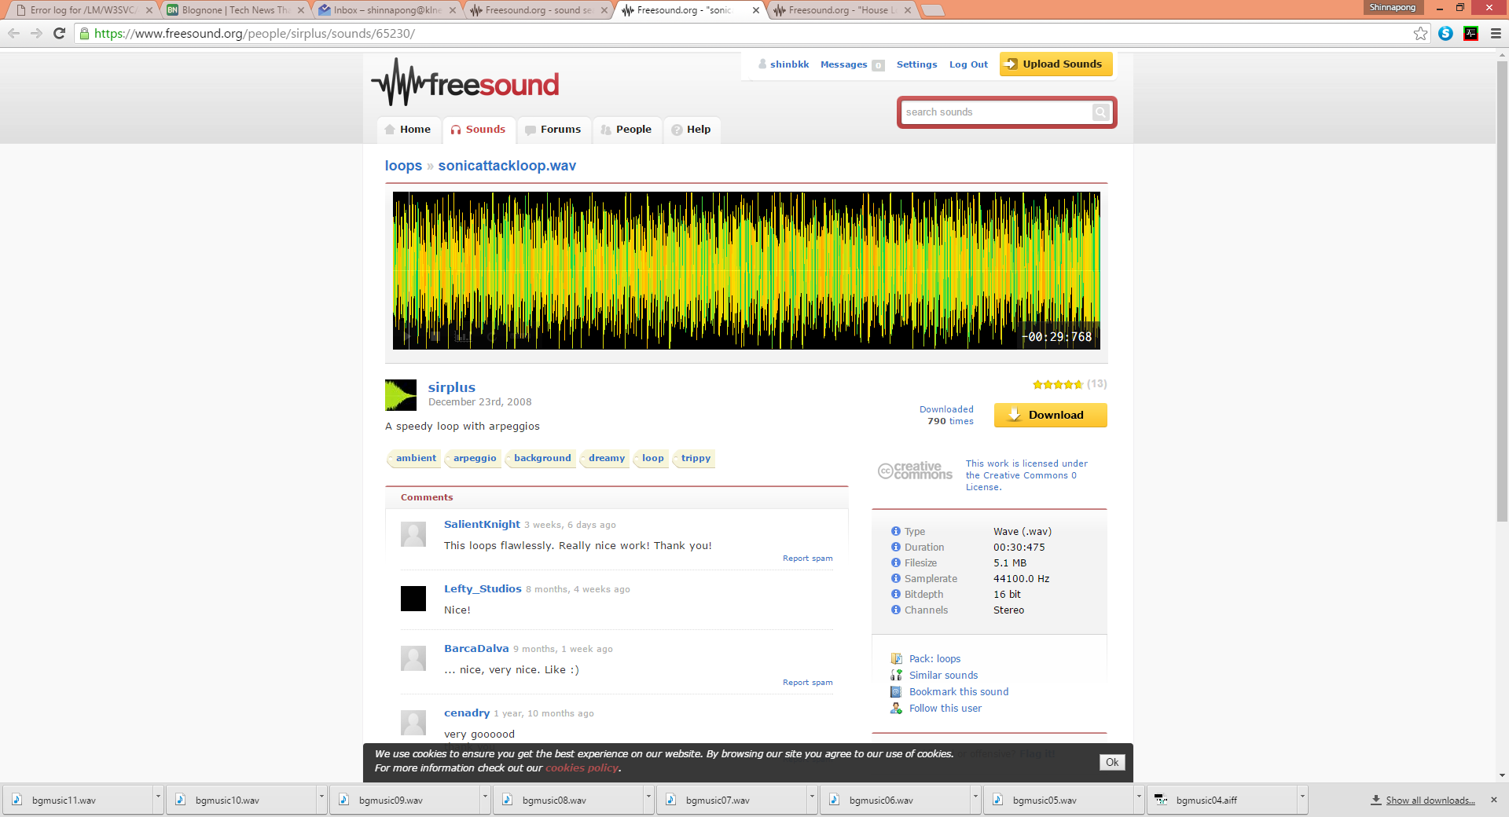

<https://www.freesound.org/people/DirtyJewbs/sounds/145493/>

bgmusic11

