  - UNILAG AI UniPod

Quiver student laboratory handbook
  - Version 1 • 25 October 2026
This course teaches students how to use the UNILAG AI UniPod safely, care for shared equipment and complete a supervised build. Use it at the bench: find the activity, follow its procedure and ask the supervisor when a condition is unclear.
Start with the daily rules. Complete the common induction before joining one of the six build teams. Your supervisor records the equipment and activities you are authorised to use.
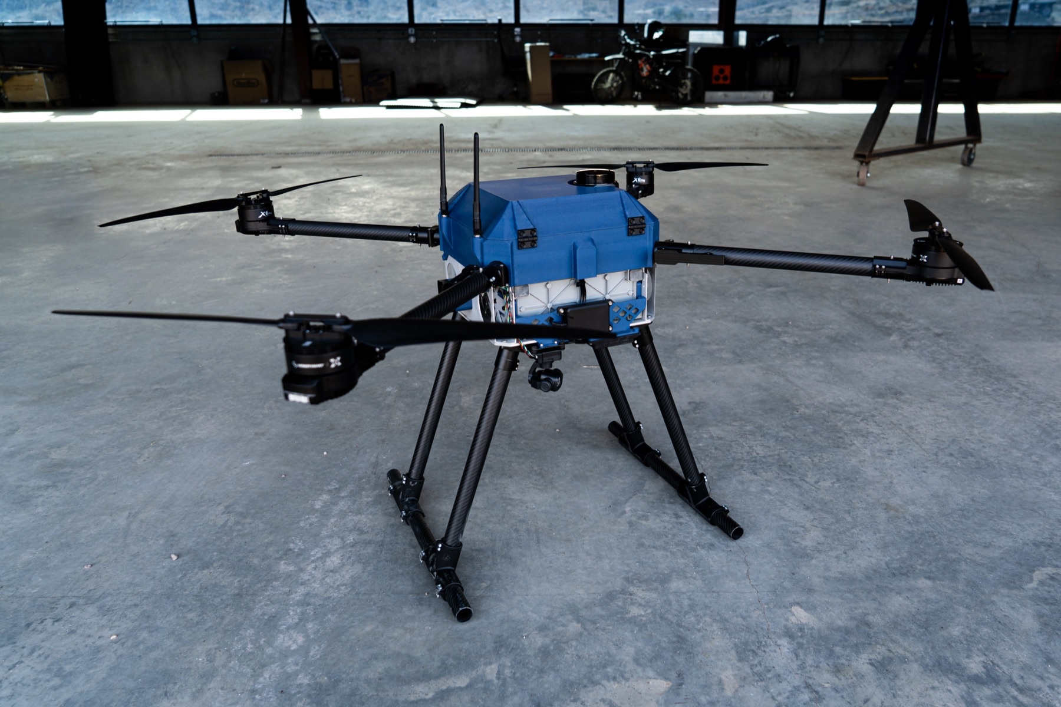
Reference photo shows Quiver aircraft. All propellers must be removed for classroom and bench work.

Find a procedure
Follow the course in order during induction. Later, use this guide or the website search to find the activity you are about to perform.
Start here

Daily lab practice
Daily laboratory rules
Access clothing and responsibilities
Opening the bench and isolating equipment
Components tools and labelled storage
Handling Quiver's TATTU 4.0 battery
Charging with the TATTU TA7200Pro
Computers files and power interruptions
Electrical benches and test instruments
Hand tools soldering and other apparatus
Printing a Quiver part on the Bambu Lab P2S
Handling the aircraft and changing payloads
Damaged equipment and emergency action
Returning items and closing the session

Build and simulate
Understanding Quiver systems
ArduPilot simulation practice
Organising parallel build work
M1 Structure
M2 Powertrain
M3 Power and wiring
M4 Avionics
M5 Payloads and enclosure
M6 Software and simulation
Integration checks and demonstration

Checklists and records
Induction checks and course completion
Individual knowledge check
Daily opening and closing checklist
Issue return and equipment authorisation
Technical work fault and handover records
START HERE

Start here

How to use this handbook
• Read the daily rules before your first session.
• Learn the actual locations of storage, exits, emergency contacts and isolation controls.
• Watch the instructor demonstrate each assigned activity, then practise under supervision.
• Use the opening and closing checklists every day.
• Keep your own evidence and sign-off records, even when working in a team.

What you will be able to do
Identify hazards and isolate equipment; manage tools and components; use authorised lab equipment; explain Quiver's systems; build or configure an assigned subsystem; run a simulation and explain its limits; hand over traceable work.

Find the right section
• Every day: access, opening and isolation, storage and closing.
• At your workstation: batteries, charging and storage, computers, electronics, tools and soldering, 3D printing and aircraft handling.
• If something goes wrong: faults and emergencies.
• Build and demonstrate: systems, SITL, team work, integration and assessment.
• Records: daily checklist, equipment record and technical work record.
EVERY DAY

Daily laboratory rules
These rules apply throughout every supervised Quiver assembly session. A clean bench and a correct return are part of the work, not an optional extra.
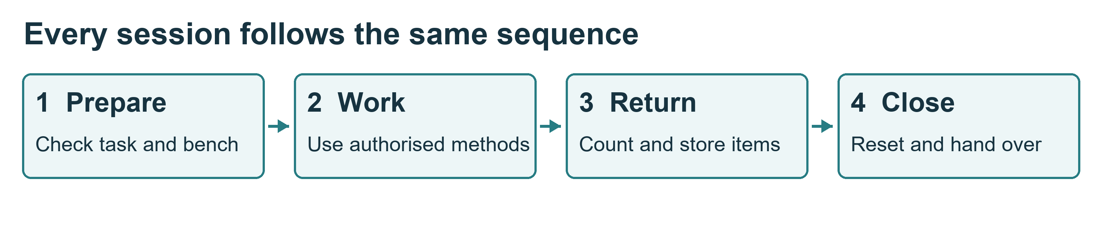

The rules students follow
1. Sign in, identify your supervisor and confirm your permitted task. Do not work alone on batteries, powered hardware or workshop equipment.
2. Inspect your bench and equipment before use. Report damage or missing items before starting.
3. Remove every propeller for bench work. Disarming does not remove electrical energy.
4. Isolate all supplies before changing wiring, tools or payloads. Include USB and test supplies.
5. Use only equipment for which you have recorded authorisation. Keep guards and protection in place.
6. Take components only from the assigned, labelled storage. Record controlled tools and parts issued to you.
7. Keep small parts in trays. Keep usable, unfinished and rejected items separate.
8. Keep food, drinks, bags and loose objects away from work surfaces. Leave exits and walkways clear.
9. Follow the battery procedure. Only the authorised electrical supervisor controls charging, connection and first power-up.
10. Stop for smoke, unexpected heat, unusual movement, a damaged cable or an unclear instruction.
11. Report faults, injuries and near misses promptly. Never return a defective item to usable stock.
12. Before leaving, return and account for items, clean the bench, save files and complete the shutdown or handover.

What good practice looks like
You finish a wiring task with two spare connectors. Check their part numbers, confirm they are clean and undamaged, return them to the correct bins and update the issue record. Put an unidentified connector in the labelled review tray and tell the stores lead. Do not guess its bin.
EVERY DAY

Access clothing and responsibilities
Your outcome: enter the laboratory prepared and recognise the limits of your permission.

Before entering
• Attend the room induction. Sign in using the laboratory's approved record and sign out when leaving.
• Know who is supervising your session. Visitors need permission and an escort.
• Wear closed footwear and clothing suited to the task. Secure long hair, loose sleeves and jewellery.
• Use the eye protection, extraction and other protection specified for your task. Ask for properly fitting equipment.
• Tell the supervisor if fatigue, illness, medication effects or an access need may affect safe work. Arrange support before starting.

What your course pass permits
A general induction permits only the activities specifically recorded by your assessor. Separate authorisation is required for soldering, battery work, powered tests and each printer or machine. Never use another student's authorisation.
Students may inspect, organise, assemble or configure the tasks released to their team. The electrical supervisor controls battery connection and first power-up. The integration lead controls work on the shared aircraft.

Conduct around others
Keep conversation and movement calm around active work. Do not distract someone soldering or operating equipment. Ask before touching another team's assembly or changing a shared computer configuration. Anyone may call STOP; pause and let the supervisor resolve the concern.
Keep emergency doors, switches, alarms and access routes unobstructed. Never rearrange benches, cabinets or fixed equipment without approval.

Find these places during induction
Exit and assembly point; first-aid contact; approved isolation controls; assigned cabinet; battery storage and charging area; fault reporting point; printer stop control; waste collection points.
EVERY DAY

Opening the bench and isolating equipment
Your outcome: check the work area and establish a safe state before touching hardware.

Open the session
1. Read the job sheet and last handover. Confirm the assembly revision, task owner and outstanding defects.
2. Check the bench is dry, stable and clear. Put bags in the assigned location.
3. Inspect tools, plugs, leads and connectors. Report missing guards, exposed conductors or damage.
4. Prepare only the required items. Use a tray for fasteners and a suitable support for the assembly.
5. Identify every possible energy source. Confirm that propellers have been removed.
6. Agree the test or assembly method with the supervisor before starting.

Isolate before changing anything
1. Announce that work is stopping. The authorised operator stops the equipment using its approved procedure.
2. Identify and disconnect each supply that can energise the work: flight battery, USB, bench supply, companion-computer supply and any other feed.
3. Prevent reconnection using the laboratory's isolation and tagging procedure. Label the assembly's state.
4. Follow the specified discharge time. A competent person verifies safe conditions at the approved test points.
5. Start work only when the supervisor releases the isolated assembly.
Never short a capacitor or terminals to discharge energy. A switched-off device may still be connected to a live supply. A disconnected battery still stores energy.

Restart deliberately
Account for tools and loose parts. Check that cables, guards and connections are correct and everyone is clear. Only the authorised person removes the isolation tag and approves reconnection. Other teams must not alter the shared aircraft during a powered test.
EVERY DAY

Components tools and labelled storage
Your outcome: take, track and return items without mixing parts or hiding defects.
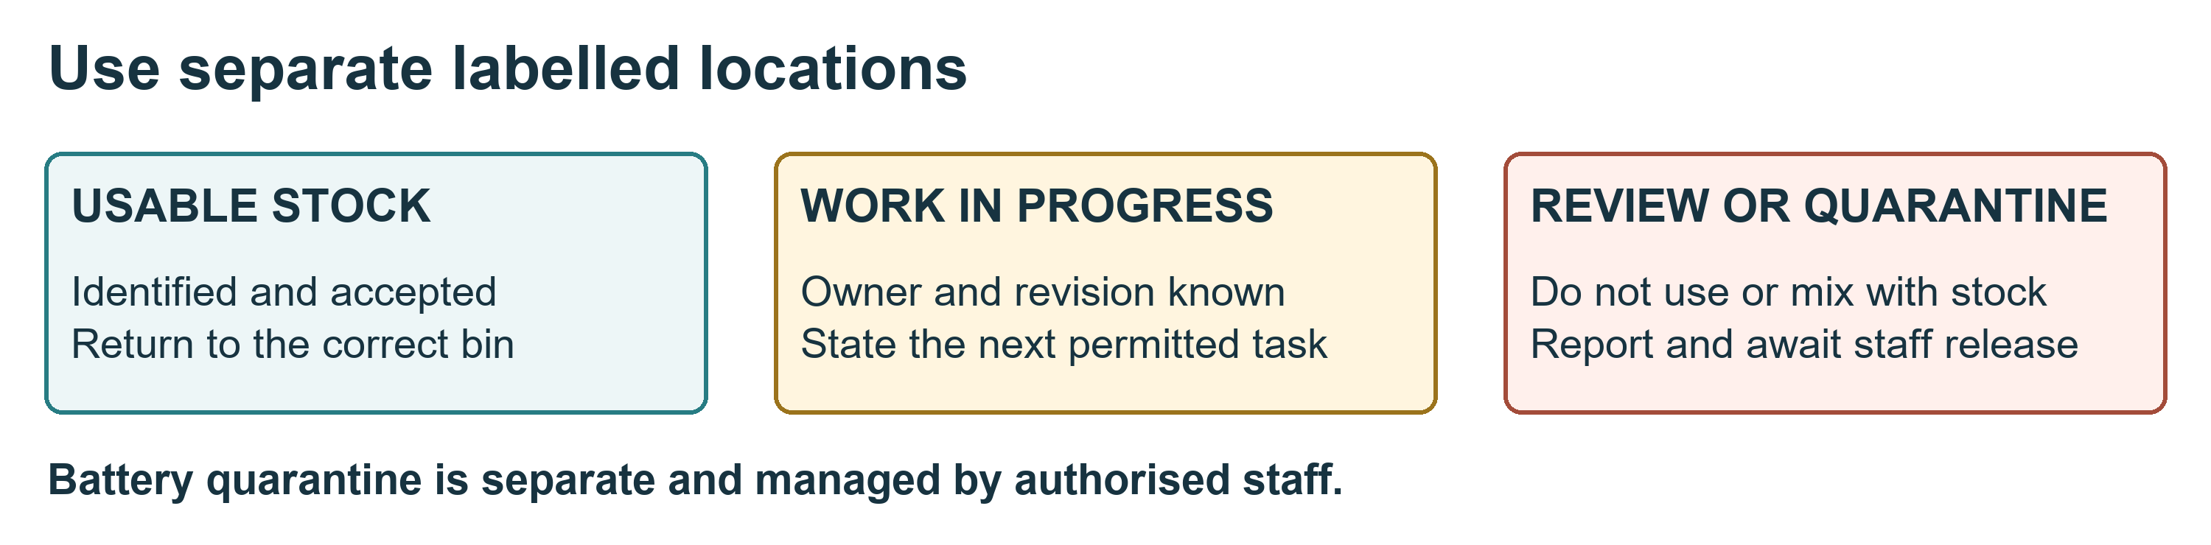

Take an item
1. Read the cabinet and bin labels. Use only storage assigned to your team.
2. Match the part number, size, rating and revision to the job sheet. Look at the container label, not only the appearance.
3. Check condition and quantity. Record controlled items before removing them: item ID, quantity, student, team, date and destination bench.
4. Put small components in a labelled tray or suitable protective packaging. Keep boards in approved ESD packaging.
5. Close drawers and cabinets. Do not leave parts on the floor or in walkways.

Keep three states separate
• Usable stock: identified, accepted items in their correct bins.
• Work in progress: an assembly or part awaiting work or inspection, labelled with team, owner, revision, status and date.
• Quarantine or review: damaged, suspect or unidentified items held outside usable stock.
The diagram shows an example layout. The lab manager assigns the actual locations. Damaged batteries follow the specialist battery procedure; they do not go into the ordinary parts quarantine tray.

Return an item
Remove debris using the approved method; inspect condition; count what remains; return accepted parts to the exact bin; update the issue record. Return leads to their rack and keep probes with their instrument. Report consumables used and tools or components that cannot be accounted for.
Do not mix similar screws, connector variants or component ratings. Do not silently substitute another item. Put uncertain parts in review and ask the stores lead.
EQUIPMENT

Handling Quiver's TATTU 4.0 battery
Your outcome: recognise a suspect battery, protect its terminals and follow the staff-controlled handling procedure.

Before handling
The Battery you will be handling in this course is the TATTU 4.0 HV 53.2 V, 14S, 20,000 mAh, 25C LiPo smart battery selected for Quiver drone. Read the actual label and record its asset ID; do not substitute the 30 Ah pack also listed in the project BOM.
Read the label: 14S means fourteen cells in series; 20,000 mAh is 20 Ah. The nominal energy is 1,064 Wh. 53.2 V is nominal voltage, not a charging target; 25C is a discharge rating, not a charger setting.
Inspect visually without squeezing, dismantling or probing the pack. Look for swelling, cuts, punctures, dents, leakage, unusual heat, damaged insulation and damaged connectors. Report a dropped pack or hard landing even if the outside looks normal.

Move and use an accepted pack
• Use the TATTU carrying handle and the lab's approved handling method. Obtain help for its weight; never lift it by its connector.
• Protect exposed terminals against contact with tools, jewellery and other conductive objects.
• Keep the pack secure and away from heat, moisture and crushing loads.
• Identify Quiver's 2211 battery slider and approved retention. Check fit and clearance with the pack switched off, under supervision.
• Only the authorised person connects or disconnects the flight battery under the agreed procedure.

If a pack is suspect
Stop using it and notify the electrical supervisor. Do not charge it, reconnect it to test it, open it or attempt a repair. Keep people clear. Staff decide whether and how it can be safely isolated and moved to the designated battery quarantine location.
If it hisses, smokes, vents or rapidly heats, raise the alarm and withdraw under the emergency plan. Do not carry an actively failing battery to a cabinet or attempt firefighting.
EQUIPMENT

Charging with the TATTU TA7200Pro
Your outcome: understand the charging and storage controls and recognise when the session must stop.

Before charging
Demonstration pair: the TATTU 4.0 14S 20 Ah smart battery and TATTU TA7200Pro, it's charger. Staff verify the actual pack variant, firmware and matching manufacturer lead. ACES and Molex variants are not interchangeable; never force or improvise an adapter.
The pack manual specifies a 60.2 V charging upper limit (4.3 V per cell). This is a verification limit, not an instruction to configure a generic charger. Do not apply a generic 4.35 V-per-cell LiHV profile.
Use the designated noncombustible, ventilated charging area and approved containment. Keep at least 30 cm between charger and pack, and between packs; staff may require more. Do not improvise a sealed box.
Facilities staff must approve the TA7200Pro supply circuit and cable. Do not power it from a computer extension strip. Record pack ID, charger ID, operator, approved mode and start time.

While charging
• A trained authorised person supervises throughout the charge cycle. Do not leave charging unattended.
• Observe the TATTU communication indicator, voltage, current and temperature. Do not select Fast mode to shorten a class.
• Report any alarm, unexpected heating, swelling, smell or damaged connection.
• For a normal stop, staff hold the Pause/Stop control as the manual directs and verify charging has stopped before disconnecting. For smoke, venting or fire, raise the alarm and withdraw; do not approach to unplug.
• Never change charger settings merely to clear a fault.

Return to storage
Staff apply the TATTU manual's storage and battery-management procedure, record the storage state and set the next inspection date. Do not guess a storage voltage or bypass the smart-battery controls.
Protect terminals individually; separate packs so connections cannot short; record their condition and location. Store only in the approved battery location and containment, away from ordinary components and combustible stock. Damaged packs require separate staff-managed arrangements.
Never put batteries in general rubbish. Staff arrange disposal through the approved route.
EQUIPMENT

Computers files and power interruptions
Your outcome: use the shared workstation responsibly and leave files and equipment ready for the next student.

Begin at the workstation
Inspect the desk, monitor, keyboard, cables and power connections. Report damage, overheating or loose outlets. Keep liquids, food, batteries and soldering work away from computer desks.
Adjust the chair and screen for a comfortable position and take short movement breaks. Keep ventilation openings clear. Use your assigned account and approved software; do not share passwords or disable security controls.

Protect the work
• Save files in the approved team location. Use meaningful names containing the part or task and revision.
• Keep a dated working copy and use the agreed backup or version-control method.
• Record changes to CAD(STEP, STL, Assembly), code and parameters. Preserve the approved baseline.
• Do not delete, rename or overwrite another team's work without agreement.
• Do not connect unknown USB devices or install unapproved software. Ask before connecting equipment to the university network.
• Keep passwords, keys and personal student records out of public repositories.

If power or network service fails
Save work if the system permits. Follow staff instructions for orderly shutdown. A UPS can remain energised after mains power fails; do not open it or repair its wiring.
Do not repeatedly switch equipment on and off. Staff inspect and release affected printers, supplies and other equipment before restart. Check restored files against the last saved revision. Report a failed backup or corrupted file.

Before leaving
Save and back up the work, record its location, close the authorised session and lock or log out. Return shared peripherals and report faults. Do not switch off a shared circuit that supports an active authorised job.
EQUIPMENT

Electrical benches and test instruments
Your outcome: prepare an approved measurement without creating a short circuit or exposing others to energy.

Before a measurement
Identify the quantity, expected range, test points and procedure. Inspect the instrument, leads and probes. The supervisor checks the circuit and setup before power is enabled.
Use only the permitted low-energy training circuit until authorised for other work. No student mains work, UPS repair or improvised high-current testing is included in this course.

Use the correct instrument method
Instrument | Required practice
Multimeter | Confirm sockets, function and range before contact. Use resistance or continuity only on isolated circuits. Never place a current-mode meter directly across a battery or supply.
Bench supply | The supervisor approves voltage, polarity and current limit. Keep the output off while making or changing connections.
Oscilloscope | Confirm the ground-reference arrangement before connecting. A ground clip can short a circuit. Use approved points; never defeat protective earth or probe mains.
ESD equipment | Use the approved setup for isolated electronics. A wrist strap prevents some static damage; it is not protection from electric shock.

Record and return
Write the expected and observed result with units, instrument identity and circuit conditions. Stop for a reading outside the approved acceptance criteria. Do not adjust a result or bypass protection to obtain a pass.
After the authorised shutdown, remove connections safely, return leads to their racks and keep probes with the instrument. Leave controls and leads in the state specified by the lab procedure.
EQUIPMENT

Hand tools soldering and other apparatus
Your outcome: choose the correct tool, use the authorised method and return it in a safe condition.

Hand tools
Check handles, jaws, cutting edges and insulation. Use the correct size and type; do not improvise a screwdriver as a lever. Secure the work and keep fingers clear of cutting and pinch points. Collect cut wire ends and fasteners so they cannot enter the aircraft.
Use only documented torque and adhesive requirements. If a value or curing time is missing, stop and obtain the engineering owner's instruction. Do not invent a setting.

Soldering
Separate authorisation is required. Use the approved local fume extraction, eye protection, stable iron stand and work support. Work on isolated circuits. Keep the hot tip and lead clear of cables and people; never leave a hot iron loose on the bench.
The instructor demonstrates a sound training joint and the inspection method. Allow joints to cool without disturbance. Wash hands after handling solder and workshop materials. Collect solder waste through the approved route.

Chemicals and cleaning
Read the label and safety data sheet before using an adhesive, solvent or cleaner. Use the specified ventilation and protection. Keep containers labelled and closed. Do not decant any chemical (e.g., flux or epoxy) into drink bottles, and do not combine unknown substances.

Specialist equipment
Drills, saws, laser cutters, CNC machines, resin printers and composite cutting or sanding require separate training, controls and authorisation. General induction does not permit their use. Dusty fabrication belongs in its assigned area, away from computers and electronics.

Return and report
Clean tools by the approved method, inspect them and return them to the labelled location. Tag and report faults; do not return a defective tool to the ordinary rack. Never remove guards or repair mains equipment.
EQUIPMENT

Printing a Quiver part on the Bambu Lab P2S
Your outcome: prepare an approved job, observe it safely and inspect the finished part.
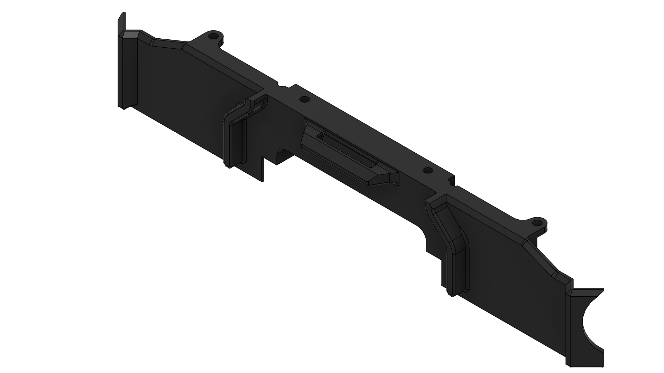
Training example: Quiver 2313 battery connector PCB cover. Project image; inspect the approved CAD revision before printing.

Before pressing print
1. Identify the Bambu Lab P2S, its pause/stop controls and trained supervisor. Check cables, build area and enclosure.
2. Confirm the approved ventilation and material. Air conditioning alone does not establish control of printing emissions.
3. Open the released 2313 model in Bambu Studio. Select P2S and the installed nozzle, build plate and filament. The BOM specifies PETG-CF; staff must verify material and nozzle compatibility.
4. Check orientation, supports, build-volume fit and the sliced Preview. Save a .3mf job with the part revision and profile. Staff approve it before printing. Never scale a part merely to fit.

During the job
Watch the first layer. Keep hands clear of the P2S toolhead, heated bed and moving mechanisms. For poor adhesion or a filament tangle, pause/stop and call the supervisor; do not reach inside during motion or defeat interlocks. Nozzle changes require separate training.
For smoke or fire, raise the alarm and withdraw. Do not open the enclosure to investigate. An unattended job requires the laboratory's explicit written arrangement.

After the job
Allow the bed and part to cool. Remove the plate/part using its approved method. Inspect the 2313 mounting holes, edges, warping and layer bonding against the drawing.
Label accepted parts with identity and revision; put rejected parts in review. Appearance alone cannot prove flight suitability. After a power interruption, a technician releases the printer and the instructor reviews any resumed structural print.
EQUIPMENT

Handling the aircraft and changing payloads
Your outcome: move and work on the assembly without exposing people to rotating parts, trapped fingers or unintended power.

Before moving the aircraft
Identify its weight, centre of gravity and approved lifting points. Clear the route and prepare a stable stand. Use the required number of people or lifting aid; do not lift by propellers, cables, sensors or unsupported covers.
The supervisor confirms isolation. Remove and account for every propeller before bench work. Support the aircraft so it cannot tip or fold unexpectedly.

Folding arms and mechanical work
Inspect joints and latches using the approved drawing and method. Keep fingers clear of hinges and pinch points. Check cables through the permitted movement range. Never force a misaligned joint or alter a structural part to make it fit.
Protect openings against loose fasteners and wire offcuts. Count tools before closing covers. Record incomplete fasteners, curing joints and restrictions on the handover label.

Payload changes
1. Obtain the integration lead's release and establish safe isolation.
2. Support the payload before releasing the attachment latch or connector.
3. Identify the approved attachment, power and data interfaces.
4. Fit the inert training payload and inspect retention, clearance and cable strain relief.
5. Record its mass, mounting position and outstanding checks.
This course requires isolation for every swap. A quick-release interface does not establish that live electrical connection is permitted. Fit and retention alone do not prove a payload is approved for flight.

Powered checks
Only the integration lead's authorised operator energises the shared aircraft. Other teams remain clear and do not change wiring or parameters. Follow the written stop plan. If a motor moves unexpectedly, call STOP and step clear; do not grab it.
EVERY DAY

Damaged equipment and emergency action
Your outcome: stop unsafe work, prevent reuse of defective equipment and give a useful report.

An ordinary fault without immediate danger
1. Stop the activity. Make the area safe only within your training and authority.
2. Tell the supervisor promptly. Do not reconnect an item to see whether the fault repeats.
3. Mark the item DO NOT USE with its asset ID, observed fault, date and reporter.
4. The supervisor isolates it and assigns the correct quarantine or repair location.
5. Record the event and its effect on other assemblies. Only authorised staff release it back to service.
Do not return suspect tools, boards or cables to usable stock. Do not place a damaged battery in the ordinary equipment quarantine area.

Smoke venting or fire
Raise the alarm, withdraw and evacuate by the safe route. Go to the assembly point and follow staff instructions. Do not carry burning or venting batteries, open an affected enclosure, attempt firefighting or re-enter to retrieve equipment.
If a fire blocks your exit and you must fight your way out, use a CO₂ or Dry Powder extinguisher:
Twist and pull the safety pin to snap the plastic seal (do not squeeze the handles while pulling).
Aim at the base of the fire, squeeze the lever, and sweep from side to side.

Injury or electric shock
Alert staff immediately. Keep clear of electrical hazards. Do not touch a person still in contact with an electrical source. Trained responders isolate the danger and provide first aid. Use the posted university emergency process.

Report near misses too
Report a dropped pack, unexpected motor movement, wrong connector, overheated lead or missing guard even when no injury occurred. Describe what you observed, what was connected, who was informed and what remains isolated. Do not assign blame or conceal an error.
EVERY DAY

Returning items and closing the session
Your outcome: leave a traceable, safe work area and an unambiguous handover.

Close in this order
1. Stop work in time. Save the final task state and identify incomplete work before the session ends.
2. Shut down or hand over. The authorised operator follows the equipment procedure. Do not interrupt a shared supply, required extraction or active job without agreement.
3. Isolate the assembly. Label the energy state and outstanding hazards. Staff control flight-battery handling.
4. Count and return. Account for tools, components, leads and consumables against the issue record.
5. Inspect and separate. Return only accepted items to usable storage. Label unfinished work; report and segregate suspect items.
6. Clean and reset. Collect fasteners, wire ends and approved waste. Use the correct cleaning method; do not blow hazardous dust around the room.
7. Save and report. Back up files, record revisions and tell the next responsible person what is complete and restricted.
8. Obtain the close check. The assigned checker or supervisor inspects the bench. Sign out.

A useful handover says
Assembly and revision; owner and next operator; work completed; evidence location; current power and isolation state; open faults; items missing; next permitted task; person accepting the handover.
“Finished” or “should be okay” is not enough. If a tool is missing, report it before the aircraft is closed or released. If a job continues, name the authorised person taking responsibility.

Example
The frame is assembled but adhesive is curing. Label the assembly with the product and procedure reference, recorded application time and the specified release time. State that loading or movement is restricted until the supervisor releases it.
BUILD

Understanding Quiver systems
Your outcome: identify the major subsystems and explain how power and commands reach the motors and payload.
Quiver combines an airframe, propulsion assemblies, custom interface and power boards, flight-control hardware, sensors and software. This course uses the documented project as a reference; the issued kit must be checked against the approved release or current devkit.
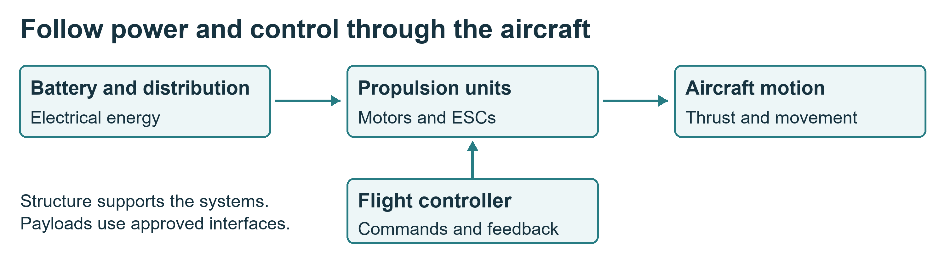

Recognise the components
• Structure: frame, landing gear, arm attachments and supporting mounts.
• Powertrain: motors, electronic speed controllers or integrated propulsion units, arm joints and the removed propellers.
• Power and wiring: battery interfaces, distribution, protection, connectors and harnesses.
• Avionics: flight controller, sensors and communication hardware.
• Payloads: bottom and side attachment hardware, enclosure and associated electrical/data interfaces.
• Software: flight firmware, parameters, ground software and simulation.
The Pix32 V6 is a flight-controller module, not a single chip. ArduPilot(Arducopter) is firmware that runs on Pix32 V6 hardware; in SITL, flight-control software runs on a computer with a simulated vehicle.
Note: run with Quiver flight configs.

Find the right project file
Use the selected BOM and manufacturing drawings to identify parts. Use harness drawings and board documentation for connector identity and pinout. Use firmware documentation only after the physical board and firmware target have been verified.
The reference repository includes attachment-interface CAD under src/quiver/supporting_structure/attachment_interface. A drawing image is not a load rating or an approved manufacturing specification.
BUILD

ArduPilot simulation practice
Your outcome: run a repeatable flight-mode exercise and explain its limits.
SITL means software in the loop. It lets you practise with flight-controller software and a simulated aircraft. It can teach modes, telemetry and mission logic. It does not establish Quiver's real endurance, payload capacity or handling without a validated physical model.

Prepare the session
Your instructor will provides a tested installation, launch instructions, vehicle model, Quiver aircraft flight configurations and parameter baseline. Record firmware version or commit, model, parameter-file revision and launch command.
Confirm that only simulator endpoints are connected. Disconnect real-vehicle connections and label the session SIMULATION. Do not upload settings to shared hardware during another team's work.

Fly the common exercise
1. Start the approved scenario. Check simulated position, home, mode and warnings.
2. Follow the instructor's arm and take-off procedure.
3. Hold position, make a short commanded move and observe altitude, speed and mode changes.
4. Use the configured return procedure, then land.
5. Save the log and a screenshot. Explain one unexpected result or warning.
6. Repeat individually as operator while a partner observes.
Guided follows supplied commands. Loiter attempts to hold position and altitude when the required estimates are available. RTL follows configured return behaviour. Land descends according to the configured landing behaviour.
BUILD

Organising parallel build work
Your outcome: know what your team owns and what must be agreed before it connects to another team's work.
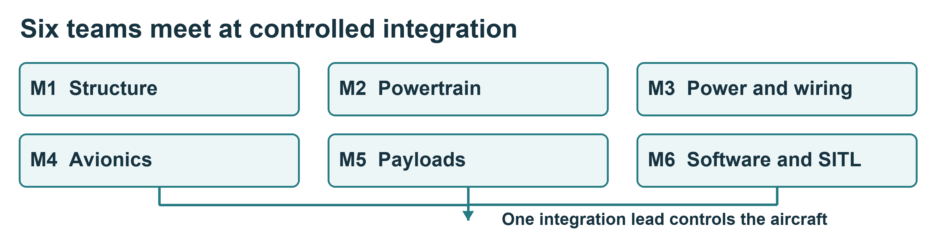

Six team responsibilities
Team | Main work | Handover
M1 Structure | Frame, landing gear and fixed mounts | Fit and mounting records
M2 Powertrain | Motor arms, joints and propulsion units | Inspected assemblies and motor map
M3 Power and wiring | Power interfaces and harnesses | Pinout, polarity and inspection evidence
M4 Avionics | Controller, sensors and communications | Hardware and port map
M5 Payloads and enclosure | Attachments, quick release and covers | Retention, mass and interface record
M6 Software and SITL | Simulation and configuration | Repeatable setup, logs and limitations

Agree the work before starting
Teams of two to four where supervision permits. Rotate builder, checker and recorder. The checker must be a different person from the builder in your team.
Record the approved revision, required parts, task sequence, hazards, acceptance criteria and interfaces. Sending and receiving teams agree dimensions, connector identity, pinout, power/data requirements and test method. Missing values go to the engineering owner.
Teams may work on isolated subsystems in parallel. The integration lead controls the shared aircraft. No team may connect a supply, change wiring or upload settings during another team's work.

Daily handover
Please after the days work state what was completed, where the evidence is saved, current isolation state, open defects and the next permitted activity. Keep individual evidence as well as the team record.
Before building: the instructor accepts the work plan and the applicable equipment authorisations. Open the work card for your team.
BUILD MODULES

M1 Structure
Deliverable: a correctly assembled frame with secure, accessible mounting points.

Prepare
Identify 1111 upper plate, 1112 middle plate, 1113 lower plate and 1310/1320 landing-gear tubes against the released drawings. Collect the fastener list, work support and inspection tools. M1 owns the fixed structure; coordinate arm and payload interfaces with M2 and M5.

Work sequence
1. Inspect parts for damage and check the required dimensions.
2. Lay out fasteners in labelled trays. Record quantities issued.
3. Assemble in the specified order using the documented fasteners, torque, adhesive and curing requirements.
4. Check alignment, retention, clearance and cable routes.
5. Invite receiving teams to check their interfaces before access becomes restricted.
6. Record the assembly state and any limits on moving or loading it.

Stop and ask
Stop for a drawing mismatch, damaged member, missing value or forced fit. Do not drill, thin, bend or cut structural parts without engineering approval. Composite work needs separate dust controls and training.

Acceptance checklist
☐ Parts and revisions match the approved work package.
☐ Fasteners and joints meet the documented assembly and inspection method.
☐ Mounts, landing gear and cable routes are checked.
☐ M2, M4 and M5 have reviewed the applicable fit.
☐ Defects, curing restrictions and pending checks are recorded.
☐ Tools and spare components have been accounted for and returned.
BUILD MODULES

M2 Powertrain
Deliverable: identified propulsion assemblies with accepted mounts, joints and cable protection.

Prepare
Identify the 3111 Hobbywing XRotor X6 Plus motor/ESC units, 1412 arm tubes and 1411 folding connectors. Compare labels with the approved motor-position map. Keep 3112 MFP 24×8.0 CW and 3122 CCW propellers removed, labelled and separately accounted for.

Work sequence
1. Inspect components and identify their aircraft positions.
2. Check folding joints, locks and retention using the specified method.
3. Fit motors and associated parts with documented fasteners and clearances.
4. Route and protect cables against pinching, abrasion and tension.
5. Check the permitted movement range on the isolated assembly.
6. Label each unit and record required motor direction for later authorised checks.

Stop and ask
Do not connect a battery or run motors at the team bench. Do not use generic ESC calibration instructions without verifying compatibility with the issued propulsion type. Stop for damaged wiring, uncertain orientation, a loose joint or a forced fit.

Acceptance checklist
☐ Propellers absent and accounted for.
☐ Motor identity and position match the approved map.
☐ Mounts, joints and locking features inspected.
☐ Cables protected through the full permitted movement.
☐ M1 accepts fit; M3 and M4 accept power and control interfaces.
☐ Powered rotation checks are clearly marked pending until authorised.

Show your understanding
Demonstrate the joint inspection and identify a possible pinch point. Explain why a secure mount does not prove correct motor configuration.
Submit: labelled motor map, mechanical inspection, photographs and pending-test list. The mechanical supervisor accepts the assembly; the integration lead schedules any powered checks. Close with the standard inventory and bench reset.
BUILD MODULES

M3 Power and wiring
Deliverable: identified harnesses and power connections with independent inspection and test evidence.

Prepare
Identify 3310 Main PCB, 3320 Battery Connector PCB and the released harness drawings. Use HAR-0008 ESC signal FR for the continuity demonstration. Obtain the specified wire, terminals, crimp tool and instruments. Confirm pin numbering and connector viewing direction; the TATTU pack stays disconnected.

Work sequence
1. Match connector and wire identities to the approved drawing. Never infer function from colour alone.
2. Label both ends as specified. Keep unused terminals and offcuts separate.
3. Assemble or inspect only the harnesses released to your team.
4. Check crimps, insulation, retention, strain relief, routing and protection.
5. On isolated equipment, perform the approved point-to-point, polarity and unintended-connection checks.
6. Record expected and actual results with units and instrument identity.
7. Obtain independent electrical review before installation or power-up.

Stop and ask
Stop for ambiguous pinouts, damaged insulation, wrong parts, a failed test or missing acceptance criteria. Do not improvise high-current joints, board repairs or test methods. The electrical supervisor controls battery connection and first power-up.

Acceptance checklist
☐ Pin identity and polarity match the drawing.
☐ Crimps, insulation, retention and cable routes are accepted.
☐ Test results are traceable to the harness revision.
☐ Receiving teams have confirmed their supply and connector requirements.
☐ No unresolved electrical defect remains before release to integration.
☐ Scrap and suspect parts are separated from usable stock.

Show your understanding
Demonstrate a check on an unpowered training harness. Explain how reversing the drawing's viewing direction could produce an incorrect connection.
Submit: connector schedule, inspection/test record, photographs and rework history. The electrical supervisor records acceptance; a student signature alone does not release the assembly for energisation.
BUILD MODULES

M4 Avionics
Deliverable: installed flight-control, sensor and communication hardware with a verified port and configuration record.

Prepare
Identify the 3332 Holybro Pix32 V6, 3330 flight-controller PCB and 3312 Raspberry Pi 5 using physical labels and the approved port map. Pix32 V6 is the flight-controller board; the Raspberry Pi is the companion computer. Verify the actual hardware before selecting firmware.

Work sequence
1. Match controller, carrier and sensor identities to the approved hardware record.
2. Confirm orientation, mounting method, clearances and cable routes.
3. Fit and label the authorised connections while isolated.
4. Review every power source with M3, including USB and companion-computer feeds.
5. Agree the firmware target, version and parameter baseline with M6.
6. List required calibrations, communication checks and integration conditions.

Stop and ask
Stop for an uncertain board target, incorrect orientation, damaged port or conflicting pinout. Obtain approval for each power arrangement. USB may energise part of a circuit. Do not flash firmware or change settings while another team is working on the shared aircraft.

Acceptance checklist
☐ Actual hardware and selected firmware target match.
☐ Orientation and mounting are documented.
☐ Power and signal connections have independent checks.
☐ M3 and M6 accept the interfaces.
☐ Calibrations and powered checks are completed at the approved stage or explicitly listed as pending.
☐ Boards and sensitive components are stored in approved protective packaging.

Show your understanding
Point out the Pix32 V6 orientation and trace one approved sensor connection. Inspect the 2311 Main PCB mount and specified vibration isolation. Explain why a displaced mount or changed assembly requires review before calibration.
Submit: port map, hardware identities, mounting photographs and configuration record. The avionics supervisor accepts the installation. Return probes with their instruments and record any loose or suspect connector before closing the session.
BUILD MODULES

M5 Payloads and enclosure
Deliverable: secure payload attachment and enclosure assemblies with clear mechanical, power and data interfaces.

Prepare
Collect 2111 side spacers, 2131 bottom spacers, 2112 quick-release plates, 3331 Attachment Interface PCBs and 2411/2412 enclosure parts, plus an inert training payload. Check the released CAD/BOM revision. M3 verifies power/data pinouts; attachment positions are not automatically electrically interchangeable.

Work sequence
1. Identify the three attachment locations and the parts assigned to each.
2. Inspect manufactured parts using the approved dimensions and acceptance criteria.
3. Assemble spacers, plates, latches and enclosure parts in the specified order.
4. Fit the inert payload while the aircraft is isolated and properly supported.
5. Inspect engagement, retention, clearance, cable routing and strain relief.
6. Record payload mass and position. Agree supply and data requirements with M3, M4 and M6.

Stop and ask
Stop for damaged prints, unclear load limits, inadequate retention or conflicting interfaces. Never infer a load rating from appearance or successful fit. Do not repair a structural print or conduct a load test without a separate approved method. All payload swaps require isolation.

Acceptance checklist
☐ Correct parts and revisions fitted.
☐ Retention and clearance satisfy the approved inspection method.
☐ No unapproved structural modification or repair.
☐ Payload mass and mounting position recorded.
☐ Mechanical, electrical and data interfaces accepted by receiving teams.
☐ Any remaining payload flight approval is explicitly outstanding.

Show your understanding
Demonstrate latch inspection with an inert payload. Explain why the location of the payload matters as well as its mass.
Submit: fit and retention evidence, part inspection, mass/location and interface record. The supervisor accepts the build; attachment acceptance alone does not approve a flight with that payload.
BUILD MODULES

M6 Software and simulation
Deliverable: a repeatable simulator setup and traceable software configuration.

Prepare
Use the approved ArduPilot SITL workstation, source revision, model and parameter files. Your instructor will make sure proper flight controller firmware is installed. Keep a separate Pix32 V6 hardware configuration record for M4; simulator settings are not automatically suitable for Quiver hardware. Confirm the team storage location and preserve the issued baseline.

Work sequence
1. Record software versions, source commits, launch commands and file origins.
2. Verify that the session connects only to the simulator.
3. Run the common take-off, hold, movement, return and landing exercise.
4. Save logs and record warnings, model assumptions and recovery actions.
5. Change one approved variable for an extension experiment, then restore the baseline.
6. Write instructions another student can follow on a second approved workstation.
7. Review any real-hardware configuration record with M4 and the integration lead.

Stop and ask
Stop for an unexpected real endpoint, incompatible firmware target, unexplained warning or missing baseline. Do not bypass checks or send commands to shared hardware during another team's work. Add Quiver Hub or companion-computer integration only within the released scope.

Acceptance checklist
☐ Versions, model, parameters and launch method recorded.
☐ Another student can reproduce the common exercise.
☐ Logs and model limitations are included.
☐ Changes and restored baseline are traceable.
☐ M4 accepts any hardware configuration interface.
☐ Files are backed up and credentials excluded.

Show your understanding
Explain one observed behaviour using the log and distinguish a control setting from an assumption about the aircraft's physics.
Submit: setup instructions, configuration files, experiment record and logs. Each student must also operate the common exercise. The instructor accepts reproducibility; a successful simulated flight does not establish real flight safety.
BUILD

Integration checks and demonstration
Your outcome: combine accepted subsystems through controlled checks, with one person responsible for the shared aircraft.

Four checkpoints
Checkpoint | Evidence required | Release
1 Ready to build | Induction, work plan, approved revisions and interfaces | Instructor
2 Subsystem accepted | Inspection, test results, defect status and handover | Relevant technical supervisor
3 Ready for powered checks | Unpowered integration, supply/polarity checks, propeller removal, tool count and written stop plan | Electrical supervisor and integration lead
4 Demonstration complete | Authorised test records, SITL evidence, individual explanations and remaining restrictions | Course lead

Before energising
Confirm that no other team is changing the aircraft. Inspect mounts, cables, connectors, retention and clearances. Verify all required unpowered electrical checks. Confirm firmware target and approved configuration. Remove and account for all propellers and loose tools.
Identify the authorised operator, observers, exclusion area and stop method. Staff choose the appropriate supply and protection for the test. The test sheet must state expected results and stop criteria before power is applied.

During and after a test
Run only the released test. Record conditions, observations and actual values with units. For an unexpected result, stop through the approved process, isolate, report and record. Do not repeat a failed powered test without supervisor review.
After rework, repeat the affected checks and record why they were selected. Keep the failed result in the record; do not replace it with a later pass.

Demonstrate the learning
Each team shows its accepted subsystem, one inspection result and one interface. Each student explains their own contribution. Show the simulated flight and its limitations.
Boundary: this course ends with supervised bench and simulation evidence. Real flight requires a separate approved aircraft, site, crew, risk assessment and compliance.
RECORDS

Induction checks and course completion
Your outcome: demonstrate the daily practices individually and know what the assessor has authorised.

Induction is observed
For every assigned item, the instructor demonstrates the actual location or procedure, the student practises, and the assessor observes. A signature confirms recorded evidence; it does not replace the demonstration.
Practical check | Student must show
Emergency orientation | Exit, assembly point, alarm and contact route
Opening and isolation | Supplies identified and safe training sequence explained
Stores | Correct issue, identification, return and review segregation
Battery awareness | Damage recognised, terminals protected and staff route explained
Workstation | Safe setup, saved file, backup and account lock
Assigned equipment | Required pre-use, operating and shutdown checks
Closing | Inventory, bench reset and accepted handover
Subsystem | One task completed and checked against criteria
Simulation | Common exercise, saved log and two limitations

Record student, task/equipment, date, assessor, evidence, result and permitted activity. Mark unassigned equipment Not assigned; this gives no permission to operate it.

Results
Pass: correct performance within required supervision and a clear explanation. Practice again: a specific gap needs instruction and reassessment. Stop: an unsafe condition or action requires intervention before continuing.

Complete the knowledge check
Use the individual knowledge check. Explain each answer in your own words. The instructor can assess this orally where an agreed learning adjustment is needed and records the evidence.
Proposed completion rule: at least 8/10, all safety items 1, 3, 4, 5, 6 and 8 correct, and all applicable practical checks passed. The department adopts the final rule. Further practice and reassessment are recorded. Completed personal records belong in approved restricted university storage.
RECORDS

Individual knowledge check
Answer in your own words. Your assessor uses this check alongside the practical demonstrations. Use a separate sheet if you need more space.
Student ____________________ Date ____________________
1. Why is disarming insufficient for wiring work?
Response ______________________________________________________________
2. Where does an unidentified component go?
Response ______________________________________________________________
3. What must happen before a damaged lead can return to service?
Response ______________________________________________________________
4. What is the response to a smoking battery?
Response ______________________________________________________________
5. May a charging pack be left unattended?
Response ______________________________________________________________
6. Why must every propeller be removed at the bench?
Response ______________________________________________________________
7. What do you record before handing over unfinished work?
Response ______________________________________________________________
8. Does a general induction authorise every machine?
Response ______________________________________________________________
9. Does SITL success prove exact Quiver handling?
Response ______________________________________________________________
10. What do you do if a required drawing value is missing?
Response ______________________________________________________________
Assessor ____________________ Score out of ten __________
Safety items 1 3 4 5 6 and 8 correct Yes / Reassessment needed
Feedback and further practice _______________________________________
__________________________________________________________________
Record practical results separately. This sheet alone does not authorise equipment use or flight.
RECORDS

Daily opening and closing checklist
Use a fresh record for each bench and session. The student completes the checks; the assigned checker or supervisor verifies the close.
Date and session ____________________ Bench ____________________
Team and students __________________________________________________
Supervisor ____________________ Job sheet and revision ____________

Before starting
☐ Signed in and permitted task confirmed.
☐ Last handover and outstanding defects read.
☐ Exit and access routes clear; work area dry and stable.
☐ Clothing and task protection correct.
☐ Tools, leads and equipment inspected.
☐ Parts and controlled tools issued and recorded.
☐ Supplies and isolation state identified.
☐ All propellers removed before bench work.
☐ Supervisor has released the task.
Restriction or action required _______________________________________
__________________________________________________________________

Before leaving
☐ Approved shutdown completed or named handover accepted.
☐ Aircraft/circuit isolation state labelled.
☐ Tools and components counted and returned to labelled locations.
☐ Suspect items reported and segregated through the correct procedure.
☐ Work in progress labelled with owner, revision and restriction.
☐ Bench cleaned; waste sorted; walkways clear.
☐ Files saved and backed up; account locked or logged out.
☐ Missing items and unfinished work reported.
☐ Checker or supervisor accepts the bench; students sign out.
Next permitted task __________________________________________________
Person accepting any continuing job ___________________________________
Student ____________________ Checker or supervisor _______________
Time completed ____________________
Do not sign a check you have not performed. If a condition fails, record it and obtain the supervisor's direction.
RECORDS

Issue return and equipment authorisation
Use the lab's controlled register or this blank form. Keep completed student records in restricted storage.

Issue and return record
Date ____________________ Team and bench ________________________
Student responsible _________________________________________________
Item ID and description ______________________________________________
Part number rating and revision _______________________________________
Storage location ____________________ Quantity issued ____________
Condition on issue __________________________________________________
Quantity returned __________ Used or consumed ____________________
Missing or quarantined quantity and reason ___________________________
__________________________________________________________________
Return location and condition ________________________________________
Returned by ____________________ Checked by _____________________

Equipment authorisation record
Student ____________________ Equipment and asset ID ______________
Procedure and revision ______________________________________________
Demonstration and supervised practice date ___________________________
Observed task and evidence ___________________________________________
__________________________________________________________________
Result Pass / Practice again / Stop
Permitted activity and required supervision __________________________
__________________________________________________________________
Restrictions and reassessment required _______________________________
Assessor and date ____________________________________________________
Authorisation is specific to the recorded equipment and activity. A change of machine, process or risk may require further instruction.
RECORDS

Technical work fault and handover records
Use a separate copy for each event or test. Record facts, units and revisions so another person can understand the work.

Inspection or test record
Assembly or job ____________________ Revision ____________________
Procedure and test points ____________________________________________
Conditions and instrument ID _________________________________________
Expected result and acceptance limits ________________________________
Actual result with units ____________________________________________
Pass or defect and action ____________________________________________
Builder ____________________ Independent checker _________________
Supervisor decision and date _________________________________________

Fault or near miss record
Item and location ____________________ Date and time ______________
What was observed ____________________________________________________
What was connected or operating ______________________________________
Immediate action and current isolation state _________________________
Who was informed and when ____________________________________________
Quarantine location or restriction ___________________________________
Authorised release or follow-up owner ________________________________

Handover record
Work completed and evidence location _________________________________
Open defects missing items and restrictions __________________________
Next permitted task and responsible person ___________________________
Handed over by ____________________ Accepted by ___________________
For a battery record also include pack/charger ID, approved settings, condition and operator. For a print include printer/material/profile, part revision and inspection. For SITL include firmware/model/parameters, launch command and log location.

