  - University of Lagos student course

Quiver student
laboratory handbook
  - Daily practice • Equipment induction • Parallel build work
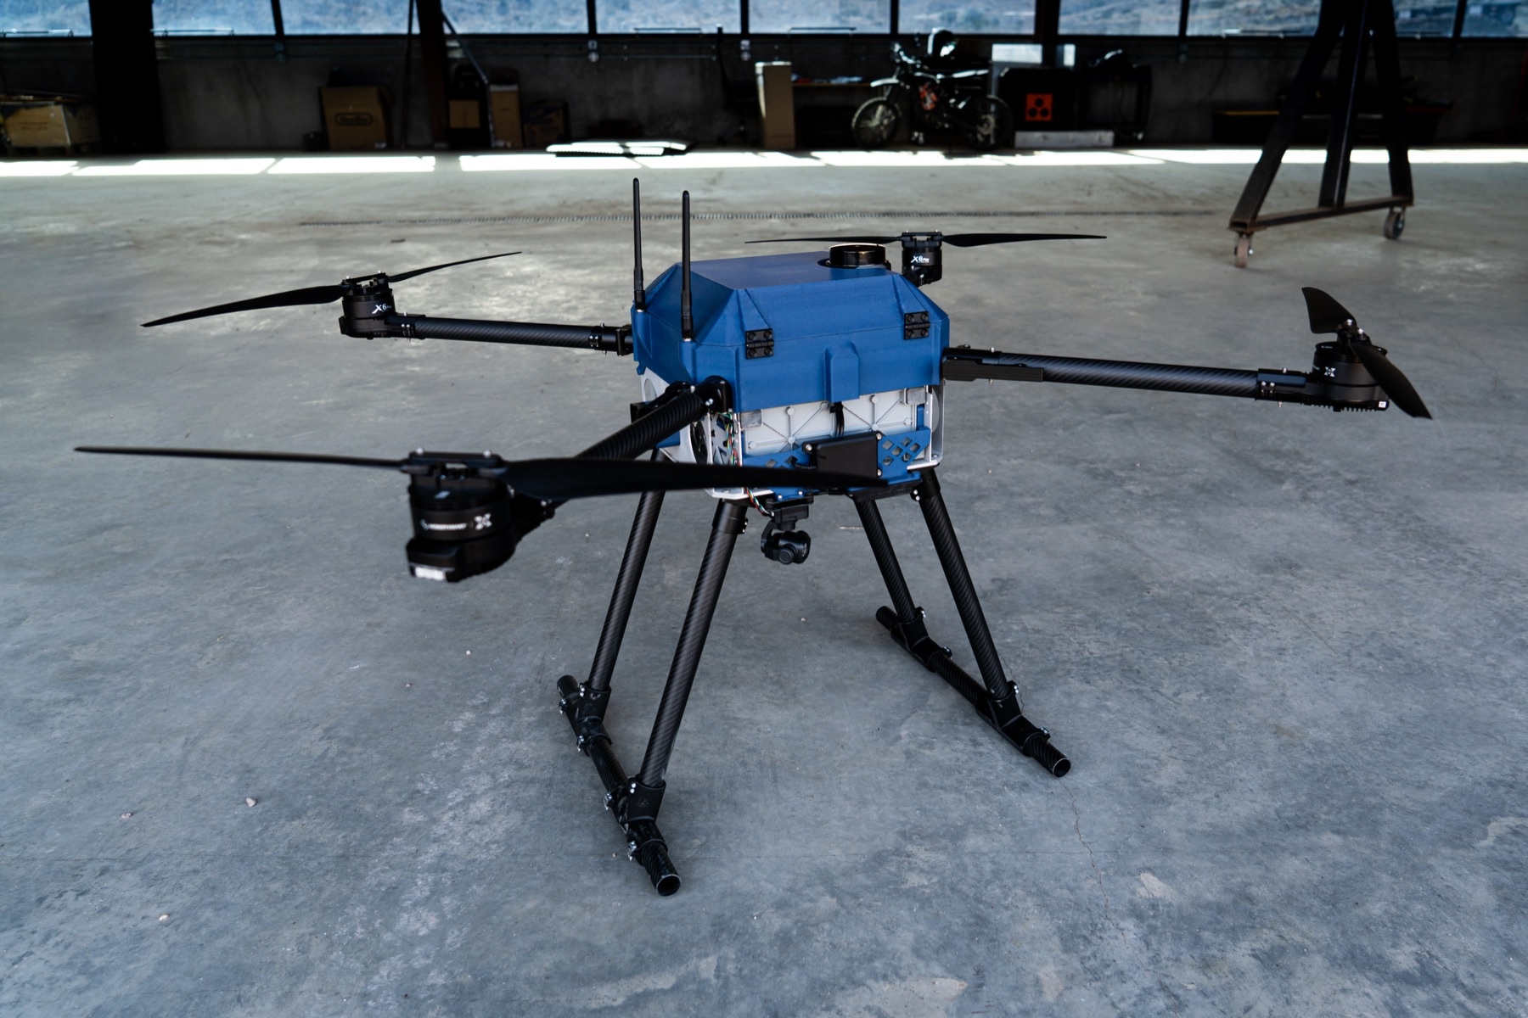
Reference aircraft from the project repository. Remove all propellers for classroom and bench work.

Learn the routine then build
This course teaches students to work safely, care for shared equipment and complete a supervised Quiver build. Start with daily laboratory practice, complete the common induction, then join one of six build teams.
For each activity, read the procedure, watch the instructor demonstrate, practise under supervision and show the required evidence. Use the opening and closing checklist at every session.

Course outcomes
Identify hazards and isolate equipment; manage tools and components; use authorised lab equipment; explain Quiver systems; contribute a checked subsystem; run and evaluate a simulation; and hand over traceable work.
Local adoption is required before practical teaching. The department completes the room arrangements and approves equipment procedures. Course completion, equipment authorisation and real flight approval are separate decisions.

Find a procedure
Follow the course in order during induction. Later, use this guide or the website search to find the activity you are about to perform.

Daily lab practice
Daily laboratory rules
Access clothing and responsibilities
Opening the bench and isolating equipment
Components tools and labelled storage
Inspecting and handling batteries
Charging and storing batteries
Computers files and power interruptions
Electrical benches and test instruments
Hand tools soldering and other apparatus
Using a filament 3D printer
Handling the aircraft and changing payloads
Damaged equipment and emergency action
Returning items and closing the session

Build and simulate
Understanding Quiver systems
ArduPilot simulation practice
Organising parallel build work
M1 Structure
M2 Powertrain
M3 Power and wiring
M4 Avionics
M5 Payloads and enclosure
M6 Software and simulation
Integration checks and demonstration

Checklists and records
Induction checks and course completion
Daily opening and closing checklist
Issue return and equipment authorisation
Technical work fault and handover records

Teaching and sources
Course timetable and instructor preparation
Sources and adaptation notes
Quiver project sources and course maintenance

EVERY DAY

Daily laboratory rules
These rules apply throughout every supervised Quiver session. A clean bench and a correct return are part of the work, not an optional extra.
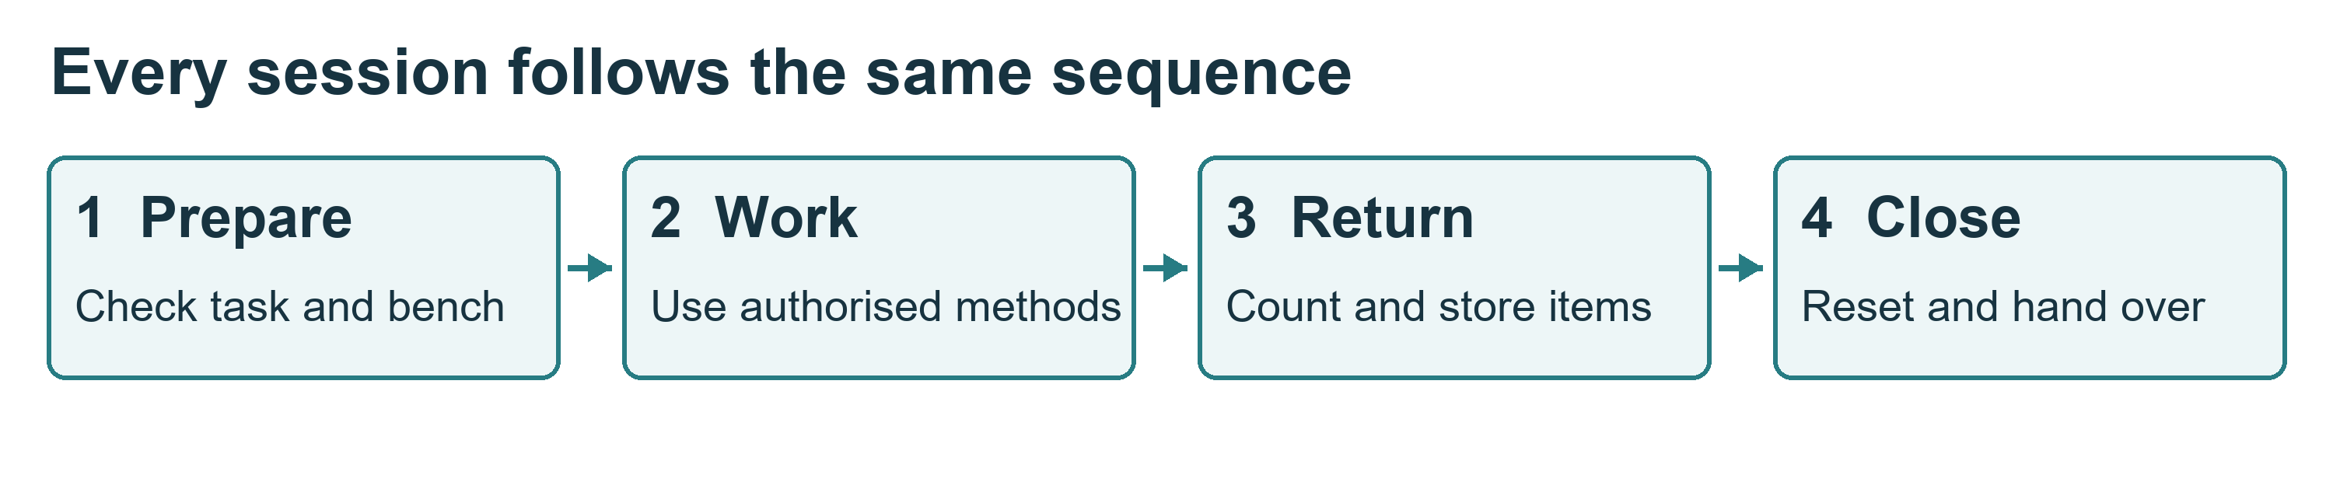

The rules students follow
1. Sign in, identify your supervisor and confirm your permitted task. Do not work alone on batteries, powered hardware or workshop equipment.
2. Inspect your bench and equipment before use. Report damage or missing items before starting.
3. Remove every propeller for bench work. Disarming does not remove electrical energy.
4. Isolate all supplies before changing wiring, tools or payloads. Include USB and test supplies.
5. Use only equipment for which you have recorded authorisation. Keep guards and protection in place.
6. Take components only from the assigned, labelled storage. Record controlled tools and parts issued to you.
7. Keep small parts in trays. Keep usable, unfinished and rejected items separate.
8. Keep food, drinks, bags and loose objects away from work surfaces. Leave exits and walkways clear.
9. Follow the battery procedure. Only the authorised electrical supervisor controls charging, connection and first power-up.
10. Stop for smoke, unexpected heat, unusual movement, a damaged cable or an unclear instruction.
11. Report faults, injuries and near misses promptly. Never return a defective item to usable stock.
12. Before leaving, return and account for items, clean the bench, save files and complete the shutdown or handover.

What good practice looks like
You finish a wiring task with two spare connectors. Check their part numbers, confirm they are clean and undamaged, return them to the correct bins and update the issue record. Put an unidentified connector in the labelled review tray and tell the stores lead. Do not guess its bin.

Practise and show
Prepare a bench with a parts tray, an approved job sheet and only the tools needed. Explain how you would deal with a missing tool and a damaged connector.
Pass evidence: the instructor sees correct preparation and a complete return and reset. See sources S1, S2 and S3 in References.

EVERY DAY

Access clothing and responsibilities
Your outcome: enter the laboratory prepared and recognise the limits of your permission.

Before entering
• Attend the room induction. Sign in using the laboratory's approved record and sign out when leaving.
• Know who is supervising your session. Visitors need permission and an escort.
• Wear closed footwear and clothing suited to the task. Secure long hair, loose sleeves and jewellery.
• Use the eye protection, extraction and other protection specified for your task. Ask for properly fitting equipment.
• Tell the supervisor if fatigue, illness, medication effects or an access need may affect safe work. Arrange support before starting.

What your course pass permits
A general induction permits only the activities specifically recorded by your assessor. Separate authorisation is required for soldering, battery work, powered tests and each printer or machine. Never use another student's authorisation.
Students may inspect, organise, assemble or configure the tasks released to their team. The electrical supervisor controls battery connection and first power-up. The integration lead controls work on the shared aircraft.

Conduct around others
Keep conversation and movement calm around active work. Do not distract someone soldering or operating equipment. Ask before touching another team's assembly or changing a shared computer configuration. Anyone may call STOP; pause and let the supervisor resolve the concern.
Keep emergency doors, switches, alarms and access routes unobstructed. Never rearrange benches, cabinets or fixed equipment without approval.

Find these places during induction
Exit and assembly point; first-aid contact; approved isolation controls; assigned cabinet; battery storage and charging area; fault reporting point; printer stop control; waste collection points.
Local contacts and locations must be posted before the session begins. Use the actual university arrangements, not telephone numbers copied from overseas sources.

Practise and show
Walk the exit route and identify your assigned work area and storage. State one activity you may perform and one that requires further authorisation. The assessor records the result. Sources S1, S3 and S5.

EVERY DAY

Opening the bench and isolating equipment
Your outcome: check the work area and establish a safe state before touching hardware.

Open the session
1. Read the job sheet and last handover. Confirm the assembly revision, task owner and outstanding defects.
2. Check the bench is dry, stable and clear. Put bags in the assigned location.
3. Inspect tools, plugs, leads and connectors. Report missing guards, exposed conductors or damage.
4. Prepare only the required items. Use a tray for fasteners and a suitable support for the assembly.
5. Identify every possible energy source. Confirm that propellers have been removed.
6. Agree the test or assembly method with the supervisor before starting.

Isolate before changing anything
1. Announce that work is stopping. The authorised operator stops the equipment using its approved procedure.
2. Identify and disconnect each supply that can energise the work: flight battery, USB, bench supply, companion-computer supply and any other feed.
3. Prevent reconnection using the laboratory's isolation and tagging procedure. Label the assembly's state.
4. Follow the specified discharge time. A competent person verifies safe conditions at the approved test points.
5. Start work only when the supervisor releases the isolated assembly.
Never short a capacitor or terminals to discharge energy. A switched-off device may still be connected to a live supply. A disconnected battery still stores energy.

Restart deliberately
Account for tools and loose parts. Check that cables, guards and connections are correct and everyone is clear. Only the authorised person removes the isolation tag and approves reconnection. Other teams must not alter the shared aircraft during a powered test.

Practise and show
On de-energised training equipment, identify all supply paths, attach the correct status label and explain how reconnection is prevented. The instructor assesses the sequence without asking students to work on an exposed live circuit.
Stop if: the supply path, isolation status or required test point is uncertain. Record the issue instead of assuming that a dark indicator means the equipment is safe.

EVERY DAY

Components tools and labelled storage
Your outcome: take, track and return items without mixing parts or hiding defects.
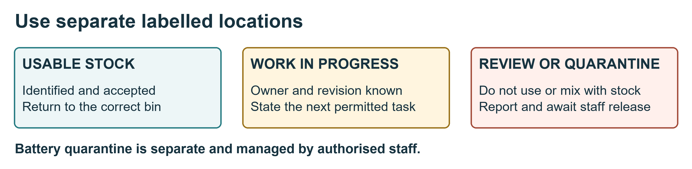

Take an item
1. Read the cabinet and bin labels. Use only storage assigned to your team.
2. Match the part number, size, rating and revision to the job sheet. Look at the container label, not only the appearance.
3. Check condition and quantity. Record controlled items before removing them: item ID, quantity, student, team, date and destination bench.
4. Put small components in a labelled tray or suitable protective packaging. Keep boards in approved ESD packaging.
5. Close drawers and cabinets. Do not leave parts on the floor or in walkways.

Keep three states separate
• Usable stock: identified, accepted items in their correct bins.
• Work in progress: an assembly or part awaiting work or inspection, labelled with team, owner, revision, status and date.
• Quarantine or review: damaged, suspect or unidentified items held outside usable stock.
The diagram shows an example layout. The lab manager assigns the actual locations. Damaged batteries follow the specialist battery procedure; they do not go into the ordinary parts quarantine tray.

Return an item
Remove debris using the approved method; inspect condition; count what remains; return accepted parts to the exact bin; update the issue record. Return leads to their rack and keep probes with their instrument. Report consumables used and tools or components that cannot be accounted for.
Do not mix similar screws, connector variants or component ratings. Do not silently substitute another item. Put uncertain parts in review and ask the stores lead.

Practise and show
Sort a mixed training tray using the labels and job sheet. Complete one issue and return entry. Identify a planted damaged or unlabelled item and route it correctly.
Pass evidence: correct identification, traceable quantity and correct storage location. Sources S1, S2 and S3.

EQUIPMENT

Inspecting and handling batteries
Your outcome: recognise a suspect battery, protect its terminals and follow the staff-controlled handling procedure.

Before handling
Read the pack label and record its asset identifier. The supervisor confirms the chemistry, cell arrangement, compatibility and approved procedure. Do not infer charging settings from connector shape or from another pack.
Inspect visually without squeezing, dismantling or probing the pack. Look for swelling, cuts, punctures, dents, leakage, unusual heat, damaged insulation and damaged connectors. Report a dropped pack or hard landing even if the outside looks normal.

Move and use an accepted pack
• Use the approved carrying method and container. Support the pack; never lift it by its leads.
• Protect exposed terminals against contact with tools, jewellery and other conductive objects.
• Keep the pack secure and away from heat, moisture and crushing loads.
• Use the approved mount and retention. Keep leads clear of moving parts and sharp edges.
• Only the authorised person connects or disconnects the flight battery under the agreed procedure.

If a pack is suspect
Stop using it and notify the electrical supervisor. Do not charge it, reconnect it to test it, open it or attempt a repair. Keep people clear. Staff decide whether and how it can be safely isolated and moved to the designated battery quarantine location.
If it hisses, smokes, vents or rapidly heats, raise the alarm and withdraw under the emergency plan. Do not carry an actively failing battery to a cabinet or attempt firefighting.

Practise and show
Use photographs or inert examples to identify acceptable-for-review, suspect and emergency conditions. Point out the approved storage location and explain the reporting route.
Record: pack ID, observed condition, event or impact, date, reporter and supervisor decision. A student's visual check is not an independent declaration that a pack is safe.
Sources S4 and S5. Exact limits and settings come from the actual manufacturer's instructions and the laboratory procedure.

EQUIPMENT

Charging and storing batteries
Your outcome: understand the charging and storage controls and recognise when the session must stop.

Before charging
The authorised supervisor checks the pack condition and identity, charger compatibility, chemistry, cell count, connections and manufacturer-approved limits. For a LiPo pack, the approved balancing method must match the pack and charger.
Use the designated noncombustible charging area and approved containment, ventilation and separation. A bag or box does not replace supervision or an emergency plan. Do not improvise a sealed container.
Record the pack, charger, operator, approved settings, start time and condition. Keep ordinary tools, paper and other combustible items out of the charging area.

While charging
• A trained authorised person supervises throughout the charge cycle. Do not leave charging unattended.
• Observe the indications and condition according to the local procedure.
• Report any alarm, unexpected heating, swelling, smell or damaged connection.
• Use the approved stop procedure when safe. For smoke, venting or fire, raise the alarm and withdraw; do not approach to unplug the pack.
• Never change charger settings merely to clear a fault.

Return to storage
The supervisor confirms the required storage state from the manufacturer's instructions. There is no universal storage voltage or percentage for every battery used in this lab.
Protect terminals individually; separate packs so connections cannot short; record their condition and location. Store only in the approved battery location and containment, away from ordinary components and combustible stock. Damaged packs require separate staff-managed arrangements.
Never put batteries in general rubbish. Staff arrange disposal through the approved route.

Practise and show
Without energising a pack, match a training battery to its approved charger record, point out the charging area and describe the complete handover and storage sequence.
Check: who remains responsible if a charge will not finish before your session ends? The supervisor must arrange an authorised handover or stop the activity. Sources S4 and S5.

EQUIPMENT

Computers files and power interruptions
Your outcome: use the shared workstation responsibly and leave files and equipment ready for the next student.

Begin at the workstation
Inspect the desk, monitor, keyboard, cables and power connections. Report damage, overheating or loose outlets. Keep liquids, food, batteries and soldering work away from computer desks.
Adjust the chair and screen for a comfortable position and take short movement breaks. Keep ventilation openings clear. Use your assigned account and approved software; do not share passwords or disable security controls.

Protect the work
• Save files in the approved team location. Use meaningful names containing the part or task and revision.
• Keep a dated working copy and use the agreed backup or version-control method.
• Record changes to CAD, code and parameters. Preserve the approved baseline.
• Do not delete, rename or overwrite another team's work without agreement.
• Do not connect unknown USB devices or install unapproved software. Ask before connecting equipment to the university network.
• Keep passwords, keys and personal student records out of public repositories.

If power or network service fails
Save work if the system permits. Follow staff instructions for orderly shutdown. A UPS can remain energised after mains power fails; do not open it or repair its wiring.
Do not repeatedly switch equipment on and off. Staff inspect and release affected printers, supplies and other equipment before restart. Check restored files against the last saved revision. Report a failed backup or corrupted file.

Before leaving
Save and back up the work, record its location, close the authorised session and lock or log out. Return shared peripherals and report faults. Do not switch off a shared circuit that supports an active authorised job.

Practise and show
Create a correctly named version, retrieve the backup, lock the workstation and explain the power-failure response. Use only a harmless training file.
Pass evidence: saved and retrievable work, protected account and a clear handover. Local university ICT rules take precedence over examples from other institutions.

EQUIPMENT

Electrical benches and test instruments
Your outcome: prepare an approved measurement without creating a short circuit or exposing others to energy.

Before a measurement
Identify the quantity, expected range, test points and procedure. Inspect the instrument, leads and probes. The supervisor checks the circuit and setup before power is enabled.
Use only the permitted low-energy training circuit until authorised for other work. No student mains work, UPS repair or improvised high-current testing is included in this course.

Use the correct instrument method
Instrument | Required practice
Multimeter | Confirm sockets, function and range before contact. Use resistance or continuity only on isolated circuits. Never place a current-mode meter directly across a battery or supply.
Bench supply | The supervisor approves voltage, polarity and current limit. Keep the output off while making or changing connections.
Oscilloscope | Confirm the ground-reference arrangement before connecting. A ground clip can short a circuit. Use approved points; never defeat protective earth or probe mains.
ESD equipment | Use the approved setup for isolated electronics. A wrist strap prevents some static damage; it is not protection from electric shock.

Record and return
Write the expected and observed result with units, instrument identity and circuit conditions. Stop for a reading outside the approved acceptance criteria. Do not adjust a result or bypass protection to obtain a pass.
After the authorised shutdown, remove connections safely, return leads to their racks and keep probes with the instrument. Leave controls and leads in the state specified by the lab procedure.

Practise and show
On an isolated training harness, select the correct lead sockets and continuity setting, identify the test points and record a result. Explain why the same setup must not be placed across a live battery.
Stop if: leads are damaged, the circuit state is uncertain, the expected range is unknown or the instrument is unsuitable. Sources S2 and S3 support inspection, authorised use and proper return.

EQUIPMENT

Hand tools soldering and other apparatus
Your outcome: choose the correct tool, use the authorised method and return it in a safe condition.

Hand tools
Check handles, jaws, cutting edges and insulation. Use the correct size and type; do not improvise a screwdriver as a lever. Secure the work and keep fingers clear of cutting and pinch points. Collect cut wire ends and fasteners so they cannot enter the aircraft.
Use only documented torque and adhesive requirements. If a value or curing time is missing, stop and obtain the engineering owner's instruction. Do not invent a setting.

Soldering
Separate authorisation is required. Use the approved local fume extraction, eye protection, stable iron stand and work support. Work on isolated circuits. Keep the hot tip and lead clear of cables and people; never leave a hot iron loose on the bench.
The instructor demonstrates a sound training joint and the inspection method. Allow joints to cool without disturbance. Wash hands after handling solder and workshop materials. Collect solder waste through the approved route.

Chemicals and cleaning
Read the label and safety data sheet before using an adhesive, solvent or cleaner. Use the specified ventilation and protection. Keep containers labelled and closed. Do not decant chemicals into drink bottles or combine unknown substances.

Specialist equipment
Drills, saws, laser cutters, CNC machines, resin printers and composite cutting or sanding require separate training, controls and authorisation. General induction does not permit their use. Dusty fabrication belongs in its assigned area, away from computers and electronics.

Return and report
Clean tools by the approved method, inspect them and return them to the labelled location. Tag and report faults; do not return a defective tool to the ordinary rack. Never remove guards or repair mains equipment.

Practise and show
Choose the correct tool for an instructor-selected task, secure the training workpiece and complete the return. If soldering is assigned, produce and inspect a training joint under supervision. Sources S1 and S3.

EQUIPMENT

Using a filament 3D printer
Your outcome: prepare an approved job, observe it safely and inspect the finished part.
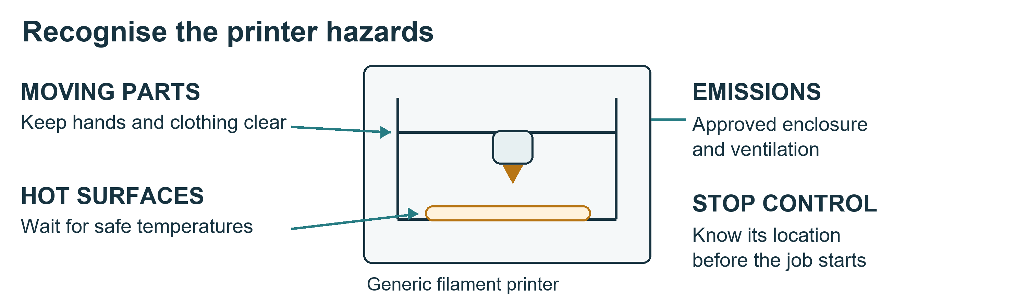

Before pressing print
1. Identify the printer, stop control and trained supervisor. Check the build area, cables, guards and enclosure.
2. Confirm the approved ventilation and material. Air conditioning alone does not establish control of printing emissions.
3. Match the CAD revision, filament, orientation, supports and machine profile to the job sheet. The instructor approves the settings.
4. Record the printer ID, part revision, profile, operator and expected finish. Start only when required supervision is available.

During the job
Keep hands, hair and clothing away from moving and hot parts. Watch the first layer. For poor adhesion, tangled material or unusual operation, use the approved pause or stop and notify the supervisor. Do not reach inside while it is moving or defeat interlocks.
For smoke or fire, raise the alarm and withdraw. Do not open the enclosure to investigate. An unattended job requires the laboratory's explicit written arrangement.

After the job
Wait for the manufacturer's safe temperature. Remove the part using the approved method and suitable protection. Inspect the specified dimensions, warping, missing material, layer separation and damaged mounting features.
Label accepted parts with identity and revision; put rejected parts in review. Appearance alone cannot prove flight suitability. After a power interruption, a technician releases the printer and the instructor reviews any resumed structural print.

Practise and show
Prepare a small non-flight training print, identify the hazards and inspect the cooled result against one agreed dimension. Log the outcome and reset the station.
Limit: this procedure covers filament printing. Resin and powder systems need separate induction. See source S6 and the actual printer manual.

EQUIPMENT

Handling the aircraft and changing payloads
Your outcome: move and work on the assembly without exposing people to rotating parts, trapped fingers or unintended power.

Before moving the aircraft
Identify its weight, centre of gravity and approved lifting points. Clear the route and prepare a stable stand. Use the required number of people or lifting aid; do not lift by propellers, cables, sensors or unsupported covers.
The supervisor confirms isolation. Remove and account for every propeller before bench work. Support the aircraft so it cannot tip or fold unexpectedly.

Folding arms and mechanical work
Inspect joints and latches using the approved drawing and method. Keep fingers clear of hinges and pinch points. Check cables through the permitted movement range. Never force a misaligned joint or alter a structural part to make it fit.
Protect openings against loose fasteners and wire offcuts. Count tools before closing covers. Record incomplete fasteners, curing joints and restrictions on the handover label.

Payload changes
1. Obtain the integration lead's release and establish safe isolation.
2. Support the payload before releasing the latch or connector.
3. Identify the approved attachment, power and data interfaces.
4. Fit the inert training payload and inspect retention, clearance and cable strain relief.
5. Record its mass, mounting position and outstanding checks.
This course requires isolation for every swap. A quick-release interface does not establish that live electrical connection is permitted. Fit and retention alone do not prove a payload is approved for flight.

Powered checks
Only the integration lead's authorised operator energises the shared aircraft. Other teams remain clear and do not change wiring or parameters. Follow the written stop plan. If a motor moves unexpectedly, call STOP and step clear; do not grab it.

Practise and show
Move an isolated training assembly using approved support and perform an inert payload fit check. Explain how a missing fastener or incorrect payload position could affect another team.

EVERY DAY

Damaged equipment and emergency action
Your outcome: stop unsafe work, prevent reuse of defective equipment and give a useful report.

An ordinary fault without immediate danger
1. Stop the activity. Make the area safe only within your training and authority.
2. Tell the supervisor promptly. Do not reconnect an item to see whether the fault repeats.
3. Mark the item DO NOT USE with its asset ID, observed fault, date and reporter.
4. The supervisor isolates it and assigns the correct quarantine or repair location.
5. Record the event and its effect on other assemblies. Only authorised staff release it back to service.
Do not return suspect tools, boards or cables to usable stock. Do not place a damaged battery in the ordinary equipment quarantine area.

Smoke venting or fire
Raise the alarm, withdraw and evacuate by the safe route. Go to the assembly point and follow staff instructions. Do not carry burning or venting batteries, open an affected enclosure, attempt firefighting or re-enter to retrieve equipment.

Injury or electric shock
Alert staff immediately. Keep clear of electrical hazards. Do not touch a person still in contact with an electrical source. Trained responders isolate the danger and provide first aid. Use the posted university emergency process.

Report near misses too
Report a dropped pack, unexpected motor movement, wrong connector, overheated lead or missing guard even when no injury occurred. Describe what you observed, what was connected, who was informed and what remains isolated. Do not assign blame or conceal an error.

Practise and show
Use a safe scenario: a frayed lead is found before use. Demonstrate the stop, label, report and segregation sequence. Then explain how the response changes if a battery is actively smoking.
Local details required: campus emergency contact, room location, alarm method, exit, assembly point and first aider. The instructor must display these before work.
Sources S3 and S4 inform reporting and battery response. Overseas emergency numbers and site-specific fire procedures are not adopted here.

EVERY DAY

Returning items and closing the session
Your outcome: leave a traceable, safe work area and an unambiguous handover.

Close in this order
1. Stop work in time. Save the final task state and identify incomplete work before the session ends.
2. Shut down or hand over. The authorised operator follows the equipment procedure. Do not interrupt a shared supply, required extraction or active job without agreement.
3. Isolate the assembly. Label the energy state and outstanding hazards. Staff control flight-battery handling.
4. Count and return. Account for tools, components, leads and consumables against the issue record.
5. Inspect and separate. Return only accepted items to usable storage. Label unfinished work; report and segregate suspect items.
6. Clean and reset. Collect fasteners, wire ends and approved waste. Use the correct cleaning method; do not blow hazardous dust around the room.
7. Save and report. Back up files, record revisions and tell the next responsible person what is complete and restricted.
8. Obtain the close check. The assigned checker or supervisor inspects the bench. Sign out.

A useful handover says
Assembly and revision; owner and next operator; work completed; evidence location; current power and isolation state; open faults; items missing; next permitted task; person accepting the handover.
“Finished” or “should be okay” is not enough. If a tool is missing, report it before the aircraft is closed or released. If a job continues, name the authorised person taking responsibility.

Example
The frame is assembled but adhesive is curing. Label the assembly with the product and procedure reference, recorded application time and the specified release time. State that loading or movement is restricted until the supervisor releases it.

Practise and show
Reset a training bench containing spare parts, a suspect cable and unfinished work. Complete the issue/return record and explain the handover to another student.
Pass evidence: complete inventory, correct segregation, an accepted bench and a clear record. Sources S1, S2 and S3.

BUILD

Understanding Quiver systems
Your outcome: identify the major subsystems and explain how power and commands reach the motors and payload.
Quiver combines an airframe, propulsion assemblies, custom interface and power boards, flight-control hardware, sensors and software. The course uses the documented project as a reference; the issued kit must be checked against the approved release.
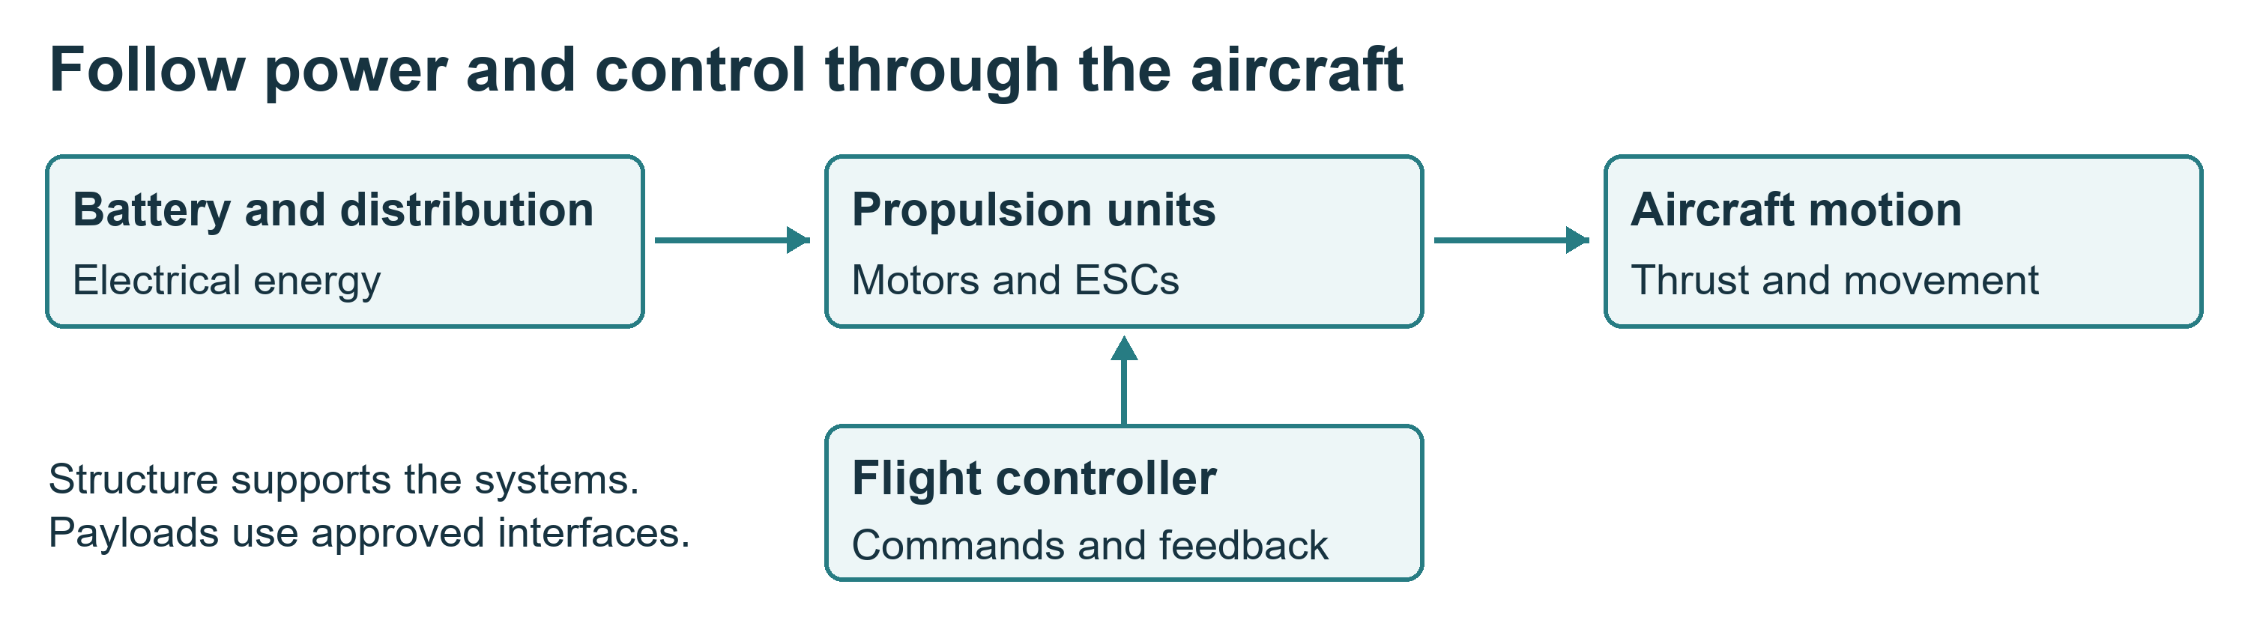

Recognise the components
• Structure: frame, landing gear, arm attachments and supporting mounts.
• Powertrain: motors, electronic speed controllers or integrated propulsion units, arm joints and the removed propellers.
• Power and wiring: battery interfaces, distribution, protection, connectors and harnesses.
• Avionics: flight controller, sensors and communication hardware.
• Payloads: bottom and side attachment hardware, enclosure and associated electrical/data interfaces.
• Software: flight firmware, parameters, ground software and simulation.
The Pix32 V6 is a flight-controller module, not a single chip. ArduPilot is firmware that runs on compatible flight-control hardware; in SITL, flight-control software runs on a computer with a simulated vehicle.

Find the right project file
Use the selected BOM and manufacturing drawings to identify parts. Use harness drawings and board documentation for connector identity and pinout. Use firmware documentation only after the physical board and firmware target have been verified.
The reference repository includes attachment-interface CAD under src/quiver/supporting_structure/attachment_interface. A drawing image is not a load rating or an approved manufacturing specification.

Practise and show
On the isolated assembly or labelled photographs, point to each subsystem. Trace one power path and one control path. Identify where your team's work meets two other teams.
Evidence: a labelled system sketch and a short explanation of one interface. See project sources P1 to P5 in Project references.

BUILD

ArduPilot simulation practice
Your outcome: run a repeatable flight-mode exercise and explain its limits.
SITL means software in the loop. It lets you practise with flight-controller software and a simulated aircraft. It can teach modes, telemetry and mission logic. It does not establish Quiver's real endurance, payload capacity or handling without a validated physical model.

Prepare the session
The instructor provides a tested installation, launch instructions, vehicle model and parameter baseline. Record firmware version or commit, model, parameter-file revision and launch command.
Confirm that only simulator endpoints are connected. Disconnect real-vehicle connections and label the session SIMULATION. Do not upload settings to shared hardware during another team's work.

Fly the common exercise
1. Start the approved scenario. Check simulated position, home, mode and warnings.
2. Follow the instructor's arm and take-off procedure.
3. Hold position, make a short commanded move and observe altitude, speed and mode changes.
4. Use the configured return procedure, then land.
5. Save the log and a screenshot. Explain one unexpected result or warning.
6. Repeat individually as operator while a partner observes.
Guided follows supplied commands. Loiter attempts to hold position and altitude when the required estimates are available. RTL follows configured return behaviour. Land descends according to the configured landing behaviour.

Keep the result honest
The Quiver repository includes an obstacle-avoidance SITL evaluation with approximate aircraft configuration and simulated sensors. Its launch command alone is not a complete, validated Quiver physics model. Advanced exercises need the matching firmware, parameters and sensor configuration verified by the instructor.
Change only one approved parameter at a time. Record the baseline, prediction, change and result, then restore the baseline. Never bypass a safety check to obtain an apparent success.

Practise and show
Submit your launch record, one flight log, one explained anomaly and two model limitations. Another student should be able to repeat the setup.
Sources S7 and P5. Passing the simulation exercise does not authorise real flight.

BUILD

Organising parallel build work
Your outcome: know what your team owns and what must be agreed before it connects to another team's work.
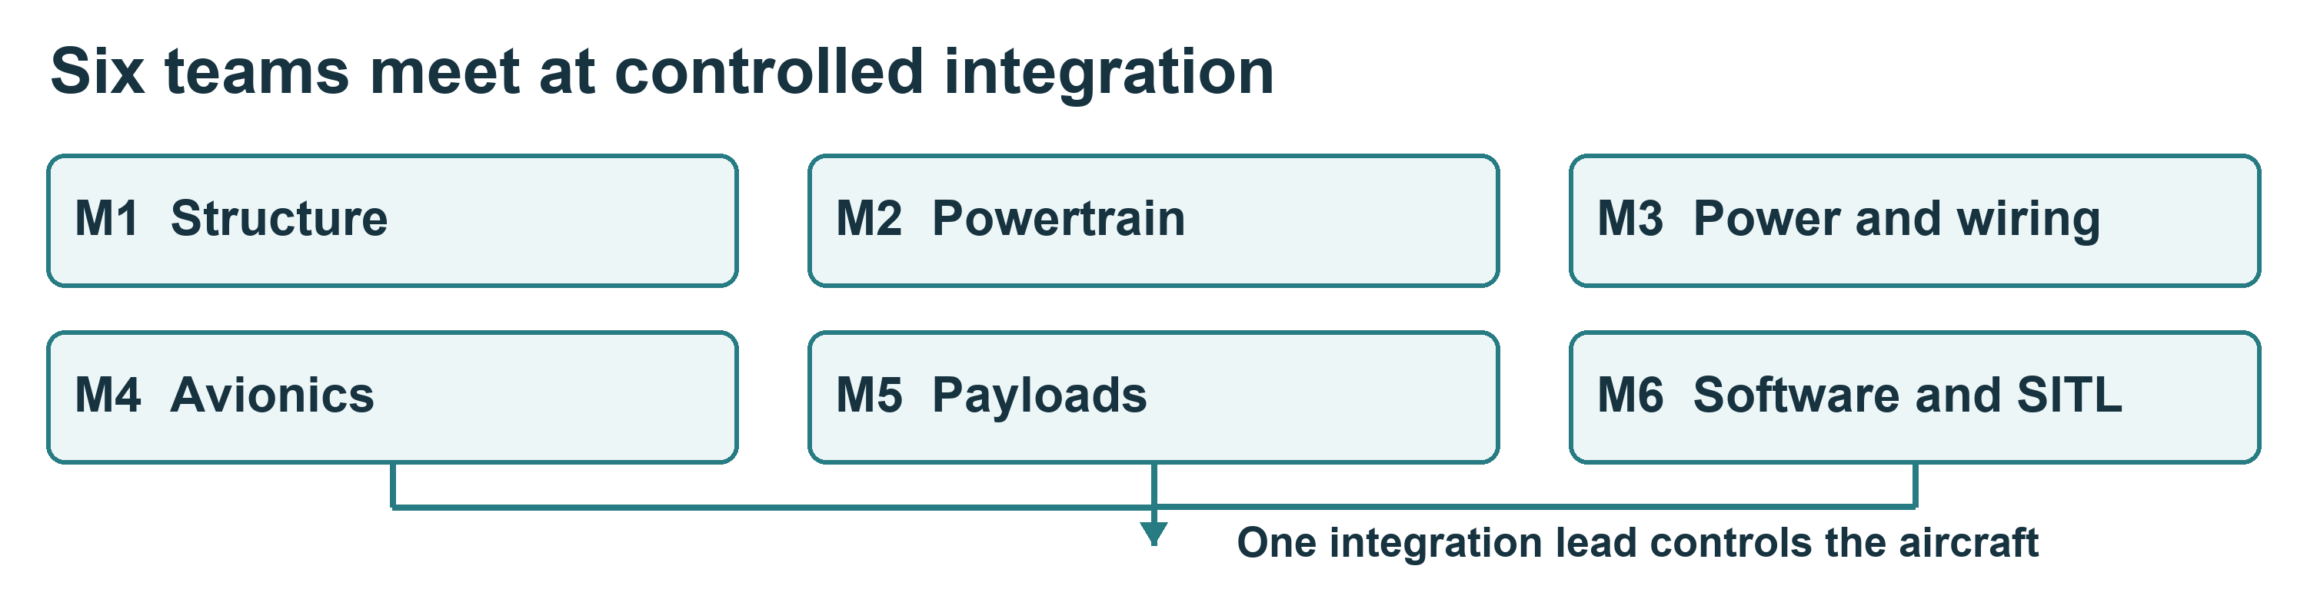

Six team responsibilities
Team | Main work | Handover
M1 Structure | Frame, landing gear and fixed mounts | Fit and mounting records
M2 Powertrain | Motor arms, joints and propulsion units | Inspected assemblies and motor map
M3 Power and wiring | Power interfaces and harnesses | Pinout, polarity and inspection evidence
M4 Avionics | Controller, sensors and communications | Hardware and port map
M5 Payloads and enclosure | Attachments, quick release and covers | Retention, mass and interface record
M6 Software and SITL | Simulation and configuration | Repeatable setup, logs and limitations

Agree the work before starting
Use teams of two to four where supervision permits. Rotate builder, checker and recorder. The checker must be a different person from the builder.
Record the approved revision, required parts, task sequence, hazards, acceptance criteria and interfaces. Sending and receiving teams agree dimensions, connector identity, pinout, power/data requirements and test method. Missing values go to the engineering owner.
Teams may work on isolated subsystems in parallel. The integration lead controls the shared aircraft. No team may connect a supply, change wiring or upload settings during another team's work.

Daily handover
State what was completed, where the evidence is saved, current isolation state, open defects and the next permitted activity. Keep individual evidence as well as the team record.
Before building: the instructor accepts the work plan and the applicable equipment authorisations. Open the work card for your team.

BUILD MODULES

M1 Structure
Deliverable: a correctly assembled frame with secure, accessible mounting points.

Prepare
Collect the approved frame and landing-gear kit, selected drawings, fastener list, work support and inspection tools. Match part numbers and revisions before assembly. M1 owns the fixed structure; coordinate arm and payload interfaces with M2 and M5.

Work sequence
1. Inspect parts for damage and check the required dimensions.
2. Lay out fasteners in labelled trays. Record quantities issued.
3. Assemble in the specified order using the documented fasteners, torque, adhesive and curing requirements.
4. Check alignment, retention, clearance and cable routes.
5. Invite receiving teams to check their interfaces before access becomes restricted.
6. Record the assembly state and any limits on moving or loading it.

Stop and ask
Stop for a drawing mismatch, damaged member, missing value or forced fit. Do not drill, thin, bend or cut structural parts without engineering approval. Composite work needs separate dust controls and training.

Acceptance checklist
☐ Parts and revisions match the approved work package.
☐ Fasteners and joints meet the documented assembly and inspection method.
☐ Mounts, landing gear and cable routes are checked.
☐ M2, M4 and M5 have reviewed the applicable fit.
☐ Defects, curing restrictions and pending checks are recorded.
☐ Tools and spare components have been accounted for and returned.

Show your understanding
Measure one selected interface and record required versus actual values with units. Explain how an incorrectly placed mounting hole affects the receiving team.
Submit: assembly photographs, part/revision list, inspection results and handover. The mechanical supervisor accepts the work. Each student provides one observed task and one record they produced or checked.

BUILD MODULES

M2 Powertrain
Deliverable: identified propulsion assemblies with accepted mounts, joints and cable protection.

Prepare
Use the approved motor-arm, folding-joint and propulsion-unit kit, drawings and motor-position map. Confirm the actual motor and ESC arrangement with the instructor. All propellers remain removed and separately accounted for.

Work sequence
1. Inspect components and identify their aircraft positions.
2. Check folding joints, locks and retention using the specified method.
3. Fit motors and associated parts with documented fasteners and clearances.
4. Route and protect cables against pinching, abrasion and tension.
5. Check the permitted movement range on the isolated assembly.
6. Label each unit and record required motor direction for later authorised checks.

Stop and ask
Do not connect a battery or run motors at the team bench. Do not use generic ESC calibration instructions without verifying compatibility with the issued propulsion type. Stop for damaged wiring, uncertain orientation, a loose joint or a forced fit.

Acceptance checklist
☐ Propellers absent and accounted for.
☐ Motor identity and position match the approved map.
☐ Mounts, joints and locking features inspected.
☐ Cables protected through the full permitted movement.
☐ M1 accepts fit; M3 and M4 accept power and control interfaces.
☐ Powered rotation checks are clearly marked pending until authorised.

Show your understanding
Demonstrate the joint inspection and identify a possible pinch point. Explain why a secure mount does not prove correct motor configuration.
Submit: labelled motor map, mechanical inspection, photographs and pending-test list. The mechanical supervisor accepts the assembly; the integration lead schedules any powered checks. Close with the standard inventory and bench reset.

BUILD MODULES

M3 Power and wiring
Deliverable: identified harnesses and power connections with independent inspection and test evidence.

Prepare
Obtain the approved harness drawings, connector schedule, inspected boards, correct wire and terminals, approved crimp tools and test instruments. Confirm pin numbering and the viewing direction shown on each connector drawing.

Work sequence
1. Match connector and wire identities to the approved drawing. Never infer function from colour alone.
2. Label both ends as specified. Keep unused terminals and offcuts separate.
3. Assemble or inspect only the harnesses released to your team.
4. Check crimps, insulation, retention, strain relief, routing and protection.
5. On isolated equipment, perform the approved point-to-point, polarity and unintended-connection checks.
6. Record expected and actual results with units and instrument identity.
7. Obtain independent electrical review before installation or power-up.

Stop and ask
Stop for ambiguous pinouts, damaged insulation, wrong parts, a failed test or missing acceptance criteria. Do not improvise high-current joints, board repairs or test methods. The electrical supervisor controls battery connection and first power-up.

Acceptance checklist
☐ Pin identity and polarity match the drawing.
☐ Crimps, insulation, retention and cable routes are accepted.
☐ Test results are traceable to the harness revision.
☐ Receiving teams have confirmed their supply and connector requirements.
☐ No unresolved electrical defect remains before release to integration.
☐ Scrap and suspect parts are separated from usable stock.

Show your understanding
Demonstrate a check on an unpowered training harness. Explain how reversing the drawing's viewing direction could produce an incorrect connection.
Submit: connector schedule, inspection/test record, photographs and rework history. The electrical supervisor records acceptance; a student signature alone does not release the assembly for energisation.

BUILD MODULES

M4 Avionics
Deliverable: installed flight-control, sensor and communication hardware with a verified port and configuration record.

Prepare
Use the approved flight controller and carrier, sensors, communication devices, mounts and port map. Read physical labels; do not select firmware solely from a photograph or an old project instruction.

Work sequence
1. Match controller, carrier and sensor identities to the approved hardware record.
2. Confirm orientation, mounting method, clearances and cable routes.
3. Fit and label the authorised connections while isolated.
4. Review every power source with M3, including USB and companion-computer feeds.
5. Agree the firmware target, version and parameter baseline with M6.
6. List required calibrations, communication checks and integration conditions.

Stop and ask
Stop for an uncertain board target, incorrect orientation, damaged port or conflicting pinout. Obtain approval for each power arrangement. USB may energise part of a circuit. Do not flash firmware or change settings while another team is working on the shared aircraft.

Acceptance checklist
☐ Actual hardware and selected firmware target match.
☐ Orientation and mounting are documented.
☐ Power and signal connections have independent checks.
☐ M3 and M6 accept the interfaces.
☐ Calibrations and powered checks are completed at the approved stage or explicitly listed as pending.
☐ Boards and sensitive components are stored in approved protective packaging.

Show your understanding
Point out the controller orientation and trace one sensor connection. Explain why calibration may need review after changing the assembly.
Submit: port map, hardware identities, mounting photographs and configuration record. The avionics supervisor accepts the installation. Return probes with their instruments and record any loose or suspect connector before closing the session.

BUILD MODULES

M5 Payloads and enclosure
Deliverable: secure payload attachment and enclosure assemblies with clear mechanical, power and data interfaces.

Prepare
Collect the approved side and bottom attachment components, quick-release parts, interface boards, covers and an inert training payload. Check the selected CAD and BOM revision before using fabricated parts.

Work sequence
1. Identify the three attachment locations and the parts assigned to each.
2. Inspect manufactured parts using the approved dimensions and acceptance criteria.
3. Assemble spacers, plates, latches and enclosure parts in the specified order.
4. Fit the inert payload while the aircraft is isolated and properly supported.
5. Inspect engagement, retention, clearance, cable routing and strain relief.
6. Record payload mass and position. Agree supply and data requirements with M3, M4 and M6.

Stop and ask
Stop for damaged prints, unclear load limits, inadequate retention or conflicting interfaces. Never infer a load rating from appearance or successful fit. Do not repair a structural print or conduct a load test without a separate approved method. All payload swaps require isolation.

Acceptance checklist
☐ Correct parts and revisions fitted.
☐ Retention and clearance satisfy the approved inspection method.
☐ No unapproved structural modification or repair.
☐ Payload mass and mounting position recorded.
☐ Mechanical, electrical and data interfaces accepted by receiving teams.
☐ Any remaining payload flight approval is explicitly outstanding.

Show your understanding
Demonstrate latch inspection with an inert payload. Explain why the location of the payload matters as well as its mass.
Submit: fit and retention evidence, part inspection, mass/location and interface record. The supervisor accepts the build; attachment acceptance alone does not approve a flight with that payload.

BUILD MODULES

M6 Software and simulation
Deliverable: a repeatable simulator setup and traceable software configuration.

Prepare
Use the approved workstation, source revision, installation guide, model and parameter files. Confirm the team storage location and naming convention. Preserve the issued baseline.

Work sequence
1. Record software versions, source commits, launch commands and file origins.
2. Verify that the session connects only to the simulator.
3. Run the common take-off, hold, movement, return and landing exercise.
4. Save logs and record warnings, model assumptions and recovery actions.
5. Change one approved variable for an extension experiment, then restore the baseline.
6. Write instructions another student can follow on a second approved workstation.
7. Review any real-hardware configuration record with M4 and the integration lead.

Stop and ask
Stop for an unexpected real endpoint, incompatible firmware target, unexplained warning or missing baseline. Do not bypass checks or send commands to shared hardware during another team's work. Add Quiver Hub or companion-computer integration only within the released scope.

Acceptance checklist
☐ Versions, model, parameters and launch method recorded.
☐ Another student can reproduce the common exercise.
☐ Logs and model limitations are included.
☐ Changes and restored baseline are traceable.
☐ M4 accepts any hardware configuration interface.
☐ Files are backed up and credentials excluded.

Show your understanding
Explain one observed behaviour using the log and distinguish a control setting from an assumption about the aircraft's physics.
Submit: setup instructions, configuration files, experiment record and logs. Each student must also operate the common exercise. The instructor accepts reproducibility; a successful simulated flight does not establish real flight safety.

BUILD

Integration checks and demonstration
Your outcome: combine accepted subsystems through controlled checks, with one person responsible for the shared aircraft.

Four checkpoints
Checkpoint | Evidence required | Release
1 Ready to build | Induction, work plan, approved revisions and interfaces | Instructor
2 Subsystem accepted | Inspection, test results, defect status and handover | Relevant technical supervisor
3 Ready for powered checks | Unpowered integration, supply/polarity checks, propeller removal, tool count and written stop plan | Electrical supervisor and integration lead
4 Demonstration complete | Authorised test records, SITL evidence, individual explanations and remaining restrictions | Course lead

Before energising
Confirm that no other team is changing the aircraft. Inspect mounts, cables, connectors, retention and clearances. Verify all required unpowered electrical checks. Confirm firmware target and approved configuration. Remove and account for all propellers and loose tools.
Identify the authorised operator, observers, exclusion area and stop method. Staff choose the appropriate supply and protection for the test. The test sheet must state expected results and stop criteria before power is applied.

During and after a test
Run only the released test. Record conditions, observations and actual values with units. For an unexpected result, stop through the approved process, isolate, report and record. Do not repeat a failed powered test without supervisor review.
After rework, repeat the affected checks and record why they were selected. Keep the failed result in the record; do not replace it with a later pass.

Demonstrate the learning
Each team shows its accepted subsystem, one inspection result and one interface. Each student explains their own contribution. Show the simulated flight and its limitations.
Boundary: this course ends with supervised bench and simulation evidence. Real flight requires a separate approved aircraft, site, crew, risk assessment and compliance with current Nigerian requirements. See S10.

RECORDS

Induction checks and course completion
Your outcome: demonstrate the daily practices individually and know what the assessor has authorised.

Induction is observed
For every assigned item, the instructor demonstrates the actual location or procedure, the student practises, and the assessor observes. A signature confirms recorded evidence; it does not replace the demonstration.
Practical check | Student must show
Emergency orientation | Exit, assembly point, alarm and contact route
Opening and isolation | Supplies identified and safe training sequence explained
Stores | Correct issue, identification, return and review segregation
Battery awareness | Damage recognised, terminals protected and staff route explained
Workstation | Safe setup, saved file, backup and account lock
Assigned equipment | Required pre-use, operating and shutdown checks
Closing | Inventory, bench reset and accepted handover
Subsystem | One task completed and checked against criteria
Simulation | Common exercise, saved log and two limitations

Record student, task/equipment, date, assessor, evidence, result and permitted activity. Mark unassigned equipment Not assigned; this gives no permission to operate it.

Results
Pass: correct performance within required supervision and a clear explanation. Practise again: a specific gap needs instruction and reassessment. Stop: an unsafe condition or action requires intervention before continuing.

Knowledge check
1. Why is disarming insufficient for wiring work?
2. Where does an unidentified component go?
3. What must happen before a damaged lead can return to service?
4. What is the response to a smoking battery?
5. May a charging pack be left unattended?
6. Why must every propeller be removed at the bench?
7. What do you record before handing over unfinished work?
8. Does a general induction authorise every machine?
9. Does SITL success prove exact Quiver handling?
10. What do you do if a required drawing value is missing?
Proposed completion rule: at least 8/10, all safety items 1, 3, 4, 5, 6 and 8 correct, and all applicable practical checks passed. The department adopts the final rule. Further practice and reassessment are recorded. Completed personal records belong in approved restricted university storage.

RECORDS

Daily opening and closing checklist
Use a fresh record for each bench and session. The student completes the checks; the assigned checker or supervisor verifies the close.
Date and session ____________________ Bench ____________________
Team and students __________________________________________________
Supervisor ____________________ Job sheet and revision ____________

Before starting
☐ Signed in and permitted task confirmed.
☐ Last handover and outstanding defects read.
☐ Exit and access routes clear; work area dry and stable.
☐ Clothing and task protection correct.
☐ Tools, leads and equipment inspected.
☐ Parts and controlled tools issued and recorded.
☐ Supplies and isolation state identified.
☐ All propellers removed before bench work.
☐ Supervisor has released the task.
Restriction or action required _______________________________________

Before leaving
☐ Approved shutdown completed or named handover accepted.
☐ Aircraft/circuit isolation state labelled.
☐ Tools and components counted and returned to labelled locations.
☐ Suspect items reported and segregated through the correct procedure.
☐ Work in progress labelled with owner, revision and restriction.
☐ Bench cleaned; waste sorted; walkways clear.
☐ Files saved and backed up; account locked or logged out.
☐ Missing items and unfinished work reported.
☐ Checker or supervisor accepts the bench; students sign out.
Next permitted task __________________________________________________
Person accepting any continuing job ___________________________________
Student ____________________ Checker or supervisor _______________
Time completed ____________________
Do not sign a check you have not performed. If a condition fails, record it and obtain the supervisor's direction.

RECORDS

Issue return and equipment authorisation
Use the lab's controlled register or this blank form. Keep completed student records in restricted storage.

Issue and return record
Date ____________________ Team and bench ________________________
Student responsible _________________________________________________
Item ID and description ______________________________________________
Part number rating and revision _______________________________________
Storage location ____________________ Quantity issued ____________
Condition on issue __________________________________________________
Quantity returned __________ Used or consumed ____________________
Missing or quarantined quantity and reason ___________________________
Return location and condition ________________________________________
Returned by ____________________ Checked by _____________________

Equipment authorisation record
Student ____________________ Equipment and asset ID ______________
Procedure and revision ______________________________________________
Demonstration and supervised practice date ___________________________
Observed task and evidence ___________________________________________
Result Pass / Practise again / Stop
Permitted activity and required supervision __________________________
Restrictions and reassessment required _______________________________
Assessor and date ____________________________________________________
Authorisation is specific to the recorded equipment and activity. A change of machine, process or risk may require further instruction.

RECORDS

Technical work fault and handover records
Use a separate copy for each event or test. Record facts, units and revisions so another person can understand the work.

Inspection or test record
Assembly or job ____________________ Revision ____________________
Procedure and test points ____________________________________________
Conditions and instrument ID _________________________________________
Expected result and acceptance limits ________________________________
Actual result with units ____________________________________________
Pass or defect and action ____________________________________________
Builder ____________________ Independent checker _________________
Supervisor decision and date _________________________________________

Fault or near miss record
Item and location ____________________ Date and time ______________
What was observed ____________________________________________________
What was connected or operating ______________________________________
Immediate action and current isolation state _________________________
Who was informed and when ____________________________________________
Quarantine location or restriction ___________________________________
Authorised release or follow-up owner ________________________________

Handover record
Work completed and evidence location _________________________________
Open defects missing items and restrictions __________________________
Next permitted task and responsible person ___________________________
Handed over by ____________________ Accepted by ___________________
For a battery record also include pack/charger ID, approved settings, condition and operator. For a print include printer/material/profile, part revision and inspection. For SITL include firmware/model/parameters, launch command and log location.

INSTRUCTOR

Course timetable and instructor preparation
Use this guide to adopt the course and prepare safe, achievable practical sessions. The rules become local operating requirements only through the responsible department and laboratory manager.

Proposed timetable
Session | Focus | Hours
1 | Room walk, daily rules, storage and isolation practice | 3
2 | Computers, battery awareness and assigned equipment induction | 3
3 | Systems and individual SITL practice | 3
4 | Team plans, drawings and interface agreements | 3
5 to 7 | Six supervised build teams | 9
8 | Unpowered integration and inspections | 3
9 | Authorised powered checks with propellers removed | 3
10 | Demonstrations, individual checks and feedback | 3

Thirty contact hours assume prepared kits and a tested simulator. Add time for fabrication, curing, rework or reassessment. Do not promise a flight-ready aircraft within this timetable.

Complete before teaching
Name the course lead, laboratory manager, technical supervisors and stores lead. Set group sizes according to competent supervision. Inspect the rooms and equipment.
Post the actual emergency contacts, room identifier, exit, assembly point and first aider. Assign usable stock, work-in-progress and ordinary quarantine locations, plus separate battery arrangements. Prepare labels, issue records, safe training items and approved waste routes.
Approve drawings, pinouts, torque, adhesives, print specifications, battery procedures and software baseline. The reference repository contains a lower-plate thickness conflict between BOM and manufacturing guide; resolve it with the engineering owner before procurement or fabrication.

Deliver each activity
Explain the outcome and hazards, demonstrate on the actual equipment, supervise practice, observe each student and record feedback and permission. Make reasonable learning/access adjustments while preserving the safety requirement. Revisit closing and storage habits at every session.

Assessment notes
Answers: 1 connected energy remains; 2 review location; 3 authorised inspection/release; 4 alarm and withdraw; 5 no; 6 prevent rotating-part injury; 7 status, evidence, defects and next task; 8 no; 9 no; 10 stop and obtain the approved instruction.
Review incident patterns, missing items, feedback and timings after the cohort. Record improvements, owners and review dates. Sources S8 and S9 provide educational context; this course is not independently accredited.

REFERENCES

Sources and adaptation notes
The course adapts practical habits from university laboratories and applies them to a supervised Quiver build. Local procedures and the actual equipment manuals determine authorisation and operating limits.

Daily laboratory practice
S1 Maryland Robotics Drone Lab — Rules and safety. Used for assigned storage, authorised tools and returning equipment. Its local flight thresholds, emergency contacts and instructions to move burning equipment are not adopted.
S2 Fresno State — Electronics laboratory safety, operating guidelines 14 to 16. Used for component trays, lead racks, keeping probes with instruments and bench reset. Its local network rules are not UNILAG rules.
S3 Penn State Behrend — Laboratory and shop procedures. Used for documented equipment training, proper return and damaged-item reporting. Local access rules and penalties are not transferred.
S4 Queen Mary University of London — Research labs and drones. Used for supervised charging, inspection and protected storage. UK law references and emergency numbers are not Nigerian requirements.
S5 NUbots — Lab induction checklist, battery items 1.1 to 1.6 and signatures. It records instruction and acknowledgement. Our observed student demonstrations are an added Quiver course design choice. Its software ownership agreement is not adopted.

Equipment and education
S6 NIOSH — Approaches to safe 3D printing. Emissions and controls for makerspaces and schools.
S7 ArduPilot — SITL documentation and motor setup safety. Verify the exact hardware and software before applying instructions.
S8 UNILAG — Student centred learning guideline and university policies.
S9 NUC — Engineering CCMAS. Programme context; the department determines any credit mapping.
S10 NCAA — Part 21 RPAS. Check current requirements before real flight operations.

Design and provenance
Use short procedures, nearby diagrams, worked examples and repeated practice. CDC information chunking and IES instructional guidance inform this approach. They do not prescribe this course's assessment threshold.
Version 5.0 prepared 25 October 2026. The aircraft photo is an unaltered project asset; diagrams are conceptual teaching aids. Project technical references are listed on the next page.

REFERENCES

Quiver project sources and course maintenance

Project baseline
The engineering reference snapshot is commit 3ed4eb25c4fbef565b2f68804b499a328c56abe1 in the Arrow Air project repository. This identifies provenance; the engineering owner must approve the actual kit and procedures.
P1 Project overview — README.
P2 Parts and assembly — BOM and manufacturing guide.
P3 Wiring and boards — Harness guide, main PCB, battery-control PCB and flight-controller PCB.
P4 Firmware — Operations firmware reference.
P5 Simulation — Quiver SITL evaluation.
The repository identifies its licence as CERN-OHL-S v2. Preserve project attribution and review the applicable licence and any third-party asset rights when redistributing engineering material.

Maintain the course
Keep the Markdown pages as the course source. Update the handbook and website together when a procedure, kit, room or software baseline changes. Record the change, responsible reviewer and effective date.
The website provides search, page navigation, print support and a handbook download. It is a documentation site, not a shared student-record database. Edit its Markdown files and rebuild to publish changes.

Local adoption record
Department and laboratory ____________________________________________
Course owner _________________________________________________________
Technical and safety reviewers _______________________________________
Approved hardware and software baseline ______________________________
Adoption date ____________________ Next review date ______________
Complete these records in the approved administrative copy. Keep personal assessment, incident and authorisation records in restricted university storage.

