**Introduction to Database Science**

**Week-1 Project Presentation**

**Introduce your company**

* **Name**

Power puff pets

* **Mission and Vision [important marketing elements]**

**Mission:**

to raise awareness about how much pets’ lives matter by providing consultants to pets owners, and to provide an excellent high-quality services and pet care products. Our dedicated and professional staff will ensure a safe, fun, and nurturing environment for your pets while ensuring the best quality and personalized experience for you, and your pet.

**Vision:**

To be the number one choice for pet owners, to make a world where every pet is happy, healthy, and safe, and to provide the best quality services and products in our country.

* **Service and/or product**

**Services:**

|  |  |
| --- | --- |
| **Current** | **Future** |
| Grooming services | Hotel |
| Consulting services | Daycare |
| Engraving | Vet. (check-ups, vaccines, etc.) |
| Subscription Options (monthly, annual):  Products | Training |
| Membership: Like a loyalty program  Services (grooming, etc.), discounts, priority, new products samples, early access. |  |

**Products:**

* Food (wet food, dry food, seeds, organic options, treats (cookies, biscuits),
* Supplements
* Grooming products (shampoos, nail clippers, brushes)
* Toys
* Cages
* Beds
* Transportations (carriers)
* Accessories (Collars, tags,
* **Years of operation [ could be 0 years if you are raising many to startup the company]**

One year

* **Market share and list of competition**
* **Pie Chart**

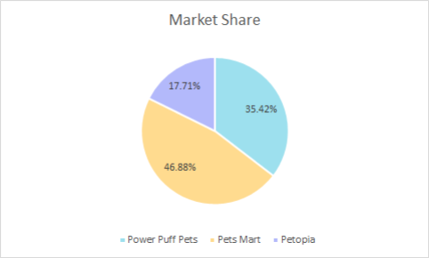

**Line chart [ increase/ decrease in market share]**

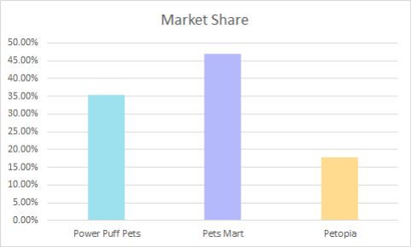

From above pie and line chart we can see that the Pets Mart has the highest percentage, at about 46.88%. While Power Puff Pets has the second highest percentage by 35.42%. The lowest percentage is Petopia, at almost 17.71.

* **Reason for raising additional funds**
* **Why? [list future projects]**

We want to rise our additional funds to expand and own our first store, also to increase the number of services (day care, hotel, training, and veterinary)

* **How much? [amount of money you need to raise now and in the future]**

We need a loan 287 k to be able to expand

For this we need to estimate and state in detail the cost of prepping and running the future plans.

* **Sara Note: give them a solid explanation in your presentation List additional/new income generated**

* **Plans for payment? [when and how you plan to pay back the money to the investors]**

**List additional/new income generated**

How much are we planning to get from the hotel?

How much are planning to get from the vet.?

How much are we planning to make from training?

How much are we planning to make from daycare?

**Assuming you will issue bonds, how much interest you plan to offer the investors?**

**Assuming [on average] banks offer 5% interest on saving accounts [safe investment]**

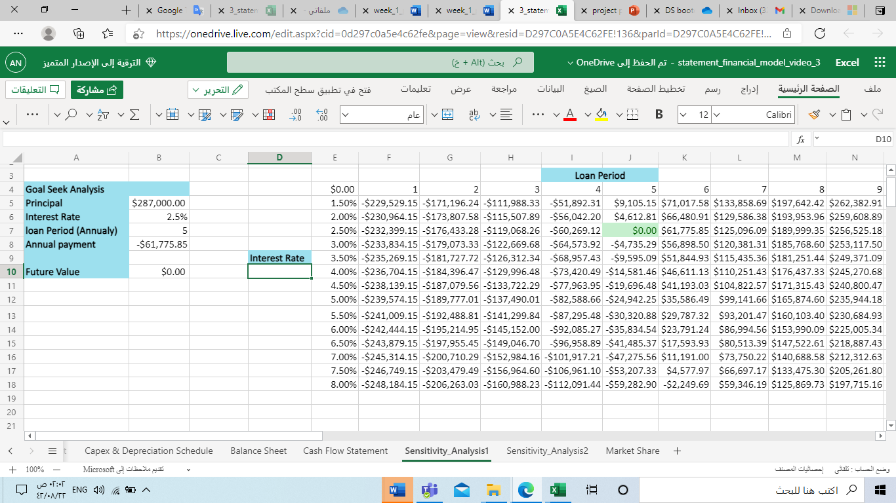

By offering 5% interest, our company should pay $61775.84 annually for five years.

**Assuming competition [on average] offer 15% interest on their bonds [risky investment]**

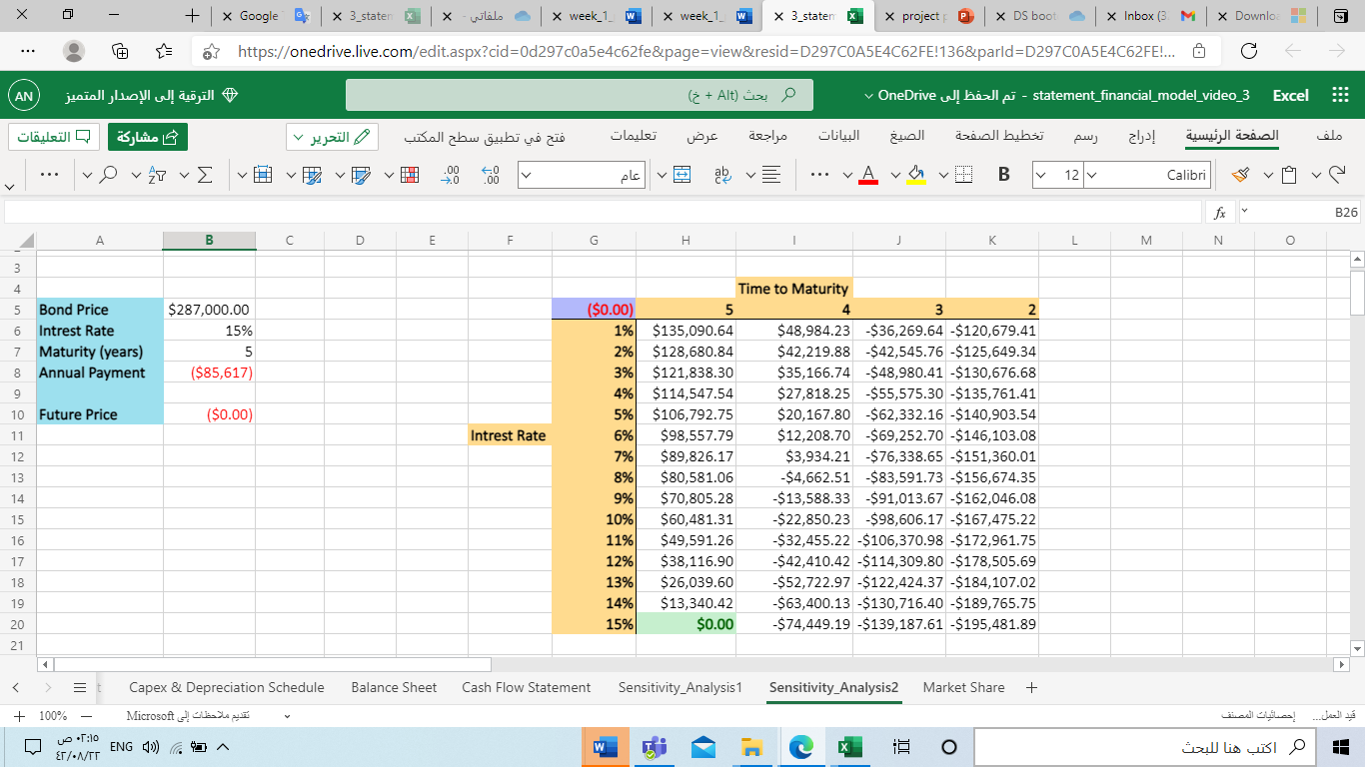

By offering 15% interest, our company should pay $ 85616.56 annually for five years.