**Replication of Study 4**

**by Dessalegn & Landau (2008, *Psychological Science*)**

Stanka A. Fitneva

Queen’s University, Canada

Fitneva@queensu.ca

**Introduction**

The interaction between language and cognition has been of interest to many. Dessalegn and Landau (2008) explored the hypothesis that language may help maintain visual feature conjunction, in particular the conjunction of color and location features. They studied this question with 4-year-old children, where failure to bind visual features may be more common than among adults due to weaker attentional control.

In four studies, children were presented with trials where they first saw a square split symmetrically into a green and a red part along the vertical, horizontal or diagonal axis. Then they had to identify the target in a set containing the target, its mirror image, and a foil. Of critical interest was the effect of the instructions children received during the initial target viewing. Study 2 showed that directional language (e.g., ‘the red is *to the left of* the green’) helps children remember the color-location features of the targets. Study 3 eliminated the possibility that the effect was simply due to increased attention to the targets. Study 4 further eliminates the possibility that the effect was due to the relational information in directional language (x *to the left of* y implies a relation between x and y). This is done by comparing children’s performance when exposed to directional language and when exposed to relational language (e.g., ‘the red is *touching* the green’). Study 4 is the target of this replication.

**Methods**

**Power Analysis**

The reported effect size of condition (directional vs. neutral/relational language) was d = .82. We calculated the observed power to be .62. Given that the effect size statistic reflects a t-test (rather than the ANOVA analysis that was carried out and included other variables), and that the effect of condition is of main interest, the power analysis was based on conducting a t-test. The power analysis also assumed a 2:1 ratio of the samples in the two conditions, which was a feature of the original study. The sample size required to detect an effect size of d = .82 with power of 80%, 90%, 95% was calculated to be 44, 60, and 74 children. Given the difficulty of accessing children, the target power of this replication is set at 80%.

**Planned Sample**

45 4-year-old children (range 4;0 – 5;0, mean 4;6) will be recruited from a mid-size urban community in Southeast Ontario. All children will be native speakers of English. Following Dessalegn and Landau’s procedure, 30 children will be randomly assigned to the directional condition and 15 to the relational condition.

**Materials**

The experimental stimuli were shared by the authors. They consisted of squares split in half by color (red, green) along one of three axes (vertical, horizontal, or diagonal). We re-recorded all sound instructions following the models we received. This was done because some files were missing, and we judged it desirable that all instructions be given by the same female voice. We constructed the practice trials following their description in the paper. The first two trials used two familiar animals as targets and the next four used novel shapes. (So we used 6 familiar items and 10 symmetrical shapes split into a black and a white half for the practice trials.)

**Procedure**

Fig. 1a of the paper, reproduced below, illustrates the structure of experimental trials.

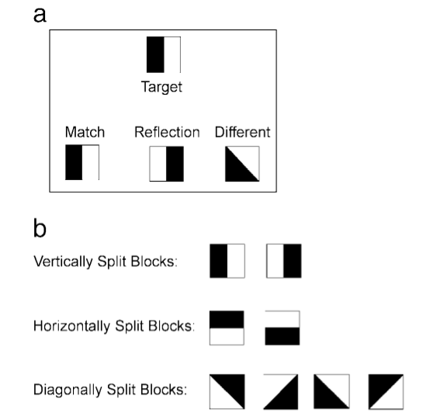

Figure 1a

On each trial, one of six different targets appeared at the top center of a computer screen (see Fig.a). After it disappears, the three shapes in the bottom appear and children have to identify the one they have just seen.

The following description joins relevant text that appears on p. 190-193 of the paper:

On each trial, one of [six] different targets appeared at the top center of a computer screen. [This included 2 vertically split, 2 horizontally split, and 2 diagonally split squares.] After the children looked at the square, the experimenter said, ‘‘Let’s ask where the red is. Where is the red?’’ She then said,‘‘The red is . . .,’’ and after a click with the mouse an audio file played a voice that completed the sentence appropriately. In the neutral condition, the completion used relational but nondirectional terms: ‘‘… touching/connected to/next to/up against the green.’’ For children in the directional condition the continuation included directional terms: ‘‘… to the left/right/top/bottom of the green.’’ (For the vertically split targets, the recorded voice said ‘‘left’’ or ‘‘right’’; for the horizontally split targets, the voice said ‘‘top’’ or ‘‘bottom.’’ For the diagonally split squares (which could be labeled either way), half of the children were told the red was on the ‘‘left’’ or ‘‘right,’’ and the other half were told it was on the ‘‘top’’ or ‘‘bottom.’’) The experimenter said, ‘‘I want you to help me find one that is exactly the same’’ and the target then disappeared. After a 1-s delay, three test objects appeared at the bottom of the screen: the target’s match, its reflection, and a differently partitioned square. The children were asked to select the square that ‘‘looks exactly the same as the one you just saw.’’

Before the experiment, the children received 6 practice trials, 2 using familiar targets (e.g., animals) and test items from different categories, and 4 using novel symmetric shapes split in half by color and test items that included the target, its reflection, and a second distractor.

The verbal instructions were shared by the authors. They also shared their exact trial composition. Following further information we received, the experimenter will control the presentation of the stimuli the entire time and children will not be allowed to do their own button pressing to advance through the study.

**Analysis Plan**

The original analysis was a 2x3 ANOVA using condition as a between-subject variable and trial (horizontal vs. vertical vs. diagonal split of the target) as a within-subject variable. No exclusion rules are reported and no participants or trials are reported to be excluded.

We plan to use a t-test to test the effect of condition, which is of focal interest. We will exclude participants who 1) fail to complete the study, or 2) their average reaction time is 5SD above the sample mean.

**Differences from Original Study**

1. Sample: The paper provides very little demographic information about the sample (e.g., no gender, SES, or language background). We believe, and the authors confirmed that the children were recruited in an urban area (Baltimore, USA) and were English speakers. The children in the replication will be Canadian, native English speakers, from varied SES. It is possible that language background would be different from the original sample (due to passive or active exposure to French).
2. Analyses: We plan to use a t-test to test the effect of condition rather than 2-way ANOVA (see above for rationale). We have also specified several exclusion criteria which are common in developmental practice.

We do not believe that any of these differences would impact our ability to detect the effect.

**(Post Data Collection) Methods Addendum**

**Actual Sample**

sample size, demographics, data exclusions based on rules spelled out in analysis plan

**Differences from pre-data collection methods plan**

Any differences from what was described as the original plan, or “none”.

Added normal color vision as a selection criterion.

**Results**

**Data preparation**

Data preparation following the analysis plan.

**Confirmatory analysis**

The analyses as specified in the analysis plan

**Exploratory analyses**

Any follow-up analyses desired (not required).

**Discussion**

**Summary of Replication Attempt**

Open the discussion section with a paragraph summarizing the primary result from the confirmatory analysis and the assessment of whether it replicated, partially replicated, or failed to replicate the original result.

**Commentary**

Add open-ended commentary (if any) reflecting (a) insights from follow-up exploratory analysis, (b) assessment of the meaning of the replication (or not) - e.g., for a failure to replicate, are the differences between original and present study ones that definitely, plausibly, or are unlikely to have been moderators of the result, and (c) discussion of any objections or challenges raised by the current and original authors about the replication attempt.  None of these need to be long.