The goal of this project is to create a recommendation system for the best anime to facilitate for the user selecting the their favorite anime.

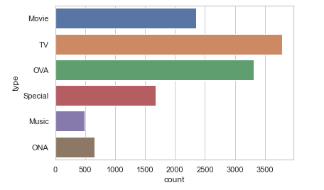

It is obvious that the highest ratings obtained on TV

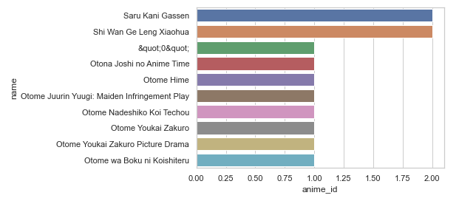

The 10 anime has received highest no of reviews.