**Anime Recommendations**

Recommender systems have taken more and more place in our lives. aimed at suggesting relevant items to users (items being movies to watch, text to read, products to buy etc..

Recommender systems are algorithms aimed at suggesting relevant items to users (items being movies to watch, text to read, products to buy or anything else depending on industries). Here we built to recommend and predict anime for users. explore the contents of this dataset to gain insights

The goal of this project is to recommend and make predictions about a user’s taste of what a user will want to watch later.

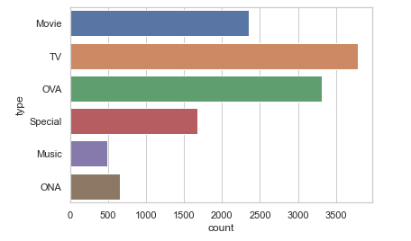

It is obvious that the highest ratings obtained on TV

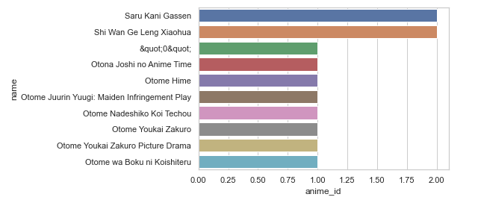

The 10 anime has received highest no of reviews.