Qatta — القطة
Step 1: Build & Refine — Making Process Documentation
Assignment 3b | Nora

1. Project Overview
Qatta (القطة) is a bilingual English-Arabic bill-splitting and debt-tracking mobile and web application. The app allows users to split expenses with friends, track who owes whom, and manage group payments — all with seamless RTL (right-to-left) Arabic language support.
The project was designed from scratch across two formats: a mobile app prototype (4 screens in phone frames) and a full browser-based web application (7 navigable pages with sidebar navigation). Both versions feature a working EN/AR language toggle that flips the entire layout direction and swaps all text content.
This project is personally meaningful because it addresses a real problem: splitting bills among friends in Saudi Arabia where both English and Arabic are commonly used. The dual-currency display (USD and SAR) reflects this real-world bilingual context.

2. Starting Point — Assignment 3a
The project began with a hand-drawn wireframe sketch showing two screens: a Welcome/Login screen with a decorative border and an envelope logo, and a Dashboard screen showing contacts with owe/owed amounts and a bottom navigation bar.
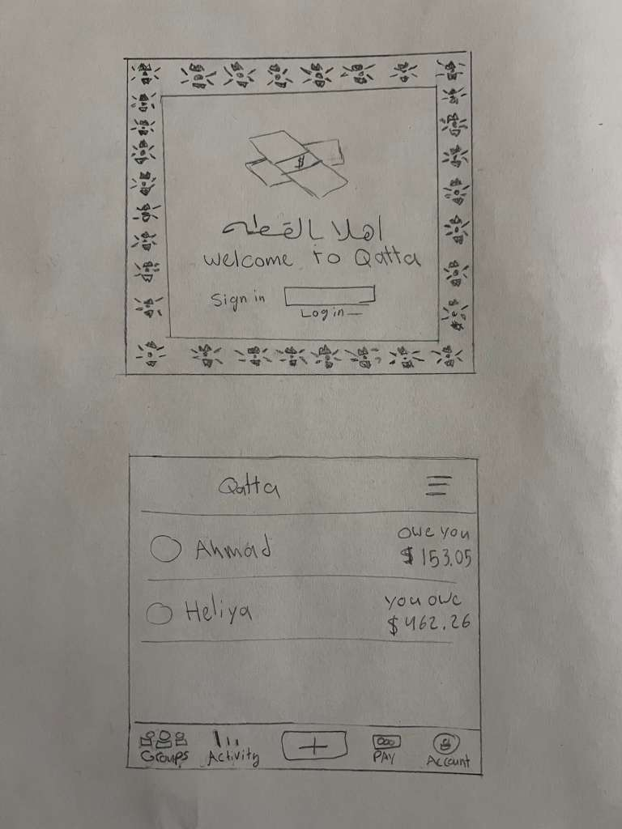
Figure 1: Original hand-drawn wireframe sketch (Assignment 3a)
The sketch established the core concept: the app name “Qatta” with Arabic text “اهلاً بالقطة”, sign in/log in buttons, contact cards showing owe/owed amounts (Ahmad: owes you $153.05, Heliya: you owe $462.26), and a bottom navigation bar with Groups, Activity, +, Pay, and Account tabs.

3. Making Process — Key Development Stages

Stage 1: Mobile App Prototype
The first major step was translating the hand-drawn sketch into a high-fidelity interactive HTML prototype. This involved critical design decisions:
- Establishing a warm gold color palette (#B8863C primary) inspired by the ornamental border in the sketch, rather than a cold fintech blue
- Selecting typography: Amiri (Arabic serif) for brand/display text, Rubik for English UI, Noto Sans Arabic for Arabic UI
- Creating the envelope illustration with SAR (﷼) symbol as SVG
- Designing 4 screens: Welcome, Sign Up, Dashboard, and Expense Detail
- Building a working EN/AR toggle using data attributes that swap all text and flip layout direction (RTL/LTR)

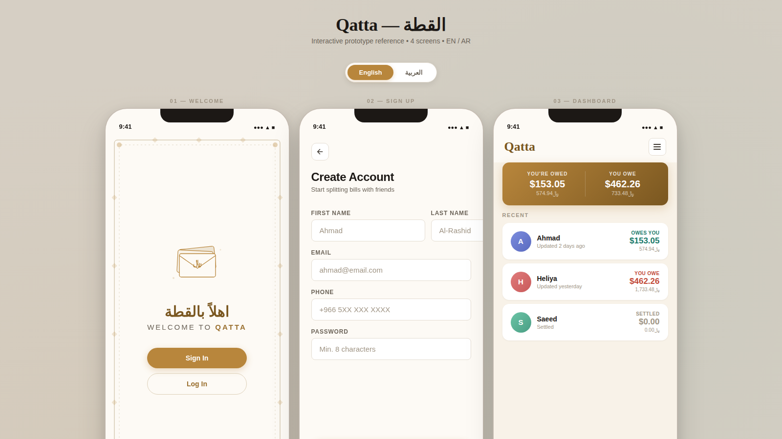
Figure 2: Mobile app prototype — all 4 screens in English (LTR)
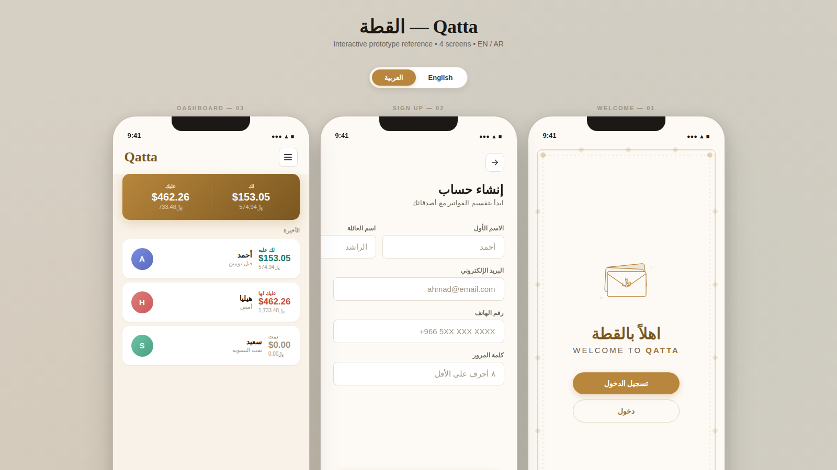
Figure 3: Mobile app prototype — all 4 screens switched to Arabic (RTL)

Stage 2: Browser Web Application
The second major stage translated the mobile concept into a full desktop/responsive web application. This required rethinking the layout for larger screens:
- Dark sidebar navigation replacing the mobile bottom tab bar
- Data table layout with status badges, monospaced currency amounts, and filter tabs
- 3 stat cards showing You’re Owed, You Owe, and Net Balance with color coding
- Activity panel showing recent transaction history
- Responsive design that collapses to mobile with hamburger menu

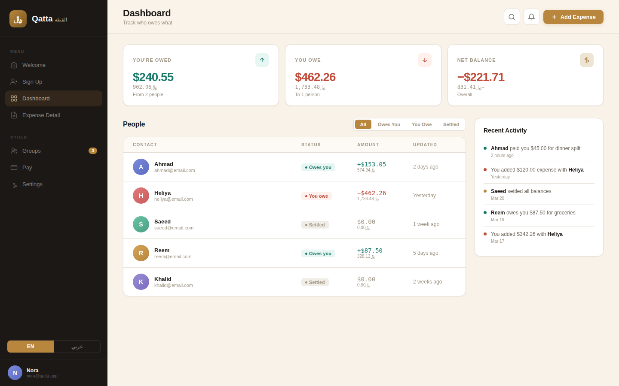
Figure 4: Web application — Dashboard view with stats, contact table, and activity panel
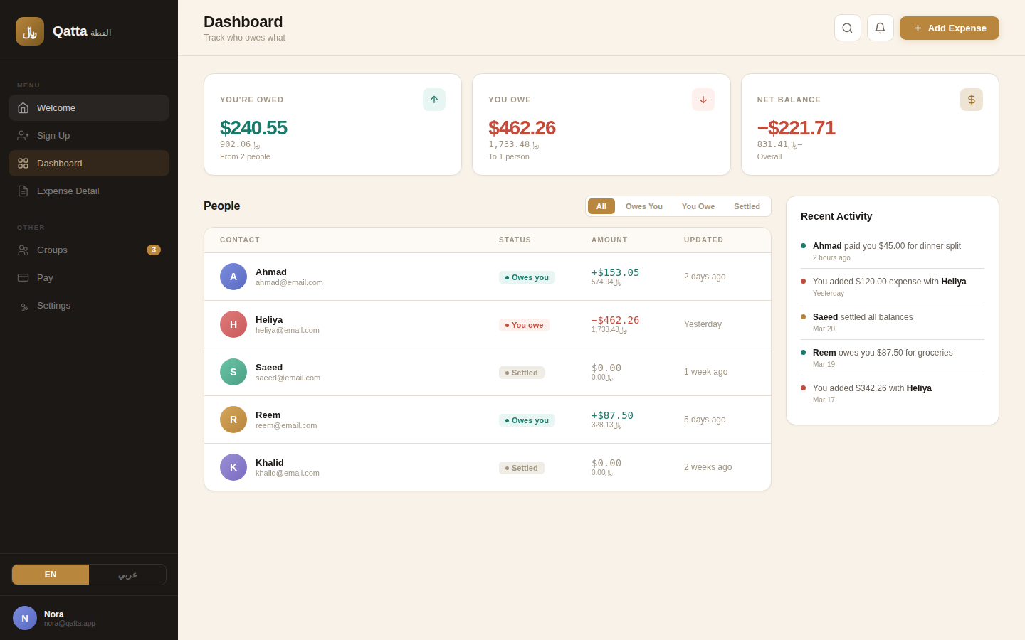
Figure 5: Web application — Welcome screen with decorative card

Stage 3: Expanding to 7 Full Pages
Based on review, the web application was expanded from 4 views to 7 fully navigable pages. Three new sections were added:
- Groups page: Showing shared expense groups (Apartment, Dubai Trip, Lunch Crew) with member lists and group balances
- Pay page: Showing pending payments and collections with action buttons (Pay Now, Remind)
- Settings page: User profile, language toggle, currency preferences, notifications, and app info

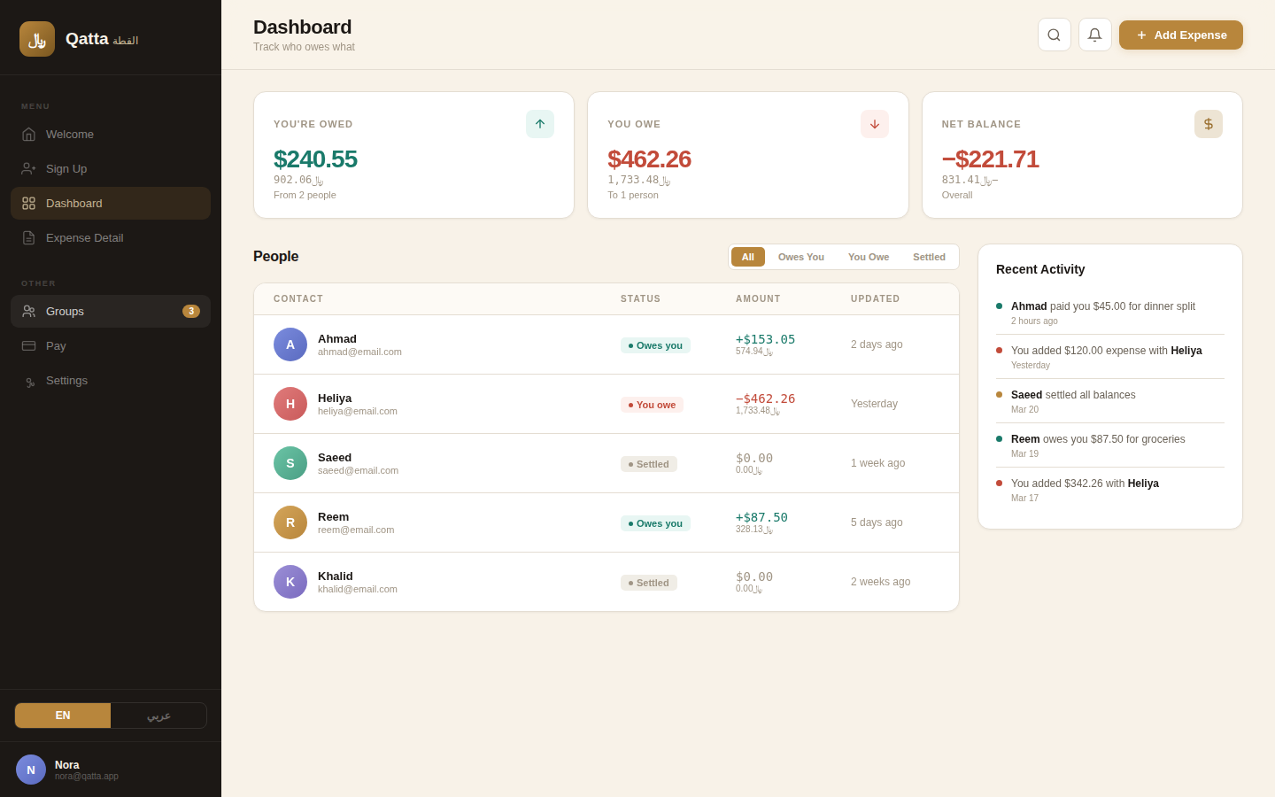
Figure 6: Groups page — shared expense groups with member counts and balances
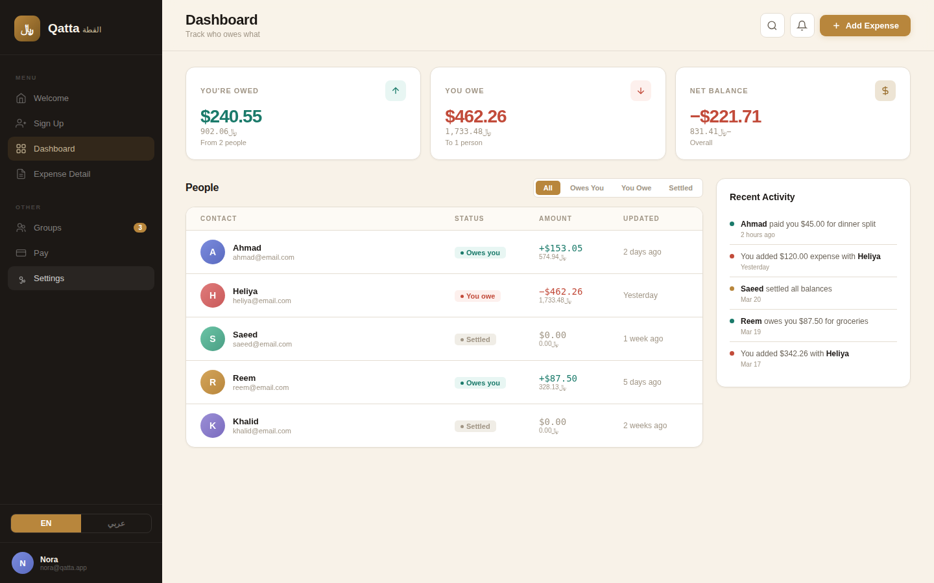
Figure 7: Settings page — profile, preferences, language toggle, and about section

Stage 4: Iteration and Refinement
Multiple rounds of testing and revision shaped the final product. Key iterations included:

Issue | Change Made
User identity | Changed all instances of “Abdullah” to “Nora” across both prototypes — sidebar, avatar initials, expense detail, email addresses
Navigation | Made all 7 sidebar menu items clickable and navigable (Groups, Pay, Settings were not linked initially)
Script blocking | Identified and removed Cloudflare-injected script tags that were blocking all JavaScript, preventing any interactivity from working
Email obfuscation | Fixed Cloudflare email protection that was replacing all email addresses with [email protected] placeholder links
Dual currency | Added SAR (﷼) amounts below every USD amount across all screens for bilingual context
Language sync | Synchronized the EN/AR toggle between sidebar and Settings page so both stay in sync when switching languages


Figure 8: Web application in Arabic (RTL) mode — full layout mirroring

4. Supporting Deliverables
Beyond the two interactive prototypes, two additional assets were created to support the Adobe XD design workflow:
- SVG Design System: Complete color palette (Sand, Gold, Teal, Coral, Ink), typography samples, spacing scale, border radii, avatar gradients, button specs, status badges, and icon set — all importable directly into Adobe XD.
- PDF Specification Document: 3-page spec with exact dimensions, spacing, component sizes for all screens, full EN↔AR text swap reference table, and Adobe XD implementation notes (grid setup, component states, Auto-Animate tips).

5. Development Summary
The project evolved through clearly defined stages, each building on the last:

Stage | Deliverable | What Changed
3a | Hand-drawn sketch | 2 screens (Welcome + Dashboard), pencil wireframe, basic layout concept
3b — v1 | Mobile prototype | 4 screens, gold palette, SVG illustrations, EN/AR toggle, dual currency, phone frames
3b — v2 | Web prototype | Full browser app, sidebar nav, stats dashboard, table view, activity panel, responsive
3b — v3 | Expanded + refined | 7 pages (added Groups, Pay, Settings), Nora identity, bug fixes, full interactivity, language sync
Assets | SVG + PDF spec | Design system (colors, type, icons, components) + 3-page specification document with XD notes

The project demonstrates sustained iteration — from a pencil sketch to two fully interactive, bilingual, multi-page prototypes with supporting design assets, refined through multiple rounds of testing and problem-solving.

