



Spark
Saudi Platform for AI-Driven Recognition & Knowledge

Sprint-0 Report

Prepared by

<Mariam Alahmed, 443204628>
<Nora Fisal Albyahi, 443200479>
<Raghad Sultan Aldajani, 443200551>
<Aljwharah Ali Alhowidy, , 443201015>

Supervised by
<Dr. Sharefah Alghamdi>

Table of Contents

1 Introduction 3
1.1 The Problem 4
1.2 The Solution 4
1.3 Product 5
1.3.1 Product Vision 5
1.3.2 Product Roadmap 5
1.3.3 Objectives 6
1.3.4 Scope 7
1.3.5 Hardware/Software Tools and Cost 8
1.4 Scrum Team 9
1.4.1 Skill Set Requirements 9
1.4.2 Roles and Responsibilities 11
2 Background 11
2.1 Esports and Their Ecosystem 11
2.2 Roles and Team Formation in MOBAs 11
2.3 Data and Analytics in Esports 12
2.4 Machine Learning in Prediction 12
2.5 Gamification and Motivation 12
3 Literature Review 13
3.1 Win/Loss Prediction in Team Esports 13
3.2 Gamification for Motivation 13
3.3 Relevance to SPARK 13
3.4 Competitive Product Analysis 14
4 System Description 17
4.1 Users 17
4.2 Requirements Elicitation 18
4.3 Architecture 21
4.4 Use Case Diagram 22
4.5 Product Backlog Table 23
Feature / Gamification 28
4.6 Non-functional requirements 29
Feature / Performance 29
Feature / Usability 29
Feature / Security 29
Feature / Robustness / Reliability 29
5 References 30
6 Appendix 32
6.1 APPENDIX A: Questionnaire for requirements elicitation 32
6.2 APPENDIX B: Interviews for requirements elicitation 35
6.2.1 Players interviews 35
6.2.2 Organizer interviews 38
6.3 APPENDIX C: Jira & Github for manage the project 39

List of Tables:

Table 1: Hardware/Software Tools and Cost 9
Table 2:Skill Set Requirements 9
Table 3: Roles and responsiblities 11
Table 4: Competitive Product Analysis summery 17
Table 5: Product Backlog 28
Table 6: Non-functional requirements 29
Table 7: interview 1 outline 36
Table 8: interview 2 outline 36
Table 9: interview 3 outline 37
Table 10: interview 4 outline 38
Table 11: interview 5 outline 39
List of Figures:
Figure 1 SPARK Roadmap 5
Figure 2 Architecture 19
Figure 3 SPARK Use Case Diagram 20
Figure 4 Questionnaire Results – Gender Distribution 30
Figure 5 Questionnaire Results – Age Distribution 30
Figure 6 Questionnaire Results – Roles of Participants 30
Figure 7 Questionnaire Results – Main Difficulties in Tournaments 30
Figure Questionnaire Results – Importance of AI in Predicting Win Probability 31
Figure Questionnaire Results – Impact of Rewards and Digital Badges on Motivation 31
Figure Questionnaire Results – Participants’ Suggestions for Platform Features 32

Introduction
The esports industry has emerged as one of the most rapidly growing sectors in the digital entertainment domain, attracting millions of players and audiences worldwide. In Saudi Arabia, esports has witnessed remarkable development in recent years, strongly supported by Vision 2030 initiatives to enhance digital transformation and create a sustainable gaming ecosystem [1].
However, despite this progress, many talented local players continue to face difficulties in gaining visibility and accessing professional opportunities. Teams and organizers also encounter challenges in identifying and evaluating players due to the lack of reliable, data driven platforms tailored to the Saudi context [4]. This gap limits the growth of the esports community and slows the recognition of emerging talents. Addressing this problem through a technological solution is of great significance both locally and globally. Locally, it empowers Saudi gamers, promotes fair opportunities, including women who face additional challenges in visibility [2], and supports the national agenda for digital entertainment and economic diversification. Globally, it contributes to the development of standardized, intelligent systems for player evaluation and fosters cross-border opportunities in the international esports industry.
In this document, we present the overall problem, propose an AI-powered solution, outline the vision and roadmap of the project, define its objectives and scope, and specify the tools, resources, and roles required to ensure successful implementation.

The Problem
The esports industry in Saudi Arabia is witnessing rapid growth, supported by national initiatives and the increasing interest of millions of players [1]. Despite this progress, there is still a clear gap between talented players and professional opportunities. Many skilled players struggle to showcase their performance or prove their abilities, as there are no localized platforms that provide fair visibility and recognition [4]. Female gamers, although increasingly active, face an additional challenge of limited exposure compared to male players [2].
A concrete example of this issue is the large difference between the millions of amateur and semi-professional players in the Kingdom and the very limited number of officially recognized professionals—only around 100 full-time players. Reports show that aspiring Saudi competitors often cite a lack of funding, limited local competition, no clear pathway to become professional, and social stigma around esports as a career [3]. While many Saudis participate in esports, only a small fraction succeed in moving to a professional level, which highlights the absence of structured tools that can reliably highlight and evaluate player performance [5].
Our project focuses on this part of the problem: the lack of a local platform that allows Saudi players to fairly showcase their skills and connect with teams and tournaments in an organized and trustworthy way.

The Solution
SPARK focuses on addressing this gap by developing a local intelligent platform that allows Saudi players to fairly showcase their skills and connect with teams and tournaments in an organized and reliable manner [5]. SPARK analyzes team composition and predicts the probability of winning after forming a team, enabling teams to try alternative formations and improve their chances before entering competitions. SPARK also provides female players with an equal opportunity to demonstrate their skills and compete on the same level as male players, addressing the issue of limited visibility for women [6]. Additionally, SPARK offers a structured local competitive environment that mitigates the problem of scarce tournaments and helps present esports in a more professional light within the Kingdom [7].
This solution directly contributes to addressing the issue of limited visibility and lack of organized opportunities for Saudi players [7]. SPARK enables both amateur and semi-professional players to gain fair recognition and supports the discovery of new talent by teams and organizers [7]. Furthermore, it enhances societal recognition of esports as a legitimate professional pathway within the Kingdom. In the long term, SPARK strengthens the infrastructure for esports, aligns with the goals of Vision 2030 in the digital entertainment sector, and reduces the gap between aspiring players and professional pathways [7] In the next section, we’ll get deeper into the product vision.

Product

Product Vision

Product Vision:
For Saudi esports players, teams, and organizers,
Who seek greater opportunities to gain visibility, join suitable rosters, and participate in professional tournaments,
The SPARK is an AI-powered esports platform,
That helps teams discover the right players, empowers players to showcase their skills, and provides reliable local competitive opportunities,
Unlike other competitors such as saudiesports,
Our product leverages intelligent insights to support decision-making, and richer player profiles, ensuring fair recognition and stronger team formations

Product Roadmap

In this section, we will outline "SPARK" app roadmap. Figure 1-1 shows the product’s development and delivery timeline.
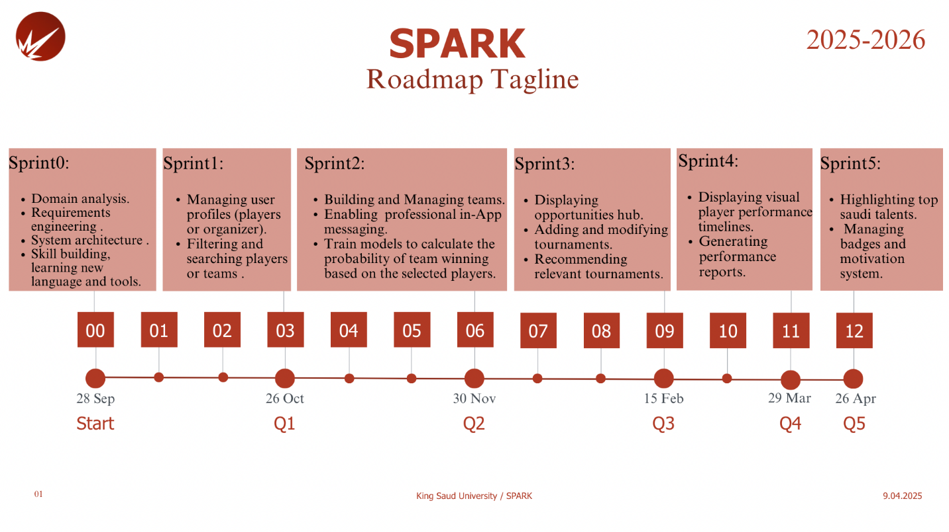
Figure 1 SPARK Roadmap

Objectives

In this section, we will outline the product, project, and learning objectives associated with the development of the "SPARK" platform. These objectives define the key goals and desired outcomes we aim to achieve by the completion of the project.
- Product (customer focus-value):
These objectives focus on solving problems and delivering benefits through key features:

- allow both players and organizers to manage their own profiles.
- Facilitate talent discovery and connect Saudi players with opportunities.
- Enable players to create and manage their own teams within the platform
- Analyze players using Artificial Intelligence to calculate the probability of a team winning.
- Launch an Opportunities Hub for tournaments and challenges.
- Provide performance support and motivation tools.
- Highlight local Saudi esports talents.

- Project (solution focus-plan):
These objectives define the tasks and stages necessary to complete the project:

- Conduct interviews and surveys with esports players, teams, and organizers to gather requirements and feedback.
- Collect and preprocess player performance data from the API such as Riot Games API [11].
- Analyze and clean the collected data to prepare it for AI model training, then train models to calculate the probability of a team winning based on the selected players.
- Identify user needs and ensure the mobile app features (profiles, teams, tournaments, reports) meet those needs.
- Design user-friendly mobile interfaces using Figma [17] for both players and organizers.
- Develop the mobile application in Flutter [12], implementing:
• Player and organizer profiles.
• Team building and management.
• Tournament hub and applications.
• In-app messaging.
- Create and connect a database (Firebase [15]/MySQL [16]) to store user accounts, match history, teams, and tournament details.
- Test the application thoroughly to ensure functionality, usability, and accurate AI predictions.
- Deploy the application on devices and gather user feedback for improvements.

- Learning (student focus):
These objectives focus on new skills and tools to be learned:

- Gain hands-on experience in mobile application development using Flutter [12].
- Apply Artificial Intelligence techniques to real-world esports data to calculate team win probabilities.
- Gain practical skills in working with external APIs, such as the Riot Games API [11], for data collection and integration.
- Strengthen knowledge of cloud-based databases using Firebase [15]/MySQL [16] for real-time data management.
- Learn how to implement gamification elements [18] (badges, achievements) to motivate users in a mobile app.
- Improve agile project management and teamwork skills [19]by working in sprints and collaborating on a multi-module application.
- Enhance problem-solving and critical thinking [20]by addressing challenges in data preprocessing, AI modeling, and mobile app integration.

Scope

In this section, we will define the limitations of our platform and outline what is outside the scope of this project, which may be considered for future development.

The "Spark" platform is a mobile application for esports players, teams, and organizers in Saudi Arabia. It allows profile management, team building, tournament browsing and applications, and AI-powered team win probability predictions. The app includes performance reports, visual timelines, and gamification features. It supports English on mobile devices using android Flutter, with future expansion to additional languages, or other platforms possible. Features such as live streaming, web support, third-party payments, or player tag verification are outside the current scope. Player tag verification will be considered in the future, potentially in collaboration with an external company to ensure secure and reliable validation.

Hardware/Software Tools and Cost

This section outlines the hardware and software resources required to develop and implement the SPARK application. It includes all necessary development environments, frameworks, APIs, and supporting tools for building, testing, and deploying the solution. Each tool’s purpose and associated cost are summarized in Table 1.

Hardware Tools
Name and Description | Cost
Computers for software development | Available
An android smartphone for testing a mobile application | 500-900 SAR
Software Tools
Name and Description | Cost
Python - [8] with libraries such as pandas, scikit-learn [9], and NumPy [10] – used for AI model training, data analysis, and feature engineering. | Free
API such as Riot API- [11] provides access to player match history, performance data, and statistics. | Depends on the chosen API
Flutter - [12] open-source frameworks for building cross-platform mobile applications from a single codebase. | Free
GitHub - [13] a version control and collaboration platform for managing the source code. | Free
Jira - [14] agile project management tools for task tracking and sprint planning. | Free
Database Management System – Firebase [15] / MySQL [16] for storing user accounts, match history, and tournament details | Free
Figma [17] cloud-based design tool for creating UI wireframes and prototypes. | Free
Table 1: Hardware/Software Tools and Cost

Scrum Team

Skill Set Requirements

This section identifies the technical skills required for developing the SPARK application, the team’s current proficiency levels, and the plan to address any skill gaps.
Table 2 provides an overview.

Technical Skill Required | What is the current level of the team (beginner-intermediate- advanced) for each skill? How will the gap be bridged? (if necessary) Learning plan
Python Programming | Intermediate – The team has prior experience with Python and will continue strengthening skills using documentation and online resources.
Machine Learning | Intermediate – The team will enhance skills through online machine learning courses and tutorials.
Flutter | Beginner – Team members will learn through official documentation, online courses, and self-learning.
API Integration | Beginner – The team will practice through tutorials and documentation.
Front-End Development | Intermediate – Team members will enhance their skills through Figma prototyping and learning modern responsive design practices.
Back-End Development | Beginner – team members will be learning server-side programming and database management, practicing open-source contributions, and keeping up to date with backend technologies.
Data Collection & Visualization | Intermediate – the team will apply Python libraries such as Pandas and Matplotlib for analyzing features, and use visualization tools like Tableau.
Table 2:Skill Set Requirements

Learning
The team has worked on developing the required skills in a balanced manner, combining both theoretical learning and practical application. In terms of data collection and API integration, the team started using the Riot Games API and successfully retrieved and initially processed player and match data. Regarding AI model training, Python along with libraries such as NumPy and scikit-learn was used to prepare the data and conduct initial experiments to predict team win probabilities. For interface design, Figma was used to develop wireframes and test user flow, with initial screen designs prepared for later implementation in Flutter. An ERD was also created to document the database design in line with the project requirements, although the practical integration with Firebase/MySQL has not yet been completed.
In addition, the team gained practical experience with project management tools such as Jira and GitHub to organize tasks and track progress. These efforts demonstrate that the team has gone beyond theoretical learning, engaging deeply in various technical aspects, which has helped build a solid foundation for completing the project efficiently in the upcoming phases.

Roles and Responsibilities

Scrum Team
Product Owner: | Dr. Sharefah Alghamdi
Developers: | Nora Fisal Albyahi  Raghad Sultan Aldajani  Mariam Alahmed  Aljwharah Alhwiedy
Scrum Master (SM): | Dr. Sharefah Alghamdi
Stakeholders: | The Examiners Committee at King Saud University, Saudi esports players and teams.
Table 3: Roles and responsiblities

Background

Esports are growing rapidly worldwide, combining the excitement of sports with the strategy of video games. To understand the motivation for SPARK, this section introduces key concepts: what esports are, which games dominate the scene, the role structure in multiplayer games, the use of data and machine learning (especially logistic regression), and how gamification elements such as badges sustain participation.

Esports and Their Ecosystem

Esports are organized, competitive video-game contests played at amateur, semi-professional, and professional levels. Like traditional sports, they involve players, teams, coaches, organizers, broadcasters, and fans. Global tournaments now attract millions of viewers and significant sponsorship.

Popular game genres in esports include:

- MOBA (Multiplayer Online Battle Arena) — 5v5 team-based strategy games such as League of Legends and Dota 2. These emphasize roles, teamwork, and objectives spread across a map.
- FPS (First-Person Shooter) — titles such as CS:GO or Valorant, where teams compete in round-based shooting matches with tactical coordination.
- Sports simulations — such as FIFA or NBA 2K, which replicate real sports through digital competition.

In Saudi Arabia, esports are recognized under Vision 2030 as part of the digital economy and youth engagement strategy. The Saudi Esports Federation hosts national and regional events, while Riyadh is home to the Esports World Cup, one of the largest global tournaments.

Roles and Team Formation in MOBAs

In MOBAs like League of Legends, each team has five specialized roles:
- Top — durable solo laner, often absorbing pressure.
- Jungle — roams the map, controls objectives, creates surprise attacks.
- Mid — central playmaker with high flexibility.
- ADC (Attack Damage Carry) long-range damage dealer, strong in later stages.
- Support — vision control, protection, and initiation.

Each role has different responsibilities, so evaluating players without considering role leads to unfair comparisons. For example, “gold earned” is meaningful for an ADC but less so for a Support. Hence, role awareness is a cornerstone of modern esports analytics.

Data and Analytics in Esports

Game APIs (like the Riot Games API) expose structured data: match history, player stats, and outcomes. From this, analysts compute rate-based features such as:
- KDA = (Kills + Assists) ÷ max(1, Deaths).
- CS/min = farming efficiency.
- Gold/min = economy growth.
- Vision score = map control through wards/vision.
- Kill participation (KP) = share of team kills a player contributed to.
These metrics allow fair comparisons across games of different lengths and help track performance trends over time.

Machine Learning in Prediction

Machine learning is widely used in esports research for win/loss prediction and performance evaluation.
- Supervised learning uses past matches to train models that can predict future outcomes.
- Logistic regression is one of the most common methods. It is a simple, explainable algorithm that outputs a probability between 0 and 1 — for example, “Team A has a 65% chance to win.”
- More complex models (Random Forests, Neural Networks, LSTMs) are also explored, but logistic regression is often preferred when clarity and speed are important.
In related fields (sports analytics, healthcare, finance), logistic regression is valued for balancing interpretability with predictive power.

Gamification and Motivation
Gamification means adding game-like elements such as badges, streaks, points, or leaderboards into non-game systems. In esports platforms, these elements are mainly cosmetic rewards that recognize participation and achievement without changing gameplay balance.
Common examples include:
- Streak badges — for playing on consecutive days.
- Win streak badges — for achieving consecutive victories.
- Milestone badges — for reaching goals such as 100 wins.
Such elements provide visible progress and recognition, which can encourage consistency and friendly competition. They are meant to motivate players and sustain engagement, not to affect the outcome of matches or the fairness of competition.

Literature Review

This chapter reviews prior research relevant to SPARK, focusing on two areas: (1) win/loss prediction in team esports and (2) gamification for motivation. By analyzing key studies, we identify methods and insights that guide our system design.

Win/Loss Prediction in Team Esports

Win/loss prediction in multiplayer online battle arena (MOBA) games such as League of Legends (LoL) and Dota 2 has been widely studied using machine learning.
Costa et al. [26] analyzed the picks and bans phase in LoL and showed that logistic regression and random forests can achieve strong performance using pre-game features. Lin [27] compared pre-match and in-game features, finding that although in-game signals are stronger, pre-game data still provides useful predictive value when decisions must be made before the match begins.
In Dota 2, Kinkade et al. [28] demonstrated that both rich and reduced input sets can predict outcomes but highlighted the trade-off between timeliness and accuracy. Johansson [29] extended this work with sequence-based models such as LSTMs on draft order, confirming that draft data alone has measurable predictive value.
These studies build on logistic frameworks such as Bradley–Terry comparisons [30] and Elo ratings [34], which introduced probability-based approaches to performance comparison. Research also highlights the need for probability calibration, with Niculescu-Mizil and Caruana [31] and Zadrozny and Elkan [33] showing that Platt scaling and isotonic regression improve reliability. Evaluation methods such as the Brier score [32] are commonly used to judge probability quality.

Gamification for Motivation

Gamification introduces game-like elements such as badges, streaks, and leaderboards into non-game systems to encourage participation.
Hamari, Koivisto, and Sarsa [21] reviewed gamification studies and found overall positive effects, while stressing that results depend on context and design. Mekler et al. [22] tested elements such as points and badges, observing consistent increases in performance quantity but mixed effects on intrinsic motivation. Sailer et al. [23] showed that badges and leaderboards can increase competence satisfaction and task meaning when implemented carefully.
Practical design guides by Werbach and Hunter [24] and Zichermann and Cunningham [25] emphasize that gamification should serve as recognition rather than competitive advantage, relying on transparency and fairness to keep players engaged.

Relevance to SPARK

Taken together, these strands provide two foundations for SPARK. Research on win/loss prediction supports the use of logistic regression on recent, role-aware, rate-normalized features to generate a clear pre-match probability, with calibration methods considered for future refinement. Studies on gamification justify the inclusion of cosmetic badges such as Pulse, Rampage, and Apex, which recognize consistency and milestones without affecting fairness. By combining these insights, SPARK positions itself as a team-focused platform that offers both predictive decision support and light motivational cues.

Competitive Product Analysis

This subsection reviews nearby platforms to understand what they offer and what is missing for team formation. We compare key features—player profiles, lineup optimization, pre-match team percentage, multi-game support, tournaments, badges, and mobile access—to position SPARK clearly.


1. OP.GG
OP.GG is one of the leading platforms specialized in tracking player statistics and analyzing their performance in competitive games in general. The platform is well-known for its large database and tools that help players review their results, compare their performance with others, and see their ranking on the server or within the game. [35]
Features:
- Player Profiles & Statistics: Provides comprehensive profiles including match history, win rates, and performance analysis by characters or roles. These statistics help players review their performance and improve their gameplay strategies.
- Leaderboards: Collects and analyzes match data, then ranks players based on performance indicators such as KDA (Kills/Deaths/Assists), win rates, and overall team impact, making it easy to identify the top players on the server.
- Support for Multiple Games (Wide): Not limited to a specific game, but extends to support various competitive games.
Differentiation:
- Strengths: Large database, detailed analysis for each role within the team, accurate metrics like KDA, ability to track progress across multiple matches, and resource/performance analysis by game phase.
- Weaknesses: Interface can be difficult for new users, and lacks interactive features like chat, achievements, or pre-match predictions offered by other platforms.
Comparison to SPARK:
- Strengths of SPARK: Easy and simple user interface, focus on social interaction such as in-app chat and achievements (Badges), provides AI-based team win probability estimates after team formation, and supports tournaments, making the user experience more comprehensive in terms of social interaction and predictions.
- Weaknesses of SPARK compared to OP.GG:Does not have a large database like OP.GG, making its analysis and statistics less comprehensive, Limited number of supported games compared to OP.GG, which covers a wide range of competitive games.



2. Kafugames
Kafu Games is a Saudi platform specialized in organizing and managing e-sports tournaments. The platform focuses on providing a comprehensive experience for players and organizers through tournament management tools, support for a variety of games, and fostering community interaction. [36]

Features:
- Tournament Management: Provides easy-to-use tools for managing teams, creating schedules, and tracking results smoothly.
- Support for Various Games: The platform supports a wide range of competitive games.
- User-Friendly Experience: Intuitive interface, instant notifications, and customizable profiles.
- Interactive Community: Allows players to interact with each other and follow competitions directly.

Differentiation:
- Strengths: Strong focus on tournament organization, easy-to-use interface, and an active, engaging community.
- Weaknesses: Limited expansion outside Saudi Arabia, and less advanced statistical analysis compared to platforms relying on large databases.

Comparison to SPARK:
- Strengths of SPARK: Easy-to-use interface, focus on social interaction such as chat and achievements (Badges), AI-based team win probability estimates, and tournament support.
- Weaknesses of SPARK compared to Kafu Games:
  - Tournament management tools are less advanced than Kafu Games, making team and schedule management less seamless.



3. Saudiesports.sa
Saudi Esports is the official platform responsible for developing and organizing e-sports in Saudi Arabia. The platform focuses on hosting regional and international tournaments, developing talent, and fostering community interaction in a professional environment. [37]

Features:
- Tournament Management: Hosts major local and regional tournaments, with professional tools to manage teams, schedules, and match results.
- Talent Development: Offers specialized training programs in coaching, refereeing, and management, in collaboration with global academies.
- Strategic Partnerships: Collaborates with major companies to enhance digital infrastructure and provide opportunities for local talent.
- Professional Competitive Environment: Provides modern facilities for hosting tournaments and competitions, such as SEF Arena.
Differentiation:
- Strengths: Organizes regional and international tournaments, professional training programs, strategic partnerships with major companies, and modern facilities.
- Weaknesses: Does not provide detailed player performance analytics, and focuses primarily on major tournaments rather than offering advanced tools for beginners or smaller local competitions.
Comparison to SPARK:
- Strengths of SPARK: Easy-to-use interface, focus on social interaction such as chat and achievements (Badges), AI-based team win probability estimates, and tournament support.
- Weaknesses of SPARK compared to Saudi Esports:
  - Lacks professional training programs for talent development.
  - Tournament scope is limited compared to the regional and international competitions offered by Saudi Esports.
  - Does not have strategic partnerships or professional facilities for large-scale tournaments

Feature / Platform | OP.GG | kafugames | Saudiesports.sa | SPARK
Type of System | Web & App | Web | Web | App
OS Support | All, IOS, Android | All, IOS, Android | All | Android
Player Profile Management & Statistics | ✔ | ✔ | ✔ | ✔
Filtering and searching players or teams. | ✔ | ✔just player | ✔ | ✔
Building and Managing teams. | ✔ |  | ✔ | ✔
App messaging. |  |  |  | ✔
Predicts the probability of a team winning using AI |  |  |  | ✔
Tournaments & Opportunities |  | ✔ | ✔ | ✔
Badges / Achievements |  |  | ✔ | ✔
Highlighting top talents. | ✔ | ✔ | ✔ | ✔
Table 4: Competitive Product Analysis summery

After examining various e-sports platforms, we found that most share features such as player statistics, team management, player and team search, and tournament organization, with differences in scope and additional functionalities.
SPARK stands out by providing AI-driven team win probability predictions for each player after team formation, detailed player performance analytics, and social interaction features such as chat and achievements through the app, offering an interactive and predictive user experience. However, its tournament scope and cross-platform accessibility may be more limited compared to other platforms like Saudi Esports and Kafu Games

System Description

Users
The SPARK platform targets three main categories of users, each with general characteristics in terms of educational level, experience, and technical expertise:
1. Players
- Educational Level: Mostly teenagers and high school students or above.
- Experience: They possess moderate to strong experience in competitive gaming but lack professional tools to showcase their skills.
- Technical Expertise: Proficient in using smartphones, interactive applications, and online gaming platforms. The application provides players with detailed profiles, accurate statistics, and opportunities to join teams and tournaments, enabling them to present their skills professionally.
2. Teams
- Educational Level: Diverse (students, graduates, or employees interested in esports).
- Experience: Team leaders usually have hands-on experience in managing teams, while other members vary in their expertise levels.
- Technical Expertise: Intermediate to advanced, including the use of team management platforms and communication tools. The application allows teams to search for suitable players, build different lineups, and analyze win probabilities using Artificial Intelligence.
3. Organizers
- Educational Level: Typically university graduates in technical or administrative fields.
- Experience: Experienced in organizing local or regional esports events and tournaments.
- Technical Expertise: Moderate, requiring simple and intuitive interfaces to manage tournaments, publish announcements, and monitor teams and players. The application provides organizers with a dashboard to create tournaments, track registrations, and communicate with players and teams in an organized and efficient manner.
Overall, the SPARK platform is designed to be a comprehensive and user-friendly solution that meets the needs of all stakeholders in the esports ecosystem, enhancing visibility, collaboration, and sustainable growth.

Requirements Elicitation

We conducted five interviews with players and organizers to explore the challenges they face in participating in or managing gaming tournaments, how they track performance, and their expectations for a better platform. Several common challenges emerged, including difficulties in finding suitable teams, late notifications of tournaments, communication issues, and registration hurdles, along with insights into how a modern application could improve the experience.

In the first interview, Omar Salem mentioned that proving himself to teams is difficult, especially when he doesn’t have a track record. He sometimes misses tournaments because he finds out about them too late, and registering for events can take a long time. He has tried platforms like Saudiesports.sa and kafugames, but they provide only basic profiles and stats. He prefers performance to be displayed using a mix of numbers and visual charts, which would help teams understand his progress and compare him with other players. Full match history is extremely important for building trust, and direct communication with teams or organizers would save a lot of time. He also finds motivational features like badges useful because they give him goals beyond winning matches.

The second interview was with Khalid Al-Mutairi. He shared that it is challenging to show he is a good player, and sometimes he gets ignored because he doesn’t have much history. Signing up for tournaments can be confusing. He has used Saudiesports but finds it lacks detailed stats, charts, and performance comparisons. He prefers a combination of charts, numerical stats, and rankings compared to peers. Full match history is extremely important for him, and he values a built-in chat system for easier coordination. Motivational features are meaningful if they represent real achievements.
In the third interview, Reem Al-Zahrani explained that sometimes registration is complicated or the information is unclear, but well-organized teams make it easier. She occasionally uses platforms to manage her profile, but she focuses more on overall skill visibility rather than detailed stats. She prefers a balanced display of key numbers and visual charts showing trends over time. Full match history is somewhat important, while badges and achievements are nice but not essential. She is fine with communication happening through other channels if needed.

For the organizers, the first interview was with Sara AlMutairi. She said that communication is the hardest part of organizing tournaments because players contact them through different platforms, and it’s difficult to keep everything in one place. They use Battlefy for registration, but she still needs to double-check player details manually. Evaluating players is usually done by looking at their profiles and past matches. She thinks it would be very helpful if the platform could show suggestions based on past performance and stats. Promotion is expensive and reaching new players is difficult. She needs performance reports after tournaments, highlighting top performers, win rates, and key moments.

The second organizer interview was with Fahad AlHarbi. He explained that scheduling is the biggest challenge because players often miss matches, and rescheduling causes delays. Verifying IDs is also a hassle. He usually relies on past matches to evaluate skill, but it can be hard if profiles lack detail. Suggestions from the platform based on stats would make organizing matches easier. Reaching the right audience is difficult, and he also wants performance reports during and after tournaments, including consistency, win rates, and head-to-head comparisons.
Overall, the interviews show that both players and organizers face challenges in communication, registration, and performance evaluation. Players want professional profiles, full match history, visual progress tracking, motivational features, and easy communication. Organizers want help in evaluating players, suggestions for suitable teams, and clear performance reports. Both groups are looking for a platform that makes tournament participation and management more efficient and transparent.

In parallel, a survey with 50 responses provides clearer insight into the needs of Spark’s community. Most respondents are players (84%) with a near-even gender split (52% male, 48% female), predominantly aged 18–24 (68%). Overall, the ease of finding local tournaments is rated around average, with responses clustering in the middle. The most cited challenges are difficulty joining teams (40%) and lack of available opportunities (30%), followed by limited information (18%). Interest in key features is high—especially tournament recommendations by skill level (60%), player/team search (58%), and a profile showcasing statistics (52%). There is also strong demand for a local leaderboard (96%) and solid motivation from rewards or digital badges (82%). The importance of AI for estimating winning probability is moderate but positive, indicating openness to AI provided it delivers practical value. These findings suggest Spark should focus on improving discovery and player–team matching, offering reliable tournament information, rich performance profiles, and motivational systems enhanced with explainable AI.

Architecture

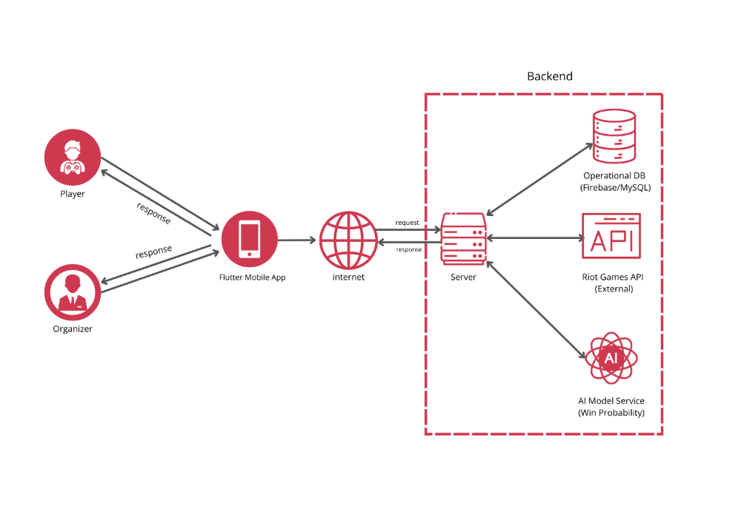

Figure 2 Architecture

The SPARK system follows a client–server architecture. The Flutter mobile app provides the user interface for Players and Organizers. A backend API handles authentication, profiles, team management, tournaments, and reporting. The backend integrates with the Riot Games API to ingest match history and player statistics, stores operational data in a central database (Firebase/MySQL), and invokes a separate AI Model Service to compute team win probability. A lightweight feature store is used to keep engineered features for inference. This decomposition separates concerns, improves scalability, and simplifies maintenance while supporting responsive user interactions.

Use Case Diagram
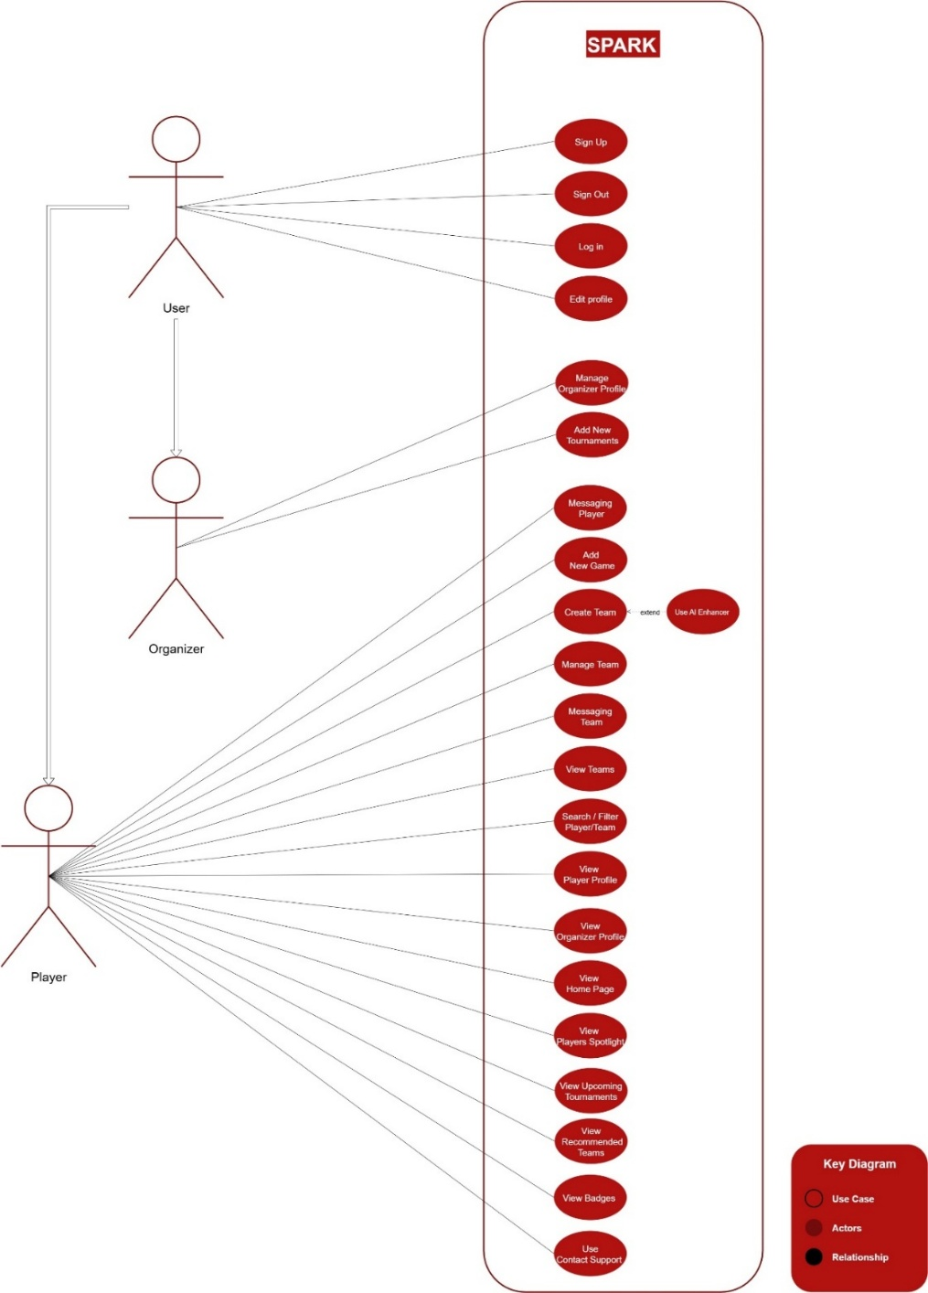
Figure 3 SPARK Use Case Diagram

The Use Case Diagram provides a high-level visual representation of the interactions between SPARK’s users and the system. It highlights the primary actors—Players and Organizers—and their main goals or tasks within the platform. The diagram illustrates how users engage with key functionalities such as profile management, team building, tournament adding and maneging, and win-probability insights, offering a clear overview of system usage without going into implementation details.

Product Backlog Table

PBI  (user story) | Size  (Story points) | Type  (Feature, defect, technical work, knowledge acquisition) | Acceptance Criteria  The conditions of satisfaction that must be met for that item to be accepted.
As a user (player or organizer), I want to sign up with my username, email and password so that I can create an account and access the application's features. | 2 | Feature | - As a nonregistered user (player or organizer), if I go to the sign-up page and enter my email and a password longer than 8 characters, then click the "Sign Up" button, I should be able to create an account and access the application.  - If I try to sign up using an email that is already registered, I should see an alert telling me that the email is already in use, and the account should not be created.  - If I leave any required field empty or enter invalid information, I should see an alert telling me to complete the required fields correctly before creating the account.
As a user (player or organizer), I want to sign in with my email and password so that I can access my account and the application's features. | 2 | Feature | - As a registered user (player or organizer), if I go to the login page and enter my email and correct password, then click the "Sign In" button, I should be able to access my account and the application.  - If I enter an incorrect email or password, I should see an alert indicating that the login credentials are invalid.  - If I leave any required field empty, I should see an alert indicating that all required fields must be completed before signing in.
As a user (player or organizer), I want to log out of my account so that I can securely end my session and protect my account. | 2 | Feature | - As a logged-in user (player or organizer), if I click the "Log Out" button, I should be signed out of the application immediately.  - After logging out, if I try to access protected pages without signing in again, I should be redirected to the login page.  - The session data should be cleared after logging out to ensure account security.
As a player, I want to edit my account information so that I can update my personal details and keep my profile up-to-date. | 3 | Feature | - As a player, I should be able to update my name, age, profile picture, city and game from my account settings page.  - After saving changes, the updated information should be immediately reflected in my profile.  - If any required field is missing or invalid (e.g., age not a number), I should see an alert prompting me to correct it.
As an organizer, I want to edit my account information so that I can update my personal details and keep my profile up-to-date. | 3 | Feature | - As an organizer, I should be able to update my name, profile picture, and info from my account settings page.  - After saving changes, the updated information should be immediately reflected in my  - profile.  - If any required field is missing or invalid, I should see an alert prompting me to correct it.
As a player, I want to search for other players or teams so that I can find teammates or opponents to play with. | 5 | Feature | - As a player, I should be able to enter a search query (player name, team name) in the search bar and see a list of matching results.  - The search results should display relevant information such as player/team name and profile photo/team logo.  - I should be able to click on a player or team to view their profile or team page.  - If no results match the query, I should see a message indicating that no players or teams were found.
As a player, I want to create a team by giving it a name, logo, and description, and assign players to specific roles so that the team is properly organized before sending invitations for approval. | 8 | Feature | - As a player, I should be able to enter the team's name, upload a logo, and write a description.  - I should be able to assign players to specific roles within the team.  - After completing the team setup, I should be able to click the "Create" button to send invitation messages to each assigned player, showing:  - The role assigned to them  - The team's description  - The team’s current win percentage or stats  - Players receiving the invitation should have the option to accept or reject the team invitation.  - The team should not appear on my list or in any of the players’ lists until all invited players accept the invitation.  - If any player rejects, all the other players should receive a notification indicating that one of the players has declined and the team stats become declined.  - Once all players accept, the team becomes visible to me and all players, and team stats become accepted.
As a team member, I want to edit the team’s page ) so that I can update the team’s information and identity. | 3 | Feature | - As a team member, I should be able to update the team’s name, logo, and description from the team page.  - After saving changes, the updated information should be immediately reflected on the team page visible to all team members.  - If any required field is left empty or invalid, I should see an alert prompting me to correct it.
As a player, I want to see the team’s win rate calculated when I assign roles to players so that I can adjust the lineup. | 6 | Feature | - As a player, after assigning roles to each team member during team creation, the system should calculate the team’s win rate and display it on the screen.  - While building my team I should be able to change player assignments or roles and see the updated win rate.
As a player, I want to use an AI feature to assign selected players to the most suitable roles so that the team achieves the highest possible win rate. | 10 | Feature | - As a player, after manually assigning all roles in my team, I should be able to activate the AI feature to optimize role assignments.  - The AI should analyze player stats, previous match history, and role suitability to assign each player to the role that maximizes the team’s win rate.  - I should be able to accept the AI-assigned lineup or manually adjust roles further if desired.
As a player, I want to send and receive messages with other players or teams that I am part of so that I can communicate and coordinate effectively. | 8 | Feature | - As a player, I should be able to open a chat section that lists all players and teams I am a member of.  - I should be able to send text messages to:  - Individual players  - Entire team groups  - When I send a message, the recipient(s) should receive it instantly and see it in their chat window.  - Messages should display with a timestamp and sender’s name (or username).
As an organizer, I want to create tournaments so that these tournaments become visible to players. | 7 | Feature | - As an organizer, I should be able to upload a tournament image, enter the tournament name, description, details, game, date, and time.  - After saving, the tournament should appear on the tournaments page and be visible to all players and teams.  - The tournament should display with its image, name, description, details, date, and time clearly formatted.  - If any required field (e.g., name, date, time) is missing or invalid, I should receive an error message prompting me to fix it.
As an organizer, I want to edit the tournaments I previously created so that I can update their information if needed. | 4 | Feature | - As an organizer, I should be able to open any tournament I created and edit its information (image, name, description, details, date, and time).  - After saving changes, the updated information should be immediately reflected on the tournaments page visible to players and teams.  - Editing a tournament is locked 2 days before the scheduled start date the system should show a warning message if the organizer tries to edit after this period.  - A clear confirmation message should appear after successful updates.
As a player, I want to view the tournaments published by organizers so that I can stay informed about upcoming competitions. | 3 | Feature | - As a player, I should be able to see a list of tournaments that organizers have published.  - Each tournament should display its image, name and description clearly.  - I should be able to click on a tournament to view its full details page.  - If there are no tournaments available, I should see a message like: “No tournaments available at the moment.”
As a player, I want to receive suggested tournaments based on games i play so that I can easily discover tournaments that match my interests. | 6 | Feature | - The system suggests tournaments only for games that the player has indicated they play.  - Suggestions are displayed on the player’s home in the Suggestions section.
As a player, I want to see a timeline of my performance so that I can track my progress over time and identify areas for improvement. | 5 | Feature | - As a player, I should be able to view a timeline chart showing my performance in past matches.  - The timeline should display key stats such as:  - Matches played  - Wins / losses  - Any other relevant performance metrics
As a player,  I want to add a game to my profile so that I can see my statistics for that game displayed on my dashboard. |  |  | - The player can select a game from a predefined list of supported games.  - The player must enter their in-game tag when adding a game.  - After saving, the new game and its tag are linked to the player’s profile.  - The player’s dashboard updates to show the newly added game with its statistics.
As a player, I want my performance reports to include personalized tips so that I can improve my skills . | 5 | Feature | - The performance report should include personalized recommendations based on my match statistics, win/loss ratio, and performance trends.  - Recommendations may cover areas such as:  - Role-specific advice  - Suggested practice focus  - Strategies to improve win rate
As a player, I want to see the top-performing players highlighted so that I can recognize high achievers and compare my performance against them. | 5 | Feature | - The system should display a list or section of top players based on Badges.  - The highlighted players should include key stats (username, rank, win percentage).  - Players should be able to click on a highlighted player to view their profile or detailed stats.
As a player, I want to earn badges and receive motivation feedback so that I feel rewarded for my achievements and stay motivated to improve. | 6 | Feature / Gamification | The system should award badges for specific achievements, including:  - Consecutive play streaks (e.g., playing X days in a row).  - Winning consecutive matches.  - Reaching 100 total wins.  Players should be able to view all earned badges on their profile.  The system should provide motivational feedback or messages whenever a badge is earned.
Table 5: Product Backlog

Non-functional requirements
PBI  (user story) | Type  (Feature, defect, technical work, knowledge acquisition) | Acceptance Criteria  The conditions of satisfaction that must be met for that item to be accepted.
As a user, I want the application to be available 99% of the time so that I can access my account, teams, and tournaments without interruptions. | Feature / Availability | - System uptime is monitored and logged  - Scheduled maintenance notifications are shown to users in advance.  - Scheduled maintenance notifications are shown to users in advance.
As a player, I want the game or tournament pages to load within 3 seconds so that I can quickly access the information I need. | Feature / Performance | - Page loads completely within 3 seconds under normal user load.  - All images, text, and interactive elements are fully rendered on load.  - Page response is consistent across devices and browsers.
As a player, I want the navigation and interface to be intuitive so that I can easily find tournaments, teams, and my profile without confusion. | Feature / Usability | - Users can access all main features within 3 clicks or taps.  - Menu labels and buttons are clear and consistent.  - A usability test with at least 5 users shows 90% task completion rate without assistance.
As a user, I want my personal data, login credentials, and team information to be securely stored so that my privacy and accounts are protected. | Feature / Security | - All sensitive data is stored encrypted in the database.  - Passwords are hashed and never stored in plain text.  - User sessions expire after inactivity.  - Unauthorized access attempts are logged and blocked.
As a player, I want the application to handle unexpected errors gracefully without crashing so that I can continue using the system without disruption. | Feature / Robustness / Reliability | - All system errors are caught and handled without crashing the app.  - Error messages are user-friendly and provide guidance.  Logging of errors is implemented for developer review and debugging

Table 6: Non-functional requirements

References

[1] Intenta Digital, “Video Game Industry: Statistics, Demographics and Trends in Saudi Arabia,” 2022. [Online]. Available: https://intenta.digital/gaming-industry/video-game-industry-saudi-arabia/
[2] Boston Consulting Group, “Gaming & Esports: Media’s Next Paradigm Shift,” 2021. [Online]. Available: https://www.bcg.com/publications/2021/gaming-and-esports-sector-are-the-next-shift-in-media
[3] P. Xenopoulos, H. Doraiswamy, and C. Silva, “Valuing Player Actions in Counter-Strike: Global Offensive,” arXiv preprint arXiv:2011.01324, 2020. [Online]. Available: https://arxiv.org/abs/2011.01324
[4] A. Smerdov, E. Burnaev, A. Somov, and A. Stepanov, “AI-enabled Prediction of eSports Player Performance Using the Data from Heterogeneous Sensors,” arXiv preprint arXiv:2012.03491, 2020. [Online]. Available: https://arxiv.org/abs/2012.03491
[5] The Future of Commerce, “AI in esports: How generative AI + data analytics help Team Liquid win,” May 8, 2025. [Online]. Available: https://www.the-future-of-commerce.com/2025/05/09/ai-in-esports/
[6] Arab News, “Saudi gamer Modhi Alkanhal on how esports are empowering women across the Kingdom,” Mar. 7, 2025. [Online]. Available: https://www.arabnews.com/node/2592769/sport
[7] A. Al Keaid, “Esports in Saudi Arabia: The New Frontier of Entertainment,” Mar. 4, 2025. [Online]. Available: https://alwaleedalkeaid.com/2025/03/04/esports-in-saudi-arabia
[8] Python Software Foundation, “Python.” [Online]. Available: https://www.python.org/
[9] Scikit-learn, “Scikit-learn: Machine learning in Python.” [Online]. Available: https://scikit-learn.org/
[10] NumPy, “NumPy: The fundamental package for scientific computing with Python.” [Online]. Available: https://numpy.org/
[11] Riot Games, “Riot Games API.” [Online]. Available: https://developer.riotgames.com/
[12] Google, “Flutter.” [Online]. Available: https://flutter.dev/
[13] GitHub, “GitHub: Where the world builds software.” [Online]. Available: https://github.com/
[14] Atlassian, “Jira: The #1 software development tool used by agile teams.” [Online]. Available: https://www.atlassian.com/software/jira
[15] Google, “Firebase.” [Online]. Available: https://firebase.google.com/
[16] Oracle, “MySQL.” [Online]. Available: https://www.mysql.com/
[17] Figma, “Figma: The collaborative interface design tool.” [Online]. Available: https://www.figma.com/
[18] S. Deterding, D. Dixon, R. Khaled, and L. Nacke, “From game design elements to gamefulness: Defining ‘gamification,’” in Proc. 15th Int. Academic MindTrek Conf. Envisioning Future Media Environ., Sept. 2011.
[19] J. Highsmith, Agile Project Management: Creating Innovative Products, 2nd ed. Boston, MA, USA: Addison-Wesley, 2009.
[20] P. A. Facione, Critical Thinking: What It Is and Why It Counts. Insight Assessment, 2011.
[21] Hamari, J., Koivisto, J., & Sarsa, H. (2014). Does gamification work? — A literature review of empirical studies on gamification. 47th Hawaii International Conference on System Sciences. IEEE.
[22] Mekler, E. D., Brühlmann, F., Tuch, A. N., & Opwis, K. (2017). Towards understanding the effects of individual gamification elements on intrinsic motivation and performance. Computers in Human Behavior, 71, 525–534.
[23] Sailer, M., Hense, J., Mayr, S. K., & Mandl, H. (2017). How gamification motivates: An experimental study of the effects of specific game design elements on psychological need satisfaction. Computers in Human Behavior, 69, 371–380.
[24] Werbach, K., & Hunter, D. (2012). For the Win: How Game Thinking Can Revolutionize Your Business. Wharton Digital Press.
[25] Zichermann, G., & Cunningham, C. (2011). Gamification by Design: Implementing Game Mechanics in Web and Mobile Apps. O’Reilly Media.
[26] Costa, L. M., et al. “Feature Analysis to League of Legends Victory Prediction on the Picks and Bans Phase.” IEEE Conference on Games, 2021.
[27] Lin, C. “League of Legends Match Outcome Prediction.” Stanford CS229 Report, 2016.
[28] Kinkade, N., et al. “Dota 2 Match Outcome Prediction with Supervised Learning.” Course Project Report, 2015.
[29] Johansson, J. “Predicting Game Outcome in Dota 2 from Draft Order Using Sequence Models.” Master’s Thesis, 2023.
[30] Bradley, R. A., & Terry, M. E. “Rank Analysis of Incomplete Block Designs: I. The Method of Paired Comparisons.” Biometrika, 1952.
[31] Niculescu-Mizil, A., & Caruana, R. “Predicting Good Probabilities with Supervised Learning.” ICML, 2005.
[32] Brier, G. W. “Verification of Forecasts Expressed in Terms of Probability.” Monthly Weather Review, 1950.
[33] Zadrozny, B., & Elkan, C. “Transforming Classifier Scores into Accurate Multiclass Probability Estimates.” KDD, 2002.
[34] Elo, A. E. The Rating of Chessplayers, Past and Present. 2nd ed., 1978.
[35] OP.GG, “OP.GG Official Website,” 2025. [Online]. Available: https://op.gg/
[36] Kafu Games, “Kafu Games Official Website,” 2025. [Online]. Available: https://kafugames.com/
[37] Saudi Esports Federation, “Saudi Esports Official Website,” 2025. [Online]. Available: https://saudiesports.sa/

Appendix

APPENDIX A: Questionnaire for requirements elicitation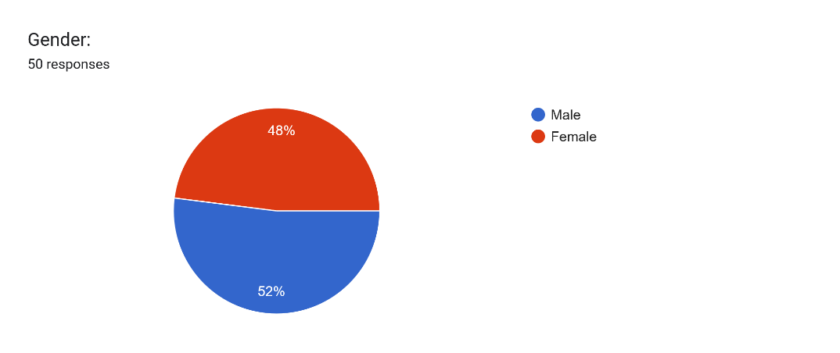
Figure 4 Questionnaire Results – Gender Distribution

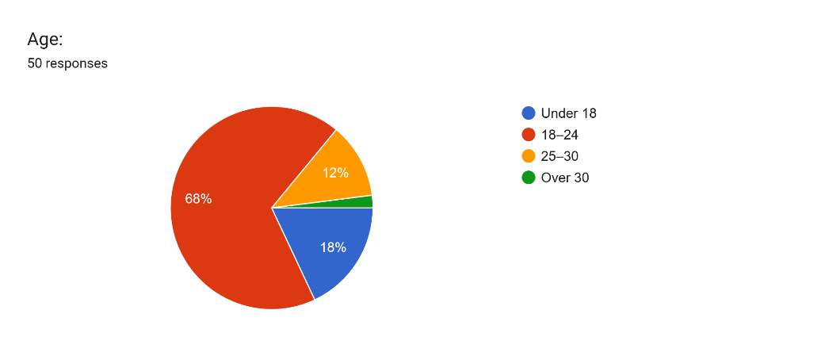
Figure 5 Questionnaire Results – Age Distribution
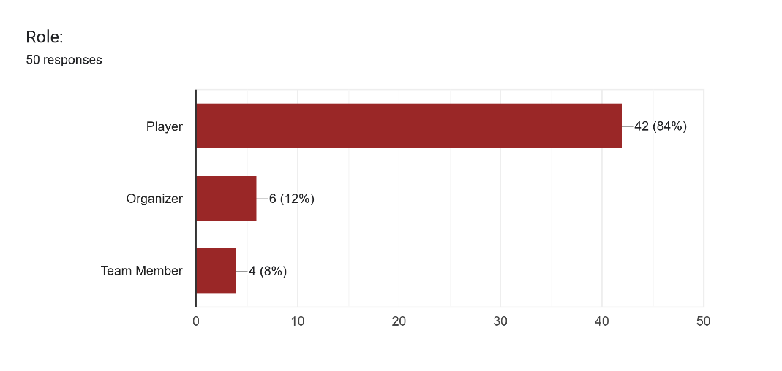
Figure 6 Questionnaire Results – Roles of Participants
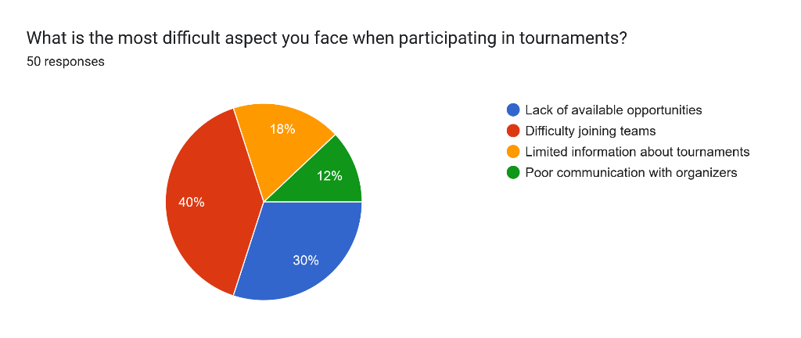
Figure 7 Questionnaire Results – Main Difficulties in Tournaments
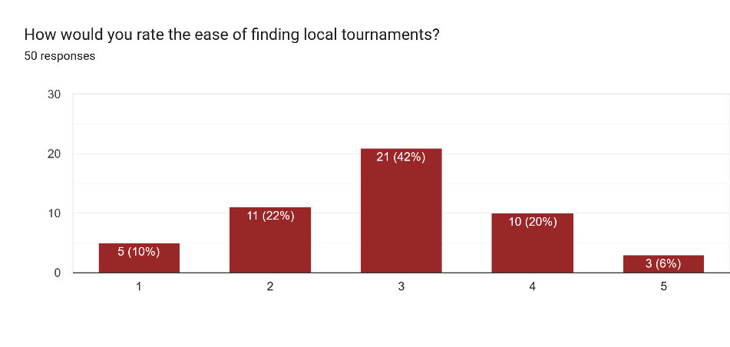
Figure 8 Questionnaire Results – Ease of Finding Local Tournaments
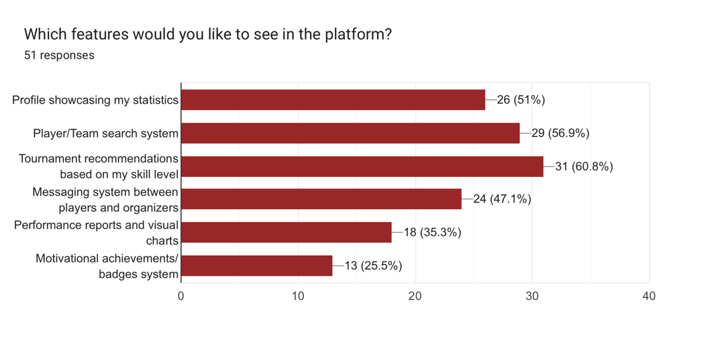
Figure Questionnaire Results – Importance of AI in Predicting Win Probability
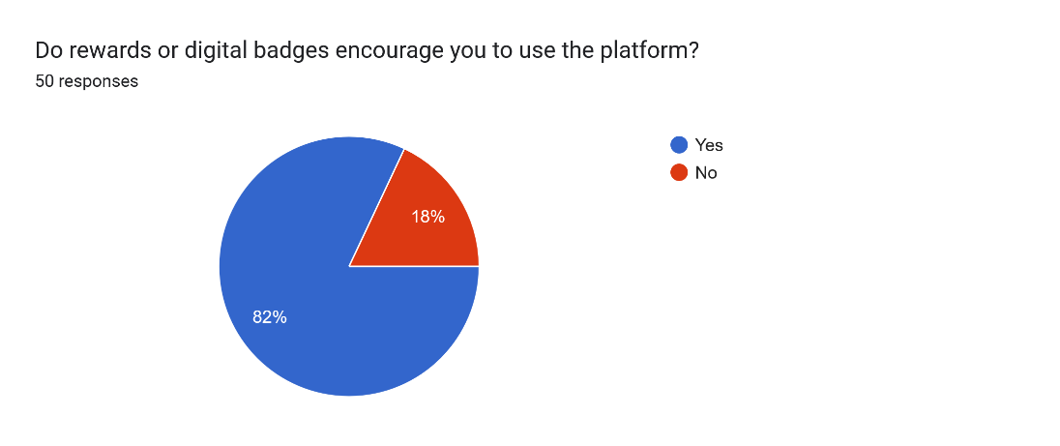

Figure Questionnaire Results – Impact of Rewards and Digital Badges on Motivation
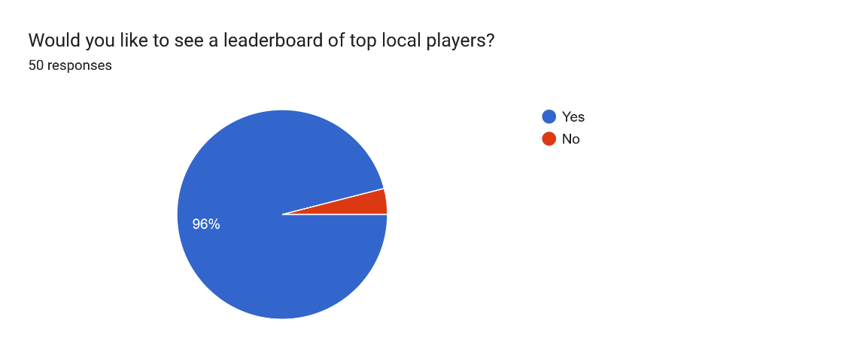
Figure 11 Questionnaire Results – Preference for Local Leaderboard
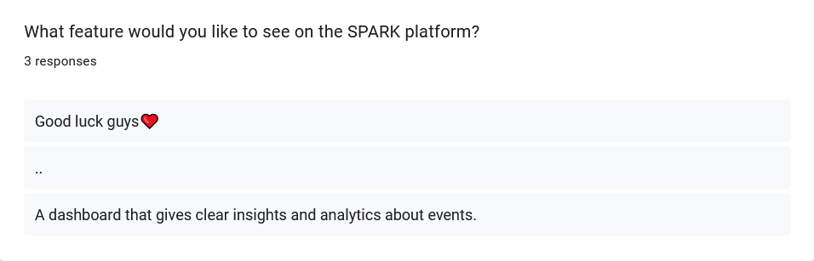
Figure Questionnaire Results – Participants’ Suggestions for Platform Features

APPENDIX B: Interviews for requirements elicitation

Players interviews

Interview 1 outline
interviewee name: Omar Salem | Interviewers: Aljwharah Alhowidy
Location: Face to Face | Date:16/09/2025
Questions | Answers
How do you usually discover tournaments or events in the gaming community? | Most of the time through Twitter and Discord. I also hear about tournaments from friends or my team.
What difficulties do you face when trying to join teams or tournaments? | The hardest part is proving myself. Teams don’t always trust me if I don’t have a history. I remember missing a tournament once because I found out about it too late. And registering for tournaments can take a while.
Do you currently use any platforms to manage your player profile? If yes, what are their main drawbacks? | I’ve used platforms like Saudiesports.sa and kafugames They let me create a profile, but it feels too simple. Usually, it only shows my ID and some very basic stats. What I’m missing is a profile that looks more professional and shows detailed performance, not just basic info.
How would you prefer your performance to be displayed? (e.g., numerical statistics, visual charts, comparisons with other players) | I like a mix. Numbers are important, but visuals make it easier to understand. For example, charts showing my progress over time, or comparisons with other players, would really help teams see where I stand.
How important is it for you that the platform shows your full match history when applying for tournaments or teams? | Extremely important. Without a full match history, teams only see highlights, but they don’t know if I’m consistent. A complete history builds trust and shows I’m serious.
Do you find it valuable to have a motivational system such as badges and achievements in the platform? Why or why not? | Yes, it’s motivating. It gives me goals beyond just winning matches.
To what extent do you want direct communication with teams or organizers through the app? | That would be very helpful. Direct chat or a structured messaging system would save a lot of time.
Table 7: interview 1 outline

Interview 2 outline
interviewee name: Khalid Al-Mutairi | Interviewers: Aljwharah Alhowidy
Location: Face to Face | Date:25/09/2025
Questions | Answers
How do you usually discover tournaments or events in the gaming community? | Mainly through friends and gaming forums. Occasionally I see ads on YouTube
What difficulties do you face when trying to join teams or tournaments? | It’s hard to show that I’m a good player. Sometimes I get ignored because I don’t have much history, and signing up for tournaments can be confusing.
Do you currently use any platforms to manage your player profile? If yes, what are their main drawbacks? | I tried Saudiesports. It’s simple, but it doesn’t provide detailed stats, charts, or performance comparisons
How would you prefer your performance to be displayed? (e.g., numerical statistics, visual charts, comparisons with other players) | I prefer a combination: charts to show progress, numerical stats for accuracy, and rankings compared to peers
How important is it for you that the platform shows your full match history when applying for tournaments or teams? | Extremely important. Full history builds trust and proves consistency
Do you find it valuable to have a motivational system such as badges and achievements in the platform? Why or why not? | Yes, if they represent real achievements. It keeps me motivated to improve and participate in more events
To what extent do you want direct communication with teams or organizers through  the app? | Very useful. A built-in chat system would make coordination much easier.
Table 8: interview 2 outline

Interview 3 outline
interviewee name: Reem Al-Zahrani | Interviewers: Raghad Aldajani
Location: Face to Face | Date: 25/09/2025
Questions | Answers
How do you usually discover tournaments or events in the gaming community? | Sometimes through Twitter and sometimes through friends from the teams I play with
What difficulties do you face when trying to join teams or tournaments? | Sometimes registration is complicated or the information is unclear, but other times it’s easy if the team is well-organized
Do you currently use any platforms to manage your player profile? If yes, what are their main drawbacks? | I use them occasionally, but I don’t focus much on detailed stats. I mainly want my overall skill level to be visible
How would you prefer your performance to be displayed? (e.g., numerical statistics, visual charts, comparisons with other players) | I prefer a balanced view: clear numbers for key stats combined with visual charts that show progress and trends over time
How important is it for you that the platform shows your full match history when applying for tournaments or teams? | Somewhat important, not essential. I think teams focus more on current skill rather than full history
Do you find it valuable to have a motivational system such as badges and achievements in the platform? Why or why not? | Not necessary. It’s nice if it exists, but I don’t rely on it.
To what extent do you want direct communication with teams or organizers through  the app? | Preferably somewhat, but I’m fine if communication happens via email or other platforms
Table 9: interview 3 outline

Organizer interviews

Interview 1 outline
interviewee name: Sara AlMutairi | Interviewers:Aljwharah Alhowidy
Location: Face to Face | Date:23/09/2025
Questions | Answers
How do you currently manage the tournament registration process? (Manually, using spreadsheets, through other platforms) | We use Battlefy platform most of the time, but I still need to double-check player details manually
What are the main challenges you face when organizing a tournament? (e.g., verifying players, scheduling, communication) | Communication is the hardest part. Players contact us through different platforms, and it’s hard to keep everything in one place.
How do you currently select players or teams to participate? Do you find it difficult to evaluate their skill levels? | We usually look at their profiles and past matches. The data gives us a good idea.
Would you prefer the platform to recommend players or teams for you based on their skills and performance? | Yes, that would be really helpful. I think if the platform could show suggestions based on past performance and stats, it would make running tournaments a lot easier.
What difficulties do you face in promoting tournaments and attracting enough players? | Promotion is expensive. Ads cost money, and without them it’s hard to reach new players.
Do you need performance reports before, during, and after the tournament? If yes, what type of data is most important to you? (e.g., KDA, win rate, consistency, etc.) | Yes, but I’d focus more on after the tournament. I want summaries like top performers, win rates, and key highlights.
Table 10: interview 4 outline

Interview 2 outline
interviewee name: Fahad AlHarbi | Interviewers: Raghad Aldajani
Location: Face to Face | Date: 24/09/2025
Questions | Answers
How do you currently manage the tournament registration process? (Manually, using spreadsheets, through other platforms) | Mostly through spreadsheets. We ask players to fill a form, then we manually enter their data. It’s time-consuming but at least we keep full control.
What are the main challenges you face when organizing a tournament? (e.g., verifying players, scheduling, communication) | Scheduling is the biggest challenge. Players often miss their matches, and rescheduling causes delays. Verifying their IDs is also a hassle.
How do you currently select players or teams to participate? Do you find it difficult to evaluate their skill levels? | We usually rely on their past matches. If a player has participated in recent tournaments, it’s easier to judge. But when the profile doesn’t show enough detail, it’s difficult to know how consistent they really are.
Would you prefer the platform to recommend players or teams for you based on their skills and performance? | Yes, that would help. Sometimes it’s hard to tell which players are reliable, so seeing suggestions based on stats would make organizing matches easier
What difficulties do you face in promoting tournaments and attracting enough players? | Reaching the right audience is tough. We rely on Twitter posts and word of mouth, but sometimes the turnout is lower than expected.
Do you need performance reports before, during, and after the tournament? If yes, what type of data is most important to you? (e.g., KDA, win rate, consistency, etc.) | Yes, especially during and after. I want to see consistency, win rates, and head-to-head comparisons.
Table 11: interview 5 outline

APPENDIX C: Jira & Github for manage the project

Jira link: https://url-shortener.me/5WHB
Github link: https://github.com/NoraFisal/2025_GP_34

