Lantian Qin

December 08, 2020

IT FDN 110 A

Assignment 08

<https://github.com/NoraQin/IntroToProg-Python-Mod07>

Custom Classes

Introduction

For this assignment, I created a program that manages a list with product names and prices for users. I used the custom classes, which is a useful way to keep your code organized and enforce the separation of concerns. In this document, I’ll walk through how the code was created.

Product Class

First, I created the Product class, which holds information about each product, including its name and price. I created two attributes, product_name and product_price. In the property definitions of each attribute, I added a raise exception statement to make sure only valid entries are entered in the Product object.

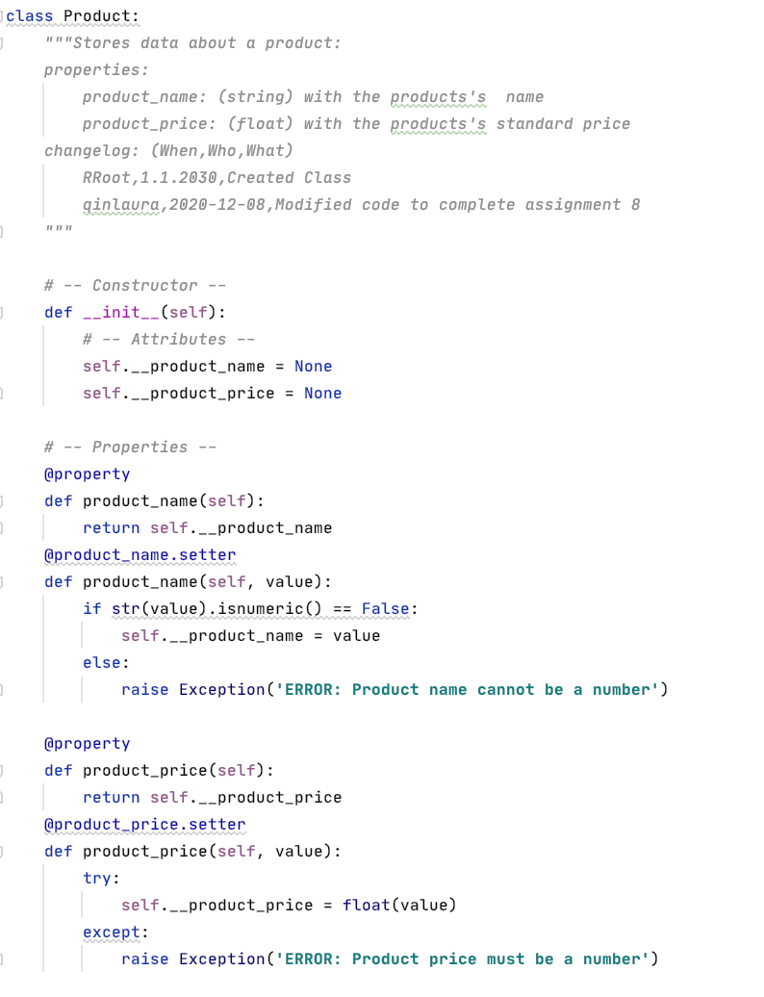

Figure 1. Product Class

FileProcessor Class

The next part of the FileProcessor class, which is used to read from and write to the txt file in local.

Figure 2. FileProcessor Class

IO Class

The IO class, short for input/output, is responsible for displaying data and menu option to the user and collecting input from them.

Figure 3. IO Class

Main body

The main body ties the code together by calling the functions as needed according to user’s menu selection. It also handles the processing of the list of Products in memory. It allows users to add new entries to the list and throws an error if the user entry is invalid.

Figure 4. Main body

Conclusion

I ran the code in console, the result is shown below. As you can see, the code is working as expected and handled the invalid entry appropriately.

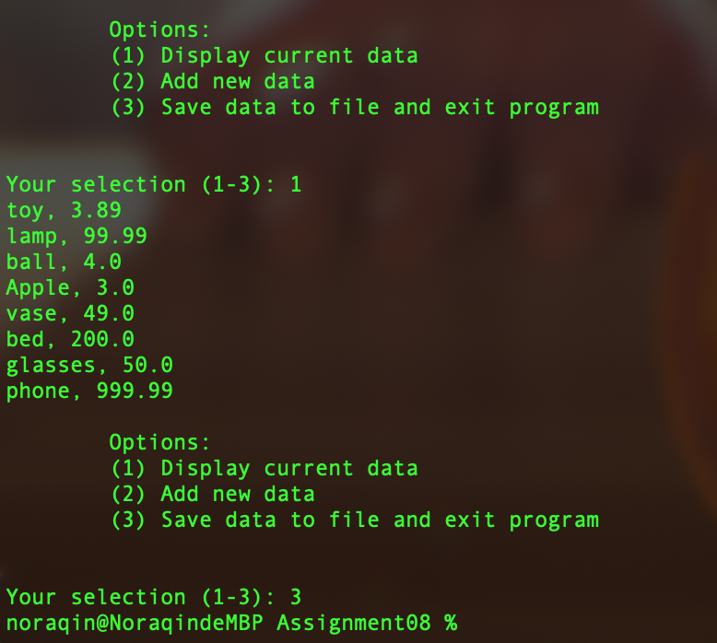

Figure 5. Result