ST515-HW4

Nora Quick

4.1:

1. Describe how you would design and execute an experiment to test the effects of CO2 concentration and temperature on plant growth.

There are 12 seedling for each of the 12 chambers so my first step would be to randomize both of those. I would start with assigning the 144 randomly into 12 groups. Next, I would assign the chamber that each of the 12 seedlings randomly.

Following this I would set incrementily increasing values for both CO2 levels and temperature. For example, temp: 32, 62, 92 and CO2: 20, 40, 60, 80.

1. Identify the statistical procedure you would use to analyze the data, and provide an ANOVA table that shows the sources of variation and associated degrees of freedom.

Personally, I would use mixed a mixed effect model. This is because I would set both CO2 levels and temperature as fixed variables. I would then randomize the chambers in which the CO2 levels and temeratures are assigned.

4.2:

1. Draw a boxplot of yield for the six treatment combinations.

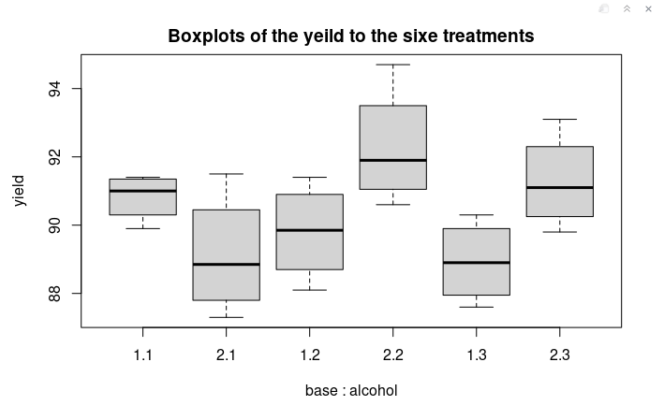

4.2.1

1. Fit the two-way ANOVA model, including the interaction term. Show the output, and interpret the results.

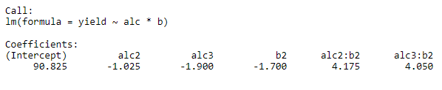

4.2.2

Neither of the interaction terms are significant on their own. The chemical reaction is only significant with the ineraction of the two variables together.

1. Create a table of the cell means (i.e., the mean yields for each of the six treatment combinations).

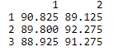

4.2.3

1. Calculate the simple effects of base (2 minus 1) for the three levels of the alcohol factor. Does there appear to be an interaction between base and alcohol? Explain.

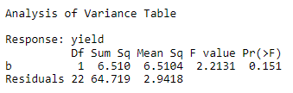

4.2.4

It appears that there is a significant interaction between base and alcohol. This is because of the large p-value indicating that there is no significance between the yeild and base on it’s own.

1. What if anything does this interval tell you about the interaction between base and alcohol?

4.2.5

4.2.5

From this interval the interaction between the two is significant and that together they range from having a negative yield to a a good positive yeild.

1. Using the residuals from the two-way ANOVA: (i) draw and interpret a plot to assess the normality assumption; (ii) draw and interpret a plot to assess the constant- variance assumption; and (iii) perform and interpret the results of Levene’s test.

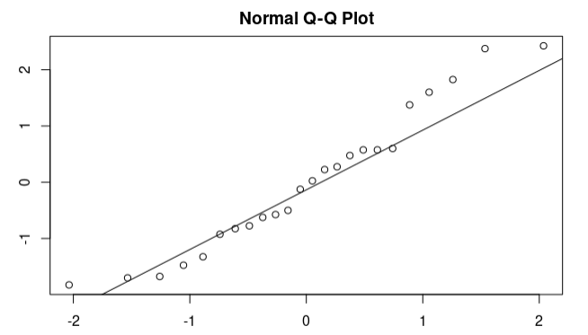

4.2.6

4.3:

1. Draw a graph of the plant weights in the four combinations of CO2 and temperature, and describe the patterns you see.

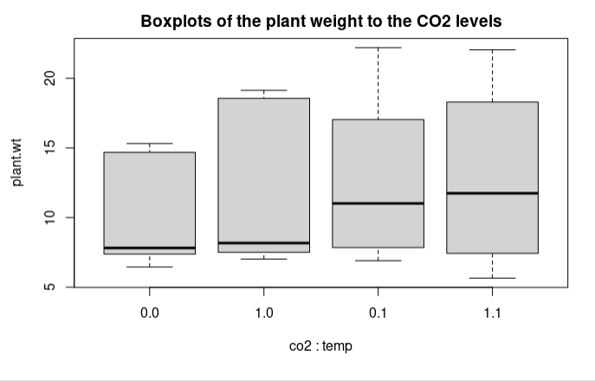

4.3.1

There is an interesting pattern where all the mean ranges overlap, however, the meam within each sample varies wildly. The lower the temperature the lower the overall mean.

(b)Perform an analysis of variance of plant weight, using a model that includes co2, temp, and their interaction. Include (i) a summary of the mean response in the different treatment combinations; (ii) the ANOVA table; and (iii) an interpretation of your results.

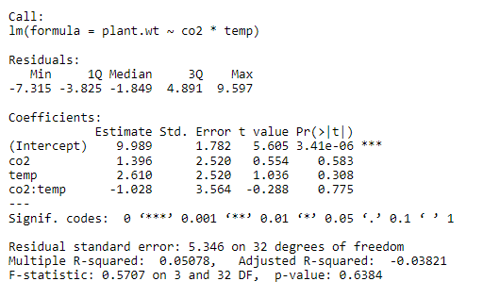

4.3.2

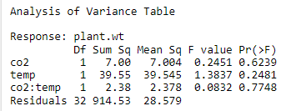

4.3.3

From the summary and the ANOVA table we can see that we can approve the null hypothesis that both co2 and temp have the same effect on the plant weight.

1. Use Levene’s test to evaluate the constant-variance assumption of your ANOVA model. Is the result consistent with what you see in your graph from part (a)? Explain.

(Could not get leneve’s working)

1. Since the interaction term is nonsignificant, drop it and fit a model with just the main effects of CO2 and temperature. Present both the ANOVA and regression output, and explain what they suggest about the effects of CO2 and temperature on plant weight.

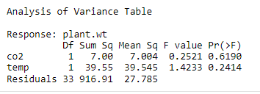

4.3.4

Without an interaction there is no siginifant data from co2 or temperature.

1. Using the ANOVA output from the two models you fit above, do an extra-sum- of- squares test of the null hypothesis that there is no interactive effect of CO2 and temperature on plant growth. That is, extract the needed sums of squares and degrees of freedom, and plug them in to the general formula for the extra-sum-of-squares F- test. Show how to obtain the P-value, and verify that it is the same as that for the interaction term in the full model from part (b).

(Could not get leneve’s working)

4.4:

1. Prepare a graphical summary of anode density in the six treatment combinations. Comment on the apparent main effects of position and temperature, and the interaction between them.

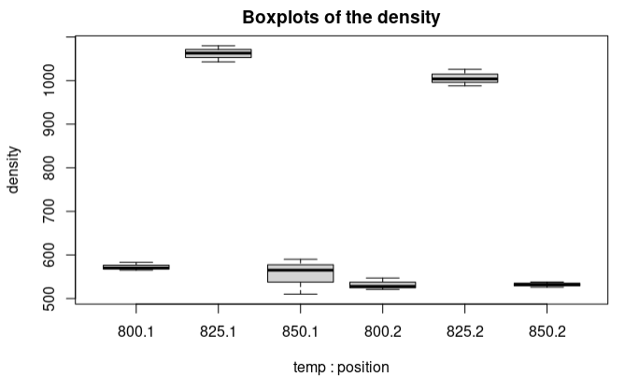

4.4.1

1. Perform an appropriate analysis of variance on these data, modeling both position and temperature as categorical variables. Show the ANOVA table; perform F-tests for both main effects and their interaction; and interpret your results. Do not drop the interaction term, even though it is nonsignificant.

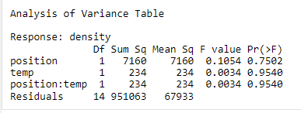

4.4.2

1. A colleague suggests that, since temperature is measured on a continuous scale, it would make more sense to model temperature as a quantitative variable, in an ANCOVA-like approach, instead of as a qualitative (categorical) variable. Eager to please, you proceed as follows.

(i) Fit a model of density as a function of the quantitative temperature variable and a factor for position, without the interaction term (since it is nonsignificant). Hand in the regression output.

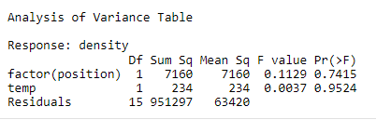

4.4.3

(ii)Interpret the magnitude and the statistical significance of the regression coefficent for temperature. How does your conclusion compare to what you inferred from the earlier model that used a categorical version of temperature? Do you agree with your colleage that temperature should be treated as a quantitative predictor? Explain.

In this we find that temperature on it’s own still is not significant. This conclusion compares to what we inferred in the earlier model as well. On it’s own it’s p-value indicates that it isn’t significant in either.

Yes, I agree that it should be a quantitative predictor because temperature is always a fixed numerical value. It quite literally provides a quantity of something (in this case it is temperature).