Homework Set 1

The goal of this first homework set is to help you

* set up R and R Studio,
* set up the data collection to be used for this class,
* run simple computations and simulations using R, and
* learn to use R Markdown to create a word document with embedded R code and output.

## Task 1. Install R and R studio

Install R and R Studio. Follow instructions at

<https://www.r-project.org/>

and

<https://www.rstudio.com/>

## Task 2. Download the class data set and load one data set into R

1. Download the class data set (data.zip). Unzip it. Keep the folder name as data.
2. Create a folder R so that the folders R and data are at the same level.
3. Save this Rmd file into the R folder and open the Rmd file from the R folder: this should automatically launch R Studio.

## Task 3. Compute normal probabilities.

1. Suppose $Z∼N(0,1)$ (standard normal, use R function pnorm to compute

$Pr(Z>2)$

$Pr(−1<Z≤1)$

$Pr(0<Z<3)$

## To compute probability Pr(Z>2)  
1 - pnorm(2)

## [1] 0.02275013

## To compute probability Pr(-1<Z\leq1)  
(1 - pnorm(1)) - pnorm(-1)

## [1] 2.775558e-17

## To compute probability Pr(0<Z<3)  
pnorm(3) - pnorm(0)

## [1] 0.4986501

1. Suppose $X∼N(μ=2,σ^{2}=5)$, use R function pnorm to compute

$Pr(X>5)$

$Pr(X<0)$

$Pr(0<X≤2)$

## To compute Pr(X<0)  
pnorm(0, mean = 2, sd = sqrt(5))

## [1] 0.1855467

## To compute Pr(X>5)  
pnorm(5, mean = 2, sd = sqrt(5), lower.tail = FALSE)

## [1] 0.08985625

## To compute Pr(0<Z<\leq2)  
pnorm(2, mean = 2, sd = sqrt(5)) - pnorm(0, mean = 2, sd = sqrt(5))

## [1] 0.3144533

## Task 4. Simulation for Central Limit Theorem

n_sim = 10000;  
  
mean = 0.5;  
sd = 0.5;  
  
for (n in c(5, 10, 50, 100, 500, 1000)) {  
 m = numeric(n_sim);   
 z = numeric(n_sim);   
   
 for (i in 1:n_sim) {  
   
 y = rbinom(n, 1, p=0.5);  
  
 m[i] = mean(y);  
  
 z[i] = sqrt(n)* (m[i] - mean)/sd  
   
 ## Or use the sample standard deviation  
 ## z[i] = sqrt(n)* (mean(y) - mu)/sd(y);  
 }  
  
 hist(z, probability =TRUE, main=sprintf("n= %d", n), nclass=30);  
  
 x = seq(-3, 3, length=100);  
 lines(x, dnorm(x));  
  
 plot(ecdf(z), col="magenta", main="Emperical CDF of z (magenta) to the normal cdf (cyan)");  
 lines(x, pnorm(x), type="l", col="darkcyan");  
}

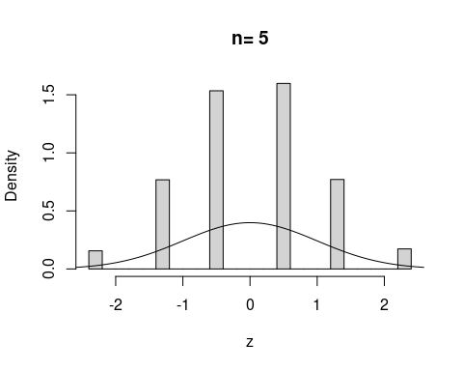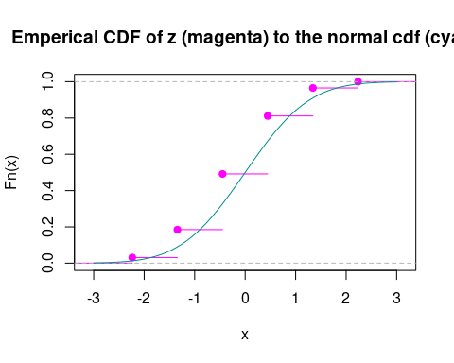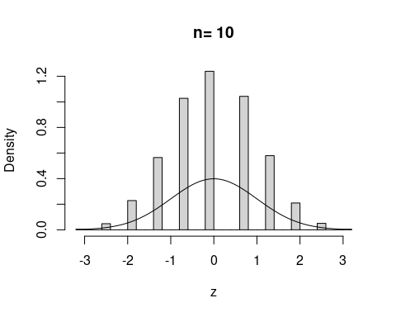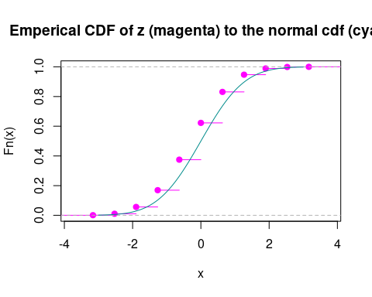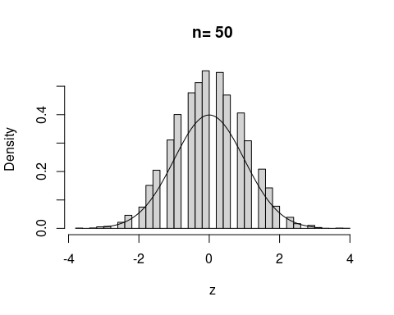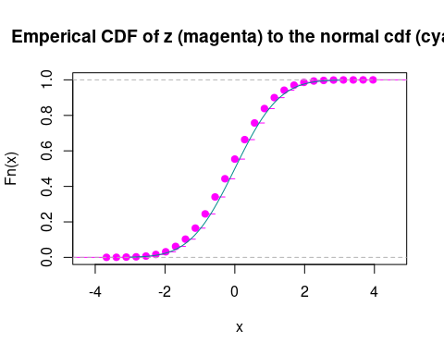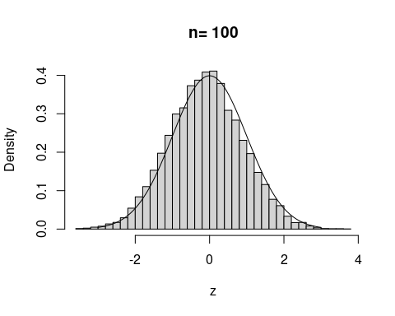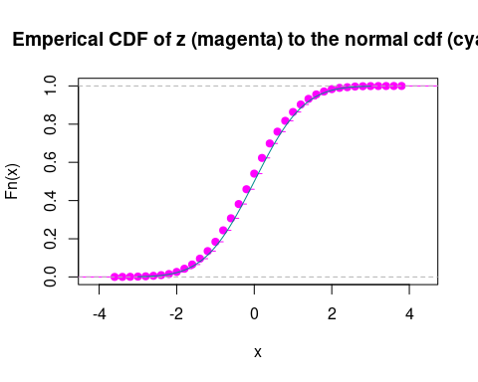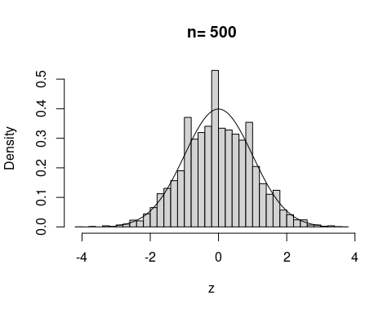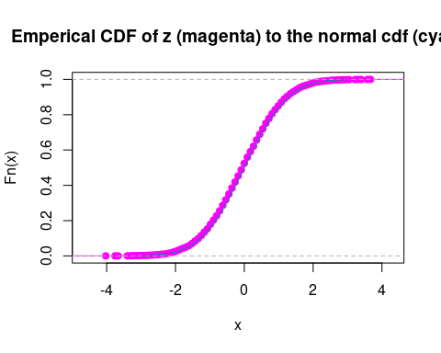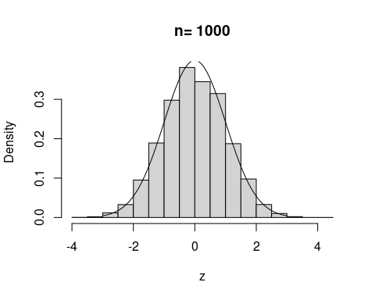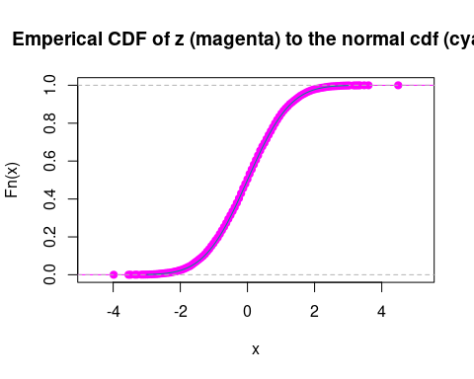

## Task 5. Knit the R markdown file

Once all your R codes work correctly, “Knit” the markdown file to create the word document. Verify that you have completed all the problems and then turn in the completed word document through Canvas.