3006ICT Robotics and Computer Vision
Vision Guided Autonomous Search
and Navigation in Webots
Group Project Report
Nora Stoklasa and Kithmini
Griffith University, Gold Coast
September 2026
One autonomous e-puck controller that finds a named target by looking at it, then drives to that station and stops.

Contents
1. Introduction and the problem
2. Design decisions and why we made them
3. System architecture and interfaces
4. Vision: finding the poster and naming the target
5. Navigation and control
6. Putting it together: the mission state machine
7. Testing and results
8. Failure cases
9. Robustness
10. Limitations and what we would do next
11. Contribution statement
12. Acknowledgements and external resources
13. Conclusion
This report contains 14 numbered figures, 22 numbered tables and 4 code listings. Every figure and table is referred to by number in the text, and every number quoted in the text comes from a committed evidence file in the project repository.

This project asked us to build one autonomous controller for an e-puck robot in Webots. The robot is told the name of a target, for example soda can or wall clock. It is not told where that target is. It has to use its own camera to work out which of the eight observation stations is displaying that target, drive there safely, and stop within 0.20 metres of that station's observation position, all inside four minutes of simulation time and without anyone touching the keyboard after the run starts.
The most important thing we understood early is that this is really two different problems joined together, and only one of them is hard.
- Getting to a station is a navigation problem, and it is already mostly solved for us. We are given an occupancy grid of the arena, the coordinates of every station, and the robot's own position and heading from GPS and the InertialUnit. Nothing about driving to a known point is unknown.
- Working out which station holds the target is a vision problem, and nothing except the camera can answer it. The map does not know. The station coordinates do not know. The target moves between missions.
That split decided the shape of our whole system. We spent our effort on perception and on making the search reliable, and we deliberately did not build things the supplied resources already made unnecessary.
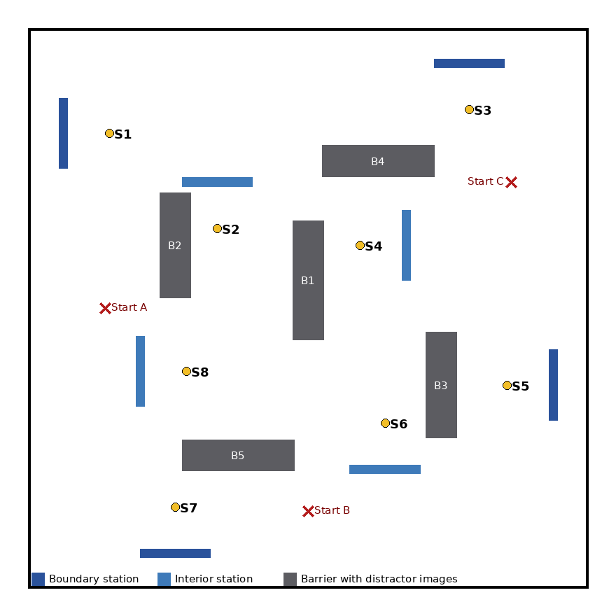
Figure 1. The 4 m by 4 m arena. Four stations sit on the boundary (S1, S3, S5, S7) and four sit in the interior (S2, S4, S6, S8). The five barriers B1 to B5 carry distractor images that are never valid targets.

1.1 What the robot knows and what it must find out
The controller is given the target name for this mission, the occupancy grid, every station's observation position and heading, its own pose every step, and the eight supplied reference photographs. It is not given which station is showing the target, and it cannot assume the arrangement matches anything it was developed against. That single unknown is what the camera has to answer.
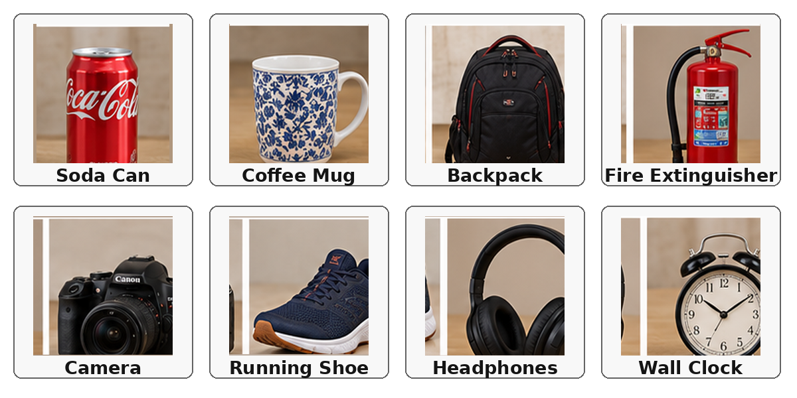
Figure 2. The eight possible targets. These supplied reference images are the only training data our identifier ever sees.
Barriers B1 to B5 carry distractor images such as bananas, keyboards and soccer balls. None of them is ever a valid mission target, so the identifier has to be able to answer none of these rather than always returning its closest guess.

1.2 The trap in the supplied worlds
All three supplied training worlds use the same target to station arrangement. Soda can is always at S1, coffee mug always at S2, and so on. The brief warns that the assessment may use a different arrangement.
This matters more than it first appears. A system that quietly learned that arrangement, even by accident, would pass every single test we could run on the supplied worlds and then fail on the day. We treated that as a real risk rather than a theoretical one, and we built three shuffled worlds of our own to test against it. Section 7.5 reports what that found.

1.3 What our robot does, in short
The robot reads the target name once at start-up, then repeats a loop: pick the nearest uninspected station by real path cost, drive there with a safety layer watching the proximity sensors, stop and turn to face the poster, and run camera frames through a poster finder and a classifier, accepting an answer only when three of the last five frames agree. If the answer is the target it makes a final precise approach and stops. Otherwise the station is marked inspected and the loop restarts. If all eight are inspected with no match, the mission ends cleanly rather than hanging.

1.4 How this report is arranged
Section 2 sets out every design decision and the measurement that settled it. Section 3 gives the architecture and the interfaces between components. Sections 4 and 5 describe the vision and navigation work in detail, and Section 6 describes how they are joined into one controller. Section 7 reports the testing, Section 8 reports the failures honestly, and Section 9 gathers the robustness evidence. Sections 10 to 13 cover limitations, contributions, acknowledgements and conclusions.

2. Design decisions and why we made them
We agreed one rule at the start of the project: a decision does not count unless it has a criterion and a measured number behind it. A preference is not a reason. Every decision in this section was recorded in our decision log at the time it was made, together with the options we rejected and the evidence that decided it. This section is a summary of that log.

Decision | What we chose | The number that decided it
How to identify the target | ResNet 18 with a frozen backbone and a retrained head | 71.1 per cent top 1 accuracy against 53.9 per cent for ORB, on 76 held out real frames
How far to stand when looking | Back off to roughly 0.8 m rather than look from the 0.295 m observation position | At 0.295 m the poster does not fit inside the 160 by 120 camera frame at either station tested
How much clearance to plan with | Selective inflation, radius 4 cells | Uniform one cell inflation makes 4 of 8 stations unreachable. Selective inflation restores all 8 only at radius 4 or more
Which order to visit stations | Nearest first by A* path cost, recomputed after each visit | 155 against 162 cells from start A, 138 against 173 from B, 141 against 188 from C
When to accept an identification | Three agreeing frames out of the last five, plus three acceptance gates | A single disagreeing frame is provably rejected. Confidence alone accepted 4 of 20 distractors
Whether to build visual SLAM | No | GPS and InertialUnit already supply pose, and the brief states a full SLAM system is not required
Table 1. The six decisions that shaped the system. Each row is expanded below.

2.1 Why we did not use the red mask method
The Week 8 workshop told us not to rely on the red mask thresholding method from Part 3. We tested that claim on our own captured frames rather than simply accepting it, because we wanted a number to put in this report.
Using the same HSV threshold from the workshop, on a soda can at 0.8 m, the mask found 365 red pixels inside the poster region and 2930 on the floor. More than half of what it detected was floor, not poster. On headphones at the same distance it found 17 pixels, which is effectively nothing.
The deeper problem is not the tuning. A single colour threshold can only ever answer is there red in this image. It cannot answer which of these eight named objects am I looking at, and that is the question the mission actually asks. Seven of the eight targets are not red at all.
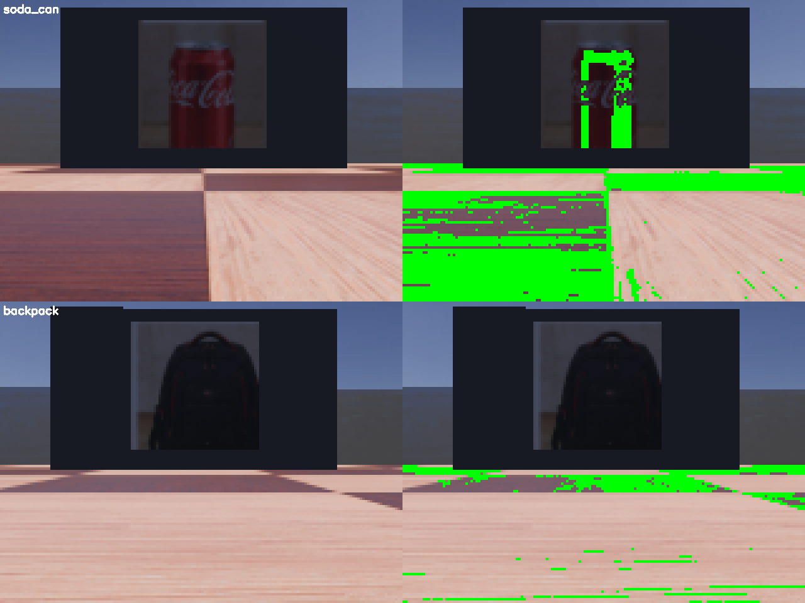
Figure 3. The red mask method on a real captured frame. Left is the raw frame, right is the mask. The floor dominates the detection, and on a target that is not red the mask finds nothing.

2.2 Choosing the identification method
We built both candidate methods properly and scored them against each other, rather than picking one and hoping.
- Option A was ORB keypoint matching with a ratio test (ORB finds distinctive corner-like points in an image and describes them, so two images can be compared by how many points match)
- Option B was a ResNet 18 with the backbone frozen and a fresh eight way head trained on augmented copies of the eight reference photographs (the backbone is the pretrained part that turns an image into numbers, freezing it means we only train the small final layer)
Both were trained only on the eight supplied reference images and scored on 76 real camera frames from all three worlds and all eight stations, never used to fit either method, so it is a genuine held out test set. Eight of the 84 captured frames were excluded because the crop step could not reliably isolate the poster, which we did rather than let a bad crop quietly pollute the comparison.

Method | Top 1 accuracy | Runtime per frame | Fits the 32 ms control step
Option A, ORB | 41 of 76, 53.9 per cent | 20.52 ms | Yes
Option B, ResNet 18 | 54 of 76, 71.1 per cent | 9.11 ms | Yes, with 23 ms to spare
Table 2. The comparison that chose our identification method. There was no accuracy against speed trade-off to make here, because the more accurate option was also the faster one.
We should report one detail honestly rather than smooth it into the average. ResNet 18 did not win at every distance. At the single longest distance tested, 1.0 m with only 14 frames, ORB scored better, 71 per cent against 36 per cent. The aggregate still clearly favours ResNet 18 because most of the test set sits in the range where it wins by 30 to 50 percentage points, and that range is where identification actually happens during a mission, but the crossover is real in our data.
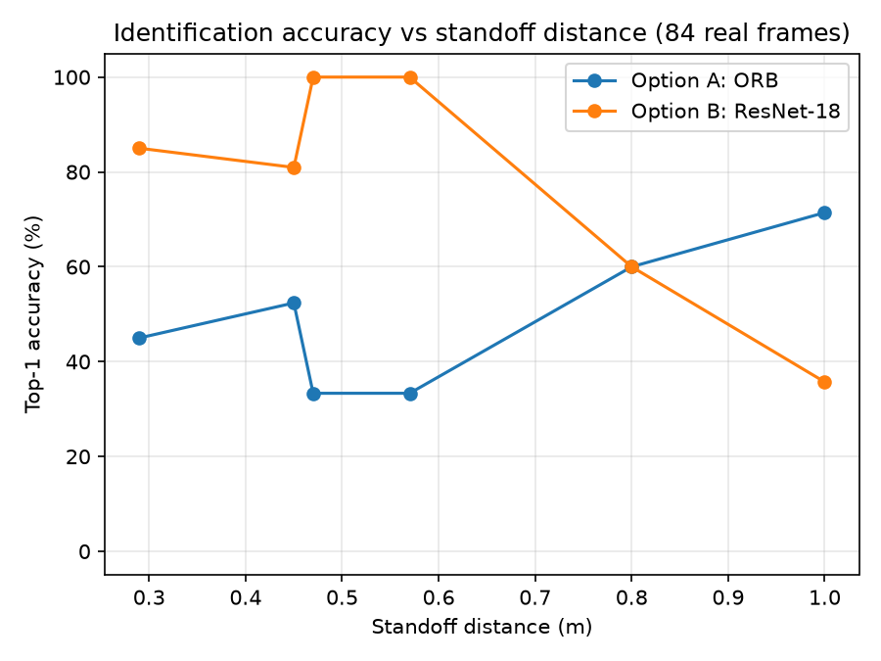
Figure 4. Accuracy against distance for both methods. ResNet 18 dominates at the close and middle distances where the robot actually identifies, and loses at the single longest distance tested.

2.3 How far away the robot should stand
The supplied observation position for each station sits about 0.295 m from the poster. We assumed at first that this was also the right place to look from. Measuring it showed the opposite.
We drove to each station, stepped back along the poster's own facing direction to a series of distances, and measured the poster's size in pixels in the real camera frame at each one. At 0.295 m the poster does not fit inside the 160 by 120 frame at all. It overflows the top edge, so the classifier would only ever see part of it.

Figure 5. A real camera frame at station S1 from the supplied observation distance of 0.295 m. The poster is cut off by the top of the frame. This one image is why the robot backs off before it looks.

Distance | S1 width | S1 height | S3 width | Clipped?
0.295 m | 81 px | 55 px | 32 px | Yes, top of frame
0.600 m | 70 px | 58 px | 28 px | Yes, top of frame
0.800 m | 52 px | 52 px | 52 px | No
1.000 m | 41 px | 41 px | 42 px | No
1.300 m | 31 px | 32 px | 31 px | No
Table 3. Measured poster size against standoff distance at two stations. Height agrees between the two stations at every distance, which tells us the geometry model is right. Width only agrees once clipping stops at 0.80 m, because a cut off object's visible width does not shrink smoothly.
The decision this produced
The recommended identification band is 0.80 m to 1.30 m. The near end is the closest distance where nothing is clipped, and the far end is the furthest distance where the poster's shorter side is still at least 20 pixels. Our controller therefore backs off about 0.5 m from the observation position before it starts reading frames, and only returns to the exact observation position after it has confirmed the target.

2.4 How much clearance to leave around obstacles
This is the most interesting finding in our navigation work, and the one that most changed our design. The standard safe thing to do is inflate every obstacle by one cell before planning so the path never hugs a wall. We tried that, then checked reachability with a breadth first search over all 24 combinations of three starts and eight stations. Uniform one cell inflation makes four of the eight stations unreachable: the interior barriers sit one to two cells apart, so inflating everything seals the corridors into the interior pocket completely, even though the observation cells themselves stay free. S2, S4, S6 and S8 are simply cut off.
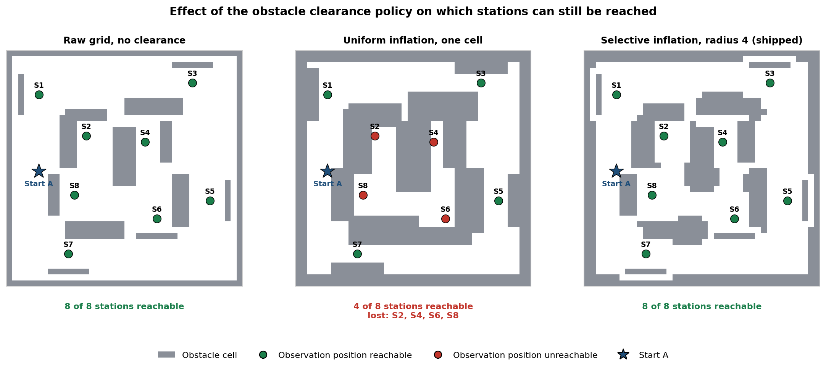
Figure 6. The clearance policy compared three ways, with reachability from start A marked on each. The middle panel shows the interior pocket sealing shut: the corridors close and four stations become unreachable. This figure was generated using the controller's own apply_clearance_policy function, so it shows the real planning grid.

Clearance policy | Stations reachable | Which are lost
Raw grid, no inflation | 8 of 8 | None
Uniform inflation, one cell | 4 of 8 | S2, S4, S6, S8
Selective inflation, radius 1, 2 and 3 | 4 of 8 | S2, S4, S6, S8
Selective inflation, radius 4 | 8 of 8 | None
Selective inflation, radius 5 | 8 of 8 | None
Table 4. Reachability for every clearance policy we tested, over all 24 start and station pairs. Radius 4 is the smallest selective radius that keeps every station reachable, so that is what we shipped.
Our policy is therefore selective inflation at radius 4: inflate every obstacle by one cell, then restore the raw grid values within four cells of each observation position. The trade we accepted is explicit. We give up the safety buffer exactly where the robot has to squeeze close to a barrier to reach a station, and we rely on the reactive proximity layer described in Section 5.5 to cover that remaining risk. The buffer stays everywhere else.

2.5 Which order to visit the stations
Since the robot does not know where the target is, it has to inspect stations until it finds it. The order matters for the time budget. We compared two strategies.
- Nearest first: pick whichever unvisited station has the shortest real A* path from where the robot is now, recomputed after every visit.
- Fixed sweep: sort the stations once by angle around the arena centre and always visit them in that order, whatever the start.

Start | Nearest first | Fixed sweep | Saving
A | 155 cells | 162 cells | 7 cells
B | 138 cells | 173 cells | 35 cells
C | 141 cells | 188 cells | 47 cells
Table 5. Total cost of visiting all eight stations, measured as A* path length in grid cells. Nearest first beat the fixed sweep from every start.
Because cell count ignores turning time, we measured the worst case for real in Webots. From start A, calling the chooser live after each visit, the robot visited all eight stations in 173.8 seconds, 66 seconds inside the budget, in exactly the predicted order. The 19 second gap against the 155 second estimate is the turning time the estimate left out. Nearest first also adapts automatically: if a station is ever unreachable its path cost comes back as no path and the chooser moves on, with no separate configuration to keep in step with the map.

2.6 What we deliberately did not build
Two things are missing from our system on purpose, and we would rather say so plainly than let a reader wonder whether we forgot them.
There is no visual SLAM and no visual localisation. SLAM means building a map and working out where you are in it at the same time. We are given the map, and GPS and the InertialUnit give us position and heading every step, so there is nothing left for SLAM to solve here. The brief states this directly. Section 10 names the dependence this creates as a real limitation of our system.
There is no hard coded route and no timed wheel sequence. The brief bans both, and they would fail the moment the target moved. Every path in our system is planned at run time from the robot's actual position.

3. System architecture and interfaces
The Week 8 workshop named agreeing the interfaces between components the single most important engineering idea in this project, because two people can otherwise spend two weeks building parts that cannot talk to each other. We drew the architecture and wrote the contracts before we wrote the group code, and we kept them true as the implementation went on.
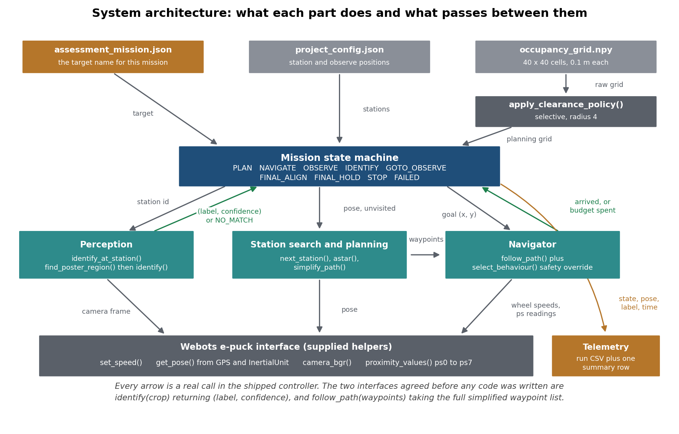
Figure 7. The whole system on one page. Every arrow is a real call in the shipped controller. The supplied Webots helpers sit at the bottom and are never reimplemented.

3.1 The two interfaces we agreed first
The workshop asks specifically for two decisions to be written down before development. Ours are below, as real function signatures.

# Vision -> Navigation
def identify(crop) -> tuple[str, float]:
"""Returns (label, confidence). label is one of the eight target
names, or the exact sentinel "NO_MATCH"."""

# Navigation -> Control
def follow_path(waypoints, base_speed=BASE_SPEED, kp=KP_HEADING):
"""Takes the full simplified waypoint list, not a single waypoint
and not a bare heading. Call next() once per control step."""
Listing 1. The two interfaces, agreed before any group code was written and unchanged since. Vision hands navigation a label and a number, never a position. Navigation hands control a whole path, never one step at a time.
Choosing a label rather than a position for the vision output matters. It means the vision code never needs to know where any station is, and in fact it contains no station identifiers at all. That is both a cleaner design and part of how we satisfy the rule that identification must be visual.

3.2 What every component promises
For each component we wrote four lines: what it takes in, what it gives out, what must be true for it to work, and what it does when it cannot produce a valid answer. That last line is the one that usually gets forgotten and is the reason our mission never hangs.

Component | Input | Output | What it does when it cannot answer
Perception | The station currently being observed | (label, confidence), or NO_MATCH | Returns NO_MATCH with 0.0 confidence. A missing crop and a wrong guess are treated the same, because neither is usable evidence
Station search | Current pose, unvisited stations, planning grid | The station dict with the shortest A* path | Returns the least bad candidate rather than None. NAVIGATE's step budget catches a genuinely unreachable choice
Planning | A goal coordinate | Simplified waypoints plus the raw cell path | Returns two empty lists. Navigator treats an empty path as SEARCH, rotate and retry, rather than crashing
Waypoint following | The full waypoint list | Drives the wheels, yields the active waypoint | An empty list makes it a no-op that returns at once, with no motion and no error
Safety override | WARN and STOP flags per side, whether a path exists | One of STOP, AVOID, FOLLOW, SEARCH | If no path exists and none can be planned it rotates and retries. The mission step budget is the backstop
Mission state machine | Nothing per call, reads the sensors through its components | Drives the components, exposes state and done() | Every non-terminal state has a named failure response, listed in Section 6
Telemetry | State, pose, label, time from the mission | One interval CSV per run, one summary row per run | Writes and flushes as it goes, so a run stopped part way still leaves usable data
Table 6. The component contracts. These were written before implementation and corrected in the same change whenever implementation proved one wrong.

3.3 How the system was actually built
We did not build the components separately and join them at the end. The workshop is blunt that late integration is the main way group projects fail, because parts connected for the first time in the final week leave several possible sources for every failure and no time to tell them apart. So we ran the whole mission loop end to end on 16 September, well before the real vision and planner were finished, using stubs. The perception stub returned a fixed station through the real interface, and the control layer was not stubbed at all.
What the first end to end run proved
It ran clean from start A to a full stop with the perception stub. With the stub set to never match, it visited all eight stations and ended cleanly in FAILED after 173.8 seconds, 66.2 seconds inside the budget. Critically, changing one environment variable from S8 to S4, with no code change at all, changed which station the robot stopped at. That proved the interface was driving the behaviour rather than the stub. No contract in our interface document was proved wrong by that run.

The stubs are still in the repository behind a flag. That was deliberate: being able to switch any one component back to a stub is the diagnostic tool we used later to answer where did the first wrong decision happen, which is the question Section 8 is built around.

4. Vision: finding the poster and naming the target
The vision system runs in two stages. First it finds the poster inside the camera frame and cuts it out. Then it decides which of the eight targets that cut out region shows, or refuses to decide. Both stages were built and measured separately, because a failure in the first stage looks identical to a failure in the second unless you check.

4.1 Finding the poster in the frame
The obvious approach, and the one the task description suggests, is to threshold the bright poster apart from the dark barrier it sits on. We tested that and it does not hold up across all eight targets. At station S3 the backpack poster measured about as bright as the plain barrier body itself, roughly 35 against 35. There is no brightness threshold that separates them.
So we invert the problem. We find the barrier first, because the barrier body looks the same whichever poster is on it, and then take the poster as a known fraction of the barrier's shape. The proportions come from the supplied barrier definition file, which is a project resource we are allowed to use. This makes the detector independent of which target is showing, which is exactly the property we need.
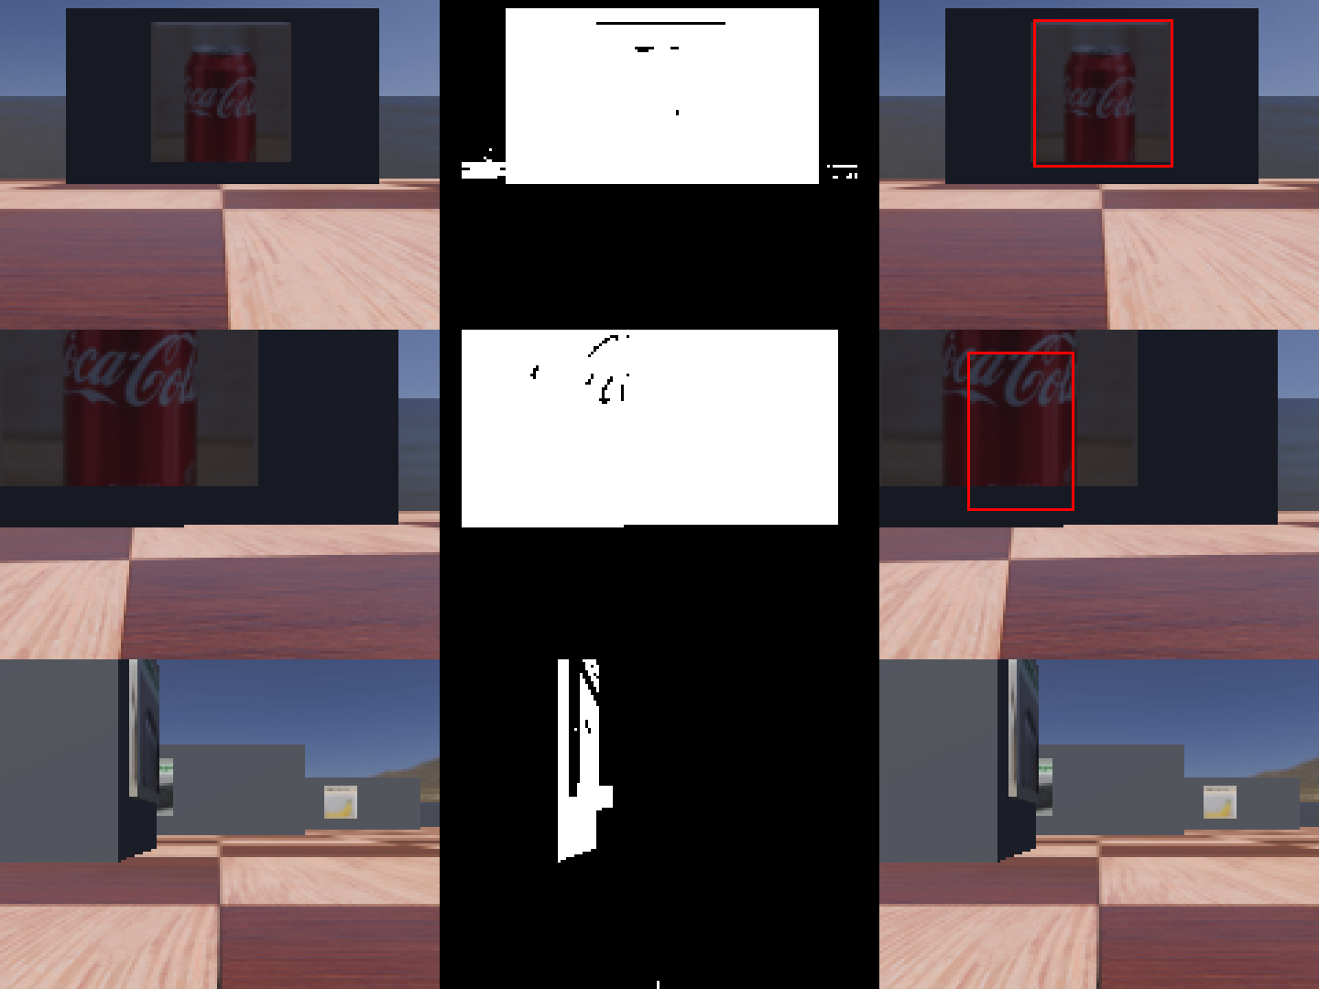
Figure 8. The poster finder on real frames. Left is the raw camera frame, middle is the mask that isolates the barrier body, right is the chosen poster box. The three rows show a near perfect case, a clipped case, and a frame with no poster in it at all.

How well it works

Measure | Result | Required | What it means
Detection rate, unclipped frames | 46 of 46, 100 per cent | 90 per cent | The detector finds a poster whenever one is fully visible
Mean IoU, hand labelled set | 0.782 | 0.5 | The box it picks closely matches where the poster really is
Frames above IoU 0.5 | 19 of 20 | 20 of 20 | One frame fails, and it is discussed below rather than averaged away
No poster frames correctly rejected | 13 of 18 | 10 of 18 | It usually says nothing is here when nothing is there
Table 7. Poster finder results. The detection rate is measured over 46 frames and the IoU is measured over a separate set of 20 hand labelled frames, so the two numbers are not describing the same set.
IoU means intersection over union, which is how much the box we predicted overlaps the box a human labelled, divided by the total area the two cover together. A score of 1.0 is a perfect match and 0.5 is the usual pass mark.
Ground truth boxes were labelled by hand on raw images, independently of the detector, so it was never scored against its own output. That labelling caught a real bug visual inspection had missed, where a meaningless candidate covering almost the whole search window was winning simply because it was the largest.

The frame that fails, and why we are showing it
One of the 20 required frames scores 0.00, which means the box we picked and the real poster do not overlap at all. It is a long range frame taken 10 degrees off axis, and the detector locked onto empty background instead of the barrier.
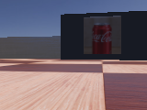
Figure 9. The frame our poster finder gets wrong. At 1.0 m and 10 degrees off axis it selects background rather than the barrier. We tried five different signals to reject the wrong candidate automatically and none of them separated it from ordinary good frames.
We tried to fix it and could not. Five separate signals were tested to tell the wrong candidate from the right one: a darkness centroid, a brightness notch detector, the internal colour range, fine detail variance, and similarity to the reference photograph. Three scored the wrong crop higher than genuine good ones, because a sharp horizon line reads as more detailed than a printed graphic.
So instead of leaving it unknown we checked whether it matters in a real mission. The trigger is 1.0 m and 10 degrees off axis together, while the robot's real first look is about 0.8 m straight on, from a fixed backoff off a known observation position. Live missions in the world that frame came from did not reproduce it. It is a real weakness at a viewing geometry our controller does not use.

4.2 Naming the target
The classifier is a ResNet 18 with its backbone frozen and a fresh eight way output layer trained for 60 steps on heavily augmented copies of the eight supplied reference photographs. Augmentation means random crops, resizing, blur, colour changes and downsampling, which makes the small amount of training data go further.
There is an honest gap here worth naming. We train on clean product photographs and we test on small, angled, slightly blurry camera views of a poster in a simulated room. That is a domain shift, meaning the training images and the real images do not come from the same kind of source, and it is the main reason our accuracy is not higher. Section 10 proposes what would fix it.

4.3 Knowing when to say nothing
This part matters more than the classifier itself. An eight way classifier always returns one of its eight classes. Shown a photograph of a banana it will confidently answer with whichever target it thinks is closest. It has no way to say none of these, and the arena is full of distractor images that are none of these.
So we put three gates in front of every answer, and any one of them failing means we refuse to commit.

reject_reason = None
if scored["confidence"] < MIN_CONFIDENCE: # 0.50
reject_reason = "below_min_confidence"
elif scored["margin"] < MIN_CONFIDENCE_MARGIN: # 0.20
reject_reason = "below_margin"
elif scored["reference_similarity"] < scored["reference_threshold"]:
reject_reason = "below_reference_similarity"

# Any rejection reason at all means we refuse to commit to a label.
if reject_reason:
label = NO_MATCH
else:
label = scored["raw_label"]
Listing 2. The three acceptance gates, from vision_utils.py. The top score must be high enough, it must be far enough ahead of the runner up, and the crop must still look like that label's own reference photograph.
- The confidence gate rejects a guess the model is not sure about.
- The margin gate rejects a guess that is barely ahead of its runner up, which is a different kind of doubt and is not caught by confidence alone.
- The reference similarity gate compares the crop back against that label's own supplied photograph. This is the gate that exists specifically because confidence cannot detect an object the model has never been taught.
Why the third gate had to exist
With confidence and margin alone, 4 of the 20 distractor images were accepted as real targets. The classifier was doing exactly what an eight way classifier does. Adding the reference check took that to 0 of 20 while keeping target accuracy unchanged. Section 7.4 explains why that number is not 0 of 20 today, and what we traded to get real targets detected in live missions.

A NO_MATCH is a useful answer, not a failure. It tells the mission to inspect the next station rather than commit to a wrong one, and committing to a wrong one is much more expensive than looking again.

One bad frame cannot commit the robot
On top of the three gates, the mission requires three of the last five frames to agree before accepting an identification. We tested this by injecting a disagreeing frame and watching the log: the bad frame is never counted towards acceptance. We started with three consecutive agreeing frames and changed to three of the last five for a measured reason, not a stylistic one. Under the stricter rule a correct reading at acceptable confidence was repeatedly broken by one noisy frame and the mission failed even though the vision was right. Section 8.1 describes the case where the looser rule was not enough either.

4.4 Following the rules
The brief forbids several shortcuts, and we want to state clearly how our design avoids each one rather than leave a marker to check.

What is forbidden | How our design avoids it
Webots built in Camera Recognition | Never called anywhere. Our perception reads raw camera pixels through the supplied camera_bgr() helper only
Simulator ground truth object identity | Never used. Ground truth for our own scoring was assigned by a person looking at the captured images
Reading .wbt files or texture filenames | Never done at run time or at evaluation time. The class list is read from the supplied configuration file, and reference images are addressed by label, not by anything the world file says
A fixed target to station mapping | The vision code contains no station identifiers at all. We verified this by searching the source for them, and Section 7.5 proves it behaviourally in worlds where the mapping is different
A pre-recorded route or timed wheel commands | Every path is planned at run time by A* from the robot's real current cell
Table 8. Each forbidden technique and the specific reason our system does not use it.
On the resources we do use: the eight reference images in the textures folder are a supplied project resource and the task explicitly permits using them as templates or training data, which is what we do. The ResNet 18 backbone uses ImageNet pretrained weights from torchvision, which the Week 4 workshop covers directly. Both are recorded in Section 12.

5. Navigation and control
Navigation has four layers, and they are deliberately separate so that each one can be tested on its own. The map layer turns world coordinates into grid cells. The planning layer finds a route through the grid. The control layer drives the wheels along that route. The safety layer can interrupt the control layer at any moment.

5.1 The map and the grid
The supplied occupancy grid is 40 by 40 cells at 0.1 metres per cell, where 0 is free and 1 is an obstacle. Before trusting it we verified the conversion between world coordinates and grid cells in both directions.
- All 1600 cells survive a round trip from cell to world coordinate and back with zero failures.
- A sweep across world coordinates produced zero out of bounds results.
- All three start poses and all eight observation positions land on free cells, which is not something to assume.
- We generated an overlay of the grid on the supplied world layout and compared them by eye as a final check.

5.2 Planning a route
Path planning uses A*, adapted from the Workshop 8 starter code. A* searches outwards from the start, always expanding whichever cell looks most promising, where promising means the distance already travelled plus an estimate of the distance still to go. Our estimate is the Manhattan distance, which is the number of steps needed moving only up, down, left and right, and that matches our four connected grid.
The planner runs on the grid returned by the clearance policy from Section 2.4, never on the raw grid.
All 24 start and station pairs produce a valid path, meaning correct endpoints, no obstacle cells and only moves between neighbouring cells. The slowest single plan took 0.390 ms against a budget of 1000 ms, and unreachable goals return an empty path without raising an error.
The raw A* result is a long list of single cells. Driving to each one in turn would make the robot stop and start constantly, so we simplify the path by keeping only the cells where the direction changes. On every leg we tested this cut the number of waypoints by about 82 per cent, and by 76 to 93 per cent across the full set of 24.

5.3 Following the path
Waypoint following uses proportional control on heading. The idea is simple: the further the robot is pointing away from where it wants to go, the harder it turns. We also cut the forward speed when the heading error is large, so the robot turns roughly on the spot rather than swinging out in a wide curve.

while distance_to(wx, wy) > WAYPOINT_TOLERANCE:
# P control: the further off we're pointing, the harder we turn.
error = bearing_to(wx, wy)
turn = kp * error
# Slow down when the heading error is big, so the robot turns
# roughly on the spot instead of driving off in a wide curve.
speed = base_speed * max(0.3, 1.0 - abs(error) / math.pi)
# One wheel faster than the other = turn while driving.
set_speed(speed - turn, speed + turn)
yield (wx, wy)
Listing 3. The heart of the waypoint follower, from group_project_controller.py. The max(0.3, ...) term stops the robot slowing all the way to a standstill on a large turn.
A bug worth reporting
The task description gives these lines as left = base + turn, right = base - turn. That steers the wrong way for this robot's bearing convention: raising the left wheel relative to the right turns the robot clockwise, away from a positive bearing error. We found this by testing, watched the robot drive away from its target, then derived the correct form from the standard differential drive relation. Our implementation is left = base - turn, right = base + turn, which converged correctly in every test below.

We tuned the gain by measuring rather than by feel. We drove a real planned path from start A to station S4 and logged the robot's position every step at three different gain values.

Gain value | Steps to converge | Max cross track error | Mean cross track error | Oscillation
2.0 | 1090 | 0.0410 m | 0.0181 m | None
8.0 (chosen) | 1053 | 0.0275 m | 0.0093 m | None
20.0 | 1081 | 0.0354 m | 0.0131 m | None
Table 9. Heading gain comparison. Cross track error is how far the robot drifts sideways off the planned line. A gain of 8.0 gave both the smallest error and the fastest convergence, so there was no trade-off to make.
We expected a high gain to oscillate and it did not, even at 20.0, which is ten times the lowest value tested. The reason is that the speed clamp caps how hard the differential can act however large the gain is, and the speed reduction term already slows the robot to a near stationary turn when the error is big. Those two together damp out the overshoot an unclamped controller would show.
Over a full three leg run the robot ended within 0.052 to 0.055 m of each observation position, against a requirement of 0.20 m, and its worst sideways drift was 0.0277 m against a limit of 0.15 m.

5.4 The safety layer
The map is only an approximation of the real world at 0.1 m resolution, and the clearance policy deliberately gives up its buffer near each station. So the robot also reacts to what its proximity sensors actually report, and safety outranks everything else.

def select_behaviour(left_warn, right_warn, left_stop, right_stop, has_path):
"""Workshop 8 priority, one function: Safety > Path following > Search."""
if left_stop or right_stop:
return "STOP"
if left_warn or right_warn:
return "AVOID"
if has_path:
return "FOLLOW"
return "SEARCH"
Listing 4. The behaviour priority in one function, called once per control step. The order of these four checks is the priority rule, written so it cannot be accidentally violated elsewhere.
- STOP means something is about to be touched. The robot stops and rotates away from it before continuing.
- AVOID means something is getting close. The robot steers away from the triggering side while still moving.
- FOLLOW is the normal case, driving the planned path.
- SEARCH means no path exists at all. The robot rotates and retries rather than stopping dead or crashing.
- A separate stuck detector watches for no real movement over 200 control steps and triggers a back off, rotate and replan recovery.

Where the thresholds came from
We drove the robot straight at one obstacle from each class, logging the real distance and all eight proximity readings every step. The three classes were an arena wall, a navigation barrier, and a station barrier.
All three look the same in shape. The reading sits flat in a noise band of roughly 65 to 95 with nothing nearby, then rises sharply only in the last few centimetres. The peak at contact varies enormously by obstacle and approach angle: the wall and the station spiked above 1750, while the barrier hit corner on reached only 355.
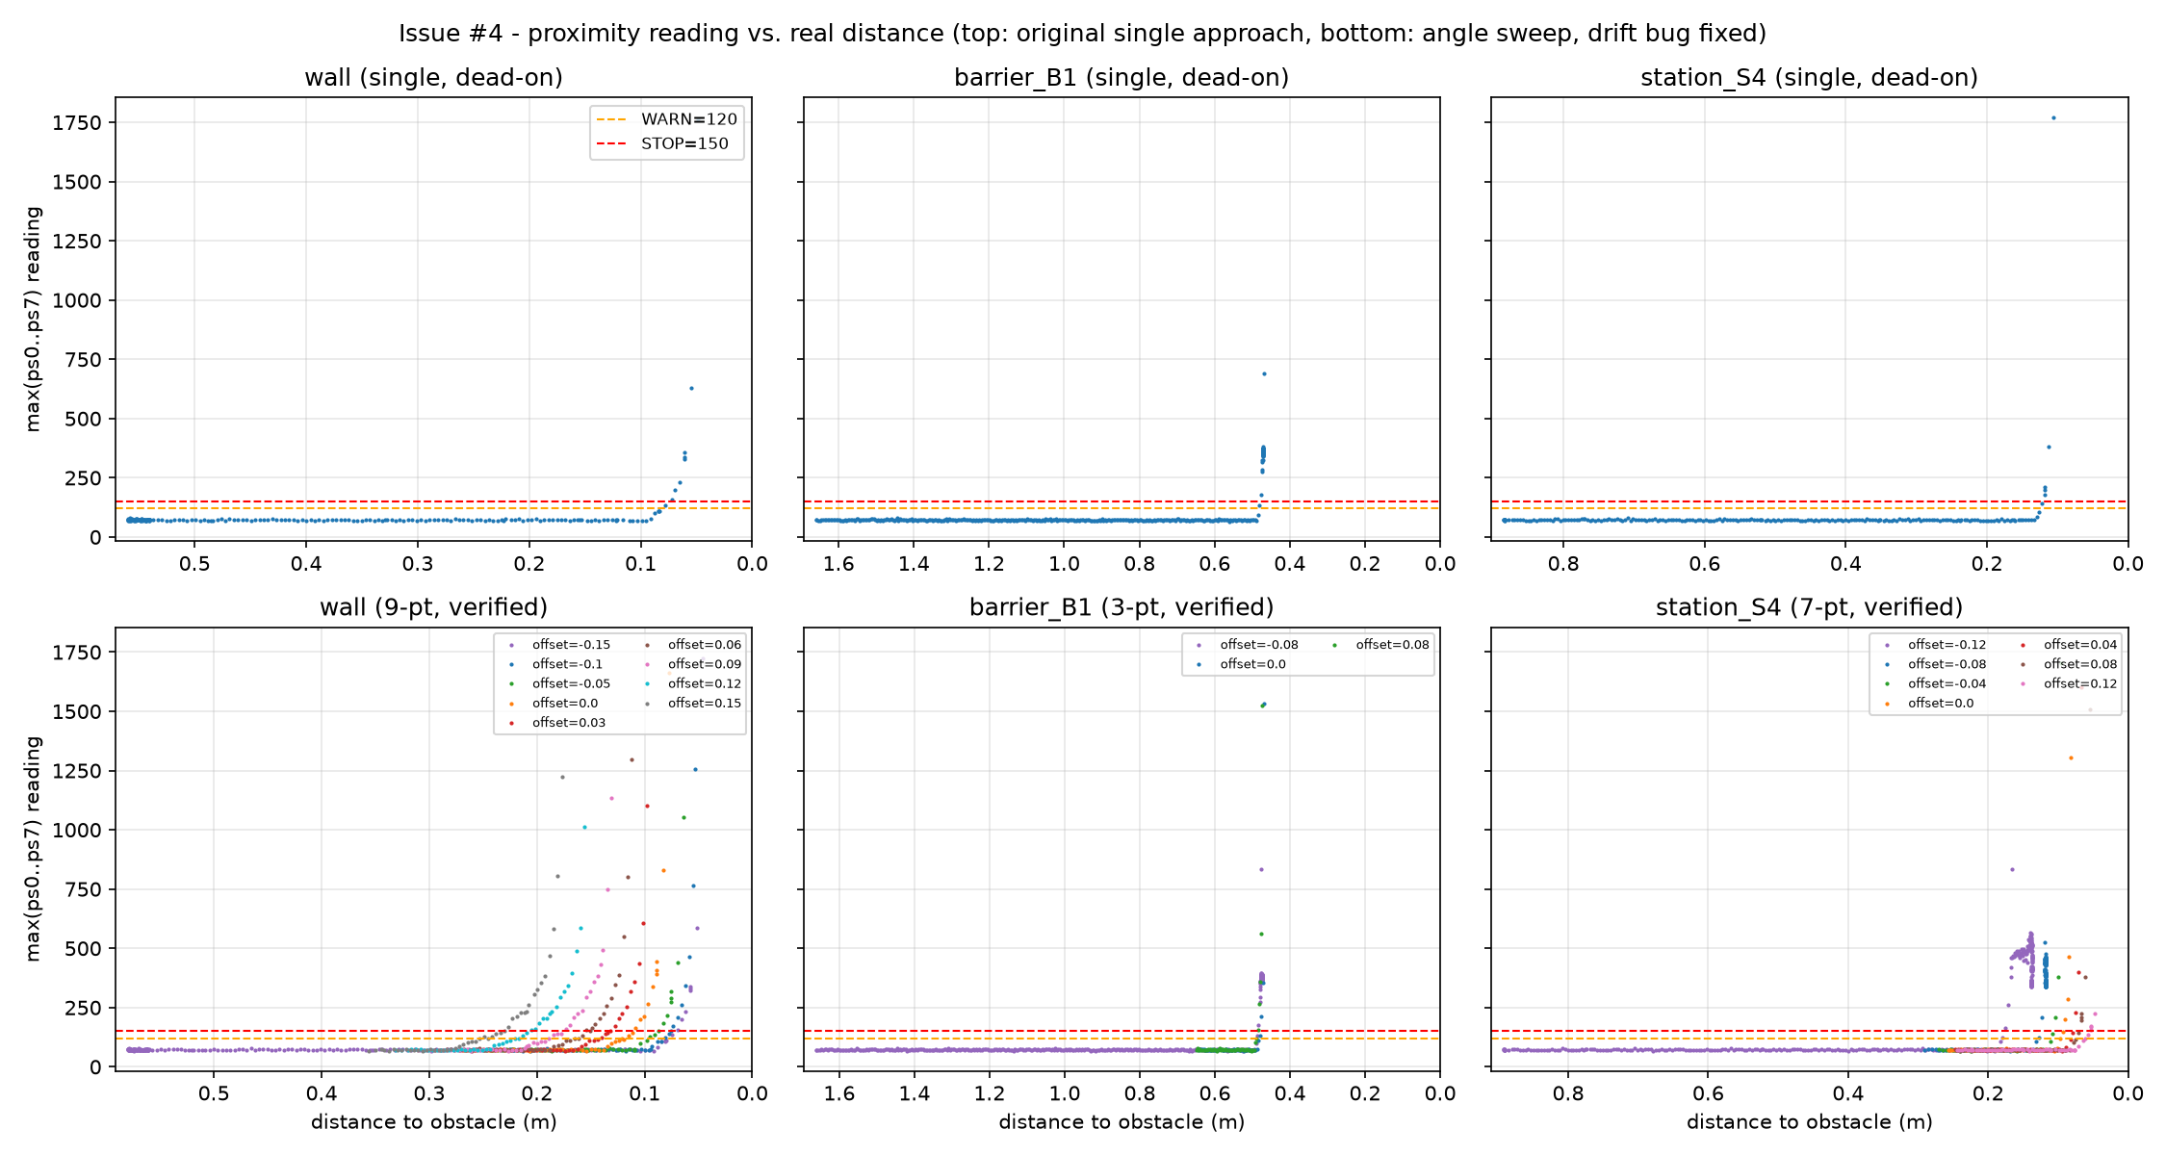
Figure 10. Proximity reading against real distance for all three obstacle classes. The top row is the first single approach per obstacle and the bottom row is the verified angle sweep. The flat region on the left of each panel is the sensor noise floor.
That difference is a real lesson rather than noise. The barrier was approached dead centre onto its corner, so both front sensors hit it at a shallow angle and neither ever pointed at a flat face. The reading a robot gets at contact depends heavily on the angle it hits at, not only on how close it is. A threshold tuned on a convenient straight on hit can badly under-read on a corner.

Constant | Value | Why this value
Noise ceiling | 80.2 | The highest reading anywhere in any log more than 0.3 m from an obstacle, with a mean around 72
WARN | 120 | About 1.5 times the noise ceiling, so it will not false trigger, but low enough to catch the rise as soon as it can be told apart from noise
STOP | 150 | Above WARN, below the weakest verified near contact reading of 226, and well below the barrier's steady 350 to 380
Table 10. The proximity thresholds and the measurements behind them.
A requirement we could not meet, stated plainly
The task asked for a WARN threshold that fires at least 0.06 m before contact. Our data shows that is not achievable from these sensors. The reading only leaves the noise floor 0.013 to 0.038 m before contact across all three obstacle classes, so no threshold value can fire earlier. This is a property of the simulated infrared sensor against these surfaces, not a tuning failure. The honest achievable margin is roughly 1 to 4 centimetres. This is precisely why our planner leans on map based clearance rather than expecting the sensors to give early warning.

Proving safety really does override
We tested this deliberately rather than assuming it. We rotated the robot to face an obstacle, drove it into warning range, then handed control to the navigator with a station as its goal. The log shows AVOID and then STOP firing while a waypoint was still pending, which is direct evidence that safety pre-empts path following rather than merely running alongside it. The robot then replanned and reached its goal within 0.058 m.
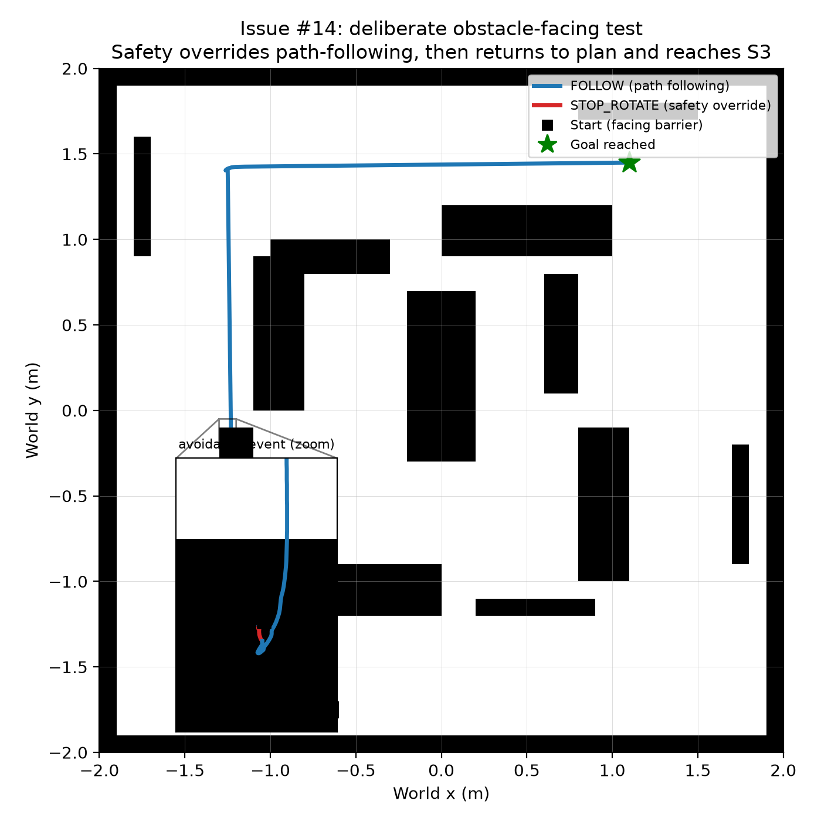
Figure 11. The full trajectory from the deliberate obstacle test. Blue is normal path following and red is the safety override, with an inset zoom on the avoidance manoeuvre itself and the return to the planned route.
Across all 24 official start and station pairs the safety layer never needed to act at all: zero AVOID events, zero STOP events, and one replan per leg. That is the clearance policy doing its job, keeping the planned path clear of real obstacles so the reactive layer has nothing to react to.
An honest limit found by stress testing beyond the official pairs. The requirement is at most three consecutive readings above STOP. Across all 24 official pairs we recorded zero. But in the deliberate obstacle test we recorded four, in the 0.13 seconds it took the sensor cone to rotate clear once the stop rotation had already begun. In a much more severe test, driving the robot straight into a concave corner, we recorded 48 consecutive readings before two stop and rotate cycles freed it, taking 42 steps. Both cleared safely without collision, but they show that escape time depends on how hard the initial contact is, and a single fixed rotate duration can exceed the three step budget when the approach is severe.

5.5 Choosing the next station
The station chooser implements the nearest first strategy from Section 2.5. It sorts the unvisited stations by identifier first, so that if two stations tie on path length the same one is always chosen, which keeps the whole mission repeatable. Calling it twice with the same inputs returns the same station, and across the three starts it chose three different first stations, which shows it is genuinely responding to the robot's position rather than following a fixed list.

6. Putting it together: the mission state machine
The state machine is what turns the separate components into one autonomous controller. It has nine states. Its job is not only to sequence the normal path but to define what happens when any component gives an unusable answer, so that the mission always ends rather than hanging.
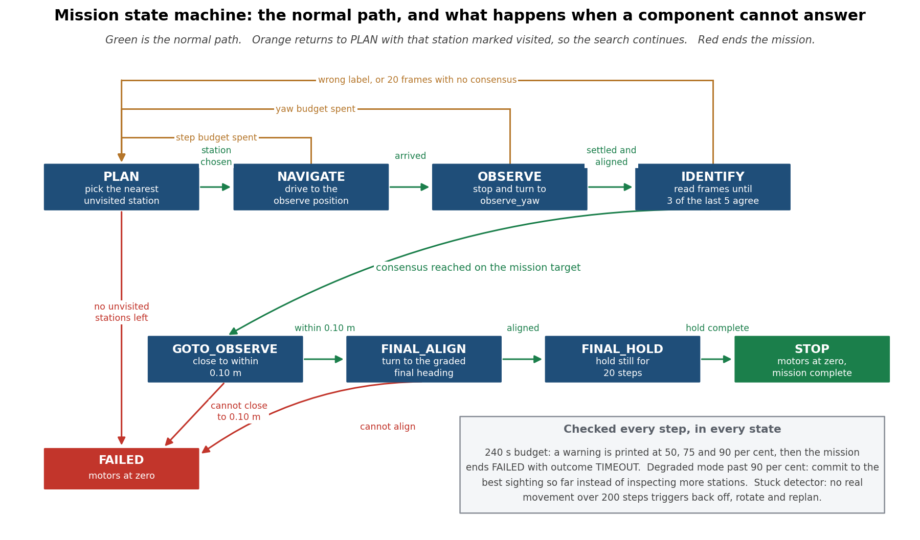
Figure 12. The mission state machine. Green is the normal path, orange returns to PLAN with that station marked inspected so the search continues, and red ends the mission. The three checks in the grey box run in every state on every step.

6.1 What each state does when it cannot answer
This is the part of the design we are most confident about, because every failure path in the table below was exercised and logged, not just written down.

State | What it does | What happens when it cannot
PLAN | Picks the nearest unvisited station by A* path cost | No unvisited stations left, so the mission ends in FAILED
NAVIGATE | Drives to that station's observation position with the safety layer active | Step budget spent, so the station is marked inspected and control returns to PLAN
OBSERVE | Stops and rotates to the station's own observation heading | Alignment budget spent, so the station is marked inspected and control returns to PLAN
IDENTIFY | Takes camera frames and runs the identifier until three of the last five agree | A non target label, or 20 frames with no agreement, so the station is marked inspected and control returns to PLAN
GOTO_OBSERVE | Makes the final precise approach to the exact observation position | Cannot close to within tolerance, so FAILED. The target is already confirmed so there is nothing else to try
FINAL_ALIGN | Rotates to the graded final heading | Cannot align within budget, so FAILED
FINAL_HOLD | Holds still for 20 consecutive steps, then prints the final pose and distance | Not applicable, this state always completes
STOP | Motors at zero, mission successful | Terminal
FAILED | Motors at zero, mission unsuccessful | Terminal
Table 11. Every state and its defined failure response. No failure path re-enters a state that could loop forever: NAVIGATE, OBSERVE and IDENTIFY failures all shrink the list of unvisited stations, and PLAN on an empty list ends the mission.

6.2 Stopping in the right place
The mission is graded on stopping within 0.20 m of the observation position. We treat arrival as a real distance check rather than a step count, because a step count could quietly report success while the robot sat somewhere else.
Our internal tolerance is 0.10 m, which is half the graded requirement, and the robot must then hold still for 20 consecutive control steps before the mission ends. It prints its final position, its distance to the observation position and its heading error, which is the evidence a marker can read directly off the console during the live demonstration.

6.3 The time budget and degraded mode
The mission has 240 seconds. Running out of time with nothing to show would be the worst possible outcome, so the budget is checked on every step in every state, not only when planning.
Degraded mode is the interesting part. Whenever the robot sees the target with reasonable confidence but never quite reaches full agreement, it remembers that sighting. Once 90 per cent of the budget is gone, it stops inspecting new stations and commits to the best sighting it has, driving there instead. It is trading a complete search for a plausible answer, which is the right trade when the alternative is running out of time having committed to nothing. It deliberately does not trigger once the real target is already confirmed, because at that point there is nothing left to pre-empt.

6.4 Every constant we tuned
Every number below was set by a measurement, not chosen by feel. This table is the single place a reader can check them all.

Constant | Value | How it was chosen
MAX_SPEED | 6.28 rad/s | The e-puck's real wheel motor limit in Webots. The starter code had 10, which flooded the console with warnings
BASE_SPEED | 5.0 rad/s | Below the clamp, and gives a measured 0.1000 m/s forward speed
KP_HEADING | 8.0 | Smallest cross track error, 0.0093 m mean, of the three gains tested
WAYPOINT_TOLERANCE | 0.05 m | Well under half a grid cell, so the robot cannot skip a cell
WARN | 120 | About 1.5 times the measured 80.2 noise ceiling
STOP | 150 | Below the weakest verified near contact reading of 226
Clearance radius | 4 cells | The smallest radius that keeps all 8 stations reachable
IDENTIFY_BACKOFF_DISTANCE | 0.5 m | Puts the robot at roughly 0.8 m, the near edge of the measured usable band
MIN_CONFIDENCE | 0.50 | From the threshold sweep in Section 7.3, balancing true accepts against false accepts
MIN_CONFIDENCE_MARGIN | 0.20 | Rejects a guess barely ahead of its runner up, which confidence alone misses
MIN_REFERENCE_SIMILARITY | -0.05 default | Two labels carry a stricter floor of 0.00. The reasoning is in Sections 7.4 and 8
IDENTIFY_CONSENSUS_FRAMES | 3 of 5 | Three consecutive frames was tested first and broke on single noisy frames
IDENTIFY_MAX_FRAMES | 20 | Past this the station is treated as no match so the search can continue
ARRIVAL_TOLERANCE | 0.10 m | Half the graded 0.20 m requirement
OBSERVE_YAW_TOLERANCE | 0.05 rad | Tight enough that the poster is reliably in frame
FINAL_HOLD_STEPS | 20 | Enough consecutive zero velocity steps to prove the robot has really stopped
STUCK_WINDOW_STEPS | 200 | About 6.4 s, longer than the worst case legitimate turn. It was 60 and false triggered, see Section 8.4
STUCK_MIN_DISPLACEMENT | 0.02 m | Well below normal progress over that window
TIME_BUDGET | 240 s | The assessment's four minute limit
DEGRADED_MODE_FRACTION | 0.90 | Leaves roughly 24 s, enough to reach a remembered station
DEGRADED_MIN_CONFIDENCE | 0.60 | Above the range real wrong readings occupy, so a poor sighting is not acted on
Table 12. Every tuned constant in the controller, its shipped value, and the measurement that set it.

7. Testing and results

7.1 How we tested
Our test matrix is the three supplied worlds crossed with all eight targets, which is 24 runs, plus one repeat, giving 25. That covers every start pose, every target label, and both boundary and interior stations in every world.
On repeated runs. Because the simulation is deterministic, with a fixed classifier seed, no injected sensor noise and a fixed start pose, we used one repeated run to confirm repeatability and then prioritised full coverage of all worlds and all targets. The repeat reproduced its original run exactly, to the same completion time and the same final distance, which is the evidence that repeatability holds.
Every run was made under the same rules as the assessment, and we recorded enough to prove it.
- Only the mission configuration file was edited between runs. The controller was never touched.
- The controller file's checksum was recorded before the matrix started, so we can show the same code ran for every row.
- Nothing was paused, reset or restarted mid-run. Any run that was touched would be recorded as void and repeated. None were.
- A collision counts as a proximity reading above the STOP threshold sustained beyond the avoidance response window. A single brief spike is not counted.
One behaviour worth explaining before the results
The first station identified in any run triggers a one-off build of the classifier, which trains the final layer on the reference images. This takes roughly 15 to 25 seconds of real time and looks like the simulation stalling. It happens once per run, it is cached afterwards, and it consumes wall clock time rather than simulation time, so it does not count against the 240 second mission budget.

7.2 Mission results

Measure | Result | Requirement
Successful missions | 25 of 25, 100 per cent | Not stated, but a single run is not enough evidence
Collisions | 0 | No collision permitted
Runs over the 240 s budget | 0 | Must complete within 4:00
Runs needing human intervention | 0 | None permitted after Run is pressed
Mean completion time | 89.59 s | Under 240 s
Slowest run | 180.93 s | Under 240 s, so 59.07 s of margin
Worst final distance to the observation position | 0.099 m | Within 0.20 m
Table 13. The headline results across the full test matrix. Every requirement is met with margin.
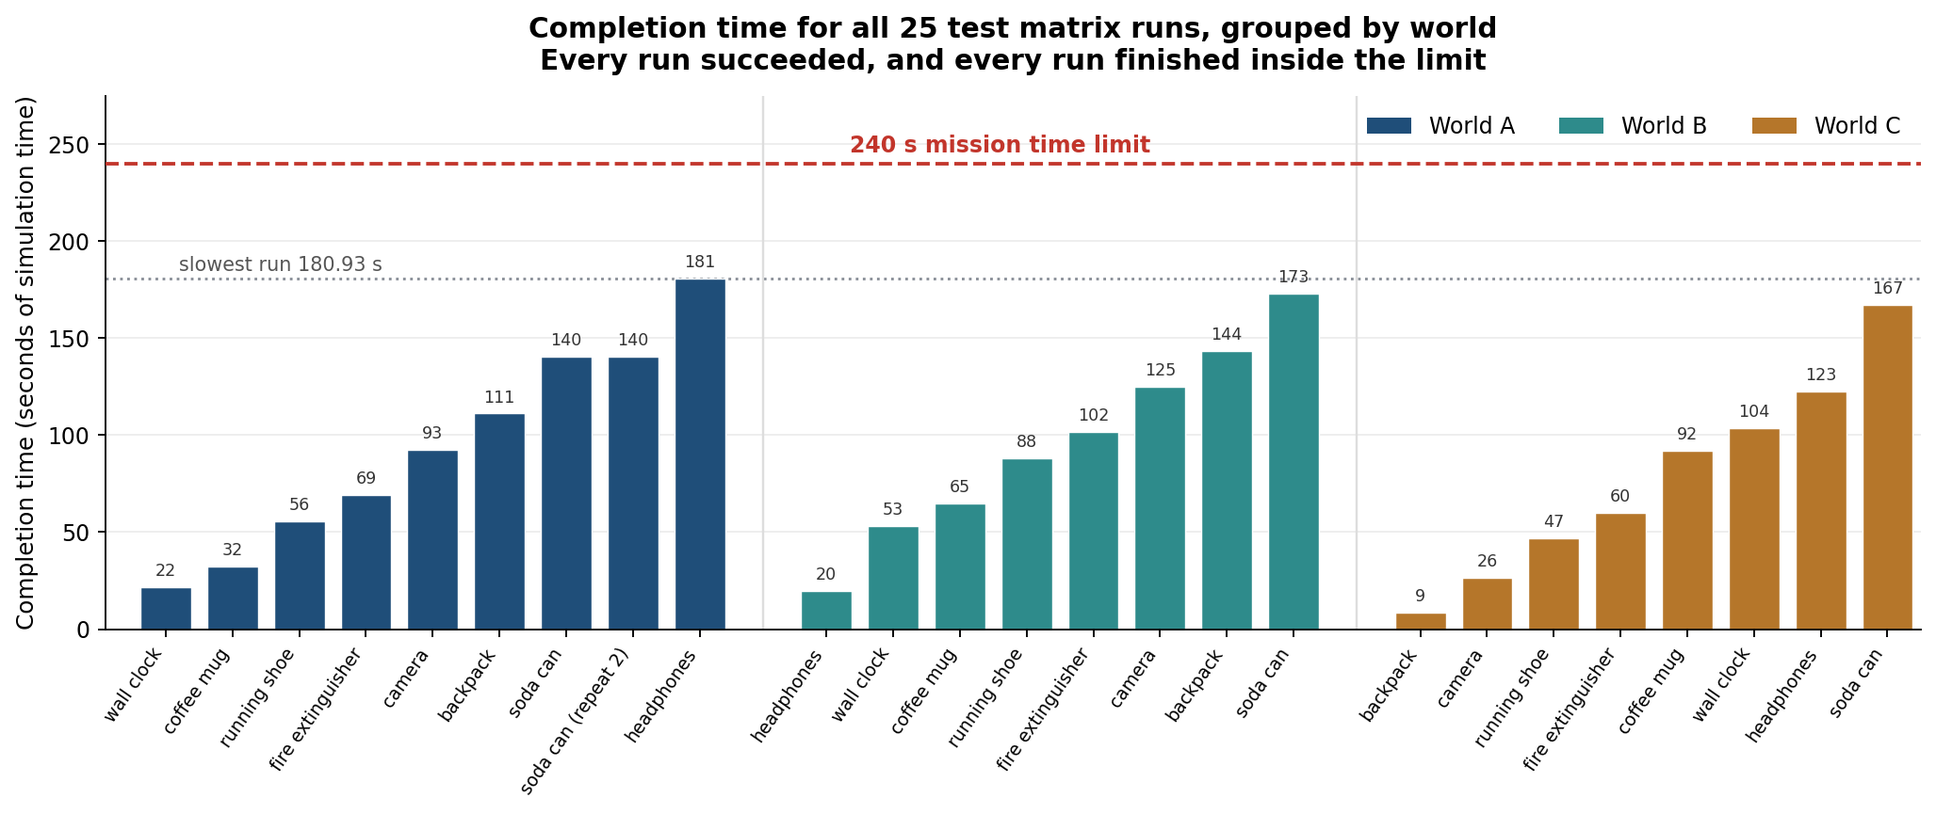
Figure 13. Completion time for every one of the 25 runs, grouped by world. The red line is the 240 second limit. The slowest run, world A with target headphones, inspected all eight stations and still finished 59 seconds inside the budget.

Breakdown | Runs | Successes | Mean time | Over budget
World A, start A | 9 | 9 (100 per cent) | 93.79 s | 0
World B, start B | 8 | 8 (100 per cent) | 96.06 s | 0
World C, start C | 8 | 8 (100 per cent) | 78.41 s | 0
Boundary stations | 13 | 13 (100 per cent) |  | 0
Interior stations | 12 | 12 (100 per cent) |  | 0
Overall | 25 | 25 (100 per cent) | 89.59 s | 0
Table 14. Results by world, which is also results by start pose since each world has one fixed start, and by station type. The interior stations are the harder case because they sit inside the pocket the clearance investigation was about, and they succeed just as reliably.
The two slowest targets on average are soda can at 155.11 s and headphones at 107.72 s. That is not because those two are harder to recognise. Their stations, S1 and S7, sit furthest along the search order from most starts, so more stations get inspected and rejected before the robot reaches them. This is the search cost of not being told where the target is, and it is exactly what the mission is meant to measure.

7.3 Vision accuracy
Mission success is the outcome that matters, but it hides how the vision performs frame by frame, so we measured that separately on the saved captures. The full confusion matrix is committed as docs/data/vision_confusion_matrix.png; the per label summary below is drawn from it.

Target | True positives | False positives | False negatives | Precision | Recall
soda_can | 13 | 0 | 1 | 1.000 | 0.929
coffee_mug | 13 | 2 | 1 | 0.867 | 0.929
backpack | 6 | 0 | 8 | 1.000 | 0.429
fire_extinguisher | 5 | 1 | 3 | 0.833 | 0.625
camera | 11 | 3 | 0 | 0.786 | 1.000
running_shoe | 13 | 0 | 1 | 1.000 | 0.929
headphones | 7 | 1 | 4 | 0.875 | 0.636
wall_clock | 11 | 0 | 3 | 1.000 | 0.786
Table 15. Precision and recall for each target. Precision is how often an answer of this label was right. Recall is how often this label was correctly found when it really was there.
The weakest label is backpack, at 0.429 recall. We investigated rather than reporting the number and moving on. The cause is mixed: at close range in world C the poster finder often fails to produce a crop at all, and even with a good crop the classifier tops out at 0.59 to 0.62 confidence for this label, which is barely over the acceptance threshold. Backpack is a dark object on a dark barrier, which is the same problem that made direct brightness thresholding fail in Section 4.1.
Precision matters more than recall for this mission. A false positive sends the robot to the wrong station and ends the mission incorrectly. A false negative only costs time, because the robot moves on and inspects the next station. Four of the eight labels have perfect precision, and the mission level results in Section 7.2 show the system finds the right station every time despite the per frame recall being well short of perfect.

7.4 Rejecting distractors
All 20 distractor images were scored through the same pipeline the robot uses. The correct answer for every one of them is NO_MATCH.
This number moved four times during the project, and out of order those four figures look like they contradict each other. In order they tell one coherent story, so that is how we report it.

Stage | What changed | False accepts | Why we made the change
1 | Confidence and margin gates only | 4 of 20 | The starting point. An eight way classifier always picks its closest class, so confidence alone cannot detect an unknown object
2 | Added the reference similarity gate | 0 of 20 | Compares the crop back to the predicted label's own reference photograph, which is the check confidence cannot do
3 | Removed the per label floor for fire extinguisher | 1 of 20 | That floor was blocking the real fire extinguisher poster in live missions. A hand traced, pixel perfect crop of the real poster still scored only 0.115, lower than the distractor the floor was protecting against, so no floor value separated them
4 | Removed the per label floor for coffee mug | 3 of 20 | Same situation. Real crops scored 0.014 to 0.018 while the two distractors scored 0.058 and 0.092, so again no floor separated them
Table 16. How distractor rejection changed across the project. Every change was checked against the confusion matrix first to confirm it could not cause confusion between two real targets.
We want to be straight about stages 3 and 4, because they made one reported number worse. We traded distractor rejection on paper for target detection in reality. Removing the coffee mug floor took its recall from 0.500 to 0.929, and a live mission that had previously failed completely then succeeded, stopping 0.098 m from the observation position. Before each removal we checked the confusion matrix and confirmed that label had zero false positives against real frames from any other station, so the change could not cause the robot to confuse two real targets. The three distractors now accepted are book and ball photographs that exist in our texture folder but are not what the barriers in the arena actually display at the geometry the robot views them from.
Section 10 proposes the proper fix, which is a real open set check rather than per label similarity floors.

7.5 Proving there is no memorised mapping
This is the strongest single piece of evidence in the report, and it exists because we went looking for a weakness in our own testing rather than waiting for the assessment to find it.
All three supplied worlds use the same target to station arrangement, so every test up to this point could in principle have been passed by a system that had memorised it. We made three copies of the worlds and shuffled the arrangement in each. All three are full derangements, meaning no station keeps its original target. We changed nothing except which poster hangs on which barrier, and we did not touch the official worlds at all.

World | Target | Station here | Station in training | Result | Distance
A | soda_can | S2 | S1 | Pass | 0.099 m
A | running_shoe | S7 | S6 | Pass | 0.099 m
B | soda_can | S8 | S1 | Pass | 0.098 m
A | camera | S6 | S5 | Pass | 0.018 m
B | backpack | S6 | S3 | Pass | 0.098 m
C | wall_clock | S7 | S8 | Pass | 0.099 m
A | wall_clock | S1 | S8 | Pass | 0.097 m
C | soda_can | S2 | S1 | Pass | 0.070 m
Table 17. Results in the shuffled worlds, where every target sits at a station it never occupied during development. All eight pass, the slowest taking 191.52 s and the worst final distance being 0.099 m.
Why this proves the point
Look at the soda can rows. The same target was correctly found at S2 in world A, at S8 in world B, and at S2 in world C, using the identical controller with no changes between runs, and none of those is its training station. A system relying on a memorised arrangement could not do that. The robot is finding the target by looking at it.

An honest qualification. When we first ran these eight cases, only three passed. Five failed inside the identification step, never in planning or navigation, and we re-ran all eight after later fixes and got eight passes. Several things changed between those two sets of runs: a similarity floor was added for one label, the agreement rule changed from three consecutive frames to three of the last five, and the retry from the observation position began doing visible work. We cannot honestly attribute the recovery to any single one of those without testing each in isolation against these eight cases, and we have not done that. What the shuffled worlds definitely did was expose gaps that the identical training arrangement had been hiding, because no earlier test had ever asked the model to recognise wall clock at S1, or backpack at S6 in world B's approach geometry.

8. Failure cases
For each case below we answer the same question first, before proposing any fix: where did the first wrong decision happen? This matters because the symptom and the cause are often in different components. A robot that stops at the wrong station may have a perfectly correct navigator and a mistaken perception, and fixing the navigator would make the system worse.

8.1 Vision: the robot was confidently wrong
What happened. In shuffled world test_start_B, the full reversal arrangement, with target headphones, which sits at station S2 in that world. The robot navigated to S2 correctly. The classifier then alternated between the right and wrong label across consecutive frames, reading headphones 0.71, camera 0.75, camera 0.74, headphones 0.72, camera 0.72. Camera reached three of the last five first, so S2 was marked inspected with a confident wrong label and the mission ended in FAILED after all eight stations.
Where the first wrong decision happened. In the agreement vote inside IDENTIFY, not in planning, not in navigation, and not in the crop. We proved the crop was not at fault by saving the real camera frames and checking them: the crop was identical on all five frames and visibly shows the headphones. This was the classifier being confused, and we only knew that because we looked rather than guessed.
Why our existing protection did not catch it. The three of five rule defends against one bad frame. It does not defend against a three to two split between two labels the model genuinely confuses. Being confidently wrong is a different failure from being unsure, and it needed a different fix.
The fix, and how we checked it. The two cases separate cleanly on reference similarity: the false camera reading scored -0.029 while genuine camera readings in the same run scored +0.123, +0.176 and +0.175. So we added a similarity floor of 0.00 for the camera label only. Before shipping it we swept every saved frame we had, 228 in total, and confirmed exactly three answers changed, all three being the wrong ones.
The result. That world went from FAILED at 168.58 s to success at S2, 0.099 m from the observation position, in 65.28 s. The other five worlds reproduced their previous station, distance and time exactly, which is how we know we did not break anything else.
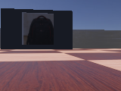
Figure 14. A confidently wrong read of the same kind, kept in the repository as evidence. This is station S3, which carries the backpack, and the identifier returns camera at 0.815 confidence. It is the clearest remaining miss in our evaluation set.

8.2 Vision: the robot was right but not allowed to say so
What happened. A live mission in world C with target coffee mug. The robot reached S2 correctly, tried both the backed off viewpoint and the final observation viewpoint, and returned NO_MATCH on all 40 frames, even though the confidence looked high.
Where the first wrong decision happened. In the acceptance gate, not the classifier and not the navigator. Saving the real frames and running them back showed the retry frames all scored the correct label, coffee mug, at 0.86 to 0.90 confidence with a margin above 0.82. Those answers were being thrown away by the per label similarity floor every single time.
The fix and its cost. We checked whether any floor value could accept the real crop while still rejecting the two distractors that floor was protecting against. There is none: the real crops scored 0.014 to 0.018 while the distractors scored 0.058 and 0.092, so the real thing scores lower than the fakes on that measure. We removed the floor. Recall for coffee mug went from 0.500 to 0.929, and distractor false accepts went from 1 of 20 to 3 of 20. The same mission then succeeded, confirming on the first three frames and stopping 0.098 m from the observation position.
These two cases are a matched pair and we find them the most interesting result in the project. The same mechanism, a per label similarity floor, was the right fix in one case and the wrong constraint in another. What separated them was not judgement but measurement: in one case the real and false readings separated cleanly on that number, and in the other they did not.

8.3 Navigation: in the right place, facing the wrong way
What happened. The very first full run using real vision rather than the stub. Start A, target soda can. IDENTIFY returned NO_MATCH on all 12 frames at S1, the one station that should have matched, with 0.00 confidence every time. The mission then wrongly confirmed a different label at S7 and ended in FAILED.
Where the first wrong decision happened. In navigation, not vision, even though the symptom appeared in vision. The navigator only ever targets an (x, y) position and never a heading. The observation heading supplied in the configuration file was not referenced anywhere in our controller. So the robot arrived at exactly the right spot facing whatever direction its last waypoint happened to leave it in, and the camera never saw the poster at all. A confidence of 0.00 on every frame was the clue: that is what you get when there is no poster in the picture, not when a poster is hard to read.
The fix and the result. OBSERVE now rotates to the station's own observation heading, with its own failure path if that takes too long, before the settle countdown starts. The re-run identified S1 correctly with real three frame agreement at 0.64, 0.70 and 0.71 confidence.
This is the clearest example in the project of why the diagnostic question matters. Every instinct said the vision was broken. Tuning the vision thresholds would have made the system worse while leaving the real bug in place.

8.4 Two navigation bugs that only real testing found
The stuck detector fired while nothing was wrong. During an avoidance test the recovery behaviour triggered at step 62 with no obstacle anywhere near the robot. The cause was correct behaviour being misread: the first waypoint was roughly 180 degrees from where the robot was pointing, and our own speed reduction rule combined with the wheel speed clamp turns a large heading error into a near pure rotation on the spot. The robot genuinely was not moving, because it was correctly turning around first. We widened the detection window from 60 steps to 200, which is comfortably longer than the worst case legitimate turn, and the false trigger stopped.
The planner refused to plan from a perfectly safe position. The navigator entered its no path state and never recovered. We first assumed the clearance margin was blocking the robot's own cell and patched around that, and it still failed. Checking the actual cell showed the robot's real, collision free position rounded onto a cell that the raw grid also marks as an obstacle. The 0.1 m grid was quantising a safe near wall position onto the wrong side of a cell boundary. The fix is simple and safe: the robot is physically standing in that cell right now, so that one cell is treated as free for the planning call whatever either grid says.

8.5 A result we had to throw away
We are including this one because it changed how we treat our own evidence.
Our first fine grained sensor angle sweep produced an alarming result: a total blind spot on the wall at certain approach offsets, with readings never leaving the noise floor. We wrote it up and used it to justify lowering the STOP threshold.
It was a bug in the test, not a property of the sensor. The sweep computed each new aim point relative to the robot's current position after backing off, rather than from a fixed reference. Small heading errors accumulated across attempts, and by the later offsets the aim point had drifted up to 0.14 m away from the wall. The robot was not failing to detect the wall. It was missing the wall entirely and correctly detecting nothing.
We rewrote the sweep to aim at the wall's own known coordinate, which cannot drift, and re-ran it. With the bug fixed the wall spikes above 1000 at every offset and is the easiest obstacle to detect, not the hardest. The genuinely weakest verified case turned out to be a station barrier at 226, and our threshold of 150 happened to still be correct, but for a completely different reason than the one we originally wrote down.
The lesson we took from it. An alarming result is not more trustworthy than a reassuring one. Both have to be checked for whether the test is measuring what you think it is measuring. We nearly shipped a threshold justified by a number that meant nothing.

8.6 Still open
One issue is unresolved and we would rather name it than leave it out.
In worlds B and C, whenever the target is not headphones, station S7 gives a first pass of NO_MATCH at 0.31 to 0.37 confidence for the full 20 frame window, and only resolves to the correct label at 0.67 to 0.71 on the automatic retry from the observation position. It costs each affected run roughly 20 to 40 extra seconds. It never caused a failure, and every affected run still succeeded, but it is a real and reproducible weak point.
What makes it odd is that when headphones is the actual target, S7 reads correctly on the very first pass at 0.88 confidence, from the same station, the same approach, the same code and the same fixed seed. Something differs between those two cases that we have not yet identified. World A never shows the pattern at all, and in world A S7 is visited last, after several other stations have already been read.
The next diagnostic step, stated so it is not vague. Re-run one affected case with frame capture enabled, save the real S7 frames from both the first pass and the retry, and compare them directly against the frames from the run where headphones was the target. That will show whether the crop itself differs or whether the classifier is reading an identical crop differently.

9. Robustness
This section gathers the evidence that the system is genuinely robust, rather than leaving it scattered across the report.

9.1 The same code across every condition we could vary

What was varied | How many conditions | Result
Start pose | 3 (A, B and C) | 100 per cent success from every start
Target identity | 8 targets | 100 per cent success for every target
Station type | Boundary and interior | 100 per cent for both
Target to station arrangement | The training arrangement plus 3 full derangements | 8 of 8 shuffled runs pass
Total runs on the shipped controller | 25 matrix runs plus 8 shuffled runs | 33 of 33 successful
Table 18. Everything we varied while holding the controller constant. Only the mission configuration file changed between runs.

9.2 What happens when something goes wrong
Robustness is not only about succeeding. It is about behaving sensibly when a component cannot do its job.
- Every state has a defined response to its component returning nothing (Section 6.1), and we exercised each path deliberately by shrinking the relevant budget until it triggered.
- The mission cannot loop forever, because navigation and identification failures shrink the unvisited list and planning on an empty list ends the mission. Forcing every identification to fail produces a clean FAILED with the motors stopped, not a hang.
- Running short of time triggers degraded mode, and the safety layer overrides path following, with a stuck detector underneath it as a second recovery layer.
One failure path is honestly untested. The GOTO_OBSERVE budget failure could not be triggered empirically, because that state re-targets the exact position the robot has already reached, so its arrival check resolves in one step by construction. The branch exists and reuses the same already proven budget mechanism as NAVIGATE, but we would rather document it as a structurally near unreachable defensive path than claim a test we did not run.

10. Limitations and what we would do next
Every limitation below is paired with the improvement that would address it. Several of them come directly from measurements reported earlier, which is why they are stated as facts rather than worries.

Limitation | Why it exists | What would fix it
The robot cannot locate itself without GPS and the InertialUnit. There is no visual localisation at all | We deliberately did not build visual SLAM because pose is supplied and the brief says it is not required | Visual odometry from the Week 7 material as a fallback, so the robot degrades rather than fails if pose is lost
The identifier is trained on eight clean product photographs and tested on small angled camera views | This is a domain shift, and it is the main reason per frame accuracy is around 71 per cent rather than higher | Capture real in-world frames across distances and headings and retrain the final layer on those instead of on the reference photographs alone
Some targets, especially backpack and wall clock, only read confidently at longer range | Measured directly: wall clock scores 0.20 to 0.61 under 0.45 m but 0.92 to 0.99 at 0.8 m and beyond | Choose the identification standoff per station from the measured visibility band, rather than using one fixed backoff distance for all
Three distractor images are still accepted as targets | We removed two per label similarity floors because they were blocking real targets in live missions | A proper open set method, which is designed to answer none of these, instead of per label floors that fight the classifier
The reactive layer's escape time depends on how hard the contact is | Measured 4 consecutive readings above STOP in one deliberate test and 48 in a severe corner test, against a 3 step target | Scale the rotation duration to the strength of the reading instead of using one fixed duration
The proximity sensors cannot give the 0.06 m warning margin the task asked for | The signal only leaves the noise floor 0.013 to 0.038 m before contact, which is a sensor property not a tuning fault | Keep relying on planned clearance from the map, which is what our design already does, and treat the sensors as a last resort only
All testing was done on a deterministic simulation with no sensor noise | The simulation has a fixed seed and no injected noise, so a repeated run reproduces exactly | Add sensor and actuator noise and repeat the matrix, which would test whether the agreement rule is tuned too tightly
The poster finder fails at 1.0 m combined with 10 degrees off axis | Five separate rejection signals were tried and none separated the bad crop from good ones | More labelled frames at that geometry, or a learned crop step rather than a hand built one
Table 19. Every limitation we know of, with the evidence behind it and the improvement we would make.

11. Contribution statement
Our team has two members rather than three. We agreed at the start not to use the suggested three way split into separate streams, because with two people that would have left each of us unable to answer questions about half the system. Instead we both worked across perception, navigation and integration.
Every Webots simulation run in this project was started and watched live by a team member. None were run unattended.

Issue | Member | What they did
1 | Nora | Set up the repository, the contributing guide and the contribution log
2 | Nora | Verified all three supplied worlds run cleanly and recorded the device baseline
3 | Nora | Implemented the motion primitives and pose utilities, and measured the motion baseline
4 | Nora | Proximity calibration across all three obstacle classes; chose and justified WARN and STOP, and documented the 0.06 m margin as unreachable
5 | Nora | Capture sweeps at S1 and S3; measured poster size against distance and set the 0.80 to 1.30 m identification band
6 | Nora | 84 frame capture sweep across all three worlds; reviewed and corrected the ORB against ResNet 18 comparison, and chose ResNet 18
7 | Nora | Negative frame sweep and independent hand labelling for the IoU test; rejected the first closure of this issue, which directed the fix taking unclipped IoU from 12 of 15 to 15 of 15
8 | Nora | Implemented target identification with the confidence and margin gates and the NO_MATCH return, and produced the first evidence table
9 | Nora | Evaluated the identifier against saved captures and all 20 distractors; found confidence alone still allowed four, and added the reference similarity check
10 | Kithmini | Grid metadata and full world to grid conversion checks; confirmed start and observation cells are free, and generated the grid overlay
11
12
13
14
15
16
17
18
19
20
Table 20. Contribution by issue, taken from our running contribution log rather than written from memory. The blank rows are to be completed before submission.
To be completed before submission
Rows 11 to 20 are deliberately blank. Our contribution log was kept from day one but was last updated at issue 10, so we do not yet have a written record of who did which parts of the clearance policy, A*, waypoint following, avoidance, visit ordering, the state machine, the stopping rule, telemetry, the shuffled worlds and the test matrix. Both members must fill in their own rows from the commit history before this report is submitted. We have left the table visibly incomplete rather than guessing, because a contribution statement that is partly invented is worse than one that is honestly unfinished.

12. Acknowledgements and external resources
This section is generated from the register we kept during the project, not written from memory at the end.

12.1 Pretrained models and third party libraries

Resource | Source | Used in, and why it is permitted
ResNet 18, ImageNet pretrained weights | torchvision, ResNet18_Weights.IMAGENET1K_V1, BSD 3 licence | The identification comparison and the shipped identifier, with the backbone frozen and only a new linear layer trained. The Week 4 workshop explicitly covers a pretrained ResNet 18 used this way. The weights are not in our ZIP; torchvision downloads them automatically on first run
OpenCV (cv2) | opencv-python | All image handling. Used by the supplied camera helper and by Workshop 8 itself, so it is standard course toolkit rather than an external addition
PyTorch and torchvision | pytorch.org | The identifier. Pre-installed in the project environment and the standard toolkit for the Week 4 transfer learning material
NumPy | numpy.org | Grid handling and array maths throughout the controller
Matplotlib | matplotlib.org | Used only to generate the figures in this report, never by the controller at run time
Table 21. Every pretrained model and third party library used, with its source.

12.3 Supplied project resources used
The eight reference images in the textures folder are used as training data for the identifier. The task explicitly permits using them as templates or training data. The barrier definition file is used for its geometric proportions, which is what lets the poster finder work from the barrier shape rather than the poster brightness. Both are supplied project resources.

12.4 AI assistance

Period | Tool | What it was used for | Reviewed by
14 to 17 September 2026 | Claude Code (Anthropic) | Substantial assistance across test and calibration scripts, the grid conversion checker, the capture sweeps, the ORB against ResNet comparison pipeline, the evaluation harness, several bug fixes, and drafting of documentation. Every Webots simulation run was driven live and watched by a team member rather than run unattended. Generated code and generated findings were reviewed, and in several cases re-tested against real captured data or corrected, before being kept | Nora
Table 22. AI assistance register. Our full change log holds a chronological record of every individual change, which is more granular than this summary.
To be completed before submission
The row above covers issues 3 to 10 as one grouped entry. It needs splitting into one row per issue, matching our change log, so that each can be spot checked individually during the presentation question and answer session. We are stating this openly rather than presenting a tidier register than we actually kept.

13. Conclusion
We built one autonomous controller that is given the name of a target and nothing else, works out by camera which of eight stations is displaying it, and drives there and stops within the required tolerance. The same controller runs unchanged from any of the three starts, for any of the eight targets, and in worlds where the target to station arrangement is completely different from the one we developed against.
Three results matter most.
- All 25 runs of the full test matrix succeeded, with no collisions, no runs over the four minute budget, and no human intervention. The mean completion time was 89.59 seconds against a 240 second limit, and the worst final distance was 0.099 metres against a 0.20 metre requirement.
- All eight shuffled world runs passed. The same target was found at three different stations across three worlds, none of them its training station, using identical code. This is the direct evidence that identification is genuinely visual.
- The clearance investigation found that the standard safe choice, inflating every obstacle by one cell, silently makes half the stations unreachable. That result shaped the navigation design and it would not have been found without checking reachability rather than assuming it.
What is still weak is the per frame vision accuracy. At around 71 per cent top 1, and with recall as low as 0.429 for the hardest label, the system succeeds at mission level largely because it is careful about when it refuses to answer, and because refusing costs time rather than correctness. A version trained on real captured frames rather than on product photographs would be a stronger system, and that is the single improvement we would make first.
The habit that helped most was not a technique. It was recording a criterion and a measured number for every decision as we made it, and writing down failures the day they happened. Several of the results in this report, including the clearance finding, the standoff distance and the discarded sensor sweep, exist only because we checked something we had already assumed was settled.

