README

Nora

**PHSL4005 Introduction to Biostatistics**

This repository contains files for the first assignment of the course.

You can find the ***gitHub Pages*** for the course at the following [site](https://kamermanpr.github.io/PHSL4005-introductory-biostats.git).

## Assignment 1.1

## Hello Octocat

I love Octocat. She's the coolest cat in town.



## Assignment 1.2

### R Markdown

This is an R Markdown document. Markdown is a simple formatting syntax for authoring HTML, PDF, and MS Word documents. For more details on using R Markdown see <http://rmarkdown.rstudio.com>.

When you click the **Knit** button a document will be generated that includes both content as well as the output of any embedded R code chunks within the document. You can embed an R code chunk like this:

### Including Plots

You can also embed plots, for example:

plot(pressure)

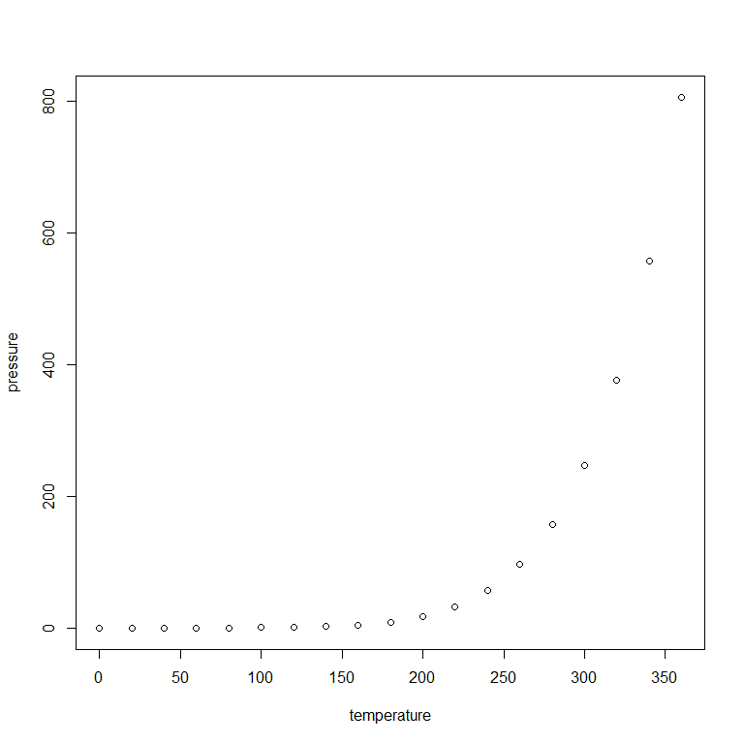

Note that the echo = FALSE parameter was added to the code chunk to prevent printing of the R code that generated the plot.

## Assignment 2

### R dataset: anscombe

data(anscombe)  
dim(anscombe)

## [1] 11 8

names(anscombe)

## [1] "x1" "x2" "x3" "x4" "y1" "y2" "y3" "y4"

head(anscombe, n=6)

## x1 x2 x3 x4 y1 y2 y3 y4  
## 1 10 10 10 8 8.04 9.14 7.46 6.58  
## 2 8 8 8 8 6.95 8.14 6.77 5.76  
## 3 13 13 13 8 7.58 8.74 12.74 7.71  
## 4 9 9 9 8 8.81 8.77 7.11 8.84  
## 5 11 11 11 8 8.33 9.26 7.81 8.47  
## 6 14 14 14 8 9.96 8.10 8.84 7.04

tail(anscombe, n=6)

## x1 x2 x3 x4 y1 y2 y3 y4  
## 6 14 14 14 8 9.96 8.10 8.84 7.04  
## 7 6 6 6 8 7.24 6.13 6.08 5.25  
## 8 4 4 4 19 4.26 3.10 5.39 12.50  
## 9 12 12 12 8 10.84 9.13 8.15 5.56  
## 10 7 7 7 8 4.82 7.26 6.42 7.91  
## 11 5 5 5 8 5.68 4.74 5.73 6.89

summary(anscombe)

## x1 x2 x3 x4   
## Min. : 4.0 Min. : 4.0 Min. : 4.0 Min. : 8   
## 1st Qu.: 6.5 1st Qu.: 6.5 1st Qu.: 6.5 1st Qu.: 8   
## Median : 9.0 Median : 9.0 Median : 9.0 Median : 8   
## Mean : 9.0 Mean : 9.0 Mean : 9.0 Mean : 9   
## 3rd Qu.:11.5 3rd Qu.:11.5 3rd Qu.:11.5 3rd Qu.: 8   
## Max. :14.0 Max. :14.0 Max. :14.0 Max. :19   
## y1 y2 y3 y4   
## Min. : 4.260 Min. :3.100 Min. : 5.39 Min. : 5.250   
## 1st Qu.: 6.315 1st Qu.:6.695 1st Qu.: 6.25 1st Qu.: 6.170   
## Median : 7.580 Median :8.140 Median : 7.11 Median : 7.040   
## Mean : 7.501 Mean :7.501 Mean : 7.50 Mean : 7.501   
## 3rd Qu.: 8.570 3rd Qu.:8.950 3rd Qu.: 7.98 3rd Qu.: 8.190   
## Max. :10.840 Max. :9.260 Max. :12.74 Max. :12.500