Contents
1. Abstract 2
2. Introduction - IoT (2-5 pg) 2
2.1. Overview of Wireless Sensor Networks (applications?) 2
2.2. Research Motivation (constrains and challenges in WSN? problem statement?) 4
2.3. Research Contribution? Propose solution? 5
3. Background Theory? 5
3.1. Operating Systems? (Contiki, TinyOS,...) 5
3.2. Simulator (Cooja, Matlab, NS2, NS3,...) 5
3.3. Protocol Stack 5
3.3.1. Network Layer/Routing - briefly on RPL 5
3.3.2. MAC Layer 6
3.3.3. Duty Cycling 8
3.3.4. Radio (IEEE802.15.4) 8
3.4. Routing 8
3.4.1. Classification of Routing Protocol (data centric, hierarchical - RPL, location, QoS) 8
3.4.2. RPL (briefly on CTP, then explanation on how RPL works) 11
3.5. Metrics 21
4. Related Work/Literature Review (10-15 pg) 21
4.1. Routing 21
4.1.1. *Maximizing Lifetime 21
4.1.2. *Minimizing Energy Consumption 27
4.2. Multichannel 29
5. What I've been doing? Findings? Exp results/evaluation? (10-15pg) 30
5.1. Power Levels 30
5.2. Channels 31
5.2.1. Frequency Hopping 35
5.3. Energy 35
6. Research Plan (1-2pg) 38
7. Conclusion (1-2pg) 38
8. References 38
9. Appendices 38

Abstract
**can use any MAC
**only nodes need to care about which channel to be in (to transmit and receive) without having to be concerned about timing or synchronisation as it’s only between nodes and its neighbors

Introduction - IoT (2-5 pg)
Wireless Sensor Networks share their radio medium with other ambient technologies such as WiFi, Bluetooth, low power radios (e.g. 802.15.4) or even microwave ovens. Dealing with such interference is of utmost importance in order to attain the quality of service required by a given application, in reliability, energy and latency. In IEEE 802.15.4 PHY standard, 16 independent channels are provided – some colliding with the WiFi spectrum and others disjoint from it.
In addition to wireless interference, the nature of radio propagation and multi-path fading phenomenon cause challenging link dynamics that affect the signal strength and packet reception rate in relation to a number of parameters; namely the used frequency, the shape of the wireless path, the objects standing/moving in the path and the location of the transceiver.
There are a number proposed channel hopping solutions on the MAC layer.
TSCH uses TDMA and channel hopping and schedules transmissions along two dimensions: time and channel. CSL, a low power listening MAC that performs channel hopping – require zero configuration and emulate always-on-links while having the nodes sleep most of the time.
Why multichannel?
Multichannel communication has potential benefits for wireless networks that possibly include: improved resilience against external and internal interference, enhanced reliability, reduced latency and increased throughput. Frequency diversity implemented by frequency-hopping is suggested to mitigate the effects of multipath fading.

Overview of Wireless Sensor Networks (applications?)
System health - monitor vital stats, mitigate problems when they happen or better, identifying trends and tendencies to stop problems before they happen. ***Finding bugs is turned into great customer service!

*WSN applications such as visual sensor networks, mobile robots and drones, and wireless capsule endoscopy.

Categorize the applications into 5; military, environment, health, home and other commercial areas.
- Military applications
Some of military applications of sensor networks are monitoring friendly forces, equipment and ammunition - attached with small sensors that report the status; battlefield surveillance - critical terrains, approach routes, paths and straits can be rapidly covered with sensor networks and closely watched for the activities of the opposing forces; reconnaissance of opposing forces and terrain; targeting; battle damage assessment; nuclear, biological and chemical (NBC) attack detection and reconnaissance (scouting/exploring) - used as a chemical or biological warning system can provide the friendly forces with critical reaction time which drops casualties drastically

PinPtr is an experimental counter-sniper system developed to detect and locate shooters. The system utilizes a dense deployment of sensors to detect and measure the time of arrival of muzzle blasts and shock waves from a shot. Sensors route their measurements to a base station to compute the shooter's location. The system was demonstrated and evaluated in various US Army test facilities providing a realistic urban environment.

- Environment applications
Can be divided into 2; tracking the movements of birds, small animals and insects; monitoring environment conditions. Forest fire detection - sensor nodes can relay the exact origin of the fire to the end users before the fire is spread uncontrollable. Biocomplexity mapping of the environment. Flood detection - ALERT system deployed in the US. Several types of sensors deployed in the ALERT system are rainfall, water level and weather sensors. Precision Agriculture - monitor the pesticides level in the drinking water, the level of soil erosion and the level of air pollution in real time.

Volcanic monitoring with WSN can help accelerate the deployment, installation and maintenance process, WSN equipments are smaller, lighter and consume less power. The challenges of a WSN application for volcanic data collection include reliable event detection, efficient data collection, high data rates and sparse deployment of nodes. When an interesting event occurs, the node will route a message to the base station.

- Health applications
Telemonitoring of human physiological data - can monitor and detect elderly people;s behaviour e.g. a fall; also allow doctors to identify pre-defined symptoms earlier; and facilitate a higher quality of life for the subjects compared to the treatment center; “Health Smart Home”. Tracking and monitoring doctors and patients inside a hospital - one sensor may be detecting the heart rate while another is detecting the blood pressure; doctors may also carry a sensor node which allows other doctors to locate them within the hospital. Drug administration in hospitals - sensor nodes can be attached to medication, the chances of getting and prescribing the wrong medication to patients can be minimized; patients have sensors that identify their allergies and required medications.

Telecare is a system of wireless sensors placed around the home, which immediately detect risks such as fires, floods and falls. The moment a risk is detected an alert is sent to a telecare monitoring centre, summoning instant help 24 hours a day, 365 days a year. Telehealth is a small unit which enables you to take your vital signs from the comfort of your own home. You take readings such as blood pressure, oxygen levels, weight and temperature and they are automatically sent via telephone line to a monitoring centre. If your condition gets worse this will be picked up and your healthcare professional will be contacted to take appropriate action.

Telecare - a personal alarm where you raise the alert by pressing a button that you keep on you at all times. Usually, it's on a small wristband or a pendant that you wear around your neck. Motion sensors which make accidents and falls less likely by automatically switching on your bathroom or hallway lights at night when you get out of bed. Other sensors can raise the alarm that something is wrong, such as a pressure mat on your mattress that can tell if you've not made it back into bed, or a sensor on a door that senses if it's open or closed. Then, if you have a fall, or you haven't got back into bed after going to the toilet in the night, or you've forgotten to close the outside door, the sensor raises the alarm. Telehealth - there's also special telehealth equipment to monitor your health in your own home. It can be equipment to measure your blood pressure, blood glucose levels or your weight. This can reduce the number of visits you make to your GP and unplanned visits to the hospital. You're taught how to do the tests on yourself and the measurements are automatically transmitted to your doctor or nurse, who can then see the information without you having to leave home. They can let you know if they have any concerns.

- Home applications
Home automation - smart sensor nodes and actuators can be buried in appliances such as vacuum cleaners, microwaves ovens, refrigerators; these sensor nodes inside the domestic devices can interact with each other and with the external network via the Internet or Satellite. Smart environment - example is “Residential Laboratory” at Georgia Institute of Technology.

Nest Thermostat - including activity sensors, a Wi-Fi radio, three temperature sensors and a humidity sensor. The activity sensors are used to activate the Auto Away feature which shuts down heating and cooling after an hour or two of inactivity to conserve energy. The Nest learns your heating and cooling habits over the first week of use and will create a schedule based on this usage.

The near sensor detects motion near the Nest display. The far field activity sensor can detect motion up to 20 feet away. The sensors have 150 degree range. The sensors will detect whether anybody is actually in a room. The sensor will automatically brighten the LCD screen when the user approaches. If the sensors do not detect motion for two hours the unit will activate the away setting.

The Nest Thermostat integrates information from its sensors and the outside weather. The activity sensors, humidity sensor which shows the indoor humidity and can manage your whole-home humidifier or dehumidifier, temperature sensors - there are three temperature sensors track your home's temperature and how quickly it changes, weather aware - Nest uses its Wi-Fi connection to keep an eye on current weather conditions and forecasts so it can understand how the outside temperature affects your energy use.

- Other commercial applications
Environmental control in office buildings - a distributed wireless sensor network system can be installed to control the air flow and temperature in different parts of the room. Interactive museums - example is the San Francisco Exploratorium that features a combination of data measurements and cause-and-effect experiment. Detecting and monitoring car thefts. Managing inventory control - each item in a warehouse may have a sensor node attached, the end users can track and locate where the inventories are at all times. Vehicle tracking and detection.

Smart Parking solutions from Streetline - more than 40 cities and universities in North America and Europe use the technology. Offer true real-time vehicle detection, which is a balancing act of speed, caution and smarts so that detection is incredibly fast, but not so fast that the system gets confused and reports false information. A smart parking system accurately senses vehicle occupancy in real time. Guides residents and visitors to available parking. Simplifies the parking experience and adds value for parking stakeholders such as drivers and merchants. Enables intelligent decisions using data, including real-time status applications and historical analytical reports. *Complete parking solution to improve the entire parking ecosystem for all space types. Every arrival and departure is detected in real-time. Motorist is guided to available parking. Motorist pays by phone and activates timer or pay by meter. Officer is guided to unpaid violations, overstays, no parking and restricted zones. Staff receives web-based analytics for decision making. The sensors will be able to detect if a car is parked over it, and therefore determine whether or not the space is vacant.

Smart Parking in the UK - SmartPark is already operating in cities like Birmingham and in the central London Borough of Westminster. SmartPark enables drivers to find a parking space quickly and simply within busy town and city centres.

Semiconductor plants and oil tanker application focus on preventive equipment maintenance using vibration signatures gathered by sensors to predict equipment failure.

Research Motivation (constrains and challenges in WSN? problem statement?)
Sensor nodes are constrained in energy supply and bandwidth. At the network layer, the main aim is to find ways for energy-efficient route setup and reliable relaying of data from the sensor nodes to the sink so that the lifetime of the network is maximized. Sensor nodes are tightly constrained in terms of transmission power, on-board energy, processing capacity and storage and thus require careful resource management.
Challenges:
- must satisfy the energy requirements of the devices, to help operating on battery and to keep maintenance costs lows
- must support traffic with any pattern in time and space, to act as an application-agnostic routing infrastructure
- must be reliable and reactive, enabling interactive applications

Research Contribution? Propose solution?

Background Theory?

Operating Systems? (Contiki, TinyOS,...)

Contiki
Contiki is an IoT OS. Helps application programs, provides; processes and concurrency, timers, memory management, networking, device drivers.
Contiki; dealing with limited memory - memory block allocation strategies, protothread. Portability - fully written in C. Application development and debugging - the Cooja network simulator.

Simulator (Cooja, Matlab, NS2, NS3,...)
1. Emulation mode, run exact same firmware images as run on hardware. Slower, more exact. 2. In Native mode, run the Contiki code, compiled for the native system. Faster, can run (much) larger systems.

Protocol Stack
***figure from ContikiRPL and TinyRPL: Happy Together
Contiki netstacks - 3 network stacks; IPv6, IPv4, Rime.
Four layers which are the Network layer, MAC layer, RDC layer and Radio layer.
 |  | IoT/IP stack
Network layer | Application | HTTP, WebSockets, CoAP | websocket.c, http-socket.c, coap.c
Network layer | Transport | TCP, UDP | udp-socket.c, tcp-socket.c
Network layer | Network, routing | IPv6, IPv4, RPL | uip6.c, rpl.c
Network layer | Adaptation | 6lowpan | sicslowpan.c
MAC layer | MAC | CSMA/CA | csma.c
RDC layer | Duty Cycling | ContikiMAC, CSL | nullrdc.c, contikimac.c
Radio layer | Radio | 802.15.4 | cc2538-rf.c, cc2420.c

Network Layer/Routing - briefly on RPL

uIPv6
Contiki provides a full IPv6 stack, with support for IPv6 address management, multiple addresses, duplicate address detection, neighbor tables, routing tables.
uIP is world's smallest, fully compliant TCP/IP stack for both IPv4 and IPv6.

IP headers are large. IPv6 headers are 40 bytes minimum. UDP headers are 8 bytes, TCP headers 20 bytes minimum. IP packets may be huge. 1280 bytes must be supported. 802.15.4 frames are 127 bytes maximum.

**need more info check Contiki documentation

MAC Layer
CSMA/CA - Carrier Sense Multiple Access with Collision Avoidance. Sense the medium before sending. Back off if someone else is sending. Avoid collisions, back off if there is too much other traffic. Two MAC layers in Contiki; CSMA/CA and nullmac. CSMA/CA is a regular CSMA/CA layer. Timing depends on RDC layer. Network layer decides the number of transmissions. Nullmac is a MAC layer that doesn't do anything.

Radio duty cycling mechanisms can be divided into 2 main categories; synchronous and asynchronous. Synchronous mechanisms depend on neighboring nodes being synchronized with each other. Asynchronous mechanisms do not depend on any priori synchronization. Asynchronous mechanisms can be further be subdivided into sender-initiated and receiver-initiated mechanisms. In sender-initiated mechanisms, the sender initiates communication between a sender and a receiver. In receiver-initiated mechanisms, the receiver initiates communication.
ContikiMAC is a sender-initiated asynchronous mechanisms.
ContikiMAC keep their radios turned off for roughly 99% of the time. Wireless transceiver often has the highest power consumption; consumes as much power when passively listening for transmissions from other devices as it does when actively transmitting, so the transceiver must be completely turned off to save power. A duty cycling mechanism must be used to turn the transceiver on every now and then.
ContikiMAC uses only asynchronous mechanisms, no signalling messages, and no additional packet headers. ContikiMAC packets are ordinary link layer messages.
ContikiMAC uses a fast sleep optimization, to allow receivers to quickly detect false-positive wake-up and a transmission phase-lock optimization, to allow run-time optimization of the energy-efficiency of transmissions.
ContikiMAC is a radio duty cycling protocol that uses periodical wake-ups to listen for packet transmissions from neighbors. If a packet transmission is detected during a wake-up, the receiver is kept on to be able to receive the packet. UNICAST - When the packet is successfully received, the receiver sends a link layer acknowledgement. To transmit a packet, a sender repeatedly sends its packet until it receives a link layer acknowledgement from the receiver. Acknowledgement transmission is done as part of the unicast packet reception. Packets that are sent as broadcasts do not result in link layer acknowledgements. Instead, the sender repeatedly sends the packet during the full wake-up interval to ensure that all neighbors have received it. Since a broadcast transmission does not expect any link layer acknowledgement, the transmitter can turn of its radio between each packet transmission to save power.
ContikiMAC wake-up frequency of 8Hz which results in a wake-up interval of 125 ms.
Radio duty cycle increase with the wake-up frequency; more wake-ups, the total power consumption of the network increase (channel check rate higher than 8Hz).

CONTIKIMAC TIMING
ContikiMAC wake-ups use an inexpensive Clear Channel Assessment (CCA) mechanism that uses the Received Signal Strength Indicator (RSSI) of the radio transceiver to give an indication of radio activity on the channel. If the RSSI is below a given threshold, the CCA returns positive, indicating that the channel is clear. If the RSSI is above the threshold, the CCA returns negative, indicating that the channel is in use.
The interval between each packet transmission must be smaller than the interval between each CCA. This is to ensure that either the first or the second CCA is able to see the packet transmission. The shortest packet size that ContikiMAC can support must be larger than the interval to require a stable RSSI + interval between each packet + interval between CCA.
The time between a packet reception and the acknowledgement transmission is defined by the IEEE 802.15.4 specification as 12 symbols. In 802.15.4, one symbol is 4/250 miliseconds long giving ta 48/250=0.192 milliseconds.
IEEE 802.15.4 receiver can reliably detect the reception of the acknowledgement is td=40/250 millisecond.
Time required for a stable RSSI is given by the data sheet of the CC2420 radio transceiver as tr=0.192milliseconds.
With a bitrate of 250 kilobit per seconds, packets must be at least 23 bytes long, including preamble, start of frame delimiter, and length field which leaves 16 bytes of packet data. To ensure that all packets are larger than the smallest packet size, packets may be padded with additional framing to ensure a minimum packet size.
Interval between packet transmission, ti=0.4 milliseconds
Interval between CCA, tc=0.5 milliseconds
Transmission time of the shortest packet, ts=0.884 milliseconds

PACKET DETECTION
ContikiMAC CCAs do not reliably detect packet transmission: they only detect that the radio signal strength is above a certain threshold. The detection of a radio signal may mean that a neighbor is transmitting a packet to the receiver, that a neighbor is transmitting to another receiver, or that some other device is radiating radio energy that is being detected by the CCA mechanism. ContikiMAC must be able to discern between these events and react properly.

FAST SLEEP
The fast sleep optimization lets potential receivers go to sleep earlier if the CCA woke up due to spurious radio noise. Specific pattern of ContikiMAC transmissions:
If CCA detects radio activity but the radio activity has a duration that is longer than the maximum packet length, the CCA has detected noise and can go back to sleep (if the activity period is not followed by a silence period).
If the radio activity is followed by a silence period that is longer than the interval between two successive transmissions, the receiver can go back to sleep.
If the activity period is followed by a silence period of the correct length, followed by activity but no start of packet could be detected, the receiver can go back to sleep.

TRANSMISSION PHASE-LOCK
A sender can learn of a receiver's wake-up phase by making note of the time at which it saw a link layer acknowledgement from the receiver. The sender can assume that the reception of a link layer acknowledgement means that the sender has successfully transmitted a packet within the receiver's wake-up window and thus the sender has found the receiver's wake-up phase. The sender can commence its successive transmissions to this receiver just before the receiver is expected to be awake.
The phase-lock mechanism is implemented as a separate module from ContikiMAC.
The phase-lock mechanism maintains a list of neighbors and their wake-up phases.

X-MAC
Power consumption of X-MAC is significantly higher than ContikiMAC due to the more costly wake-up mechanism in X-MAC.
X-MAC is sender-initiated.
X-MAC, the wake-up tone is composed of a series of strobe packets. When the receiver wakes up, it sends a link-layer acknowledgement to the sender to indicate that it is awake and ready to receive the data packet.

Duty Cycling
Radio transceivers consume significant power when just listening. Often as much as or more as when transmitting. Need to duty cycle the radio transceiver to keep it off as much as possible and coordination needed. ContikiMAC is highly optimized for 802.15.4. *****ABOUT CONTIKIMAC??
Duty cycling slight increase in response time as must wait until receiver is awake, throughput reduced but save power. Nullrdc is an RDC layer that always keeps the radio on.

Radio (IEEE802.15.4)
27 logical channels; 0-10 sub GHz bands, 11-26 2.4 GHz band. - from frequency band of 2400-2483.5 MHz.
The maximal data rate in 802.15.4 is limited to 250kbits/s.
Unfortunately all 16 channel overlap with channels used by Wi-Fi in Europe and these are therefore likely to be disturbed by stronger Wi-Fi signals. However, if Wi-Fi implementations only use the European non-overlapping channel set (Wi-Fi channels 1, 7, 13), this leaves the 802.15.4 channels 15, 16, 21, and 22 undisturbed. As another solution, it is also possible to use channel hopping schemes.
IEEE 802.15.4 is a relatively short range transmission mechanism whose range is only a few meters and is a standard radio technology for power networks. Uses 3 different frequency ranges because of different regulations in different parts of the world. United States, 902-928 MHz, Europe 868-868.8 MHz and rest of the world uses 2400-2448.3 MHz. The rates vary from 20-250kbit/s depending on the frequency.
Multi-channel support with a fast 192µs turnaround time (at 2.4GHz, 250kbps = 62.5ksps->16µs per symbol, thus 16 * 12 which is the given value gives 192µs turnaround time).*switch channel in less than 192µs.***check with data sheet since it might use more clock. 250kbps is equal to 62.5KSps (4bits/Symbol); 250/4 = 62.5KSps which is 62.5/4 = 15.6 Symbols ~ 16 symbols.
Contiki set transmission turnaround time to the lower setting (8 symbols = 0.128ms; 16*8) instead of the default (12 symbols = 0.192ms; 16*12).

Routing

Classification of Routing Protocol (data centric, hierarchical - RPL, location, QoS)

Flat based and Data Centric
Data centric protocols are query-based and depend on the naming of desired data which helps in eliminating many redundant transmissions. In data centric routing, the sink sends queries to certain regions and waits for data from the sensors located in the selected regions. Since data is being requested through queries, attribute-based naming is necessary to specify the properties of data.
Flooding and gossiping are two classical mechanisms to relay data in sensor networks without the need for any routing algorithms and topology maintenance. In flooding, each sensor receiving a data packet broadcast it to all of its neighbors and this process continues until the packet arrives at the destination or the maximum number of hops for the packet is reached. However causing duplicated messages sent to the same node, resource blindness by consuming large amount of energy without consideration for the energy constraints. Gossiping is a slightly enhanced version of flooding where the receiving node sends the packet to a randomly selected neighbor which picks another random neighbor to forward the packet to and so on. However, it cause delays in propagation of data through the nodes.
Data centric - all communication is neighbor to neighbor, no need for addressing mechanism.

Sensor protocols for information via negotiation (SPIN) is to name the data using high-level descriptors or meta-data. Before transmission, meta-data are exchanged among sensors via a data advertisement mechanism. Sensor advertise the availability of data allowing interested nodes to query that data. Each node needs to know only its single hop neighbors. A advertise to B. B responds, send request to A. A sends data. B advertises to its neighbors. Neighbors send request back to B, B send data. If B is not interested, data cannot be delivered to B's neighbors.

Directed Diffusion is by using a naming scheme for the data. An interest is defined using a list of attribute-value pairs. The interest is broadcast by a sink through its neighbors. Each node receiving the interest can do caching for later use. A gradient is a reply link to a neighbor from which the interest was received. By utilizing interest and gradients, paths are established between sink and resources. Directed Diffusion basically reinitiates reinforcement by searching among other paths which are sending data in lower rates. Employing multiple paths in advance so that in case of a failute of a path, one of the alternatives is chosen without any cost for searching for another one but at the extra overhead to keep the alternative paths alive. In Directed Diffusion the sink queries the sensor nodes if a specific data is available by flooding some tasks. Caching is a big advantage in terms of energy efficiency and delay. Sink sends interest. Reply back from where the interest was received to the sink. Data is sent from the path of lower rates.

Energy-aware routing use a set of sub-optimal paths to increase the lifetime of the network (chosen by means of a probability function depending on energy consumption of each path). Select a single path randomly from multiple alternatives to save energy. Complicate route setup than Directed Diffusion.

Constrained anisotropic diffusion routing (CADR) - two techniques namely information-driven sensor querying (IDSQ) and constrained anisotropic diffusion. Query sensors and route data in a network to maximize the information gain while minimizing the latency and bandwidth - achieved by activation only sensors that are close to a particular event and dynamically adjusting data routes. IDSQ mechanism to determine which node can provide the most useful information by using estimate theory. Each node evaluates information/cost objective and routes data based on local information/cost and end-user requirements. IDSQ provides a way of selecting optimal order of sensors for maximum incremental information gain - more energy efficient (select which sensors to get the data).

COUGAR - sensor nodes select a leader node to perform aggregation and transmit data to gateway (sink). In-network data computation from several nodes require synchronization.

ACtive QUery forwarding In SensoR nEtworks (ACQUIRE) - the query is forwarded by the sink and each node receiving the query tries to respond partially by using its pre-cached information and forward it to another sensor. ACQUIRE is to deal with one-shot, complex queries for data where a response can be provided by many nodes.

Hierarchical - RPL is hierarchical
Hierarchical protocols aim at clustering the nodes so that cluster heads can do some aggregation and reduction of data in order to save energy.
Single-tier network can cause the gateway to overload with the increase in sensors density - might cause latency in communication, inadequate tracking of events. Also not scalable for larger set of sensors. Hierarchical routing - to efficiently maintain the energy consumption of sensor nodes by involving them in multi hop communication within a particular cluster and performing data aggregation and fusion to decrease the number of transmitted messages to the sink. Network clustering to cope with additional load and to be able to cover a large area of interest without degrading the service. Cluster heads sometimes chosen as specialized nodes that are less energy-constrained. Cluster head performs aggregation of data and send to sink on behalf of the nodes within its cluster.
Low-energy adaptive clustering hierarchy (LEACH) - form clusters of the sensor nodes based on the received signal strength and use local cluster heads as routers to the sink. All data processing (data fusion and aggregation) are local to the cluster. Cluster heads change randomly over time to balance the energy dissipation of nodes. Nodes die randomly and dynamic clustering increases lifetime of the system - but extra overhead. Use single-hop routing where each node can transmit directly to the cluster head and the sink.
Power-efficient GAthering in Sensor Information Systems (PEGASIS) is an improvement of the LEACH protocol. Rather than forming multiple clusters, PEGASIS forms chains from sensor nodes so that each node transmits and receives from a neighbor and only one node is selected from that chain to transmit to the base station (sink). Use multi-hop routing by forming chains and selection only one node to transmit to the base station instead of using multiple nodes. However, introduces excessive delay for distant node on the chain.
Hierarchical-PEGASIS - extension of PEGASIS. Reduce delay by simultaneous transmissions of data. Chain-based protocol with CDMA capable nodes - to avoid collisions. Tree like hierarchy, each selected node in a particular level transmit data to the node in the upper level. Nodes that are receiving at each level rise to next level. Avoid clustering overhead but still require dynamic topology adjustment since sensor's energy is not tracked.
Threshold sensitive Energy Efficient sensor Network protocol (TEEN) - designed to be responsive to sudden changes in the sensed attributes. Responsiveness is important for time-critical applications. Closer nodes form clusters. Cluster head broadcasts two thresholds to nodes. Hard threshold allows the nodes to transmit only when the sensed attribute is in the range of interest. It is the minimum value to trigger sensor node. Soft threshold will further reduce the number of transmissions if there is little or no change in the value of sensed attribute. However, user may not get any data at all if the thresholds are not reached. Adaptive Threshold sensitive Energy Efficient sensor Network protocol (APTEEN) - extension of TEEN, capture periodic data collections and reacting to time-critical events. Drawbacks - overhead, complexity of forming clusters in multiple levels, implementing threshold-based functions and dealing with attribute-based naming of queries.
Energy-aware routing for cluster-based sensor networks; sensors are grouped into clusters prior to network operation. Algorithm employs cluster heads, namely gateways. Gateways maintain the states of the sensors and set up multi-hop routes for collecting sensor's data. The command node (sink) communicates only with the gateways. Sensor nodes in cluster can be sensing only, relaying only, sensing-relaying and inactive. Gateway will continuously monitor the available energy level at every sensor that is active - gateway is powered. Rerouting is triggered by an application related event.

Location Based
Location based protocols utilize the position information to relay the data to the desired regions rather than the whole network.
Location information needed to calculate distance between two particular nodes so that energy consumption can be estimated. Query can be diffused only to the particular region (if known) which eliminate the number of transmission significantly.
Minimum energy communication network (MECN) sets up and maintains a minimum energy network by utilizing low power GPS. The main idea of MECN is to find a sub-network which will have less number of nodes and require less power for transmission between any two particular nodes. Performed using a localized search for each node considering its relay region. Use distributed Belmann-Ford shortest path algorithm with power consumption as the cost metric. MECN is self-reconfiguring and thus can dynamically adapt to node's failure or the deployment of new sensors. The small minimum energy communication network (SMECN) is an extension to MECN. The sub-network constructed by SMECN for minimum energy relaying is smaller; the number of hops for transmissions will decrease. However, fining a sub-network with smaller number of edges introduces more overhead in the algorithm.
Geographic adaptive fidelity (GAF) - energy-ware location-based routing algorithm. Conserves energy by turning off unnecessary nodes in the network without affecting the level of routing fidelity. It forms a virtual grid for the covered area. Each node uses its GPS-indicated location to associate itself with a point in the virtual grid. Nodes associated with the same point on the grid are considered equivalent in terms of the cost of packet routing. Keep some nodes located in a particular grid area in sleeping state in order to save energy. GAF can increase the network lifetime as the number of nodes increases. Nodes 2, 3, and 4 are equivalent and two of them can sleep. Nodes changes states from sleeping to active in turn so that the load is balanced. GAF can be considered as a hierarchical protocol; clusters are based on geographical location. However, does not do any aggregation or fusion.
Geographic and energy-aware routing (GEAR) uses energy aware and geographically informed neighbor selection heuristics to route a packet towards the target region. Only considering a certain region rather than sending the interests to the whole network. Each node keeps an estimated cost and a learning cost of reaching the destination through its neighbors. Estimated cost is a combination of residual energy and distance to destination.

Network flow and QoS-aware
Routing approaches that are based on general network-flow modelling and protocols that strive for meeting some QoS requirements along with the routing function.
Network flow - route setup.
QoS aware - end to end delay requirements while setting up the paths in the sensor network.
Energy aware QoS routing in sensor networks will ensure guaranteed bandwidth (or delay) through the duration of connection as well as providing the use of most energy efficient path.
Maximum lifetime energy routing - maximize the network lifetime by carefully defining link cost as a function of node remaining energy and the required transmission energy using that link. Use Bellman-Ford shortest path algorithm.
Sequential assignment routing (SAR) - table driven multi-path approach striving to achieve energy efficiency and fault tolerance. SAR protocol creates tree rooted at one-hop neighbors of the sink by taking QoS metric, energy resource on each path and priority level of each packet into consideration. Multiple paths from sink to sensors are formed. One of these paths is selected according to the energy resources and QoS on the path. Any local failure causes an automatic path restoration procedure locally - failure recovery is done by enforcing routing table consistency between upstream and downstream nodes on each path. Drawback - overhead of maintaining the tables and states at each sensor node.
Energy-aware QoS routing protocol - find a least cost (using Dijkstra's algorithm) and energy efficient path that meets certain end-to-end delay during the connection. A class-based queuing model is employ to support best effort and real time traffic at the same time.
SPEED - requires each node to maintain information about its neighbors and uses geographic forwarding to find the paths. SPEE strive to ensure a certain speed for each packet in the network so that each application can estimate the end-to-end delay for the packets by dividing the distance to the sink by the speed of the packet before making the admission decision. SPEED can provide congestion avoidance when the network is congested.

RPL (briefly on CTP, then explanation on how RPL works)
RPL is a routing protocol that provides any-to-any routing in low-power Ipv6 networks, standardized by the IETF in March 2012. Its design is largely based on CTP, the reference data collection protocol for sensor networks. The RPL topology is a DODAG (Destination Oriented Directed Acyclic Graph) built in direction of the root, typically an access point to the Internet. Any-to-any traffic is routed first upwards, i.e. towards the root until a common ancestor of destination and source is found, and then downwards, following the nodes routing table. RPL uses a simple rooted topology instead of a full mesh; it is devoted to the maintenance of reliable paths to a single destination. The purpose of this strategy is to scale to large networks while containing the routing overhead, at the price of increased hop count (routing via a common ancestor). RPL terminology, the distance from a node to the root according to the routing metric is called rank. RPL requires sharing routing tables among siblings. In RPL, nodes propagate their routing entries through unicast (so-called DAO messages) to their parents. RPL’s rank hysteresis mechanism prevents nodes from switching parent for too little rank improvements. ContikiMAC – has wakeup consists of two clear channel assessments and has a phase-lock mechanism where senders record their neighbor’s wake-up phase and use it to make the next transmissions cheaper. *Experience an outage during which they cannot receive or send any data. This reflects for example scenarios where battery maintenance requires to disconnect a part of the network, or where external interference (e.g. WiFi or Bluetooth) affects communication. RPL experiences a sharp drop in the reliability during the first outage, consequence of failed MAC transmissions. Nodes react by switching parent, which heals the topology and slowly improves reliability. The next outages result in less churn (less agitate).

CTP
2 principles for wireless routing protocols; datapath validation - data traffic quickly discovers and fixes routing inconsistencies; adaptive beaconing - extending the Trickle algorithm to routing control traffic reduces route repair latency and sends fewer beacons. CTP Neo - an implementation of CTP.
Datapath validation actively uses data packets to validate the routing topology and detect loops. Each data packet contains the link-layer transmitter’s estimate of its distance. A node detects a possible routing loop when it receives a packet to forward from a node with a smaller or equal distance to the destination.
CTP is a routing protocol that computes anycast routes to a single or a small number of designated sinks in a wireless sensor network. CTP may appear very simple. They provide best-effort, unreliable, anycast packet delivery to one of the data sinks in the network.
4 goals; reliability - a protocol should deliver at least 90% of end-to-end packets when a route exists. Robustness - should be able to operate without tuning or configuration in a wide range of network conditions, topologies, workloads and environments. Efficiency - should deliver packets with the minimum amount of transmissions. Hardware independence - without assuming specific radio chip features.
Rapid topology changes necessitate distance-vector rather than link-state algorithms. Simple distance-vector protocols however suffer from routing loops and other problems that harm reliability and efficiency. Link topology changes may result in transient loops which causes packet drops. A collection protocol builds and maintains minimum cost trees to nodes that advertise themselves as tree roots. Collection is address-free; when there are multiple base stations, it sends to the one with the minimum cost without knowing its address.
Every node maintains an estimate of the cost of its route to a collection point. ETX as the cost metric (any similar gradient metric can work just well). ETX does not effectively capture throughput. A node’s cost is the cost of its next hop plus the cost of its link to the next hop. The cost of a route is the sum of the costs of its links. Collection points advertise a cost of zero. Each data packet contains the transmitter’s local cost estimates. When a node receives a packet to forward, it compares the transmitter’s cost to its own. Cost must always decrease.
When a timer interval expires, Trickle doubles it, up to a maximum value. When Trickle hears a newer version number, it shrinks the timer interval to a small value. Trickle enables quick discovery of new nodes and recovery from failures, while at the same time enabling long beacon intervals when the network is stable.

CTP provides best effort anycast datagram communication to one of the collection roots in a network. A collection protocol delivers data to one of possibly several data sinks, providing many-to-one network layer. CTP uses routing frames to update and build collection tree in the network. CTP uses data frames to deliver application payload to the sink and to probe topology inconsistencies.
CTP is a tree-based collection protocol. Some nodes advertise as tree roots. Nodes form a set of routing trees to these roots. CTP is address free in that a node does not send a packet to a particular root, instead, it implicitly chooses a root by choosing a next hop. Nodes generate routes to roots using a routing gradient. CTP assumes that it has link quality estimates of some number of nearby neighbors (ETX). These provides an estimate of the number of transmissions it takes for the node to send a unicast packet whose acknowledgement is successfully received.
CTP uses expected transmission (ETX) as its routing gradient. A root has an ETX of 0. ETX of a node is the ETX of its parent plus the ETX of its link to its parent. CTP should choose the one with the lowest ETX value.
Problem is routing loops; occur when a node choose a new route that has a significantly higher ETX than its old one. CTP tries to resolve the inconsistency by broadcasting a beacon frame. Packet duplication - when a node receives a data frame successfully and transmit an ACK but ACK is not received. Thus CTP keeps a small cache of packet signature for the packets it has seen to detect packet duplicates.CTP data frames has additional time has lived (THL) field which the routing layer increments on each hop. Link-layer retransmission has the same THL.
If node’s ETX value changes significantly, CTP should transmit a broadcast frame to notify other nodes which might change their routes. A parent can detect when a child’s ETX is significantly below its own. When a parent hears a child advertise an ETX below its own, it must schedule a routing frame for transmission in the near future.

RPL
RPL - "Ripple". Proactive any-to-any routing protocol but optimized for the many-to-one case. RPL forms routing graph from root node. Packet forwarding along graph, routing metric dynamically updated; short-lived routing loops are tolerated. RPL solves resource constrains such as memory constraints, power constrains and bandwidth constraints; also when wireless is unpredictable where it pick good routes.

RPL is optimized for many-to-one routing where all report packets to the sink. Any-to-any routing must go through closest common ancestor, to the root, in the worse case.

RPL pitfalls: rebooting the root node - must listen for a while to obtain network version. Global repair may take a while.

IPv6 addresses are large, 6lowpan compresses header. Automatic meshing: RPL, automatically form large (1000+) node networks. Also has self-suppression of control traffic.

*Mesh display (information can get from RPL); DAG ID, parent IPv6 address, DAG version, RPL rank, number of neighbors, number of routes, estimated number of hops, EXT - RPL link quality indication, RSSI - Received Signal Strength Indicator.

Routing protocol called RPL. RPL does not define any specific routing metrics, path costs or forwarding policies. RPL leaves this open so that different networks can apply different mechanisms to meet different objectives such as minimizing latency or minimizing energy consumption.
ContikiRPL implementation of the RPL protocol which allows replaceable routing objective functions. ContikiRPL is the main IPv6 routing protocol in Contiki. RPL is a distance-vector protocol for IPv6 networks comprising low-power devices connected by lossy links. The protocol maintains Directed Acyclic Graph (DAG) topologies toward root nodes. The topologies are built proactively according to an objective function. It is flexible regarding the rules to form topologies and to select next-hops for individual packets. Routing decisions are taken by the objective function, which essentially specifies the constraints and metrics used in a network.
One objective function uses a simple hop count and one uses expected transmissions (ETX) to do the forwarding decision. The simple hop-count objective function results in a shorter path length at the expense of higher power consumption.

RPL Protocol Overview
-what is RPL - is an IPv6 based distance vector routing protocol for low power and lossy networks (LLNs)
-RPL is a gradient based routing protocol that builds the graph knows as Directed Acyclic Graph (DAG) by using a set of metrics/constrains and an objective function
-DAG grounded at the point known as Low power and lossy network Border ROuter (LPBR)
-each node, rank incremented as node move away from LPBR; packet forwarding towards LPBR is consisting in picking the neighbor node with lowest rank
-RPLInstanceID - set of multiple DODAGs

Tsvetkov, Tsvetko. "RPL: IPv6 Routing Protocol for Low Power and Lossy Networks." Sensor Nodes–Operation, Network and Application (SN) 59 (2011): 2.

The protocol makes use of IPv6 and supports not only traffic in the upwards direction, but also traffic flowing from a gateway node to all other network participants.
RPL is a distance vector routing protocol that makes use of IPv6. A Destination Oriented Directed Acyclic Graph (DODAG) which is routed at a single destination is built.
The graph is constructed by the use of an Objective Function (OF) which defines how the routing metric is computed. OF specifies how routing constraints and other functions are taken into account during topology construction. The protocol tries to avoid routing loops by computing a node’s position relative to other nodes with respect to the DODAG root, called Rank and increases if nodes move away from the root and decreases when nodes move in the other direction.
RPL specification defines 4 types of control messages for topology maintenance and information exchange. DODAG Information Object (DIO) is the main source of routing control information. It may store information like the current Rank of a node, the current RPL Instance, the IPv6 address of the root, etc. Destination Advertisement Object (DAO) enables the support of down traffic and is used to propagate destination information upwards along the DODAG. DODAG Information Solicitation (DIS) makes it possible for a node to require DIO messages from a reachable neighbor. DAO-ACK (optional) is sent by a DAO recipient in response to a DAO message. RPL specification defines all 4 types of control messages as ICMPv6 information messages with a requested type of 155.
RPL adapts the sending rate of DIO message by extending the Trickle algorithm.
Upward routing is a standard procedure which enables network devices to send data to a common data sink, also called sometimes a gateway or root node. (BORDER ROUTER??!!)
The Mode of Operation (MOP) field is set by the DODAG root
A DIO message may be extended by the use of options. DODAG Configuration option plays a crucial role for parameter exchange. MaxRankIncrease field defines an upper limit for the Rank. MinHopIncrease field stores the minimum increase of the Rank between a node and any of its parent nodes.
3 types of nodes in a RPL network. 1. Root nodes which are commonly referred in literature as gateway nodes that provide connectivity to another network. 2. Routers which may advertise topology information to their neighbors. 3. Leafs that do not send any DIO messages and only have the ability to join an existing DODAG.
The construction of the topology starts at a root node that begins to send DIO messages. Each node that receives the message run an algorithm to choose an appropriate parent. The choice is based on the used metric and constraints defined by the OF. Afterwards, each of them computes its own Rank and in case a node is a router, it updates the Rank in the DIO message and sends it to all neighboring peers. *In most sensor node deployments several data collection points (root nodes) are needed.
Whenever the sending timer expired, RPL doubles it up to the maximum value. Whenever RPL detects an event which indicates that the topology needs active maintenance, it resets the timer to minimum value.
Router nodes forward DIO control messages for topology maintenance - such messages are sent in a multicast manner to the neighboring nodes. RPL node does not process DIO messages from nodes deeper (higher Rank) than itself.
RPL metric - status includes typical resources such as CPU usage, available memory and left energy. Node energy consumption - node should consider the energy level of its neighbors before picking them as possible parents. RPL metric specification defines 3 possible states for the first information field: powered, on batteries and scavenger **** This may be a rough estimation of how much load a node experiences for a given period of time. ETX - is an approximation of the expected number of transmissions until a data packet reaches the gateway node*. A node that is one hop away from the root with perfect signal strength and very little interference may have ETX of 1. ETX is bidirectional single-hop link quality computation between 2 neighbor nodes.* A metric called Packet Reception Rate (PRR) is calculated at the receiver node for each window of received packets.
Downward routing - by supporting P2MP traffic it is possible for a network administrator to control nodes that are even not in range. RPL specification defines 2 modes of operation for supporting P2MP. 1. Non-storing mode which makes use of source routing. In this mode each node has to propagate its parent list up to the root. After receiving such topology information, the root computes the path to the destinations. Each node has to extend the DAO message. After collecting the needed information, the root pieces the downward route together. If it needs to send a data packet to a given destination the IPv6 Source Routing header is used. 2. Storing mode which is fully stateful. Each non-root and non-leaf network participant has to maintain a routing table for possible destinations. DAO messages are used by RPL nodes to propagate routing information in order to enable P2MP traffic. DAO is no longer propagated to the DODAG root. Instead, it is sent as unicast to all parent nodes which maintain additional downward routing tables.
**DODAG root may act as a border router

Graph Building Process
-building a DAG
-DODAG is a set of vertices that are connected by directed edges with no cycles
-each DODAG is optimized to provide different QoS requirements
-DODAG starts from root node that advertises the graph related information to other nodes.
-Root (Sink) node sends information in the form of ICMPv6 control messages known as DIO; nodes received will decide to join the graph or not and forward the DIO messages to it's neighboring nodes. Process continues such that DAG topology is built from sink node towards edge nodes. Every node that joins the graph has a route towards the root (DAO)
-leaf nodes?
-leaf nodes send data packets hop-by-hop towards root (Upwards) and represents a Multipoint-to-Point (MP2P) model

Types of RPL Messages
-3 different ICMPv6 based control messages; DIO, DAO, DIS
-all 3 messages using the same ICMPv6 code point (Type 155)

**refer to RFC 6550 page 30
A RPL control messages is identified by a code and composed of a base that depends on the code (and a series of options)
-most RPL control messages have the scope of a link.
-for all other RPL messages (apart from DAO/DAO-ACK) the source address is a link-local address, and the destination address is either the all-RPL-nodes multicast address or a link-local unicast address of the destination. The all-RPL-nodes multicast address is a new address with a value of ff02::1a
-RPL Control Message consists of an ICMPv6 header followed by a message body. The message body is comprised on a message base and possibly a number of options

RPL control message
Type 155 | Code *** | Checksum
Base ***
Options

**refer to RFC 6550 page 38

DIS - may be used to solicit a DIO from a RPL node. A node may use DIS to probe its neighborhood for nearby DODAGs
Type 155 | Code 0x00 | Checksum
Flags | Reserved | Options(s)
Options

DIS Options
0x00 Pad1
0x01 PadN
0x07 Solicited Information

DIO - carries information that allows a node to discover a RPL Instance, learn its configuration parameters, select a DODAG parent set and maintain the DODAG
Type 155 |  |  |  | Code 0x01 | Checksum
RPLInstanceID |  |  |  | Version Number | Rank
G | 0 | MOP | Prf | DTSN | Flags | Reserved
DODAGID
Options
Options

MOP by default is 2; storing mode of operation with no multicast support.
page 111 - multicast is not supported through the means described in the specification, though it may be supported through some alternate means
page 104 - if the MOP field does not require multicast support, then multicast is handled by some other way. Examples may include a series of unicast copies or limited-scope flooding.

DIO Options
0x00 Pad1
0x01 PadN
0x02 DAG Metric Container
0x03 Routing Information
0x04 DODAG Configuration
0x08 Prefix Information

DAO - used to propagate destination information Upward along the DODAG. In Storing mode, the DAO message is unicast by the child to the selected parent(s). In Non-Storing mode, the DAO message is unicast to the DODAG root. The DAO message may optionally be acknowledged by its destination with a Destination Advertisement Acknowledgement (DAO-ACK) message back to the sender of the DAO. DAO-ACK message is sent as a unicast message packet by a DAO recipient (a parent or DODAG root) in response to a unicast DAO message.
Type 155 | Code 0x02 |  |  | Checksum
RPLInstanceID | K | D | Flags | Reserved | DAOSequence
DODAGID
Options
Options

DAO Options
0x00 Pad1
0x01 PadN
0x05 RPL Target
0x06 Transit Information
0x09 RPL Target Descriptor

page 48
*Pad1 - is used to insert a single octet of padding into the message to enable options alignment. If more than one octet of padding is requited, PadN should be used.
*PadN - is used to insert two or more octets of padding into message to enable options alignment. PadN option data must be ignored by the receiver

RPL downward routes - storing mode vs non-storing routes. In Storing mode, all nodes store the addresses of their child nodes. Drawback, needs routing tables. Non-storing mode, the root node knows the full route to all nodes, sends full route in every packet. Drawback, increases header overhead, this technique is known as source routing.

Objective Function
RPL packet forwarding - given multiple choices what route should a packet take? hop count - shortest amount of hops to the root? Some other dynamic metric? Two Objective Functions specified; of0: hop count, of1: ETX. ETX - Expected Transmissions; for every packet transmission, measure how many tries it takes until an ACK is received - use as a measure of how many transmissions to expect. Keep a moving average, for every neighbor. To build routes, simply compute the sum of all ETXes.

The minimum rank with hysteresis objective function (MRHOF), an Objective Function that selects routes that minimize a metric while using hysteresis to reduce churn in response to small metric changes. Objective Function specifies how RPL selects paths. RPL requires that all nodes in a network use a common Objective Function. RPL advertises metrics in RPL Destination Information Object (DIO) messages with a Metric Container suboption. RPL describes routes through a value called Rank. Rand corresponds to the distance associated with a route.
RPL defines how nodes decide on paths based on Rank and advertise their Rank. An Objective Function defines how nodes calculate Rank, based on the Rank of its potential parents, metrics and other network properties.
MRHOF uses hysteresis while selecting the path with the smallest metric value. The metric that MRHOF uses is determined by the metrics in the DIO Metric Container. The use of MRHOF with ETX metric allows RPL to find the stable minimum-ETX paths from the nodes to a root in the DAG instance. MRHOF defaults to using ETX to compute Rank. The selection of ETX metric is indicated by the absence of the Metric Container in which case ETX is advertised as Rank. MRHOF seeks to minimize path costs as described by metrics.
Path cost - property of an end-to-end path. Obtained by each node summing up the selected link metric to the path cost advertised by the parent. Path cost can be used by RPL to compare different paths. Worst parent - node in the parent set with the largest path cost.
MRHOF is designed to find the paths with the smallest path cost while preventing excessive churn in the network. 2 mechanisms; 1. it finds the minimum cost path (path with the minimum Rank). 2. It switches to that minimum Rank path only if it is shorter (path cost) than the current path by at least a given threshold. This is called hysteresis. Nodes must support at least one of these metrics; hop count, latency or ETX.
The path cost of a neighbor represents the cost of the path, in terms of the selected metric, from a node to the root of the Destination Oriented DAG (DODAG) through that neighbor. If the selected metric is a link metric, the selected metric for the link to the candidate neighbor. If the selected metric is a node metric, the selected metric for the node.
A node should compute the path cost for the path through each candidate neighbor reachable through an interface. If cannot compute, it may join the candidate neighbor as a Leaf. If the selected metric is a link metric and the metric of the link to a neighbor is not available, the path cost for the path through that neighbor should be set to MAX_PATH_COST.
*After computing the path cost for all the candidate neighbors reachable through an interface for the current DODAG iteration, a node selects the preferred parent. A node must select the candidate neighbor with the lowest path cost as its preferred parent. Once the preferred parent is selected, the node sets its cur_min_path_cost variable to the path cost corresponding to the preferred parent. The value is carried in the Metric Container corresponding to the selected metric when DIO messages are sent.
DAG roots set their Rank to MinHopRankIncrease. Non root node selects its parent set, convert the path cost of a parent to a Rank value (table**). MRHOF uses this Rank value to compute the Rank it associate with the path through each member of the parent set. Picking a parent set whose paths have a large range of Ranks will likely result in suboptimal routing, nodes might not choose good paths because they are advertised as much worse than they actually are.
cur_min_path_cost is the cost through the preferred parent, a node advertises the highest cost path from the node to the root through a member of parent set through metric container when DIO messages are sent.
**If ETX is the selected metric, a node must not advertise it in a metric container. DODAG Roots advertise a metric value that computes to a Rank value of MinHopRankIncrease.
MRHOF parameters; maximum allowed for the selected link metric for each link on the path, maximum allowed value for the path metric of a selected path, parent switch threshold, parent set size which is the number of candidate parents.
If use ETX as the selected metric and UDP as the transport protocol, should use small MAX_LINK_METRIC (ETX of 1.1) so that link layer retransmissions are sufficient to provide a good chance of end-to-end reliability.
DAG information including DODAGID, RPLInstanceID, Mode of Operation, Rank of this node, current Version Number, value of Grounded flag. A list of neighbors indicating the preferred parent; indicate for each neighbor the Rank, current Version Number, Grounded flag and associated metrics.

Objective Functions (OF) is not an algorithm. The separation of OFs from the core protocol specification allows RPL to be adapted to meet the different optimization criteria required by the wide range of deployments, applications, and network designs.
RPL forms Directed Acyclic Graphs (DAGs) as collections of Destination-Oriented DAGs (DODAGs) within instances of the protocol. Each instance is associated with a specialized OF. An instance of RPL uses an OF to determine which DODAG and which version of the DODAG it should join. OF is also used by the RPL Instance to select a number of routers within the DODAG current and subsequent Versions to serve as parents or as feasible successors. RPL Instance use OF to compute a Rank for the device. The Rank is exchanged between nodes using RPL and allows other RPL nodes to avoid loops and verify forward progression towards the destination. step_of_rank - an intermediate computation based on the link properties with a certain neighbor.
OF0 encodes the 2-octet Rank in units of 256. Default settings allow for the encoding of a minimum 28 (worst acceptable) hops and maximum of 255 (excellent) hops.
**OF0 does not specify how the link properties are transformed into a rank_increase and leaves that responsibility to the implementation. OF0 enforces the values for the rank_increase by normalizing the step_of_rank for a normal link and its acceptable range as opposed to formulating the details of the step_of_rank computation. OF- ignores metric containers. The exact method for computing the rank_increase is implementation dependent.
Goal of OF0 is for a node to join a DODAG Version that offers good enough connectivity to a specific set of nodes or to a larger routing infrastructure though there is no guarantee that the path will be optimized according to a specific metric. OF0 is designed to find the nearest Grounded root. OF0 selects a preferred parent and a backup feasible successor if one is available. All the upward traffic is normally routed via the preferred parent with no attempt to perform any load balancing. When the link condition do not let an upward packet through the preferred parent, the packet is passed to the backup feasible successor.
RPL specification describes constraints on how nodes select potential parents, called a parent set from their neighbors.

Trickle Timer
Once the RPL network is established, it reduces the rate of control messages, exponential increase. To avoid control message explosion, nodes suppress transmissions if it hears too many messages from other - called the Trickle algorithm.

Dynamically adjusting transmission windows allows Trickle to spread new information on the scale of link-layer transmission times while sending only a few messages per hour when information does not change.
When a node's data does not agree with its neighbors, that node communicates quickly to resolve the inconsistency (in milliseconds). When nodes agree, they slow their communication rate exponentially such that nodes send packets very infrequently (a few packets per hour). Trickle algorithm controls the send rate so each node hears a small trickle of packets, just enough to stay consistent.
Trickle communication rate: the sum of the number of messages sent or received by the Trickle algorithm in an interval. Trickle transmission rate: the sum of the number of messages sent by the Trickle algorithm in an interval.
Trickle - a node transmits data unless it hears a few other transmissions whose data suggest its own transmission is redundant. Trickle sends all messages to a local communication address (can be the broadcast message).
Trickle timer runs for a defined interval and has 3 configuration parameters: the minimum interval size lmin, maximum interval size lmax (is described as a number of doublings of the minimum interval size - the base 2 log(max/min)) and a redundancy constant k.
When the interval I expires, Trickle doubles the interval length. If this new interval length would be longer than the time specified by lmax, Trickle sets the interval length I to be the time specified by lmax. If Trickle hears a transmission that is inconsistent and I is greater than lmin, it resets the Trickle timer.
There is an inherent delay between detecting inconsistency (shrinking I to lmin) and responding to that inconsistency (transmitting at time t in the new interval). Immediately responding to detecting an inconsistency can cause a broadcast storm.
*If nodes do not agree on the redundancy constant k, then nodes with higher values of k will transmit more often than nodes with lower values of k. Mismatched lmin values are usually not a significant concern. Mismatched lmin values and matching lmax doubling constants will lead to mismatched maximum interval lengths. Mismatched lmax - nodes with small lmax values will transmit faster, suppressing those with larger lmax values. This can cause long-term inequities in energy cost. Disabling suppression (k is set to infinity) means that every node will always send on every interval, this can lead to congestion in dense networks.
**Attempts to tweak its behavior are typically not worth the cost. The algorithm is already highly efficient; further reductions in transmissions or response time come at the cost of failures in edge cases.
A protocol uses Trickle to periodically advertise the most recent data it has received, typically through a version number. Routing control traffic - a protocol uses Trickle to control when it sends beacons that contain routing state.

To save energy the DIOs are sent periodically controlled by the trickle timer whose duration is doubled each time it is fired. The value of trickle timer starts from the lowest possible value lmin and is doubled each time it is transmitted until it reaches its maximum possible value of lmax.
lmin = 2 ^ RPL_DIO_INTERVAL_MIN
In core/net/rpl/rpl-conf.h
RPL_DIO_INTERVAL_MIN = 12, lmin = 2^12ms = 4.096 s. This is the smallest interval between two DIOs.
#According to the specification, the default value is 3 which means 8 milliseconds. That is far too low when using duty cycling with wake-up intervals that are typically hundreds of milliseconds.

lmax = 2 ^ (RPL_DIO_INTERVAL_MIN + RPL_DIO_INTERVAL_DOUBLINGS)
lmax = lmin * 2 ^ (RPL_DIO_INTERVAL_DOUBLINGS)
RPL_DIO_INTERVAL_DOUBLINGS = 8, lmax = 2^(12+8) ms = 1048.576 s. This is the maximum time between two successive DIOs required under a steady network condition.
#RFC6550 suggests a default value of 20 which is unsuitable when we start with a minimum interval of 2^12.

RPL Traffic Pattern
RPL supports three basic traffic flows: multipoint-to-point (MP2P), point-to-multipoint (P2MP) and point-to-point (P2P).

Multipoint-to-Point
Multipoint-to-point is a dominant traffic flow in many LLN applications. The destinations of MP2P flows are designated nodes that have some application significance, such as providing connectivity to the larger Internet or core private IP network. RPL supports MP2P traffic by allowing MP2P destinations to be reached via DODAG roots.

RPL enable the MP2P traffic in upward direction by sending DIO messages from the DODAG roots down towards the leaf nodes. DIO messages are used to form and maintained the DODAGs.

Point-to-Multipoint
P2MP is a traffic pattern required by several LLN applications. RPL supports P2MP traffic by using a destination advertisement mechanism that provisions Down routes towards destinations (prefixes, addresses or multicast groups), and away from roots. Destination advertisements can update routing tables as the underlying DODAG topology changes.

RPL enable the P2MP traffic and provide the routes down the DODAG to reach the certain non DODAG root nodes in downward direction. P2MP traffic is accomplished by sending the DAO messages in upward direction towards the DODAG root. The downward routes are maintained by nodes in two modes known as storing and non storing. In storing mode, each non-root node in a graph need to store prefix information that they received in the form of DAO messages from neighbor nodes. Some nodes in the network have constraints over memory and may be incapable of storing routing entries for downward. These nodes are non-storing nodes and in this non-storing mode only the DODAG root store the routes and responsible for all downward routing.

In non-storing mode - DAOs are sent directly to the root. A node uses DAOs to report its DAO parents to the DODAG root. The DODAG root can piece together a Downward route to a node by using DAO parent sets from each node in the route. In storing mode - when a node generates a new DAO, it should unicast it to each of its DAO parents. These DAOs do not communicate information about the routes themselves, the information is stored within the network. Because this information is stored within each node's routing tables in Storing mode, DAOs are communicated directly to DAO parents who store this information.

Point-to-Point
RPL DODAGs provide basic structure for P2P traffic. For a RPL network to support P2P traffic, a root must be able to route packets to a destination. Nodes within the network may also have routing tables to destinations. A packet flows towards a root until it reaches an ancestor that has a known route to the destination. The common ancestor may be the DODAG root. In may be a node closer to both the source and destination.

In RPL, nodes also send P2P traffic where a node sends its traffic upwards to a common ancestor point at which it is forwarded in the downward to the destination. P2P routing can also be supported by storing and non-storing modes.

Metrics
Packet Delivery Ratio (PDR) is the fraction of packets received over those sent, in end-to-end communication. It tells how reliable the protocol is.
Packet latency is also measured end-to-end, from the application requesting transmission at the source node, to the application receiving the data at the target node.
Duty cycle – the portion of radio on-time, as a metric for energy efficiency. This metric is a good proxy for power, because typical sensor platforms have their power profile dominated by the radio chip, and because transmit and listen operations commonly have similar current draw. Duty cycle is a platform-independent metric.

Related Work/Literature Review (10-15 pg)

Routing

*Maximizing Lifetime
prolong sensor lifetime - balancing techniques
- energy aware routing schemes (distribute routes)
-intra route scheme - shift node to same route
-cross layer (eg: phy, MAC, routing layer) but higher overhead

S. K. A. Imon, A. Khan, M. Di Francesco, and S. K. Das, “RaSMaLai: A Randomized Switching algorithm for Maximizing Lifetime in tree-based wireless sensor networks,” in 2013 Proceedings IEEE INFOCOM, 2013, pp. 2913–2921.

The energy consumption of nodes belonging to different paths in the data collection tree may vary significantly.
The focus of the work is to maximize the lifetime of data collection trees that route raw (not aggregated) data to the sink. Lifetime of a data collection tree is defined as the time elapsed until the first node in the network depletes all its energy.
Proposed a novel randomized switching algorithm called Randomized Switching for Maximizing Lifetime (RaSMaLai) to maximize the lifetime of wireless sensor network (WSN) through load balancing with a low time complexity based on the concept of bounded balanced trees. D-RaSMaLai is a distributed version which incurs low energy overhead. - no aggregation. RaSMaLai, randomized algorithm which balances the path loads of nodes in the network through switching. **Switching strategy.
Energy conservation approaches - efficient duty-cycling, data aggregation (such a way that sensor nodes have uniform loads in terms of data forwarding) and load balancing. Load balancing to address the lifetime maximizing problem by creating a balanced tree data collection tree.
Lifetime of a node is inversely proportional to its load - balanced tree (symmetrical with same load on each parent) is likely to first node runs out of energy.

The probability that the node is switched is called the switching probability. In RaSMaLai, if there is at least one leaf is unbalanced, the node with the highest load (contributing to the maximum path load for some leaf) is selected to initiate the switching of its descendants. If a descendant of the node has an alternative path, RaSMaLai randomly decides whether to switch it or not. It it does not have an alternate path or is not chosen for switching, the children are considered in turn. Switching helps to lower its load since it does not have to forward messages for the descendants which have switched to alternate paths.
Oscillation - if load of new parent (changed) exceed the path load of previous before change node by a threshold. RaSMaLai switching step where the new itself is selected for switching of its descendants. Oscillation helps to explore balanced trees that may never be found without it. RaSMaLai converges with high probability, based on the number of oscillations a switchable node can participate in.
FINDPOTENTIALPARENTS - select suitable parents for a node when it is selected for switching. UPDATE TREE - updates the load and path loads of the nodes. SWITCH - count how many times the node is selected as the node with the highest load. There is a maximum number of times an individual node can be selected for switching.
*If vj has no potential parent, the descendants of vj are considered for switching in subsequent rounds. When vj is switched, its descendants are not considered for switching since the entire subtree T(vj) forwards data through the new parent after vj has switched. If a path load is lower than vj by more than a threshold, it is added to potential parent list.
D-RaSMaLai - distributed version, goes through 3 phases. Phase 1; node vi maintains a table where the transmission rates and downward path loads of its children are stored. The maximum downward path load in the sink represents the maximum load value of the current tree. Phase 2 - Each node updates its path load by setting it to the maximum of their own load and the path load of its parent. Phase 3 - the sink identifies the node with the maximum load to begin switching - looks up its download path load table. A node can decides to switch or not - and inform all of its neighbor. If decides to switch, first collect information about its potential parents by broadcasting SwitchReq (SwitchDeny to not switch). After receiving replies from neighbors, will know which nodes are its potential parents and chooses one. The old parent deletes it from table and updates its loads and downward path load. D-RaSMaLai terminates after a maximum of rounds (maximum number of times a node can be selected for switching).
Sink positioned at the middle gives better balancing.

Related work:
- An adjustable convergecast tree algorithm to regulate the children of aging nodes by using localized information.
- Construct degree-constrained trees and capacitated spanning trees.
- Traffic adaptive routing algorithm - a node decides its next hop forward data based on the current traffic loads of its neighbors.
- Each node assigned a certain packet forwarding probability to each of its links to the upper level nodes.
lifetime of a given tree can be improved by switching the parent of the node under consideration:
- LOCAL-OPT algorithm - optimizes the data collection tree by means of local information.
- Maximum lifetime tree (MITT) algorithm - based on min-max-weight spanning tree.
----------------------------------------------
D. Luo, X. Zhu, X. Wu, and G. Chen, “Maximizing lifetime for the shortest path aggregation tree in wireless sensor networks,” in 2011 Proceedings IEEE INFOCOM, 2011, pp. 1566–1574.

The paper studies the problem of maximizing the lifetime of data aggregation trees, which are limited to shortest path trees. Transform the problem into a general version of semi-matching problem. The problem can be solved by min-cost max-flow approach in polynomial times. Scheme focuses on how to construct a shortest path aggregation tree with maximum lifetime.
During the data collection process, some divisible functions (SUM, MAX, MIN, AVERAGE, top-k etc) can fuse data from different sensors to eliminate redundant transmissions. A shortest path tree is a tree in which each node has the least hop count path to the sink. Shortest path usually has shorter delay. The restriction to shortest path tree comes from the requirement of delay.
The problem of selecting a maximum lifetime tree from the set of shortest path trees - problem can be reduced to a general version of semi-matching problem. Divide the problem into several sub-problems each to which is a general version of a semi-matching problem. The optimal shortest path tree is the union of the semi-matchings.
Sink has infinite energy. Nodes consume the same energy to transmit and receive a message. Assume the routing structure is a static tree. Each node can do in-network aggregation; node aggregates the received messages, combines them with its own message into a single outgoing message, send to parent. The energy consumption for a node in a round is the sum of energy depletion for transmitting exactly a message to its parent and that for receiving a message from each of its children.
Lifetime of the network is the time until the first node depletes its energy. Each node stores its height (hop counts) to the sink and the nodes of the next hops along the shortest paths to the sink. Any edge between 2 nodes at the same height will be removed from the graph. By using fat tree, can reduce the number of edges to simplify the graph. In order to get optimal tree, each node needs to select several neighbors from its neighbors as its children. The load of a node is only affected by its number of children and its initial energy. Conflict in children assignment only happens among the nodes with the same height.

Distributed approach
Compute children assignment locally. Children assignments are independent from each other. Distributed approach is based on the distributed DFS and BFS. First, node broadcast a (distributed) BFS message to construct an alternating search tree and aggregating the desired path (fat tree) rooted at sink. Node u continues the distributed DFS by sending a distributed DFS message. If a node receives BFS messages from node u and finds that it is in the tree, it records the corresponding node as the parent in the tree and then broadcast a BFS message. It waits until it collects all aggregation messages from its children in the tree.
Extending the matching - nodes along the path switch the corresponding matching and non-matching edges in the path by sending modification message. When a node receives a modification message, it switches the state of edges in the path. Node u reactivates the distributed DFS by sending a DFS message.
When the node density increases, each node has more candidate parents to choose from, so the optimal scheme will be more balanced among nodes. The convergence time and the overhead increase linearly with the node density.

Related work:
- A well-known protocol is Collection Tree Protocol (CTP) which computes anycast routes to sinks.
- An approach proposed to construct a shortest path tree for each sink and dynamically adjust to balance the load among the sinks

Comment:
The use of semi-matching (maximum bipartite matching) - bipartite; connects a vertex in U to V (both are independent sets). Static tree but fat tree (edges at level k - level 1 have 2 or more times the capacity of the edges at level k+1; root is at level 0)
-----------------------------
J. Liang, J. Wang, J. Cao, J. Chen, and M. Lu, “An Efficient Algorithm for Constructing Maximum lifetime Tree for Data Gathering Without Aggregation in Wireless Sensor Networks,” in 2010 Proceedings IEEE INFOCOM, 2010, pp. 1–5.

A key challenge in data gathering without aggregation is to conserve the energy consumption among nodes so as to maximize the network lifetime. Lifetime - the time until the first node depletes its energy. Lifetime of a node - number of rounds from it beginning to work to its death. Lifetime of a tree - lifetime of the first dead node in the tree. Construct a min-max-weight spanning tree in which the bottleneck nodes have the least number of descendants according to their energy. Approximation algorithm MITT is proposed to solve the problem without location information. Maximum weight is the minimum among trees of the network.
High correlation exists among data sensed by nodes. They would be aggregated into a data with constant size regardless of the number of data sources - data gathering with aggregation. Without aggregation - no data reduction is available and all data would be transmitted to the sink. Without aggregation, nodes close to the sink would suffer from heavy loads and their energy would be exhausted soon which shorten the network lifetime. In order to extend the network lifetime, energy consumption of nodes should be balanced effectively. Construction a min-max-weight spanning tree which bottleneck nodes have the least number of descendants according to their energy. Nodes with larger energy should take more responsibilities by serving more descendants in a tree. Maximum weight is the minimum among trees of the network.
All nodes have different initial energy, sink has infinite power supply and powerful computation ability. The transmission range does not enable all nodes to communicate with the sink directly. Nodes mainly consume energy in communication.
MITT starts from an arbitrary tree, then it keeps transferring descendants of nodes with the largest weight to nodes with smaller weights iteratively. Tree - picks all of its neighbors not in the tree as its children. Bottleneck nodes - nodes whose weights equal to or close to the maximum weight of the tree. Sub-bottleneck nodes - nodes will become bottleneck if the number of their descendants is increased by one. Rich nodes - nodes will not become bottlenecks if the number of descendants is increased by one. Different nodes can afford different quantities of descendants. Capacity - to denote a node ability of serving descendants. MITT can compute nodes capacity values by transversing the tree in depth first order once. Reducing the number of descendants of bottleneck nodes means that descendants of bottleneck nodes need to be transferred to rich nodes.
MITT constructs an arbitrary tree. Then computes the capacities of all nodes. Next, sort the nodes in decreasing order according to their weight and performs the transferal operation on the node whose weight is the largest.
Computation of MITT is complicated - let sink perform the algorithm. MITT needs more time to be performed by better for data gathering without aggregation since it is done at sink (powerful computation ability).

Related work:
- MLDR and BEC assume that each node has the ability to transmit its packets to any other sensor in the network or directly to the sink which is not practical in a large scale sensor network.
- ORDA requires nodes know their positions and their neighbors (hard to obtain in practical environment).
- PEDAP-PA considers nodes energy during tree construction. Constructs a minimum spanning tree through iterations. After all nodes added, terminate. MLDGA and MNL adopt better scheme in selecting nodes to join the current tree.
- LOCAL-OPT defines a tree to be locally optimal if the lifetime of the tree cannot be improved by switching the parent of any single node.

Comment:
Use node capacity to decide the descendants. If the weight is the largest, transfer the children to another parent. **weight - load; capacity - number of children it can support
---------------------------
M. de Graaf, “Energy efficient networking via dynamic relay node selection in wireless networks,” Ad Hoc Networks, vol. 11, no. 3, pp. 1193–1201, May 2013.

Lifetime defined as the time until the first node runs out of energy. The selection of a dynamic relay set consisting of a single node (master) providing lower bounds to the optimal lifetime in the general setting. Paper on analysis of dynamic master selection algorithm compared to relaying to direct routing. Ask for a fixed set of relay nodes to maximize the network lifetime. Paper is on, asking for a single relay node (master) which is allowed to change over time. Implementing a dynamic master selection algorithm imposes little memory requirements while enhancing the relaying capabilities, and increasing network lifetime. Communication is a much more energy expensive tasks than data processing. This paper focus on the efficiency of the distance-dominated communication related power consumption (nodes in a circle) Not target a single (unicast) destination (base station) but the master (cluster head) should broadcast the data to all nodes. The algorithm is deterministic and takes residual energy explicitly into account.
A node can only be chosen a master if it can reach all other nodes when transmitting at maximum power. Paper focus on the efficiency of the distance-dominated communication related power consumption assuming a linear battery model.
Optimal Master Selection (OPT) - dropping the integrality constraints on the number of rounds. Under OPT, nodes with small remaining battery capacity can transmit to a nearby master instead of having to transmit to all nodes.
Direct Transmission (DIR) - there is no master; all nodes reach all other nodes via a single hop transmission, from source to destination. Approximately equal battery capacities direct routing leads to longer lifetimes than dynamic master selection. Depends strongly on initial battery capacities.
When the battery capacities are ‘equally’ distributed over the network (the smallest battery capacity is not too small compared to the others).
Analyse an independent model - each node transmit power thresholds are independent from the other nodes.
It is highly likely that a node starts with an almost empty battery determining the network lifetime. Total power in the network determines the network lifetime.
Impact of geometrical setting for network lifetime problem with dynamic relay node selection. Central Master Selection (CEN), Maximum Battery Master Selection (BAT); BAT select a master node that it has maximum battery capacity. After this, re-evaluate the master choice; choose a new master. Repeat the process periodically at each rounds. CEN - follows similar pattern; the optimal master choice is node that maximize the network lifetime.
The actual transmit powers assigned to nodes were just enough to reach the desired neighbor.
Dynamic master selection extends the lifetime significantly compared to static master selection. With increasing number of nodes, node that is a master for a long time is closer to the center - master needs lower transmit power than arbitrary node. For discrete power levels, dynamic master selection can only improve upon direct routing. Results suggest that 8 power levels are sufficient for multihop routing to have longer network lifetime than direct transmission except for small networks.

Related work:
- It is natural to use power control to reduce the transmission power and thus minimize the energy consumption at the physical layer
- selection of multihop routes in order to maximize the network lifetime
- maximizing the amount of information transfer between origin and destination given the limited energy
- the problem is to find the (energy-optimal) location of relay nodes, given the location of the sensors within the network
Why Low Energy Adaptive Clustering Hierarchy, LEACH?
- perhaps the first cluster based routing protocol for wireless sensor networks
- uses a stochastic model for cluster head selection
- does not take residual (remainder) energy into account
--------------------------------------------------------
Y. Peng, Z. Li, D. Qiao, and W. Zhang, “I^2C: A holistic approach to prolong the sensor network lifetime,” in 2013 Proceedings IEEE INFOCOM, 2013, pp. 2670–2678.

I^2C - Intra-route and Inter-route (energy aware routing) (leverage 2 lifetime balancing techniques) to prolong the sensor network lifetime under end-to-end delivery delay constraint. 2 lifetime balancing modules; 1. Intra-Route Coordination module the allows the nodes on the same route to balance their nodal lifetimes through adjusting the MAC behaviors collaboratively - techniques for duty cycle sensor networks. 2. Inter-Route Coordination module that balances the nodal lifetimes across different routes via adjusting the communication routes. 3. cross layer design; joint routing and MAC or congestion control, or physical, MAC and routing layers in time slotted networks - but impose high overhead.
Energy-aware routing and intra-route coordination are 2 nodal lifetime balancing techniques commonly used to prolong the network lifetime. 1. Energy-aware routing scheme balance the nodal lifetime through distributing more communication workload to routes that contain nodes with longer nodal lifetime and/or higher residual energy - but nodes close to the sink may still consume more energy than others. Nodes with lower energy or shorter lifetime can participate less in data transmission activities. SImply directs a sensor node to switch to a new parent node with a higher nodal lifetime. 2. Intra-route coordination schemes attempt to balance the nodal lifetime of nodes along the same routing path such that the communication workload at the bottleneck nodes can be shifted to other nodes on the same route but with a higher nodal lifetime - but cannot balance the nodal lifetime of nodes belonging to different routes. SEESAW - adapting data retry interval at the sender side and the channel checking period at receiver side. ZeroCal - in duty cycle, by dynamically tuning the nodal wakeup interval.
I^2C, the new parent node of a sensor node may not simply be the one with the highest nodal lifetime; it is the one with the maximal potential to increase the minimal nodal lifetime among the node neighborhood. It works through limited control information exchange locally between neighbor nodes.
Proposed scheme does not require a particular MAC protocol underneath the routing layer, use RI-MAC (receiver initiated asynchronous duty cycle MAC protocol). A node wakes up every Tr interval to interact with potential senders; replies with an ACK. In energy consumption rate, short beacon and ACK transmissions are omitted. An approach that adjusts both routing and MAC behaviors of sensor nodes.
Control information contains residual nodal energy, data generation rate, and network topology.
In I^2C, coordinations only take place between neighbor nodes which exchange lightweight control information and adjust their routing and MAC behavior together in a collaborative manner. Parent receives data packet from child node; extract control information and fed to Intra-Route Coordination module that decides how the node (parent and child) shall adjust its MAC behavior (Tr). Child node may also decide via Inter-Route Coordination module to adjust its routing behavior by selecting a different parent for future communications.
Intra-Route Coordination module coordinates between neighbor nodes on the same route of the current data collection tree. It coordinates the MAC behavior of a pair of parent-child nodes and adjusts their MAC parameters by piggybacking lightweight control information in the data/ACK exchanged between parent-child nodes. Data packet received from child contains information: 1. estimated nodal lifetime of child 2. MAC parameter of child 3. maximal delivery delay from the leaf node to child. Parent compare with its own nodal lifetime and adjust its Tr (the adjustment affects nodal lifetime of parent, child and end-to-end delivery delay).
Lifetime parent > lifetime child; parent decrease Tr (until reaches a default minimal value), child increase Tr which as a result the time that child waits before transmitting a data packet to parent is reduced; child reduces its energy consumption and increases its nodal lifetime at the expense of parent node spending more time on periodic channel checking. Lifetime parent < lifetime child; parent increase Tr to reduce its energy consumption for idle listening and increase its nodal lifetime. Child node has data to send, it turns on radio and waits idly for its parent node beacon to start the data transmission.
Inter-Route Coordination module - attempts to extend the network lifetime via dynamic adjustment of the data collection tree. Each sensor node periodically selects the best neighbor as its parent node towards the sink; decides how the node’s communication workload shall be distributed among neighbors. Adjustment is conducted by every node in the network - nodal lifetimes may be balanced by every node in the network. Each node embeds control information in the routing update messages: 1. nodal residual energy 2. nodal energy consumption rate 3. Tr of node itself and parent node 4. Delivery delay from node to sink. Using these information, node can predict the nodal lifetime for each of its potential new parent nodes. If the delay from potential parent to sink is smaller, adjust Tr of child. Increase in Tr of new parent may result in a violation of end-to-end delay requirement on other branches of the subtree rooted at p; Tr of new parent can’t be done.
Handling packet losses - include ETX, expected number of transmission attempts. Handling routing loops - if delay is larger than end-to-end delay bound, parent node will be blacklisted and a new parent node is selected. Handling child leaving and joining - each node checks its children nodes periodically to evict stale ones from its children set; when a node becomes a leaf node it will reset its Tr to the default value.
Network power consumption is defined as the total amount of energy consumed by the entire network of sensor nodes divided by the network lifetime.
A node can only increase its wakeup interval Tr to a certain value.

Comment:
Intra-route (adjust MAC behavior, listening time), Inter-route (adjust routes; change parents). Child node decides which to do. No specific way? Conditions that would say do intra or inter?
*Other papers did similar things but not explicitly categorised as intra and inter.
Uses Collection Tree Protocol (CTP) routing protocol to transmit data from one or more sensors to one or more root nodes. ETX is used as the routing metric; routes with lower metric are preferred. The metric is the sum of the ETX of the individual hops. Each node that wishes to collect data advertises itself as a tree root. Each node sends its data to the tree root (ETX of zero) to which it is nearest
Initial energy is fixed
----------------------------------------------------------------
Q. Li, J. Aslam, and D. Rus, “Online Power-aware Routing in Wireless Ad-hoc Networks,” in Proceedings of the 7th Annual International Conference on Mobile Computing and Networking, New York, NY, USA, 2001, pp. 97–107.

Paper discussed online power-aware routing in large wireless ad-hoc networks. Developed an approximation algorithm called max-min zPmin and zone-based routing. Power level is provided by batteries, it is finite. To develop a power-aware approach to routing messages that is fast, scalable, online in that it does not know ahead of time the sequence of messages that has to be routed over the network. Try to minimize power consumption during communication - while transmitting and receiving messages (doesn’t minimize during idle time - idle time corresponds to a baseline power consumption). Choose to maximizing the lifetime of the network - time to the earliest time a message cannot be sent.
max-min zPmin algorithm selecting the path with the minimum power consumption and the path that maximizes the minimal residual power in the nodes. Proposed algorithm requires information about the power level of each computer.
Represented by a weighted graph G(V,E);vertices (node) have weights that corresponds to the power level. Power consumption weights formula is given; e=kd^c where k and c are known; initial power also known or fix***. Edge - correspond to to pairs that are in communication range. Weight between nodes is the power cost of sending a unit message. Message routes should avoid nodes whose power is low. Would like to route messages along the path with the maximal minimal fraction of remaining power after the message is transmitted - max-min path. However, nodes with high residual power may be expensive compared to path with minimal power consumption. Proposed to enhance a max-min path by limiting its total power consumption. *Done is compute a path with minimal power consumption Pmin and maximize the minimal residual power in the network. max-min zPmin where consume at most zPmin while maximizing the minimal residual power fraction. Parameter z measures the tradeoff between max-min path and minimal power path (z can be any value, if =1, minimal power consumption path, if infinite, max-min path. smaller z is better but lead to large power consumption).
Another online algorithm called zone-based routing where area covered by sensor is divided into small number of zones. Consists of algorithm for estimating the power level of each zone, algorithm computing a path for each message across zones and for computing the best path for the message within each zone. Group nodes that are in geographic proximity as a zone - geographical partitioning using GPS information. Each zone decide how to route a message across. Local routing estimate the zone power level. Each message is routed across zones using information about the zone power estimates.
Power estimate for each zone is controlled by a node in the zone. Controller node consists of polling each node for its power level. When power level is high, the power estimation update can be done infrequently (not much change). Neighboring zones that can communicate with each other have an area of overlap. Global route across zones and local routes for messages within a zone (max-min Pmin directly for within a zone). Each node in the overlap region; compute how many paths can be routed locally through that node when zone power is evaluated - paths that can sustain maximal number of messages.

Comment:
“Online” means there is no knowledge of message sequence. They use different term than other papers to refer to “online”, “power”. The paper is a bit confusing however, the main idea is on using max-min to maximize the lifetime.

S. Duquennoy, O. Landsiedel, and T. Voigt, “Let the Tree Bloom: Scalable Opportunistic Routing with ORPL,” in Proceedings of the 11th ACM Conference on Embedded Networked Sensor Systems, New York, NY, USA, 2013, pp. 2:1–2:14.

Routing Protocol for Low-Power and Lossy Networks (RPL)
ORPL, an opportunistic protocol that supports any-to-any, on-demand traffic. Combining RPL’s tree-like topology with opportunistic routing, ORPL forwards data to any destination based on the mere knowledge of the nodes sub-tree. Use bitmaps and Bloom filters to represent and propagate this information in a space-efficient way. ORPL uses a rooted multipath topology (DODAG) rather than a full mesh.

Challenges:
- must satisfy the energy requirements of the devices, to help operating on battery and to keep maintenance costs lows
- must support traffic with any pattern in time and space, to act as an application-agnostic routing infrastructure
- must be reliable and reactive, enabling interactive applications
Saving energy requires radio duty cycling which increases latency, and makes it harder to support non-scheduled transmissions.

ORPL route towards the network root using all available parents as potential next hops. Performed through low-power anycast transmissions. Routing away from the node - directed by a set of reachable destinations stored locally at every node. This routing set is represented either as a bitmap or Bloom filter - both are significantly more compact than a routing table. ORPL adopts the same rooted topology, but alleviates latency problems through multipath routing and exploits shortcuts between branches.
Opportunistic routing uses multiple potential forwarders through anycast transmissions. Example is ORW - instead of waiting for a specific neighbor to wake up, nodes anycast the packet until any valid forwarder receives and acknowledges it. ORW exploits any potentially useful links rather than using stable links only.
ORPL focuses on providing a low-power mesh that supports any-to-any traffic with arbitrary patterns. The selection of the next hop is done during the transmission. The first neighbor that wakes up and successfully receives the packet and is closer to the root, acknowledges the packet and forwards it. ORPL uses anycast and transmits to the first awoken forwarder that receives the packet, regardless of link quality estimates. Anycast - nodes do not need to choose a next hop (next hop elects itself while receiving) thus no need for traditional routing table. Routing set - set of nodes that are below in the DODAG. A neighbor forwards a packet downwards if it wakes up, successfully receives the packet, is farther from the root and has the destination in its routing set. ORPL supports any-to-any traffic by first routing upwards to any common ancestor, and then downwards to the destination. *use bitmap to represent the routing set. Bloom filter - to allow new nodes to join the network at runtime.
ORPL uses a DODAG as topology, based on the EDC (Expected Duty Cycles) metric. EDC represents the number of MAC wakeup periods required to reach the root. It is the multipath equivalent of ETX. EDC is calculated as the sum of 2 components; expected time to deliver a packet to any forwarder, and the expected remaining time to reach the root. ORPL uses periodic broadcast with a Trickle Timer.
ORPL nodes anycast packets instead of choosing a next hop and unicasting to it. Nodes receiving a packet decide whether to forward it or not, and send a link-layer acknowledgement only if they choose to act as next hop. Any-to-any routing is performed by sending the packet upwards until it reaches a common ancestor, then downwards to the destination. Decision to route downwards in intentionally independent which enables direct transmission between distinct branches. Going down ensures the packet will eventually reach either the destination or a node having it in radio range.
ORPL nodes uses a routing set storing the nodes that are below them in the DODAG. The routing set only contains destinations. In ORPL, the routing set is broadcasted and the decision to consider a node as a child is made by the parent based on the rank. Avoid broadcast storms through simple delayed transmissions. Nodes are inserted in routing sets based on link quality estimates between parent and child. With low-power listening, broadcasts are sent repeatedly for exactly one wakeup period. Link estimates are based on the number of acknowledgements received by the neighbors.
*Bloom filters imply false positive (FP) which lead to wring routing decisions - has FP recovery to tries and reach the destination via other routes.
**Extend ContikiMAC to support anycast. ORPL extends the periodic DIO beacons with the current routing set of the sender.

*Routing tables scale linearly with network size. In RPL, each routing entry consumes 48 bytes (global and local IPv6 adresses, lifetime and other data)
*Neighbor tables scale linearly with network density. Each neighbor consumes 18 bytes.

ORPL uses less RAM than RPL (RPL ~10 times more). ORPL does not need to adjust its topology during network outages. Anycast transmissions use any available forwarder as next hop, leaving many node failures unnoticed. Because ORPL selects the first awoken neighbor that offers routing progress as the next hop, the resulting end-to-end latency is more stable than with RPL.

Comment:
ORPL use routing set (destinations) instead of routing table. The next hop is decided on the go (whichever node wakes up first). However, problem with false positive (sending to wrong node) which is a drawback. Multipath - rather than passing upwards, passing it downwards.

----------------------------------------------------------

*Minimizing Energy Consumption
-data aggregation methods
-finding energy-efficient routing path
-conserving power at MAC layer (sleep)
-transmission power control(?)

***M. Ozger and O. B. Akan, “Event-driven spectrum-aware clustering in cognitive radio sensor networks,” in 2013 Proceedings IEEE INFOCOM, 2013, pp. 1483–1491.

Cluster-heads are selected among eligible nodes according to node degree, available channels and distance to the sink in their neighborhood. Clusters are between event and sink and are no longer available after the end of the event. This avoids energy consumption due to unnecessary cluster formation and maintenance overhead. It is energy efficient with a delay due to spontaneous cluster formation.
Clustering is a structured way to manage topology effectively and to increase the system capacity and stability. Clustering divides ad-hoc network into self organized structures each managed by cluster-heads. Clusters handle the communication in an organized manner by arranging inter-cluster and intra-cluster communication. Cluster-heads are selected according to the node ID, residual energy and weight of nodes. Formed clusters are valid if the nodes forming the cluster have common channels.
Spectrum-aware clustering provides spectrum sharing by grouping nodes according to their available channels. Proposed event-driven spectrum-aware clustering (ESAC) protocol. ESAC forms clusters after event detection and they are maintained until the end of the event. The protocol forms clusters not in the entire network but between event and sink. Construct spectrum-aware clusters by maximizing the number of available channels.
Transmission and listening are not done simultaneously. 2 nodes can exchange control information through common control channel (available for second users at any time).
Nodes send eligibility request message to non-eligible one-hop neighbors and this process continues until the request message reaches to sink. Eligible nodes form clusters with their eligible one-hop neighbors. Clusters are maintained until the end of the event. 2 phase; 1. determine the eligible nodes. 2. form cluster according to the spectrum-awareness of the nodes.
In 1, clusters are only formed only when an event takes place. Messages are sent by event detecting nodes to their one-hop neighbor through common control channel. Condition for becoming eligible for clustering is to be located closer to the sink and farther to the event. New eligible nodes send message to their non-eligible one-hop neighbors until reaches sink.
In 2, group the nodes according to their spectrum availabilities while maintaining communication between intra-cluster and inter-cluster nodes which can be degraded by primary users activities. The clustering protocol is cluster-head first protocol and there is an additional constraint that cluster-heads maximize the number of two-hop members that they can reach by its one-hop members through the cluster channels. Eligible nodes immediately start forming clusters after having full knowledge about the eligibility of its one-hop members. The clusters are formed according to the spectrum availabilities. Eligible node is assigned to a weight. Node with the highest weight in the neighborhood is chosen as cluster-head; select the nodes which have higher eligible node degree (if a few max, select with highest number of cluster member) and available channel and which are closer to the sink in its neighborhood. Cluster-head node determines the weight of every channel which is the number of one-hop neighbors that node can reach through the channels. The weight of each channel is determined by the number of one-hop neighbor nodes having this channel in their available channel list. Cluster-head chooses the iteration which has the highest weight. Clusters are formed from scratch upon detection of an event.
Clustering does not take place in the entire network but occurs in the event region in addition to the corridor between event and sink. As the distance between event and sink increases, the time required to form clusters rises since number of hops between event and sink increases. Algorithm aims to maximize the number of two-hop neighbors which are the members of neighbor clusters having common channels with the cluster-head.

Related work:
Assigns control channel to each cluster so that each node in cluster can communicate within the cluster through local common channels. Common channel is assigned to each cluster in the network. Through the assigned control channel intra-cluster communication is performed.

Comment:
Assuming the sink location is known? In a cluster, cluster head can receive/transmit from several channels. Cluster head can reach two-hop neighbors through members.
In short, first find the neighbor using common channel (doesn’t matter if the nodes are of different channel since common channel can reach all nodes). Node is assigned a weight; highest weight is cluster-head. Cluster head - node that has higher eligible node degree and available channel, and closer to the sink. Cluster according to channel. Channel with most weight is chosen.
**Does not take into account residual energy of node; just that clustering this way avoids unnecessary energy consumption in cluster formation and overhead maintenance.
------------------------------------------

Multichannel
Multichannel protocol such as MC-LMAC, Y-MAC, MuChMAC, EM-MAC typically allow nodes to switch channels independently of one another. MC-LMAC, Y-MAC are inherently TDMA-based, which entails a need for time synchronization between nodes. MuChMAC and EM-MAC facilitate asynchronous channel access with a pseudo-random channel hopping sequence on every node. EM-MAC introduces interesting features such as channel blacklisting, clock-drift estimation and correction.
Chrysso is a multi-channel solution that is specifically designed for mitigating external interference in data collection WSNs. Chrysso supposes that the network is formed as a tree with a sink node, parent nodes and children nodes. Each parent uses 2 channels for inbound and outbound communication with children, and decides to hop either of the channels when the channel quality degrades. Chrysso interfaces to the routing layer with an additional scan procedure that facilitates neighbour discovery over multiple channels. The core of Chrysso’s functionality comprises a set of channel switching policies that interface to both the MAC layer and the network layer (Collect).
TSCH (Time Synchronized Channel Hopping) employs TDMA and channel hopping such that it schedules communications in 2 dimensions: time and frequency. Drawback – it requires schedules to operate. CSL follows an unscheduled low-power listening approach. In CSL, nodes periodically wake up to sense the radio medium and hop the channel in an increasing order every wakeup.

V. Iyer, M. Woehrle, and K. Langendoen, “Chrysso #x2014; A multi-channel approach to mitigate external interference,” in 2011 8th Annual IEEE Communications Society Conference on Sensor, Mesh and Ad Hoc Communications and Networks (SECON), 2011, pp. 449–457.

Chrysso, a protocol extension specifically designed for data collection applications that leverages the channel diversity of sensor node radios. Chrysso switches only the directly affected set of nodes onto a new channel. Present a practical approach for exploiting the frequency diversity of 802.15.4 radios to mitigate the interference generated outside of the sensor network, so-called external interference. External interference may only be local; coordination of channel assignments to nodes should be localized. External interference varies over time, cannot be performed offline and impossible to determine a single channel that is not affected by any source of external interference.
Chrysso handles interference locally and does not require global synchronization or scheduling. When interfered Chrysso switches only the subset of affected nodes to a new channel effectively evading the interference source on the spot.
Chrysso organize nodes of a data collection tree into parent-children groups. Each parent-children group communicates on a selected channel. Individual parent-channel groups may operate on different channels. Parent receiving packets from its children on its inchannel. Child sending packets to its parent on its outchannel. The inchannel and outchannel may be the same. Channel selection component controls the channel switching between in and outchannels as determined by the Chrysso control loops. Uses 5 channels; 26, 14, 20, 11 and 22 in the specified order. (Tx- outchannel; outgoing traffic, rx- inchannel; incoming traffic) Outer loop decides on autonomous channel switch; only performed when inner loop fails to trigger a channel switch for an extended duration.
On the lowest level, Chrysso adds a channel quality monitor that continuously monitors the links. The monitor collects information about congestion backoffs and send successes. Overhead of forwarding the information is negligible (5 bytes).
Control loops - manages whether parent-children pair should stay on the same channel or switch to a new channel: inner loop responsible for coordinated channel-switching between a parent and its children as soon as external interference is detected; otherwise outer loop, a watchdog mechanism initiates an autonomous channel switch.
Inner loop: Channel good or bad? Parent node computes an average over the backoff values and check if exceeds a predetermined threshold. If yes, notify all its children, switch the next inchannel through ACk messages. Child node can responds to channel switching requests from its parents and increment its outchannel.
Outer loop: Child and parent decides independently to switch channels - instantaneous. Child node monitors the number of failed transmissions and switches its outchannel if the failure ratio exceeds a threshold. Parent switches to the next inchannel when the ratio of received packets drop below a threshold. Outer loop when inner loop fails to trigger (child misses the channel switching indication from parent).
Channel switching and routing switching - will reset its collected channel quality statistics. Child clears its routing entries. Child channel switch, starts a watchdog timer to initiates the scan mode to find parent available on the new channel.
Scan mode - when sensor node loses connectivity to parent and has no other entry in its neighbor table due to channel switch by outer loop. Previously used outchannel is blacklisted for that period.
Neighborhood discovery - scan mode to find a new parent; only triggered on demand. Relies on beacons containing routing information - send on the inchannel. Node performing neighborhood discovery scans through the list of available channels to search for a new parent. Collected a set of parent candidates, choose the best one and restart channel monitoring. Blips allow fast neighbor discovery (short preamble transmission) instead of broadcast? sent on inchannel of a node.
Uses X-MAC - use short strobe packets called announcement blips that are sent periodically with a random offset so that neighbors receive it within a given probability. Also includes an optimization that uses time synchronization between sender and receivers. Also use Collect routing protocol. The routing tree is formed and maintained by announcement blips that are broadcast by every node. Each blip contains information of node address and its routing gradient (distance) to sink. Node selects its neighbor with the best routing metric to sink. Node switch routing parent only if the newly discovered expected transmission count (ETX) is below the currently perceived best ETX. Also, generate data every Tdata on every node except sink.

Comment:
Not sure whether they use X-MAC or WiseMAC (sender starts transmission before receiver wakes up). Child change channel, parent not necessarily change channel too unless inner loop where both are dependent.
Radio duty cycle - on off (energy); uses energest module.
*Introduced jammer - transmits an unmodulated signal of a channel, interfering any concurrent communication within range. And wi-Fi interference - initiated file downloads.
-------------------------------------------

What I've been doing? Findings? Exp results/evaluation? (10-15pg)

Power Levels
For real sensors, the message transmission may be instable and the transmission range for a fixed output power may vary in real environment. TelosB sensors provide programmable and adjustable output power for data transmission. Users can control adequate transmission power for each sensor. There is a steadily-transmitted distance for every power level. For certain power level, successfully-transmitted ratio was approximately 100% when the distance between sender and receiver was less than the steadily-transmitted distance.
Power level Tmote Sky features the Chipcon CC2420 radio for wireless communications which has programmable output power levels. User can change the transmission power at both compile time and run time. The output power level values are ranged from 0 to 32 levels and the maximum transmission range is measured up to 25m. According to xx, the antenna may attain 50 meter range indoors and upwards of 125 meter range outdoors.
According to Crossbow data sheet, outdoor range is 75m to 100m and indoor range is 20m to 30m.
When one sensor sends data to another, some packets can not be delivered successfully. By reducing the distance between the two sensors, the number of the lost packets reduces. The packet successfully-transmitted ratio has a close relationship with distance.

Experiment
Sensor A sends packets to a base station periodically. The distance between base station and Sensor A is changed in order to observe the relationship between the packet successfully-transmitted ratio and the distance.
Power level 1 has high successfully-transmitted ratio when the distance is less than 0.2m. Level 2, less than 0.3m and level 3, less than 2.2m. There is a steadily transmitted distance for each corresponding level.
*All members use power level 1 to send messages to each other. If not received, the transmission power level will be increased by one level.
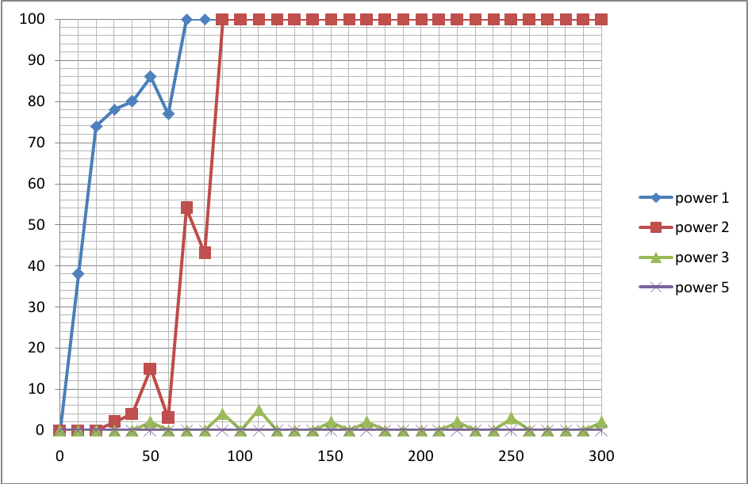
Based on the result, power level 1 distance should be less than 20cm (0.2m). Power level 2 is less than 80cm (0.8m). Power level 3 shows little packet loss at the distance up to 300cm (3m). Power level 5 shows no packet loss up to 300cm (3m). This would mean that the higher the power level, the likeliness for packet loss decreases. However, this would depend on the condition of the channel used. This experiment was done in a home environment where interference with Wi-Fi and Bluetooth were kept at minimum*.

Channels
TelosB transmit and received data in 2.4 GHz ISM band. The frequency band is shared with Wireless LAN and Bluetooth. These services cause considerable problem for wireless sensor networks which often rely on low packet loss, low electrical noise and good timing constrains. In Wi-Fi rich environments, much of the WSN traffic is lost due to collisions with other services. A metric called the packet delivery ratio (PDR) is used to measure the ratio of packets received to those sent on a specific channel. Two TelosB nodes are used and were powered by battery - battery discharge is assumed to be negligible even though it could have effect the result by running the experiments at the same time for two days and the result from both days are similar. The nodes were separated at a distance of less than 1 metre. The distance vs power level are discussed in the next section. A transmitting node sent 10 000 packets out and the receiving node counted how many were received. The percentage of packets received and lost were calculated. The result shows the lowest packet lost on which channel.
***check key channels for IEEE 802.11 Wi-Fi. eduroam, the universities wireless network is on channel ***which overlaps with channel ****. A clear degradation in packet delivery ratio is visible where the channels overlap with Wi-Fi channels.
*Based on the spectrum analyzer, Wi-Fi in the building (Gower Street) is at channel 12-19(23?)
**need to check - however the signal is not too strong thus not affecting TelosB badly.
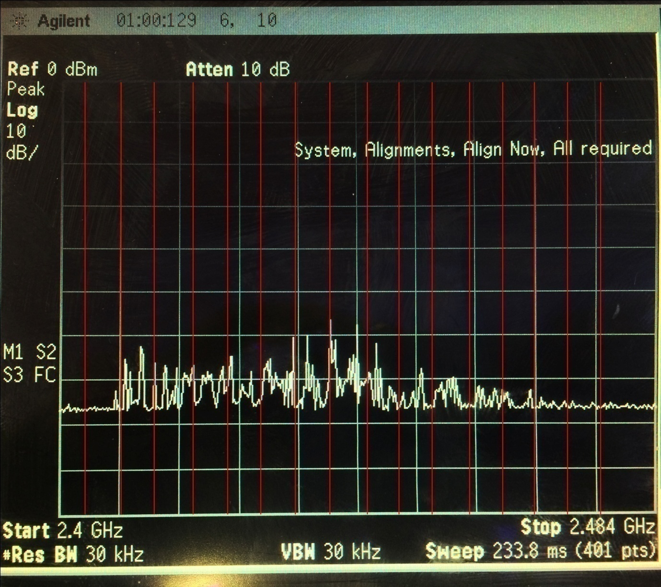

Comparing Wi-Fi and result
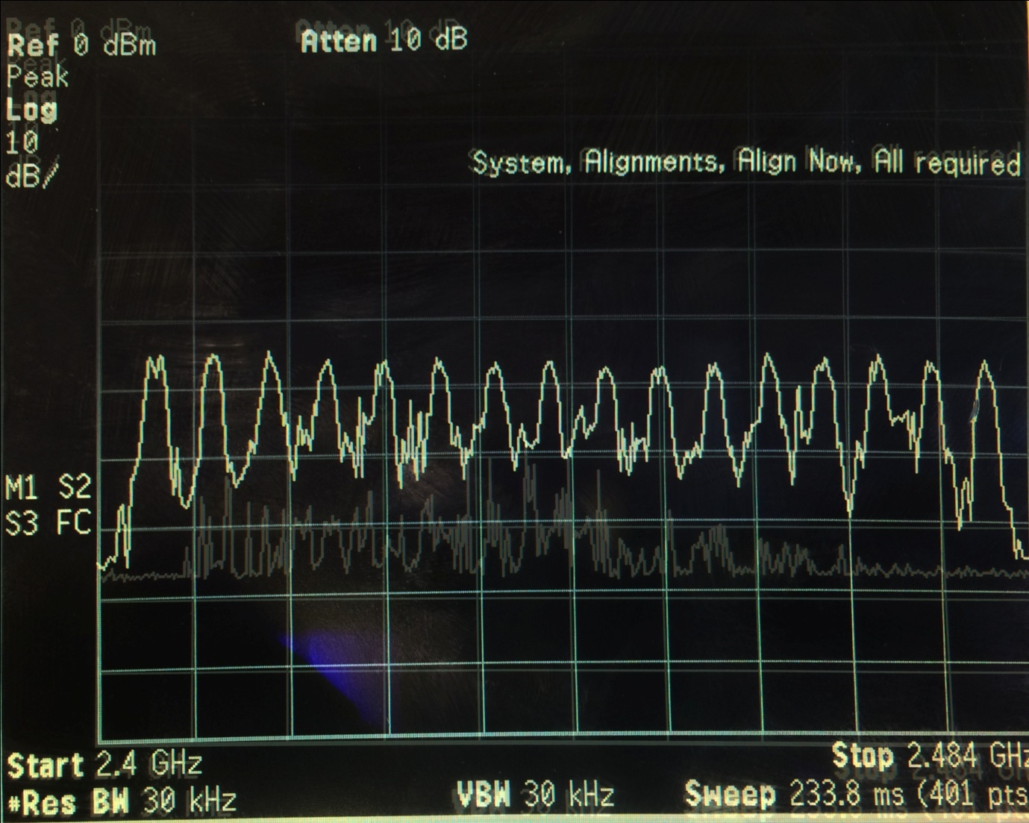
The graph shows the effect of the Wi-Fi channels used. The red line is the average of the runs for each channel
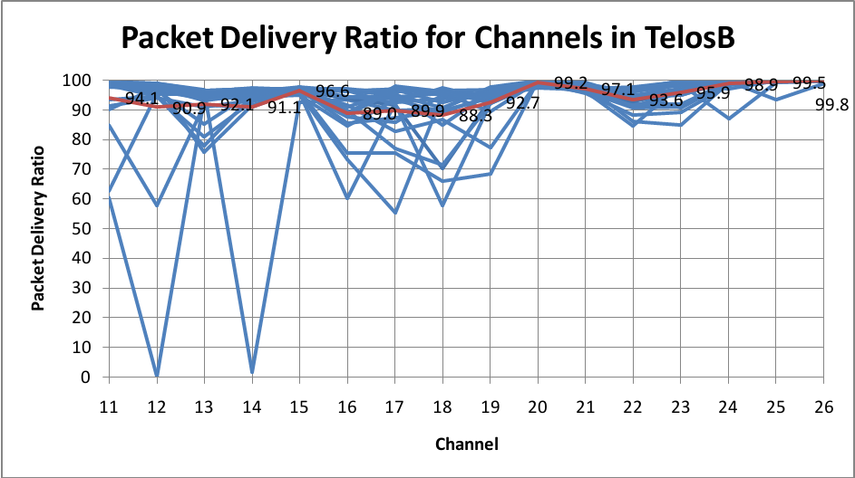
**Try at home to measure the environment at home? (29, 30 April 12pm-8pm)

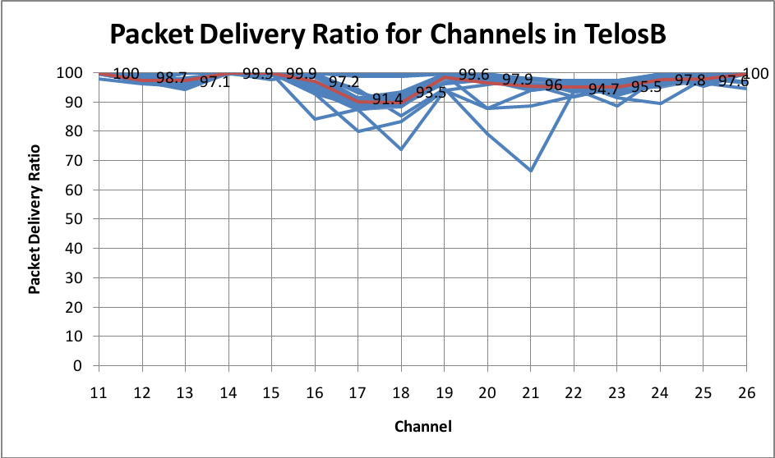
LinSSID
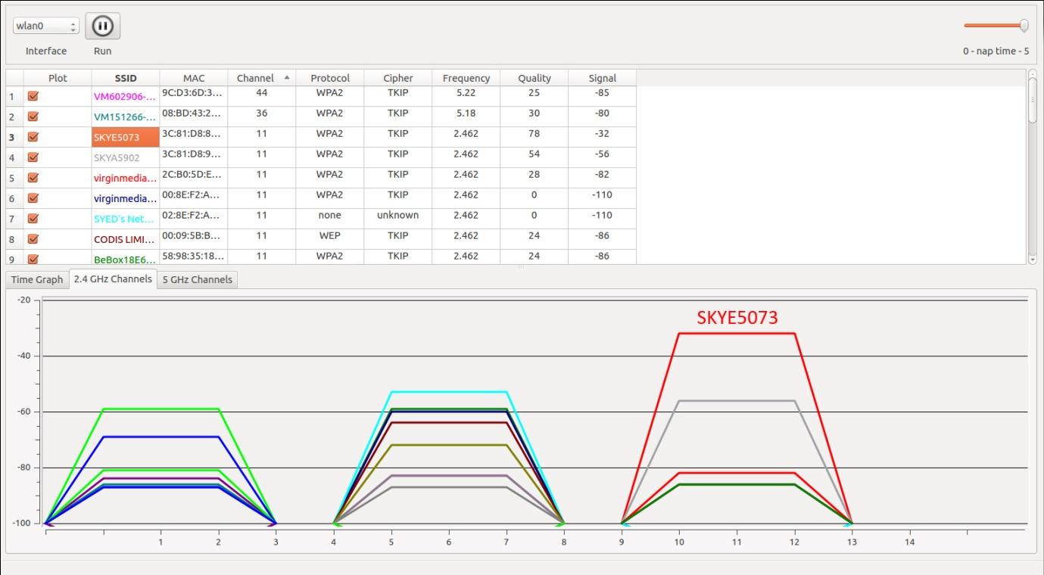

SKY/RSSI-SCANNER.C
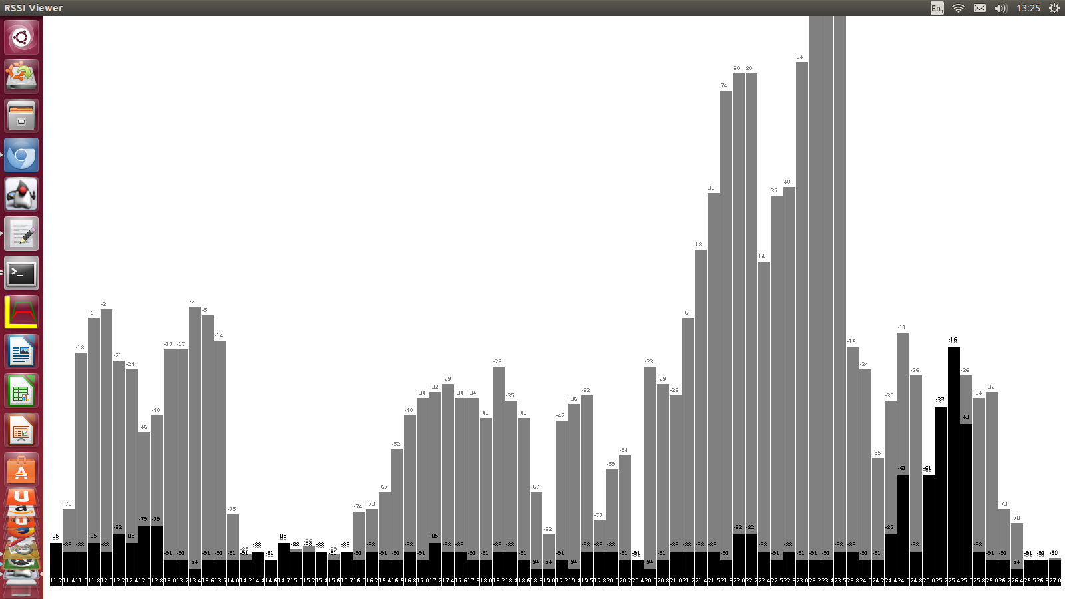

Frequency Hopping

Energy
***BATTERY LEVEL? DRAINING?
Radio dominates power consumption. Listening as expensive as transmitting.
To conserve energy, sensor nodes frequently switch on and off their components. Energy model - the total energy consumption E is defined as ******equation?*****
The energy estimation module maintains a table with entries for all components, the CPU and the radio transceiver. Each table entry contains the total time that the corresponding component has been turn on. Energy estimation is implemented in two line of code in the device driver for the hardware for which energy is to be estimated. When the component is turned on, the energy estimation module is called to produce a time stamp. When the component is turned off, the time difference from when the component was turned on is computed. The time difference is added to the table entry for the component. Use 32768Hz clock divided by 8, producing 4096 clock ticks per second.
To be able to accurately estimate the energy, the estimation mechanism must know the current draw for the microprocessor, communication device and the components. The value is given in the data sheet where Crossbow give the current as 23mA in receive mode, 21uA in idle mode and 1uA in sleep mode while Tmote Sky gives 17.4mA in transmit mode, 19.7mA in receive mode, 365uA in listening mode (radio on) and 1uA in idle mode.
The energy overhead is negligible.

A PC connected to one of the motes shows the real-time energy estimation of the network nodes and where the energy is spent: CPU active, CPU sleeping, radio transmitting, radio listening and LEDs.

***in the code, example-demo4.c (5 Jan 2014 folder)
/*--------------------------------------------------------------------
according to datasheet page 14:
current consumption: radio receiving 19.7mA
current consumption: idle mode 20uA
page 13 provides the table for power level and the curent consumption
-----------------------------------------------------------------
| PA_LEVEL | CURRENT CONSUMPTION (mA) |
-----------------------------------------------------------------
| 31 | 17.4 |
| 27 | 16.5 |
| 23 | 15.2 |
| 19 | 13.9 |
| 15 | 12.5 |
| 11 | 11.2 |
| 7 | 9.9 |
| 3 | 8.5 |
-----------------------------------------------------------------
---------------------------------------------------------------------*/
energy_rx = incoming->listen * 19.7 * 3 /4096.0;
energy_tx = incoming->transmit * 17.4 * 3 / 4096.0;

graph result??? 5 Jan 2014 folder>3

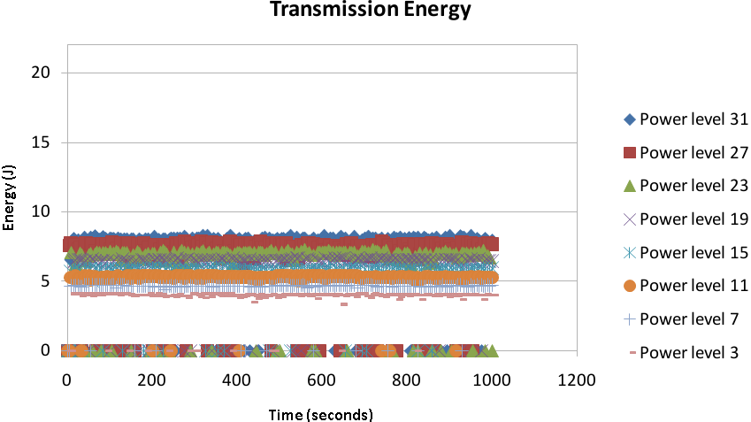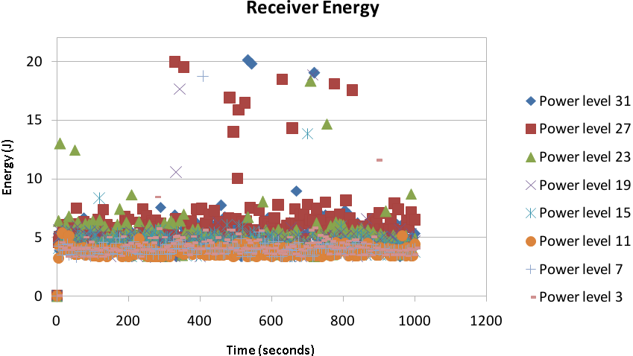
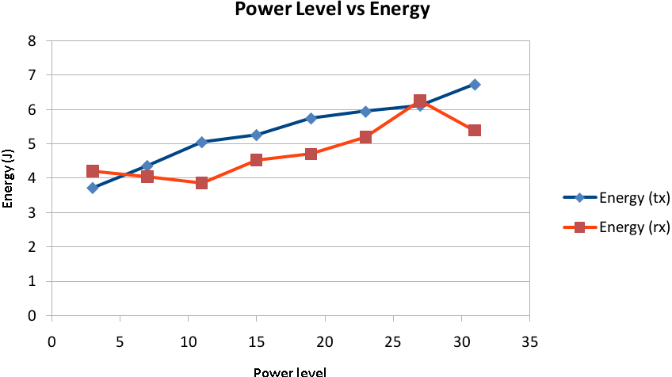
*Listening as expensive as transmitting. (can compare with graph in the link)

Research Plan (1-2pg)

Conclusion (1-2pg)

References

Appendices

