Lab Activities:
Task 1: Build your first HTML file with Fundamental HTML Document and HTML tags (Lecture 4 – part1)
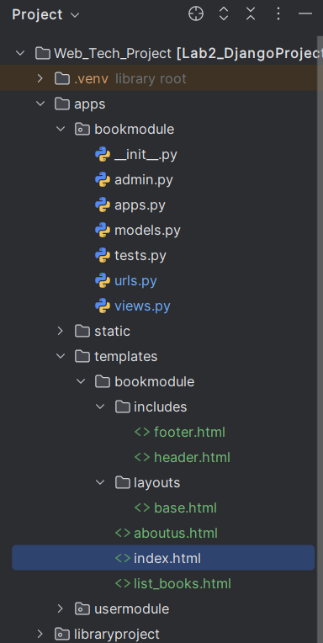

Task 2: Style the previous HTML files with CSS in three ways (inline CSS, internal style element, and separated CSS file)
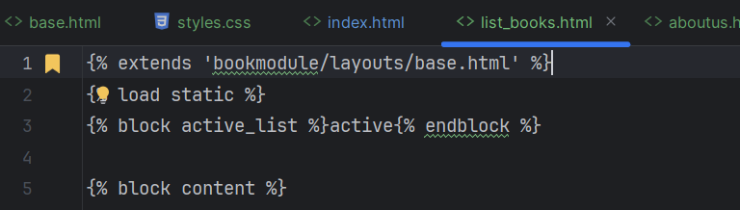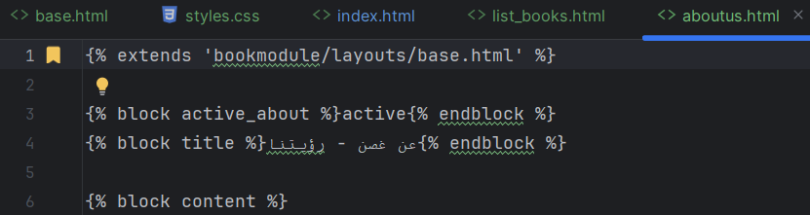

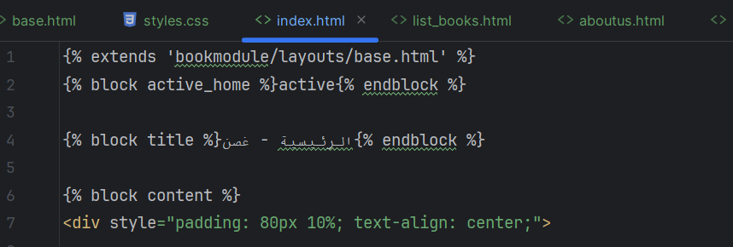

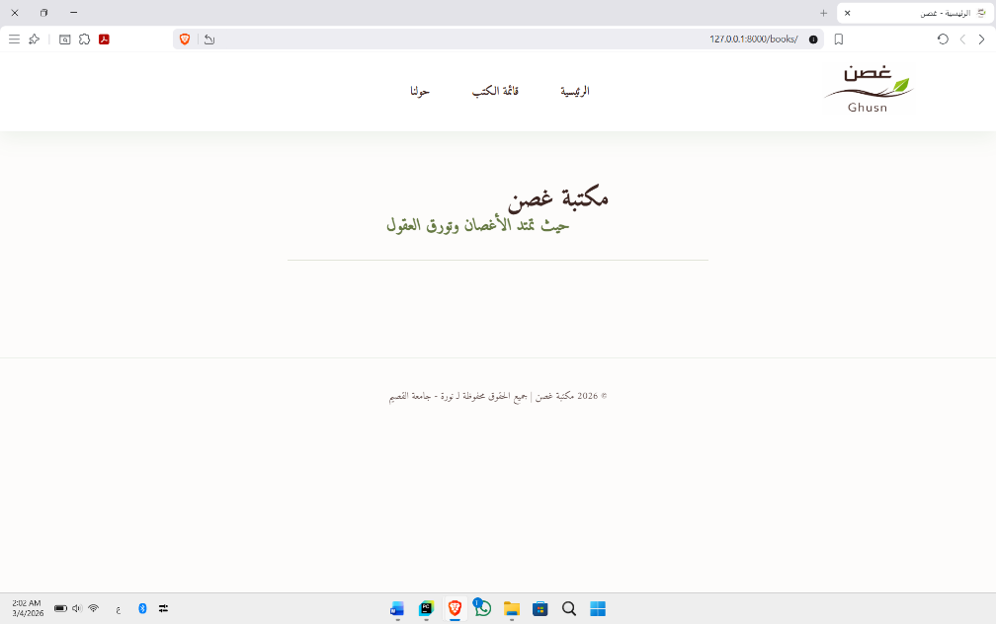

Task 3: W3C HTML5 Validation Service to use proper HTML5 syntax to ensure that browsers process your documents properly.
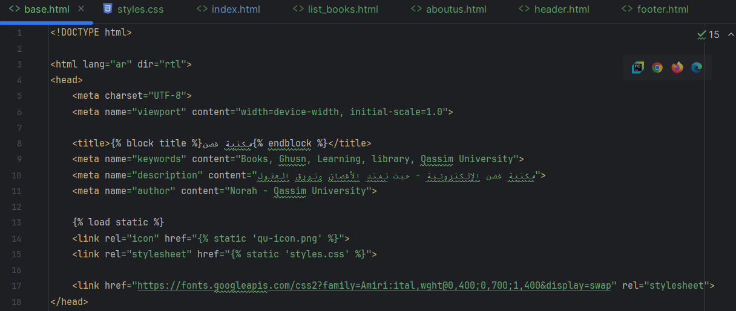

Task 4: Implementation and management of the previous HTML and static files (e.g. CSS and images) in Django framework.
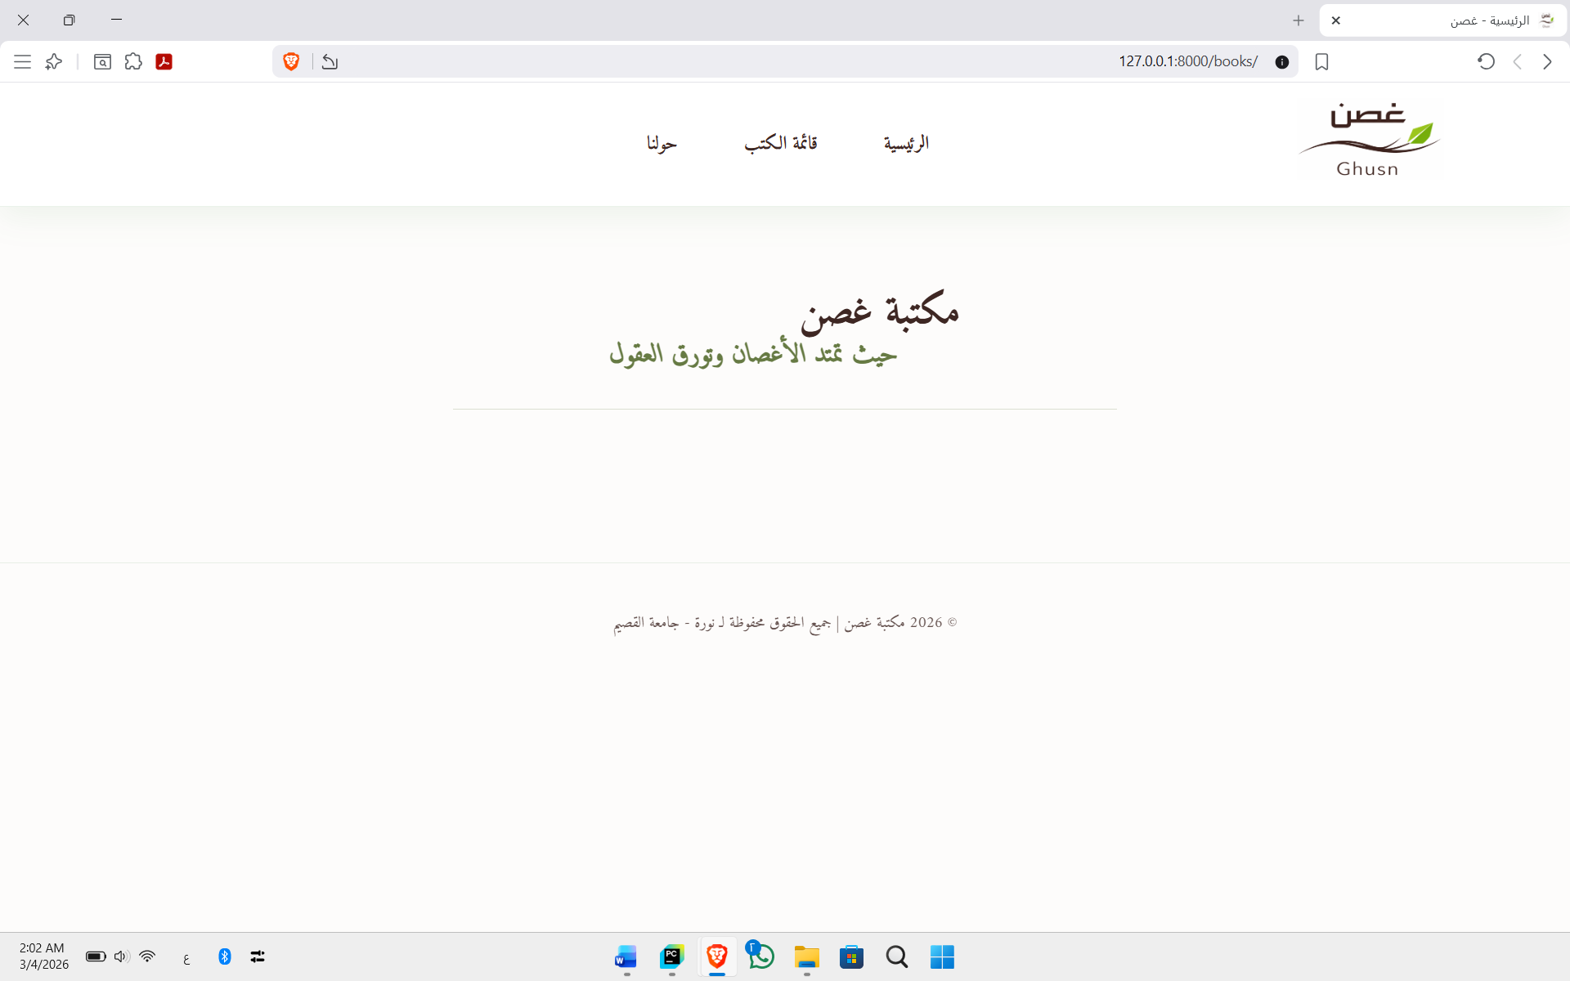

Task 5: Additional implementation of Django tags to build one layout instead of repeating the layout for every HTML file.

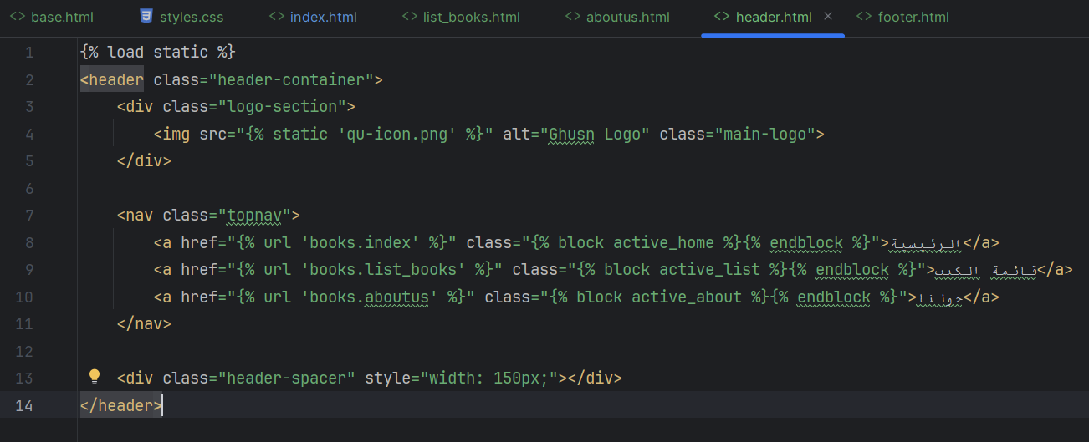

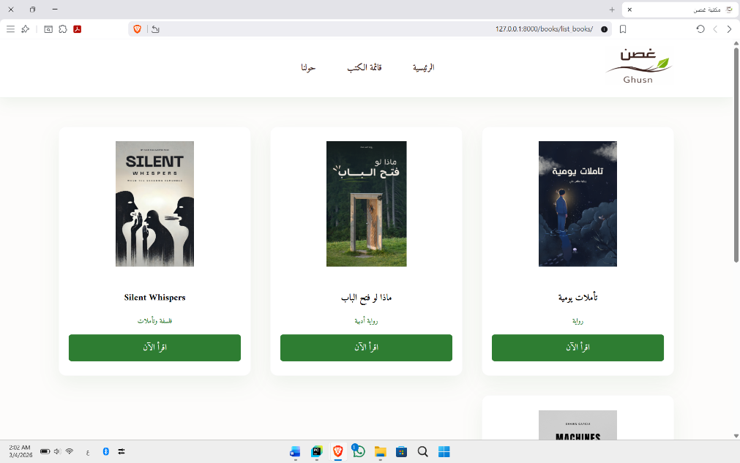

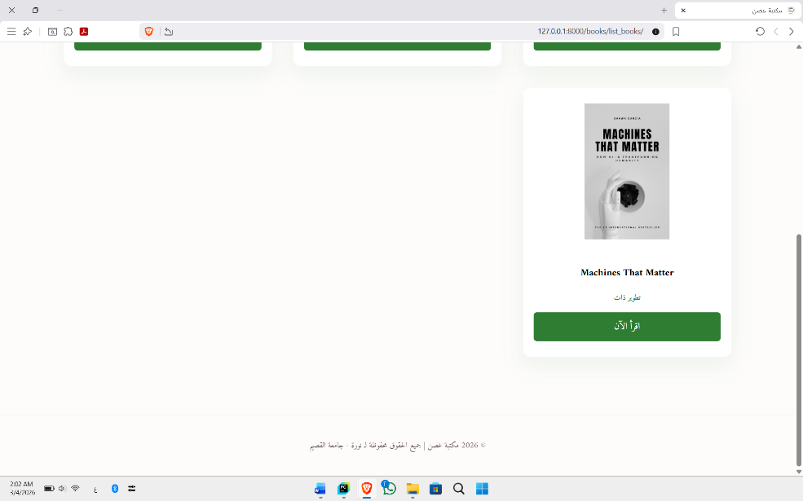

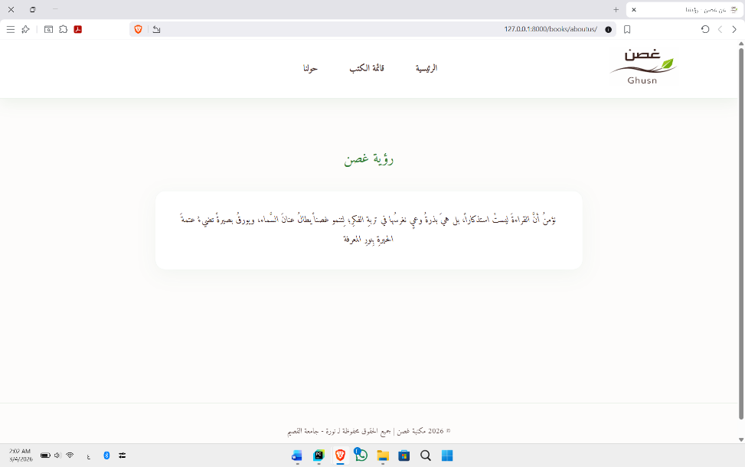

The World Wide Web Consortium (W3C) provides a validation service (at validator.w3.org) for checking a document’s syntax

