This lab session covers the basics of Django Models (Part 1). By the end of this session, students should have a very good understanding of how to build a basic model and how to access models in Django.

Pre-lab Preparation:
- Having bookmodule and usermodule in apps directory, with necessary configurations in settings.py.

Lab Activities:

Task 1: using models, we create a database scheme
ID | Title | Authors | Price | Edition
1 | Continuous Delivery | J.Humble and D. Farley | 120.00 | 3
2 | Reversing: Secrets of Reverse Engineer | E. Eilam | 97.00 | 2
3 | The Hundred-Page Machine Learning Book | Andriy Burkov | 100.00 | 4

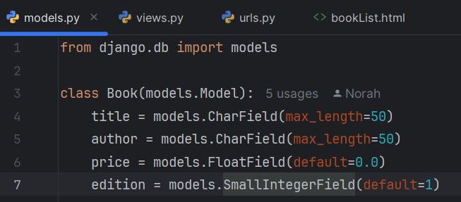

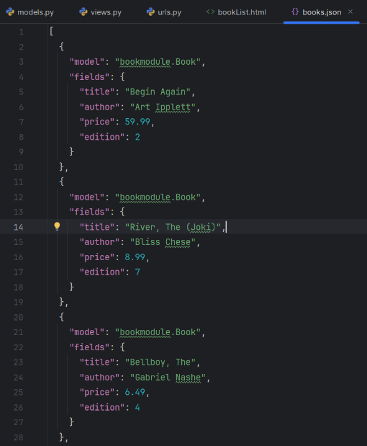

Task 2: use the application ‘DB Browser for SQLite’ or ‘VS code’ to view the database and insert fake data into it.
Note: For VS code, you need SQLite extension, and for SQLite, you will use sqlitebrowser at (https://sqlitebrowser.org/dl/). In the lab, we assumed that you are familiar with at least one of them.
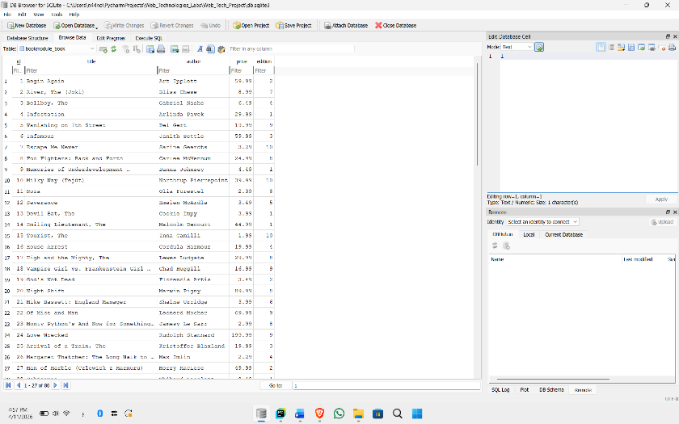

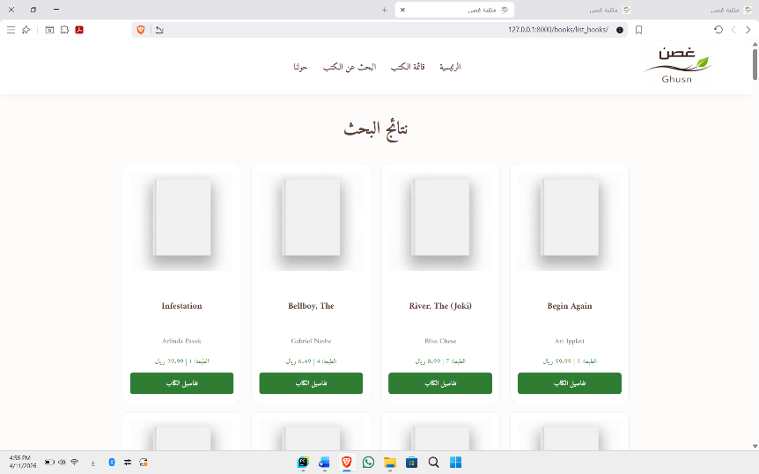

Task 3: Use simple queries using Django ORM.
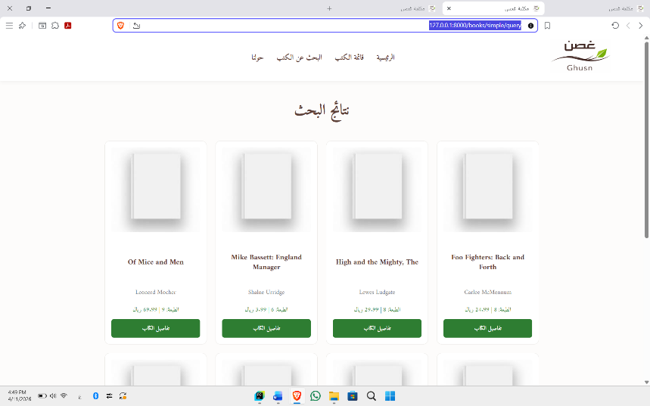

Task 4: Customize queries using common lookup conditions and keywords.
