Norah Al-Doghmani = 412205566

Lab Activities:
Part 1: Capturing HTTP Traffic.
Task 1: Start Wireshark and capture packets.
Task 2: Filter HTTP packets and analyze them.
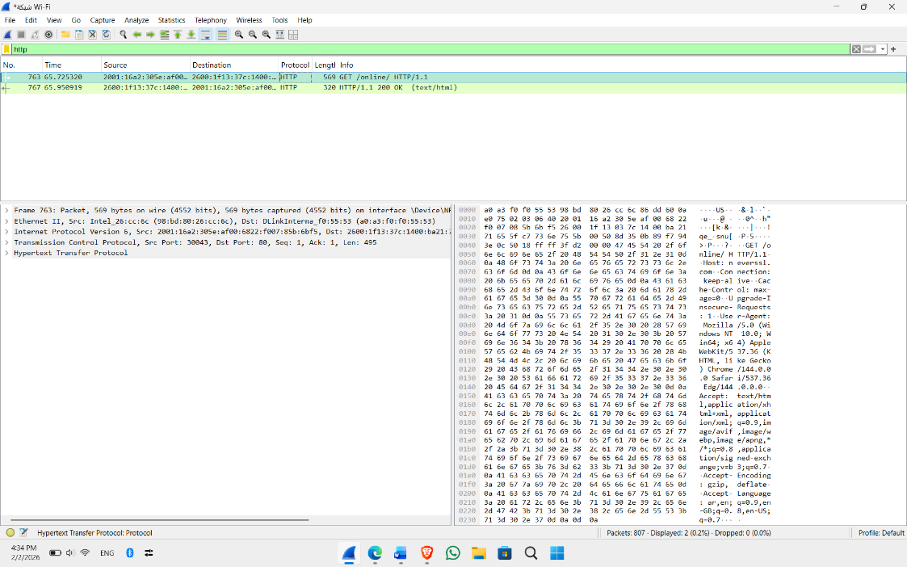

Part 2: Analyzing TCP/IP Traffic.
Task 1: Filter TCP packets
Task 2: Analyze TCP handshake and investigate Data Transfer and Termination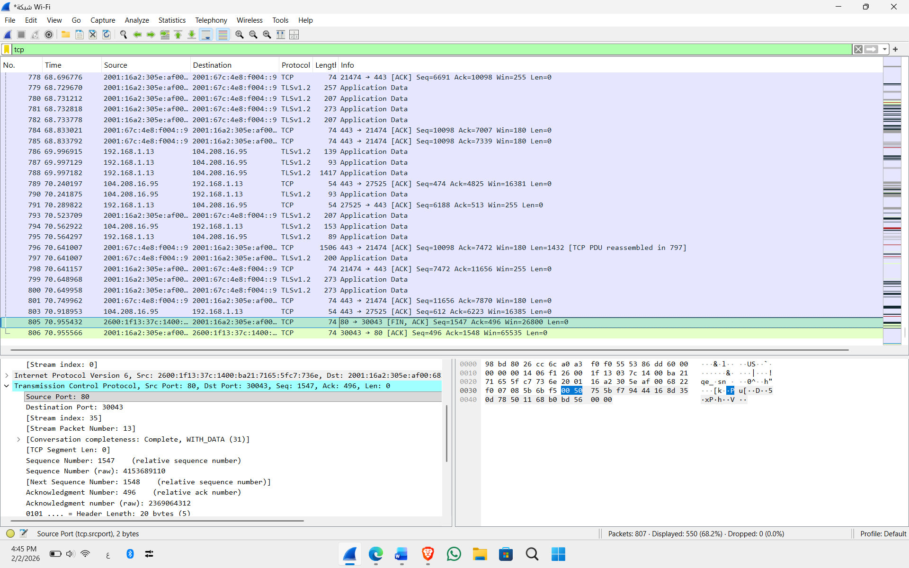
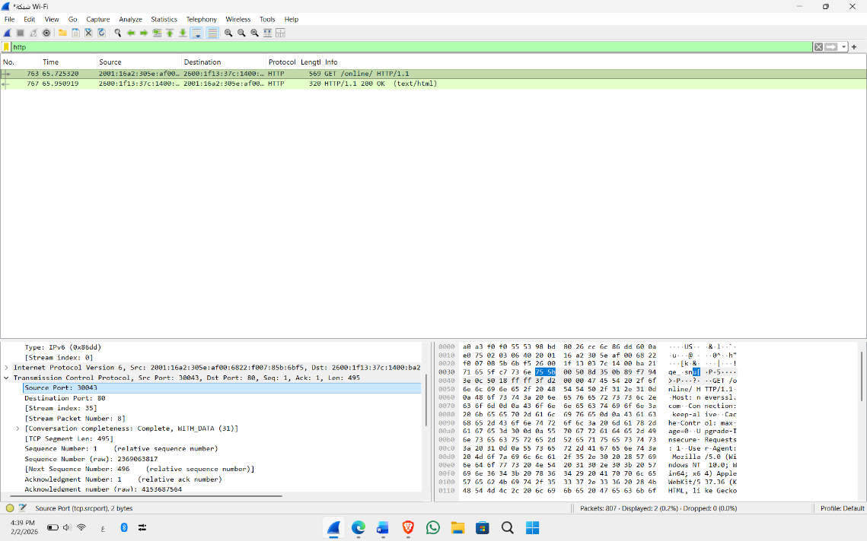

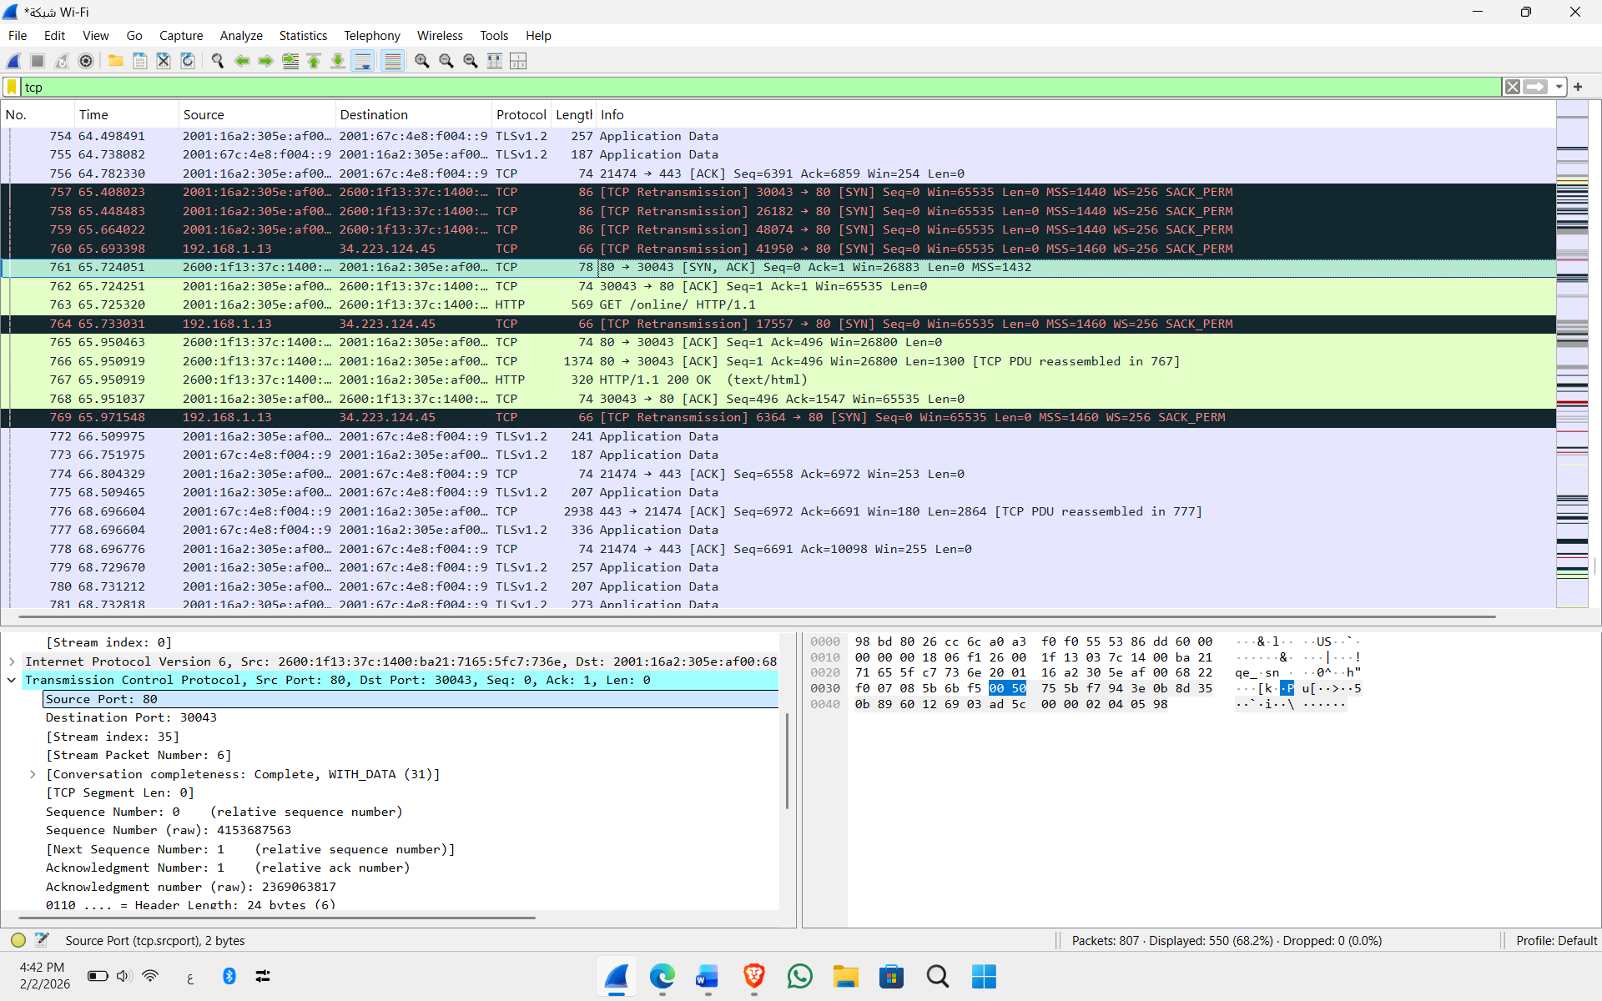

Part 3: Capturing and Analyzing UDP Traffic
Task 1: Generate UDP traffic and capture packets
Task 2: Filter and analysis UDP Packets
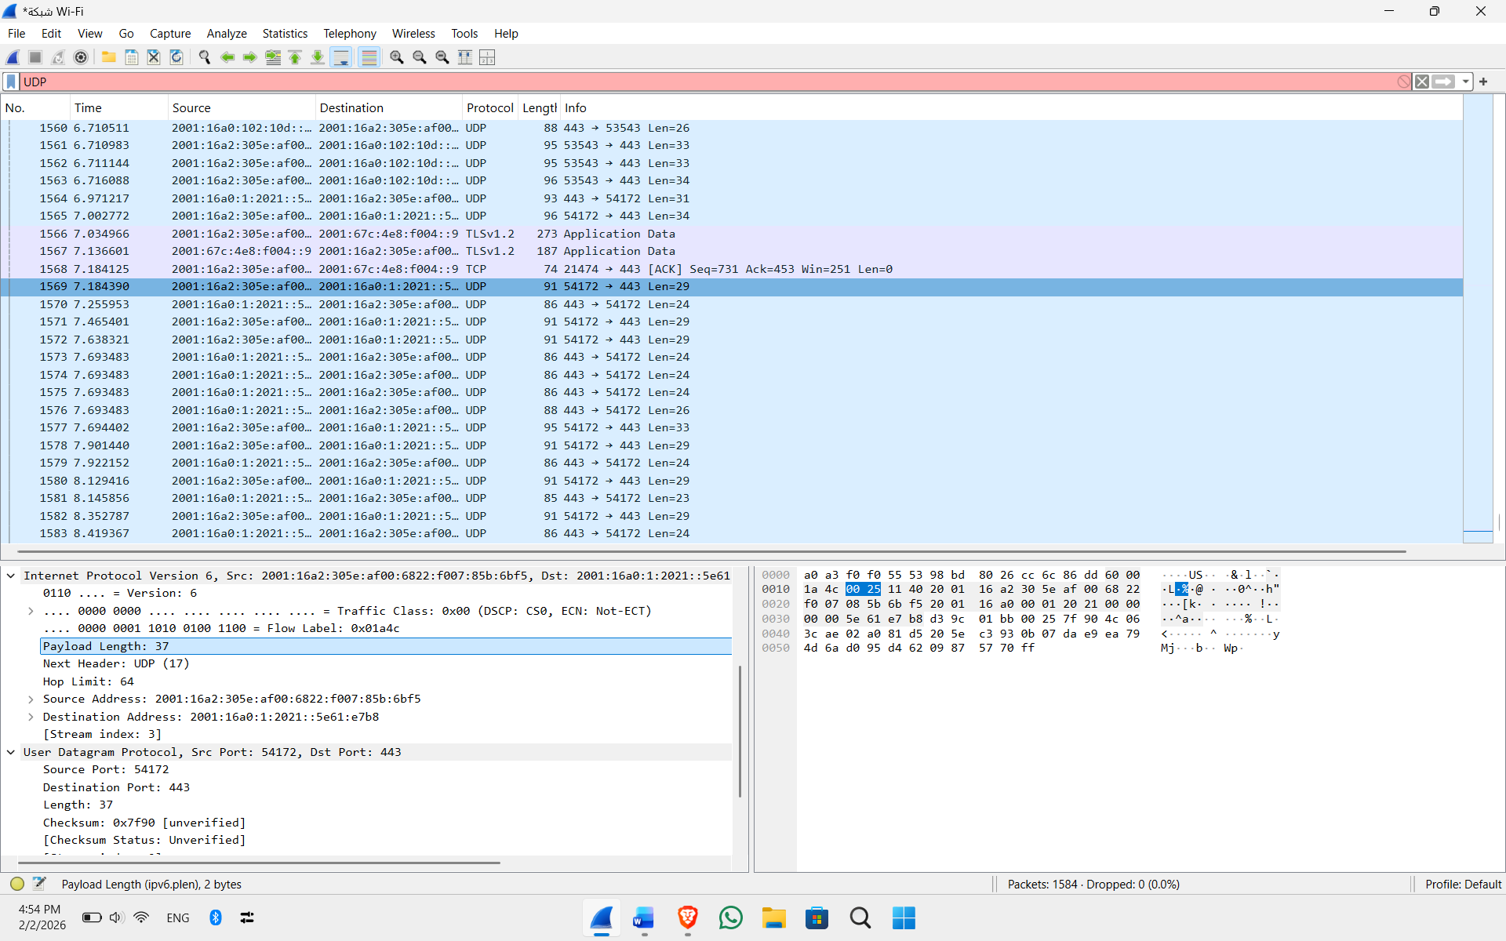

Part 4: Comparing TCP and UDP by filling in the following tables. Save your work (e.g., in an MS Word document), and upload it to your online git repo.
Task 1: Fill in the following table and provide reasons.

 | TCP or UDP | Reasons
Reliability and Connection Establishment | TCP | TCP uses the Three-way Handshake, (SYN, SYN-ACK, ACK) to establish a reliable connection before data transfer.
Data Integrity and Ordering | TCP | TCP uses Sequence Numbers to ensure data is received in the correct order and retransmits any lost packets.

Task 2: Identify the use Cases and Performance of TCP and UDP.

 | TCP | UDP
Use cases | Web browsing (HTTP), Email (SMTP), File Transfer (FTP). | Live streaming, Online gaming, VoIP (Video/Voice calls).
Performance | Slower due to error checking and connection overhead. | - Faster and more efficient for real-time applications as it has no handshake.

