This lab session covers the basics of the Django development framework and the Git system. By the end of this session, students should have a very good understanding of how to install and configure a Django application and how to structure it. They should also have practical involvement with the Git system and how to use basic commands to version control their repository.

Pre-lab Preparation:
- Install Python: Ensure that Python 3.7+ is installed in your system (macOS users shouldn’t use their built-in Python version; they should have their own Python environment). Also, ensure to upgrade your pip command by typing 'python3 -m pip install --upgrade pip'
- Install Git: Ensure that you have git installed. (macOS users may install Xcode or install the commands without Xcode by typing ‘Xcode-select --install’ in the terminal command line).
- Since we are using the command line for Git, you must generate SSH keys. Here is an example of how to do that:
(https://docs.github.com/en/authentication/connecting-to-github-with-ssh/generating-a-new-ssh-key-and-adding-it-to-the-ssh-agent).

Lab Activities:
Part 1: Django web development framework
Task 1: install Django
Task 2: create, configure, and organize a new Django project
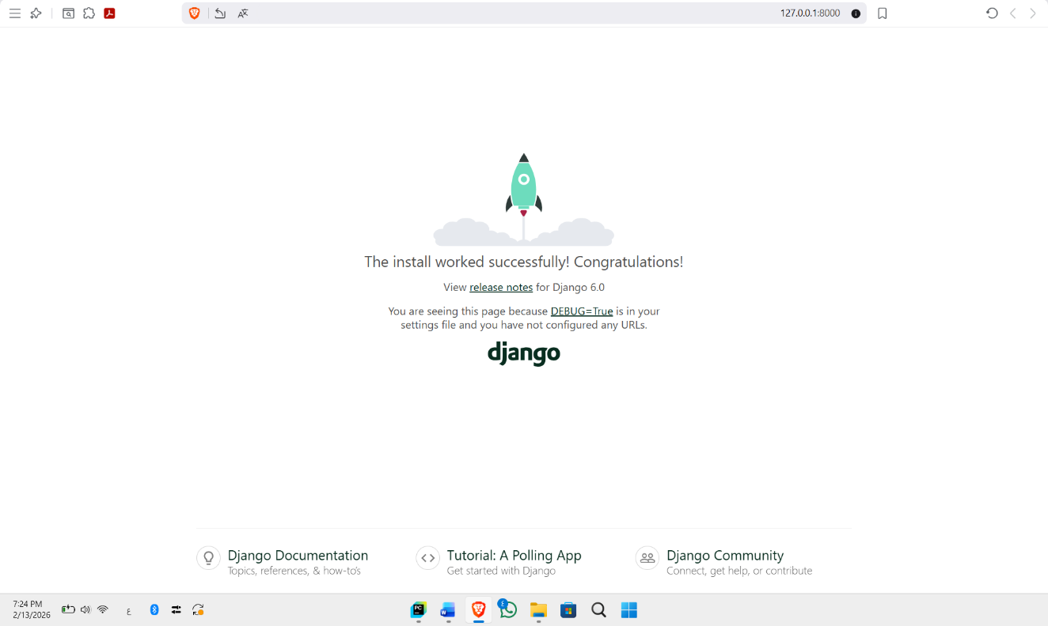
Task 3: configure your Django application
Step 2: create two module services in the apps folder: bookmodule and usermodule
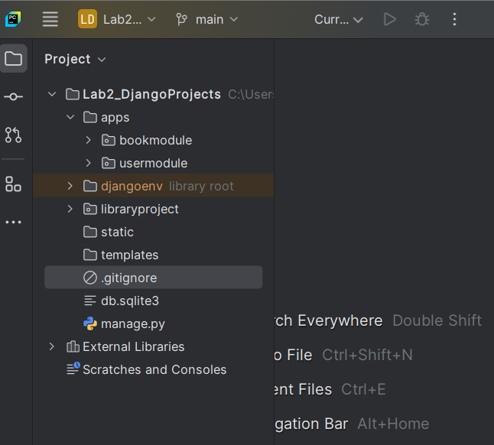

Step 3: Open the files modules configuration files.
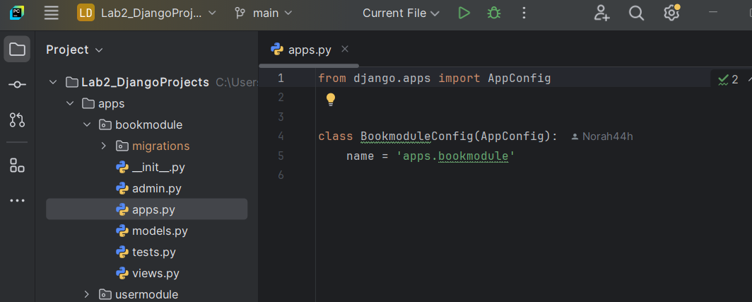

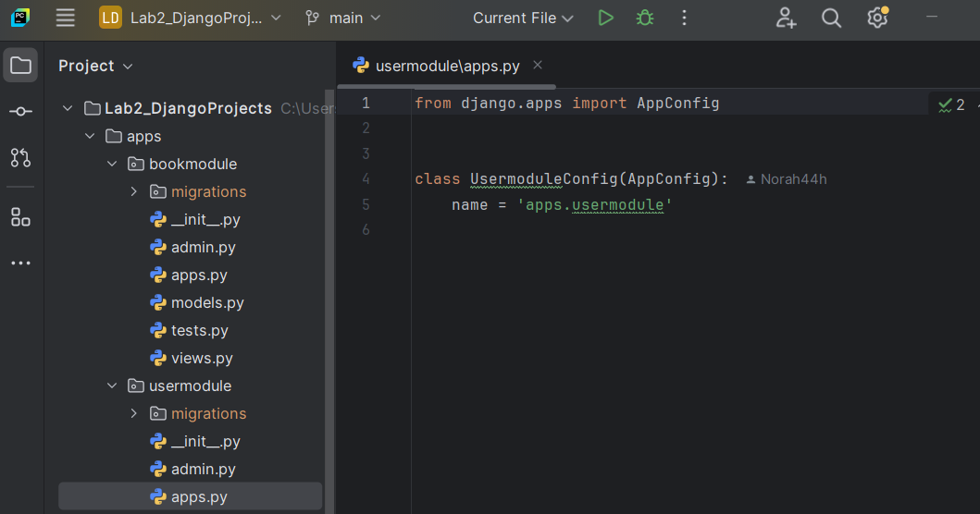

Step 4: Update the Django application settings at ROOT/libraryproject/settings.py, and add the following to the INSTALLED_APPS array.
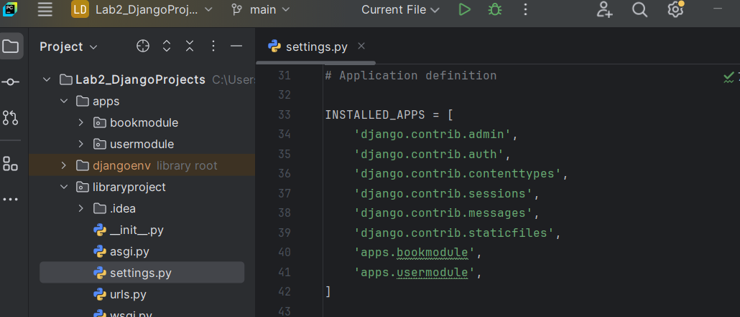

Part 2: Git system and connect your online repo with a local repo
Task 1: Create a local git repo.
Step 3: You don’t want to add all the files from your local repository to the online one. So, create an ignore file to add all file extensions that the git system will overlook.
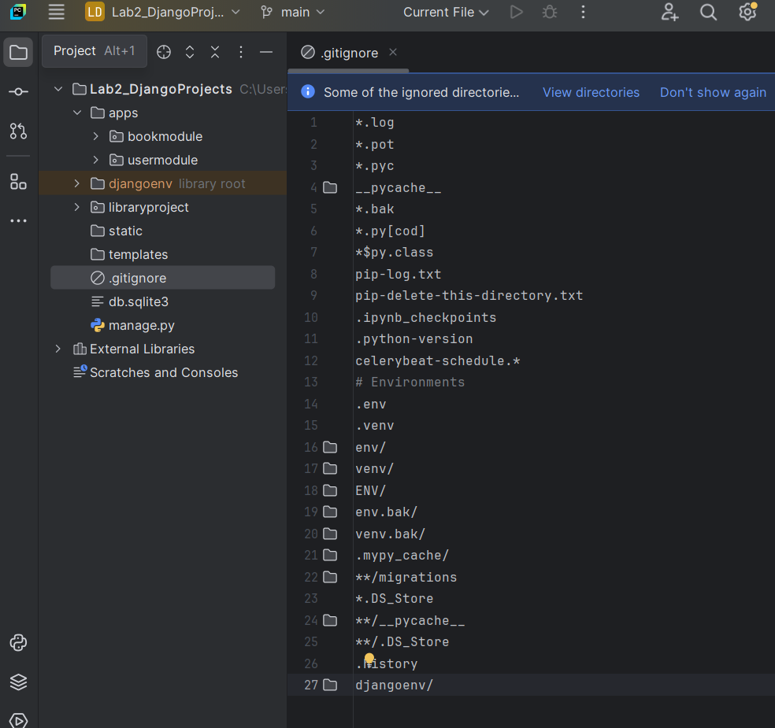

Task 2: connect your local repository with the remote repository you created in Lab 2.
