Lab Activities: Build and configure a simple link between a URL and a view (simple pattern), along with a simple HTML template.

Task 1: Build your first view function and corresponding URL mapping in the core/urls.py
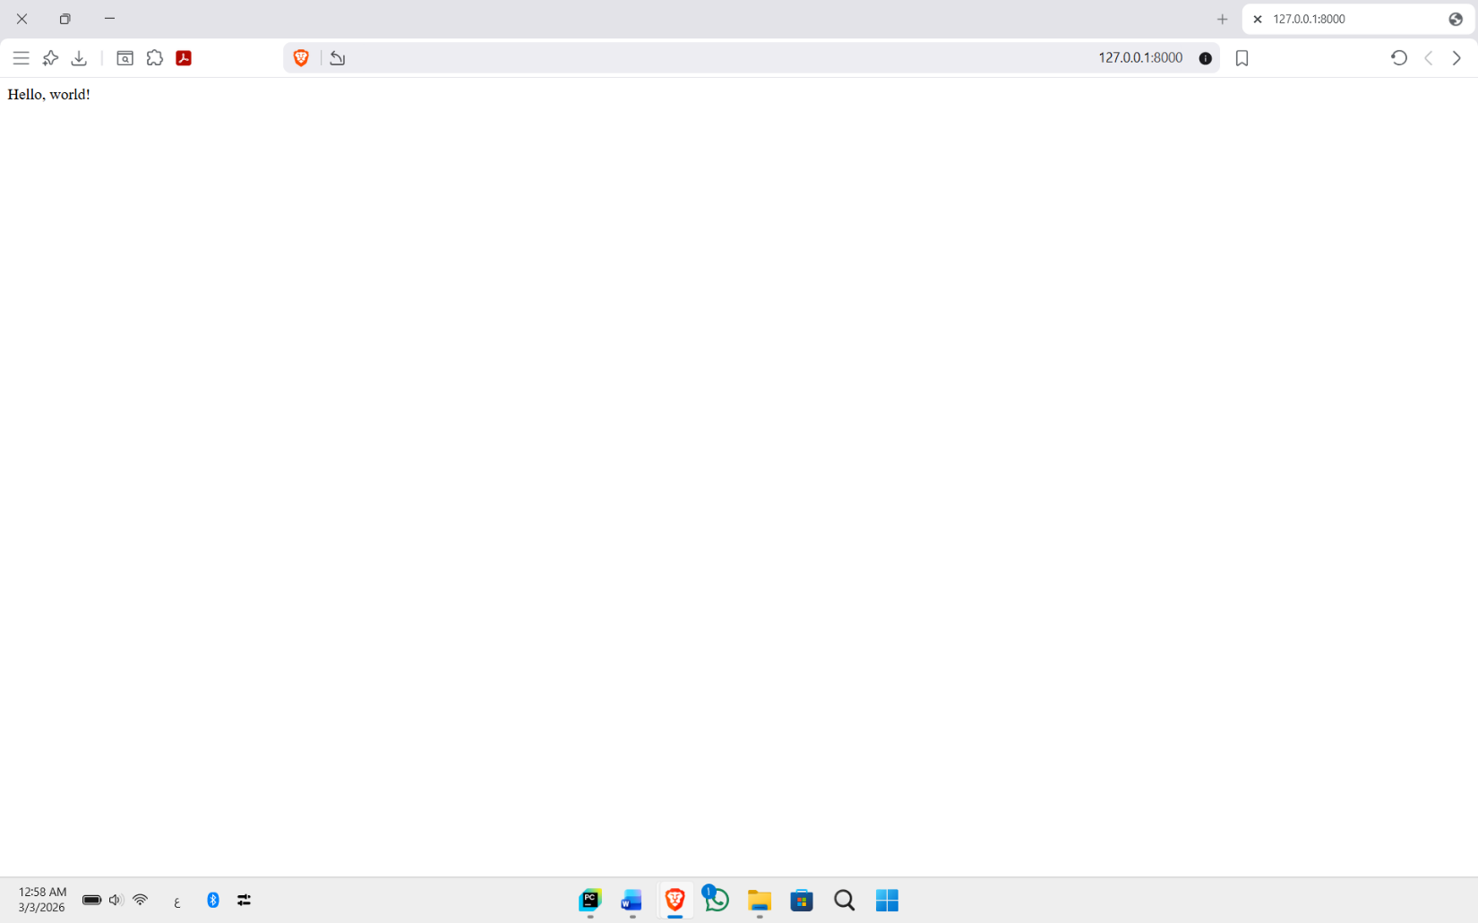

Task 2: Add parameters with HTTP requests
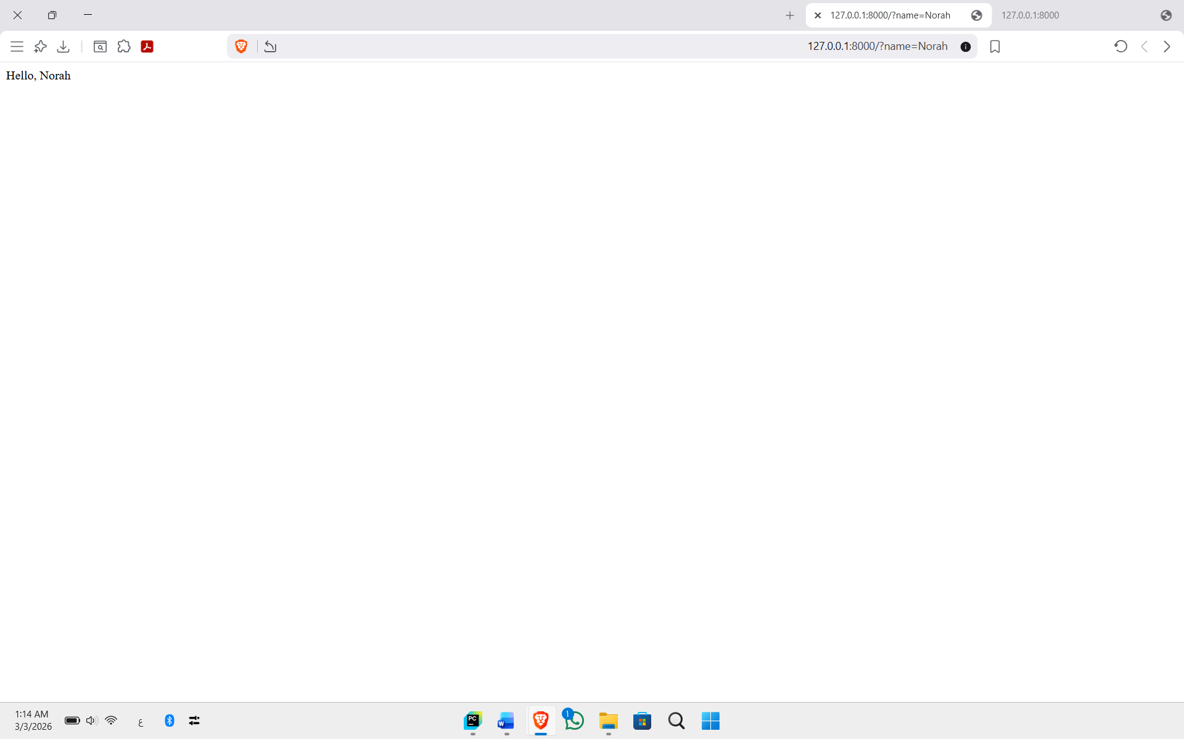

Task 3: Build your second view function and corresponding URL mapping with parameters within URL path

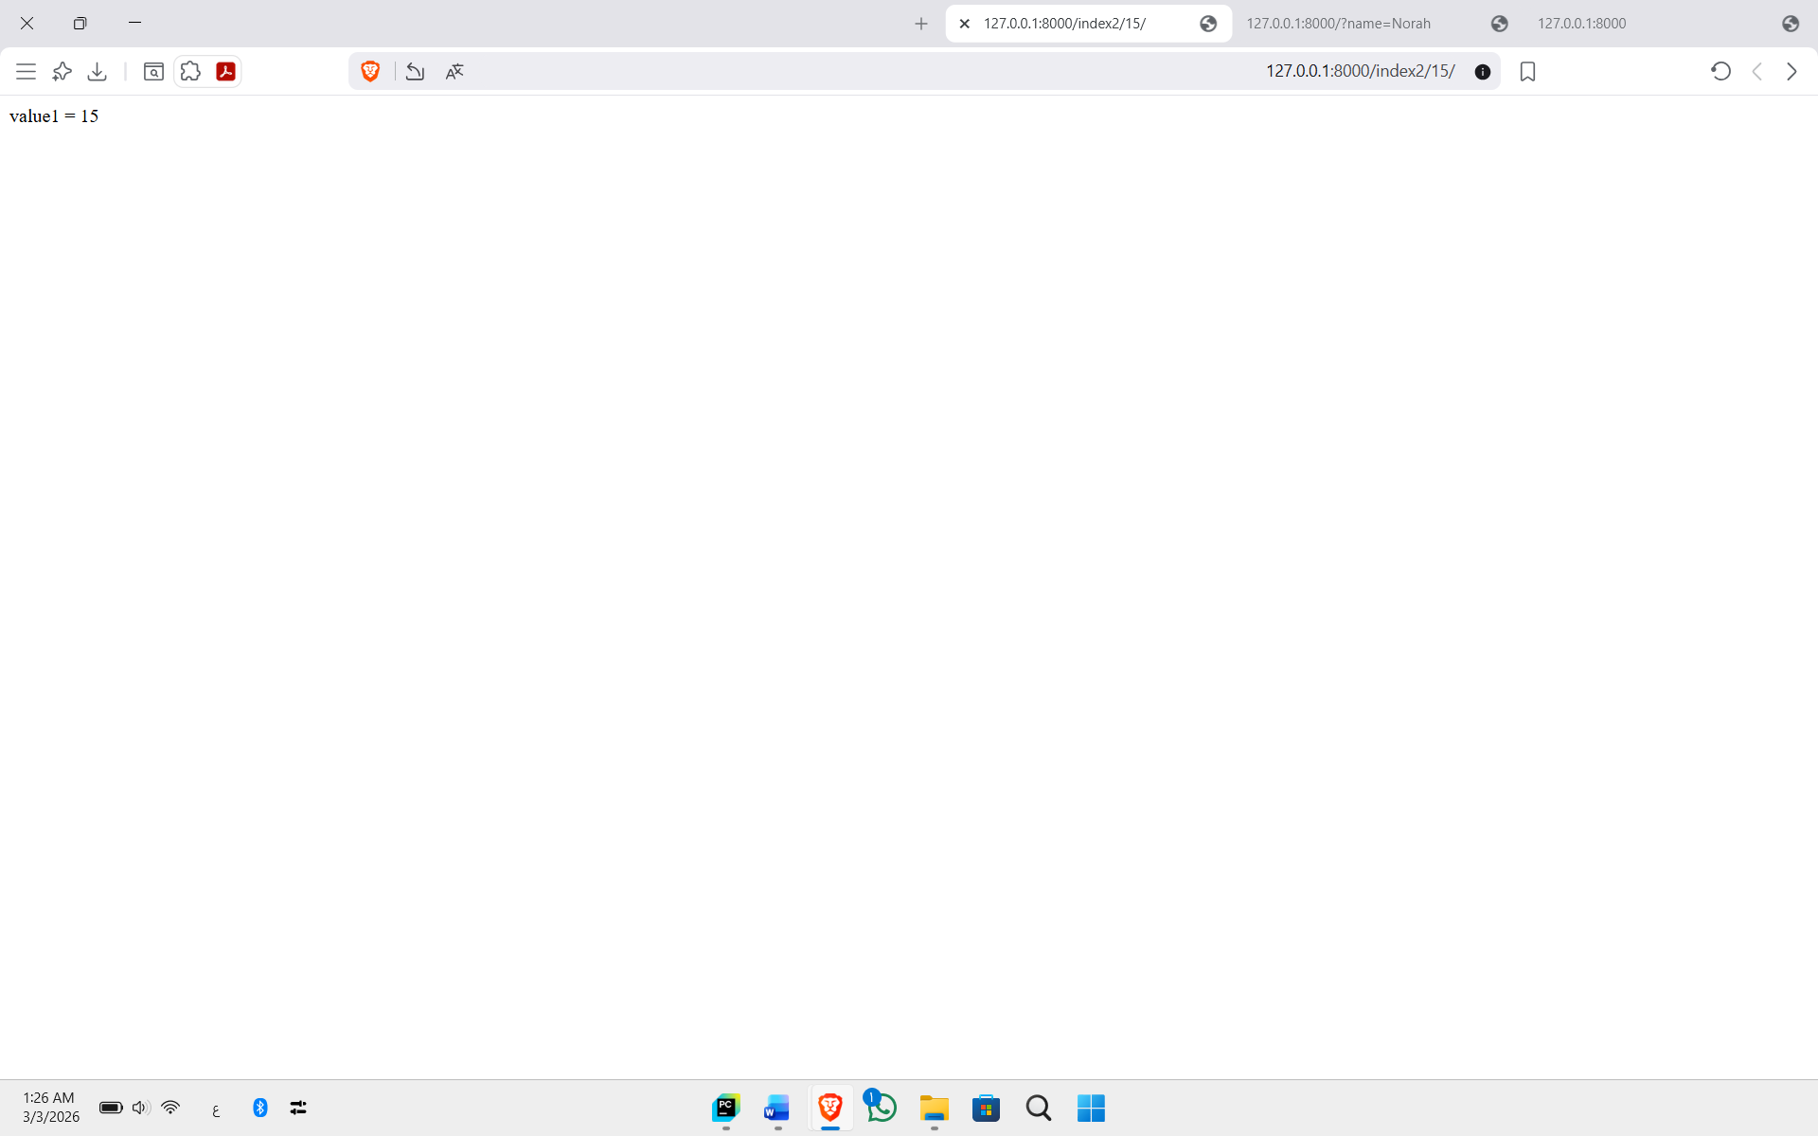

Task 4: Create a simple HTML template
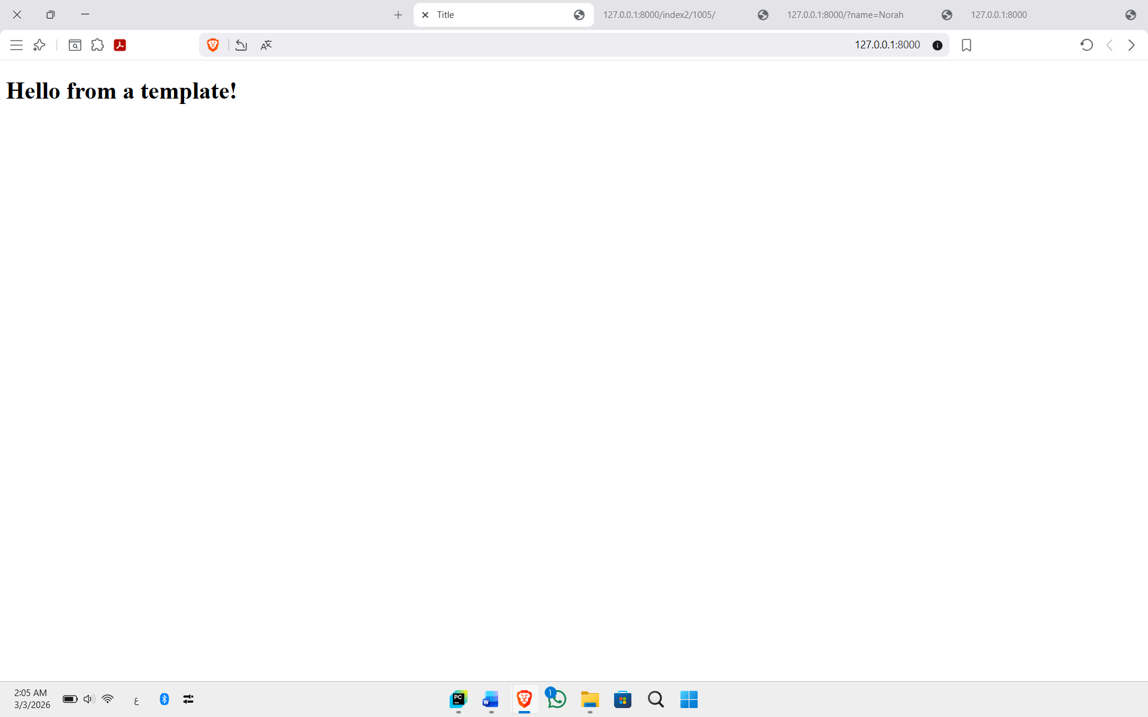

Task 5: Rendering variables in the HTML template that processes a context
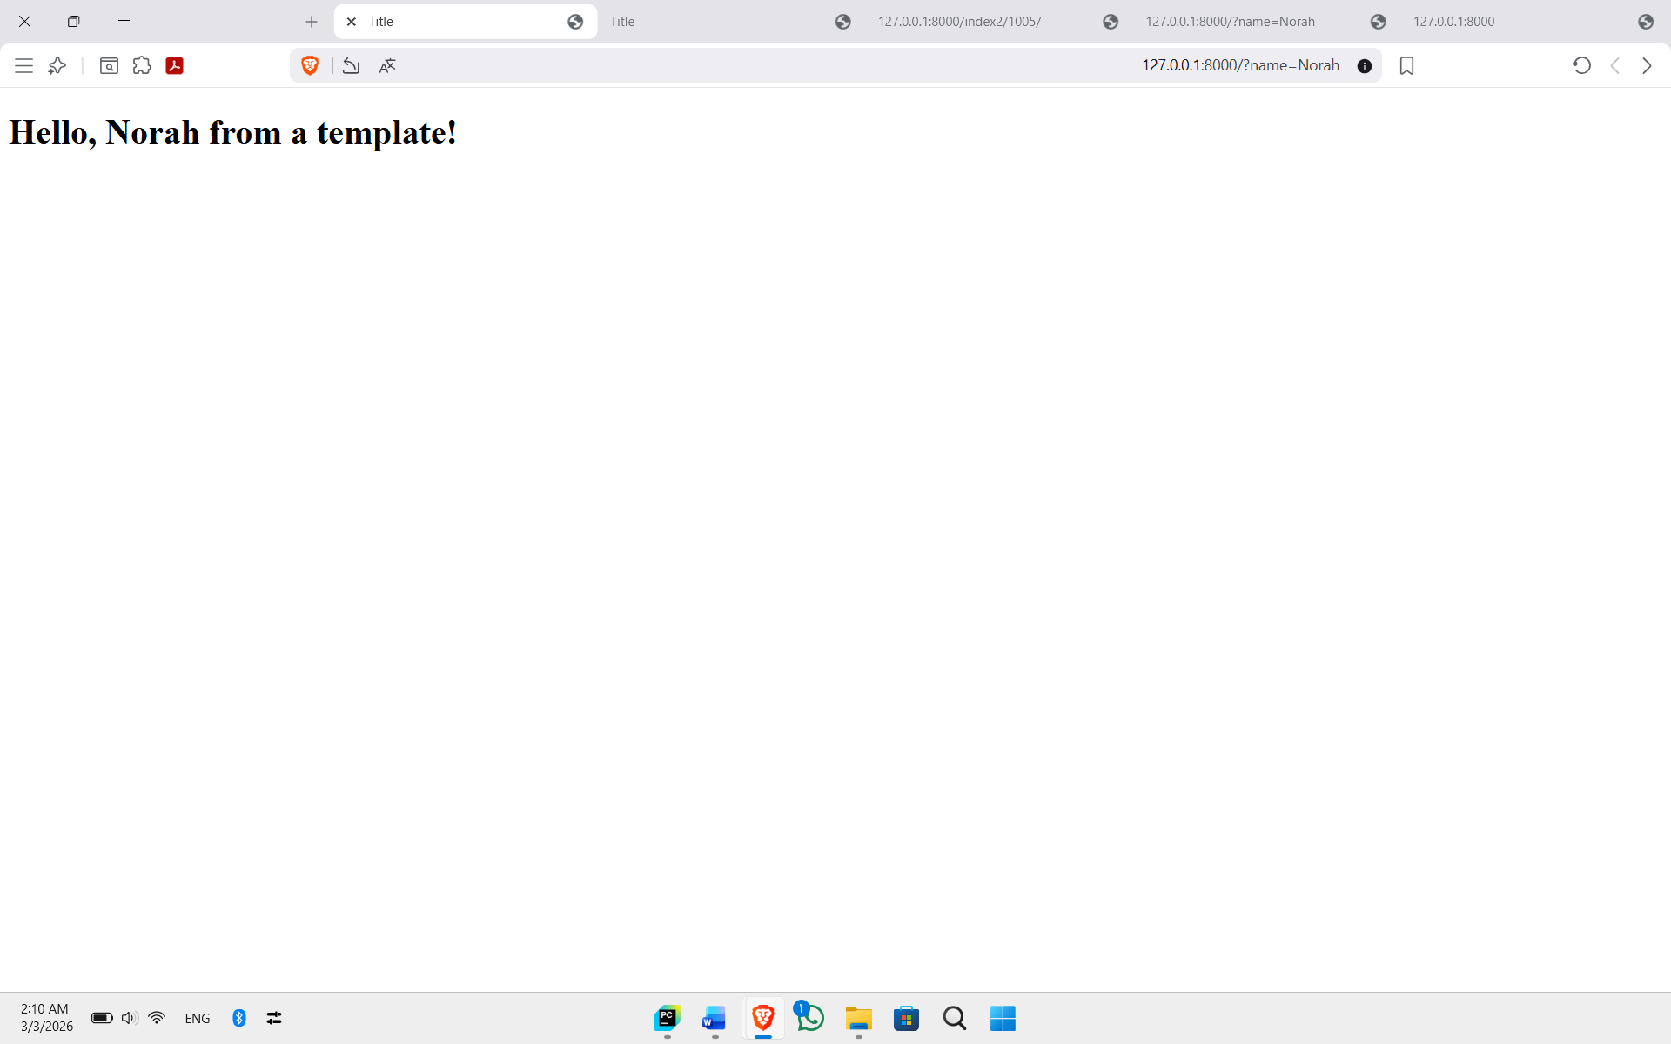

Task 6: Define patterns globally (DjangoProjects/urls.py) with specific urls.py file for each app/module
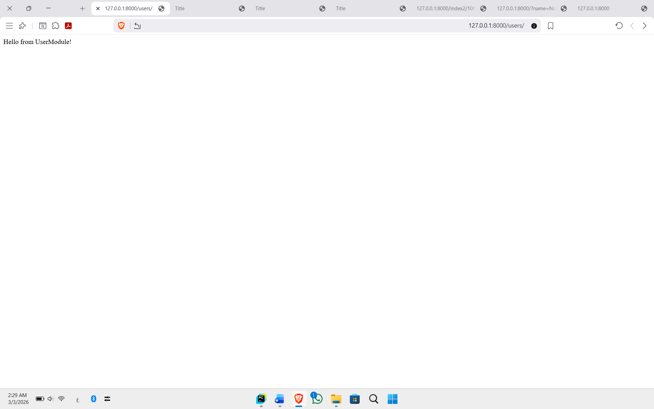

Task7: Create a URL, view, and HTML to display one book details
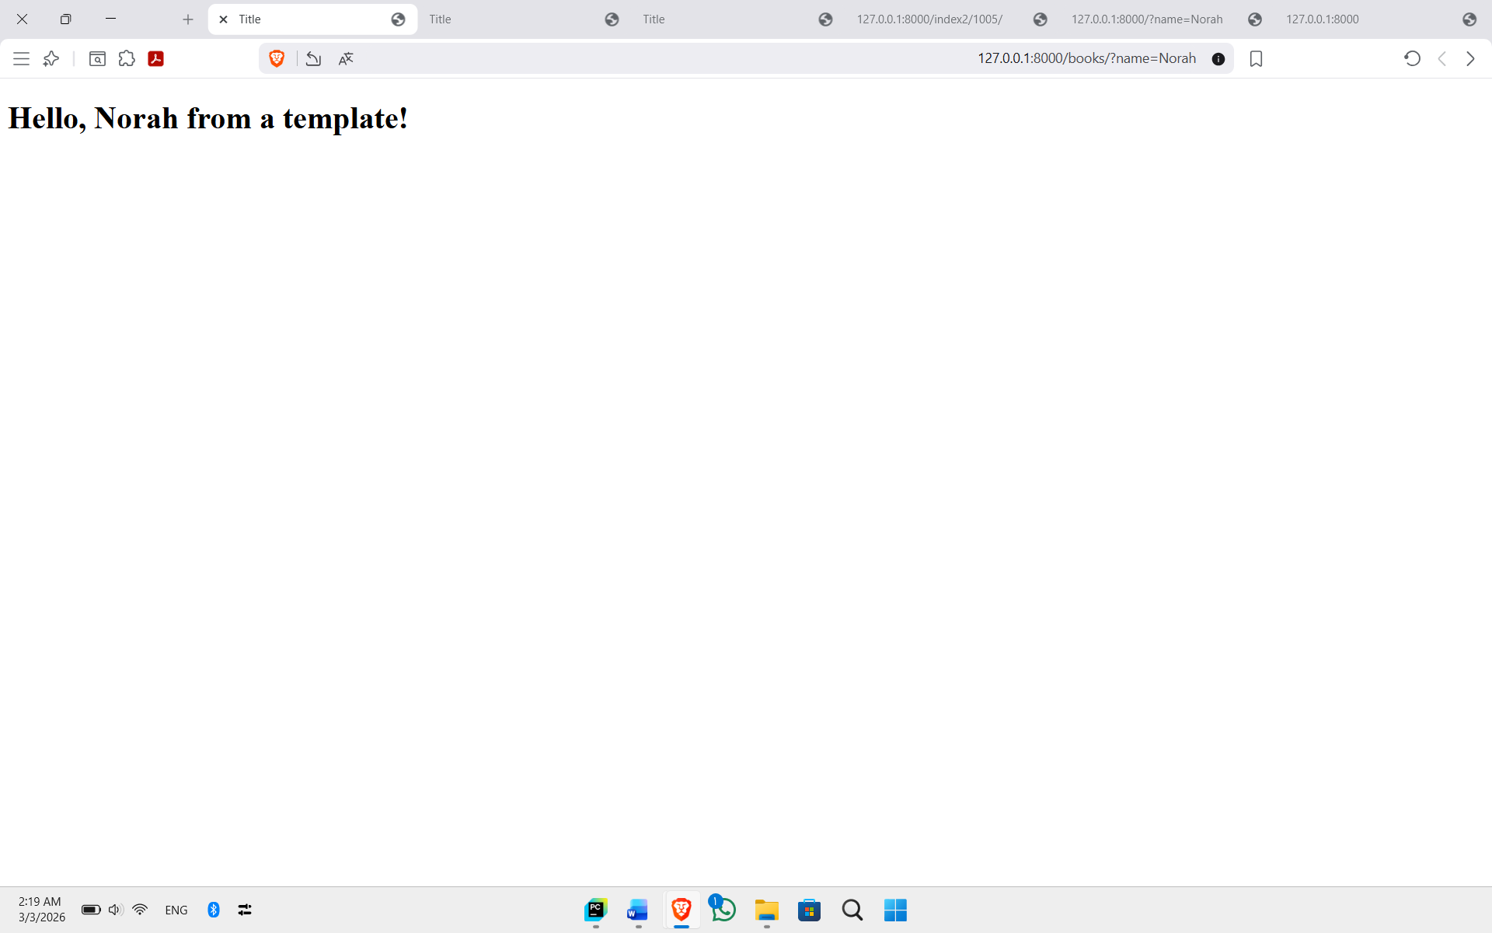

It is possible to have more than one parameter, like http://127.0.0.1:8000?id=10&name=world!&age=18 Note: this method is GET HTTP request, which is not recommended for security reasons, and use POST HTTP request instead.

