This lab session covers the basics of HTML form. By the end of this session, students should have a very good understanding of how to build a basic form and how to Handle form in Django.

Pre-lab Preparation:
- Having bookmodule and usermodule in apps directory, each containing separate URL configurations.
- Template directory located in ‘apps’ with necessary settings.
- Master template ‘base.html’

Lab Activities: A complete webpage example with html form and Handling form in Django

Task 1: Build HTML form template
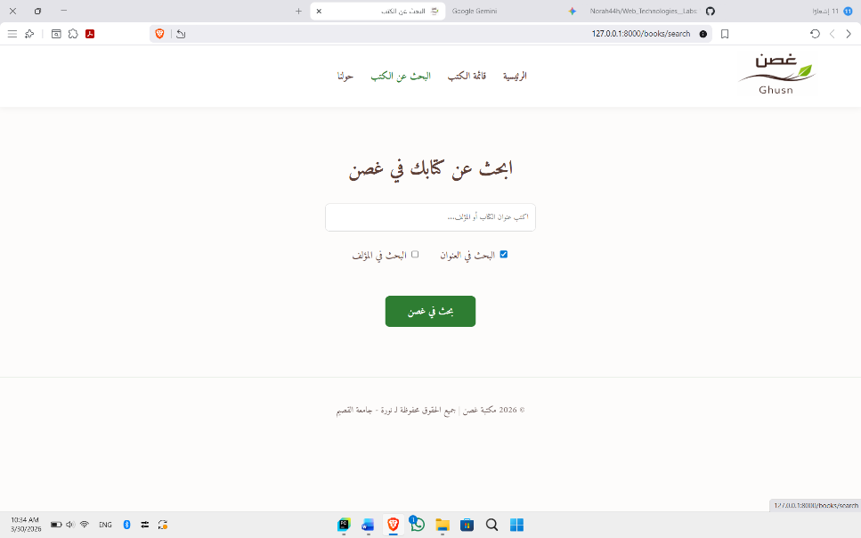

Task 2: Handle the form once submitted
