|  |  |
| --- | --- |
| **Name** | **Email** |
| Norah Alsadhan | Norah_alsadhan@hotmail.com |

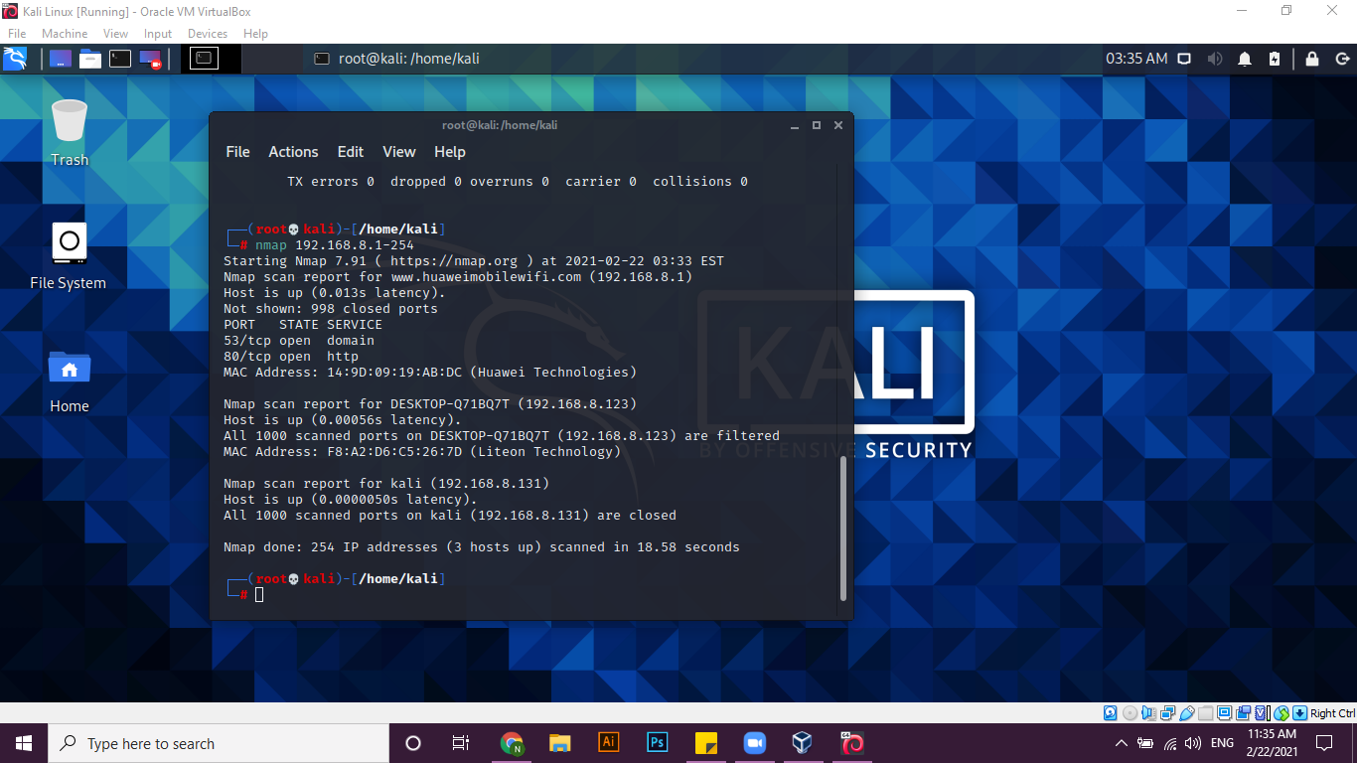

­­­­­

Have discovered 3 hosts:

* The first for the site [www.huaweimobliewifi.com](http://www.huaweimobliewifi.com) ip (192.168.8.1)
* The second IP of my laptop ip (192.168.8.123)
* And the last for kali ip (192.168.8.131)

Nmap is a Network Mapper tool is used in It is used to identify open ports and active devices and determine the holes in systems.