Object Oriented Programming-II Document Report
Flower Delivery Application

Submitted by:

Name | ID
Norah Hamad Al-ShaikhMubarak | 216017861
Norah Abdulrahim Al-ShaikhMubarak | 216005229
Dina Maher Al-Bushaier | 216010684

Submitted to: Dr. Noor E Hafsa
Submission Date: April 29, 2018
Section: 64

Project Summary
In this project we have done 11 classes.
First the welcome class, which gives three options of entering our application, second the user, can choose the flower type and packaging among several options.
Third after these two classes the user gets the payments details and the total price calculated from the database based upon the user’s choice. Fourth the user has two options whether to pay cash on delivery or pay via card, if the user chooses pay via card, a card information frame will appear containing the information needed and it will be stored in our database, otherwise the user will proceed to the rating class to give an opinion about our application.

Document History (Creation&Modification)
Date | Name | Change Type | Comments
27, February, 2018 | All Group | Identify classes and attributes
25, February, 2018 | Dina Maher Al-Bushaier | Submitted UML and Flowchart | Create
13, March, 2018 | Norah Hamad AlShaikhmubarak | Welcome frame, login and register | Create
14, March, 2018 | Dina Maher Al-Bushaier | Types Of Flowers and Details classes | Create
17, March, 2018 | Dina Maher Al-Bushaier | Packaging Details Class | Create
25, March, 2018 | Norah Hamad AlShaikhmubarak | Payment Details Class | Create
28, March, 2018 | Norah Abdulrahim Al-ShaikhMubarak | Continue working the previous classes | Modified
1, April, 2018 | Norah Hamad AlShaikhmubarak | Review for the classes and check the listener | Modified
1, April, 2018 | Norah Abdulrahim Al-ShaikhMubarak,  Dina Maher Al-Bushaier | Payment Frame, Card Information class | Create
1, April, 2018 | Norah Abdulrahim Al-ShaikhMubarak | Rating frame class | Create
12, April, 2018 | Norah Hamad AlShaikhmubarak, Dina Maher Al-Bushaier | Started working with MySQL database
16, April, 2018 | Norah Hamad AlShaikhmubarak,  Norah Abdulrahim Al-ShaikhMubarak | Login class, register, Details of flowers | Modified
16, April, 2018 | Norah Hamad AlShaikhmubarak, | Worked with database and made connection | Create
22, April, 2018 | Norah Abdulrahim Al-ShaikhMubarak | Review | Modified
23, April, 2018 | Norah Abdulrahim Al-ShaikhMubarak | Testing is done successfully

Table of Contents:
1.INTRODUCTION………………………………………………………………………………………………………………4
2.PROJECT REQUIREMENTS……………………………………………………………………………………………….5
3.PROJECT METHDOLODY………………………………………………………………………………………………….6
Step-1: UML Diagram…….………………………………….……………………………………………………………7
Step-2: Flow Chart Diagram…………………………………………………………………………………….…….11
Step-3: Implementation/Code details……..…….………………………………………………………………12
Step-4: Summary table………………………………………..………………………………………………………..14
4.PROJECT TESTING & VALIDATION…………………………………………………………………………………..15
5.CONCLUSION…………………………………………………………………………………………….……………………26

Introduction

Flowers and plants play an important role in people’s life. “People were, are and always will be buying flowers” due to that fact we thought about an easier way for buying flowers so we developed the “NDN Flower Boutique”
NDN Flower Application: is a combination of products and services:
Products:
1-Several types of flowers: (Sun Flowers, Roses, Tulips, Orchids, Lilies, Mixed flowers)
2-Several packaging options: (Cellophane, Vase, Basket, Box, Bag)
Services:
User can register by providing the information needed and their information will be stored in our database.
- User can login if an account already exist
- User can continue as a guest
- User can choose a flower among several options
- User can choose specific details for their order
- User can choose a package among several options
- User can choose a payment type (Cash on delivery, Card)
User can provide their card information and the information will be stored in our database incase the user wanted to buy again; there’s no need to provide their information again

Project Requirements
- Equation for calculating total price for the flowers upon the number order
- Equation for calculating the total price in addition to the package chooses
- MySQL Environment
- Database Schema
- Table for registered users
- Table for types of flowers
- Table for packaging
- Table for card information
- Net beans environment

Project Methodology

In this section, we will be introducing with the step-by-step approach adopted for designing this software application:

Step-1: Class Diagram

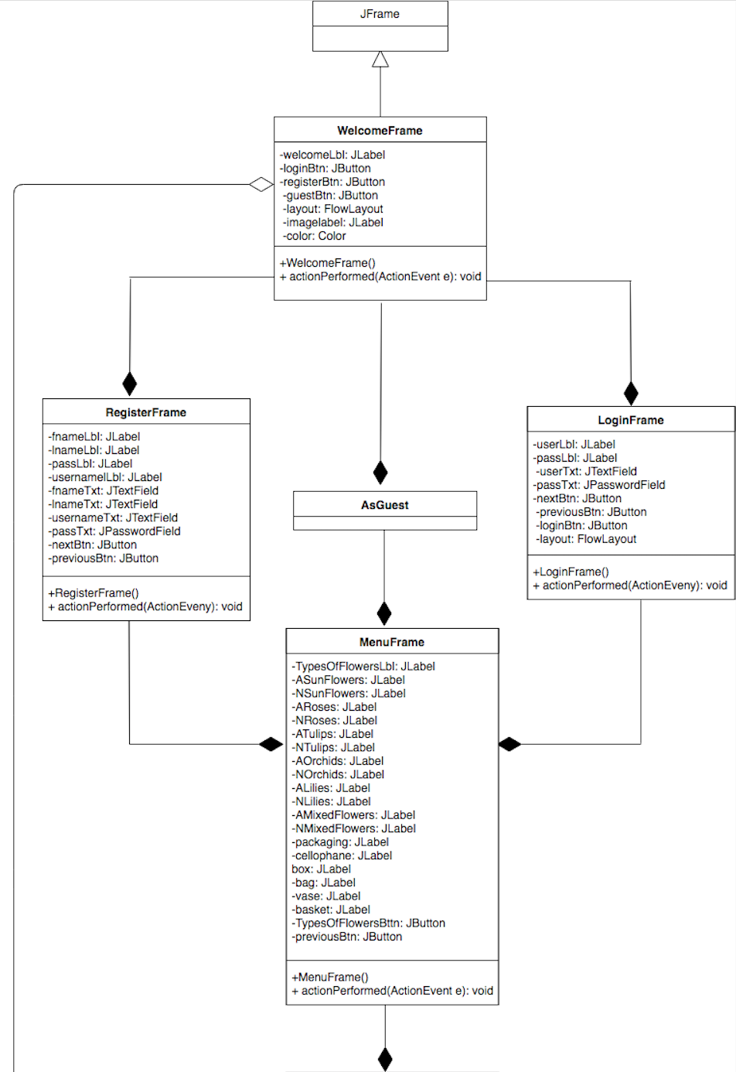
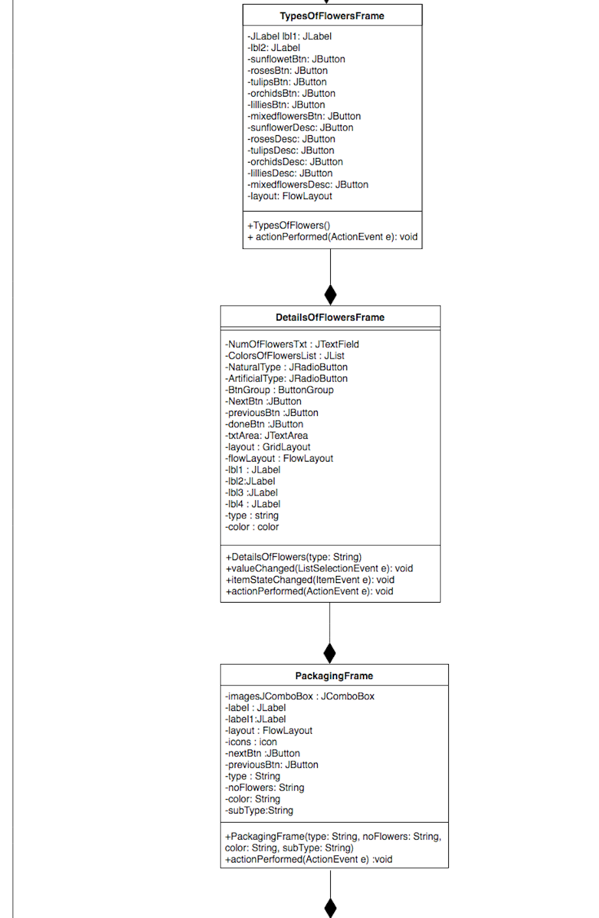
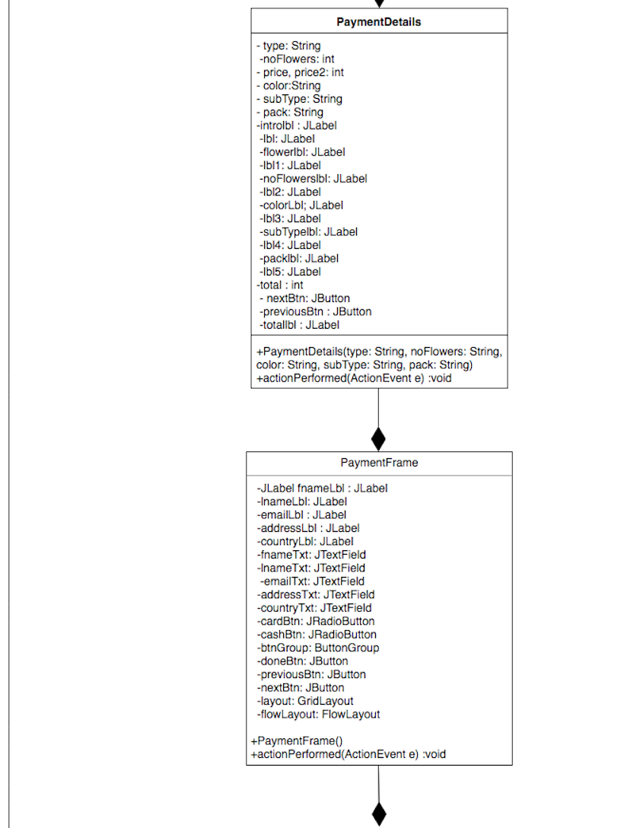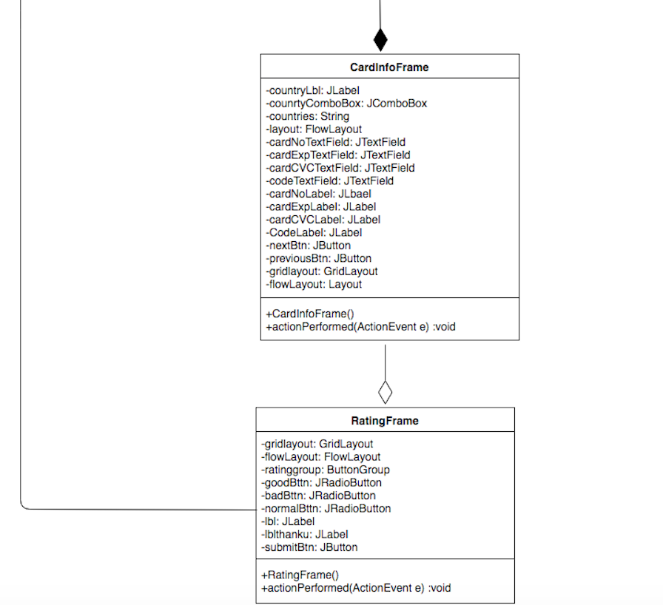

Step-2: Process Flow Diagram

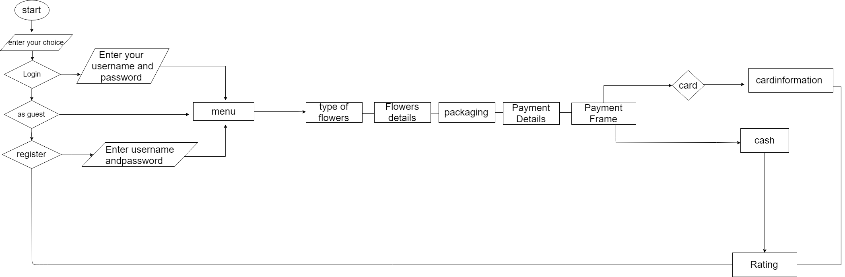

Step-3: Implementation / Code Details
There are several classes that perform specific functions to provide services for the user:
The list of classes:
1) Login window: This class is going to ask the user about his username and password. The class will have the implementation to check whether the information entered by the user are correct or not, and this will be done by using the method actionPerformed. If the information entered were correct and the user clicks the button LogIn, the Details of flowers window will appear, otherwise, the user will be asked again to enter the correct username and password. There will be two labels, one text field, one password field and one button "LogIn".
2) Register window: This class will take the information about a new user and will store it in the system such as the username, password, and email. There will be three labels, three text fields and one button "Next". If the user clicks the button, the method actionPerformed will have the implementation to check the username, password, and email if they are valid or not. If the information were valid the Type of flowers window will appear and if they were not valid the user will be asked again to change it to make it valid.
3) Menu frame: This class will contain 20 labels, 2 buttons, that labels will display each flowers and how much it costs and depending on the type of flowers either artificial or natural, and will display each packaging and how much it cost, the two button for choose the type of flowers and other to return back to the previous frame by using actionPerformed mehod.
3) Type of flowers: This class is going to provide 12 buttons, six buttons each one of them will be considered as one type of flower, the background of the button will be the picture of the flower. The other six buttons are description buttons. For example, if the user wants to choose Roses button, there will be a description button under the Roses button. The user can click the description button, which will provide a JOptionPane including a text that describes the flower, so the user can have an idea before making a choice. If the user clicks a flower button, then actionPerformed method will have implementation to go to the next window, which is the Details of flowers.
4) Details of flowers: This class will provide 1 textfield to enter the number of flowers , 1 list to choose the color of flower, Also two radio buttons will be provided in which the user can choose wether it is natural or artificial flowers
The major methods are: itemStateChanged to handle the two radio buttons , valueChanged to handle list selection event for the list, and acionPeromed to handle the buttons.
5) Packaging: this class will provide one combo box that will include the types of packaging we can provide in addition to an icon that will be displayed when the user clicks the type of package to give the user an idea of how each package would look like.
Major method: itemStateChanged to handle the combo box
6) Payment: This class is to process the payment details, it includes 5 text fields in addition to 5 labels which are: first and last name, address, email and country. It also includes 2 radio buttons so the user can choose the way of payment weather it’s via card or cash on delivery
The major method is: itemStateChanged to handle the radio buttons , and acionPeromed to handle the buttons.
7) Card info: This class is going to ask the user about the information of his card , it includes 1 combo Box that Specifies the country in which the card was created. There will be 4 Label in addition to 4 text Field which are: Card No, CardExp, CardCVC, and Card Code.
The major method is: itemStateChanged to handle the comboBox and actionPerformed to handle the TextField and buttons.
8)Rating: This class will confirm the request and evaluate the site. It include 1 Label it is Review and 4 Button which are Bad Button, Good Button, Normal Button and Perfect Button also 1 text Field the user be able to write his comment . these steps will help the user to see the customer's evaluation after each purchase process. After the Text Field will be 1 Button to the customer can submit his order.
The major methods are: actionPerformed to handle the TextField and buttons..

Database: Includes 4 tables:
- Registered users: saves the information for the user
- Types of flowers: includes the type, id, quantity and price
- Packaging includes the type, id, quantity and price
- Card Information: saves the information for the card

Step-4: Summary Table

1 | Welcoming Frame | Norah Hamad Al-Mubarak
2 | Menu Frame | Norah Abdulrahim Al-Mubarak
3 | LogIn Frame | Norah Abdulrahim Al-Mubarak
4 | Register Frame | Norah Hamad Al-Mubarak
5 | Types Of Flowers Frame | Dina Maher Al-Bushaier
6 | Details Of Flowers Frame | Norah Hamad Al-Mubarak
7 | Packaging Frame | Dina Maher Al-Bushaier
8 | Payment Details Frame | Norah Abdulrahim Al-Mubarak
9 | Payment Frame | Dina Maher Al-Bushaier
10 | CardInfo Frame | Norah Hamad Al-Mubarak
11 | Rating Frame | Norah Abdulrahim Al-Mubarak

Project Testing & Validation
In this report, we have analyzed the requirements and based on our application process following are our project test cases …….
Project Name: Flower Ordering Application
Test Case # 1

Test Case ID: TC_UI_1 | Test Designed by: Norah Abdulrahim Al-Mubarak
Test Priority (Low/Medium/High): Med | Test Designed date: 26-4- 2018
Module Name: Welcome Frame. | Test Executed by: Norah Abdulrahim Al-Mubarak
Test Title: Verify welcoming page that has three buttons. | Test Execution date: 26-4- 2018
Description: The user will have the option to either login, register, or continue as a guest.
Pre-conditions: User can click any button.
Dependencies:
.
Step | Test Steps | Test Data | Expected Result | Actual Result | Status (Pass/Fail) | Notes
1 | When the user clicks login. | Clicking a button. | The Login frame should appear. | The login frame appears. | Pass.
2 | when the user clicks register. | Clicking a button. | The Registration Frame should appear. | Registration frame appears. | Pass.
3 | When the user clicks continue as a guest. | Clicking a button. | Start the process of ordering | Types of Flowers frame will appear. | Pass.
4
Post-conditions:
After running the test case, the next frame will appear.
Project Name: Flower Ordering Application

Project Name: Flower Ordering Application
Test Case # 2

Test Case ID: TC_UI_2 | Test Designed by: Norah Abdulrahim Al-Mubarak
Test Priority (Low/Medium/High): Med | Test Designed date: 26-4- 2018
Module Name: Login Frame. | Test Executed by: Norah Abdulrahim Al-Mubarak
Test Title: Verify login page with a valid username and password. | Test Execution date: 26-4- 2018
Description: If the user has an account (Username and password), test the login frame.
Pre-conditions: User can enter username and password.
Dependencies:
.
Step | Test Steps | Test Data | Expected Result | Actual Result | Status (Pass/Fail) | Notes
1 | Provides valid username | Nourahm |  |  | Pass.
2 | Provides valid password | NM12345 | User should be able to login | LogIn | Pass.
3 | Click login button
4
Post-conditions:
After running the test case, the next frame will appear.

Project Name: Flower Ordering Application

Test Case # 3

Test Case ID: TC_UI_3 |  | Test Designed by: Norah Abdulrahim Al-Mubarak
Test Priority (Low/Medium/High): Med |  | Test Designed date: 26-4- 2018
Module Name: Registration Frame. |  | Test Executed by: Norah Abdulrahim Al-Mubarak
Test Title: Verify Registration page with a valid user information. |  | Test Execution date: 26-4- 2018
Description: If the user complete the form of registering, test the registration frame.
Pre-conditions: User can enter valid information and then the registration process of a new user will be completed.
Dependencies:
.
Step | Test Steps | Test Data | Expected Result | Actual Result | Status (Pass/Fail) | Notes
1 | Provides valid first name | Norah |  |  | Pass.
2 | Provides valid last name | Al-Mubarak |  |  | Pass.
3 | Provides valid username | NouraMub |  |  | Pass.
4 | Provides valid password | NM111111 |  |  | Pass.
5 | Clicking Next Button |  | The next frame, which is types of flowers frame should appear. | The types of flowers frame appear after inserting the correct information. | Pass. | All the information entered are correct, so registration process is completed.
6 | Clicking Previous Button |  | Welcoming frame should appear. | Welcoming frame appear. | Pass.
Post-conditions:
After running the test case, the next frame will appear.

Project Name: Flower Ordering Application
Test Case # 4

Test Case ID: TC_UI_4 | Test Designed by: Norah Abdulrahim Al-Mubarak
Test Priority (Low/Medium/High): Med | Test Designed date: 26-4- 2018
Module Name: Menu Frame. | Test Executed by: Norah Abdulrahim Al-Mubarak
Test Title: Test Menu Frame | Test Execution date: 26-4- 2018
Description: The user can have an idea of all flowers provided by the application.
Pre-conditions: User will click next button to start ordering flowers.
Dependencies:
.
Step | Test Steps | Test Data | Expected Result | Actual Result | Status (Pass/Fail) | Notes
1 | User clicks Types of flowers button | Clicking a button | Next frame which is types of flowers should appear | Next frame appears. | Pass
2 | Previous | Clicking a button | Welcoming frame will appear. |  | Pass.
3
4
Post-conditions:
After running the test case, the next frame will appear.

Project Name: Flower Ordering Application
Test Case # 5

Test Case ID: TC_UI_5 | Test Designed by: Norah Hamad Al-Mubarak
Test Priority (Low/Medium/High): Med | Test Designed date: 27-4- 2018
Module Name: Types of Flowers Frame. | Test Executed by: Norah Hamad Al-Mubarak
Test Title: Test Types of flowers frame | Test Execution date: 27-4- 2018
Description: The user can click any type of flower
Pre-conditions: User can click any type of flowers.
Dependencies:
.
Step | Test Steps | Test Data | Expected Result | Actual Result | Status (Pass/Fail) | Notes
1 | User clicks a flower type button | Clicking a button | Next frame should appear | Next frame appears. | Pass
2 | User clicks flower’s description | Clicking a button | JOptionPane will appear showing the description of the flower |  | Pass.
3
4
Post-conditions:
After running the test case, the next frame will appear.

Project Name: Flower Ordering Application
Test Case # 6

Test Case ID: TC_UI_6 | Test Designed by: Norah Hamad Al-Mubarak
Test Priority (Low/Medium/High): Med | Test Designed date: 27-4- 2018
Module Name: Details of flowers frame. | Test Executed by: Norah Hamad Al-Mubarak
Test Title: Test Details of flowers frame | Test Execution date: 27-4- 2018
Description: The details of flowers will be provided to the user to specify how many flowers, size of flowers, and many other requirements for ordering flowers.
Pre-conditions: User can fill the details of flowers he wants to order.
Dependencies:
.
Step | Test Steps | Test Data | Expected Result | Actual Result | Status (Pass/Fail) | Notes
1 | When the user select and fill all the details. Click the Next Button | Clicking a button | Next frame which is Packaging should appear | Next frame appears. | Pass
2 | User clicks Previous | Clicking a button | The types of flowers frame should appear. | Previous frame appears. | Pass.
3
4
Post-conditions:
After running the test case, the next frame will appear.

Project Name: Flower Ordering Application
Test Case # 7

Test Case ID: TC_UI_7 | Test Designed by: Norah Hamad Al-Mubarak
Test Priority (Low/Medium/High): Med | Test Designed date: 27-4- 2018
Module Name: Packaging frame. | Test Executed by: Norah Hamad Al-Mubarak
Test Title: Test Packaging | Test Execution date: 27-4- 2018
Description: This frame is going to let the user to choose the packaging of the flowers.
Pre-conditions: User can select the packaging of the flowers.
Dependencies:
.
Step | Test Steps | Test Data | Expected Result | Actual Result | Status (Pass/Fail) | Notes
1 | When the user select the packaging. Click the Next Button | Clicking a button | Next frame which is payment details should appear | Next frame appears. | Pass
2 | User clicks Previous | Clicking a button | The details of flowers frame should appear. | Previous frame appears. | Pass.
3
4
Post-conditions:
After running the test case, the next frame will appear.

Project Name: Flower Ordering Application
Test Case # 8

Test Case ID: TC_UI_8 | Test Designed by: Dina Al-Bushaier.
Test Priority (Low/Medium/High): Med | Test Designed date: 28-4- 2018
Module Name: Payment details frame. | Test Executed by: Dina Al-Bushaier.
Test Title: Test Payment Details | Test Execution date: 28-4- 2018
Description: This frame is going to display the information about the order.
Pre-conditions: User can check the prices and that every step is correct.
Dependencies:
.
Step | Test Steps | Test Data | Expected Result | Actual Result | Status (Pass/Fail) | Notes
1 | When the user checks the details of the order. Click the Next Button | Clicking a button | Next frame which is payment frame should appear | Next frame appears. | Pass
2
3
4
Post-conditions:
After running the test case, the next frame will appear.

Project Name: Flower Ordering Application
Test Case # 9

Test Case ID: TC_UI_9 | Test Designed by: Dina Al-Bushaier.
Test Priority (Low/Medium/High): Med | Test Designed date: 28-4- 2018
Module Name: Payment details. | Test Executed by: Dina Al-Bushaier.
Test Title: Test Payment frame | Test Execution date: 28-4- 2018
Description: In this frame, the user is going to provide the correct information to be able to continue ordering process.
Pre-conditions: User can check the prices and that every step is correct.
Dependencies:
.
Step | Test Steps | Test Data | Expected Result | Actual Result | Status (Pass/Fail) | Notes
1 | When the user is done from entering all the information and checking whether the payment is via cash or card. Click Done Button | Clicking a button | Next frame should appear | Next frame appears. | Pass | If the user chooses to pay via card ( card Information frame will appear) and if the user chooses to pay cash (Rating frame will appear)
2
3
4
Post-conditions:
After running the test case, the next frame will appear.

Project Name: Flower Ordering Application
Test Case # 10

Test Case ID: TC_UI_10 | Test Designed by: Dina Al-Bushaier.
Test Priority (Low/Medium/High): Med | Test Designed date: 28-4- 2018
Module Name: Card information frame. | Test Executed by: Dina Al-Bushaier.
Test Title: Test card information frame | Test Execution date: 28-4- 2018
Description: In this frame, the user is going to fill the information about the card.
Pre-conditions: User can check the prices and that every step is correct.
Dependencies:
.
Step | Test Steps | Test Data | Expected Result | Actual Result | Status (Pass/Fail) | Notes
1 | When the user is done from entering all the information about the card. Click Next Button | Clicking a button | Next frame which is Rating frame should appear | Next frame appears. | Pass.
2 | When the user clicks previous | Clicking a button | Previous frame which is payment frame should appear | Previous frame appears. | Pass.
3
4
Post-conditions:
After running the test case, the next frame will appear.

Project Name: Flower Ordering Application
Test Case # 11

Test Case ID: TC_UI_11 | Test Designed by: Dina Al-Bushaier.
Test Priority (Low/Medium/High): Med | Test Designed date: 28-4- 2018
Module Name: Rating frame. | Test Executed by: Dina Al-Bushaier.
Test Title: Test Rating frame | Test Execution date: 28-4- 2018
Description: In this frame, the user can rate the application.
Pre-conditions: User can rate the application.
Dependencies:
.
Step | Test Steps | Test Data | Expected Result | Actual Result | Status (Pass/Fail) | Notes
1 | When the user is done from rating the application. Click submit to submit the order. | Clicking a button | The First frame of the application will appear. Which is the welcoming frame | Welcoming frame appears. | Pass.
2
3
4
Post-conditions:
Order is submitted.

Conclusion

We arrive to the last stage in the project. And put last points in the report starting of Creation History and ending with this conclusion by proceeding through the UML diagram, flow chart, implementing the code and the database needed.
Finally, ending the project successfully .

